In this reflective report I’ll be looking at the area of education in my career, how it started, the journey undertaken and how I have developed relevant skills over time using formal and experiential learning at appropriate times. I did not start this journey with predefined learning outcomes, however on reflection I can see the areas that I have developed and how they relate to improvement in this area. I have annotated how each section relates to my learning outcomes.
Learning Area: Educating in Digital Marketing
- Learning Outcome 1: Understand how to communicate to people of varying backgrounds the complexities of digital marketing in business
- Learning Outcome 2: Be able to assess peoples learning using appropriate methods to the situation
- Learning Outcome 3: Be able to deliver relevant learning to people depending on the context of teaching
Schön (1983) suggests two reflective models, in action and on action. In action happens at the time of the incident, is often unconscious and allows immediate change, and is a reactive situation. On action takes place afterwards and is a more conscious process, giving time to think about the incident, consider a different approach, talk to others, it’s about being proactive and considering measures to improve in the future.
“When we reflect, we not only challenge our assumptions about why we do what we do, we can also help ourselves identify where we feel lacking and why we may be setting ourselves unnecessary unachievable standards.” Hillier (2005, p7).
On action reflection has become a habit for me, mentally running through EDAR (Gravells, 2016) points after significant events to understand why I did something, why did it go well, or not well and how I could change something as a result. EDAR is a framework to prompt an individual to take an Experience I would like to change or improve, Describe aspects such as who was involved, what happened, when it happened and where. Analyse the experience in depth and ask myself why and how it happened and then Revise, thinking about how I would do it differently if it happened again and then try it out when the opportunity arises.
Reflecting on my career in the digital sector, I identified that in the very early stages my line manager saw in me strong communication skills. I was sent to key customer accounts to act as a liaison between client, sales, and development as I could manage and translate the requirements of each to reach an amicable solution. Being able to articulate complex topics to each party I believe is a key skill I started to develop at this stage which would prove to be fruitful as my career evolved. I can’t place where this skill came from, I don’t believe it was taught and must stem from personality traits. Perhaps I am a Type B, patient, relaxed and easy-going individual as identified by cardiologists Friedman and Rosenman in the 1970s.
LO1
As a freelance website developer, again my communication skills were key, transposing client requirements into solutions and at this stage training people on how to use the software that I had developed. I now understand personality types, but at the time I did not realise this, I would try to ascertain people’s level of technical ability throughout the project and work out the best way to train them through trial and error. I found some people needed a lot more training and a simplistic description whereas others wanted more complex information. Of course, in reflection this makes sense and from studying learning styles and understanding consumer behaviour. I can now see that I needed to adjust based on peoples personality types and learning styles and I’ve since learnt about the key Myers Briggs’ Type Indicator and Kiersey’s Temperament Sorter which are based on the works of Carl Jung (1875 – 1961). One day I might be training a greengrocer who did not like technology how to use software to manage their website orders, the next day an administrator in an engineering company how to publish a blog post and the next a plumber to update the case studies on their website. All of which had individual learning styles, but my assumptions of their likelihood of understanding were often out of alignment.
LO1, LO3
As the business grew and I expanded the business into the provision of digital marketing management services the educating aspect of my career started to evolve as I ran digital marketing workshops. The purpose of this activity was in our own marketing, to get a group of people together, share knowledge with them and give them a few “golden nuggets” but the aim was to make them think to themselves “these guys know what they’re talking about, I don’t get it, let us outsource to them”.
LO3
Interestingly I reverted to formal education at this stage. Since leaving University in 2003 my formal education had stopped and everything, I learnt was through life experience and informal learning from online resources. Upon reflection now I can comprehend the differences between formal education and experiential learning (Kolb, 1984) and the benefits and necessities of each. While starting and running a small business, one needs to gain multiple skills and wear lots of hats. I couldn’t get a degree in HR, Accounting, Business, Law, Economics and so much more, so informal experiential learning of the snippets of information I needed at the time was my education, which compounded over time and upon reflection I have a vast array of knowledge in a lot of these areas. However, I felt that as I was going into a new subject area, to be taken seriously by my peers, I needed formal accreditation, so I undertook in 2014 – 2016 CIM qualifications in marketing.
When I reflect upon my performance at this stage delivering workshops, I lectured to people, and there was little engagement and in the early days we did not get much response in client signups as can be seen in an early recording on YouTube https://youtu.be/0coMyKQt2tQ. Experiential learning was key here and reflection on practice, which at the time I did not know is what was happening, I would try different methods, more breaks, more question opportunities and learnt from session to session what went well and what did not.
LO1, LO3
In terms of my own personal development, I find it fascinating now how my presentation skills have evolved. At school and university, the prospect of public speaking would put me into a cold sweat, however as my knowledge in this subject grew, so did my confidence. I am aware now as my mind has matured how to manage situations and I am aware that I am now a subject matter expert and although I struggle with imposter syndrome, I am able to overcome my fears and feel confident in my delivery. Formal education helps here as I have external endorsement, formal qualifications from CIM in the subject area and now my doctoral journey, but I am also a professional member of the CIM and am now a chartered marketeer after completing the necessary CPD – all of which help me feel empowered as a subject matter expert.
LO3
I produced a small self-published book at this stage (https://www.gowerdigital.co.uk/wp-content/uploads/2020/10/Bens-Internet-Marketing-Book.pdf) for two reasons, one as a marketing tool for expert positioning, but also to educate people. At the time it was primarily a marketing tool, so I created a framework and outsourced it to a ghost-writer to fill it out to an acceptable length. It has now been used for six years, mainly as a free electronic download, but also one thousand copies have been printed and given away and the feedback has always been positive. It is on my agenda to re-write the book and this will probably be an outcome of my research, but this time I would not outsource and would bring together all aspects of my continual learning to produce a version that will better educate people in the topic of digital marketing using my knowledge of learning styles and observations in education over time.
LO1, LO3
As my reputation grew in the subject area of digital marketing and running workshops, I was asked to collaborate on projects with other organisations. The digital marketing workshops I delivered for marketing purposes for my own business evolved into free educational workshops delivered in collaboration with Swansea Bay Futures, a series of training events with The Wave (https://youtu.be/qVxwRI0FxkU), workshops on GDPR with JCP Solicitors (https://youtu.be/KGOAkcoKVrE) and pre-recorded webinars (https://youtu.be/igA7FbETYkM). All of these experiences gave me the chance to communicate and deliver to different audiences in terms of need, background, age and situation, from students to employees to business owners.
LO1, LO3
The next stage in my education journey was in formal education. I was asked to deliver a series of guest lectures in digital marketing by Swansea University. I defaulted into lecture mode on these occasions, delivering a 45-minute talk to groups of hundreds of students in a lecture theatre scenario. A situation I found very hard as I knew I needed to provide opportunities for engagement, but in the situation, I struggled to create the right learning environment. However, again a great opportunity to reflect and improve my communication and delivery skills.
LO1, LO3
Then an opportunity arose to design and deliver with UWTSD a work-based learning course at level 5 for the GWLAD project. I learnt a tremendous amount during this process about creating a learning programme for adults in business following a formal process of learning design, creating learning outcomes, designing sessions that catered for learning styles, delivery of content, time for questions and engagement and creating formative and summative assessment methods. This experience was my first in formal education and helped me refine my skills by watching and learning by experience from others in a formal setting.
LO1, LO3
After this project I was asked to deliver level 5 and 6 undergraduate programmes for UWTSD in digital marketing which evolved into other related subject areas such as strategic marketing, innovation in business, and consumer behaviour. Now I was having a broad audience on a regular basis, adult business owners, younger employees in marketing, young students at the start of their careers, I had to learn quickly through experience how to perform my duties at a high quality. I was also now starting to formally assess peoples work and while I could easily mark work due to my subject area knowledge, my feedback skills and knowledge of the feedback process was week, I had no formal education on this process at this stage, which I later corrected, but again I was learning through experience. This is where my learning on assessing individuals began and the relationships between learning styles and personality types started coming together to compound my understanding and ability to communicate, deliver and assess on a wide range of individuals.
LO1, LO2, LO3
My reason for wanting to do this I believe was due to my own educational process which was detailed in another report and as an employer, I found students coming out of university didn’t have the relevant skills and knowledge to be able to start a career without further additional training. I also found people working in marketing had self-taught and I wanted to use my skills to correct this and give people the skills needed and better career opportunities.
When I first delivered a module on digital marketing, I knew I was confident with the subject knowledge, but again I was back in the lecture environment and I became aware I would default into lecturing and not cater for individual learning styles. So, on a session-by-session basis I would reflect and evolve my teaching to create opportunities for discussion.
LO1, LO3
At this stage all my self-development came from what I now know to be experiential learning, I was self-taught, I tried something, felt it did or did not work and work tweak and try again. It was at this time I then felt I needed formal learning myself to improve on an area of weakness in my abilities as this was an area of my career that I enjoyed, was developing and I knew I needed to improve upon. So, I researched what qualifications were important and relevant and enrolled upon a level 4 certificate in education and training.
LO1, LO2, LO3
The course involved online lessons and reading with summative assessments in the form of reflective reports. There were areas I struggled with and through learning about learning styles I can see how this method of delivery did not allow for tutorial sessions and questions and auditory learning which I would have benefited from. A key element of doing this course taught me how I liked to learn and the need for diverse learning methods to cater for the audience. Understanding the VARK model for learning styles (Fleming et al., 1992) - visual, auditory, reading/writing and kinaesthetic – has also helped me improve my communication and delivery skills to my learners. Part of this course required me to video my lessons so I could watch back and reflect, they were also peer reviewed and valuable feedback was given.
LO1, LO3
I had now had experience of educating adults in business about digital marketing, who wanted a few key tips to improve their skills and very practical learning; educating young people in a formal academic environment where much more theory was taught. My understanding of learning styles had grown and my own ability to reflect upon my performance and evolve had grown.
LO1, LO3
Next, I was asked to undertake a role with Gower College (GCS) delivering a level 3 and 4 apprenticeship in digital marketing. This process taught me a vastly different process of education. I was teaching work-based learning to a diverse range of people from young adults with limited commercial experience and employed within the health sector to older, experienced adults who were employed had been employed for many years as marketing managers. Their needs were diverse, some needed to be taught from basics upwards, and some just wanted the formal assessment to gain a qualification for their CV. I was teaching people who know just as much as me, if not more in certain situations and areas of niche expertise.
LO1, LO3
This experience also taught me about a different way of assessment through City & Guilds where courses were designed and approved by Ofqual and disseminated through awarding bodies to educational institutions and delivered and assessed by people like me. The content I had to deliver was constrained by detailed learning outcomes, some assessments were predefined and some flexible, where alignment with learning outcomes was open to interpretation. But the process was heavily regulated, my teaching was more often sampled by internal quality assurance, as to was my methods of assessment and assessment of learners, this was also audited externally by the awarding bodies quality assurance team. Until this time any formal assessment I had undertaken of learners had felt to be more informally controlled and only occasionally had my assessment of learners been audited.
LO2
Reflecting on these experiences I have developed a much greater understanding of how to teach; to young people going through academic learning to older people who sought more practical learning. I have found the university style of setting learning outcomes much more open to interpretation and yet the City & Guilds method very restrictive.
LO1, LO2, LO3
For example, a learning outcome for level 5 digital marketing at university would be:
Demonstrate knowledge and a critical understanding of the well-established principles of the disruptive digital environment and the challenges and opportunities that it brings.
There may be two or three learning outcomes and a list of indicative content for a module. However, with level 4 City & Guild there would be four or five learning outcomes along with indicative content, however each learning outcome would also specify approximately half a dozen specific assessment criteria:
1. Understand planning requirements for the use of digital and social media
1.1 Describe the importance of the objectives and budget for digital and social media marketing aligning with the marketing plan
1.2 Describe how to identify the nature and location of target customers
1.3 Describe sources of information about the nature and location of target customer groups
1.4 Explain the implications of retention and acquisition programmes as they affect the choice of digital/social media
1.5 Explain how to reach target customers in accordance with the plan
1.6 Explain the requirements of a data collection and reporting system that is capable of capturing the information required by the plan
1.7 Explain the importance of agreeing the message that conveys the marketing proposition
A requirement for delivering and assessing the City & Guilds course for Gower College was the attainment of a level 3 Training, Assessment, and Quality Assurance qualification, even though I had already obtained a level 4 qualification covering the same content. However, going through this process compounded my formal learning and in particular helped me understand the assessment process more, having learnt about assessing to assessment criteria I found I was far better placed to complete assessments to the specified cratering in the reverse role. This has allowed me to adapt my teaching to explain to learners how they need to write assessments in that scenario.
LO2, LO3
I have also decided to put myself through a level 4 internal quality assurance qualification to help myself understand how the process above me works for internal auditing. This has taught me the procedures of sampling work and ensuring standardisation across trainers/teachers and assessors in terms of delivery, assessment methods and assessment marketing.
LO2, LO3
While my process of teaching was developed through experiential learning in the early stages, the formal learning has helped me refine my offering and accelerated my understanding of academic topics around learning styles and the process of assessment, learning which I would never have obtained through self-teaching.
LO2, LO3
Alongside my teaching activities, my own commercial digital marketing training continues and from going through the process of teaching undergraduates with UWTSD and work-based learners with UWTSD and GCS has substantially evolved. My business now offers informal workshops and short courses to businesses and individuals along with formal accredited qualifications. I undertook a lot of research at this stage of options for accreditation and settled on becoming an accredited centre with the awarding body OCN to deliver level 4 digital marketing qualifications. The main reason I chose this was because of the learning outcome structure, I felt it was the right balance of detail and formal structure, with flexibility built in, an example of their learning outcomes is:
1. Understand the changes in consumer behaviour caused by digital technology.
1.1. Explain how digital technology has increased consumer power.
1.2. Compare online buying with offline buying.
1.3. Describe customers’ expectations and concerns when buying online.
LO2, LO3
I find this to be more structured than that shown above from a university, yet with more room for customisation than that of City & Guilds. It is interesting too however that both the level 4 digital marketing qualifications from OCN and C&G are regulated to the same standard by Ofqual.
LO2
My reason for developing my skills in teaching is that through my own journey of self-learning and self-discovery, I truly believe that effective digital marketing requires an element of formal learning. While we are in a sector that advocates the use of technology and living in the information age where content for self-learning is abundant online, especially in the subject area of digital marketing, the best marketeers have a formal background.
There are a lot of people that are self-taught, and often learning from self-proclaimed self-taught gurus and while this content that is available for free on the internet can be insightful, there is still a need for a more academic approach to teach principles. Fads and platforms come and go, and the sector evolves quickly, so if an individual is taught, or learns, principles and how to take prior learning and apply it to a problem, it is far better than learning tactics of how to use a particular system which is the current hot topic. For example, both Google and Facebook have their own online learning platforms for their tools, how to run a paid advert on Google or Facebook as an example, if an individual learns how to use their system, and then a new one comes along, the formal academic approach will allow that user to adapt to any specific platform, not just the one they learnt on.
Part of my research will look at the level of education people have had and the role that plays in the business’s performance in digital marketing. I want to study if an organisations success can be attributed to the education of their marketing function. It might be outsourced completely, in which case I will look at their suppliers, or if they have an internal resource, is that person self-taught, have they obtained a degree in the discipline, undertaken a degree with a few modules in digital marketing, or have they completed other work-based learning in the subject area.
My effectiveness at teaching is an ongoing reflective process. I feel my formal education in the subject area is sufficient for now, however experiential learning is key for me at this stage as I continue to teach people of different academic levels, at different stages of their career, with different levels of academic maturity and with different personal goals from undertaking education. I need to continue to evolve my delivery to accommodate the different levels of study (from 3 to 6) and to cater for the individuals learning styles.
I’ve found this reflective process fascinating; I can see my communication LO1 skills have evolved over time through experiential learning, my delivery skills LO3 have again evolved with experiential learning, but formal education was critical to my growth in this area, and finally my assessing skills LO2 were developed through formal education, and experiential learning alone in this area would not have sufficed.

References
Fleming, Neil & Mills, Colleen. (1992). Not Another Inventory, Rather a Catalyst for Reflection. To improve the academy. 11. 10.1002/j.2334-4822.1992.tb00213.x.
Gravells, A., 2016. Principles and practices of quality assurance. London: Sage.
Hillier, Y. (2005) Reflective Teaching in Further and Adult Education (2nd end). London: Continuum.
Kolb, D.A. (1984) Experiential Learning as the Science of Learning and Development. Englewood Cliffs, NJ: Prentice Hall.
Schön., 1983. The reflective practitioner. New York: Basic Books.

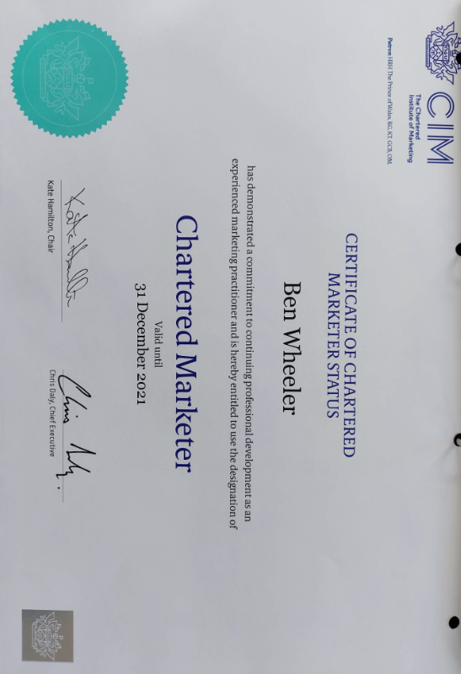
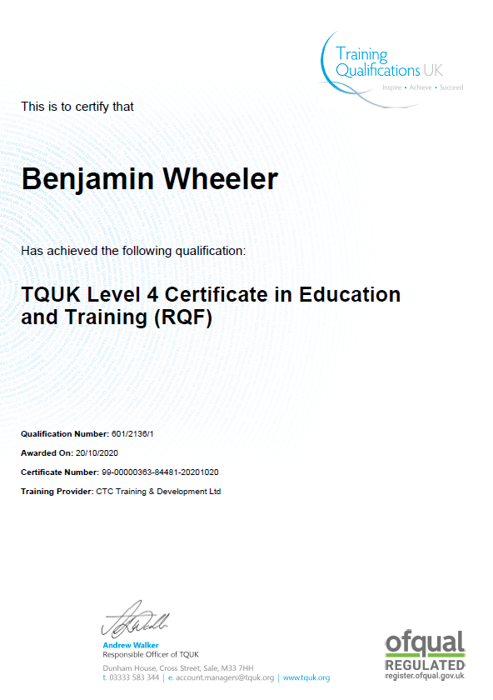
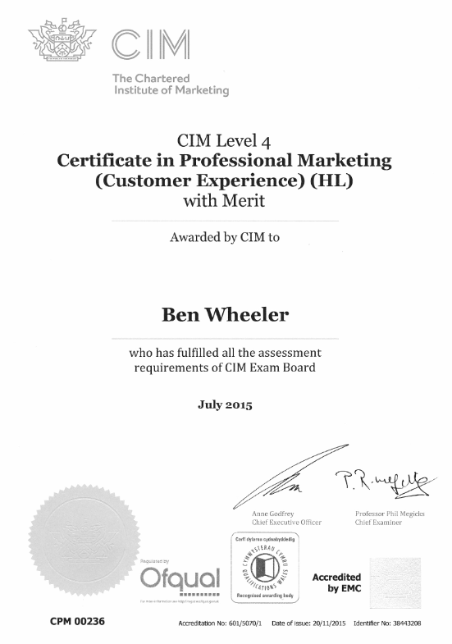

Ben Wheeler
698 Gower Road, Swansea, SA2 7HE · 07530 051 028
bpwheeler@gmail.com · linkedin.com/in/benpwheeler



personal skills
- Critical / Analytical thinking, analysis, and innovation
- Active learning and self-development
- Reasoning, complex problem-solving and ideation
- Creativity, originality, and initiative
- Leadership and social influence
- Technology use, design, programming, monitoring and control
- Resilience, stress tolerance and flexibility

self-employed Experience

NOVEMBER 2020 – PRESENT
I’ve started a new business in Digital Marketing consultancy and training, having become a recognised OCN Centre, I’m building a new team to train individuals in digital marketing and gain a qualification to either start or enhance their careers.

september 2008 – October 2020
I started as a freelance web developer and built a company which I sold after turning it into a profitable sustainable business with a strong self-sufficient team.

Over the years I have been responsible for all aspects of the business, but my reputation was in digital strategy, transformation, and marketing.

I designed solutions for websites, SaaS, mobile apps, web apps and digital marketing. Working with hundreds of clients from one many bands to international organisations with various budgets and needs.

employed Experience

Febuary 2020 – present

Digital Trainer & Assessor

Gower College Swansea
Part-time contract to design course material, deliver and assess C&G L3/4 Digital Marketing qualifications on the apprenticeship framework.

December 2018 - present

Hourly Paid Lecturer

UWTSD
Casual contract to design course material, deliver and assess for L5/6 Innovation and Digital Marketing qualifications.

june 2016 – may 2017

Project Fellow

UWTSD
Headhunted for my local reputation to design a new digital marketing accredited course for work-based learners and assisted in delivery.

may 2017 – august 2017

consultant marketing manager

oxwich bay hotel
Short term contract to manage major change in the organization.

November 2007 – november 2008

Web Development Manager

Digital Virtue LTD
Fixed term contract to assist a business that had relocated. Employed as a software developer and manager of a small team, my role was to recruit and create a stable team for the business.

June 2003 – November 2007

graduate Software Developer

Unit 4 Agresso (Distinction Systems LTD)
Graduate training scheme, developing student management software.

development Team Leader

Unit 4 Agresso (Distinction Systems LTD)
Over time I took on responsibility for creating ISO9001 documentation and being audited. In 2004 I started undertaking a customer liaison role, meeting clients, and working with the sales team as a bridge to the development team. I then progressed to a development team leader in April 2005, taking over the role from my line manager. This gave me a fantastic understanding of HE and FE education which has stayed with me throughout my career.

awards

2020

best business enabler, Top 6
National entrepreneur awards
Self-nominated, Copper Bay was selected from thousands of entries to be in the final, ceremony postponed due to COVID-19.

2016

Small business company director of the year (Wales), Winner
Institute of directors
Recognised for my achievement starting and growing Copper Bay. I was anonymously nominated, interviewed, and selected from the top 3 to receive the award.

2016

business of the year (0-25 employees), Top 3
swansea bay business awards
Copper Bay was Highly Commended in the award ceremony.

2015

top 35 businessmen under 35 in wales
Wales Online media group
This is an annual listing they create from their own selection process.

2014

most impressive company growth, Top 6
National entrepreneur awards
Self-nominated, we were selected from 1200 entries to be in the final 6 and Highly Commended in the award ceremony.

2014

rising star of wales

Wales Online media group
This is an annual listing they create from their own selection process.

Education & qualifications

2020

Level 3 Award in Residential Letting & Property Management

propertymark

2020

Level 4 Certificate in Education and Training

CTC Courses

2020

Level 3 Certificate in Assessing Vocational Achievement

Gower college swansea

2019

PRINCE2 Agile® Foundation

prince2.com

2016

google SPECIALIST

google
Google Advertising Modules – Fundamentals, Search, Display, Mobile, Video, Shopping.

2016

Level 6 Award in Mastering Metrics

CIM

2015

Level 4 Certificate in professional Marketing

CIM
Awards in Customer Experience, Integrated Communications, and Digital Marketing.

2003

Electronic & computer engineering

university of portsmouth
BEng (Hons.) 2:1

2001 / 2002

summer placement broadcast engineer

BBC
Undergraduate training.

2000

A Levels

John hampden grammar school
2 A Levels, 1 AS Level

2000

Engineering in Education Scheme

Engineering Education Continuum
Gold CREST Award
Head Start Scheme

1998

GCSEs

John hampden grammar school
7 B’s, 3 C’s

other

2020

voluntary NON-EXECUTIVE director

Family housing association wales
I was co-opted onto the board to provide advice on digital adoption.

2014 - 2016

voluntary Chair

upper killay community council
Upon moving to the area in 2014, I wanted to get involved in the local community. I was select for Chair within a few months. Left due to work commitments.

2006 - 2008

voluntary charity director

dylan thomas theatre
Upon moving to the area in 2003, I joined the amateur theatre group. After a few years, I was asked to join the board of directors. Left due to family commitments.

2014

digital marketing for small business owners

author
During my entrepreneurial career, I decided to write and self-publish a small book that is primarily used in marketing activities. It is also available on Kindle.

2018

article contributor

The ENTREPRENEURS Network magazine
During my entrepreneurial career, I was asked to write monthly articles for a magazine for 12 months.

Job Description
I don’t have a provided job description, as someone who is categorised as self-employed / a business owner / an entrepreneur I have the fortunate, or possibly, unfortunate ability to define my own.
“To do what I want, how I want, when I want.”
Is a typical job description of someone in my position. The freedom to choose to do what I want, how I want to do it and when I want to do it because I am responsible for how I spend my time to generate an income for my family.
As opposed to a document that can define my duties for my role within an organisation, that can subsequently be reviewed against performance, I have researched the qualities and characteristics applicable to my ‘job’ – because there is no-one who can provide me with a definitive job description.
The following is an extract from an article; “What is an entrepreneur?” (Prospects.ac.uk, 2019).
An entrepreneur can be defined as a person who devises, sets up and runs a new business or businesses.
While all entrepreneurs are self-employed, not all self-employed individuals are entrepreneurs - some are better categorised as small business owners.
Entrepreneurs typically:
- devise untested ideas
- make high-risk decisions that have a potentially significant long-term impact
- delegate management to experts, meaning that the company can easily continue to function without the entrepreneur's input if and when they move on
- aim to generate buyer interest in their business.
In contrast, small business owners typically:
- solve existing and sometimes obvious local problems
- make low-risk decisions that ensure short-term security
- manage their employees closely, meaning that the company may struggle to function without the small business owner's input
- have little or no intention of ever selling their business.
I personally believe, and feel this will form part of my research, someone who is self-employed, say for example, a plumber, is good at their trade and works for themselves, alone and has no aspirations for anything more.
A small business owner employs, but the business is owner-managed, and that person is key to the business, it can’t survive without them, and is unlikely to be a saleable asset.
An entrepreneur takes more risk, they may have multiple businesses, but the key difference, is that they can operate without their input.
The article; “What is an entrepreneur?” (Prospects.ac.uk, 2019) goes on to say:
Five skills to succeed in business - creativity, knowledge, leadership, organisation and self-belief. …entrepreneurs also need to be:
- Decisive
- Innovative
- Flexible
- Passionate
- Resourceful
- Results-orientated
- Risk-taking
- Persistent
- Visionary
As well as possessing these entrepreneurial skills, you'll also need to be wise enough to ensure that any shortcomings that you possess are compensated for. This usually requires recruiting other individuals and the ability to attract external support.
Another article “Entrepreneur Job Description” (BestJobDescriptions.com, 2019) repeats similar characteristics, but says:
An Entrepreneur has to know how to work with others. In the world of business, one will meet different types of personalities with different backgrounds in life and experiences. Therefore, knowing how to reach out to others with the most effective way of communication is a must in order for the business to flourish.
An Entrepreneur, one must be able to develop a system for you to be able to run your business smoothly. This system will allow you to evaluate areas of your business in terms of inventory, manpower and production rate.
An Entrepreneur should take it upon himself to get educated on the type of business he wants to venture in. Learning is like practice in sports. When you immerse yourself in your business every day, you make yourself aware of so many issues that in the long run you will be able to address certain issues even with just mere observation.
An Entrepreneur has to manage his time with the best of his ability. In this way family and business will never be neglected.
Interestingly, linked to my Review of Learning, and discussion on “Am I a professional?” the article “Entrepreneur Job Description” (BestJobDescriptions.com, 2019) suggests that there is no formal educational requirement to be an entrepreneur, however education can be beneficial and states:
To any known Entrepreneur, education coupled with experience in the business industry will guarantee better management of your business enterprise.
Another article, “Tasks & Responsibilities of a Small Business Owner” (Smallbusiness.chron.com, 2019) highlights well the job description of a small business owner, and says;
As a small business owner, you can have a lifestyle of freedom and flexibility not offered to an employee. However, being a small business owner also carries greater responsibility with many more tasks to juggle. Most small businesses have limited resources when launching, which means that, as the owner, you have many hats to wear, depending on the nature of your business.
Planning and Strategy
First, a small business owner must be the principal strategist and planner. To understand the new business, as well as the necessary resources and strategies, it makes sense to start with a business plan and a marketing plan. You’ll need to do research, planning and writing to develop a plan, and expect to revisit and change it as needed.
Finance and Accounting
Most small businesses need start-up capital to get established and grow their products and services. Depending on the business, some owners can bootstrap and start with a smaller budget. Other ventures require a small business loan to fund expenses for retail space, office equipment and hiring employees. You’ll also need to set up and maintain business bank accounts, payment processing, accounts payable and accounts receivable, and taxes.
Compliance and Legal Responsibilities
Small business owners must comply with federal and state business licensing laws. From forming a limited liability company to creating legal contracts, they must know basics of the law and have access to an attorney if legal problems with customers or employees arise. You might need to write, review and sign legal contracts and sales agreements. When legal issues occur, you’ll need to consult a lawyer.
Marketing and Sales
No matter how good your product or service is, you need marketing and sales to drive business. Marketing and sales strategies and implementations vary widely, depending on the business, and could include tactics such as print advertising, public relations, online marketing, networking, cold calling and commissioned salespeople.
Customer Service Duties
In the beginning, many small business owners are responsible for providing all or most of the customer service duties. These include phone calls, email messages and follow-ups concerning product delivery and quality issues. As the business grows, it makes sense to automate and hire customer service people when possible to scale operations and growth.
Employees and Human Resources
As a small business grows, so do its hiring needs to accommodate more orders and faster growth. The owner needs to identify human resources needs, write job descriptions, screen and interview candidates, train, manage and pay employees. For some businesses, it makes sense to hire a dedicated HR manager to handle screening, hiring, training and employee-related processes.
A small business owner has many broad and diverse tasks and responsibilities that are essential for starting and managing a successful business. Depending on the type of business and the stage it is in, the roles and responsibilities change, and the owner continually must adapt to thrive.
These articles, I feel provide a good overview of my ‘job’ and provide the best ‘job description’ which really highlights the varied complexity involved.

Bibliography
Prospects.ac.uk. (2019). What is an entrepreneur? | Prospects.ac.uk. [online] Available at: https://www.prospects.ac.uk/jobs-and-work-experience/self-employment/what-is-an-entrepreneur [Accessed 24 Nov. 2019].
BestJobDescriptions.com. (2019). Entrepreneur Job Description - BestJobDescriptions.com. [online] Available at: https://www.bestjobdescriptions.com/business/entrepreneur-job-description [Accessed 24 Nov. 2019].
Smallbusiness.chron.com. (2019). Tasks & Responsibilities of a Small Business Owner. [online] Available at: https://smallbusiness.chron.com/tasks-responsibilities-small-business-owner-23718.html [Accessed 24 Nov. 2019].

