Student Name: | Joseph Slattery
Title of Project: | The effect of chemical additives on the ultra violet output of MTV
Supervisor: | Ewa Kazimierska
2nd marker: | David Holley
Pathway: | Technical Research & Development  Safety  Manufacturing & Processing  Breakdown & Disposal  Test & Evaluation  (please indicate)
Project Type: | Survey Review Experiment Development (please indicate)

 | Mark %
First Marker’s General Comments and Original Mark  The research idea is very good. Prevention and readiness are two important aspects of the defence sector. Unfortunately due to internal issues at DSTL it could not have been completed in the originally planned form. All experimental part was changed to modelling.  The report seems incomplete. There are unfinished parts (eg. Acknowledgements, symbol explanation on page 23). It lacks clarity, depth and coherence. There are also many spelling, grammar and punctuation errors. The language is occasionally too colloquial and the report is structured in a way that is difficult to follow. In the literature review, important aspects (eg. black body radiation) are not discussed at all. Results are not presented in a clear way (the table would be better). There are errors in references. Regular project progress review meetings could help identify and address any issues early on, not leaving them to the last minute. | 42
Second Marker’s General Comments and Original Mark

Comment After Consultation With Other Marker & Final Agreed Mark

Signature: 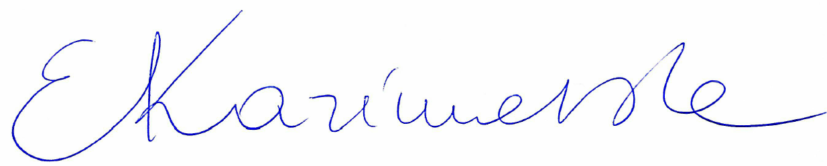.........................…… Date: 18/03/2024……..…….....……..
 |  | Survey | Review |  | Experiment |  | Development
1.Research-informed Literature
Introduction |  | /5 | /5 |  | /5 |  | 3/5
Literature Review |  | /20 | /35 |  | /20 |  | 6/15
Comments:
A good statement of the problem. Joseph started with a broad argument but did not refine it to more specific items. More background information is needed, for example blackbody radiation in this project should be discussed in more detail (definition, picture, etc).

The objectives say ‘what’ but they don’t say ‘why’ and ‘how’.
Is Objective 2 bringing anything new to the known facts about MTV or it is more literature review?
It is not clear to me what exactly is going to be simulated (Objective 4).

A good range of reference sources was visited but some statements remained unreferenced. There are also errors in the IEEE format.
 |  | Survey | Review |  | Experiment |  | Development
2. Knowledge and Understanding of Subject
Methodology |  | /5 | /5 |  | /5 |  | 3/5
Survey Design |  | /15 | - |  | - |  | -
Requirements/Design |  | - | - |  | - |  | 3/5
Comments:
There is no clear connection between the methodology and objectives. Applied equations are not discussed.
Compositions and parameters selected for modelling are described but not justified.

 | Survey |  |  | Review |  | Experiment |  | Development
3. Analysis
Results & Discussions | /25 |  |  | /25 |  | /25 |  | 10/25
Conclusions and Recommendations | /10 |  |  | /10 |  | /10 |  | 4/10
Why the temperature correction factor can be used to all compositions if it is based only on composition D?

If the results ‘are unlikely to be a true representation of the actual spectral output’, how would you improve the responses?

What new does the plot in Figure ? (all four predicted blackbody curves) bring that is not shown in the individual plots?
 | Survey |  |  | Review |  | Experiment |  | Development
4. Practical Application and Deployment
Development | - |  |  | - |  | - |  | 7/15
Experimental Design | - |  |  | - |  | /15 |  | -
How would you plan and conduct the real world testing?
Writing that ‘Data collection will be a simple process’ you are undermining your efforts with this sentence.
If the software is doing all the work, what is your share? It should be emphasised.
If you are going to produce ‘products of combustion’, the methodology for doing so is not described.

 | Survey |  |  | Review |  | Experiment |  | Development
5. Skills for Professional Practice
Reflection | /10 |  |  | /10 |  | /10 |  | 4/10
Quality of Report | /10 |  |  | /10 |  | /10 |  | 2/10
Comments:

Your reflection fits more the conclusion section. Reflection should be more personal, focused on the experiences (surprises, difficulties, etc) faced during the work on this project and how they changed you as a researcher.

There are many spelling, punctuation and grammatical errors. Some parts lack clarity. Too colloquial language, not suitable for this type of writing used occasionally. Using spell check such as Grammarly and asking a friend or colleague to read your report with a fresh eye would allow you to correct many of these mistakes.

Please see more specific comments provided within your project report submitted in Moodle.

TOTAL: | /100 |  |  | /100 |  | /100 |  | 42/100

