Module Code:
BMHP5021
Component 2: Written Report
Protecting and Supporting Families in Health and Care
Gazala Haroon
Student code: 2411422
Lecturer: Gillian weaver
Contents
Introduction 2
What is Early Help? 2
Multi-Agency Working 3
Website Analysis 4
Local Authority 1 — Leeds City Council 4
Local Authority 2 — Tower Hamlets Council 5
Local Authority 3 — Nottinghamshire County Council 6
Comparison 7
Conclusion 8
Recommendations 9
References 10

Introduction
Early Help refers to support provided to children, young people, and families at an early stage when difficulties first arise. The aim of Early Help is to prevent problems from becoming more serious and reduce the need for statutory intervention such as social care involvement (Department for Education, 2023). Early Help is important because many families experience challenges such as poverty, mental health issues, domestic abuse, and adverse childhood experiences (ACEs), which can negatively affect children’s development and wellbeing. Research shows that early intervention can improve outcomes for children and reduce long-term risks, including poor health, educational difficulties, and social exclusion (Okediji et al., 2024; NSPCC, 2023).
This report examines how three UK local authorities signpost Early Help services on their websites. The selected local authorities are Leeds City Council, Tower Hamlets Council, and Nottinghamshire County Council. These councils were chosen to provide a balanced comparison of different regions and populations.
The report will first explain Early Help and multi-agency working, followed by an evaluation of the three websites, a comparison of findings, and recommendations for improvement.

What is Early Help?
Early Help refers to support provided to children, young people, and families when problems first emerge, with the aim of preventing issues from becoming more serious. Early Help focuses on identifying needs at an early stage and providing appropriate support through coordinated services such as education, health, and social care (Department for Education, 2023). The Early Help approach is designed to improve outcomes for families and reduce the need for statutory interventions, including child protection services.
The purpose of Early Help is to support families experiencing challenges such as financial difficulties, mental health issues, parenting concerns, and social isolation. By providing timely support, professionals can reduce risks and improve children’s wellbeing and development. Early Help also promotes resilience in families and encourages collaboration between services to address complex needs (NSPCC, 2023).
Early intervention is particularly important because difficulties experienced in childhood can have long-term impacts. Research suggests that children exposed to early adversity are more likely to experience poor educational outcomes, mental health problems, and social exclusion later in life (CPD Certification Service, 2025). Therefore, providing support at an early stage helps prevent problems from escalating and improves long-term outcomes.
Early Help is closely linked to safeguarding because it aims to protect children from harm before risks become severe. Multi-agency professionals work together to identify concerns and provide appropriate support to ensure children remain safe and healthy (Department for Education, 2023).
Early Help is also connected to Adverse Childhood Experiences (ACEs). ACEs include experiences such as abuse, neglect, domestic violence, and parental substance misuse. These experiences can negatively affect children’s health and development. Research highlights that early intervention and family support can reduce the impact of ACEs and improve children’s long-term outcomes. Therefore, Early Help plays a crucial role in supporting families and preventing long-term harm.

Multi-Agency Working
Multi-agency working refers to professionals from different organisations working together to support children, young people, and families. These professionals may include teachers, social workers, health visitors, police officers, and other support services. Multi-agency working aims to share information, identify risks early, and provide coordinated support to families. This approach is an important part of safeguarding children and improving outcomes for families (Department for Education, 2023).
Professionals work together because families often experience multiple challenges that cannot be addressed by one service alone. For example, a child experiencing poor school attendance may also face mental health difficulties, family conflict, or financial hardship. When professionals collaborate, they can share knowledge and develop a more effective support plan. Multi-agency working also reduces duplication of services and ensures families receive the right support at the right time (HM Government, 2023).
Examples of multi-agency working include schools working with social workers to support children at risk, health visitors identifying developmental concerns in young children, and family support workers helping parents access community services. For instance, a teacher may notice changes in a child’s behaviour and refer the family to Early Help services. A social worker and health visitor may then work together to assess the family’s needs and provide appropriate support.
Multi-agency working is closely linked to Early Help because Early Help relies on professionals working together to identify problems early and prevent escalation. The Working Together to Safeguard Children 2023 guidance highlights that effective safeguarding depends on strong partnership working between agencies to protect children and support families (Department for Education, 2023). Therefore, multi-agency working is essential for delivering effective Early Help services.

Website Analysis

Local Authority 1 — Leeds City Council
Leeds City Council provides Early Help information through its children and families and safeguarding webpages. The website explains that Early Help is support offered to children, young people, and families when problems first emerge, with the aim of preventing issues from becoming more serious. Leeds promotes a graduated Early Help approach, which includes universal services such as schools and health services, as well as targeted support through family hubs and specialist services (Leeds City Council, 2024). The website also highlights that Early Help is voluntary and focuses on providing the right support at the right time to improve outcomes for families.
One strength of the Leeds City Council website is that it clearly explains the Early Help approach and provides accessible information for families. The website outlines available services such as family hubs, children’s centres, and cluster services, which help families access support easily. In addition, Leeds emphasises multi-agency working, showing that different professionals collaborate to support families effectively.
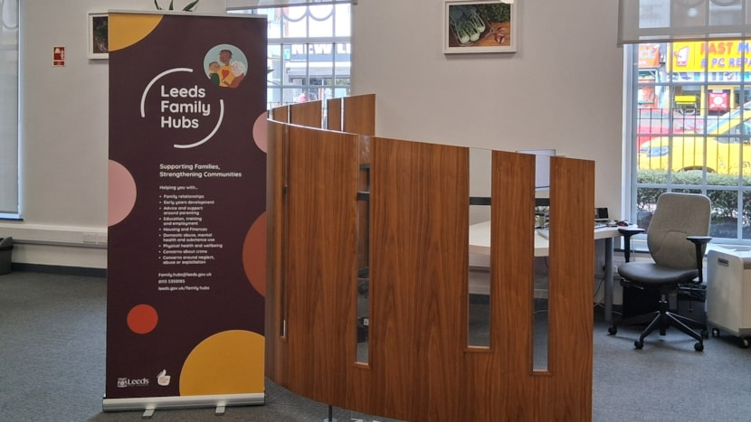
Figure 1:Leeds Family Hub delivering early help and multi-agency support for children and families (Leeds City Council, 2024).

Another strength is that Leeds provides contact information and referral guidance, making it easier for families and professionals to access services. The launch of family hubs across Leeds also improves accessibility by bringing multiple services together in one place (Leeds City Council, 2025).
However, a weakness of the Leeds website is that some information is spread across multiple pages, which may make navigation difficult for families unfamiliar with the system. Additionally, some sections are written in professional language, which may not be easy for all families to understand.

Local Authority 2 — Tower Hamlets Council
Tower Hamlets Council provides Early Help information through its Early Help and Children and Family Service webpages. The website explains that Early Help provides support to families early to prevent problems from becoming more serious. Services are delivered through family hubs and children and family centres, supporting children from pregnancy to 19 years old, or up to 25 years for young people with special educational needs and disabilities (Tower Hamlets Council, 2024).
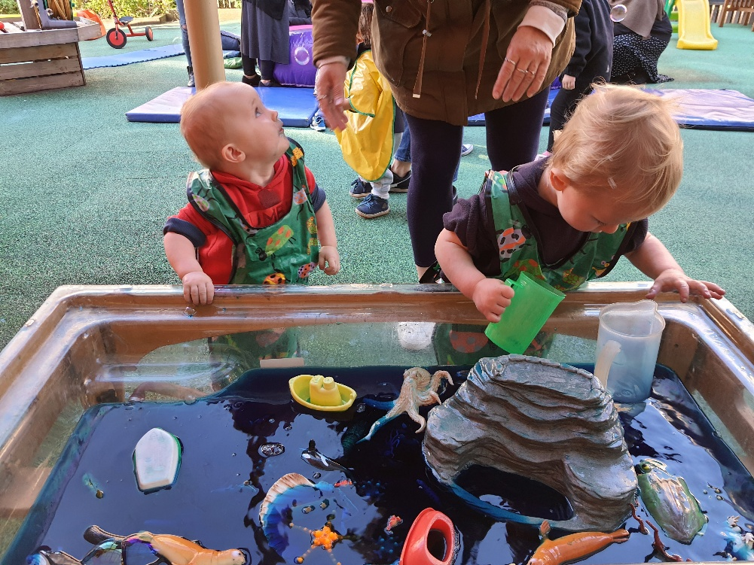
Figure 2:Children engaging in play-based learning at a Children and Family Centre providing early help support (Tower Hamlets Council, 2024).
A key strength of the Tower Hamlets website is that it clearly identifies who Early Help services are for and how families can access support. The website also outlines a range of support areas, including housing issues, emotional wellbeing, parenting support, financial difficulties, and family breakdown. This helps families understand the types of support available (Tower Hamlets Council, 2024).
Another strength is that Tower Hamlets promotes coordinated multi-agency working. The Early Help hub provides advice, guidance, and assessment to ensure families receive the right level of support. The Early Help assessment also helps professionals identify risks early and develop individual support plans.
However, a weakness of the Tower Hamlets website is that some pages contain limited detail about referral pathways. Additionally, navigation between family hub services and Early Help information may be confusing for some users, particularly those unfamiliar with local authority services.

Local Authority 3 — Nottinghamshire County Council
Nottinghamshire County Council provides Early Help information through its family services and Early Help webpages. The website explains that Early Help services provide support to children and families to address problems before they escalate. Families can access support through family hubs, targeted Early Help services, and safeguarding teams (Nottinghamshire County Council, 2024).
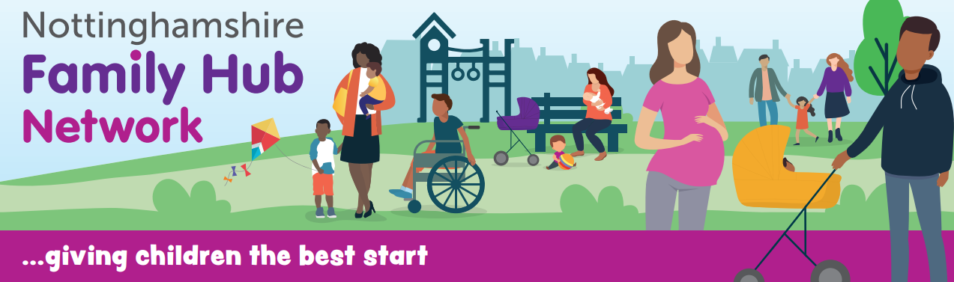
Figure 3:Children and families accessing early help support through play-based activities in a Nottinghamshire Family Hub (Nottinghamshire County Council, 2024).
One strength of the Nottinghamshire website is that it provides clear referral pathways. Families and professionals can contact the Early Help unit directly, which makes access to services easier. The website also outlines the types of support available, including parenting support, behaviour concerns, and family conflict. This helps families understand how Early Help can support them (Nottinghamshire County Council, 2024).
Another strength is that Nottinghamshire promotes a preventative approach to family support. The website highlights that Early Help aims to provide the right support at the right time and improve outcomes for children and families. This aligns with national safeguarding guidance and Early Help principles.
However, a weakness of the Nottinghamshire website is that some information is designed mainly for professionals rather than families. This may make it harder for families to understand how to access services. Additionally, the website contains fewer visual resources compared to other councils, which may reduce accessibility for some users.

Comparison
The three local authority websites—Leeds City Council, Tower Hamlets Council, and Nottinghamshire County Council—provide Early Help information, but they differ in accessibility, clarity, and the level of detail provided. All three councils follow national safeguarding guidance by promoting early intervention and multi-agency working. This aligns with Working Together to Safeguard Children 2023, which emphasises partnership working and early identification of need to support families effectively (Department for Education, 2023).
Leeds City Council demonstrates strong practice by clearly explaining Early Help services and outlining how families can access support. The website also highlights multi-agency working and provides information about family hubs and local services. This makes it easier for families to understand available support. Tower Hamlets also provides detailed information and explains the types of support available, such as parenting support, housing assistance, and emotional wellbeing services. Nottinghamshire County Council provides clear referral pathways and explains how professionals and families can access Early Help services.
However, each website also has weaknesses. Leeds City Council’s information is sometimes spread across multiple pages, which may make navigation difficult. Tower Hamlets provides detailed information, but some referral processes are not clearly explained. Nottinghamshire County Council’s website contains more professional language, which may make it harder for families to understand.
In terms of accessibility, Leeds City Council appears to be the most user-friendly. The website provides structured information, clear headings, and accessible language. Tower Hamlets provides detailed information but may require more navigation. Nottinghamshire provides clear referral information but fewer visual resources.
Overall, Leeds City Council provides the most effective Early Help information. The website clearly explains services, promotes multi-agency working, and provides accessible support information, which aligns with national safeguarding guidance (Department for Education, 2023).

Conclusion
This report evaluated how Leeds City Council, Tower Hamlets Council, and Nottinghamshire County Council signpost Early Help services on their websites. All three councils provide useful information and promote early intervention and multi-agency working to support families. However, there were differences in accessibility, clarity, and navigation. Leeds City Council provided the most clear and accessible information, with structured content and easy-to-understand language. Tower Hamlets offered detailed support information but required more navigation, while Nottinghamshire provided clear referral pathways but used more professional language. Overall, Leeds City Council was the most effective because it provided clear, accessible, and comprehensive Early Help information.

Recommendations
Local authorities should improve Early Help website accessibility by using clear language, simple navigation, and visual guides to help families find support quickly. Providing a single Early Help page with clear contact details and referral pathways would improve access to services. In addition, councils should include translated information and accessibility tools to support diverse communities. This aligns with Working Together to Safeguard Children 2023, which highlights the importance of accessible information and multi-agency collaboration to support families effectively (Department for Education, 2023). Improving website clarity and accessibility would help families access Early Help earlier and prevent problems from escalating.

References
CPD Certification Service (2025) Understanding adverse childhood experiences (ACEs) and their impact on behaviour and development.
Available at: https://www.cpduk.co.uk/news/understanding-adverse-childhood-experiences-aces-and-their-impact-behaviour-and-development (Accessed: 23 March 2026).
Department for Education (2023) Working Together to Safeguard Children. London: HM Government.
Available at: https://www.gov.uk/government/publications/working-together-to-safeguard-children (Accessed: 22 March 2026).
Edwards, R., Gillies, V. and White, S. (2019) Adverse Childhood Experiences – Implications and Challenges. Social Policy & Society. Cambridge University Press.
Available at: https://www.cambridge.org/core/journals/social-policy-and-society (Accessed: 21 March 2026).
HM Government (2023) Working Together to Safeguard Children: Statutory Guidance. London: HM Government.
Available at: https://www.gov.uk/government/publications/working-together-to-safeguard-children (Accessed: 24 March 2026).
Leeds City Council (2024) Early Help services. Leeds City Council.
Available at: https://www.leeds.gov.uk/one-minute-guides/early-help (Accessed: 20 March 2026).
Leeds City Council (2025) New family hubs launched in Leeds to boost support for those in need of early help. Available at: https://news.leeds.gov.uk/news/new-family-hubs-launched-in-leeds (Accessed: 22 March 2026).
Local Government Association (2022) Family hubs and early help: an overview. London: Local Government Association.
Available at: https://www.local.gov.uk/sites/default/files/documents/Family%20hubs%20and%20Early%20Help%20an%20overview.pdf (Accessed: 23 March 2026).
Nottinghamshire County Council (2024) Early Help services.
Available at: https://www.nottinghamshire.gov.uk/care/family-hub-networks/families (Accessed: 22 March 2026).
NSPCC (2023) Early help and early intervention. NSPCC.
Available at: https://learning.nspcc.org.uk/safeguarding-child-protection/early-help-and-early-intervention (Accessed: 25 March 2026).
NSPCC (2023) Multi-agency safeguarding arrangements.
Available at: https://learning.nspcc.org.uk/child-protection-system/multi-agency-working-child-protection (Accessed: 21 March 2026).
Okediji, P., Troy, D. and Heron, J. (2024) ‘Exploring the associations between adverse childhood experiences (ACEs) and adolescent risk behaviours’, BMC Public Health, 24, pp. 1–12.
Available at: https://bmcpublichealth.biomedcentral.com (Accessed: 20 March 2026).
Tower Hamlets Council (2024) Early Help support.
Available at: https://www.towerhamlets.gov.uk/lgnl/health__social_care/children_and_family_care/Early_Help/About_Early_Help.aspx (Accessed: 24 March 2026).
Tower Hamlets Council (2024) What help can I get from my local children and family centre? Available at: https://www.towerhamlets.gov.uk/lgnl/health__social_care/children_and_family_care/Early_Help/Children-and-Family-Centres/What-help-can-I-get-from-my-local-children-and-family-centre.aspx (Accessed: 23 March 2026).

