Critical Evaluation of the Organisational Structure of Hilton Hotel Group

Student name: Simona Militaru
Student ID: 2214268
Lecturer Name: Lola Villard-Coles
Module Name: Management and Organisational Behaviour (BMIH5004)

Executive summary
This report critically analysed the strategic initiatives undertaken by the Hilton Hotel group to maintain its leadership position in the global hospitality industry. Focusing on factors such as digital transformation, sustainability, health, safety protocols, employee development and brand innovation, this enterprise had effectively managed changes to further enhance the pre-existing level of guest satisfaction and operational efficiency to the utmost possible extent. Through the implementation of different advanced technologies and programs, Hilton Hotel group demonstrated a strong commitment to environmental stewardship as well as social responsibilities. This report critically evaluated the way the strategic direction of Hilton capitalizes on its unique resources in the later parts of this report. It also highlighted the capabilities to sustain competitive benefits. All these factors ensure long-term growth and success for the brand in this competitive global hospitality industry.
Table of Contents
Introduction 4
Main body 4
Organisation structure 4
Organisational culture 6
Organisational goals 8
Recent change initiatives 9
Impact of the change initiatives 11
How well these were managed 12
Organisational strategic direction 13
Conclusion 13
Recommendation 14
Reference list 15

Introduction
The Hilton Hotel Group, a global leader in the hospitality industry, provides a robust context for examining the key aspects of organisational dynamics along with managerial practices. Initially, it will critically analyse the intricate relationship between structure, culture, people and performance. Understanding these factors is essential to appreciate the way the brand maintains its competitive edge while achieving high service standards across its global operations. This report also delves into the crucial nature of managerial work at Hilton. It will examine both the functions and processes associated with the brand; it will communicate the pivotal role of leadership within the organisation while elucidating the variables that contribute to effective management. This includes an analysis of the way leadership strategies at Hilton Groups drive organisational success and adaptability in a dynamic market. This report will also evaluate the behavioural approach to management by understanding the factors that influence individual behaviour within Hilton. By exploring these outcomes, this report will provide a comprehensive understanding of the m, managerial and organisational practices that underpin the sustained success of Hilton in this competitive hospitality sector.

Main body

Organisation structure
The Hilton Group has a hierarchical organisational structure, designed to support its expansive global operations. This structure ensures efficient decision-making. It also assists the brand to maintain high service standards across all its properties around the globe. At the top, the corporate headquarters houses the executive leadership teams, led by the CEO. This team includes senior executives responsible for strategic decisions (Hilton.com, 2024). It also includes the overall direction and corporate governance teams. Functional departments such as marketing, HR, IT, finance and legal provide centralised support and services to entire enterprises, below the corporate level. Hilton is divided into regional divisions managed by the Regional president and vice presidents. These leaders oversee operations within specific geographic areas. These individuals ensure regional alignment with corporate strategies while managing regional performance. They are supported by regional support teams who offer specialised assistance in areas such as sales, marketing and operations (Reidhead, 2020). These activities are tailored to the needs of the hotels within the specific region.
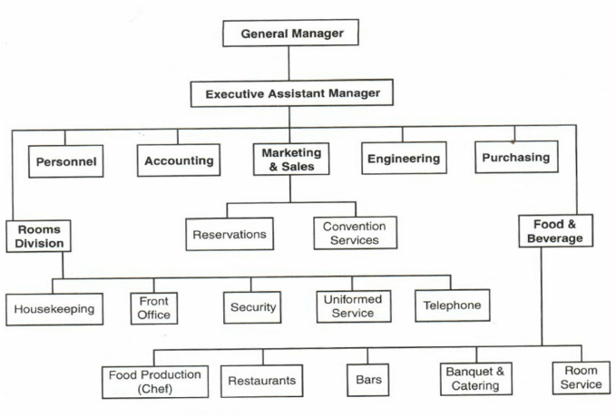
Figure 1: organisational structure
(Source: Guided by Reidhead, 2020)
The brand management structure of the Hilton Group features dedicated team leaders for each of its distinct brands. This is inclusive of the Hilton Hotels and Resorts, Double Tree and Embassy Suites. These leaders focus on brand-specific strategies standards and performances. These individuals are supported by the brand teams responsible for maintaining brand consistency and driving innovation (Zientara et al. 2020). They also enhance the pre-existing level of customer experience across all properties within these respective brands. At the property level, each of the hotels is managed by a general manager who is responsible for overseeing day-to-day operations. They also take care of guest satisfaction and financial performance. Within each hotel, department heads lead specific areas such as front office, housekeeping, food and beverage along with engineering. These individuals respite directly to the general manager of the brand. Frontline employees take the initiative of delivering direct services to guests. That way they ensure the operational execution of the standards and practices of Hilton (Maclean et al. 2024). This hierarchical structure allows the brand to tactfully balance centralised strategic control with decentralised operational flexibility. This balance enables the brand to efficiently manage its diverse portfolio of properties from a global perspective.

Organisational culture
The organisational culture of the Hilton Hotel Group is deeply rooted in its commitment to hospitality along with other factors such as customer service and employee engagement, the culture of the brand is built on its foundational values that include integrity, teamwork, leadership and a commitment to continuous improvements (Toksöz, 2021). These values are embedded in every aspect of the operations of the enterprise. They are reflected in the behaviour and attitude of its employees. It has been highlighted that Hilton emphasises delivering exceptional guest experiences and the culture of the brand encourages employees to go above and beyond to meet and exceed guest expectations. This customer-centric approach is supported by extensive training programs
These programs equip the staff with the skills and knowledge necessary to provide high-quality services. The “Make It Right” policy of Hilton Group employs the employees to resolve issues effectively. This ensures optimistic experiences for all the guests. Hilton is also committed to fostering an inclusive and supportive work environment. The company values diversity and inclusion. This assists the brand to recognise that a diverse workforce brings a variety of perspectives that drive innovation (Maclean et al. 2020). These initiatives undertaken by Hilton include employee resource groups along with other factors such as diversity training and inclusive hiring practices. This commitment to inclusion extends to creating a supporting organisational atmosphere where the employees can feel valued. This, in turn, enhanced the pre-existing level of job satisfaction and performance.
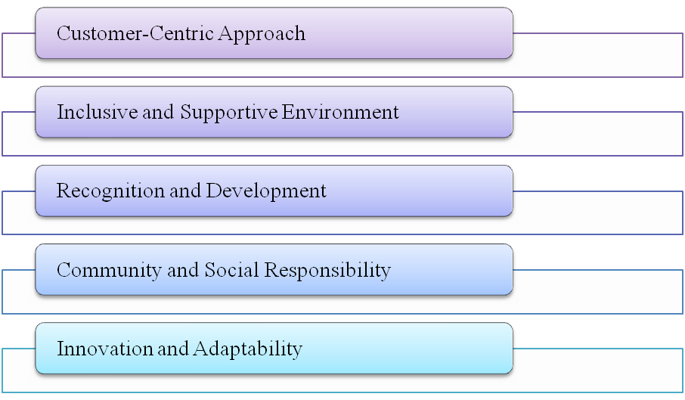
Figure 2: Key factors of the organisational culture of the Hilton Hotel groups
Employee recognition and development is another jetty competent of the organisational culture of Hilton. The company regularly acknowledges and rewards employees for their hard work and contribution through different recognitions such as “Catch me at My Best” initiatives Furthermore, the brand also invests in employee development through continuous learning opportunities and leadership development programs (Griffin, 2022). This focus on development helps the employees of the Hilton Hotel Group to grow within the enterprise while contributing to a high level of employee engagement and retention. Additionally, the culture of Hilton emphasises CSR and community involvement. The company is committed to sustainability and has set ambitious goals to reduce its environmental footprint through initiatives such as “Travel with Purpose”.
The brand encourages employees to participate in community services and voluntary activities. This fosters a sense of pride and purpose among staff. These efforts benefit the community in which Hilton operates and strengthen the bond between the company and all its employees. Lastly, Innovation and adaptability are integral to the culture of Hilton (Ertuna et al. 2022). The enterprises encourage a mindset of continuous improvement and innovation. It is evident in the adoption of new technology in Hilton along with innovative service offerings and its responsiveness to market trends and customer feedback by fostering a culture that embraces change and innovation, Hilton ensures that the brand remains a leader in the competitive hospitality sector.

Organisational goals
The pre-determined set of organisational goals of the Hilton Hotel Group aims to sustain leadership in the global hospitality industry while achieving sustainable growth. These goals include delivering exceptional guest experiences through enhanced service quality and innovation. This assists the brand to expand their global presence by opening new opportunities. It also assists the brand to tactfully develop a distinctive brand image (Ponting, 2020). It has been critically analysed that the Hilton Hotel Group also focuses on operational excellence by optimising efficiency and leveraging advanced technologies. Moreover, employee engagement and development have been crucial, with efforts to attract, retain and develop top organisational talents. CSR has been integral for the brand as well, with its commitments to sustainability and community services. The company takes the initiative of prioritising innovation along with adapting to stay ahead of the pre-determined industrial trends while meeting changing market demands. Financial performance goals include consistent revenue growth, profitability and strategic cost management (Shin et al. 2021). By pursuing these objectives, the Hilton Hotel Group aims to maintain its competitive edge while providing superior guest values. This superimposes an optimistic impact on all the organisational employees along with the respective operational communities.

Recent change initiatives
The brand has recently undertaken several change initiatives to further enhance its operations while adapting to industrial trends and meet evolving customer expectations. One major area of focus is digital transformation (Gürlek and Kılıç, 2021). Hilton has implemented contactless technologies such as digital check-ins and digital key services. This offered a comparatively safer and more convenient guest experience. Additionally, the “Hilton Honours” app has been updated with more features and personalised services such as room selection and other on-demand services. Sustainability has been another key initiative for Hilton. The brand has set ambitions to travel with purpose 2030 goals to tactfully reduce its environmental footprint. These goals include reducing carbon emissions, water usage and waste reduction while boosting the utilization of suitable renewable energies (Hughes, and Christensen, 2021). Hilton also expanded its soap recycling program, through our partnership with “Clean The World”. This easy brand recycles used soaps and distributes them to communities in need.
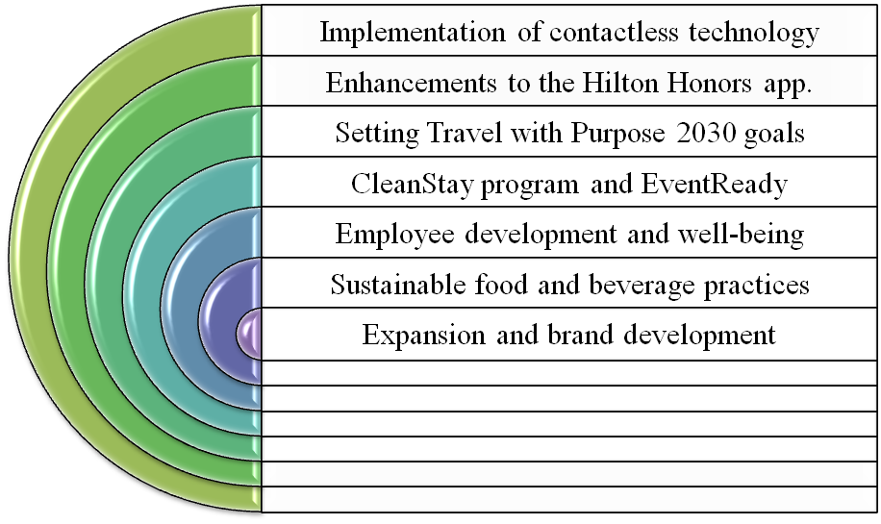
Figure 3: Recent change initiatives at the Hilton Hotel Group
Hilton also introduced the “CleanStay program” in response to the Covid-19 pandemic. It featured enhanced cleaning protocols and sanitization practices to ensure guest safety. Hilton also focused on employee development and well-being (Farrell, 2022). The company has revamped its Team member value propositions to include enhanced benefits. The brand also launched diversity and inclusion initiatives, for example, unconscious bias training, diverse hiring practices and support from employee resource groups. The company has added more plant-based menu options to cater to changing dietary preferences while reducing the environmental impact. Lastly, Hilton continues to expand its global footprint by opening new opportunities in key markets and developing new brands to cater to diverse customer segments (Bibi et al. 2022). Existing brands have also undergone refreshes to remain relevant and appealing to modern travellers. This incorporates contemporary design elements and updates service offerings.

Impact of the change initiatives
These change initiatives have significantly impacted the operations of the brand. Based on the principles of Rogers’ Diffusion of Innovation theory, the implementation of digital transformation initiatives enhanced guest convenience along with operational efficiency to the utmost possible extent (Helmold and Helmold, 2020). Similarly, the sustainability efforts resonated with the stakeholder theory and reflected the commitment of Hilton to social and environmental responsibilities. This played a crucial role in improving the pre-existing level of brand loyalty and corporate reputation (Ergashev and Berdiev, 2020). The principles of Herzberg’s Two-factor theory aligned with the CleanStay program, which addressed hygiene as a fundamental guest expectation. This played a key role in preventing dissatisfaction.
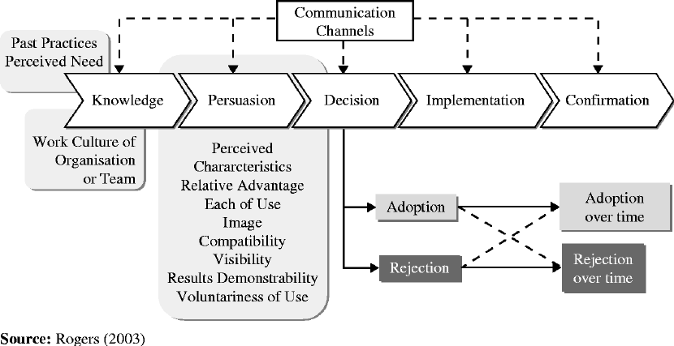
Figure 4: Rogers’ Diffusion of Innovation Theory
(Source: Guided by Ergashev and Berdiev, 2020)
Moreover, the employee-focused initiatives such as enhanced benefits and diversity programs were in line with the principles of Maslow’s hierarchy of needs. This promoted higher employee engagement while motivating them by addressing factors such as safety, belonging and self-actualisation needs (Wang et al. 2020). Lastly, sustainable food practices and brand refreshes cater to contemporary consumer preferences. This has been supported by different market positioning strategies. As a result, these initiatives fostered a resilient adaptive and socially responsible enterprise. This led to the amplification of the pre-existing level of guest satisfaction along with other crucial factors such as employee retention and long-term profitability.
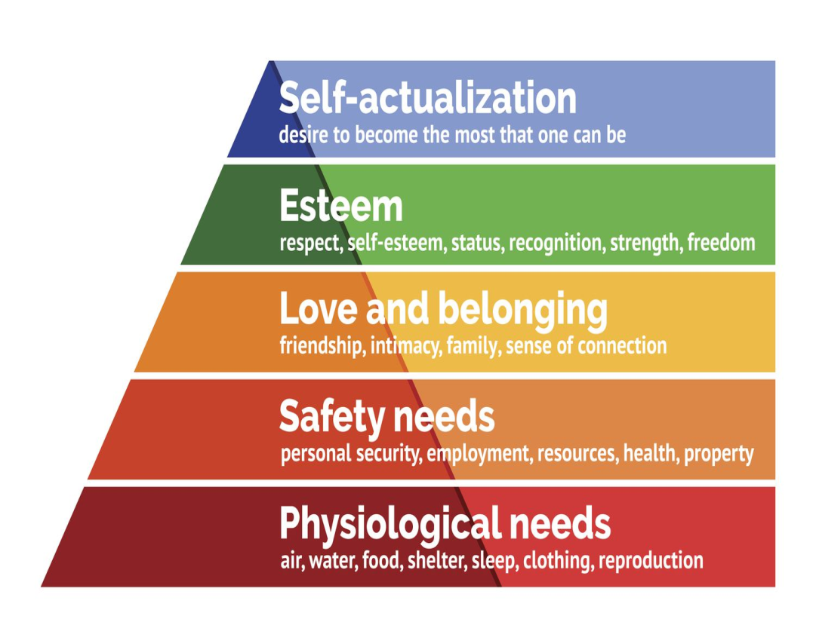
Figure 5: Maslow’s hierarchy of needs
(Source: Guided by Wang et al. 2020)

How well these were managed
The brand has managed these change initiatives effectively. This demonstrated tactful strategic planning and execution. The digital transformation initiatives were rolled out seamlessly, with the Hilton Honour app updated and contactless services implemented effectively (Ruiz Molina et al. 2022). Sustainability efforts such as Travel with Purpose 2030 goals and soap recycling programs were well-coordinated across the enterprises. All these factors fostered employee and stakeholder engagement. The implementation of health and safety protocols under the CleanStay program ensured compliance with regulatory requirements while maintaining guest satisfaction. The sustainable food practices and brand refreshes were strategically executed as well. This aligned with the market trends and consumer preferences (El-Said et al. 2024). Consequently, Hilton's management of these change initiatives reflected a high level of competence, adaptability and commitment to achieving strategic objectives in this competitive business landscape.

Organisational strategic direction
The strategic decision of the brand aligned with a market-driven approach. This emphasised factors such as innovation, sustainability and stakeholder engagement. This reflected elements of the Resource-Based View theory, suggesting that sustained competitive benefits come from leveraging unique resources and capabilities (Ma, 2021). The Hilton group capitalised on its strengths to tactfully differentiate itself in the market. This strategic direction demonstrated a commitment to creating value for both guests and stakeholders while maintaining a competitive edge in this competitive hospitality industry.

Conclusion
To culminate, The Hilton Hotel group set its authority in the worldwide friendliness industry through essential drives. These drives centre on advanced change, supportability, well-being and security. Extra factors, for example, worker improvement and brand development were related too. These endeavours, utilized the one-of-a-kind strength of their image to additional improve factors, for example, visitor experience while advancing corporate obligations and guaranteeing long-haul intensity. By focusing on advancement, ecological stewardship and partner commitment, Hilton is strategically set up for supported development around here scene that is progressively acquiring seriousness as time passes.

Recommendation
For effective change management in Hilton Hotels clear definition of the strategy of change and awarding the employees and leaders about the need for change is necessary for successful change implementation. A balance needs to be maintained between operations and change so that change does not affect customer service quality (Wang et al. 2020). Apart from this using data-driven decision-making for change identification through needs assessment is necessary so that the needs of the organisation are met. In this regard, Hilton can use predictive analytics and deep learning to develop simulation models of different business situations which can give them an idea of impending risks and challenges based on how the organisation can implement change (El-Said et al. 2024).

Reference list
Bibi, S., Khan, A., Hayat, H., Panniello, U., Alam, M. and Farid, T., 2022. Do hotel employees really care for corporate social responsibility (CSR): a happiness approach to employee innovativeness. Current Issues in Tourism, 25(4), pp.541-558.
El-Said, O.A., Elhoushy, S., Smith, M. and Youssif, M., 2024. Crisis-driven innovation in hospitality: How do international hotel chains innovate to recover from a global crisis?. International Journal of Hospitality Management, 120, p.103758.
Ergashev, T.K. and Berdiev, J.Q., 2020. THEORETICAL AND PRACTICAL ASPECTS OF USING MODERN MANAGEMENT METHODS IN THE HOTEL INDUSTRY. Theoretical & Applied Science, (4), pp.849-859.
Ertuna, B., Gu, H. and Yu, L., 2022. “A thread connects all beads”: Aligning global CSR strategy by hotel MNCs. Tourism Management, 91, p.104520.
Farrell, K., 2022. Transformational Leadership for the Hospitality and Tourism Industry. In Humanistic Perspectives in Hospitality and Tourism, Volume 1: Excellence and Professionalism in Care (pp. 273-292). Cham: Springer International Publishing.
Griffin, R.W., 2022. Fundamentals of management. Cengage Learning, Inc..
Gürlek, M. and Kılıç, İ., 2021. A true friend becomes apparent on a rainy day: corporate social responsibility practices of top hotels during the COVID-19 pandemic. Current Issues in Tourism, 24(7), pp.905-918.
Helmold, M. and Helmold, M., 2020. Total revenue management (trm) (pp. 1-12). Springer International Publishing.
Hilton.com 2024. About us. Available from: https://www.hilton.com/en/ [Accessed on: 27/05/2024]
Hughes, J.C. and Christensen, J.D., 2021. Talent management innovation in a time of unprecedented disruption: implications for practice and research. In Talent Management Innovations in the International Hospitality Industry (pp. 153-179). Emerald Publishing Limited.
Ma, R., 2021. Human resource management in multinational companies——from the perspective of Hilton Hotels. In E3S Web of Conferences (Vol. 235, p. 02058). EDP Sciences.
Maclean, M., Harvey, C. and Suddaby, R., 2020. Institutional entrepreneurship and the field of power: The emergence of the global hotel industry. In Historical Organization Studies (pp. 149-169). Routledge.
Maclean, M., Harvey, C. and Suddaby, R., 2024. Institutional biography and the institutionalization of a new organizational template: Building the global branded hotel chain. Business History, 66(1), pp.311-339.
Ponting, S.S.A., 2020. Organizational identity change: impacts on hotel leadership and employee wellbeing. The Service Industries Journal, 40(1-2), pp.6-26.
Reidhead, C., 2020. Impact of organizational culture on employee satisfaction: A case of Hilton hotel, United Kingdom. Journal of Economics and Business, 3(1).
Ruiz Molina, M.E., Belda-Miquel, S., Hytti, A. and Gil-Saura, I., 2022. Addressing sustainable food management in hotels: proposing a framework and examining hotel groups. British Food Journal, 124(2), pp.462-492.
Shin, H., Sharma, A., Nicolau, J.L. and Kang, J., 2021. The impact of hotel CSR for strategic philanthropy on booking behavior and hotel performance during the COVID-19 pandemic. Tourism Management, 85, p.104322.
Toksöz, S., 2021. Impact of engagement exist in organisations’ internal environment on employees’ motivation, satisfaction, commitment and turnover intention. In E3S Web of Conferences (Vol. 258, p. 10010). EDP Sciences.
Wang, C., Hu, R. and Zhang, T.C., 2020. Corporate social responsibility in international hotel chains and its effects on local employees: Scale development and empirical testing in China. International Journal of Hospitality Management, 90, p.102598.
Zientara, P., Bohdanowicz-Godfrey, P., Whitely, C. and Maciejewski, G., 2020. A case study of LightStay (2010–2017)—Hilton’s corporate responsibility management system. Energies, 13(9), p.2303.

