How to create a chart in Excel

- Open Microsoft Excel

- Open NEW Blank Workbook
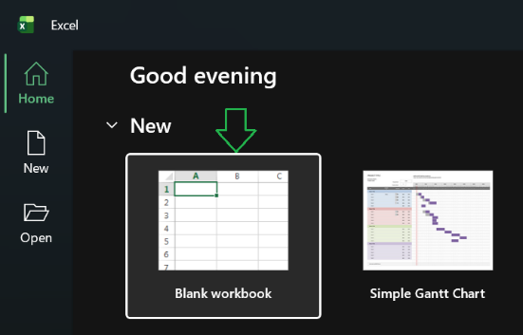
- Add information in Excel for
your future chart
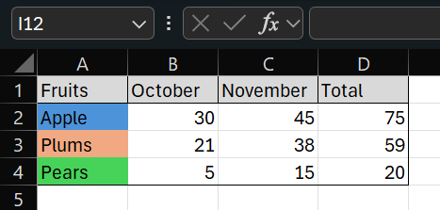
- Select All information
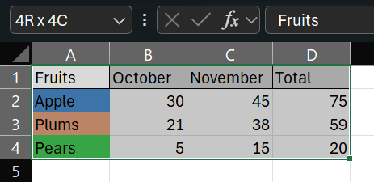
Two ways create charts (choose one):

- 1) Click “Insert” on the Tab
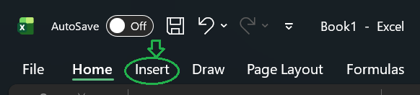
2) Choose one of the charts ( in the middle of the ribbon)
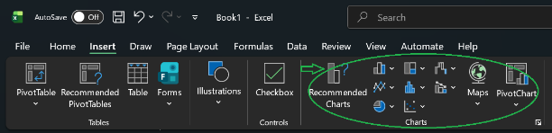
5.1. 1) Quick analysis (Right on the bottom your information) or use shortcut (Ctrl+Q)
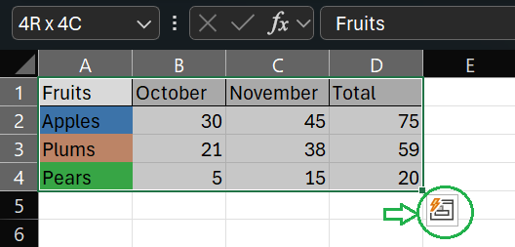
2) Click on “Chart”
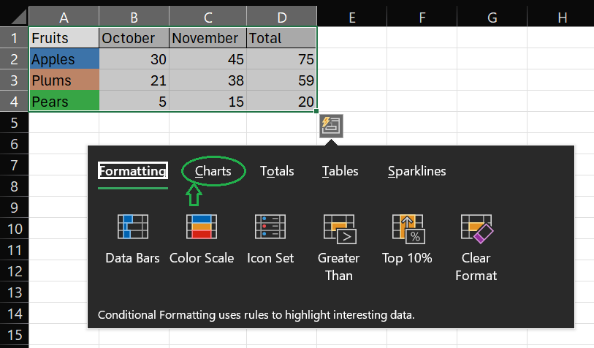
3) Choose one of the charts
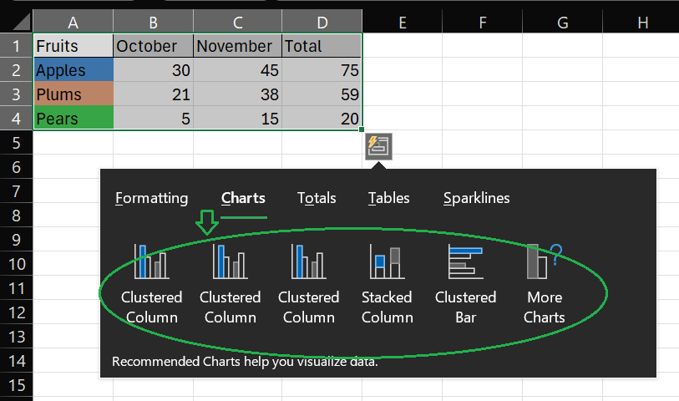
- Create chart
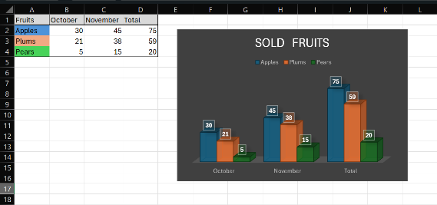
- Change name a workbook
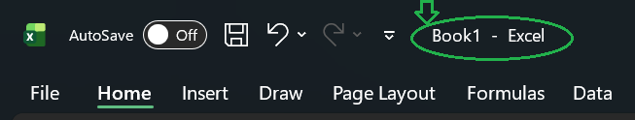
- Save workbook
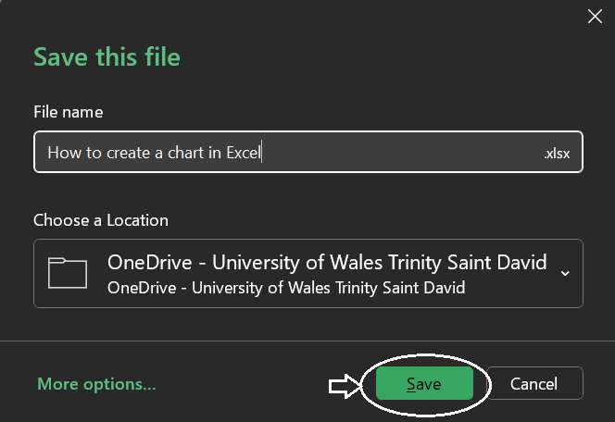
- Done

