Game Design and critical analysis

Unreal Engine 4's Sequencer

Source Film Maker

By Joseph Kenyon
P141089

Abstract
Unreal engines sequencer will be compared to Valves source film maker, this will be an ease of use test using the UI (User Interface) and using help from the respectable community’s, this and using the same type of objects, characters and maps will make this a fair test.
Unreal is easier to use, as getting custom characters and objects into the scene is just a simple export of an FBX, whereas source film maker uses a different system that didn’t work on the university computers. Trying to find things in source film maker is also a difficult task.

Table of Content
Abstract 2
Introduction 5
Literature Review 6
Methodology 7
FINDINGS 8
Source Film Maker 8
Unreal 11
Results 13
Conclusion 16
Further work 17
Bibliography 18
Appendix 19

Introduction
Unreal engine 4 will be compared for an ease of use test with Valves Source film maker. This will consist of looking at which one is easier to use by testing how long objects take to find and trying to add an object or character to the scene. Testing out the cameras to see which one is easier to use or better than the other.
This will also be made into a fair test by using the same sort of map. As the map creator for source film maker did not work which made it so that a map from the Steam community page was needed and it had to be similar to the one that is ready made in unreal. The characters also have to be the same so that the character aspect of the test can also be the same.

Literature Review
Source Film Maker or SFM for short is an animation software for making cinematics for games. Made by Valve, SFM has all of Valves assets which includes characters, effects and lighting. Everything that is needed to make an animation straight away is on SFM. SFM also comes with some animations for the characters that are already in source film maker that can be used and tweaked. Key framing in motions also works so custom animation is possible without having to use different software. There is also a competition called Saxxy Awards that people can upload there animations and win something if they have the most votes.
Unreal Engine 4’s (UE4) Sequencer is also for making cinematics in games, however, Unreal Engine is not just for animation there are many other uses for it. It is the animation side of this engine that is going to be looked at. Sequencer in the unreal engine is used by importing a character that has been made in a different program, same with the animations. This is good because custom characters can be made and put in.
The benefit of using in game engine for animation is a lot less of a hassle too. Instead of having to render something out for a long time, all that is needed is a quick drag and drop of the game engines assets. This has no render time so there is no need to wait for long periods. This doesn’t make them better to use, Unreal Engine 4’s sequencer does not have any characters or animations that are useable right at the start so animations and models will have to be imported in to the engine. Source Film Maker on the other hand has many animations, models and others so animation can start as soon as it is loaded up.
Both of these programs can be used to make cinematics for games. These cinematics are normally small clips within the game that are there after an event has happened, because these are made in engine there wouldn’t be long loading screens to render the short seen.

Methodology
To make this test fair the same map and characters will be used on both Unreal Engine and Source Film Maker. There will be a few tests for ease of use, actually getting the characters and assets into the scene. How long that will take and if there will be any research that will need completing so that they can be put into the scene. How easy / hard the interface is, lighting and camera placements will also be tested and moved around. (The maps used will be shown in the appendix as 1 and 2)

FINDINGS

Source Film Maker
Opening up Source Film Maker and getting started is easy enough, starting with opening up steam and logging in is the only way to get on it, almost the same as the Unreal Engine 4. Having to log in on that too. Once on it, Source Film Maker pops up with a window asking where the animation is going to be stored, it also asks for the name and what the Frame rate is going to be or just open one of Valves own animations to manipulate, different animations and characters can be added to the scene to make it completely different to what it was.
After creating a new scene there is a black screen with red lettering saying “no map loaded” right clicking this and loading a map allows assets and props to be added in the scene, there are many maps to pick from and also custom made ones already on Source Film Maker. This makes it easier to get started straight away. If you are a novice and know nothing about Source Film Maker then there is a help button that is useful and gives pointers, however just going to the steam community usually helps as there are many people who use Source Film Maker so just asking can be beneficial. (Developer.valvesoftware.com, 2015)
The UI is quite simple as there isn’t really much there, there are three windows. The left windows is an animation set editor and an element viewer. The animation set editor shows what is in the scene and keeps track of everything in there, whether it needs to be deleted or cannot be found this helps find it. The animation set editor is used so that animations, props, characters and many more things can be put into the scene. The other window is not only just a view point it also can create cameras these cameras can be moved and made to whatever is needed like a wide shot to a close-up this window also has the standard play, pause, record and multiple skip buttons.
The last window is the timeline this is the main part of Source Film Maker. Image 1 below shows the UI and how simple it is to use.
Image 1.
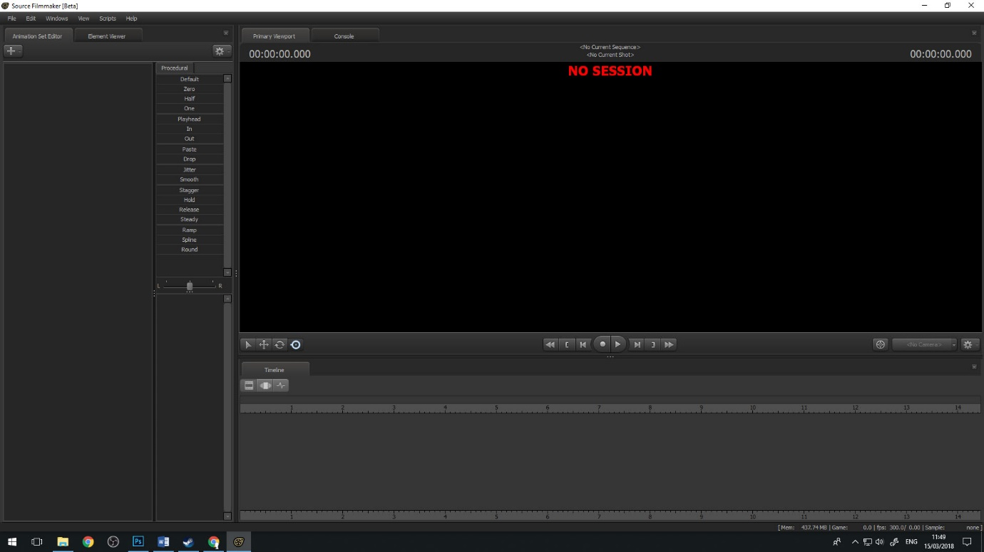
Making a map in Source Film Maker isn’t the easiest as it did not work on the PC’s in the university, they would not allow the software to allow it to work properly. However in the steam work shop there are many maps other people have made, even a simple flat map that will be used for the test as it is similar to Unreal Engine 4’s start up map that can be chosen from the start of creating a new scene. This is because there is a bug in SKD (the map maker for Source Film Maker) makes pops up with a message saying “failed to load the default scheme file” a fix was found for this, found on the steam community about source film maker, saying go to program files (x86) > Steam > Steamapps > Common > Team Fortress 2 > Bin then hammer but, clicking on hammer doesn’t do anything this might be because the computer is running through the university therefore this will be checked on a personal computer at home. Running the program as admin still didn’t seem to work (Developer.valvesoftware.com, 2017). This can be a problem as there is more than one program that is needed if a specific homemade map is wanted. Image 3 and 4 below shows this not working even with all the fixes the steam community suggested.
Image 2.
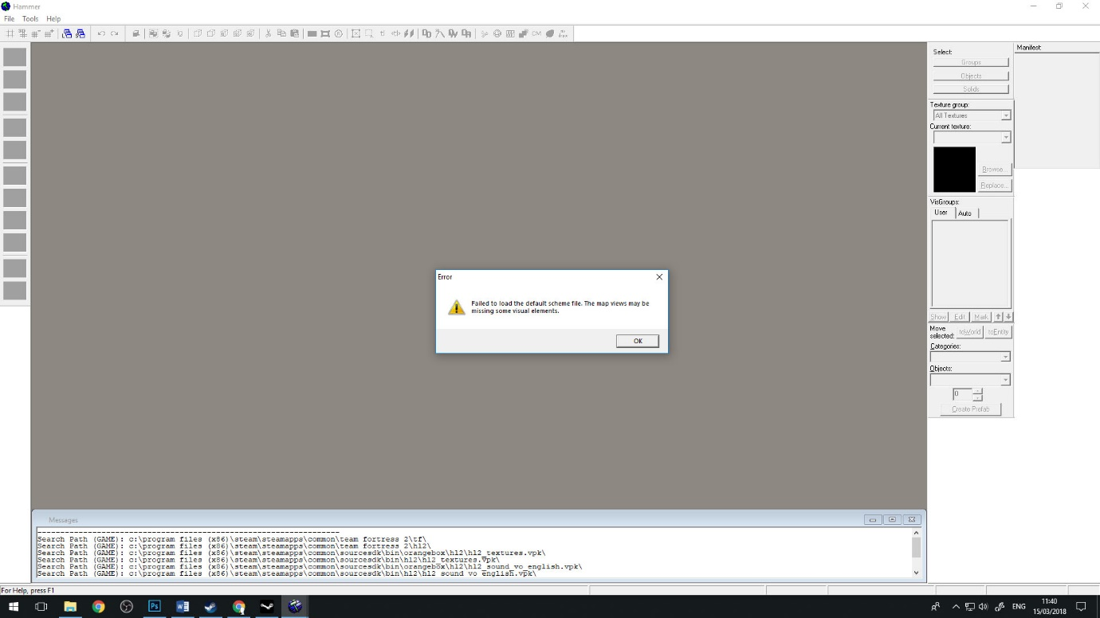

Image 3.
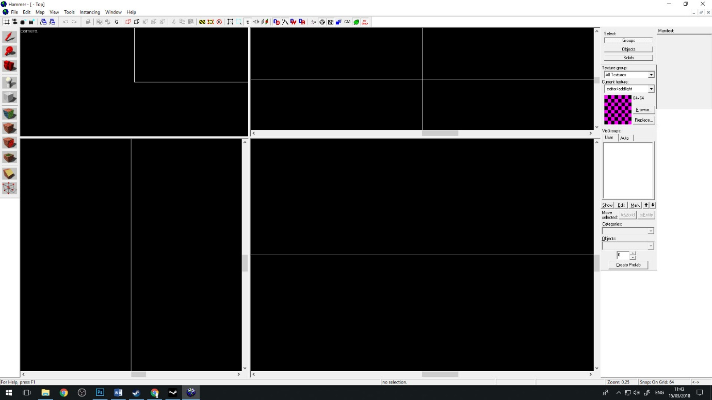
Having to look up how to get a character into Source Film Maker, this was found and it uses the workshop in steam to get a variety of things that other people have made and it’s all free. A simple room to put in Source Film Maker that will work as it can easily be made in the Unreal Engine. Using the Steam workshop doesn’t seem to be putting the models and other maps into the scene this still might be because the computer is coming through the university, this will have to be checked on a personal computer to see if this is correct also to make sure it isn’t possible more assets will be downloaded. Later, after a quick reset this was found to be incorrect as the models were found (Developer.valvesoftware.com, 2012)
Source film maker has facial animations for some of the characters that are already in there, same with some animations. Anything that is made by Valve that is in Source Film Maker has all of their animations in there. Going to the Steam Market is useful because there are many models, animations and maps that can be used by anyone as they are all free to download not only this all of the characters have a rig that can be put into them in Source Film Maker there are also many rigs that are free to download on the steam workshop all that’s needed to do after is select the character that needs to be rigged then go to the rig selection part and there should be a drop down that has all the rigs that have been downloaded. These rigs can be used on anything however, it is recommended to use the correct rig to the character that it’s for because if not the character will not move properly or just implode. This also happens when the character has an animation taken from the Steam workshop and isn’t applied properly. (Steamcommunity.com, 2017)

Unreal
Unreal is not just soul animation sequencer, there are more things that can be done in this it as it is a game engine, Unreal Engine 4 can also be used to make games so having this sequencer inside the engine makes it so there is no render time on the animations, same as Source Film Maker as it also does not have to render any of the animations that are made on it.
There are some maps that can be downloaded for free on this but there is no need to as white boxes can be made and assets can be put into the scene with ease. It is a simple export of something that is made in Maya or anything that can be made into an FBX can be put in to the Unreal Engine 4. This is also easier to do than Source Film Maker as maps can not be made in there, having to use another bit of valves soft where is needed to do this but unfortunately this did not work. However, there are many maps on the steam work shop to pick and choose from, this is the same with animations. Sequencer is shown below image 4. (Docs.unrealengine.com, n.d.)
Image 4.
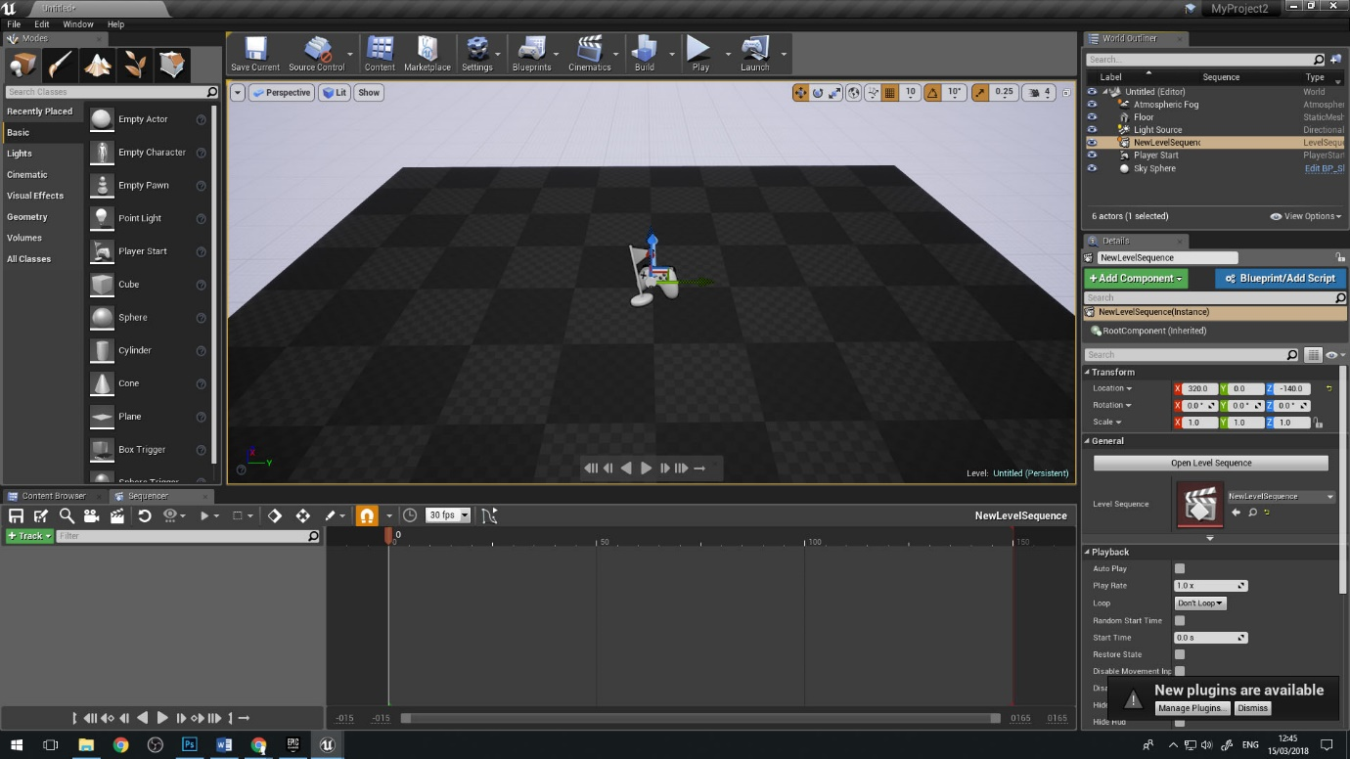
From opening up the Unreal Engine they have a lot of tutorials to get started. All that’s needed to do is click on the flashing hat that’s at the top of the screen, this hat cannot be missed because of its pulsing green circles coming out of it, these tutorials are quite good as most of them are step by step. For anyone just starting out with Unreal Engine and sequencer they can navigate it easily. The tutorial for sequencer and matinee was used for this test to make it easier using Unreal Engine. To go alongside these tutorials they have readymade sequences that can be used with them that includes some assets that can be manipulated and moved around, or more things can be put into the scene and two characters that are also in there. It is a full scene that has animations, cameras, lighting and more that can be changed to make the scene completely different to what it was. (Docs.unrealengine.com, 2017)
To actually add something to the Unreal Engine is fairly quick and simple, just click on import, go to the folders that have the assets, characters, skeletons or animations that are FBX’s. Not only do they have to be an FBX if there is a skeleton that needs to be put in for animation then all the joints in the bones need to be the correct naming conventions this is because unreal has its own names for them so it can recognise the rig. Having a rig in unreal with IK handles (IK’s make it so that the parts that are mobile, move how they would in real life) it won’t show that they are there, just the bones however, in Source Film Maker creating a rick on a character comes up with IK handles showing them a purple they can be used just like in Maya.
Unreal has a few windows open when just starting out to actually find sequencer it’s in the top window where there are a few buttons in between the mix of these there is one that looks like a clapperboard. Clicking on this brings a drop down menu with three choices “add level sequence”, “add master sequence” and “add Matinee sequence” the one that’s needed to open sequencer is add level sequence. This comes up with a new window allowing assets to be put in to the sequence after all the assets that are needed are put in to the sequence, click on save it closes that window and comes up with another, Sequencer pops up this is where all the cinematic animations or in game animations are made. There are other icons that come up when going on to sequencer similar to Source Film Maker but it is in a full game engine as a small window. These icons consist of making cameras, saving, actually playing the sequence and more what makes this easy to use is its icons that look like what they do. Possibly because Maya also has an animation part in their Unreal Engine seems to use a similar key set for animation as most of the keys that work for animating in Maya also work here.

Results
Trying to get any model in to Source Film Maker is a real task. Trying to actually find out how to do this took a long time, in turn making it so the character choice for this test was the scout from a game called Team Fortress 2, this is a valve game so the character was already in Source Film Maker however trying to find this character in there is also very annoying to find unless the naming conventions are known otherwise the content browser comes up with errors because it can’t find what was searched. This is also the same with any object that might be needed for the scene to find it there is a specific thing that is needed to be typed in for each object this is very time consuming if there are a lot of assets meant to be in the scene.
However, if there was no need for any other models outside of Steam or Source Film maker itself then it is quite easy to use even though it is hard to find the right asset that’s needed purely because there are ready made animations and facial animations in there that can be used on the characters unfortunately to find these animations the same proses to find objects has to be used because they are all in the same place.
Getting a model or anything in to Unreal Engine 4 is simple all that was needed was the model to be saved as an FBX this is the same for anything that is needed not only this there is a window at the bottom of the screen that has all of the assets characters or anything ells that was put in to the engine folders can also be made so that animations, objects, skeletons or anything ells that is put in to the Unreal Engine 4 can then be easily found because of the named folders that were created.
One of the benefits of Source Film Maker is the community as anything that is in the Steam workshop is free to use all that is needed is to subscribe to the creator of the thing that is wanted and it downloads in to Source Film Maker the trouble is sometimes this doesn’t work or something ells is needed before it can work not to mention trying to find it in the mess that is the contend finder as it is still using the place that has all of the animations and objects in it luckily the names are whatever the creator gave it so it is easier to find than the rest of valves objects.
While there is a large community on unreal on their version on Steam Work Shop most of the models and other things are expensive as most of these aren’t just the one thing there are normally many things that would be purchased in the same folder, this also means that if original models, animations, rigs, objects or anything ells that would be put on there can make the person that did it some money from it.
While there is a map maker for Source film maker to get it to work was a hassle while there were many fixes for this it would still not work making it so the screen was just black with the tools still up clicking on them didn’t do anything ether so a map from steam was downloaded to fit with the start-up map from Unreal Engine 4 this would make the test fair because both the maps were flat and dint have anything put in the map.
To make a map for Unreal Engine 4s sequencer was very simple there is no extra download that is needed it already has everything that’s needed on there to actually make a game this includes small white box levels this was used for unreal so there was no need to download a map that was made by somebody ells or one less step then Source Film Maker.
Source Film Maker dose have some grate characters and animations straight from downloading it these animations if putting the correct animation on the right character it will work this is useful if a simple running or walking animation is needed and just needs to be repeated, this can then be put on to the character and whatever frim the animation was put on the character would do that animation. If a different animation would go on to a different character it would mess up and not do the animation correctly.
For animations that are to be put in Unreal Engine 4 however a different program like Maya is needed before they can go on this does mean however that long animations can be made in Maya, then game exported as an FBX in to Unreal not only this like Source Film Maker sequencer can also key frame in animations this also includes cameras or anything else that is needed. Another thing that is great with unreal is that folders can be made for different assets that go in to the engine so trying to find things in unreal is a lot easier that Source Film Maker as folders can't, be made the only way of finding something quick is if the correct naming convention is used to find what is needed.
Source Film Maker hasn’t been updated in quite some time so Valve doesn't really help much with its community anymore but thanks to the community many questions of how to use Source Film maker are normally already answered if there is something that is not knows all that is needed to is to go on to the Source Film Maker community page on steam and someone will answer that question.
There are many tutorials for unreal and Unreal is also being constantly updated making it easier to use no matter how experienced in unreal they are alongside with theses updates they also make tutorials for whatever id needed to be done there are also many community made tutorials because like source film maker unreal has a very big following of people who use it.
Moving a character or an object in unreal and source film maker are practically the same the Q W E R keys on both of the programs switch from rotate, make the object bigger or smaller move the object around or select and object or character these are the same for both programs.
Both cameras are the same to use although they are very different from one another. The camera in source film maker is placed in by the picture of on in the mane window where all the characters and models are when placed in it comes in as a small square and four lines this camera is odd but it works and is very visible, these cameras can be named differently and moved around, the square that is there is used for talking different shots like a close up or a wide shot so this is very useful because there is no need to look through the camera to get the shot that is needed.
Unreal Engine 4's sequencer camera is located in the window that comes up when sequencer is open this is a simple picture of a camera, clicking on it will make a new camera that automatically becomes the camera that is being used this is useful because there aren’t any visible lines to see where the camera is looking, not only this but to show that it is a camera that is in the scene the physical object is of a camera not just lines.
If there is a custom animation needed in ether of the Unreal or source film maker it can be done by using the skeleton that’s attached to that character and keyframing in the animations by moving the bones source film maker has an option to add a rig to any character however it is best to use the correct rig or the right character this is also good because when rigged the characters face can now be manipulated by sliders on the left ranging from angry to happy or frightened to angry there is also custom face poses ranging from most motions that people make with their mouths this only useful however if the character if rigged from a valve character because if something ells were to use this if it wasn’t rigged how it's meant to be on source film maker it wouldn't work otherwise this is a good future if only steam work shop or the in program sources. In Unreal Engine 4 however there are no sliders or any other automatic rigging all this is done on a different program however this dose means that custom rigs for characters that have been made in there and turned in to an FBX can be used in unreal.
They both have similar ways that can be learnt to one another as they have ready-made animated scenes that can be manipulated this means that some camera shots or movements in the characters and objects can be changed this is good for practicing with if not much is known about the program or engine, in the Unreal Engine 4 however there is a step by step guide that they have made so that simple or advanced controls and buttons can be learnt just by reading how to use it. Trying to find something to use for source film maker however can't really be found like this as a lot of the information on how to use source film maker is mostly community-based which for the most part is good, because there are many people willing to help if some information isn't known for what is needed like adding in animations or putting in characters, even how to set the cameras to get better shots with better lighting ideas. There are also many lighting and sky effects in Unreal engine 4 such as spotlights or whole room lights that make faces brighter, these can also be tweaked to how they need to be used

Conclusion
Source film maker can make high quality animations and animations are still made with it today like the newest valve animation for a game called "team fortress 2" it was a short animation about the characters of the game it has great animations, good camera shots and excellent lighting there are also many community made animations as there is an animation contest called the saxxy awards some people use it just for fun, however if source film maker was to be the first program to be used there would be quite a bit of research before being able to us source film maker to its full potential. Not only this but just trying to set up a scene in source film maker can take a while if the right naming conventions aren't known this means just trying to find simple objects for a small scene can take a while to do even with knowing the naming conventions sometimes it still takes a while to find or sometimes it even pops up with an error object if what is needed can't be found so then more downloads have to be done in order to even see the object so it might not even be a god object for the scene.
Unreal engine on the other hand has a lot of help right of the bat with its pulsing green tutorial button this makes it easier to learn how to use whatever it is that is needed to know about the engine so trying to learn about its sequencer doesn't really need any researching unless even more advanced information is needed but they also have this covered on their website with videos alongside what is being taught this makes unreal engine very friendly for newer people.
Unreal also for many objects, effects, characters or anything that’s needed to be put in to it and having all of these be put in to a folder that was specifically made for that asset making it a lot easier to find compered to source film maker where to find an item it would take a while to find because of its system so unreal has an easier system for this.

Further work
2D traditional animation so hand dawn and painted for colour if needed and 2D digital animation would be a good thing to compare as they are quite similar even though they use completely different methods, 2D traditional animation uses a lot of animation paper and cameras whereas 2D digital animation uses frames and drawing on a computer.
To do this test there would have to be a time comparison on how long it took to make a simple animation using pen and animation paper and then on the computer using digital these animations would be the same as each other so that it would be a fair test. Then there would be what one was easier to do weather research on ether would be needed before getting started. After this there would be a cost comparison how much paper would be needed to do the animation if more was needed because mistakes might be made in turn this would make it so more paper would be needed the cost of pens, painting utensils all the other equipment that would be needed to start to use traditional 2D animation. This would then be compared to the cost of the chosen animation soft where how much it would cost if it was just a one-time payment or a monthly or a yearly cost. This test will last one month to gather numbers for the cost turning that in to an average and then estimating just how much it would cost for a year.
The animation for this will go on in the month as well to see how much can be done in a month then tallying up the amount that could be done in a year using one or the other.

Bibliography
Developer.valvesoftware.com. (2017). Starting the SFM - Valve Developer Community. [online] Available at: https://developer.valvesoftware.com/wiki/SFM/Starting_the_SFM [Accessed 6 Nov. 2017].
Developer.valvesoftware.com. (2017). Failed to load the default scheme file - Valve Developer Community. [online] Available at: https://developer.valvesoftware.com/wiki/Failed_to_load_the_default_scheme_file [Accessed 5 Nov. 2017].
Developer.valvesoftware.com. (2012). Adding objects - Valve Developer Community. [online] Available at: https://developer.valvesoftware.com/wiki/SFM/Adding_objects [Accessed 9 Oct. 2017].
Steamcommunity.com. (2017). Steam Community :: Steam Workshop. [online] Available at: http://steamcommunity.com/workshop/ [Accessed 14 Mar. 2018].
Docs.unrealengine.com. (2017). Sequencer - How To's. [online] Available at: https://docs.unrealengine.com/en-us/Engine/Sequencer/HowTo [Accessed 16 Nov. 2017].
Docs.unrealengine.com. (n.d.). Sequencer Overview. [online] Available at: https://docs.unrealengine.com/en-us/Engine/Sequencer/Overview [Accessed 19 Nov. 2017].

Appendix
- Sfm (source film maker) map simple quire map found on the steam workshop.
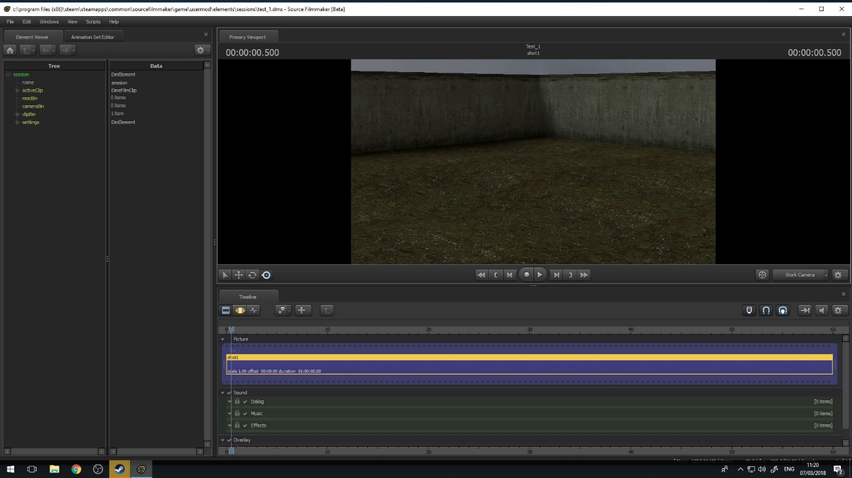
- Unreal sequencer map this is just the base map when loading unreal up.


