ACDA6004: Power Electronics & Drives
Tutor: Stephen Mosey

Contents
Table of Figures 2
Abstract 2
Introduction 3
Power Factor Correction 3
Power factor calculations 3
Three-phase Inverters 4
Working principle 4
Method 5
Exercise 1 Power Factor Correction 5
Phase angle formula 7
Current amplitude formula 8
Power factor formula 8
Power formula 8
Fault responses 8
Fault code A 8
Fault code B 9
PWM of Variable Frequency Drives 10
Three-phase inverter 10
Over-current protection 11
Results 12
Power Factor Correction 12
No fault code 12
Findings 16
Fault code A 17
Findings 18
Fault code B 18
Three-phase Inverter 19
Over-current Protection 20
Discussion 22
PFC 23
Three-phase Inverter 23
Over-current Protection 23
Conclusion 24
References 24

Table of Figures
Figure 1 – Power triangle 4
Figure 2 – Three-phase inverter construction 5
Figure 3 – Power factor correction circuit 6
Figure 4 – Oscilloscope showing Δt and T 7
Figure 5 – single-phase no PFC 9
Figure 6 – Three-phase inverter 10
Figure 7 – PWM generating sine wave 11
Figure 8 – PWM half sine wave 11
Figure 9 – Over-current protection 12
Figure 10 – No correction capacitor, no fault 13
Figure 11 – correction capacitor C2, no fault 14
Figure 12 – correction capacitor C2+C3, no fault code 15
Figure 13 – correction capacitors C2+C4, no fault 16
Figure 14 – voltage amplitude peak to peak 17
Figure 15 19
Figure 16 – PWM labelled 19
Figure 17 – PWM half wave labelled 20
Figure 18 21
Figure 19 21
Figure 20 – Over-current protection with short introduced 22
Figure 21 23

Abstract

This assignment will investigate the following.
- Power factor & power factor correction.
- Three-phase inverters.
- Over-current protection circuits.
- Single-phase synchronous motors

In order to undertake this assignment, the use of the following hardware and software is needed.
- LJ Create software.
- LJ Create instrumentation platform.

Introduction

Power Factor Correction

Power factor (PF) is a measure of how efficiently power is being used, within an electrical system. It is usually shown as a percentage where a low percentage indicates an inefficient use of power. Power factor is defined as the ratio of active, measured in kilowatts (kW), to apparent power, measured in kilovolt amperes (kVA). Apparent power is the A.C. power needed to run equipment or circuitry and can be calculated by multiplying (kVA = V x A) [1].
The ideal power factor is one, which means that all power going to the system is being used to power the system, in other words there is no waste. If the power factor is anything less than one, then extra power is required to achieve the actual task at hand. As an example of this, if a “motor with current draw of 10 Amps and a power factor of 0.75. The useful current is 7.5A. The useful power from the motor is 230 x 7.5 = 1.725kW but the total power that has been supplied is 230 x 10 = 2.3kVA. Without power factor correction, to achieve the required output of 1.725Kw (7.5a) a power of kVA (10A) has to be supplied” [2]. In this example, a 10A current is supplied but only 7.5A of the current is producing useful output.

Power factor calculations

- The formula for power factor(pf) = $\frac{P}{S}$ = $\frac{Active power (kW)}{Apparent power (kVA)}$
- The product of power factor can be used to the calculate phase angle between active power and apparent power.
- The formula for the phase angle (φ) = $\cos^{-1}pf$
- These two formulas can be rearranged to give (active power = apparent power x cos phase angle)
A visual relationship of the above calculations can be seen in figure 1.
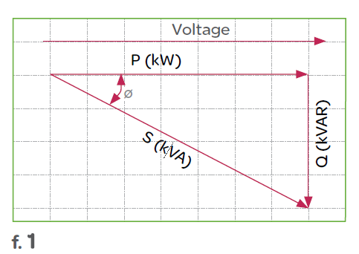
Figure 1 – Power triangle

Three-phase Inverters

An inverter is a device used to convert power from D.C. to A.C at the necessary frequency voltage. Inverters have two classifications, voltage source inverters (VSI) and current source inverters (CSI). VSI inverters have a D.C. voltage source, and less impedance at the terminals of the inverter. CSI inverters have a C.C. current source, and high impedance. A three-phase inverter converts D.C. voltage to a three-phase A.C. supply. These are often utilised in variable frequency drives.

Working principle

The construction of a three-phase inverter is three inverter switches with single-phase, where individual terminals can be connected to the load terminal. The three-phase inverter can use PWM in order to generate a voltage sine wave and can manipulate its shape by the changing of D.C. pulse width.

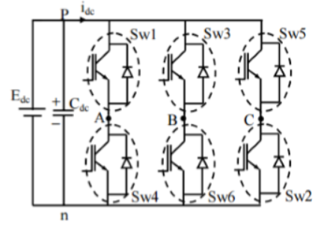
Figure 2 – Three-phase inverter construction
[3]

Method

This section outlines the method used in this assignment. This entails the equipment used, how it was manipulated, and for what reason. There are two exercises in this section, each will be discussed in its own sub section. The first exercise focuses on the power factor correction (PFC) whereas the second is an investigation of pulse width modulation (PWM) of variable frequency drives.

Exercise 1 Power Factor Correction

The first step to this exercise is to connect the circuit as show in figure 3 below.
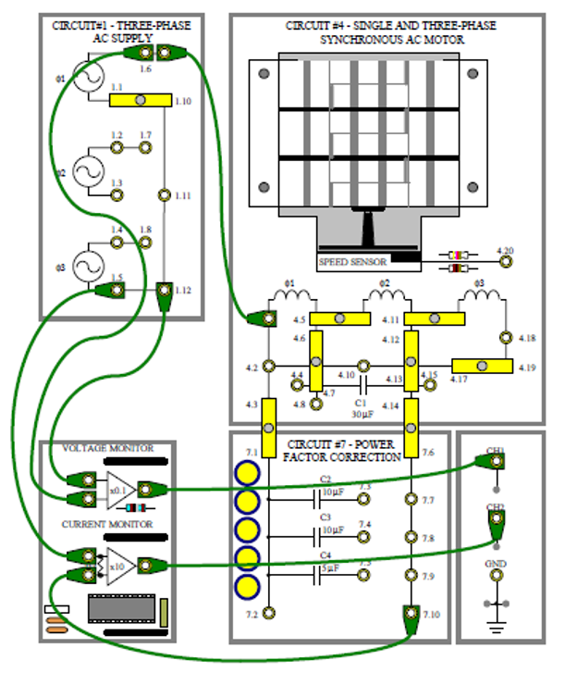
Figure 3 – Power factor correction circuit

Now that the circuit is connected, the motor must be running for results to be collected. In order to increase or decrease the inductive reactance of the motor windings, frequency must increase or decrease. This can be achieved with the frequency control. In order to calculate the best possible PFC for this circuit, calculations are needed to determine the phase angle and current amplitude of the circuit with no correction capacitor in place. Various correction capacitors can then be added into the circuit in order to take readings for their phase angle and current amplitude. Three different capacitor combinations can be added into the circuit. They are made from a combination of three capacitors available to be added into the circuitry. They are C2=10µF, C3=10µF, and C4=5µF. The three combinations can be seen in table 1 below.

Correction capacitor | None | C2 10µF | C2+C3 20µF | C2+C4 15µF
Phase angle (lead/lag) | Lead/lag° | Lead/lag° | Lead/lag° | Lead/lag°
Current amplitude | mA P-P | mA P-P | mA P-P | mA P-P
Table 1 – Blank correction capacitor table

Phase angle formula

In order to calculate and complete table 1, the phase angle (φ) of the current needs to be calculated and shown if it is leading or lagging the voltage. In order to achieve this, the following formula is used.
(φ = $\frac{Δt}{T}×360$) where:
- Δt is the time difference between voltage sine wave and current sine wave
- T is the time taken for one half wave period on the oscilloscope (this is adjusted by changing the time base on the oscilloscope)
- 360 is the number of degrees in a full wave cycle

In order to determine the figures from the above formula, the oscilloscope needs to be setup as in figure 4.

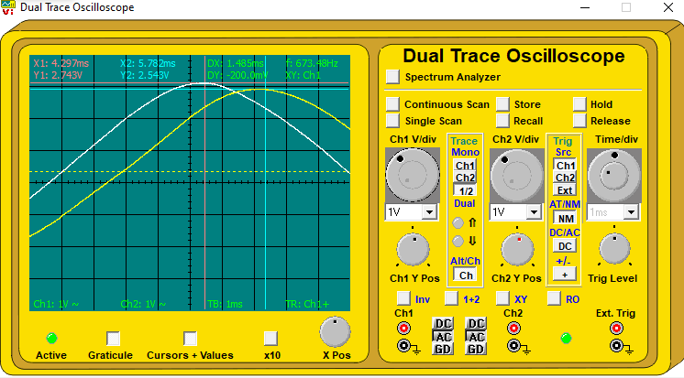
Figure 4 – Oscilloscope showing Δt and T
In figure 4 measurement points (circled in red) are placed at the peak of the voltage wave (white) and the current wave (yellow) to give a time difference ‘DX’. This time difference is Δt. The time period of T is shown as the period to complete one half wave period and can be seen (circled in yellow) on the voltage wave. This period is nine as it takes nine squares on the oscilloscope to complete one half wave cycle.
Once these figures are determined the values of phase angle and current amplitude can be calculated for when there is no correction capacitance in the circuit. In order to calculate the subsequent capacitor results, capacitance is added into the system by adding short circuits between points on the circuit. For capacitor C2 a shorting link between 7.3 & 7.7, for C3 a short between 7.4 & 7.8, and for C4 a short between 7.5 & 7.9 The recording of these results completes ‘table 1’.

Current amplitude formula

In order to calculate the amplitude of the current the following formula is used.
mA p-p = ($\frac{2 ×peak amplitude × 1000}{10}$)

From figure 4 the peak amplitude can be seen at the peak of the yellow wave form (circled in red) which is defined on the oscilloscope as ‘Y2’.

Power factor formula

Power factor is calculated by cos of the phase angle (φ).

Power formula

As the measurements from the oscilloscope are being taken peak to peak, to convert to RMS the formula needs to be divided by $2×\sqrt{2}$. This gives the following formula.
$$P=\frac{V}{2\sqrt{2}}×\frac{I}{2\sqrt{2}}=\frac{V×I}{8}$$

Fault responses

In order to gain an understanding of how various faults affect the synchronous motor circuit, two faults are inserted. The purpose of this is to analyse the changes in the system from the initial results, to try and detect what the fault is.

Fault code A

After initial calculations have been completed, a fault condition is added into the circuit. The fault code used for this exercise was ‘fault A’. Once the fault had been added into the circuit it was visible on the oscilloscope that conditions had changed. In order to detect what had changed the same method as used for ‘table 1’ is used. Calculations for phase angle and current amplitude are used in the same way, with the same capacitors added into the system.
From recording results in table 1 it should be evident that that the values are not the same as the first time around. In order to further investigate the system, ‘table 1’ is expanded to include values of C3 independently, and C3 + C4 combined. The results of this can be analysed to see if there are any differences. The expanded table can be seen below in table 2.

Correction capacitor | None | C2 | C2+C3 | C2+C4 | C3 | C3+C4
Phase angle (lead/lag) | Lead/lag | Lead/lag | Lead/lag | Lead/lag | Lead/lag | Lead/lag
Current amplitude | mA p-p | mA p-p | mA p-p | mA p-p | mA p-p | mA p-p

Fault code B

For ‘fault B’ the circuit is connected in the same manner as figure 3 except initially, the link between 4.3 and 7.1 is omitted. This missing link is the connection to power factor correction, so the signal seen in figure 5 is the supply with no PFC applied. After connection of the circuit VR1 and VR2 are set to maximum, and the power is switched on which supplies a single-phase supply.

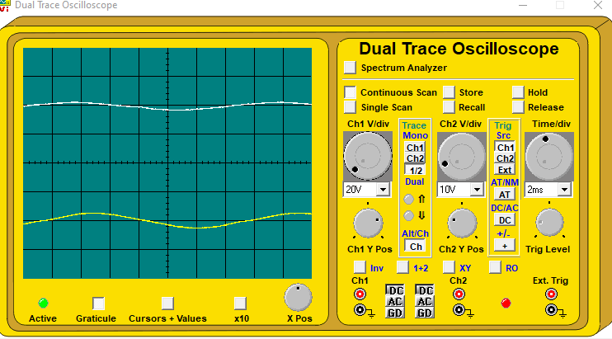
Figure 5 – single-phase no PFC

The link between 4.3 and 7.1 is now added to the circuit, introducing PFC into the circuit. ‘Fault B’ is added into the circuit which stops the motor from running. The fault now needs to be deduced by probing different areas of the circuit with a multimeter to see is voltage or current have changed after the introduction of the fault.

PWM of Variable Frequency Drives

Three-phase inverter

This section is an investigation of PWM, variable frequency, and three-phase inverters. In order to begin this exercise, the circuit is connected as seen in figure 6.
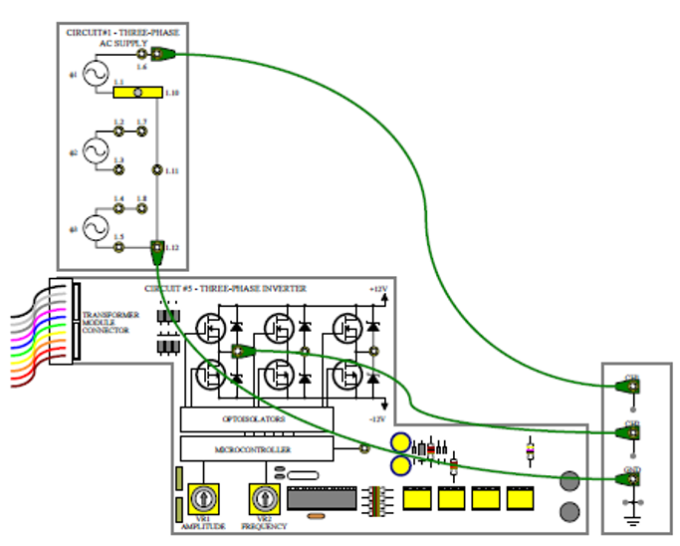
Figure 6 – Three-phase inverter

Once the oscilloscope is setup correctly, the amplitude control is set to position 3 and the frequency control needs to be adjusted so that one full cycle is displayed on the oscilloscope, as seen in figure 7. This figure shows PWM and the resultant sine wave it produces.
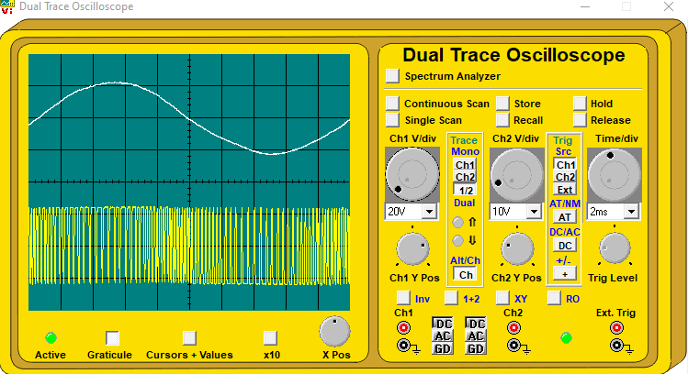
Figure 7 – PWM generating sine wave

Images and results from the oscilloscope are recorded and then the timebase is changed to 1ms/div so that only one-half cycle is shown as seen in figure 8.

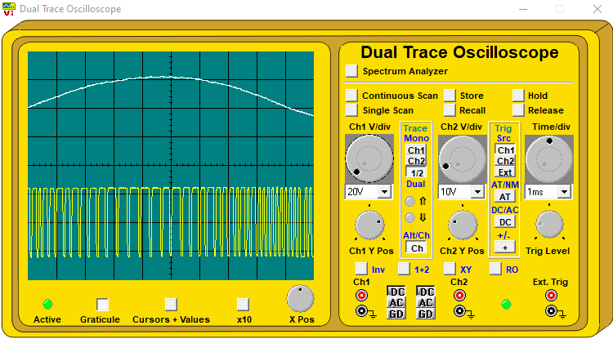
Figure 8 – PWM half sine wave

Over-current protection

The three-phase supply generator has built in over-current protection. In order to bring the over-current protection into the circuit, it is connected in the way shown in figure 9. Again, VR1 and VR2 are set to maximum to give a single-phase supply at maximum frequency.
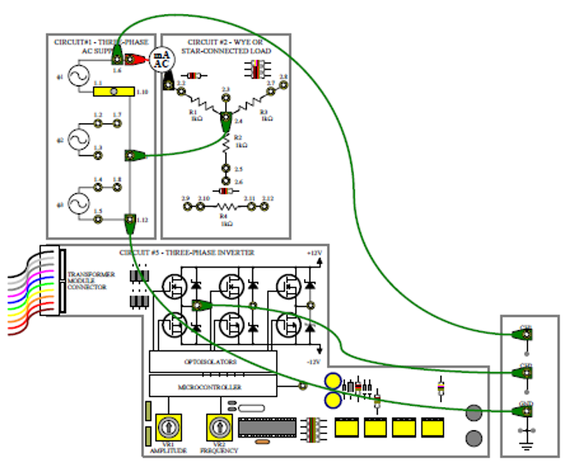
Figure 9 – Over-current protection

Results

Power Factor Correction

This section focuses on the results gained from power factor correction, three-phase inverter, over-current protection, and single-phase synchronous motor.

No fault code

Without a fault code in the system, the following table of results has been produced.

Correction capacitor | None | C2 10µF | C2+C3 20µF | C2+C4 15µF
Phase angle (lead/lag) | 59.4 lag | 27 lag | 45 lead | 20.86 lead
Current amplitude | 508.6mA | 405.8mA | 451.4mA | 417.2mA
Table 2 – Correction capacitor table

The results in ‘table 2’ are calculated by using the formulas stated in the method section. The time taken for one half period (T) is the same throughout this section. The value is 9.

No correction capacitor

With no correction capacitor applied, the oscilloscope produces the image shown in figure 10.
Figure 10 – No correction capacitor, no fault
From this oscilloscope the values of Δt, T, and peak amplitude can be derived. They are as follows.
- Δt = 1.485ms
- T = 9
- Peak amplitude = 2.543mA
From these values the phase angle is calculated:
Φ= $\frac{1.485}{9}×360=59.4°$
The current amplitude is calculated:
mA p-p = $\left(\frac{2×2.543×1000}{10}\right)=508.6mA$

The phase angle of 59.4° is lagging the voltage wave. This can be observed on the oscilloscope.

C2

When the correction capacitor C2 is applied, the following oscilloscope image is observed.
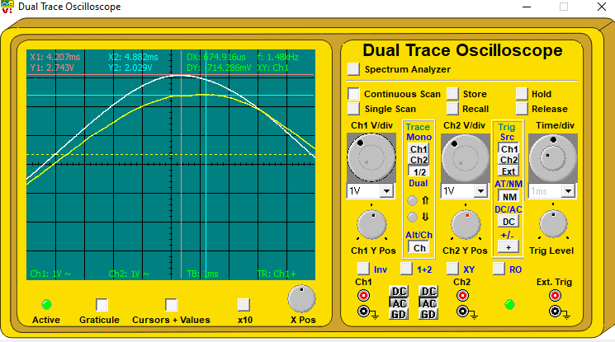
Figure 11 – correction capacitor C2, no fault
From the oscilloscope the values of Δt, T, and peak amplitude can be derived. They are as follows.
- Δt = 0.675ms
- T = 9
- Peak amplitude = 2.029mA
The phase angle is calculated:
Φ= $\frac{0.675}{9}×360=27°$
The current amplitude is calculated:
mA p-p = $\left(\frac{2×2.029×1000}{10}\right)=405.8mA$

The phase angle is lagging the voltage wave by 27°. This is observable figure 11 and when compared to figure 10, the amplitude wave is significantly closer to the voltage wave than in figure 10. This proves that the phase angle has reduced from the previous.

C2+C3

When the correction capacitors C2+C3 are applied, the following oscilloscope image is observed.
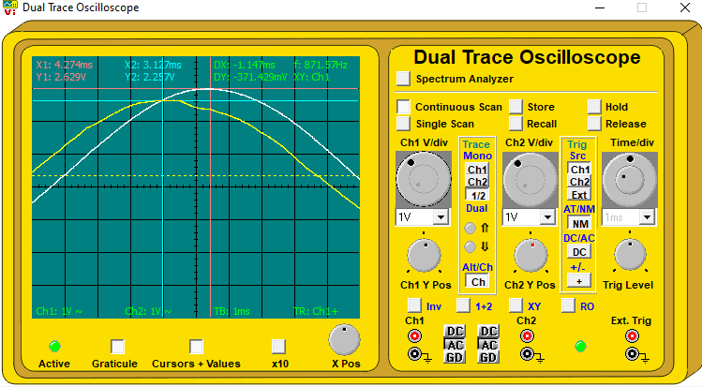
Figure 12 – correction capacitor C2+C3, no fault code
- Δt = -1.147ms
- T = P
- Peak amplitude = 2.257mA
The phase angle is calculated:
Φ= $\frac{-1.147}{9}×360=-45.88°$ (negative phase angle indicates that the current is now leading the voltage).
The current amplitude is calculated:
mA p-p = $\left(\frac{2×2.257×1000}{10}\right)=451.4mA$

The phase angle from this PFC now has the phase leading the supply voltage. When comparing to the previous PFCs it is easily observable that the current is now in front of the voltage. This supports that the phase leading is calculated correctly.

C2+C4

When the correction capacitors C2+C4 are applied, the following oscilloscope image is observed.
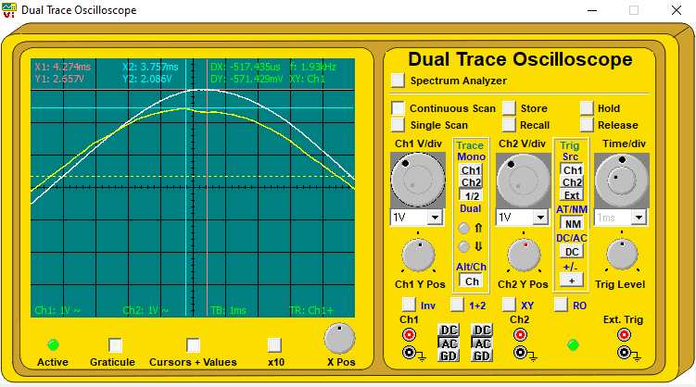
Figure 13 – correction capacitors C2+C4, no fault
- Δt = -0.517ms
- T = 9
- Peak amplitude = 2.086mA
The phase angle is calculated:
Φ= $\frac{-0.517}{9}×360=-20.68°$
The current amplitude is calculated:
mA p-p = $\left(\frac{2×2.086×1000}{10}\right)=417.2mA$

Findings

From the above results it can be observed that the value of shunt capacitance that gives the nearest to complete correction of phase angle is C2+C4. Once C2+C4 is applied the phase angle and current are both a minimum. In order to visualise the PF of C2+C4 and how it impacts voltage and power, a comparison is made against the circuit with no PFC. With no PFC applied, the PF of the circuit produces:
- Cos φ = cos (59.4°) = 0.51
With the best PFC C2+C4 applied the PF is:
- Cos φ = cos (20.68°) = 0.94
It is easily observable from the above that C2+C4 has the best PFC. It is also seen that reducing the phase angle increases the PF. The supply voltage of this PFC can be calculated by changing the oscilloscope to show a full wave period and measuring the peak-to-peak amplitude of the voltage, as seen in figure 14. The supply voltage can then be used to calculate power used in the system for each PFC. From this it can be deduced that the supply voltage is:
- 5.343 x 10 = 53.43V p-p.
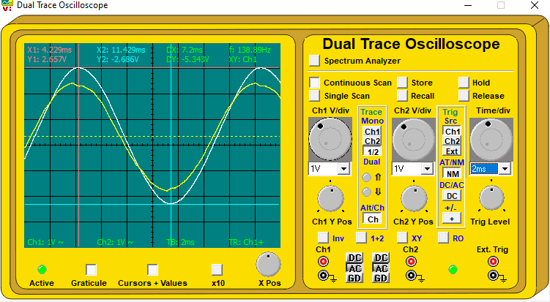
Figure 14 – voltage amplitude peak to peak
Now for the analysis of the power usage on the circuit. In order to see that PF is working correctly, the best PF of C2+C4 should draw less power than with no PF applied. To prove this the formula for power VIcosφ is applied. In this formula V=voltage, I=current, and cosφ signifies the PF applied. From the results in table 2 the following results occur.
- No PF correction: $\frac{V×I}{8}=\frac{53.43×0.508}{8}=3.39W$
- With C2+C4 PFC: $\frac{V×I}{8}=\frac{53.43×0.417}{8}=2.79W$

Fault code A

With fault code A inserted into the circuit, the following table has been produced, showing phase angle and current amplitude of each capacitor.

Correction capacitor | None | C2 | C2+C3 | C2+C4 | C3 | C3+C4
Phase angle (lead/lag) | 54.84 lag | 42.28 lead | 77.72 lead | 60.56 lead | 28.56 lag | 21.68 lead
Current amplitude | 508.6mA | 451.4mA | 594.2mA | 520mA | 417.2mA | 428.6mA
Table 3 – Correction capacitor table, with fault code A
From inspecting this table and comparing it to table 2 that had no fault code, it is obvious that the values of some correction capacitors have changed. The phase angle and current amplitude from table 3 with no correction capacitor is very similar to that of table 2, with only a slight change in the phase angle. This is likely due to slight differences in the placement of the cursor on each wave peak. However, the amplitude is identical which supports that no change has been made due to the fault. The values of C2, C2+C3, and C2+C4 have changed drastically from table 2. This indicates that the fault is likely a change in the capacitance of one of these capacitors.
In order to determine which one, C2 and C3 are first analysed. As both capacitors should have the same value of 10µF, the value of C2 in table 2 should equal the value of C3. The capacitor C3 is added into the system on its own and produces values like those that were seen for C2 in table 2. With the fault code, the phase angle and current amplitude are almost identical (again slight difference due to cursor placement). This indicates that C3 still holds a value of 10µF. As one final check, C3+C4 are added into the system together. If both have retained their initial capacitance then the values seen should be like the values of C2+C4 seen in table2. This is the case and there are only very slight differences. Now it can be said that C4 also holds its initial capacitance of 5µF.

Findings

From the above analysis of table 2 and table 3, it can be deduced that the capacitance of C2 has increased beyond its original value of 10µF.

Fault code B

Once a link has been set between 4.3 & 4.7, and power factor correction is brought into the system, fault code B is inserted into the system. From this fault, the motor stops instantaneously, voltage reduces to zero, but current remains continuous. Seen in figure 15. By using a multimeter and taking readings of current and voltage across the motor circuitry, and across the PFC circuitry, readings on the capacitor banks of the PFC show that there was no current or voltage present at any points from link 7.1 to 7.10. Effectively the entire bank has been shorted.

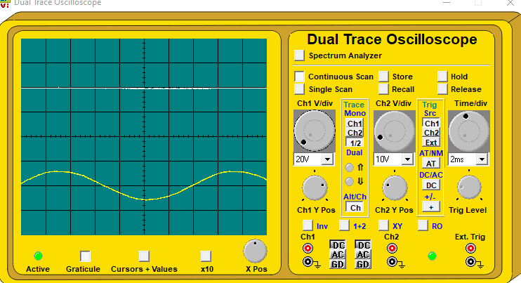
Figure 15

Three-phase Inverter

Once the three-phase inverted has been connected and powered on, the oscilloscope image from figure 16 is seen. This shows a sine wave at the top (A.C.) and the PWM beneath (D.C.) that generates that sine wave. When the D.C. pluses are positive for a longer period than they are negative, this indicates that the sine wave is at the positive side of the wave (seen in red circle). When the D.C. waves are negative for longer than they are positive, this indicates that the wave is at the negative side (yellow circle). If the time that the D.C. pulses are positive for is increasing and time that they are negative is decreasing, this indicates the wave is rising towards the positive peak. The inverse of this is true when the wave is decreasing from the positive peak.
Figure 16 – PWM labelled

When viewing the half sine wave there is a much clearer view of the D.C. signal, and the widths of the waves are plain to see. The area where the waves are broader can be seen circled in red, and when they begin to become narrower, they are circled in yellow. From this increased view it is easy to see the number of positive pulses for a half wave is around 40. There does not appear to be any ripple in the system.

Figure 17 – PWM half wave labelled

Over-current Protection

Initially when the power is turned on, the current is recorded and shown to be 26mA (figure 17). With the circuit connected but no short circuit, the wave can be seen in figure 18. This shows that the amplitude of the system is constant when the sine wave is at its positive peak and when it’s at its negative peak, the current is off for a constant period.

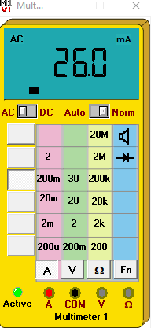
Figure 18

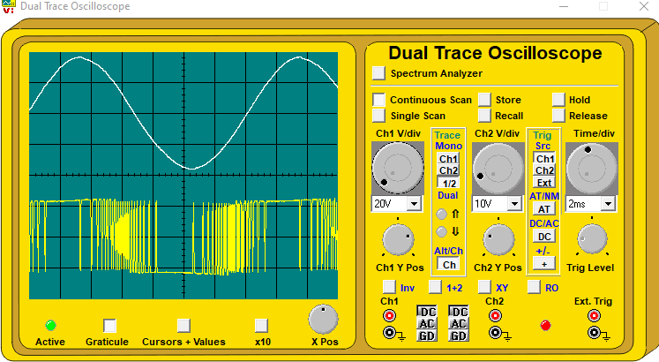
Figure 19

Once the short circuit is introduced into the system, the supply voltage immediately reduces to zero. The formation of the current amplitude appears to remain the same as when the short was not active. As the short circuit is allowed to stay for a longer period, the current rises to a maximum and then gradually reduces. Once the short is removed the voltage and current slowly return to normal. If the power is switched off and immediately back on, the supply will not return to normal. However, is the power is switched off for a period (five minutes in this instance) then the supply will return to normal.

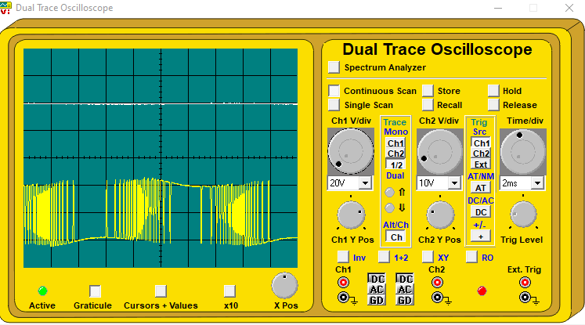
Figure 20 – Over-current protection with short introduced

Discussion

This section is a brief discussion on why the results gained are the way they are, and why the systems behave in the ways observed.

PFC

Reactive components such as capacitors and inductors to not dissipate power. Capacitors charge to a peak of applied voltage as it rises to a maximum. Inductors store energy in the magnetic field as the current rises to maximum. Both return their stored values on the following quarter cycle. With a capacitor circuit the current leads the voltage whereas in an inductive circuit the voltage leads the current. Changing the value of capacitance will shift the current closer to the voltage if it is lagging, but too much will shift the current in front of the voltage to be leading. Gaining an appropriate capacitance that reduces the phase angle to as small as possible is the goal.

Three-phase Inverter

An inverted performs the function of turning D.C. signal into A.C. In order to do this, the microprocessor generates pulses of different widths that are clocked and stored in EPROM. This is known as pulse width modulation (PWM). A visual indicator of the pulses can be seen in figure 20. The broader the pulse, the more positive the output voltage will be. The pulses shown are integrated to produce a sine wave. Normally this wave would have ripple which would produce a non-uniform wave, but this wave has been smoothed by the inductance of the transformer. The waveform shape is limited by the control over the width of the pulses. The more frequent/accurate that the pulses are the more accurate the wave form will be. The output sine waves are controlled by the frequency of the clocking pulse which drives the microprocessor.

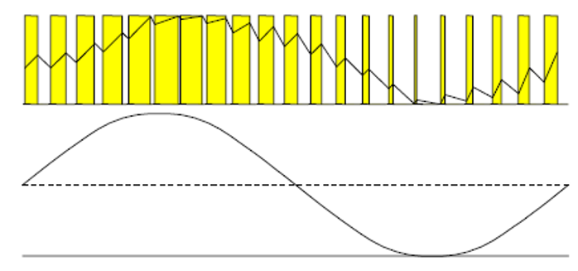
Figure 21

Over-current Protection

As seen in the results, once a short circuit is introduced, the supply voltage immediately reduces to zero while the current is allowed to rise. This is to prevent damage to the circuit. If the short circuit is immediately remedied, then the supply will return to normal. If, however, the short remains, and the current in the circuit is high, a thermal protection circuit is brought into operation. The thermal protection circuit alters the pulses of the microcontroller to reduce the output voltage further, bringing the current to a safe level. After this has happened, the thermal fuse will be at a high temperature and needs time to reduce its heat. The system must be powered off in order to do this. Therefore, the current will remain at maximum when switching power on and off but will return to normal if left for a longer period.

Conclusion

In conclusion the following has been learned and observed during this assignment.
- Power factor correction aims to improve the power factor of a circuit. This can be done by increasing the capacitive or inductive values of the circuit. It is important to try and gain a power factor of as near to 1 as possible.
- The method used to generate an AC sine wave from a microprocessor is pulse width modulation. This works by integrating the pulses of a DC signal and smoothing any ripple with inductance.
- In order to protect a circuit from damage due to a short circuit, over-current protection is utilised. When a short is experienced, the voltage is immediately reduced to zero to protect the circuit from damage. Current remains high for a period until this is also reduced by a thermal fuse.

References

[1] | Fluke, “What is power factor and why is it important?,” Fluke, [Online]. Available: https://www.fluke.com/en-gb/learn/blog/power-quality/power-factor-formula. [Accessed Tuesday 05 April 2022].
[2] | J. Ware, “Power factor correction,” IET, [Online]. Available: https://electrical.theiet.org/media/1687/power-factor-correction-pfc.pdf. [Accessed Tuesday 05 April 2022].
[3] | E. technology, “Three-phase induction motor- Construction,” Electrical technology, [Online]. Available: https://www.electricaltechnology.org/2020/05/three-phase-induction-motor.html. [Accessed Tuesday 05 April 2022].

