
prOFESSIONAL cAREER DEVELOPment
THOHURA AHMED 1806406


Contents……to be added

Summary

The purpose of this report is to give myself and the reader a clear understanding of my current position as well as analyse and create an action plan from the research I have carried out.
I have researched a variety of learning style strategies and utilized learning tools & models in order to focus on the steps necessary to further develop my learning.

Introduction

I will be writing a reflective review of my learning journey through my personal development.
I will be contemplating why I believe professional career development is both crucial and imperative.
In this report I will include an outline of my understanding of the self-awareness skills and knowledge which contribute towards working effectively and being employment ready. I will attain this using swot analysis, GO MAD framework, smart targets, VARK, as well as Honey & Mumford’s learning styles.
The overall objectives of this report is to showcase my development skills and knowledge mentioned above in order to Improve my career prospects and progress to a management level.

Findings

Part 1

Career progression

I believe learning is a key aspect in life. If you do not learn then it will be difficult for you to attain success in any field.
Professional career development is the improvement of skills & qualifications. In order to increase knowledge, experiences, abilities and understanding through learning, developing one’s professional skills is vital to getting promoted to higher level of jobs and positions.
At present I am a house wife, mother of three beautiful children. I have A-levels qualifications but would like to be an academic.
Although I have a satisfactory communication and bilingual skills, I do not have a higher education qualification which is a requirement for managerial role.

Seven habits of highly effective people

One of the very first things I learnt during this course was Stephen Covey’s ‘7 habits of highly effective people’. He suggests that when embarking on an endeavour, people who achieve success begin with ‘the end in mind’. Covey (1989).

To help me secure a successful completion of my degree, I have adopted this strategy of visualising my ‘end’.
1 Habits include being proactive. Don’t dwell in negativity of a situation. Instead taking an initiative action to improve oneself/product.
2 Begin with ‘end’ in mind.
3 Put first things first.
4 Think Win-Win. Another person not need to lose in order for you to succeed.
5 Seek first to understand & then to be understood.
6 Synergise ‘The whole is greater than some of its part’. Stephen Covey, (2018)
7 Sharpen your saw. Brush up on existing or learn new skills. Stay up to date.
(Covey, S. R., insert pag1999)

SWOT

SWOT Analysis is a simple but useful framework for analysing your strengths and weaknesses. It is a very useful technique for understanding both the opportunities open to you and the threats you face when used with Johari’s window. It helps you focus on your strengths, minimize threats, and take the greatest possible advantage of opportunities available to you. It is a simple way of analysing your level of readiness for any task. It can take you to the core of the issue very quickly.
SWOT analysis is a tool designed to enable businesses to function at optimum level. It was first referenced by Albert Humphries, (1960-70). This model has been adopted across the board and these principles can be used on a personal level. The acronym SWOT stands for; Strengths, Weaknesses, Opportunities and Threats.

Diagram 3.2 Johari’s Window

Johari’s window is an excellent way of diagnosing one’s potentials. It makes you identify your skills/talents/ experience you may have which are known to yourself and others.

Diagram 3.3 Swot table

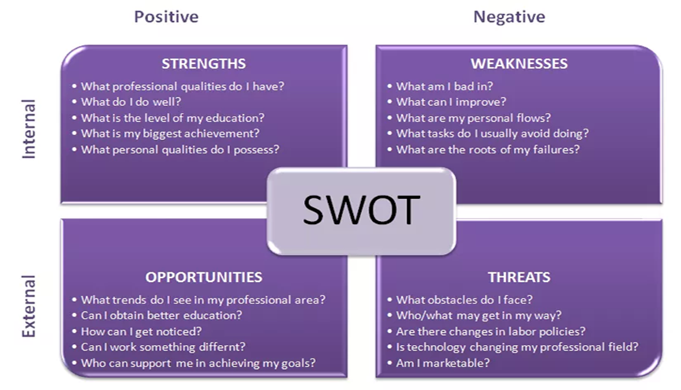

I then used my outcome from Johari’s Window to further find my personal SWOT using diagram 3.3
See table 3.4 for results

Table 3.4 My SWOT Analysis.
Strengths | Weaknesses
-Quick and keen learner.  -perfectionist.  -optimistic.  -confident, head full of determination.  -well organised.  -creative.  -don’t give up easily.  -good problem solver.  -good friend/ support/ well-wisher.  -know what I’m doing.  -emotional when it comes to family.  -good at speaking/ bilingual/ eloquent and persuasive.  -positive thinker, mostly focus on positive things in any given situation.  -good at cooking, baking and personalised frames.  -able to find deep meaning to words/ things.  -cannot leave chores/work unfinished (no peace until task completed)  - persistent in trying until skill is acquired  -Work well in a team  -Enjoy learning  -Positive outlook  -Reliable and empathetic | -sometimes lack confidence  -can be hasty at (very few) times.  -not so good using information technology  -not too confident using IT  -panic when not on top of things.  -can get distracted  -sometimes not so confident.  -can be hasty at (very few) times.  -not so good or confident using technology.  -panic when not on top of things.  -can get distracted
Opportunities | Threats
-confident. I can do good networking and go for interviews.  -optimistic. try and find a solution to things others maybe missing.  -quick, keen learner. Learn new skills easily and stay up to date with technology.  -well organised. Plan a head. Have a vision of tasks I will carry out over a set period.  - find deep meaning of things. Do research to learn about something in depth from  -Enrolled on skills course  -Gain qualifications  -Access to teachers with vast expertise and  -knowledge  -Make connections with people | -not confident or skilled enough with technology. Therefore, risk being less competitive.  -not always confident in myself. Holds me back from trying something which I know I can do well. Need moral support at times to push me in the right direction.  - Hesitant at times. Sometimes lack confidence and need second opinion. Therefore, may lose out on good opportunities.  -over confident. May make a mistake.  -Lack of degree hinders career progression e.g. management role  -Everything is done electronically

Learning styles

Honey & Mumford

Peter Honey & Alan Mumford developed a method of learning style based on and expanded further from Kolb’s cycle. (1982). “Learning is the process whereby knowledge is created through the transformation of experience” (Kolb, 1984, p. 38). Kolb's experiential learning style theory is typically represented by four stage learning cycle in which the learner touches all the bases.
They suggest there are four different approaches and preferences towards learning. some people are better at learning in specific way(s) and if they were to understand which learning style they lean more towards, they would be in better position to learn more effectively.
George Evans (date) suggests every person can learn. Everyone’s learning progress depends on the individuals. Some are quick learners while others may take time to understand as well as individuals’ learning style(s) varies. (reference)
The four different approaches are:
*Activists. They learn by having an active involvement in concrete tasks and relatively short-term goals.
*Reflectors. They review, reflect, stand back, listen and think.
*Theorists learn by taking on new situations but need to relate to theory.
*Pragmatists who learn by linking new information real life problems. They like techniques which can be applied immediately.

Diagram 3.4 Honey & Mumford learning style table

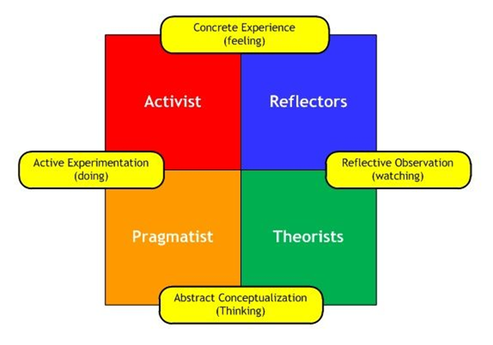

VARK

In 1990’s Fleming & Mills (1992) developed a learning style model called VARK. This model works on the premises that people absorb information in different ways and learn by using all their senses. There are four categories for this.
Visual learners learn best when taught with images, pictures, videos, posters, slides and other things which is by using optical methods. Seeing and learning from observation and examining.
Aural learners. They learn using aural methods. These include listening, speaking, discussions and expressing views with others.
Read/Write strategies. These learners use self-explanatory to learn, by reading and writing information.
Kinaesthetic learners find using hands on experience and practical activities help them learn better.
(www.Vark-learn.com)

After completing the above ‘styles of learning’ questionnaires, the results show I am an aural and read/write learner. I learn best when engaging in verbal conversations.
According to Honey & Mumford, I lean more towards a reflector and then closely followed by theorists. Please see questionnaires 3.8 and 3.9 in appendices for further information.

Go MAD

Andy Gilbert and Ian Chakrovairty developed the Go Mad Thinking Model System with the book originally published in 1999.
This model was made by Gilbert & Chakrovaity in 2001. Go mad model can be used for diagnostic tool as well as an analytical tool. Go mad framework can be used as a flexible coaching pathway to help gain clarity, explore possibilities, build a plan of priorities including who to involve and challenge people to take responsibility for their actions.

Go mad framework can be used to coach people facilitate teams and even train managers to coach their teams for maximum effect.
(www.Gomadthinking.com/accelerating-results/coaching-facilitation/)

For Go MAD Framework see diagram 3.5 in appendices

SIDBAC

I have used SIDBAC to help me answer my questions in the Go MAD framework.
SITBAC
Strength – strong reason (Goal).
Importance – Important to Plan and prioritise.
Tasks – Possible tasks to undertake and people to involve with assisting in completing tasks
Buy in – convincing people to buy into your plan – so they also buy into your goal.
Achievability – how achievable do you believe your goal is, with time scales in mind, the knowledge you currently pose along with confidence and resources available to you.
Check – Maintain high level of self-belief and why – without either it would not work.

SMART

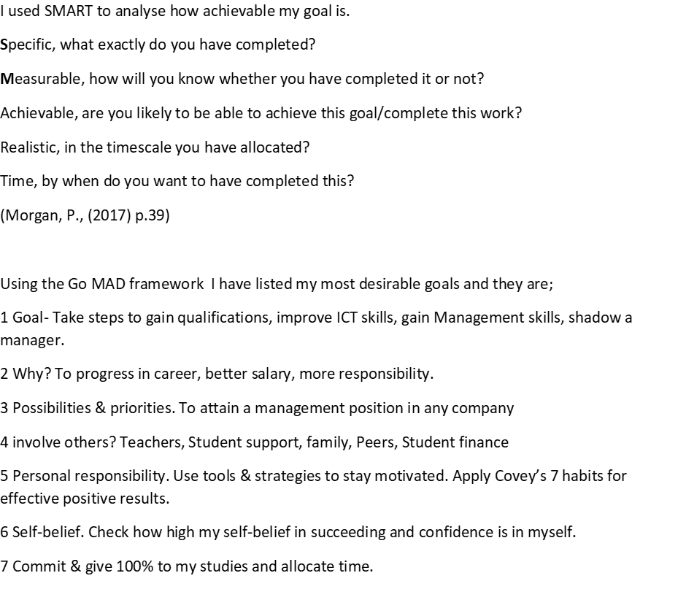

PDP (Personal Development Plan) Table 3.6

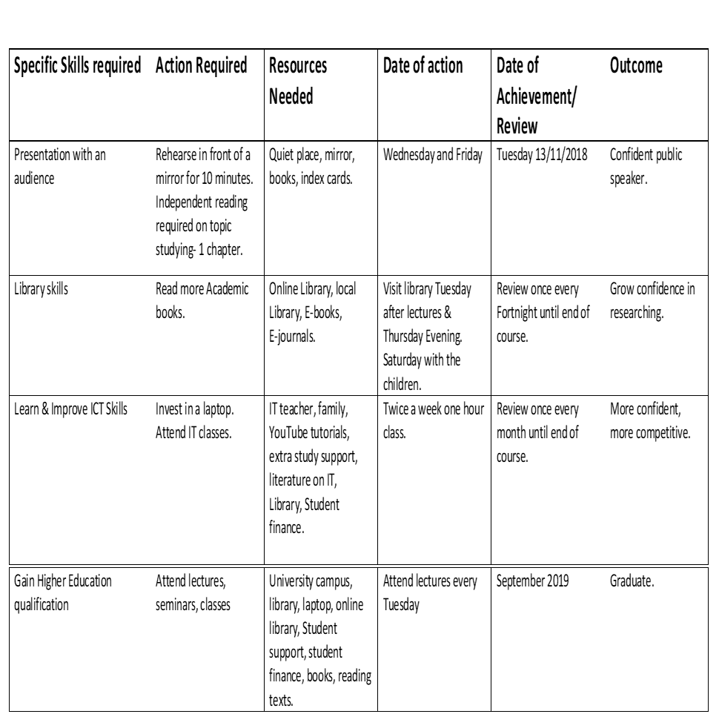

3.7 Part 2

I have chosen these important points in table 5 to focus on as they need to be addressed urgently. The main reason being I need to learn these skills as soon as possible as they are crucial for my learning and development skills. Not only for this course but for life experience.
I have taken questions from diagram 4 and used to help me question and reason my urgent needs of learning in order to complete my tasks and reach my goal.

I have used to answer my questions using SMART goals
I would rate my goals in table 3.6 to be very achievable. Rating these as 1 being not achievable to 10 being very achievable. I would rate all my goals to be 10. I am determined to learn these skills in the time frame given. I will do this by the necessary action(s) listed in table.
I would rate my confidence level in carrying out these tasks to be 10. I will give my best 100% in achieving my goals.
The areas I would like to develop are giving presentations in front of an audience. This will not only build my confidence and gain experience with communication skills with large number of people at the same time. Improving my speech and eye contact skills.
Another area I have chosen as important for me to learn is library skills. I have some skills to use the online library but lack knowledge of accessing other online materials which will benefit from a vast-resources available at my disposal.
Although I have some ICT skills. This field is very important for me to acquire as there is a requirement of IT skills in most modern work places.
Lastly my long-term goal is to complete this course and gain Higher Education qualification. This will enable me to advance to a Managerial position in any company.
As demonstrated earlier in the conversion strategy, I would need to develop my IT skills. This is necessary in all aspects of my studies and career. It would greatly help further my research skills when completing and submitting my assignments electronically. Here is an example of how I would use smart goals and objectives to achieve ICT skills. Specific – enrol on and gain a European computer driving licence (ECDL) qualification in Cardiff.
Measurable – by completing different computer programme and office productivity software, applications. Including Word, Excel, PowerPoint etc. By progressing through beginner, intermediate to advanced level. Also, by getting feedback off tutor on how I am progressing. I would also use what I have learnt and apply it on the assignments set out by the course.
Achievable – by breaking down and learning step by step what the course entails. By believing in myself. I have managed to learn and use other new technology so should be able to learn this too. Thereby developing my skills.
Realistic – by possessing a laptop for personal use. Attending and participating in all lectures and practicing at home. Learning valuable skills from tutors, friends, family and fellow students. Keeping in mind there is an online version of the course available as a backup plan!
Time based – to complete the course in 12 months and gain the Skills for the workplace qualification. Personal Development Plan In a managerial role I would need to address many groups of people too. I find I struggle with presentation skills. I get extremely nervous and find it difficult to talk loud and clear. This is a skill which is I need to develop further.

Barriers & Support

At present I’m not driving which mean I must attend all my lectures via public transports. I have a small family who need my attention. I find multitasking a breeze and hence I can juggle both study and family life. My greatest barrier is I lack knowledge in IT and I would want to overcome that during this course.
My largest support has been my husband. He encouraged me to join this course and fulfil my dream of becoming an academic, gaining HE qualification. My lecturers are always there on standby to guide me and help may it be in class or online.

Conclusion

I have discussed in detail a reflective review of my learning journey through my personal development and have explained why I believe professional career development is important for career success. I have also outlined and demonstrated my understanding of the process by discussing the skills and knowledge which contributes towards working effectively and being employment ready. I have supported my findings using models and strategies and extracts of suitable academic research.
I Have provided references using the Harvard referencing system. I believe I have achieved my objective of showcasing my development of the skills and knowledge mentioned in this report to help enhance and increase my chances of career progression to a management level.

Recommendations

The recommendations I would follow from the conclusions of my report are to study according to the preferences identified by the Learning style questionnaire’s i.e. Aural/read/write from VARK. Reflector and Theorist from Honey and Mumford, build on my Strengths, tackle my weaknesses and practice IT skills as much as possible.

References

Morgan, P. (2017) The business students guide to study and employability. London: Sage publications ltd (Chapter 5, pages 96-97)
Covey, S. R. (1999) The seven habits of highly effective people. London: Simon & Schuster UK ltd
Covey, S. R. (1989) 7 habits of highly effective people. [online], Available at www.youtube.com/watch?v=ktITxC4Q8g accessed on 5-11-2018
Morgan, P. (2017)
Mindtools. (no date). Swot analysis. [online]. available at www.mindtools.com/pages/article/newTMC_05.htm accessed on 2-11-2018
Gilbert, A. and Chakrovaity, I. (2001) GoMAD about coaching. Bath: Bath Press.
Kolb, D. A. (1984) Experiential Learning: Experience as the source of Learning and Development. Englewood Cliffs, N J: Prentice Hall.
Honey, P and Mumford, A. (1992) The Manual of Learning Styles. (3rd edition). Maidenhead: Peter Honey.
Maund. A., Shriek. M and Tinkler. P. K., (2017) Certificate in higher education: Skills for the workplace student yearbook. London: sage
www.Vark-learn.com accessed 28-10-18

Appendices

Diagram 3.5 Go MAD Framework

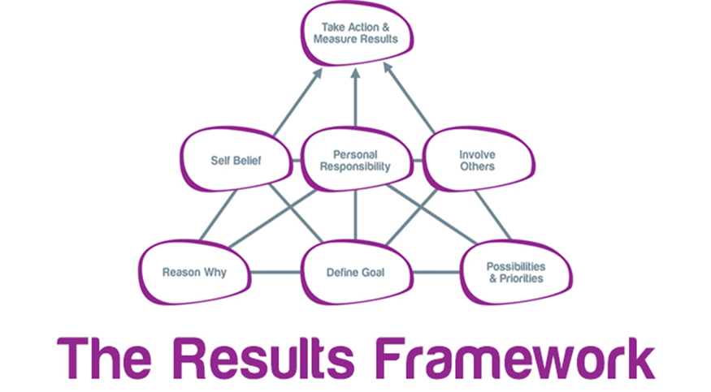

There are three levels of the pyramid. The first two levels refer to personal planning and it links principals 1, 2 and 3 – these are foundations upon which success is built.
Level 1 – Links the Why / What and How. (Principal 1) - Forms strong foundation. Maintains motivation, Face challenges/ overcomes obstacles.
The other cornerstone is well constructed plan of priorities. These principals are linked by defining goal (principal 2) to central support the remaining four principals.
(principal 3) – priorities cannot be planned without a well-defined goal - Well constructed plan of priorities
principal 2 – linked by having a defined goal. The goal cannot be achieved without a strong enough reason to make a difference.
Level 2 – Maintaining momentum. Build upon personal planning of the foundation. Having self-belief (principal 4) to succeed in making a difference is dependent upon having a defined gaol which you believe in – without self-belief a desire to achieve it, the plan will fail.
Involving others (principal 5) should be built into plan and prioritised- without the additional support it might be difficult to move to next level.
At the centre of GO MAD framework is the choice every individual has in taking personal responsibility for their action(s) principal 6. if this choice is exercised then all other all other key principals which all linked to this will stand a chance of being applied.
The third level is making a difference and can only be reached by building the foundations with the first three principals and maintained the momentum by applying 4,5,6 but it is still necessary to act and measure results – principal 7 to know the goal has been achieved and difference has been made.

3.8 Honey & Mumford Learning Style Questionnaire

Insert Questionnaire

3.9 VARK Learning Style Questionnaire
Insert questionnaire

