

Esports: A Breath Of Fresh Air In The 21st Century Or Doomed To Be Overshadowed By “Traditional Sports”?

Course: Business Management
Supervisor: Gareth Hughes
Word Count: 9093

May 2022

Declaration of Originality

I, ............................................Benjamin Lewis Gabriel………………………………… declare that I am the sole author of this Project; that all references cited have been consulted; that I have conducted all work of which this is a record, and that the finished work lies within the prescribed word limits.
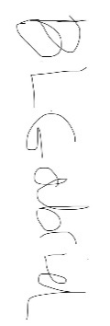
This work has not previously been accepted as part of any other degree submission.

Signed :

Date : ........................13/05/2022.......................

FORM OF CONSENT

I ............................................Benjamin Lewis Gabriel………………………………… hereby consent that my Project, submitted in candidature for the B.A.(Hons) Business Management degree, if successful, may be made available for inter-library loan or photocopying (subject to the law of copyright), and that the title and abstract may be made available to outside organisations.

Signed :

Date : ....................13/05/2022 ...........................

Copyright Acknowledgement

I acknowledge that the copyright of this project report, and any product developed as part of the project, belong to University of Wales Trinity Saint David, Swansea

Abstract
Esports is often a topic which doesn’t receive much praise apart from the people who are interested in the topic it is pushed under the rug by people who don’t see the point in playing video games and therefore don’t see how professional esports athletes are similar to regular athletes, yet they will go home and watch 11 men kick a ball about for 90 minutes each week. Prior research showed that esports has been on the rise since the 90’s with funded tournament from this mid 2000’s and with it growing each year and showing no signs of stopping. The study aimed to examine and analyse the general publics view on what they believe esports needs to accomplish to be recognised and perceived on the same level as “traditional” sports. This study also investigated whether or not lack of representation in sports and sports was a barrier to people wanting to have a career in the area. The study also looked at the effects gambling has on esports and sports as well as briefly looked at the effect the covid 19 pandemic had on esports and sports. The literature review revealed that the main viewers of esports were found to have been found active gamers seeking to improve their skills by watching and learning from their favourite players. The rise of the streaming platform Twitch enabled viewers to watch their favourite players outside major tournaments this allows them to interact with their fans and show them their gameplay as well as explain the mechanics behind the situations they are in. It was also revealed that the French government officially recognises esports as a national sport and expressed heavy interest in potentially adding esports to the 2024 Olympics games which are due to be held in France. A questionnaire was posted online and gathered 25 participants of which 15 were Male and 10 were Female. Results were analysed using google sheets due to the fact that you can export results from google forms into sheets. The main limitations of this topic were regarding the number of participants that completed the questionnaire as only 25% of the intended amount was met. The researcher decided that this was going to be more than likely due to this topic being aimed at the younger generation the older generation is most likely going to not complete the survey if they scrolled past unless the topic piques their interest. Recommendations suggest that the main reason as to why esports aren’t viewed the same is that there needs to be more awareness of what esports as well as that they need to be as entertaining and skilled as “traditional” sports. 40% of women who responded believed that lack of representation is a major barrier to those wishing to pursue a career in the sector, and that 40% of women who feel a lack of representation is a barrier said they have been harassed online because of their gender. Therefore esports needs to focus on becoming a more welcoming community and push out any of the toxic environments which women are turned off by in order to attract more people .

Table Of Contents
Chapter 1 – Introduction 1
1.1 Introduction 1
1.2 Background 1
1.3 Aim And Objectives 2
1.3.1 Primary Research Aim 2
1.3.2 Objectives 2
1.4 Research Structure 2
1.5 Conclusion 3
Chapter 2 – Literature Review 4
2.1.Introduction 4
2.2 Conceptual Framework 5
2.3 Surrounding Literature 6
2.4 Conclusion 8
Chapter 3 - Methodology 10
3.1.Selection Of Research Methods 10
3.2 Research Onion 10
3.2.1 Research Philosophy 11
3.2.2 Research Approaches 11
3.2.3 Research Strategies 11
3.2.4 Choice 12
3.2.5 Time Horizon 12
3.2.6. Data Collection Methods 13
3.2.6.1 Data Collection 13
3.2.6.2 Questionnaire Design + Why Each Question Was Chosen 13
3.2.6.3 Pilot Study 17
3.2.6.4 Analysis 17
3.3 Sample 18
3.4 Reliability and Validity 18
3.5 Limitations 18
3.6 Ethical Considerations 19
3.7 Conclusion 19
Chapter 4 – Data Analysis 20
4.1 Introduction 20
4.2 Data Analysis 20
4.3 Methods 20
4.4 Demographics And Descriptive Statistics 21
4.5 Questionnaire Results 22
4.6 Discussion 29
4.7 Conclusion 32
Chapter 5 – Conclusion And Recommendations 33
5.1 Introduction 33
5.2 Recommendations 33
5.3 Limitations 33
5.4 Further Research 34
5.5 The Achievement Of Objectives 34
5.6 Self Reflection 35
5.7 Conclusion 35
6.0 References 36
7.0 Appendices 42
7.1 Questionnaire Questions 42
7.2 Ethics Form 46
7.3 Research Onion Image 64

Chapter 1 – Introduction

1.1 Introduction
This chapter aims to provide a background and rationale for the research that is going to take place. It will explain the aim and objectives of this research, along with its description and structure as well as anything necessary.

This dissertation aims to examine and provide an answer as “What people think esports needs to accomplish to become recognised and accepted compared to more “traditional sports” also looking at what effects gambling and the COVID-19 Pandemic have on esports as a whole”. The shortened term ‘esports’ (Electronic Sports) will be used quite heavily throughout the study as a shortened term and what the topic is most well-known as to everybody within the sector.

1.2 Background
Since the very first event dating back to the 1970’s and developer funded tournaments being introduced from 2010 onwards. Esports has grown increasingly each year. Back in 2017 “ESL” (Electronic Sports League) welcome 173,000 people in person attended the event and the surround festivals over 2 weekends and over 46 million unique online users to watch people complete at the Spodek arena in Katowice, Poland which was a 30% increase on the previous year (ESL, 2017).

Similarly on the sporting side Footballs most recent large scale sporting event was the euro 2020 final between England and Italy in which around 62,000 fans travelled to watch the clash between the 2 teams and around 31 million viewers watching either on their T.V or online. (UEFA, 2021).

With audience members and online viewers being in the millions and showing no signs of stopping. This bring about the question that is going to be researched for this research project which is “What do Esports need to accomplish to be recognized as being on the same level as sports when compared to traditional sports as viewed by society”.

1.3 Aim And Objectives

1.3.1 Primary Research Aim
To research what people think esports needs to accomplish to become recognised and accepted compared to “traditional sports” also looking at what effects gambling and the COVID-19 pandemic have on esports as a whole with a focus on football as the traditional sport.

1.3.2 Objectives
Objective 1
Critically Analyze to what extent gender and age have on whether people are going to consider watching esports over regular sports due to possible lack of representation in their chosen sport/ esport in a heavily male dominated environment.

Objective 2
Analyze the effect gambling has on esports and the presence in sports in general with a focus on the presence it plays in both esports and sports with a focus on football as the main sport.

Objective 3
Analyze the effect the COVID-19 Pandemic had on esports and the issues that arose from the online era as well as the effect no fans in stadiums had on sports.

1.4 Research Structure
This study will consist of five chapters in order for the dissertation to achieve all of its previously mentioned objectives. The first chapter is an introduction, the second is a literature review, the third is methodologies and methodology, the fourth is responsible for data collection, and the fifth is conclusion and recommendations.

Chapter one will have provided the aims and background of this research as well as identifying the primary aim of this research as well as what the objectives are going to be and also outlines why the research is taking place.

Chapter two will be an in-depth literature review to pre-establish any prior information of the topic as well as highlighting in depth the reasoning behind the aims this chapter will also provide the gap in the research that the researcher is intending to fill.

Chapter three will complete the research of the study aspect by identifying a suitable research method in the form of a questionnaire as well as justifying every aspect of the research should anyone need to question any of it as well as providing a research onion analysis which shows where the research fits in study wise.

Chapter 4 will analyse the primary data that was collected in chapter 3 and discuss anything that was found as a result of the research section. The data will be analysed using google sheets which provides a spreadsheet for all answers to be and also for it to be easy to organise.

Chapter 5 will be the conclusion section and will close off any research as well as discussing the main finding, recommendations as to what should be done next as well as any limitations of the research and there will also a further research section which will briefly cover what should happen next.

1.5 Conclusion
Chapter one provided the aim and background of this research as well as identifying the primary aim of this research as well as what the objectives are going to be and also outlines why the research is taking place. The following chapter will be an in-depth literature review of the topic as well as highlighting in depth the reasoning behind the aims.

Chapter 2 – Literature Review

2.1.Introduction
The main focus of this chapter is to analyse and evaluate the previously done literature available surrounding the main aims and objectives of this dissertation which is “To research what people think esports needs to accomplish to become recognised and accepted compared to more “traditional sports” also looking at what effects gambling and the COVID-19 Pandemic have on esports as a whole”.

This chapter will look at the rise of esports as to where they are today as well as what goes into people’s mind when deciding on what sport to invest their time into looking into audience participation and the human relation theory. This chapter’s research will be conducted using a wide variety of up-to-date sources such as academic journals, web articles, official reported statistics as well as anything else that is found to be relevant to the topic at hand to help achieve and gain a more understand of the research already conducted surrounding the aims laid out in the previous chapter.

The literature review has been carried out using google scholar and the University of Wales Trinity Saint David’s library database with the intent on using the information found to assist the research found as a result of the primary research and will help identify the gaps that are present within the surrounding topics this will be concluded upon in Chapter 4. The main parameters that were used to find relevant literature on google scholar and using the UWTSD database was “esports”, “gambling within esports/sports,” “football” and “COVID 19 Pandemic effects on sports” intending on finding the most accurate literature toward my topic and the parallels between both.

This dissertation is intended to bridge the gap between “traditional sports” and esports as it shows no signs of stopping and could one day grow to be on the same level. This will also help researchers to understand what goes through someone’s mind when pursuing a career in esports over “traditional sports”.

2.2 Conceptual Framework
Regarding the aims and research question that is being tackled back in chapter 1 this section of chapter 2 is going to focus on what framework will be used when analysing the current situation esports is in the main theories that are going to be focused upon are Stuart Hall’s “Audience response theory” (Hall, 2001) and Elton Mayo’s “Human Relation Theory” (Mayo, 2003) as it has been shown they are the most beneficial when analysis the audience’s impact on decision making also how the structures is formed as well as understand why people play the same game over and over for many years straight.

The audience response model suggests that an active audience engages, observes, and reacts to various types of media in various ways, as well as being capable of challenging the ideas expressed, as opposed to a passive observer, who is more willing to accept messages without questioning them, and thus is more likely to be directly affected by the messages. This concept may be traced all the way back to Stuart Hall's studies in the 1980s and 1990s, when he claimed that the media had the ability to affect people directly. He further argued that the audience might change the message to fit their existing social situation (Hall, 2001).

The human relation theory suggested that productivity and efficiency and motivation can be strengthened by strong social relationships in the workplace and recognition of the individual as a unique person, according to the human relation theory, which was initially advocated by Elton Mayo in the twentieth century. It claims that better working environment results in higher output with some aspects of the theory being traced back to as far as the 1920’s. This dissertation decided to focus on this theory because certain esports require immense teamwork and coordination and having bonds with the teammates has been proven to produce better results even under pressure. This theory also states that effective management is essential to producing better results (Mayo, 2003).

2.3 Surrounding Literature
Electronic sports, often known as esports, are described as "a type of sport or activity in which people exercise their mental or physical talents via the use of information and communication technology" (Wagner, 2007). While no definition of esports has been established, as the industry grew larger and drew more attention, the bigger picture became clear, and there was no doubt a link between esports and traditional sports such as competitive leagues, live broadcasts, and a global following (Funk et al, 2018). It should also be noted that esports can take place independently or as part of a team with as many as 6 players involved, including on a casual level at local tournaments.

The main viewers of esports have been found to be active gamers seeking to improve their gameplay skills and performance by watching others play and learning from their favourite players (Jang et al, 2020). With the ever-increasing popularity of streaming games to people using sites such as Twitch and YouTube enabling viewers to watch their favourite players outside of large-scale double elimination tournaments where its 2 loses and you’re out this allows them to interact with their fans whilst also showing them their gameplay explain the mechanics behind the situations they are in which is something sports players cannot do live only watching replays and analysing them.

Similar to how Sky Sports has the rights to every formula 1 race from 2019-2024 (Sky Sports ,2016). Esports has a comparable distribution as traditional sports. It was also disclosed that in 2020, YouTube purchased the rights to act as the broadcaster for all Activision Blizzard esports events in a three-year exclusive deal worth $160 million, which includes the Overwatch, Hearthstone and Call Of Duty pro scenes replacing the previous broadcaster of twitch (Stern, 2020). This is just 3 competitions that takes places every year where teams compete against each other further pushing the idea that there are parallels between esports and traditional sports (Wolf, 2018). The French government has also formally recognised esports as a national sport and has voiced strong interest in potentially include esports in the 2024 Olympics, which will be held in France (BBC News ,2018).

Gambling is prevalent almost everywhere we go from the national lottery which is held every week in which around 70% of the UK's over 18s take part in which is close to 45 million people to being able to bet on nearing every sporting event (The National Lottery, 2022) and video games are no different just because they named differently they purpose is the same. Loot boxes are video game consumables that can be purchased with real money and offer players with a randomly selected reward of unknown value. Players have no means of knowing exactly what they'll get in exchange for their money when they pay it.

Loot boxes were identified in 58.0% of the top Google Play games, 59.0% of the top iPhone games, and 36.0% of the top Steam titles, according to an examination of the top 100 games from both the Google Play and Apple App stores, as well as the top 50 most-played games on Steam. 93.1% of Android games with loot boxes and 94.9 percent of iPhone games with loot boxes were rated acceptable for children aged 12 and higher. Only 38.8 percent of desktop games containing loot boxes were made available to children, indicating that age ratings were slightly more conservative in evaluating whether loot boxes are available in games that children are permitted to play if they are launched on PC (Zendle et al, 2020).

Just like when esports moved to online as result of the Covid-19 Pandemic, Sports also had to stop for a while whilst people worked out a solution to bring them back to T.V. One example being a lot of sports leagues including rugby and footballs were paused and a lot of the athletes ceased heavy training whilst a solution was found (The Guardian, 2020). These events were later held in sports bubbles where players had to have negative covid test on the day of the match these took place without a live audience.

Given the sport industry's significant position in society and its symbolic importance in relation to health, hope, and joy, the suspension of sporting events and limits on physical activity and live spectators has sparked heated debate. Simply said, people's participation in sports may have a significant impact on their well-being, which is especially vital amid a global crisis that much of the globe hasn't seen in a long time. It should also be mentioned that by 2020, 50 Overwatch League players had dropped out, citing the league's stress and mental health difficulties (Castello, 2020).

When it comes to the gender of a person, In terms of women's roles in esports, research has indicated that they are with in minority, accounting for only 5% of all competitors at the top level (Hilbert, 2019) Moreover, studies have claimed that the fabrication of masculinity in esports, which is acquired from video games, does have real and significant bad repercussions for equality when it comes to women in high tiers of video games (Xue et al, 2019), putting them in a vulnerable situation in which they frequently face general and sexual discrimination from other players (Ruvalcaba et al., 2018). Despite this, women's participation in esports has surged in recent years. All of these unfavourable attitudes against women make them feel dissatisfied, as they perceive the esports sector to be run by and heavily for males (Rogstad, 2021). As a result, it becomes reasonable to draw a differentiation between men and women while investigating brand-related factors in order to see if gender inequalities exist in esports.

Of the original 100 players that were selected for the Overwatch Leagues first season none of them were female. Many event analysts observed the absence of Kim "Geguri" Se-Yeon, a female teenager from South Korea who was recognised for being one of the most talented players on the Overwatch Zarya (Carpenter, 2018). During the press day of the event multiple teams had acknowledged that they had considered signing her but decided against it due to it potentially being viewed as a publicity stunt and the nature of it would shadow her career and potentially attract unwanted negative attention (Grayson, 2018). She did eventually get signed by the Shanghai Dragons a well-known Chinese team during the mid-season transfer window and the Overwatch League commissioner Nate Nanzer stated that she has inspired "millions of females" all around the world, and Nate was named one of Forbes' 40 under 40 in 2018 as a result of the Overwatch League's popularity. (Forbes, 2018).

2.4 Conclusion
According to the study conducted as part of the literature review, the primary viewers of esports were found to be active gamers looking to better their gameplay abilities and performance by watching others play and learning from their favourite players (Jang et al, 2020). With the ever-increasing popularity of streaming games to people using sites such as Twitch and YouTube which enable viewers to watch their favourite players outside major tournaments this allows them to interact with their fans whilst also showing them their gameplay explain the mechanics behind the situations they are in which is something they have that sports player cannot do live as they can only watch replays and analysing them esports players can do it live. The literature review also indicated that the French government officially recognises esports as a national sport and has expressed strong interest in potentially including esports in the 2024 Olympics, which will be held in France. (BBC News , 2018).

The prior research done on the topic also revealed that gambling is prevalent almost everywhere we go, and video games are no different just because they are named differently their purpose is still the same which is to take your money. Loot boxes are video game consumables that can be purchased, and people have no means of knowing whether they are going to get a common item or a legendary item in exchange for their money when they pay it also that children are allowed to play these games with loot boxes inside them although only 38% of games aim towards kids have them.

The dissertation aims to provide more light into what goes into people’s mind when choosing traditional sports over regular sports when the number for esports are rising and showing no signs of stopping.

The following chapter will identify the suitable research methodologies and methodology to solve the concerns indicated by this chapter's literature evaluation.

Chapter 3 - Methodology
This study is based upon the experience of the public and what people think esports needs to accomplish to become recognised and accepted compared to more “traditional sports” also looks at what effects gambling and the COVID-19 pandemic have on esports as a whole as well as the effect on traditional sports. Primary information will be collected via online questionnaires which will be sent out and responded to by people around the world as the chosen topic at hand isn’t based in a singular area but worldwide. The rest of the information will be collected from online sources such as databases and news articles as collecting information solely based in Swansea wouldn’t provide a large enough audience to reliably draw any conclusions and make repeating it for different people rather difficult.

3.1.Selection Of Research Methods
When deciding on what method was best suited to conduct the study, various methods were considered with comparisons based on these positives and negatives and eventually decided on questionnaires as the main form of primary research due to the nature of the study and it is worldwide not based in a singular city questionnaire allowed the study to be conducted worldwide enabling participants from around the world with little to no issues other than language barriers (Johnson et al, 2000). Most information gathered can be split into 2 diverse types: “Quantitative” and “Qualitative”. Quantitative data is non-numerical information such as interviews, diaries, replies to open-ended questions, sound files, and pictures are just some examples of qualitative data (Taylor et al, 2005). The act of acquiring, analysing, and comprehending non-numerical data, such as speech, is known as qualitative research. Qualitative research may be used to discover how a person perceives and understands their social surroundings (Gelo et al, 2008).

3.2 Research Onion
The research onion framework (see appendix section 7. 3 for image) was created by Saunders (Saunders et al, 2007). Which outlines the several components of the research that is taking place that must be considered and addressed to arrive at a decent research methodology.

3.2.1 Research Philosophy
As described by Geoff Walsham in 1995 (Walsham, 1995). The effect of social and cultural factors on an individual is referred to as interpretivism. This viewpoint focuses on people's thoughts and ideas in the context of their social and economic circumstances. To get a thorough knowledge of the participants and their behaviours, beliefs, and intentions, the interpretative research theory encourages the researcher to take a more active role in the inquiry.. This study falls under Interpretivism since it is based on gathering people’s answers from a questionnaire and using them to draw a conclusion based on what is found.

3.2.2 Research Approaches
This study will be using an inductive approach as according to David Thomas (Thomas, 2006). When there is really little knowledge about a topic, an inductive research strategy is applied, which means that any information acquired can be translated into ideas based on what has been discovered as a result of the study. Another reason inductive will be used is that since Esports are still a new topic there are only limited amounts of information out there and a lot of that information is related to the video games themselves rather than the tournaments they are a part of. The public's responses will be analysed, and a result will be decided based on the findings. Furthermore, because the theories will be founded on the findings, there will be no hypothesis during the first phases, as any deductions will have to wait until the end of the study owing to the nature of the research.

3.2.3 Research Strategies
There are a lot of different methods and techniques that can be used when gathering data and all of them have their advantages and disadvantages such as interviews allow you to build up a rapport with your participants and allows more clarity on certain answers they give ensuring you receive the correct answers for what you asked them. Questionnaires on the other hand allow you to reach a wider audience enabling a lot more participants in your study but you can’t discuss any issues that arise within questions due to participants realistically being from anywhere (Granello et al, 2004).

When conducing this study surveys and questionnaire were decided on as the best option of data collection as esports is a very worldwide based topic and having participants from round the world would make the research more dependable and valid instead of just a single area in one country. The survey was built using Google Forms and distributed across social media platforms such as WhatsApp, Facebook, Discord, and Reddit. The questionnaires remained confidential and anonymous which enabled participants to not feel restricted by any of the answers that they provided and also allowed anyone with access to an electronic device the ability to participate in the study making the results more consistent and iron out any inconsistencies (De Leeuw, 2005).

3.2.4 Choice
The primary strategy for this study will be a single-method questionnaire and survey-based investigation. (Bell et al, 2018) Says in their first-time guide for researchers that you should use a variety of different collection method if possible to obtain the best results as the country is still coming out of the COVID-19 pandemic and a lot of people are still wary off the virus the researcher decided that it would be best to conduct online questionnaire where there wasn’t any contact between people that could put anyone at risk. Due to the previous statement about the restrictions of the research the researcher decided on only using qualitive based data as the questionnaire that was sent out and the type of topic that was being researched lead to a lot of open-ended questions and people giving them opinions on topics and then making conclusions based upon the information given (Punch, 2013). By only using qualitive data although the research is restricting themselves by only using one type of data this allows the data to be analysed in more depth resulting in more consistent conclusion, more reliable data and more precisely related to the topic. Since there is only one data set there was limitations as you can’t verify the results being given against the participants. Another issue was that qualitive research requires a lot of thought into each question as a lot of it is based upon opinion and judgement numbers and results this also makes them quite hard to replicate (Silverman, 2015).

3.2.5 Time Horizon
As the period for this study is around 6 months the researcher best decided that the most useful time horizon would be cross section where a certain section in time gets analysed. According to (Munn et al, 1990) Questionnaires are best used when doing research over a brief period of time which means as the study is taking place over 6 months cross sectional would be the correct time horizon.

3.2.6. Data Collection Methods

3.2.6.1 Data Collection
This study will be primary research based which means collecting data based on a pre-set question which was decided prior to the study. The primary research in this study will be obtained via questionnaire and will be distributed to the general public. According to Ghauri, the downsides of questionnaires include their time commitment and lack of access to the essential resources. This study has direct public access and adequate time to conduct a cross-sectional study (Ghauri et al, 2020).

3.2.6.2 Questionnaire Design + Why Each Question Was Chosen
A lot of consideration is needed when designing a questionairre such as how many of each type of questions are needed and what types of questions they are going to be. E.g., Closed, Open, Rating. This questionairre used closed questions with a few opened ended questions intended of giving recipients a chance to comment using their own opinion (Siniscalco et al, 2005). The researcher chose to use question types because they give the best responses to the questions asked and allow the researcher to analyse the data. The researcher kept the closed questions to only “Yes” or “No” options as having the 3rd option of maybe would make the research not analysable due to it becoming a median.

Also consideration was given to questions which may make the participants uncomfortable such which is why all the question were pretested with 5 participants varying in age and gender to ensure all question would be appropriate for anyone no matter the age (Taherdoost, 2016).

Questionnaire
Introduction
This was presented to the participants to inform them of the why the study is taking place and what the objective of the study is and also explains why the email is needed (See appendix 7.1 for full questionnaire).

Question 1
This question notifies the participant that all data obtained from this questionnaire is private and anonymous, and they agree to the data being used as part of the researcher's dissertation study.

Question 2
This question is used to determine the age range of all participants and also helps with analysing the data as previously stated the main age range of Esports watchers is between the ages of 18-25. The other age brackets were determined on where the people would most likely be at in life with the middle bracket being the largest due to it being the most prominent bracket for people with families.

Question 3
This question is used to determine the gender of the participants and helps with the analysis sections as previously stated Esports is a heavily male dominated environment and knowing the gender of the participants allows the researcher to see what each genders answer were in relation to the topic.

Question 4
This question is used to determine whether or not each participant has ever watched any Esports as since the primary aim is to do with gaging what people think Esports needs to do to become more like traditional sports having one of the 1st questions be about esports helps the researcher establish who actually has prior knowledge of Esports.

Question 5
This question is used to determine whether or not each participant has ever watched any traditional sports as since the primary aim is to do with understanding what goes through people’s minds when they decide whether or not to watch sports. This helps the researcher establish who actually has prior knowledge of traditional sports.

Question 6
This question is used to determine how much traditional sports each participant watches and helps the researcher understand how heavy of a fan is the participant.

Question 7
Similar to the previous question this is used to determine how much Esports each participant watches and helps the researcher understand how heavy of a fan is the participant.

Question 8
This question is used to determine how if the participant has gambled if at all as the 2nd aim of the research project is determining how big of a presence and effect gambling has on Esports and traditional sports.

Question 9
This question is used to determine why each participant gambles if at all and as previously found out 75% of the UK’s over 18’s gamble this question helps the researcher gain and understanding of the different reason behind why people gamble.

Question 10
This question helps the researcher with the 2nd aim of the study relating to gambling and helps the researcher understand different people’s perspectives on whether or not they think the gambling presence has an effect on the viewer.

Question 11
This question assists the researcher with the second goal of the study, which is to learn how frequently various people gamble and is valuable during the analysis part when contrasted to whether or not they believe gambling has an influence on the viewer.

Question 12
This question assists the researcher with the third goal of the study, which is to comprehend different people's viewpoints on whether or not having no supporters in stadiums and events affected the outcome of the match.

Question 13
This question is used to determine whether or not anyone has been harassed online as a result of their Gender, Race or Sexuality. This question is used to answer the 2nd half of the 1st research aim which is to determine whether a lack of representation in their chosen sport/ esport in a heavily male dominated environment affects their decision to pursue a career in the Sport/ Esport.

Question 14
This question is used to determine what the participants reasons are for not choosing to watch sports if they have chosen not to. This question is used to answer the main research aim which is to research what people think esports needs to accomplish to become recognised and accepted compared to more “traditional sports”.

Question 15
Similar to the previous question this question is used to determine what the participants reasons are for not choosing to watch Esports if they have chosen not to. Just like the last question this question is used to answer the main research aim which is to research what people think esports needs to accomplish to become recognised and accepted compared to more “traditional sports”.

Question 16
This question is used to determine whether or not lack of representation in Sports/ Esports discourages people from pursuing a career in the sport. This question is used to answer the 2nd half of the 1st research aim which is to determine whether a lack of representation in their chosen sport/ esport in a heavily male dominated environment affects their decision to pursue a career in the Sport/ Esport.

Question 17
The last question is an open-ended question giving the participant the chance to voice their own opinion as to what they believe Esports needs to accomplish to be viewed on the same level as traditional sports. This answers the main research aims of the study which is to research what people think esports needs to accomplish to become recognised and accepted compared to more “traditional sports”.

3.2.6.3 Pilot Study
The pilot study was a preliminary test of the questionnaire designed to influence the real questionnaire by highlighting any issues and changing the wording of any questions that the testers found to be hard to understand (In, 2017). The pilot study also shows the researcher the feasibility and the rough amount of time it would take someone to complete the questionnaire. The pilot research was carried out with the help of five interested volunteers, and a few small adjustments were made to the fluidity of the question as well as some of the replies.

3.2.6.4 Analysis
The data will be analysed in section 4 using the “Human Relation theory” as well as the “audience response theory” to identify findings and complete the research aims as well as the study.

3.3 Sample
To have the entire world answer the questionnaire would be completely unreasonable and also very unrealistic. As a result, a smaller sample would be employed to represent the entire population, increasing the study's reliability and validity. This study's target demographic will be the general public, with a little emphasis on gamers due to the prior knowledge of the topic. In order for the research to be considered valid and credible, a sample population of 100 participants was necessary. (Wright , 2005) Says that the number of participants all determines on how much of a margin of error you are willing to have and for a city of 500 if you allow a 10% margin of error you realistically only need 80 people.

The participants for this study were recruited via social media. This was due to a lack of budget and the ability for social media to send the questionnaire across the world and enable the researcher to have a large study.

3.4 Reliability and Validity
Reliability is when the data that is collected is accurate. Reliability and validity are essential in research as without these the data is useless s the same person could’ve answered the questionairre 100 times but just clicked different answers therefore forging the results (Reliability & Validity, 2018).

To make the questionnaire reliable and valid the questionnaire required the entering of the participants email to ensure that only 1 person was entering the questionnaire from one device.

3.5 Limitations
The limitations of the questionnaire were the inability to control who answered the questionnaire therefore potentially leading to one sided answer if a lot of older people answered leading to an imbalance of gender and age. Another limitation of the research was the inability to determine whether the answers given by the participants are truthful especially in some of the deeper question such as the ones about gambling habits (Ochieng, P.A., 2009).

3.6 Ethical Considerations
Ethical considerations refer to the moral aspect of the research meaning is your research conducted with moral aspects taking into consideration. Sales says the importance of ethics in research with human participants is to acknowledge social responsibility and also only ask the necessary questions to obtain the information for you research aims (Sales et al, 2000).

This research questionairre was conducted in line with the ethical standards of The University Of Wales Trinity Saint David with prior approval from the research supervisor along with an ethics form completed prior to the start of the research study. Ethical considerations were met through the participants being anonymous, the research only being used for what was stated on the questionairre and the security of the data that was sent. The surveys were completely optional, which means that no one was compelled to fill them out, and all participants were over the age of 18. To prevent abuse, the data was captured and saved on the researcher's password-protected device. Prior to the questionnaire, the ethics form was completed, and the researcher and supervisor perceived no possible harm to anybody who might participate (Gregory, 2003)

3.7 Conclusion
This section successfully completes the research aspect of the main study which was “To research what people think esports needs to accomplish to become recognised and accepted compared to more “traditional sports” also looking at what effects gambling and the COVID-19 pandemic have on esports as a whole as well as the effect on traditional sports”. This chapter successfully completed the research aspect by identifying a suitable research method in the form of a questionnaire as well as justifying every aspect of the research should anyone need to question any of it.

The following chapter will analyse and discuss the data collected in this chapter and discuss anything that was found as a result of research section.

Chapter 4 – Data Analysis

4.1 Introduction
The main purpose of this chapter is to analyse and present the questionnaire data. The poll, which included 25 participants, investigated what people consider while deciding whether to watch esports or traditional sports.

4.2 Data Analysis
Data analysis entails analysing, classifying, changing, and gathering together all of the data gathered throughout the research stage in order to make appropriate findings and view helpful information (Brandt et al, 1998). Data analysis is critical for organisations because it allows them to make more informed decisions, cut expenses by recognising trends and patterns, and better target their intended audience The data will be compiled using various charts, mostly bar charts and pie charts, as well as open-ended responses that will be categorised based about what each respondent has expressed (Kosslyn, 1989). The primary analysis method will be to use Google Sheets to sort data by individual replies as well as grouped responses based on answers to specific questions and also it will be used due to the fact that you can export all responses from google forms into Google Sheets and the data will be ready for analysis without anything needing to be done.

4.3 Methods
The participants who replied to the questionnaires were split into groups depending on their sex and age (Anscombe, 1973). There were no respondents who answered "nonbinary" or "others," this means that all of the data obtained could be evaluated on the basis of gender. All people who participated had to be 18 years old or older to partake and also due to the fact that one of the questions was regarding gambling which cannot be done unless you 18+ in the UK, age groups were ascertained based on data found during the literature review which stated, "The main viewers of esports have been found to be active gamers seeking to improve their gameplay skills and performance by watching others play and learning from their favourite players (Jang et al, 2020)”.

4.4 Demographics And Descriptive Statistics
This study recruited 25 participants through an online questionnaire posted on WhatsApp, Facebook, and Discord, a social media platform used by gamers, which assisted in bringing individuals who also had an interest in the subject as well as people who had prior knowledge about the subject, while Facebook and WhatsApp had been used to gain a large sample size for contrast (Gondran et al, 1984).

Of the total 25 respondents, 60% of the participants were male and 40% were female. In terms of age bracket 68% of the participants were between the ages of 18-25, 24% was between the ages of 51-64 and the remaining 10% was 1 participant who was between 26-35 and 1 participant who was between 36-50 . It should also be noted that 60% of the participants had heard of Esports beforehand and 40% had not whilst 88% of the participants had previously watched sports and only 12% had not.

4.5 Questionnaire Results
Question1
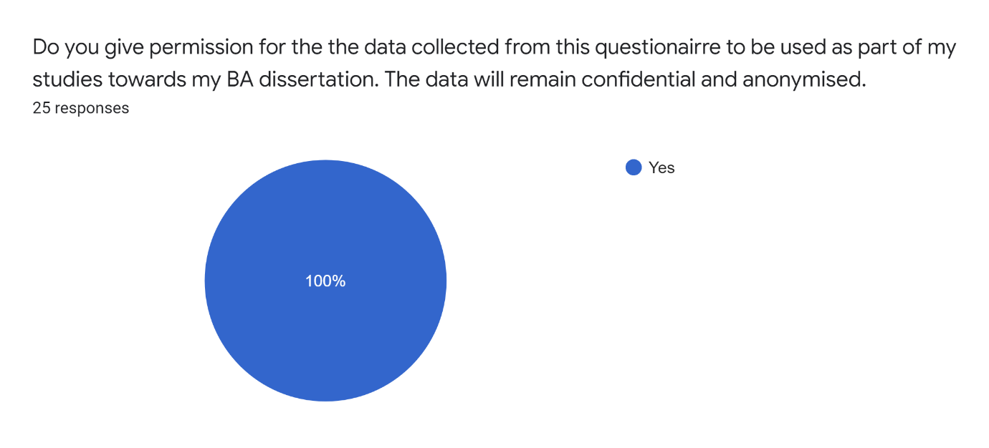
Question 2
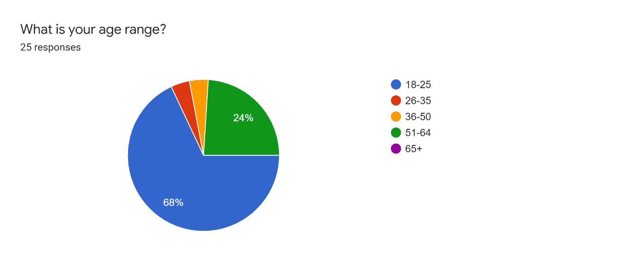
Question 3
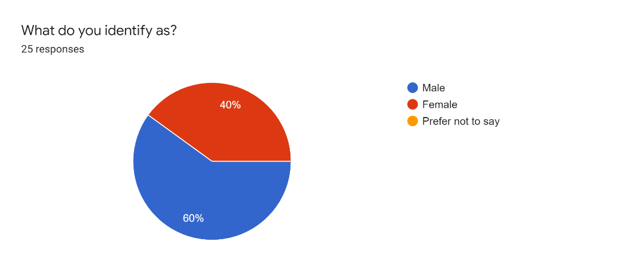
Question 4
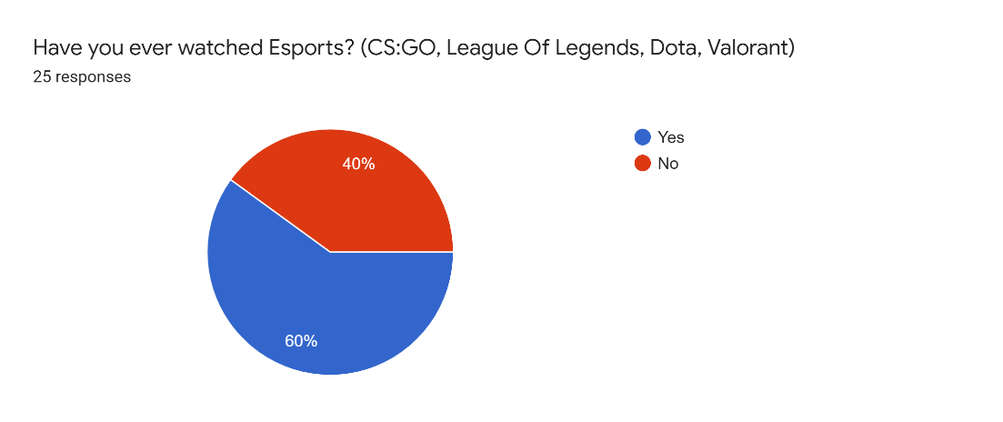
Question 5
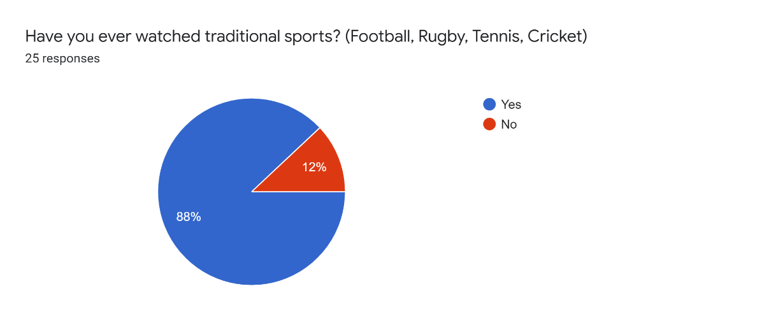

Question 6
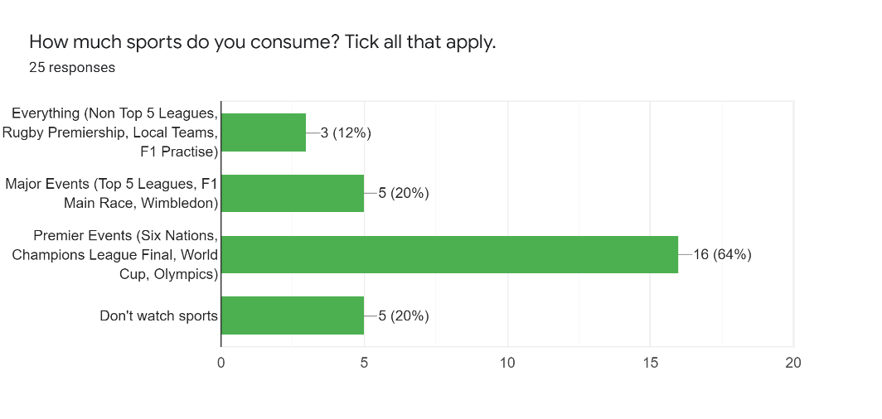

Question 7
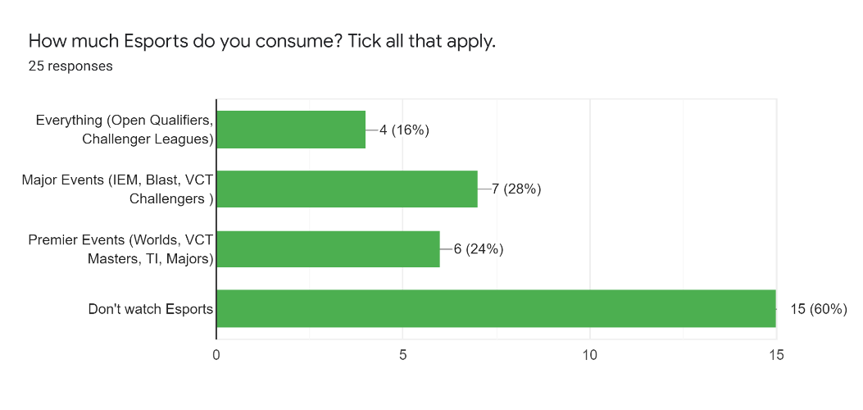
Question 8
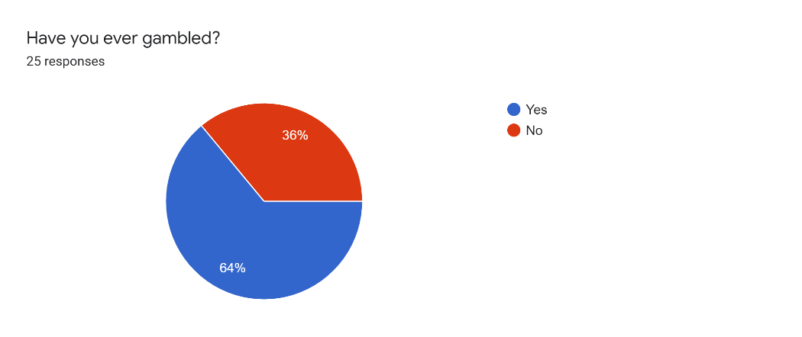

Question 9
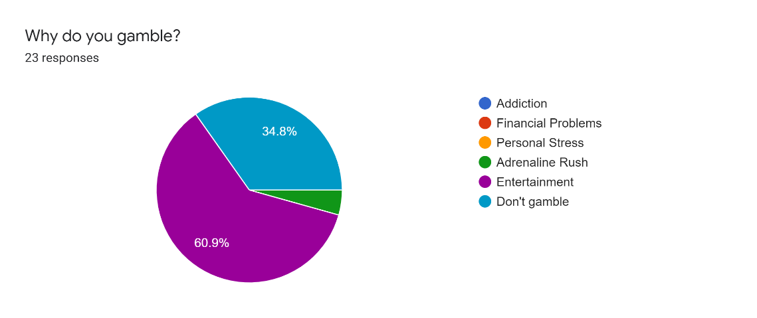

Question 10
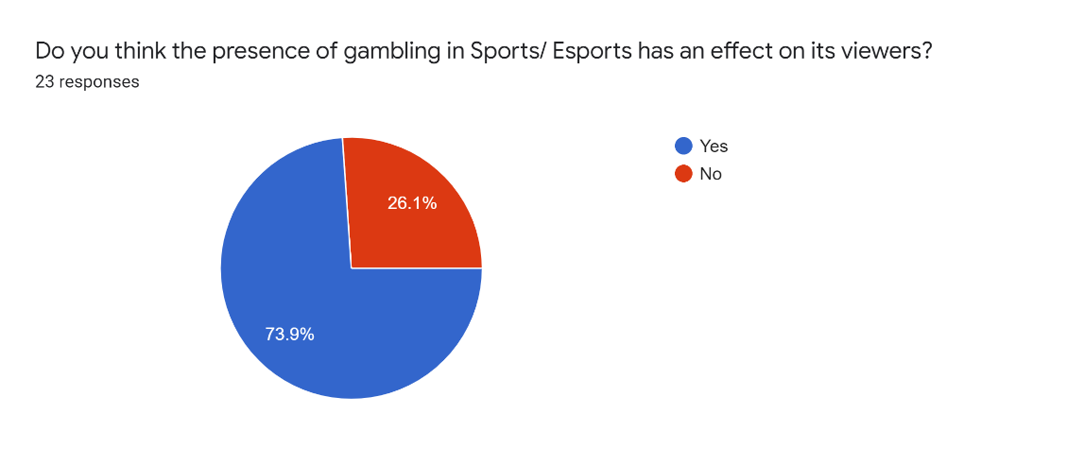

Question 11
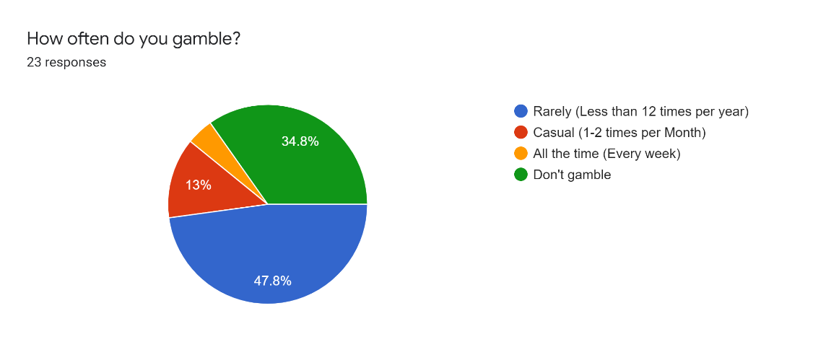

Question 12
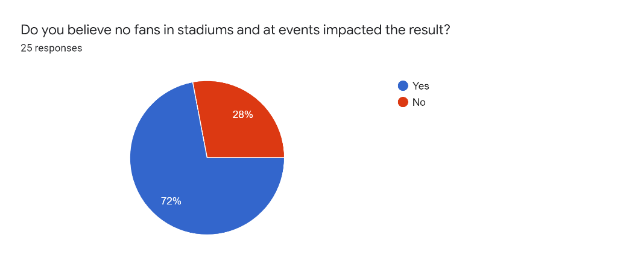
Question 13
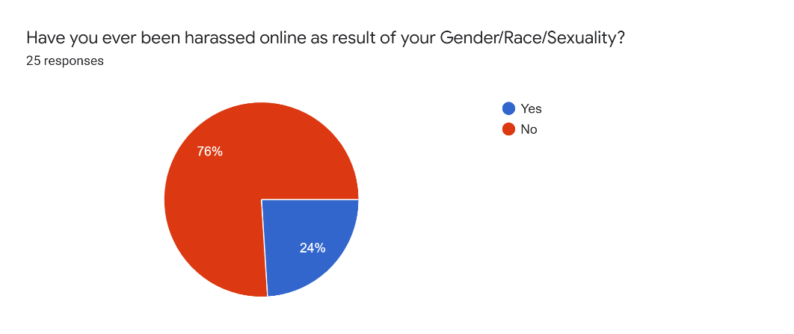

Question 14
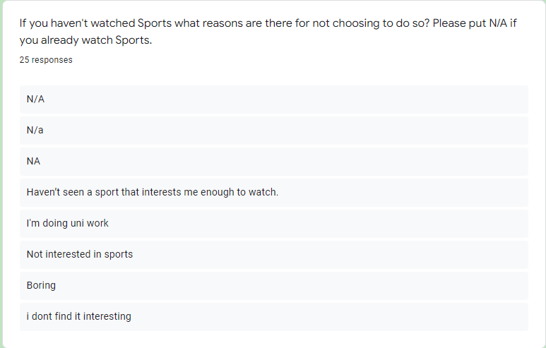

Question 15
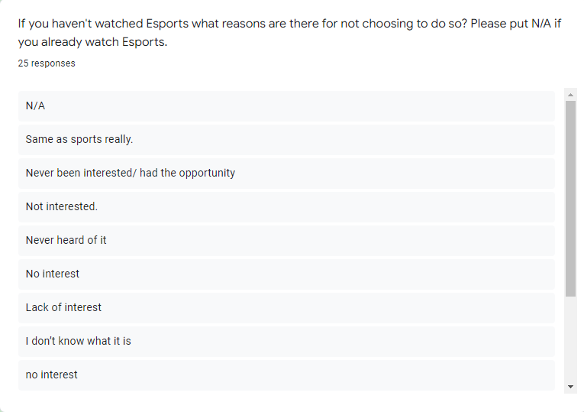
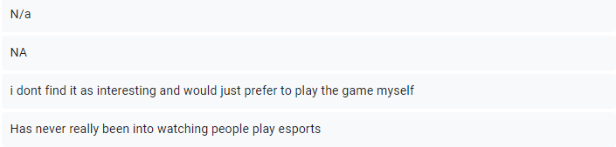
Question 16
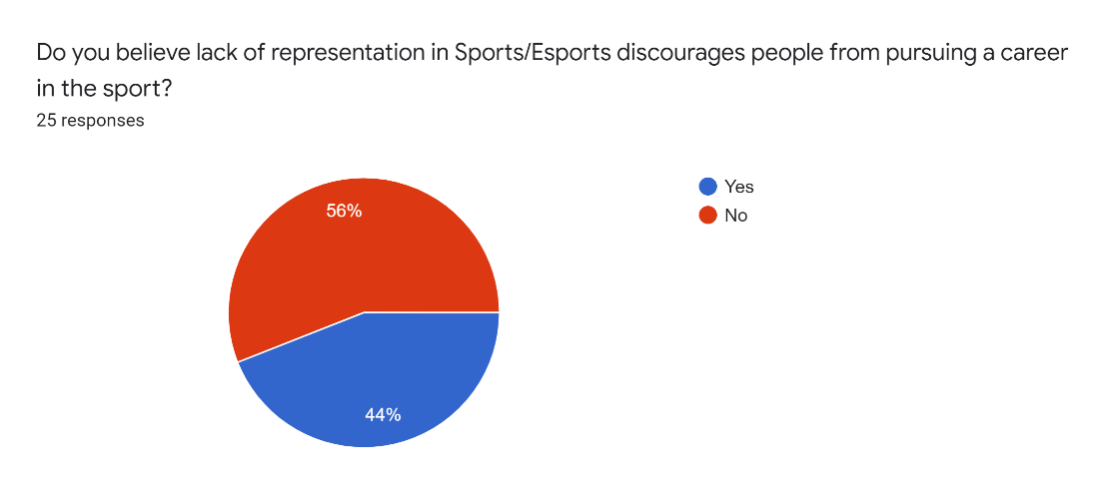

Question 17
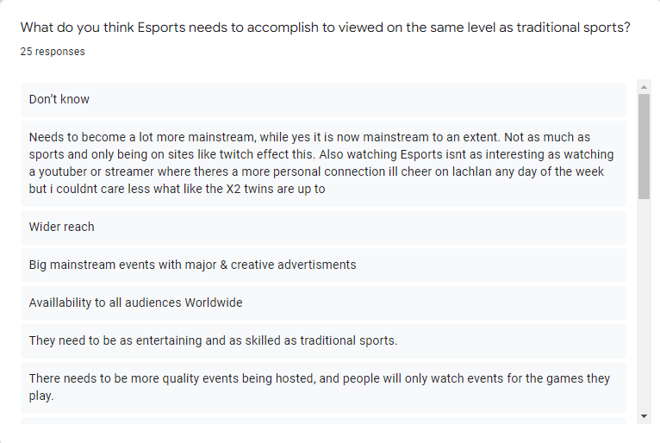
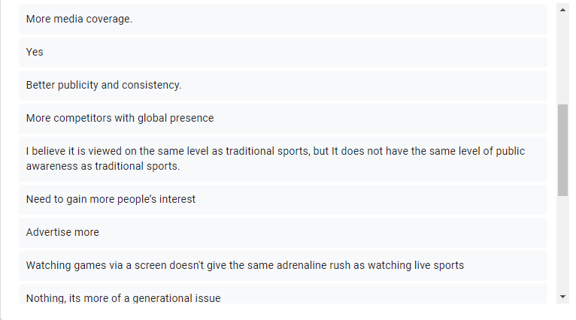
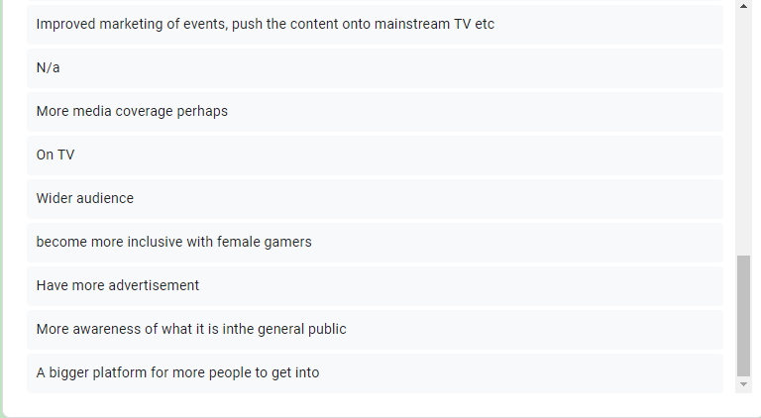

4.6 Discussion
The research sought to evaluate the general public's perceptions of what esports must do in order to be recognised and acknowledged in comparison to "conventional sports," as well as the impact of gambling and the COVID-19 Pandemic on esports/ sports as a whole.
Among the 16 inquiries that did not contain one requesting participants for permission to use their data for this dissertation. There was a huge range of responses when it came to Males vs Females, most notably during the "Do you watch esports?" question, where 9/10 of the women that responded did not watch esports or had heard of esports before. It was projected that this would happen because it was discovered during the literature analysis that just 5% of women competed at the highest level of video games, allowing the researcher to predict that male participants would have heard about esports whilst most women would not have (Gantz et al, 1991).

By combining the responses to questions 2 and 4, it is possible to derive that 0% of those over the age of 25 have previously watched esports. One participant commented, "Esports has to become more mainstream, and being on Twitch has a major impact on this”. Twitch is a free livestreaming platform that broadcasts 95% of all esports and is major component of gamers wanted to watch people play their favourite game (Granic et al, 2014). This is likely one of the main reasons why they are perceived differently than conventional sports, as many elderly people aren't as internet knowledgeable as younger generations, and hence 90% of their entertainment comes from television.

It was discovered using open-ended question 17, which questioned individuals, "What do you believe Esports has to do to be considered on the same level as traditional sports?" that the main reasons given by people over the age of 25 who had never watched or heard of esports before, and the most common reasons for them not being viewed the same way, were "More awareness of what sports are to the general public," "More competitors with a global presence," "They need to be as entertaining and skilled as traditional sports," and "Nothing, it's more of a generational issue." Apart from being a "generational issue," (Chen et al, 2011). The overwhelming opinion was that esports require more advertising to prove that they are equally as skilled as normal sports and, hopefully, attract more attention (Wagner, 2006).
Following the receipt of participant responses to question 16, it was discovered that 40% of the women who responded believed that lack of representation in esports/sports is a major barrier to those wishing to pursue a career in the sector, while 40% of the overall participants believe that lack of representation is a barrier. It should also be mentioned that 40% of women who feel a lack of representation is a barrier said they have been harassed online because of their gender during question 13. As a consequence, it can be determined that one of the primary reasons why women choose not to pursue jobs is because they view the environment to be toxic or have previously had a poor experience, and because it's a predominantly male dominated field, they are turned off by this and decided against pursuing careers (McLean et al, 2019).

After looking at the answers provided to question 8 within regards to “Do you gamble” and question 11 which is about “How often you gamble” It can be said that the largest selected answer within regards to each question was 64% of the total participants answered that they had gambled before and around 47% of participants stated that they gamble less than 12 time per year and 13% of the participants said they gambled casually which is around 1-2 times per month (Hing et al, 2013). It should also be noted that 60.9% of people said they gambled due to entertainment. This is not surprising because it can be justified by the previous research during the literature review that stated 70% of the over 18’s in the United Kingdom gambled in national lottery which takes place once per week (Miers, 1996).

"Do you think the existence of gambling in Sports/Esports has an influence on its viewers?" posed Question 10. This allowed the researcher to collect information for the second aim and given the prevalence of gambling in both sports and esports, it was critical that this be included in the questionnaire. The most common response was yes, with 73.9% of participants believing that gambling has an influence on viewers and only 26.1% believing that it does not (Lamont et al, 2016). This shows that over 2/3rds of the total participants believe that gambling has an effect on the viewer and since it plays such as integral part in esports and sports and is actively shown before matches and via adverts this could lead to addiction and potentially lead to financial problems further down the line and with the literature review finding out that when regarding youngsters aged 12 and up, 93.1 % of Android games had loot boxes and 94.9 % of iPhone games had loot boxes and these games were rated appropriate for children meaning this could become a huge issue in the future if kids developed gambling addictions as a young age due to low regulations surround the topic.
The third and final goal concerned the covid nineteen epidemic and whether no fans in football stadiums influenced match outcomes. Question 13 was about this issue and asked, "Do you believe no fans in stadiums and at events effected the result?" 73.1% of individuals said they thought the lack of spectators in the stadiums influenced the outcome of the game in certain manner, while just 26.9% said they did not think it did.

During the pandemic, esports events went online and had zero premier tournaments from September 8th, 2019, to October 26th, 2021, and all big events moved online, and they played on the nearest servers to their headquarters, which caused latency issues and time zone difficulties. The sporting events were halted and later held in sports bubbles where players had to have negative covid tests the day of the match (Horky, 2021). These took place without a live crowd and some people made the argument that some teams were abusing the covid test guideline and sending fraudulent tests when certain members of the squad were unable to play in order to postpone the match to a future date. According to the literature review part, many individuals thought that having supporters in the stadiums created a better environment and gave players a boost of morale, especially during away games.

Human relation theory proposed that good friendships in the workplace might boost productivity, efficiency, and motivation. This idea was first supported by Elton Mayo in the twentieth century. It asserts that improved working conditions lead to increased productivity, with certain components of the theory dating back to the 1920s. This is significant since esports and sports need a great deal of collaboration and coordination and establishing relationships with teammates has been shown to provide superior performance even when under pressure or facing a loss. This theory also claims that competent management is necessary for creating better outcomes, and similarly in esports, when coaches are not behind the team, the results have proved to create lower results, as well as during sports when teams do not have managers to advise them (Mayo, 2003). This is essential in making esports more well known as having teams perform at their best 100% of the time is essential within getting new viewers to come back to watch the next match if they enjoyed a particular team (Scholz et al, 2019).
According to the audience reaction model, viewers interact, perceive, and respond to diverse forms of media in diverse ways, and what happens as a consequence varies from viewer to viewer. This idea may be traced back to Stuart Hall's research in the late 1980s and early 1990s, when he argued that the media had the potential to directly affect individuals. He went on to say that the audience may modify the message to match their current social circumstances (Hall, 2001). This is appropriate to both esports and sporting events because once people have found a favourite player or squad of players, they will want to consume everything related to that player, whether that is livestreams to see them in action in esports or post-match media appearances in sports. Being able to view players outside of major tournaments and games is critical in closing the gap between esports and "traditional" sports and making them more accessible to every generation.

4.7 Conclusion
To conclude this section, this chapter successfully analysed the data that was found during the questionnaire which explored the general public’s views on what they believe esports needs to accomplish to become recognised and accepted compared to more “traditional sports”.

The last chapter will include suggestions based on the findings of the study, as well as the implications and limits of the research. It will also highlight the possibility for future research.

Chapter 5 – Conclusion And Recommendations

5.1 Introduction
The main goal of this chapter is to wrap up all that has been done while also returning to the research aims and objectives and ensuring that they are complete. This chapter will also make recommendations for bridging the gap between sports and esports, as well as address the constraints that happened before concluding with a self-reflection and subsequent study paragraph.

5.2 Recommendations
The main consensus was that esports needs more awareness of what esports is to the general public as well as that they need to be as entertaining and skilled as “traditional” sports and not just target the demographic that games are played by, but rather a wider scale to attract more attention and show esports on a worldwide basis. 40% of the women who responded believed that lack of representation in esports/sports is a major barrier to those wishing to pursue a career in the sector, and that 40% of women who feel a lack of representation is a barrier said they have been harassed online because of their gender during. Therefore esports needs to focus on becoming a more welcoming community and push out any of the toxic environments which women are turned off by.

5.3 Limitations
The main limitations of this topic were regarding the number of participants that completed the questionnaire as only 25% of the intended amount was met. The researcher decided that this was going to be more than likely as with online surveys the amount of people who answer them was going to be a non-controllable variable meaning you can’t control how many are going to submit answers and especially with this topic being aimed at the younger generation the older generation is most likely going to not complete the survey if they scrolled past unless the topic piques their interest.

5.4 Further Research
It would be beneficial in the future to incorporate mixed methodologies techniques and qualitative data in the form of interviews for future study. This would be advantageous since it would give a more in-depth look into the sector and would be highly valuable because you could interview professional esports players, coaches from teams, and others in the business to find out their thoughts on the subject.

Further research could also incorporate a large-scale population for the survey to provide a narrower margin as well as receive responses from different age groups intending on closing the gap in the research and learning what each age group believes is the most important thing when it comes to bringing esports on the same level as “traditional” sports.

Further research would also benefit from exploring in depth the effect gambling has on different age groups as well as the presence it has in the world not just related to esports and sports. The research could also look at the presence it plays in video games and the effects this can have on people from young ages when they have access to large sums of money and aren’t supervised.

5.5 The Achievement Of Objectives
Objective 1 was to “Critically Analyze to what extent gender and age have on whether people are going to consider watching esports over regular sports due to possible lack of representation in their chosen sport/ esport in a heavily male dominated environment”. This objective was completed by conducting previous research into the topic and looking at how females are represented in gaming as well as if there are any potential barriers that are already found to be in place. This objective was also completed by sending out a questionnaire to receive the general public’s response on the topic and then analyses the response using “active audience” and the “human relation” theories.

Objective two was to “Analyze the effect gambling has on esports and the presence in sports in general with a focus on the presence it plays in both esports and sports with a focus on football as the main sport.” This was completed by researching the presence gambling had in sports and esports as well as asking the public there gambling habits in response to the research done in the literature review.

Objective three was to “Analyze the effect the COVID-19 Pandemic had on esports and the issues that arose from the online era as well as the effect no fans in stadiums had on sports”. This objective was completed by researching the effect the covid nineteen pandemic had on football stadiums and esports as well as by receiving answers during the questionnaire relating to whether fans not being in the stadium affected the result.

5.6 Self Reflection
To begin reflecting on this study, the researcher would want to remember how much he liked investigating the topic of esports and having the opportunity to conduct research on a topic that was interesting while yet bringing it back to business.

The researcher would also like to state that he enjoyed conducting the questionnaire and learning in depth about each generation’s views on esports especially the viewpoints from people who had no idea of esports beforehand, these responses were extremely interesting for the researcher to analyse as it provided a brief look into older people minds and their opinions on a brand-new topic which wasn’t around during the younger years which has gained a large fanbase extremely quickly. The researcher also feels that this study wouldn’t have been nearly as long or the information being as relevant as it could be if the researcher didn’t have an interest in the topic.

5.7 Conclusion
Chapter five concluded on everything that was researched as part of this dissertation as well as looking back at the aims and objectives and reflecting on whether they had been completed successfully or if there was a reason behind why they had not.

6.0 References
Anscombe, F.J., 1973. Graphs in statistical analysis. The American statistician, 27(1), pp.17-21.
BBC News . (2018). Paris 2024 Olympics: Esports “in talks” to be included as demonstration sport. https://www.bbc.com/sport/olympics/43893891
Bell, J. and Waters, S., 2018. Ebook: doing your research project: a guide for first-time researchers. Mcgraw-hill education (uk).
Berge, C., 2001. The theory of graphs. Courier Corporation
Brandt, S. and Brandt, S., 1998. Data analysis. Springer-Verlag.
Bruce, K. and Nyland, C. (2011) ‘Elton Mayo and the Deification of Human Relations’, Organization studies, 32(3), pp. 383–405. doi:10.1177/0170840610397478.
Bryman, A., 2006. Integrating quantitative and qualitative research: how is it done?. Qualitative research, 6(1), pp.97-113.
Carpenter, N. (2018). OWL commissioner Nate Nanzer: Geguri has inspired “millions of girls” around the world. Available: https://dotesports.com/overwatch/news/ow-league-nate-nanzer-geguri-inspiration-31719. Last accessed 11th May 2022.
Castello, J. (2020). Don’t worry about the Overwatch League, worry about its workers. Available: https://www.polygon.com/2020/1/28/21083588/overwatch-league-player-caster-talent-burnout-season-3. Last accessed 11th May 2022.
Chen, K. and Chan, A.H., 2011. A review of technology acceptance by older adults. Geotechnology.
Core concepts in research. Reliability & validity (2018). Leicester, England: Shortcuts TV.
Cranmer, E.E. et al. (2021) ‘Esports matrix: Structuring the esports research agenda’, Computers in human behaviour, 117. doi:10.1016/j.chb.2020.106671.
De Leeuw, D., 2005. To mix or not to mix data collection modes in surveys. Journal of official statistics, 21(2), p.233.
ESL. (2017). Intel and ESL Welcome 173,000 Fans at World’s Biggest Esports Event in History. Available: https://www.eslgaming.com/press/intel-and-esl-welcome-173000-fans-world-s-biggest-esports-event-history. Last accessed 30th November 2021.
Forbes. (2018). Forbes 40 Under 40. Available: https://fortune.com/40-under-40/2018/nate-nanzer/. Last accessed 11th May 2022.
Frey, J.H. and Eitzen, D.S., 1991. Sport and society. Annual review of sociology, 17(1), pp.503-522.
Funk, D. C., Pizzo, A. D., Baker, B. J. (2018). Esports management: Embracing esport education and research opportunities. Sport Management Review, 21, 7–13.
Gantz, W. and Wenner, L.A., 1991. Men, women, and sports: Audience experiences and effects. Journal of Broadcasting & Electronic Media, 35(2), pp.233-243.
Gelo, O., Braakmann, D. and Benetka, G., 2008. Quantitative and qualitative research: Beyond the debate. Integrative Psychological and behavioural science, 42(3), pp.266-290.
Ghauri, P., Grønhaug, K. and Strange, R., 2020. Research methods in business studies. Cambridge University Press.
Gondran, M., Minoux, M. and Vajda, S., 1984. Graphs and algorithms. John Wiley & Sons, Inc..
Granello, D.H. and Wheaton, J.E., 2004. Online data collection: Strategies for research. Journal of Counseling & Development, 82(4), pp.387-393.
Granic, I., Lobel, A. and Engels, R.C., 2014. The benefits of playing video games. American psychologist, 69(1), p.66.
Grayson, N. (2018). No Overwatch League Team Signed The Game's Most Notable Female Pro To Their Roster. Available: https://kotaku.com/no-overwatch-league-team-signed-the-games-most-notable-1821968992. Last accessed 11th May 2022.
Gregory, I., 2003. Ethics in research. A&C Black.
Hall, S., 2001. Encoding/decoding. Media and cultural studies: Keyworks, 2, pp.163-173.
Hilbert, J. (2019). Gaming & gender: how inclusive are eSports? The Sports Integrity Initiative.
Hing, N., Vitartas, P. and Lamont, M., 2013. Gambling sponsorship of sport: An exploratory study of links with gambling attitudes and intentions. International Gambling Studies, 13(3), pp.281-301.
Horky, T., 2021. No sports, no spectators–no media, no money? The importance of spectators and broadcasting for professional sports during COVID-19. Soccer & Society, 22(1-2), pp.96-102.
In, J., 2017. Introduction of a pilot study. Korean journal of anesthesiology, 70(6), p.601.
J S C Amor, M Alguacil and A M Gómez-Tafalla (2022) ‘Gender influence on brand recommendation at an esports event’, Journal of Physical Education and Sport, 22(1), pp. 231–238. doi:10.7752/jpes.2022.01030.
Jang, W., Byon, K. K. (2020). Antecedents of esports gameplay intention: Genre as a moderator. Computers in Human Behaviour, 109, 106336.
Jiménez-Murcia, S. et al. (2014) ‘Video Game Addiction in Gambling Disorder: Clinical, Psychopathological, and Personality Correlates’, BioMed research international, 2014, pp. 315062–11. doi:10.1155/2014/315062.
Jin, D.Y. (2021) Global esports : transformation of cultural perceptions of competitive gaming. Edited by D.Y. Jin. New York: Bloomsbury Academic. doi:10.5040/9781501368745.
Johnson, B. and Christensen, L., 2000. Educational research: Quantitative and qualitative approaches. Allyn & Bacon.
Kenny, D., Kashy, D. and Bolger, N., 1998. Data analysis. In The handbook of social psychology: Vols. 1 and 2, (pp. 233-265). New York: McGraw-Hill.
Kosslyn, S.M., 1989. Understanding charts and graphs. Applied cognitive psychology, 3(3), pp.185-225.
Lamont, M., Hing, N. and Vitartas, P., 2016. Affective response to gambling promotions during televised sport: A qualitative analysis. Sport Management Review, 19(3), pp.319-331.
Laurent Michaud (2020) ESPORTS, Digiworld Yearbook. Montpellier: Institute de l’Audiovisuel et de Telecommunications en Europe (IDATE), pp. 62–63.
Lopiano, D.A., 2000. Modern history of women in sports: Twenty-five years of Title IX. Clinics in sports medicine, 19(2), pp.163-173.
Mayo, E. (2003) The human problems of an industrial civilization. London: Routledge. doi:10.4324/9780203487273.
McLean, L. and Griffiths, M.D., 2019. Female gamers’ experience of online harassment and social support in online gaming: A qualitative study. International Journal of Mental Health and Addiction, 17(4), pp.970-994.
Melnikov, A., 2018. Towards an explicit research methodology: Adapting research onion model for futures studies. Journal of Futures Studies, 23(2), pp.29-44.
Miers, D., 1996. The implementation and effects of Great Britain's National Lottery. Journal of Gambling Studies, 12(4), pp.343-373.
Munn, P. and Drever, E., 1990. Using Questionnaires in Small-Scale Research. A Teachers' Guide. Scottish Council for Research in Education, 15 St. John Street, Edinburgh, EH8 8JR, Scotland, United Kingdom.
Nagorsky, E. and Wiemeyer, J., 2020. The structure of performance and training in esports. PloS one, 15(8), p.e0237584.
Ochieng, P.A., 2009. An analysis of the strengths and limitation of qualitative and quantitative research paradigms. Problems of Education in the 21st Century, 13, p.13.
Punch, K.F., 2013. Introduction to social research: Quantitative and qualitative approaches. sage.
Reade, J., Schreyer, D. and Singleton, C., 2020. Echoes: what happens when football is played behind closed doors?. Available at SSRN 3630130.
Reitman, J.G. et al. (2020) ‘Esports Research: A Literature Review’, Games and culture, 15(1), pp. 32–50. doi:10.1177/1555412019840892.
Rogstad, E. T. (2021). Gender in eSports research: a literature review. European Journal for Sport and Society. https://doi.org/10.1080/16138171.2021.1930941
Rosell Llorens, M., 2017. eSport gaming: the rise of a new sports practice. Sport, Ethics and Philosophy, 11(4), pp.464-476.
Ruvalcaba, O., Shulze, J., Kim, A., Berzenski, S. R., & Otten, M. P. (2018). Women's Experiences in eSports: Gendered Differences in Peer and Spectator Feedback During Competitive Video Game Play. Journal of Sport and Social Issues, 42(4), 295-311. https://doi.org/10.1177/0193723518773287
Sales, B.D. and Folkman, S.E., 2000. Ethics in research with human participants. American Psychological Association.
Saunders, M., Lewis, P., & Thornhill, A. (2007). Research Methods for Business Students, (6th ed.) London: Pearson.
Scholz, T.M., Scholz, T.M. and Barlow, 2019. eSports is Business. Springer International Publishing.
Silverman, D., 2015. Interpreting qualitative data. Sage.
Siniscalco, M.T. and Auriat, N., 2005. Questionnaire design. Quantitative research methods in educational planning, 8.
Sky Sports. (2016). Sky Sports to show every F1 race live from 2019 until 2024. Available: https://www.skysports.com/f1/news/12433/10215419/sky-sports-to-show-every-f1-race-live-from-2019-until-2024. Last accessed 8th April 2022.
Stern, A. (2020). Sources: YouTube’s Deal With Activision Blizzard Valued At $160M. Available: https://archive.esportsobserver.com/sources-youtube-actiblizzard-160m/. Last accessed 11th May 2022.
Taherdoost, H., 2016. Validity and reliability of the research instrument; how to test the validation of a questionnaire/survey in research. How to test the validation of a questionnaire/survey in research (August 10, 2016).
Taylor, G.R. ed., 2005. Integrating quantitative and qualitative methods in research. University Press of America.
The Guardian (2020). Premier League and British football shut down until April due to coronavirus. https://www.theguardian.com/football/live/2020/mar/13/premier-league-and-british-football-set-for-shutdown-due-to-coronavirus-live.
The National Lottery. (2022). About Lotto. Available: https://www.national-lottery.co.uk/games/lotto/about-lotto. Last accessed 12th April.
Thomas, D.R., 2006. A general inductive approach for analysing qualitative evaluation data. American journal of evaluation, 27(2), pp.237-246.
UEFA. (2021). EURO 2020 semi-finals and final: Wembley capacity increased to more than 60,000. Available: https://www.uefa.com/uefaeuro-2020/news/026a-1294bb69ec39-89bc7ae2b3d7-1000--wembley-capacity-raised-for-semis-final/. Last accessed 30th November 2021.
Volberg, R.A., 1996. Prevalence studies of problem gambling in the United States. Journal of gambling studies, 12(2), pp.111-128.
Wagner, M. (2007). Competing in metagame game space: Esport as the first professionalized computer metagames. In von Borries, F., Walz, S. P., Böttger, M. (Eds.), Space time play: Synergies between computer games, architecture and urbanism (pp. 182–185). Springer.
Wagner, M.G., 2006, June. On the Scientific Relevance of eSports. In International conference on internet computing (pp. 437-442).
Walsham, G., 1995. The emergence of interpretivism in IS research. Information systems research, 6(4), pp.376-394.
Wenner, L.A. ed., 1989. Media, sports, and society. sage.
Wolf, J. (2018). Overwatch League to be streamed on Twitch.tv in two-year, $90 million deal. ESPN.
Wright, K.B., 2005. Researching Internet-based populations: Advantages and disadvantages of online survey research, online questionnaire authoring software packages, and web survey services. Journal of computer-mediated communication, 10(3), p.JCMC1034.
Xue, H., Newman, J. I., & Du, J. (2019). Narratives, identity and community in esports. Leisure
Zendle, D. et al. (2020) ‘The prevalence of loot boxes in mobile and desktop games’, Addiction

7.0 Appendices

7.1 Questionnaire Questions
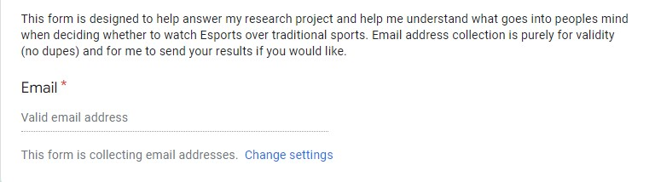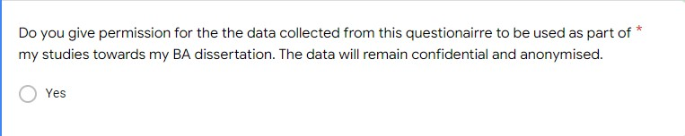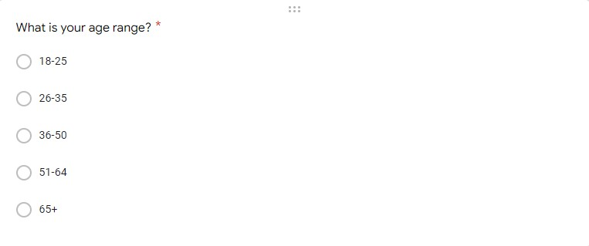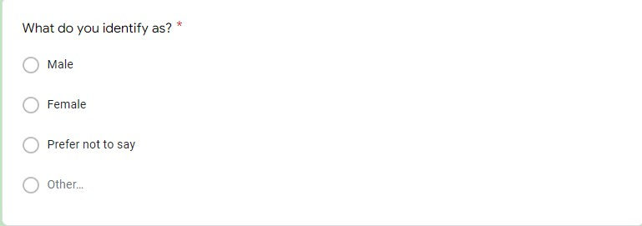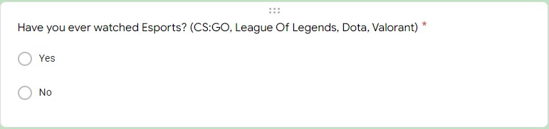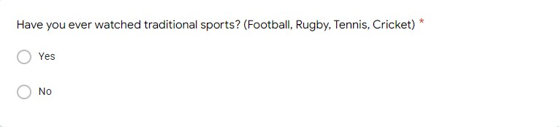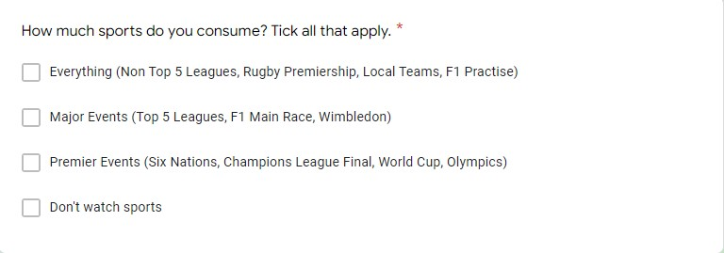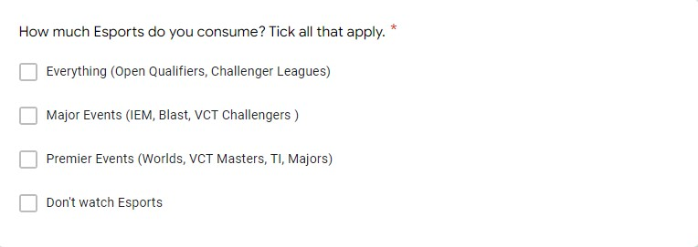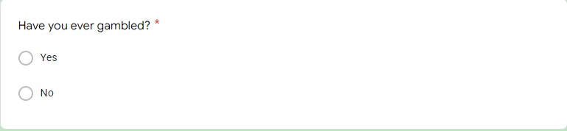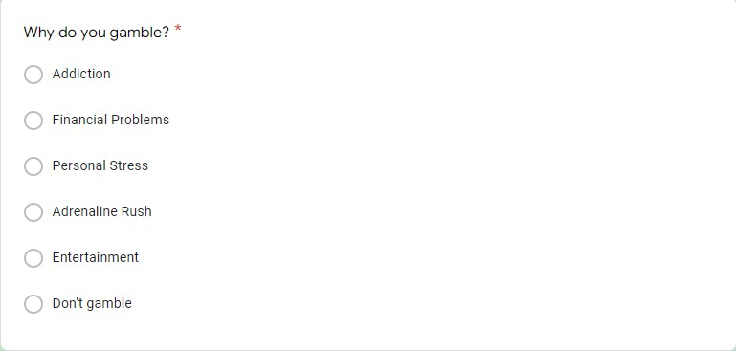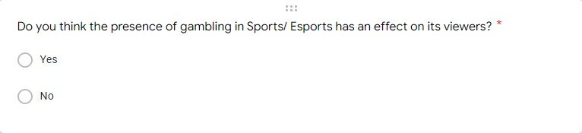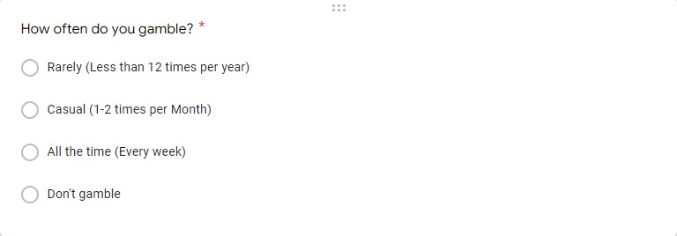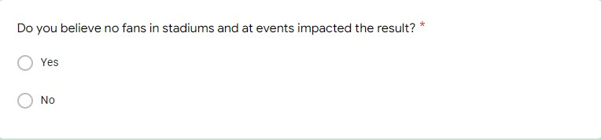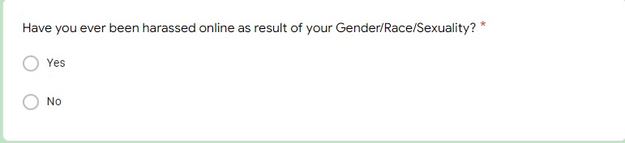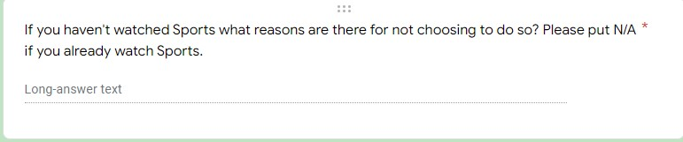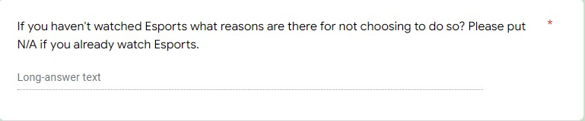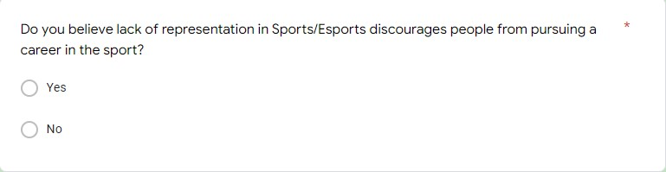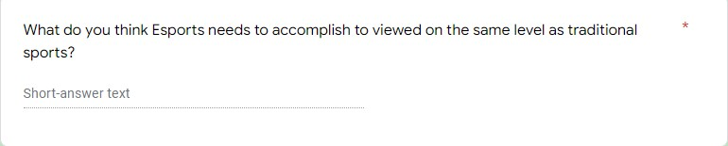

7.2 Ethics Form

APPLICATION FOR ETHICAL APPROVAL

In order for research to result in benefit and minimise risk of harm, it must be conducted ethically. A researcher may not be covered by the University’s insurance if ethical approval has not been obtained prior to commencement.

The University follows the OECD Frascati manual definition of research activity: “creative work undertaken on a systematic basis in order to increase the stock of knowledge, including knowledge of man, culture and society, and the use of this stock of knowledge to devise new applications”. As such this covers activities undertaken by members of staff, postgraduate research students, and both taught postgraduate and undergraduate students working on dissertations/projects.

The individual undertaking the research activity is known as the “principal researcher”.

Ethical approval is not required for routine audits, performance reviews, quality assurance studies, testing within normal educational requirements, and literary or artistic criticism.

Please read the notes for guidance before completing ALL sections of the form.

This form must be completed and approved prior to undertaking any research activity. Please see Checklist for details of process for different categories of application.

SECTION A: About You (Principal Researcher)
1 | Full Name: |  | Benjamin Lewis Gabriel
2 | Tick all boxes that apply: |  | Member of staff: | ☐ | Honorary research fellow: | ☐
 | Undergraduate Student | ☒ | Taught Postgraduate Student | ☐ | Postgraduate Research Student | ☐

3 | Institute/Academic Discipline/Centre: | Business school (IMH)
4 | Campus: | Swansea
5 | E-mail address: | 1901710@student.uwtsd.ac.uk
6 | Contact Telephone Number: | 07375 561181
 | For students:
7 | Student Number: | 1901710
8 | Programme of Study: | BA Business Management
9 | Director of Studies/Supervisor: | Gareth Hughes

SECTION B: Approval for Research Activity
1 | Has the research activity received approval in principle?  (please check the Guidance Notes as to the appropriate approval process for different levels of research by different categories of individual) |  | YES | ☐ | NO | ☒
 |  |  |  |  | Date
2 | If Yes, please indicate source of approval (and date where known): Approval in principle must be obtained from the relevant source prior to seeking ethical approval | Research Degrees Committee |  | ☐
2 |  | Institute Research Committee |  | ☐
2 |  | Other (write in) |  | ☐

SECTION C: Internal and External Ethical Guidance Materials
 | Please list the core ethical guidance documents that have been referred to during the completion of this form (including any discipline-specific codes of research ethics, location-specific codes of research ethics, and also any specific ethical guidance relating to the proposed methodology). Please tick to confirm that your research proposal adheres to these codes and guidelines. You may add rows to this table if needed.
1 | UWTSD Research Ethics & Integrity Code of Practice | ☒
2 | UWTSD Research Data Management Policy | ☒
3 | [List any other relevant documents here] | ☐

SECTION D: External Collaborative Research Activity
If there are external collaborators then you should gain consent from the contact persons to share their personal data with the university. If there are no external collaborators then leave this section blank and continue to section E.
1 | Institution
2 | Contact person name
3 | Contact person e-mail address
4 | Is your research externally funded? |  | YES | ☐ | NO |  | ☐
5 | Are you in receipt of a KESS scholarship? |  | YES | ☐ | NO |  | ☐
6 | Are you specifically employed to undertake this research in either a paid or voluntary capacity? | Voluntary | YES | ☐ | NO | ☐
7 |  | Employed | YES | ☐ | NO | ☐
8 | Is the research being undertaken within an existing UWTSD Atheroma Professional Learning Partnership (APLP)? | If YES then the permission question below does not need to be answered. | YES | ☐ | NO |  | ☐
9 | Has permission to undertake the research has been provided by the partner organisation? | (If YES attach copy)  If NO the application cannot continue | YES | ☐ | NO |  | ☐

Where research activity is carried out in collaboration with an external organisation
10 | Does this organisation have its own ethics approval system? | YES | ☐ | NO | ☐
 | If Yes, please attach a copy of any final approval (or interim approval) from the organisation (this may be a copy of an email if appropriate).

SECTION E: Details of Research Activity
1 | Indicative title: | Esports: A Breath Of Fresh Air In The 21st Century Or Doomed To Be Overshadowed By “Traditional Sports”?
2 | Proposed start date: | 1st December 2021 | Proposed end date: | 13th May 2022
Introduction to the Research (maximum 300 words per section)
Ensure that you write for a Non-Specialist Audience when outlining your response to the points below:
- Purpose of Research Activity
- Proposed Research Question
- Aims of Research Activity
- Objectives of Research Activity
Demonstrate, briefly, how Existing Research has informed the proposed activity and explain
- What the research activity will add to the body of knowledge
- How it addresses an area of importance.
3 | Purpose of Research Activity  With audience members being in the millions and showing no signs of stopping. This the question that I am going to be researching for this research project is “What do Esports need to accomplish to be recognized as being on the same level as sports when compared to traditional sports as viewed by society”.
4 | Research Question  What do Esports need to accomplish to be recognized as being on the same level as sports.
5 | Aims of Research Activity  To research what people think esports needs to accomplish to become recognised and accepted compared to more “traditional sports” also looking at what effects gambling and the COVID-19 pandemic have on esports as a whole with a focus on football as the traditional sport.
6 | Objectives of Research Activity  Critically Analyze to what extent gender and age have on whether people are going to consider watching esports over regular sports due to possible lack of representation in their chosen sport/ esport in a heavily male dominated environment.  Analyze the effect gambling has on esports and the presence in sports in general with a focus on the presence it plays in both esports and sports with a focus on football as the main sport.  Analyze the effect the COVID-19 Pandemic had on esports and the issues that arose from the online era as well as the effect no fans in football stadiums have on football as a sport.
Proposed methods (maximum 600 words)
Provide a brief summary of all the methods that may be used in the research activity, making it clear what specific techniques may be used. If methods other than those listed in this section are deemed appropriate later, additional ethical approval for those methods will be needed. You do not need to justify the methods here but should instead describe how you intend to collect the data necessary for you to complete your project.
7 | My approach to this project will be an approach consisting of primary research and secondary research. These will be a mix of qualitative and quantitative data to ensure maximum amount of information as well as collecting the best information available and secondary research from journals, books, articles, interviews, questionnaires to get the best amount of information from the public and receiving the most no bias answers possible to ensure nothing is tipping the project in favour of one side
Location of research activity
Identify all locations where research activity will take place.
8 | Swansea, Wales
Research activity outside of the UK
If research activity will take place overseas, you are responsible for ensuring that local ethical considerations are complied with and that the relevant permissions are sought. Specify any local guidelines (e.g. from local professional associations/learned societies/universities) that exist and whether these involve any ethical stipulations beyond those usual in the UK (provide details of any licenses or permissions required). Also specify whether there are any specific ethical issues raised by the local context in which the research activity is taking place, for example, particular cultural and/or legal sensitivities or vulnerabilities of participants. If you live in the country where you will do the research then please state this.
9 | Worldwide

10 | Use of documentation not in the public domain: Are any documents NOT publicly available? | NO | ☒
10 |  | YES | ☐
11 | If Yes, please provide details here of how you will gain access to specific documentation that is not in the public domain and that this is in accordance with the current data protection law of the country in question and that of England and Wales.  Everything should be available in the public domain.

 | Does your research relate to one or more of the seven aims of the Well-being of Future Generations (Wales) Act 2015? | YES | NO
12 | A prosperous Wales | ☐ | ☒
13 | A resilient Wales | ☐ | ☒
14 | A healthier Wales | ☐ | ☒
15 | A more equal Wales | ☐ | ☒
16 | A Wales of cohesive communities | ☐ | ☒
17 | A Wales of vibrant culture and thriving Welsh language | ☐ | ☐
18 | A globally responsible Wales | ☒ | ☐
19 | If YES to any of the above, please give details:
 | With audience members being in the millions and showing no signs of stopping. This bring about the question that I am going to be research for this research project which is “What do Esports need to accomplish to be recognized as being on the same level as traditional sports as viewed by society.

SECTION F: Scope of Research Activity
 | Will the research activity include? | YES | NO
1 | Use of a questionnaire or similar research instrument? | ☒ | ☐
2 | Use of interviews? | ☒ | ☐
3 | Use of focus groups? | ☐ | ☒
4 | Use of participant diaries? | ☒ | ☐
5 | Use of video or audio recording? | ☒ | ☐
6 | Use of computer-generated log files? | ☐ | ☒
7 | Participant observation with their knowledge? | ☒ | ☐
8 | Participant observation without their knowledge? | ☐ | ☒
9 | Access to personal or confidential information without the participants’ specific consent? | ☐ | ☒
10 | Administration of any questions, test stimuli, presentation that may be experienced as physically, mentally or emotionally harmful / offensive? | ☐ | ☒
11 | Performance of any acts which may cause embarrassment or affect self-esteem? | ☐ | ☒
12 | Investigation of participants involved in illegal activities? | ☐ | ☒
13 | Use of procedures that involve deception? | ☐ | ☒
14 | Administration of any substance, agent or placebo? | ☐ | ☒
15 | Working with live vertebrate animals? | ☐ | ☒
16 | Procedures that may have a negative impact on the environment? | ☐ | ☒
17 | Other primary data collection methods. Please indicate the type of data collection method(s) below. | ☐ | ☐
 | Details of any other primary data collection method: | ☐ | ☐
If NO to every question, then the research activity is (ethically) low risk and may be exempt from some of the following sections (please refer to Guidance Notes).

If YES to any question, then no research activity should be undertaken until full ethical approval has been obtained.

SECTION G: Intended Participants
If there are no participants then do not complete this section, but go directly to section H.

 | Who are the intended participants? | YES | NO
1 | Students or staff at the University? | ☒ | ☐
2 | Adults (over the age of 18 and competent to give consent)? | ☒ | ☐
3 | Vulnerable adults? | ☐ | ☒
4 | Children and Young People under the age of 18? (Consent from Parent, Carer or Guardian will be required) | ☐ | ☒
5 | Prisoners? | ☐ | ☒
6 | Young offenders? | ☐ | ☒
7 | Those who could be considered to have a particularly dependent relationship with the investigator or a gatekeeper? | ☐ | ☒
8 | People engaged in illegal activities? | ☐ | ☒
9 | Others. Please indicate the participants below, and specifically any group who may be unable to give consent. | ☐ | ☒
 | Details of any other participant groups: | ☐ | ☒

Participant numbers and source
Provide an estimate of the expected number of participants. How will you identify participants and how will they be recruited?
10 | How many participants are expected? | I hope to achieve around 100 participants and am expecting a 60-40 ratio of Men to Women as Men are the primary watchers of sports and esports, but I do hope to receive answers off women as to ensure a non-biased survey has taken place.
11 | Who will the participants be? | Public  Students  Family
12 | How will you identify the participants? | I will identify participants willing to take place by first asking around my family and any local friends who may wish to take part as well as online to achieve a wide as audience as possible.

 | Information for participants: | YES | NO | N/A
13 | Will you describe the main research procedures to participants in advance, so that they are informed about what to expect? | ☒ | ☐ | ☐
14 | Will you tell participants that their participation is voluntary? | ☒ | ☐ | ☐
15 | Will you obtain written consent for participation? | ☐ | ☒ | ☐
16 | Will you explain to participants that refusal to participate in the research will not affect their treatment or education (if relevant)? | ☒ | ☐ | ☐
17 | If the research is observational, will you ask participants for their consent to being observed? | ☒ | ☐ | ☐
18 | Will you tell participants that they may withdraw from the research at any time and for any reason? | ☒ | ☐ | ☐
19 | With questionnaires, will you give participants the option of omitting questions they do not want to answer? | ☒ | ☐ | ☐
20 | Will you tell participants that their data will be treated with full confidentiality and that, if published, it will not be identifiable as theirs? | ☒ | ☐ | ☐
21 | Will you debrief participants at the end of their participation, in a way appropriate to the type of research undertaken? | ☒ | ☐ | ☐
22 | If NO to any of above questions, please give an explanation
 | No written consent will be need as the first question of the questionnaire can only be answered yes and required participants to state that they are ok with the data collected from this questionairre to be used as part of the researchers’ studies towards my BA dissertation. The data will remain confidential and anonymised.

 | Information for participants: | YES | NO | N/A
24 | Will participants be paid? | ☐ | ☒ | ☐
25 | Is specialist electrical or other equipment to be used with participants? | ☐ | ☒ | ☐
26 | Are there any financial or other interests to the investigator or University arising from this study? | ☐ | ☒ | ☐
27 | Will the research activity involve deliberately misleading participants in any way, or the partial or full concealment of the specific study aims? | ☐ | ☒ | ☐
28 | If YES to any question, please provide full details
 | (this box should expand as you type)

SECTION H: Anticipated Risks

Outline any anticipated risks that may adversely affect any of the participants, the researchers and/or the University, and the steps that will be taken to address them.

If you have completed a full risk assessment (for example as required by a laboratory, or external research collaborator) you may append that to this form.
1 | Full risk assessment completed and appended? |  | Yes | ☐
1 |  |  | No | ☒
2 | Risks to participants  For example: sector-specific health & safety, emotional distress, financial disclosure, physical harm, transfer of personal data, sensitive organisational information
 | Risk to participants:  No risks are present as survey and questionnaire are conducted online due to the ongoing COVID-19 pandemic ensuring no one is exposed to anything while this research is taking place. | How you will mitigate the risk to participants:
3 | If research activity may include sensitive, embarrassing or upsetting topics (e.g. sexual activity, drug use) or issues likely to disclose information requiring further action (e.g. criminal activity), give details of the procedures to deal with these issues, including any support/advice (e.g. helpline numbers) to be offered to participants. Note that where applicable, consent procedures should make it clear that if something potentially or actually illegal is discovered in the course of a project, it may need to be disclosed to the proper authorities
Gambling Safety Website - https://www.begambleaware.org/
National Gambling Helpline Phone Number - 0808 8020 133

4 | Risks to the investigator  For example: personal health & safety, physical harm, emotional distress, risk of accusation of harm/impropriety, conflict of interest
 | Risk to the investigator:  None Present | How you will mitigate the risk to the investigator:  Survey is anonymously sent out via link which participants click.
5 | University/institutional risks  For example: adverse publicity, financial loss, data protection
 | Risk to the University:  None Present | How you will mitigate the risk to the University:  None Present
6 | Environmental risks  For example: accidental spillage of pollutants, damage to local ecosystems
 | Risk to the environment:  None Present | How you will mitigate the risk to environment:  None Present

 | Disclosure and Barring Service
 | If the research activity involves children or vulnerable adults, a Disclosure and Barring Service (DBS) certificate must be obtained before any contact with such participants. | YES | NO | N/A
7 | Does your research require you to hold a current DBS Certificate? | ☐ | ☒ | ☐
8 | If YES, please give the certificate number. If the certificate number is not available please write “Pending”; in this case any ethical approval will be subject to providing the appropriate certificate number.

SECTION I: Feedback, Consent and Confidentiality

1 | Feedback  What de-briefing and feedback will be provided to participants, how will this be done and when?
 | Debriefing and feedback will be available to anyone who wants it and will be able to be sent via email as soon as the university gives me confirmation that I am allowed to send it to them. I will ask a question at the beginning of the primary research method I am using whether or not they would like to receive an update once it has been completed.
2 | Informed consent  Describe the arrangements to inform potential participants, before providing consent, of what is involved in participating. Describe the arrangements for participants to provide full consent before data collection begins. If gaining consent in this way is inappropriate, explain how consent will be obtained and recorded in accordance with prevailing data protection legislation.
 | Consent will be obtained as the first question of any primary research I am conducting so I know that before any answers have been given I have their consent to the research.
3 | Confidentiality / Anonymity  Set out how anonymity of participants and confidentiality will be ensured in any outputs. If anonymity is not being offered, explain why this is the case.
 | Email will only be required in a separate question section regarding if they want to receive the results of the study and also to ensure only 1 person via each email is participating in the survey.

SECTION J: Data Protection and Storage

 | Does the research activity involve personal data (as defined by the General Data Protection Regulation 2016 “GDPR” and the Data Protection Act 2018 “DPA”)? | YES | NO
1 | “Personal data” means any information relating to an identified or identifiable natural person (‘data subject’). An identifiable natural person is one who can be identified, directly or indirectly, in particular by reference to an identifier such as a name, an identification number, location data, an online identifier or to one or more factors specific to the physical, physiological, genetic, mental, economic, cultural or social identity of that natural person. Any video or audio recordings of participants is considered to be personal data. | ☐ | ☐
 | If YES, provide a description of the data and explain why this data needs to be collected:
2 | (this box should expand as you type)
 | Does it involve special category data (as defined by the GDPR)? | YES | NO
3 | “Special category data” means sensitive personal data consisting of information as to the data subjects’ –  (a) racial or ethnic origin,  (b) political opinions,  (c ) religious beliefs or other beliefs of a similar nature,  (d) membership of a trade union (within the meaning of the Trade Union and Labour Relations (Consolidation) Act 1992),  (e) physical or mental health or condition,  (f) sexual life,  (g) genetics,  (h) biometric data (as used for ID purposes), | ☐ | ☐
 | If YES, provide a description of the special category data and explain why this data needs to be collected:
4 | (this box should expand as you type)

 | Will data from the research activity (collected data, drafts of the thesis, or materials for publication) be stored in any of the following ways? | YES | NO
5 | Manual files (i.e. in paper form)? | ☐ | ☒
6 | University computers? | ☒ | ☐
7 | Private company computers? | ☐ | ☒
8 | Home or other personal computers? | ☒ | ☐
9 | Laptop computers/ CDs/ Portable disk-drives/ memory sticks? | ☐ | ☒
10 | “Cloud” storage or websites? | ☐ | ☒
11 | Other – specify: | ☐ | ☒
12 | For all stored data, explain the measures in place to ensure the security of the data collected, data confidentiality, including details of backup procedures, password protection, encryption, anonymisation and pseudonymisation:
 | First question in the questionnaire will be “Do you give permission for the data collected from this questionairre to be used as part of my studies towards my BA dissertation. The data will remain confidential and anonymised.” Therefore removing any participants who do not wish for their data to be shared before the survey begins.

 | Data Protection
 | Will the research activity involve any of the following activities? | YES | NO
13 | Electronic transfer of data in any form? | ☒ | ☐
14 | Sharing of data with others at the University outside of the immediate research team? | ☒ | ☐
15 | Sharing of data with other organisations? | ☐ | ☒
16 | Export of data outside the UK or importing of data from outside the UK? | ☐ | ☒
17 | Use of personal addresses, postcodes, faxes, emails or telephone numbers? | ☐ | ☒
18 | Publication of data that might allow identification of individuals? | ☐ | ☒
19 | Use of data management system? | ☐ | ☒
20 | Data archiving? | ☐ | ☒
21 | If YES to any question, please provide full details, explaining how this will be conducted in accordance with the GDPR and Data Protection Act (2018) (and any international equivalents, where appropriate):
 | Stored on a password protected computer and only upload to Moodle upon completion. Research will only be shared with participants and they have to request it in the questionnaire.
22 | List all who will have access to the data generated by the research activity:
University Staff
Anyone who requested feedback upon completion will receive a copy.

23 | List who will have control of, and act as custodian(s) for, data generated by the research activity:
 | University
24 | Give details of data storage arrangements, including security measures in place to protect the data, where data will be stored, how long for, and in what form. Will data be archived – if so how and if not why.
 | Date will be stored on student’s computer hard drive with a password protected account required before login.
25 | Please indicate if your data will be stored in the UWTSD Research Data Repository (see https://researchdata.uwtsd.ac.uk/ ). If so please explain. (Most relevant to academic staff)
26 | Confirm that you have read the UWTSD guidance on data management (see https://www.uwtsd.ac.uk/library/research-data-management/) | YES | ☒
27 | Confirm that you are aware that you need to keep all data until after your research has completed or the end of your funding | YES | ☒

SECTION K: Declaration
The information which I have provided is correct and complete to the best of my knowledge. I have attempted to identify any risks and issues related to the research activity and acknowledge my obligations and the rights of the participants.

In submitting this application I hereby confirm that I undertake to ensure that the above named research activity will meet the University’s Research Ethics and Integrity Code of Practice which is published on the website: https://www.uwtsd.ac.uk/research/research-ethics/
1 | Signature of applicant: |  | Date: 30/11/21

For STUDENT Submissions:
2 | Director of Studies/Supervisor: | Gareth Hughes | Date: 13/05/22
3 | Signature: |  | Date: 13/05/22

For STAFF Submissions:
4 | Academic Director/ Assistant Dean: |  | Date:
5 | Signature: |  | Date:

Checklist: Please complete the checklist below to ensure that you have completed the form according to the guidelines and attached any required documentation:
☒ | I have read the guidance notes supplied before completing the form.
☒ | I have completed ALL RELEVANT sections of the form in full.
☐ | I confirm that the research activity has received approval in principle
☐ | I have attached a copy of final/interim approval from external organisation (where appropriate)
☐ | I have attached a full risk assessment (where appropriate) ONLY TICK IF YOU HAVE ATTACHED A FULL RISK ASSESSMENT
☒ | I understand that it is my responsibility to ensure that the above named research activity will meet the University’s Research Ethics and Integrity Code of Practice.
☒ | I understand that before commencing data collection all documents aimed at respondents (including information sheets, consent forms, questionnaires, interview schedules etc.) must be confirmed by the DoS/Supervisor, module tutor or Academic Director.

RESEARCH STUDENTS AND STAFF ONLY
All communications relating to this application during its processing must be in writing and emailed to pgresearch@uwtsd.ac.uk , with the title ‘Ethical Approval’ followed by your name.
You will be informed of the outcome of your claim by email; therefore it is important that you check your University and personal email accounts regularly.
STUDENTS ON UNDERGRADUATE OR TAUGHT MASTERS PROGRAMMES should submit this form (and receive the outcome) via systems explained to you by the supervisor/module leader.

7.3 Research Onion Image


