University of Wales Trinity Saint David

Wales Institute of Science & Art

BEng Manufacturing Systems Engineering

Module: Materials and Introduction to Processing (ACMA4000)
Assignment Title: Manufacturing processes and defects

Name: Grant Brooks
Student ID: 2514976
Date: January 2026

Abstract
This report examines three manufactured items: a forged ball-pein hammer, a silicone phone case, and an aluminium engine block, focusing on their materials, production methods, and mechanical properties. The forged hammer benefits from hardness and toughness, enabling it to withstand repeated impact strikes. The silicone phone case, produced through compression moulding, offers flexibility, energy absorption, and low-cost mass production. The aluminium engine block, manufactured through sand casting, combines low mass with effective heat dissipation and structural reliability. The analysis highlights how material selection and manufacturing processes influence performance, durability, and economic viability, and proposes alternative materials to improve sustainability and efficiency.
Contents
Abstract 1
Table of Tables 3
Table of Figures 3
Introduction 4
1. Object selection 5
Steel Ball-Pein Hammer 5
Silicone Phone Case 6
Aluminium Engine Block 7
2. Manufacturing Methods 8
Steel Ball-Pein Hammer 8
Silicone Smartphone Case 9
Aluminium Engine Block 10
3. Comparison of Mechanical properties 11
4. Lifespan and Cost Analysis 12
Steel Ball-Pein Hammer 12
Silicone Phone Case 12
Aluminium Engine Block 12
5. Material Selection and Alternatives 13
Ball-Pein Hammer 13
Phone Case 13
Engine Block 13
6. Conclusion 14
7. Bibliography 15

Table of Tables
Table 1 Mechanical and Thermal Properties 11
Table 2 Lifespan and Cost Analysis 12

Table of Figures
Figure 1. Ball Pein Hammer (Rs-online.com, 2020) 5
Figure 2. Silicone Phone Case (Amazon.co.uk, 2026) 6
Figure 3. Aluminium Engine Block (FAE, 2025) 7
Figure 4 Forging - Ball-pein hammer (OpenAI, 2025) 8
Figure 5 Compression Moulding - Silicone Phone Case (OpenAI, 2025) 9
Figure 6 Sand Casting - Aluminium Engine Block (OpenAI, 2025) 10

Introduction
Material selection and design are integrated terms in the development of any product with a competitive cost. It is difficult to select an appropriate material for any product design without having the knowledge on the importance of material selection in design. (Maleque and Salit (2013)). This report analyses three objects of different material classes: a forged steel ball-pein hammer (metal), a silicone phone case (polymer), and an aluminium engine block (alloy). For each, the material choice, manufacturing method, mechanical properties, lifespan, and cost implications are examined.

Object selection

Steel Ball-Pein Hammer
Primary Material: High-carbon steel
Reason for Selection: High strength, hardness, toughness, and durability
High-carbon steels are widely used for hand tools due to their ability to achieve high hardness and toughness after heat treatment. These properties are essential for tools subjected to repeated impact loading (Callister and Rethwisch, 2020). High-carbon steel can be quenched and tempered to produce a hard striking surface while retaining a tough core, reducing the risk of brittle fracture. When combined with forging, the steel exhibits refined grain structure and improved fatigue resistance, making it suitable for long-term industrial use (Serope Kalpakjian, Schmid and Vijay (2014))
Estimated Worldwide Production: 100–150 million hammers annually (industry estimates).
Manufacturing Process: Hot forging, machining, heat treatment, and surface finishing.
.

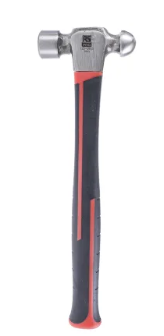
Figure 1. Ball Pein Hammer (Rs-online.com, 2020)

Silicone Phone Case
Primary Material: Silicone
Reason for Selection: Flexibility, shock absorption, lightweight, and cost-effectiveness
Silicone elastomers exhibit high elasticity, good tear resistance, and stability across a wide temperature range (Mark, Erman and Roland (2013)). These properties make silicone suitable for protective cases that must absorb impact energy and resist environmental degradation. Compression moulding enables precise shaping with minimal waste.
Estimated Worldwide Production: Approximately 540 million units. In 2024, the market's volume reached 1.2 billion units, with expectations to climb to 1.8 billion units till 2028. Silicone cases dominate the market with a 45% share (Market Research Reports and Consulting – Global Insight Services, 2023)
Manufacturing Process: Compression moulding of silicone rubber into heated mould cavities.


Figure 2. Silicone Phone Case (Amazon.co.uk, 2026)

Aluminium Engine Block
Primary Material: Aluminium
Reason for Selection: Lightweight, high strength-to-weight ratio, corrosion resistance, and good thermal conductivity
Aluminium alloys are extensively used in automotive engines due to their low density, good strength-to-weight ratio, corrosion resistance, and high thermal conductivity. Efficient heat dissipation is critical for internal combustion engines, making aluminium a preferred choice over traditional cast iron (Polmear, 2005). Aluminium alloys can be cast into complex shapes, allowing the integration of cooling channels, mounting features, and structural ribs within a single component.
Estimated Worldwide Production: Over 80 million engine blocks annually, with aluminium used in more than 60% of modern engines (Industry Estimates).
Manufacturing Process: Sand casting followed by machining and finishing.

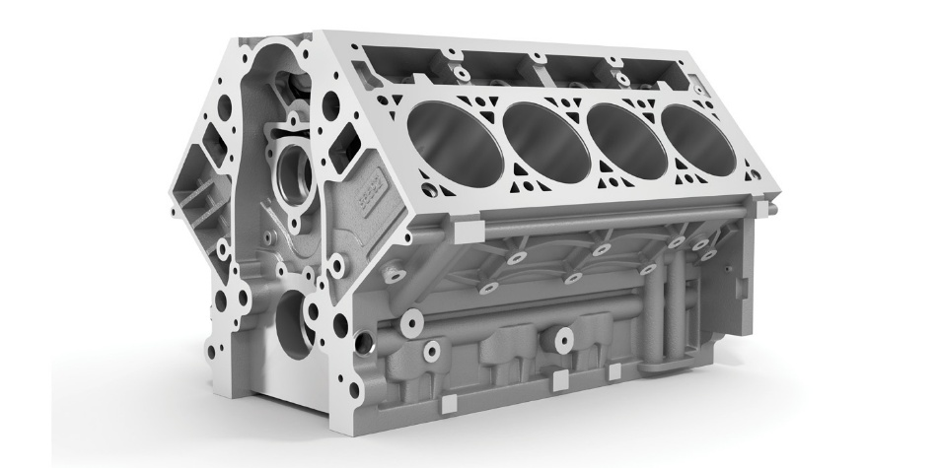
Figure 3. Aluminium Engine Block (FAE, 2025)

Manufacturing Methods

Steel Ball-Pein Hammer
Manufacturing Method: Forging
Forging involves heating high-carbon steel and shaping it under compressive force. This process aligns the grain flow with the hammer geometry, significantly improving strength, toughness, and fatigue resistance (Serope Kalpakjian, Schmid and Vijay, 2014). Forging also reduces porosity and internal defects compared to casting. The process is moderately complex and energy-intensive, requiring controlled heating and specialised tooling. Production rates are moderate because each piece must be individually heated and formed. Costs are relatively high due to labour, energy consumption, and post-forging machining.
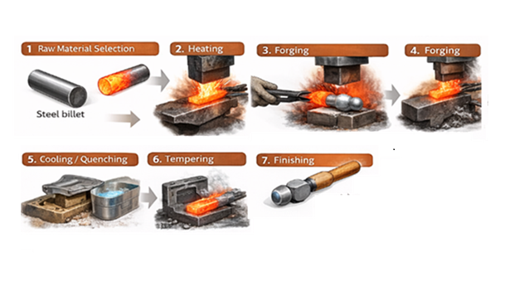
Figure 4 Forging - Ball-pein hammer (OpenAI, 2025)

Silicone Smartphone Case
Manufacturing Method: Compression Moulding
Compression moulding involves placing pre-measured silicone rubber into a heated mould, applying pressure, and curing the material. Silicone’s cross-linked structure forms during curing, giving the final product elasticity and durability (Mark, Erman and Roland (2013)). The process is simple, with low tooling costs and high production rates. Multiple moulds can operate simultaneously, making it ideal for mass production. Energy consumption is low compared to metal processing, and material waste is minimal.
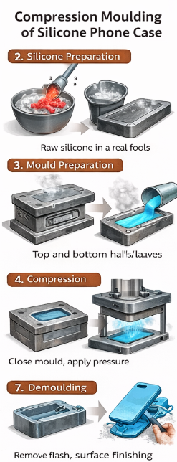
Figure 5 Compression Moulding - Silicone Phone Case (OpenAI, 2025)

Aluminium Engine Block
Manufacturing Method: Sand Casting
Sand casting involves packing sand around a pattern to form a mould cavity, pouring molten aluminium alloy, and allowing it to solidify. After cooling, the sand is removed, and the casting is machined to achieve precise tolerances (Mikell P. Groover , 2021) The process is moderately complex due to temperature control, mould preparation, and shrinkage allowances. Production rates are moderate because each mould is single-use. Costs are moderate to high due to melting energy requirements and extensive machining. However, sand casting remains the most economical method for large, complex components such as engine blocks.
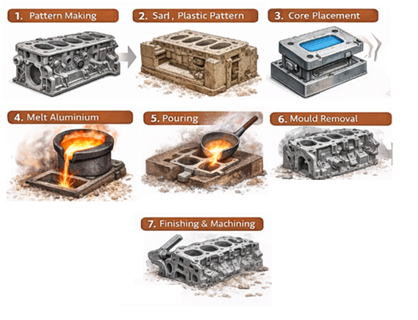
Figure 6 Sand Casting - Aluminium Engine Block (OpenAI, 2025)

Comparison of Mechanical properties
Table 1 Mechanical and Thermal Properties
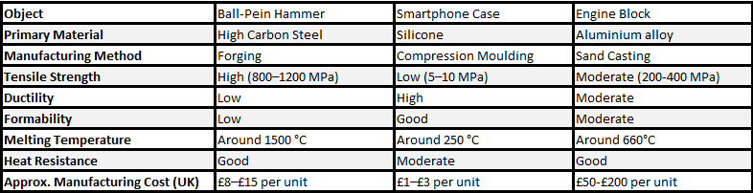
- The forged hammer exhibits the highest tensile strength and heat resistance, ideal for impact tools that experience repeated mechanical stress.
- The silicone case shows low strength but high elasticity, allowing it to absorb shock and flex without permanent deformation.
- The aluminium engine block provides a balance between strength, lightness, and thermal conductivity, which is essential for engine performance.
- Processing cost reflects material complexity: forging and casting are labour and energy intensive, while moulding is inexpensive and rapid.

Lifespan and Cost Analysis
The three selected objects demonstrate clear differences in expected lifespan and production cost, reflecting the trade-offs inherent in material choice.

Steel Ball-Pein Hammer
Forged high-carbon steel hammers can last for decades due to their toughness and resistance to deformation. Corrosion is a potential issue, but protective coatings and proper maintenance extend service life. Production costs are relatively high because forging requires significant energy and skilled labour (Mikell P. Groover , 2021). However, the long lifespan makes forged hammers cost-effective over time.

Silicone Phone Case
Silicone elastomers degrade through tearing, UV exposure, and loss of elasticity. Academic studies show that silicone materials can experience mechanical degradation over months to years depending on environmental conditions (Sciencedirect.com, 2018). Typical consumer use results in a lifespan of 6 months to 3 years. Manufacturing costs are very low due to inexpensive materials and efficient moulding processes. However, silicone is not biodegradable, and recycling is limited, raising sustainability concerns (Hopewell, Dvorak and Kosior, 2009).

Aluminium Engine Block
Aluminium engine blocks typically last 10–20 years, consistent with vehicle lifespans. Fatigue, thermal cycling, and corrosion in coolant passages are common degradation mechanisms (Polmear, 2005). Production costs are moderate to high due to melting, casting, and machining requirements. Recycled aluminium from end-of-life vehicles, including components such as engine blocks, can be remelted into casting alloys and reused in new automotive parts, significantly reducing energy use compared with primary aluminium production (Unlocking Resource Efficiency Phase 1 Vehicles Report, 2023)
Table 2 Lifespan and Cost Analysis
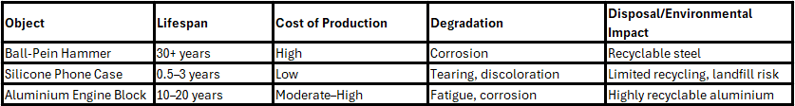

Material Selection and Alternatives

Ball-Pein Hammer
Designers selected forged high-carbon steel for the hammer head because it provides the necessary hardness, toughness, and impact resistance for metalworking. Forging increases the hardness and impact toughness of steel by refining the microstructure and aligning grain flow, which improves resistance to repeated mechanical impact and fatigue loading, making forged high-carbon steel suitable for hammer heads (Jiang, Liu and Liu, 2022) Alternative materials exist, but each has clear limitations. Copper is used in soft-face mallets to avoid surface damage and sparking, but its low hardness and strength result in rapid plastic deformation, preventing its use in metalworking tools that require high impact resistance (Asm International Handbook Committee, n.d.). Polymer composite materials are suitable for light-duty mallets due to their low density and damping capacity; however, their relatively low stiffness, limited thermal stability, and poor wear resistance result in cracking, deformation, and rapid degradation under repeated impact loading, making them unsuitable as substitutes for forged steel in ball-pein hammers (Ashby, M.F. & Jones, D.R.H., 2019)

Phone Case
Silicone is selected for its flexibility and shock absorption. Alternatives include thermoplastic polyurethane (TPU). Silicone may be preferred over TPU for phone cases because TPU has poor thermal resistance, hot water resistance and compression resistance while silicone materials exhibit excellent low-temperature resistance, weather resistance, high-temperature resistance an] aging resistance, making silicone more stable and durable for long-term consumer use under varying environmental conditions (Yang, Ou and Jiang, 2023). TPU may suit more rigid or eco-focused designs however, it does not fully replicate silicone’s flexibility and aging resistance, which are critical performance requirements for mobile phone cases.

Engine Block
Aluminium alloys are widely used for automotive engine blocks because they offer a high strength-to-weight ratio and good thermal conductivity, enabling reduced engine mass and efficient heat dissipation. An alternative is compacted graphite iron (CGI), which provides higher strength, stiffness, and wear resistance than aluminium, but its significantly higher density increases engine weight and negatively affects fuel efficiency (Guesser et al., 2001). Magnesium alloys offer even greater weight reduction than aluminium; however, their susceptibility to corrosion, lower high-temperature strength, and higher material and processing costs limit their suitability for engine block applications (Polmear, 2005).

Conclusion
This report compared three manufactured items—a forged steel ball pein hammer, a silicone phone case, and an aluminium engine block—to demonstrate how material selection and manufacturing processes influence performance, cost, and sustainability. Forged steel provides exceptional durability for impact tools, silicone offers low-cost flexibility for consumer products, and aluminium alloys deliver lightweight strength for automotive components. Each process carries typical defects, such as porosity in castings or flash in mouldings, highlighting the importance of quality control. Selecting appropriate materials and processes remains essential to achieving functional, economic, and environmental objectives in engineering design.

Bibliography
Maleque, M.A. and Salit, M.S. (2013). Overview of Materials Selection and Design. SpringerBriefs in Materials, pp.1–15. doi:https://doi.org/10.1007/978-981-4560-38-2_1 Available at: http://ndl.ethernet.edu.et/bitstream/123456789/40895/1/220.pdf [Accessed 18 Dec. 2025]
Callister, W.D. and Rethwisch, D.G. (2020). Callister’s Materials Science and Engineering. [online] Wiley Global Education. Available at: https://books.google.co.uk/books?id=ZHP2DwAAQBAJ&printsec=frontcover#v=onepage&q&f=false [Accessed 5 Jan. 2026]
Mark, J.E., Erman, B. and Roland, M. (2013). The science and technology of rubber. [online] Amsterdam: Elsevier Academic Press. Available at: http://e-port.linhd.uned.es/short/8A3893T/4A1126309T/science-and__technology-of_rubber-second_edition.pdf [Accessed 18 Dec. 2025].
Market Research Reports and Consulting – Global Insight Services. (2023). Phone Case Market Size, Growth, Trends and Forecast. [online] Available at: https://www.globalinsightservices.com/reports/phone-case-market/ [Accessed 28 Dec. 2025].
Polmear, I. (2005). Light Alloys. [online] Elsevier. Available at: https://books.google.co.uk/books?hl=en&lr=&id=td0jD4it63cC&oi=fnd&pg=PP1&dq=Polmear,+I.+(2005).+Light+Alloys.+Elsevier.&ots=pdrcv74Brl&sig=LLKW9oeQBtHBo9rHcjeZeyfJwZs#v=onepage&q=Polmear%2C%20I.%20(2005).%20Light%20Alloys.%20Elsevier.&f=false [Accessed 28 Dec. 2025].
Serope Kalpakjian, Schmid, S.R. and Vijay, S. (2014). Manufacturing engineering and technology. [online] Singapore: Pearson Education South Asia Pte Ltd. Available at: https://api.pageplace.de/preview/DT0400.9781292422299_A42937630/preview-9781292422299_A42937630.pdf [Accessed 18 Dec. 2025].
Rs-online.com. (2020). RS PRO Carbon Steel Ball-Pein Hammer with Fibreglass Handle, 910g. [online] Available at: https://uk.rs-online.com/web/p/hammers/1250945 [Accessed 17 Dec. 2025].
Amazon.co.uk. (2026). OitiYaa Silicone Case Compatible with iPhone 11 Case 6.1 Inch, Soft Ultra Slim Protective Shockproof Liquid Silicone Phone Case with Anti-Scratch Microfiber Lining,Mint Green: Amazon.co.uk: Electronics & Photo. [online] Available at: https://www.amazon.co.uk/OitiYaa-Compatible-Protective-Shockproof-Anti-Scratch-Mint-Green/dp/B0BNLC2Y24?th=1 [Accessed 17 Dec. 2025].
FAE. (2025). Engine Machining & Cylinder Head Repair | FAE Ltd UK. [online] Available at: https://fae.uk.com/services/ [Accessed 17 Dec. 2025].
Mikell P. Groover (2021). Fundamentals of Modern Manufacturing: Materials, Processes and Systems, International Adaptation, 7th Edition. [online] Wiley.com. Available at: https://www.wiley.com/en-hk/Fundamentals+of+Modern+Manufacturing%3A+Materials%2C+Processes+and+Systems%2C+International+Adaptation%2C+7th+Edition-p-9781119706434 [Accessed 17 Dec. 2025].
OpenAI (2025). ChatGPT. [online] ChatGPT. Available at: https://chatgpt.com/ [Accessed 29 Dec. 2025]. AI Generated Manufacturing Method – Forging a Ball Pein Hammer
OpenAI (2025). ChatGPT. [online] ChatGPT. Available at: https://chatgpt.com/ [Accessed 29 Dec. 2025]. AI Generated Manufacturing Method – Compression moulding of Silicone Phone case
OpenAI (2025). ChatGPT. [online] ChatGPT. Available at: https://chatgpt.com/ [Accessed 29 Dec. 2025]. AI Generated Manufacturing Method - Sand Casting of an Aluminium Engine Block
Sciencedirect.com. (2018). Polymer Testing | Vol 67, Pages 1-550, A1-A2 (May 2018) | ScienceDirect.com by Elsevier. [online] Available at: https://www.sciencedirect.com/ journal/polymer-testing/vol/67/suppl/C. [Accessed 29 Dec. 2025].
Hopewell, J., Dvorak, R. and Kosior, E. (2009). Plastics recycling: Challenges and opportunities. Philosophical Transactions of the Royal Society B: Biological Sciences, [online] 364(1526), pp.2115–2126. Available at: https://www.ncbi.nlm.nih.gov/pmc/articles/PMC2873020/ [Accessed 29 Dec. 2025].
Unlocking Resource Efficiency Phase 1 Vehicles Report. (2023). Available at: https://assets.publishing.service.gov.uk/media/6564e847888c060013fa7dd3/unlocking-resource-efficiency-phase-1-vehicles.pdf. [Accessed 18 Dec. 2025].
Jiang, J., Liu, Y. and Liu, C. (2022). Effect of forging ratio on the microstructure, mechanical properties and abrasive wear behavior of a new C–Cr–Mo–V martensitic steel. Journal of Materials Research and Technology, 19, pp.4076–4091. Available at: https://www.sciencedirect.com/science/article/pii/S2238785422009309 [Accessed 18 Dec. 2025].
Asm International Handbook Committee (n.d.). ASM Handbook, Volume 02 - Properties and Selection: Nonferrous Alloys and Special-Purpose Materials. [online] Asm International. Available at: https://www.slideshare.net/slideshow/asm-handbook-volume-02-properties-and-selection-nonferrous-alloys-and-special-purpose-materials-usa-1992-3470p-pdf/271741750 [Accessed 18 Dec. 2025].
Ashby, M.F. and Jones, D.R.H. (2019) Engineering Materials 1: An Introduction to Properties, Applications and Design. 5th edn. Oxford: Butterworth-Heinemann Available at: http://ndl.ethernet.edu.et/bitstream/123456789/22924/1/123.pdf [Accessed 27 Dec. 2025].
Yang, L., Ou, Z. and Jiang, G. (2023). Research Progress of Elastomer Materials and Application of Elastomers in Drilling Fluid. Polymers, [online] 15(4), p.918. doi: https://doi.org/10.3390/polym15040918. Available at https://www.ncbi.nlm.nih.gov/pmc/articles/PMC9959665/ [Accessed 05 Jan. 2026].
Guesser, W.L., Guedes, L.C. and Gonçalves, J.A. (2001) ‘Compacted graphite iron for engine blocks’, Materials Science and Engineering A, 318(1–2), pp. 17–28. Available at: https://www.tupy.com.br/downloads/guesser/compacted_graphite_iron_for_diesel.pdf [Accessed 18 Dec. 2025].

