Essay About Essential Study Skills For Me

Index
Assessment 1. Task 1. 3
Cloud Computing 3
About Me 3
My Skills 3
Skills to develop in the future 4
Coding 4
Data Management 4
Social Media Management 4
References 7

Assessment 1. Task 1.

Cloud Computing
(University Of Wales Trinity Sant David, 2022) Cloud Computing is a specialization of computer networking that is concerned with the management of large data in data centres, virtualization, and the provision of cloud services.


About Me
My name is Cristopher González I am a Cloud Computing student from University of Wales Trinity Sant David (UWTSD). Though this page, I want that you know me and how I love the technology and my interests for the future and of course I hope that you like it.

I'm very fascinate with the technology and how it affect in our lives. We can do almost all that we imagine and that is thanks to the continues improvements to the technology. I like to much the football, videogames, and the internet in general.

My Skills
I prefer to develop some skills such us:
- Developing Programming
- Database Management
- Project Administrator
- Development Mobile Phone Apps
I got some titles from a private Learning Platform Web called (Aprende) “Aprende.org”:
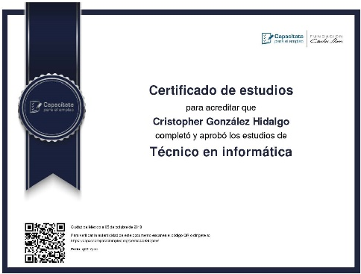
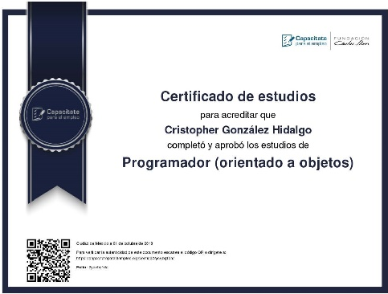

Skills to develop in the future
I consider that every day is going to be important to get good skills to make the difference between you the others. I think is you have good knowledge about, for example:

Coding
Knowing how to program is a skill that is highly valued in the computer industry, since it implies the ability to create tools and applications for users who, through them, drive the entire society towards this new digital age.


Data Management
(IBM) According with IBM in their web page. A Database Management is essentially nothing more than a computerized data-keeping system. In the new era of technology, all the digital actions we do generate data and keeping it safe, secure, and available is essential.

Networking Configuration
Computer networks are the main means by which the digital activities of this new technological era are developed, so having a good management of them as well as providing a secure and private network is very important for companies to carry out their commercial activities. without risks.


Social Media Management
When it comes to trying an application or making a purchase, it is increasingly important to know the experience of others in the same about it, so good management of social networks is essential.


I consider that these skills are very important for the computing students, are important for me and I’ll try to put my focus in these because I know that developing, I can get good changes for the professional future.

Assessment 1. Task 2.

Similarity

References
Aprende. (n.d.). Aprende. Retrieved from Aprende.org: https://aprende.org/
IBM. (n.d.). IBM. Retrieved from IBM: https://www.ibm.com/docs/en/zos-basic-skills?topic=zos-what-is-database-management-system
University Of Wales Trinity Sant David. (2022). University Of Wales Trinity Sant David. Retrieved from University Of Wales Trinity Sant David: https://uwtsd.ac.uk/apprenticeships/digital/cloud-computing/

