Introduction

Historically, across NHS Wales, medicines management relied on paper-based processes, utilising the Inpatient Medication Administration Record (appendix 1), which was developed in collaboration with the All-Wales Chief Pharmacist Committee. Evidence suggests a plethora of problems associated with the paper-based medicines management process (Welsh Government, 2018; Vaghasiya et al. 2021; Austin et al. 2018), including medication errors, illegible handwriting, and missing medication records. The root cause analysis (RCA) using Ishikawa’s fishbone diagram (Figure 1) offers a more detailed analysis of the potential causes and contributing factors that may compromise patient safety.

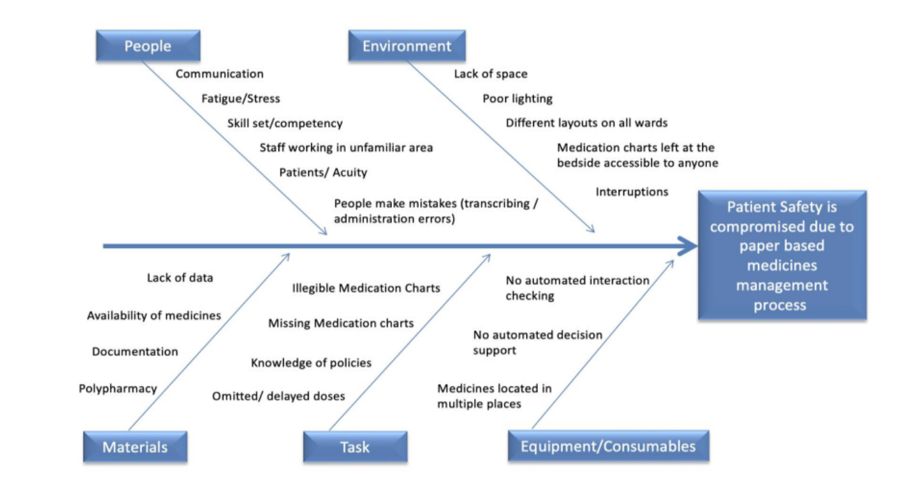
Figure 1. Figure 1. Fishbone diagram developed by Karou Ishikawa (1960), RCA of factors contributing to compromised patient safety.

By successfully implementing a software product to digitalise the medicines management process, many benefits could be realised (Welsh Government, 2018), including improved efficiency, workflow and patient safety will be enhanced by removing paper-based processes, contributing to the provision of seamless patient care.

For this assignment, a software product adopted by Swansea Bay University Health Board (SBUHB) will be critically analysed. The software product is the electronic Prescription and Medication Administration (ePMA) system. The functionality, benefits, and limitations of the ePMA system will form part of the critical analysis using the Fit between Individual, Task and Technology (FITT) framework.

Service Context
SBUHB is part of NHS Wales and serves around 390,000 people in the Neath, Port Talbot, and Swansea areas, as illustrated in Figure 2. With a budget of approximately £1bn, they employ around 12,500 staff within their hierarchical structure, 70% of whom are directly involved in patient care.


Figure 2. The service area of Swansea Bay University Health Board

Within SBUHB are three major District General Hospitals (DGH), including Morriston Hospital, located in Swansea, a regional acute tertiary hospital comprising 750 beds, offering a range of specialist services. Singleton a DGH comprising approximately 330 inpatient beds and provides various medical, surgical, inpatient and outpatient services and Neath Port Talbot hospital (NPTH) in Port Talbot which has around 200 beds, providing a range of inpatient, outpatient, and day services.

In NPTH and Singleton, 3,942 patients are admitted annually, and virtually all patients have one or more medications prescribed (Connelly and Cotterell, 2019), equating to 121,921 individual medications and 1,245,673 medication doses administered by registered nurses annually (Thomas, 2022). A multidisciplinary team support the holistic care and treatment of the patients admitted to the inpatient wards. As a result, several healthcare professionals may simultaneously need access to the paper medication record. Therefore, medication errors are likely to occur with multiple people involved, including omission or delayed medication administration when the chart is unavailable to the registered nurse during scheduled medication rounds or when a patient requires additional medicines. Medication errors have the potential to be severe or critical. In 2010, there were over 300,000 hospital-based medication errors in Wales, 6,000 of which would have caused severe harm (Connelly and Cotterell, 2019).

In 2017, Abertawe Bro Morgannwg University Health Board (ABMUHB), the predecessor of Swansea Bay University Health Board (SBUHB), proposed to digitalise the medicines management process by replacing the paper-based Inpatient Medication Administration Record with an electronic Prescribing and Medicines Administration (ePMA) system.
Upon approval of the proposal by the Welsh Government, £954,000 of funding was provided to NPTH and Singleton to implement ePMA. SBUHB is expected to serve as a pathfinder for implementing national systems across NHS Wales’s remaining health boards and trusts.

On the 11th February 2020, after years of research and preparation, the hospital electronic prescribing and medicines administration (ePMA) system was procured and introduced for the first time in a hospital in NHS Wales, replacing the Inpatient Medication Administration Record on one ward at NPTH. A phased adoption continued throughout 2020-2021, as illustrated in figure 3.

Figure 3. Showing phased implementation of ePMA software across:
Neath Port Talbot Hospital

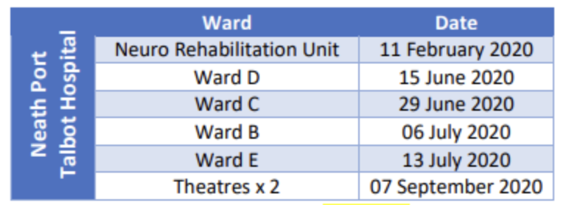
Singleton Hospital

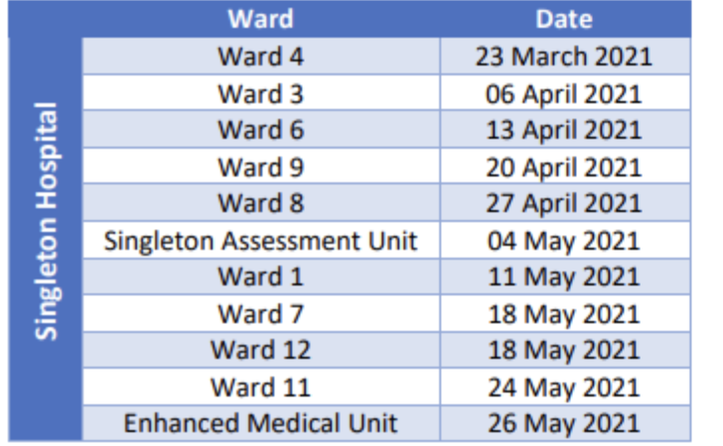
Figure 3. Phased implementation of ePMA across NPTH and Singleton

Selected Team
NPTH comprises around 200 beds, and Singleton has 330 beds distributed across their inpatient wards. The software product ePMA has been adopted to support the medication management process using a phased approach between the 11th February 2020 and the 31st May 2021 across NPTH and Singleton Hospital inpatient wards (figure 3). These wards will be referred to as ePMA wards for the remainder of this assignment.

Software Product
The software product is the ePMA system. Through successful implementation of the ePMA system, all stages of the medicines management process including, prescribing, dispensing, and administering medicines will be digitalised. The ePMA system aims to improve patient safety, reduce medication errors, and increase efficiency in medication management.

Methods

Many software projects will fail entirely or partially because they do not meet all their requirements. The failure rates of software projects range between 60-70% (Ammenwoth et al. 2006), leading to financial loss within healthcare and loss of confidence in Information Technology (IT) from users and managers. Some projects are considered a success by one department or professional group and a failure or at least problematic by another (Ammenworth et al. 2006).

Evaluation frameworks are an important tool to help structure and link evaluation questions, outcomes, indicators, data sources and data collection. The choice of evaluation framework is critical in ensuring that the evaluation aligns well with the project goals (Moran, Burson and Conrad, 2023). However, Coto, Mora and Collazos (2014) argue that this can depend on the approach to collaboration and individual perspectives on the value of evaluation.

Several evaluation frameworks are associated with common practice in programme evaluation. In 1989 Davis developed the Technology Acceptance Model (TAM) which assumes that two factors determine whether a computer system will be accepted by its potential users: their perceived usefulness and perceived ease of use. The critical feature of TAM is its emphasis on the perceptions of potential users. The theory says very little about the technology itself but about people's perceptions, which could change depending on who the users are. It also assumes that people plan their behaviour; however, as not everything people do is planned, it would be difficult to apply this theory to the practical implementation of ePMA. The TAM framework also emphasises the importance of making technology useful and easy to use. However, it does not offer recommendations for making the technology useful following evaluation. In their seminal review of TAM, Holden and Karsh (2010) highlighted the framework's value in assessing the relationship between users and technology. However, there is a need for additional constructs to allow other relationships to be explored.

The Task Technology Fit (TTF) model (Goodhue and Thompson, 1995) holds the theory that IT is more likely to positively impact individual performance and be used if the capabilities of the IT match the task that the user must perform. Unlike the TAM model, the TTF model explicitly includes a task-technology construct (Prgomet, 2019). The premise of the TTF model is that technology will be used if it adequately supports the demands of the task. However, the TTF does not include a construct that examines user characteristics (Prgomet, 2019) and, therefore not a suitable tool to guide the evaluation of the implementation of ePMA, as the user is an essential component.

DeLone and McLean (1992) described the effects of IT on the user in the Information System Success Model (ISSM) which seeks to provide a comprehensive understanding of information system success by identifying, describing, and explaining the relationships among six dimensions (system quality, information quality, use, user satisfaction, individual impact, and organisational impact), along which information systems are commonly evaluated. In 2003 the ISSM was further refined by the original authors DeLone and McLean, aligned to the changing role and progress made with information systems for measuring e-commerce system success. However, Ammenworth et al. (2006) caution that IT success is multi-dimensional. As the ISSM is focused on IT quality and system quality, it does not explain why the same IT system can be adopted differently and have different effects.

Prgomet (2019) states that the TAM and TTF are prominent theories widely accepted in healthcare that describe ways to explore the notion of fit between technology and work practices. However, in 2006 Ammenworth et al. proposed Fit between Individual, Task and Technology (FITT) as a framework, encompassing the interactions of users and technology (TAM concepts) and task and technology (TTF concepts) and the interactions between users and tasks (Ammenworth et al, 2006).

The author will adopt the FITT Framework to guide the evaluation of the ePMA system at NPTH and Singleton hospitals, as there is evidence to suggest that the FITT framework has been effective in evaluating factors that influence the success or failure of IT implementation in healthcare settings (Kujala et al., 2020 Tsiknakis M, Kouroubali, 2009; Prgomet et al., 2019; Schnall et al., 2012 and Cho et al., 2019).

The FITT Framework

The adoption of ePMA will be evaluated using the FITT framework to enable a better analysis of the socio-organisational-technical factors that influence IT adoption. Moullin et al. (2019) maintain that a well-thought-out evaluation framework will help guide effective and systematic data collection to form the evidence base for assessing progress. Arbour (2020) also suggests that evaluation frameworks guide developers and evaluators to ensure that the evaluation design reflects and incorporates the originating motivations, principles, and context of the programme.

The FITT framework is based on the idea that IT adoption in a clinical environment depends on the fit between the attributes of the individual, technology, and clinical tasks (see figure 4). Kujala et al. (2020) suggest that a particular strength of the FITT framework is the focus on the interaction between the user and the task, as issues related to IT support of professional workflows are the most frequently reported failure factor of electronic health interventions (Granja, Janssen and Johansen, 2018). Comparatively, the TTF model focuses on the task and technology without considering the user as essential. Compared to other frameworks, such as the Consolidated Framework for Implementation Research (CFIR), TAM, and ISSM, the FITT framework differs in adding the interaction aspect, making it an appropriate tool to guide the critical evaluation of the ePMA solution.

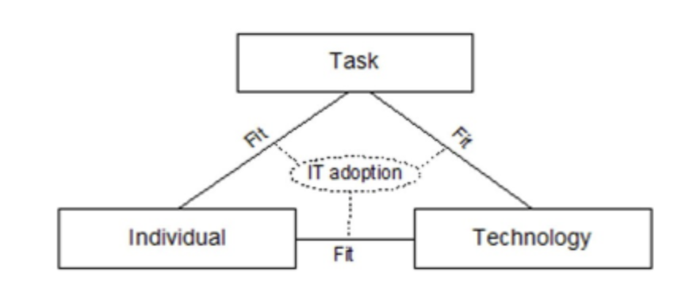
Figure 2. The FITT Framework, developed by Ammenworth et al. (2006)

The concept of the "individual" can represent an individual user or a user group. For this assignment, the user group is the multidisciplinary team of clinicians involved in the medication management process in the inpatient wards, including registered nurses, pharmacists, and doctors, who have a range of roles notably medication reconciliation, prescribing, ordering, and administering medication.
The "technology" concept can represent the tools required to accomplish the given task, including the hardware, software, and network. Therefore, the ePMA system, the hardware, including desktop and handheld devices, the available network, and Wi-Fi connections. However, Ammenwerth et al. (2006) caution that the technology concept does not only comprise computer-based tools, but all tools used by individuals to execute the task and, therefore, may include paper-based tools. In this instance, the paper-based tools are the supplementary medication charts for administering intravenous infusions, continuous subcutaneous infusions, epidural charts, blood transfusion charts, and the patient's medical records, which are currently paper-based in NHS Wales.
The "task" concept comprises the whole task and working processes that must be completed by the user and supported by the given technology. The ePMA system allows prescribers and administrators to prescribe and administer medication efficiently. Although many researchers (Nilsen, 2015; Greenhalgh et al. 2005; and Wilson, Brady and Lesesne, 2011) focus on the aspect of "organisation", according to Ammenworth et al. (2006), the organisational aspect is part of the individual concept, as individuals play different roles in the organisation, or it is part of the task concept since defined responsibilities are assigned to technical tasks.

Data Collection

Data for this critical analysis has been collected using multiple sources. SBUHB published an evaluation document authored by Marc Thomas, Digital Programme Manager, in July 2022 following the implementation of the ePMA solution across NPTH and Singleton. The evaluation provides detailed information relating to the implementation approach. This data was collected pre- and post-implementation, including quantitative data from the Datix incident reporting system and time in motion studies. The Datix incident reporting system is a software application used in NHS Wales to manage and report incidents, near misses and other safety events (Mushcab et al. 2020). Qualitative data was collected using staff surveys, free text feedback and informal feedback captured verbally. A review of relevant literature was also conducted to enhance the data sourced through the evaluation document published by Thomas (2022).

Pre-Implementation data
Pre-implementation baseline data on medication incidents were captured using the Datix incident reporting system. There were 13 prescribing errors, and 74 administration errors reported, as per Figure 5. However, the data displayed relies on individuals being aware of an error and self-reporting medication errors, therefore, the actual figures may be much higher. Pre-implementation data relating to the duration of medication rounds were captured through time in motion studies and the completion of data capture forms completed by registered nurses recording the start and end times of their medication rounds, see Figure 6.

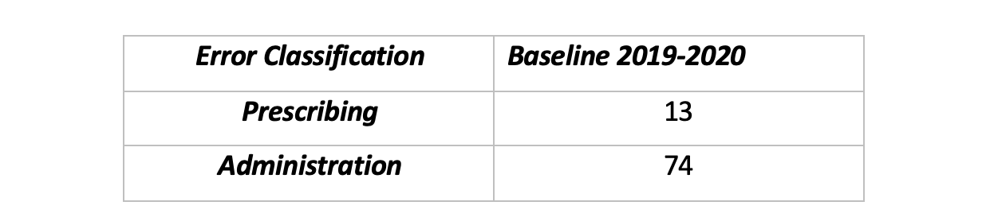
Figure 3. Baseline number and type of medication error reported using the Datix incident reporting system pre-implementation

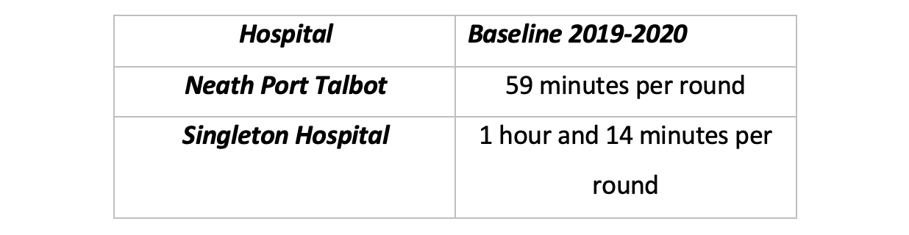
Figure 4. Baseline data showing the time taken to complete a medication round pre-implementation

Post-implementation data collection
As users of the ePMA have different tasks associated with the technology, different survey questions were issued to each user, as seen in Figures 7, 8 and 9. Users were categorised into three groups for qualitative data collection; prescribers (medical and non-medical), nursing staff and pharmacists. Respondents were asked to; strongly agree, agree, neither agree nor disagree, disagree, or strongly disagree with the statements and to provide free text feedback regarding the ePMA system.
Quantitative data was collected using the Datix incident reporting system to ascertain the baseline number of medication errors before ePMA implementation and subsequently at agreed intervals following implementation to understand causality, changes, and trends.

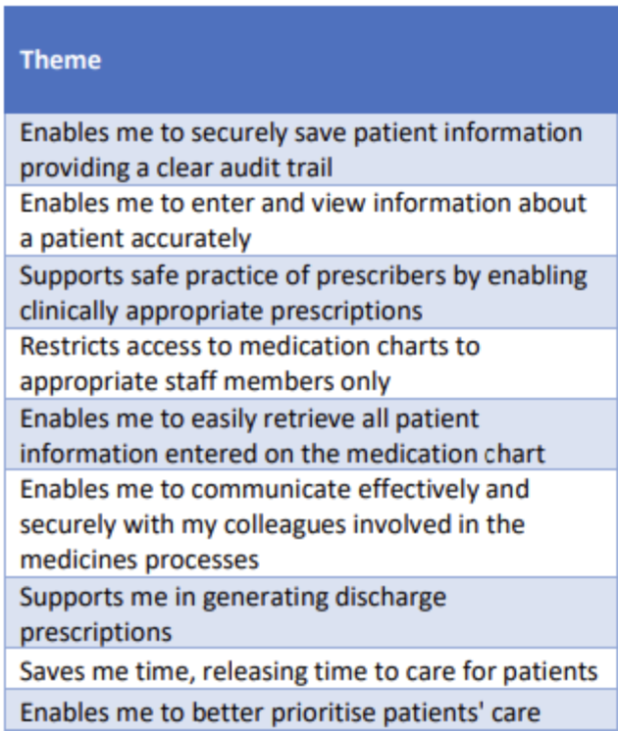
Figure 5. Survey questions issued to prescribers (medical and non-medical)

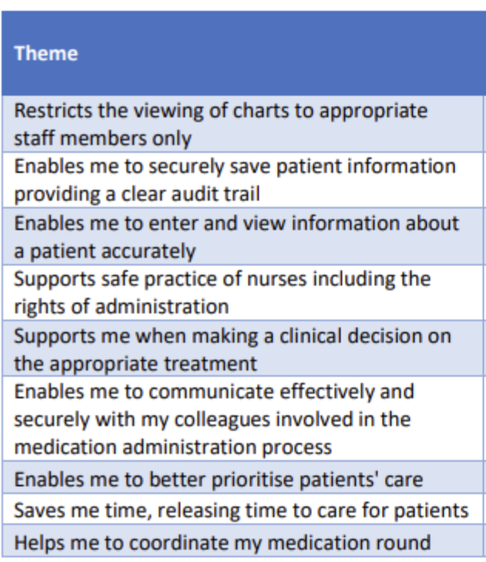
Figure 6. Survey questions issued to registered nurses

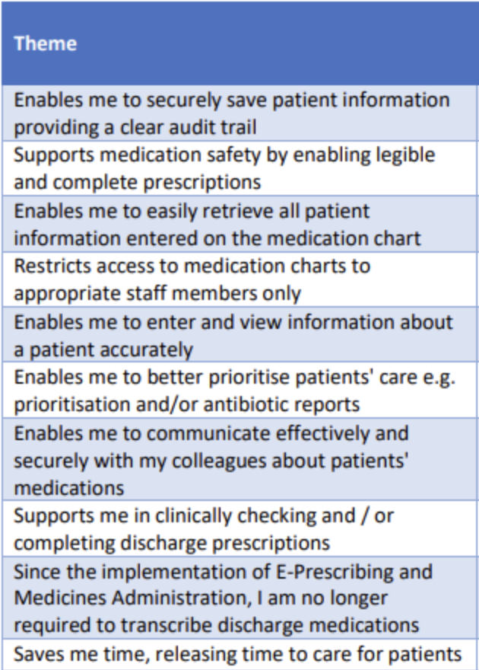
Figure 7. Survey questions issued to pharmacists

Literature Review, Search Strategy
The initial search was carried out using google scholar, using the phrase "electronic medicines management systems". A further search was conducted using PubMed, Embase and Medline, using the keywords; "prescribing', "admin*", "midic*", and "health information system" truncation technique was used to broaden the search, and Boolean operators were utilised to enhance the specificity. Exclusion criteria were applied, with articles not published in English, relevant, duplicated or written before 2012 excluded.

Results

The FITT framework was applied to the findings from the evaluation and literature review (Thomas, 2022) to assess the relationships between users, tasks, and technology based on the responses to the survey, free text feedback and relevant literature. The author acknowledges the diverse role of the users discussed. However, discussing the full function of any clinical professional is beyond the remit of this assignment. It, therefore, will focus on the user's role relevant to using the ePMA system and associated technology.

FITT: Prescribers (medical and non-medical), task and technology

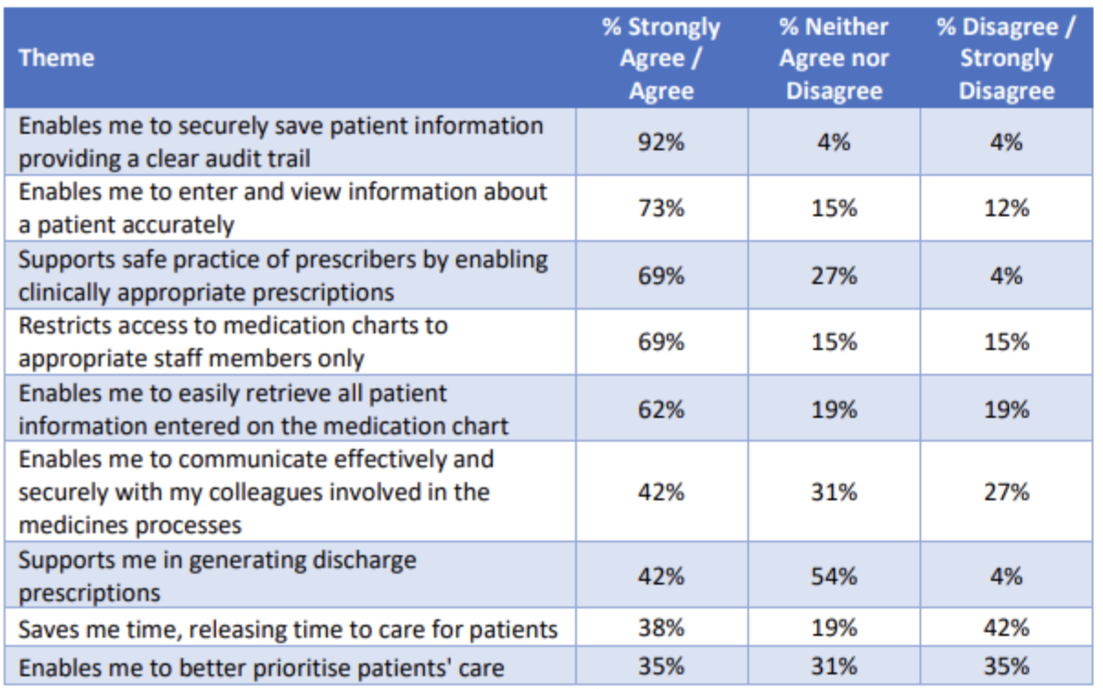
Figure 8. Prescribers’ response to the survey
The main types of tasks conducted by medical and non-medical prescribers as users of the ePMA system include reviewing the patient’s condition, their medical notes, medication records and test results to appropriately prescribe medication for the patient. A hybrid information system requiring prescribers to access computer devices and paper-based records introduces confusion about where information is accessed or documented, which can result in omissions or duplications that adversely affect patient safety.
Prescriber feedback also revealed that the implementation of ePMA did not offer any timesaving efficiencies due to the hybrid nature of the information available. However, the lack of timesaving is not uncommon in the early stages of a new clinical information system (Miller et al. 2016; Atun et al. 2015; and Kulkarni et al. 2020).

FITT: Registered nurse, task, and technology

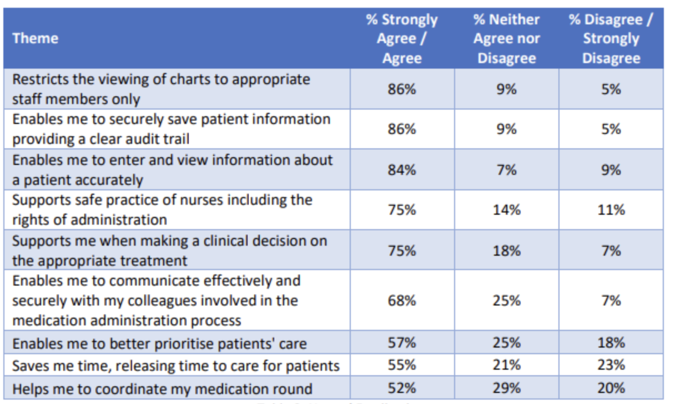
Figure 9. Registered nurse response to the survey

The tasks carried out by registered nurses as users of the ePMA system include accessing information to prepare medication, documenting medication administration, reviewing patient notes and administering and observing that the patient has taken their medication safely and as prescribed with appropriate consent. However, during their medication rounds, registered nurses are frequently required to complete additional tasks, often going from patients' bedsides to attend to another patient's needs or to the medication room to obtain medications that are unavailable at the patient's bedside. Like prescribers, nurses require access to hybrid information systems using computer devices and paper-based records. Nurses reported that mobile devices supported them in moving around the ward as needed during their medication rounds and that fixed computing devices would not be suitable for medication administration.
Some nurses reported that they found it quicker and easier to complete tasks using paper charts. However, the consensus was that mobile devices provided several benefits over paper-based charts.

FITT: Pharmacist, task, and technology

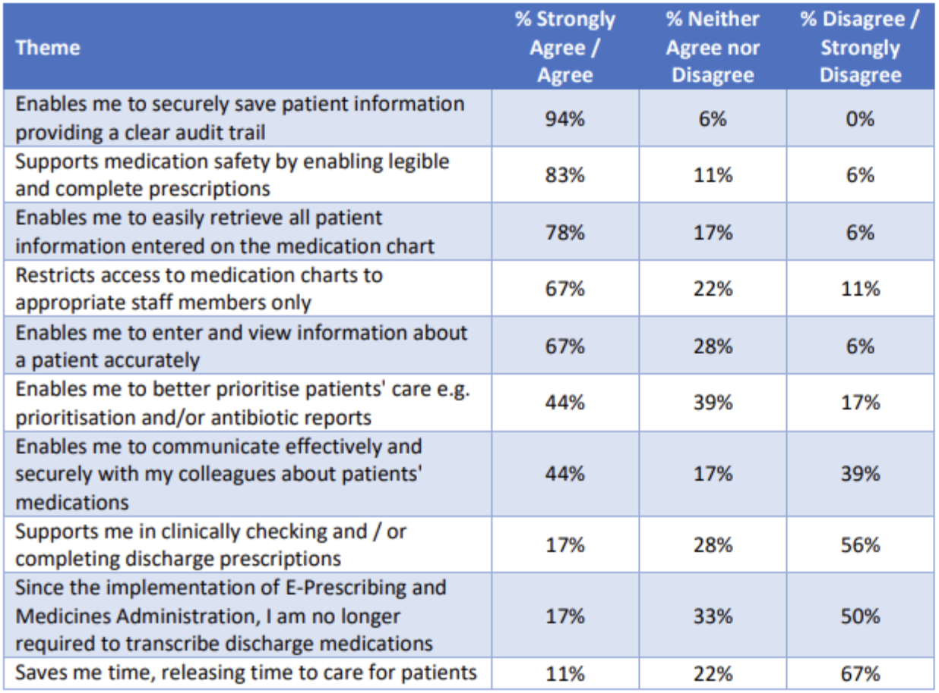
Figure 10. Pharmacist response to the survey

The pharmacist’s role differs from that of the registered nurse and prescriber within the hospital environment. The primary role of the hospital pharmacist as a user of the ePMA system is to complete medicines reconciliation, perform regular reviews to identify and address medicine-related issues, support patients to get the best outcomes from their medications, and reduce inappropriate prescribing of medicines. The pharmacist will liaise with multidisciplinary teams to ensure that patients have the necessary medicines. Traditionally the pharmacist will not be part of the regular medication rounds but will be part of a weekly ward round to ascertain the information they need from the multidisciplinary team. Like the nurse and the prescriber, the pharmacist will need access to paper-based and computer-based information simultaneously. However, the results of the free text survey reported that a key benefit for pharmacists is the accessibility of the ePMA, as they could access the ePMA system before and after attending the ward/patient bedside using fixed devices (including laptops and desktop computers in their department). Therefore, they could focus their interventions, did not need to compete for devices, and were not affected by interruptions in a busy clinical environment.

Literature Review Results
The final number of articles included was 18, as detailed in Figure 13.

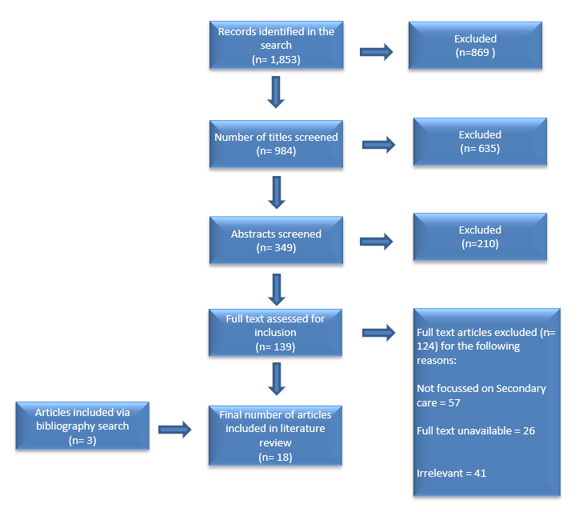
Figure 11. PRISMA flow diagram showing literature search and inclusion/exclusion process

A review of the full-text articles revealed several key themes associated with implementing ePMA systems, as discussed in the next section.

Qualitative Themes
Qualitative themes were identified through a review of the literature sourced and the responses to the survey. Key themes are as follows: workflow and time, medication safety, data availability, accessibility, confidence, and competence.

Workflow and time
The most negative response received across the prescriber user and registered nurse user concepts were related to releasing time to care and overall timesaving. Initial results suggested less efficiency and 'time wasting' while using the ePMA. Similarly, the pharmacist users reported a lack of timesaving due to processes relating to discharge advice taking longer since the implementation of ePMA. However, it can be anticipated that as changes to process, and workflow are embedded, it will become more streamlined, and timesaving benefits and workflow efficiencies will be realised according to the evidence available in the literature relating to the benefits of ePMA systems (Porterfield, Engleber and Coustasse, 2014; Armada et al. 2014; and Moore at al. 2020).

Medication Safety
There was a strong consensus among pharmacists, nurses, and prescribers that the ePMA supports safe practice and medication safety. Users reported improved medication safety through legible and complete prescription information and safely sharing relevant information across clinical settings, consistent with the relevant literature findings (Moore et al. 2020). The aspect of patient safety is further discussed in the quantitative rating section, as it is possible to see the exact numbers of medication-related incidents reported using the Datix incident reporting system for quantitative review.

Accessibility
Pharmacist users reported the benefit of accessibility, as they could access the ePMA system away from the clinical area and, as a result, could focus their intervention at the patient's bedside. In addition, they did not have to compete for an available device on the ward and were not subject to multiple interruptions as they would be at the patient's bedside. In addition, given the timing of implementation, the added benefit of accessibility during the covid19 pandemic made it possible to reduce footfall on the ward and reduce the likelihood of transmission aligned to infection prevention and control procedures.

Confidence and Competence
Respondents to the survey gave feedback about confidence and competence within the free text feedback. Specifically, registered nurse users expressed concerns as they had not previously used an electronic device as part of their role. Prescribers also described a lack of confidence in using the ePMA system without additional training, and pharmacists requested further training to improve their confidence and competence.

Quantitative Ratings

A time-in-motion study focused on three elements of the users' tasks to determine the maximum amount of time that could be released to patient care by implementing an ePMA system. A summary of the findings is illustrated in Figure 14.

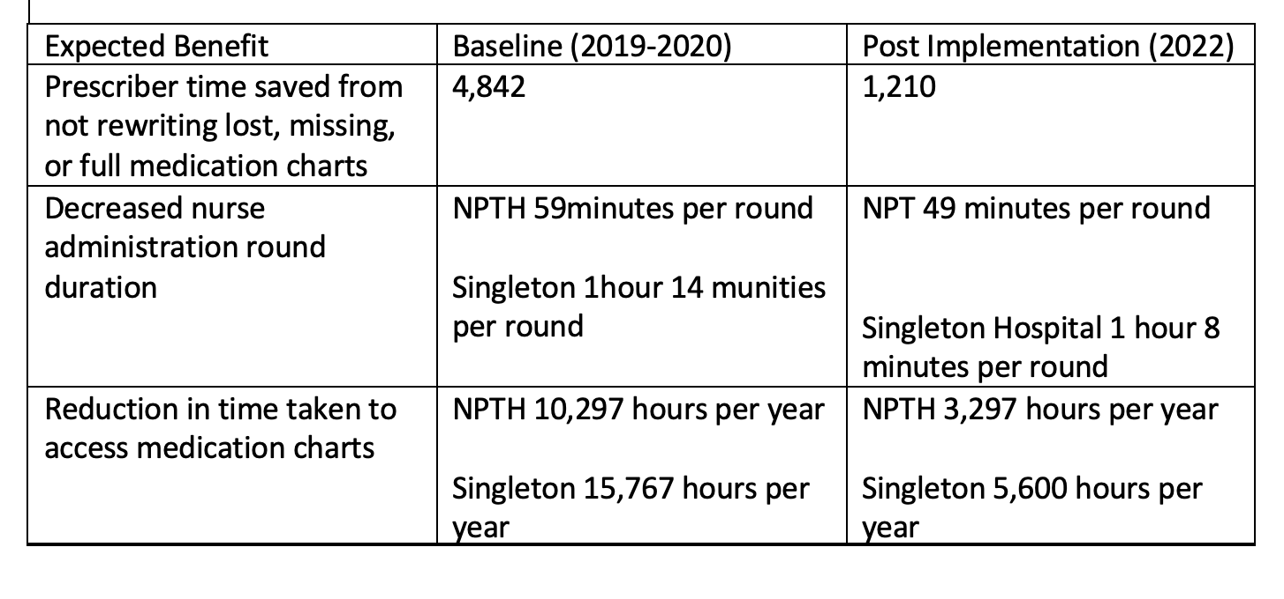
Figure 12. Summary of findings, time in motion studies

Approximately 10,167 hours were released to care at Singleton and 7,000 hours at NPTH.
Data were obtained from the Datix incident reporting system concerning the number of incidents relating to the medicines management process, focusing on three elements, as illustrated in Figure 15.

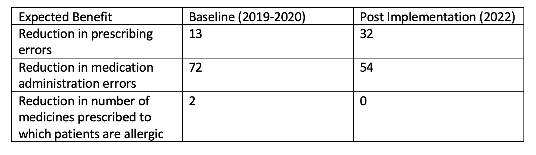
Figure 13. Errors in Prescribing and medicines administration
The data captured from the Datix incident reporting system relies upon individuals to recognise that they have made an error and to self-report.

Discussion and Conclusion

Using the FITT framework has enabled the author to critically analyse how well the ePMA system aligns with the needs of the individual (users of the ePMA) and the tasks (medicines management tasks) they are performing. However, there are several limitations to the FITT framework for consideration. Davidoff et al. (2015) support that the FITT framework does not provide a standard set of criteria for evaluating the fit between the individual, task, and technology concepts. Since other evaluations may have used a different set of criteria, the conclusion that the ePMA system is a suitable solution aligned with the users' needs and tasks associated with the medication management processes may not be comparable to other evaluations. The FITT framework also requires an understanding of the complex interactions between individuals, tasks, and technology and, therefore, can be challenging to use when many individuals and tasks are involved (Greenhalgh et al. 2017). However, although the FITT framework was an appropriate tool to guide the evaluation of the ePMA implementation at NPTH and Singleton, due to its lack of standard criteria, the complexity of relationships between users, tasks, and technology, as well as its limited scope, it is unlikely to be an appropriate tool to support a more extensive evaluation. In addition to organisational culture and external factors like regulatory and environmental constraints, other factors influencing technology adoption and use are not considered in the FITT framework.

An alternative framework to evaluate the implementation of the ePMA system on a national scale is the Technology, People, Organisations and Macroenvironmental (TPOM) framework. The TPOM framework (Figure 16.) was developed by Creswell, Williams, and sheikh (2020) specifically for health information technology implementers. Within this framework, all dimensions are equally important and illustrate the interdependencies of the components.

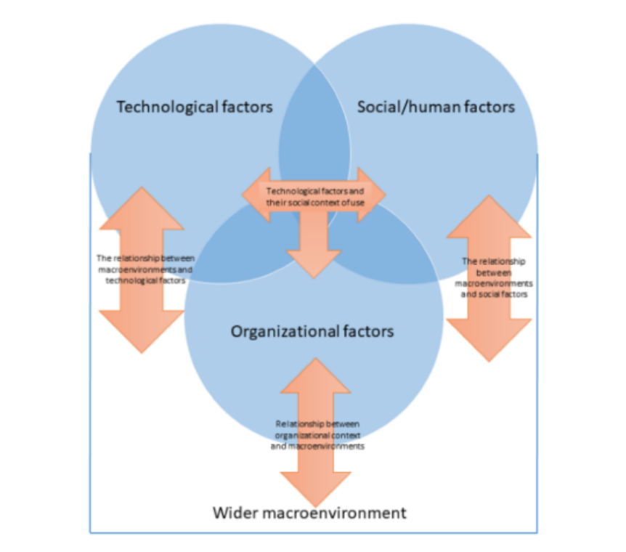
Figure 14. The TPOM framework (Creswell, Williams and Sheikh, 2020)

While the TPOM framework and the FITT framework share some similarities in assessing the fit between technology, tasks, and individuals, there are some important differences between the two frameworks (Gehman, 2018). Cram, Proudfoot and D’arcy (2017) state that the main difference is that the TPOM framework takes a broader organisational perspective and includes the Person-Organisation Fit (POF) and Management of Change (MOC) components. In contrast, the FITT framework primarily focuses on the fit between individuals, tasks, and technology without considering the organisational context as its own concept.

In contrast to the FITT framework, which is primarily a tool for describing the fit between the individual, task, and technology concepts and does not provide specific recommendations for improving the fit (Davidoff et al. 2015), the TPOM framework is more prescriptive. It offers a structured approach for assessing and improving the fit between technology, tasks, individuals, and the broader organisational context, including specific strategies for managing change (Hanelt, Bohnsack, Marz and Antunes Marante, 2021). Overall, while the TPOM and FITT frameworks are useful tools for assessing and improving the fit between technology, tasks, and individuals, they have different areas of focus and different levels of prescriptiveness, and the choice of the framework will depend on the specific research question or organisational context (Pfadenhauer, 2017).

The expected impact of implementing ePMA systems is improving patient safety by digitalising the medicines management process and removing variation in paper-based practices. Applying the FITT framework to evaluate the data available in the SBUHB evaluation and the evidence sourced through the literature review suggest that the ePMA system is a good fit aligned with the individual task and technology, as it facilitates increased accuracy, improved efficiency, and patient safety (Porterfield, Engelbert and Coutasse, 2014; Kweon and Lee, 2021; and Vaghasiya et al. 2021). However, there is a perception by some users that the ePMA system may not be considered a good fit, specifically relating to time saved and the ability to prioritise patient care better (Thomas, 2022). The lack of agreement with the statements around timesaving and prioritising patient care may be attributed to the requirement to continue to work in a hybrid fashion, as not all medicine charts are within the scope of the ePMA system, and medical notes remain paper-based. Consistent with the findings of the literature review, where multiple sources (Westbrook et al. 2013; Lau et al. 2019) reported an increase in clinicians' time to generate prescriptions using an electronic system. Although, the ability to keep patient information safe, to have a clear audit trail and to have accurate patient information is highlighted as a benefit to the users of the ePMA system.

The survey responses by registered nurses suggest that the implementation of ePMA aligned with the needs of the user (registered nurse), task and technology. More than 50% of registered nurses strongly agreed or agreed with all statements. The timesaving benefits reported in the time-in-motion study also demonstrate the practicality and benefits of implementing the ePMA system to support the medicines management process. The evidence from the literature also suggests that the introduction of health information systems reduced documentation time, allowing nurses to spend more time on care activities (Moore et al. 2020). Lau et al. (2019) argue that disadvantages associated with increased prescribing time can be counteracted by fewer orders needing clarification and saving time on other medication-related tasks.

There was a reduction in medication administration errors reported at NPTH and Singleton, but a significant increase in prescription errors was reported. The decrease in administration errors is expected, consistent with the benefits suggested in the available literature that patient safety will be improved through complete and legible prescription charts (Pontefract et al. 2018; Van Wilder et al. 2020). The increase in prescribing errors captures a limitation of the ePMA system, and Payne et al. (2015) and Xie et al. (2014) report on alert fatigue, which could contribute to prescribing errors, Lau et al. (2019) cautioned adopters of ePMA systems, to ensure that alerts are relevant and appropriate. In addition, it is difficult to ascertain the actual increase in prescribing errors and decrease in administration errors. Before the implementation of ePMA, detecting errors was reliant on individuals realising that they had made an error and self-reporting. Another benefit of the ePMA system is the ability to track and audit activity.

Implementing an ePMA system that aligns with the users' needs has highlighted several benefits contributing to seamless and safe patient care. The benefits include Improved patient safety, as electronic systems can help reduce medication errors by providing decision support tools, including drug interaction alerts, that can help users avoid potentially harmful drug combinations or dosages. Increased efficiency is achieved by streamlining the prescription and medication administration processes and reducing the time and effort required. This can result in improved workflow and reduced waiting times for patients. EPMA systems can facilitate better communication between healthcare providers, such as physicians and pharmacists, making sharing information and coordinating care easier. EPMA systems can help reduce errors associated with manual data entry, such as illegible handwriting or transcription errors. Improve medication adherence by generating reminders and alerts when a medication is due, resulting in improved compliance with treatment plans. Better data management also enables users to view an audit trail of medication prescribed and administered and to identify trends or patterns that can help inform clinical decision-making (A Healthier Wales, 2018; Vaghasiya et al. 2021; Westbrook et al. 2013, and, Thomas, 2022).

Based on the evidence generated in the literature review and the benefits data outlined in the SBUHB evaluation (Thomas, 2022), ePMA systems have been successfully implemented in NHS Wales and worldwide, demonstrating improved patient safety and enhanced efficiency (Kweon and Lee, 2021).

In conclusion, following the successful implementation of an ePMA system at NPTH and Singleton, the author recommends learning from areas that have implemented ePMA and adopting a national ePMA system that is interoperable with other systems across NHS Wales, which will enhance the provision of seamless patient care.

