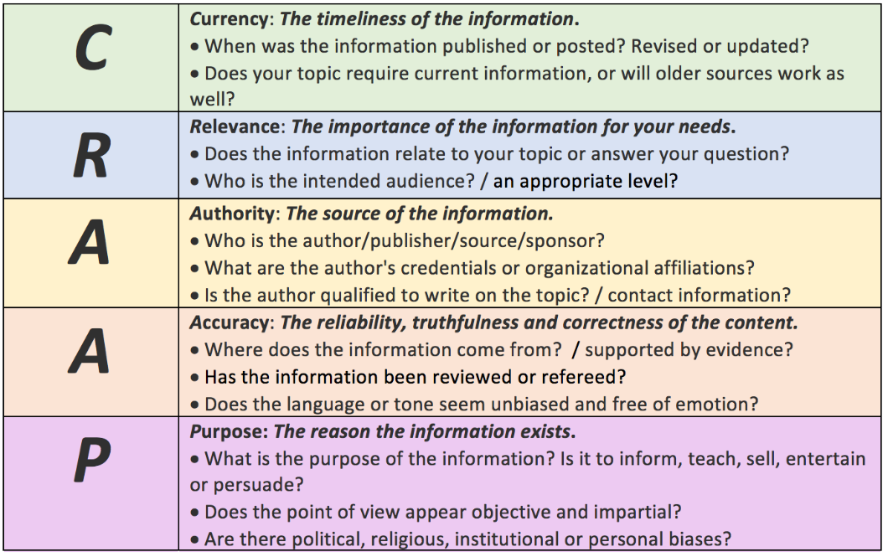
Blakeslee, S., (2004) "The CRAAP Test," LOEX Quarterly: Vol. 31: No. 3, Article 4.
Available at: https://commons.emich.edu/loexquarterly/vol31/iss3/4

