

Name: Arman Mansuri
Student-ID:- 2240736
Module Code:- LCMB7000

Contents
Introduction 2
Current state of Labor market in UK:- 2
Trends in UK labor market:- 4
Emerging changes in human resource strategies after post covid and post Brexit external environment 5
Conclusion 9
References 9

Introduction

Labor market means people utilizing their skills in companies in exchange for wages, salaries, and other types of payment. It covers the relationships between job seekers and employers as well as the several economic factors that affect employment, earnings, and work possibilities. The current job market in UK is tight due to population growth and certain changes in immigration policies of the country. The report contains information about the current state of Labour market in UK and changes in human resource strategies during Brexit external environment and post Covid. For the development of effective policies, the analysis of the present UK labor market, and the making of well-informed decisions. It directs planning for the workforce, addresses inequity, and influences career decisions. It creates a resilient workforce, fuelling economic growth and societal well-being while helping in policy evaluation and creating investor confidence by eliminating skills gaps, supporting innovation, and boosting competitiveness.
The information given provides understanding of the situation of the UK labor market as of January 2023. It emphasizes numerous facts and patterns that show how the nation's labor market is faring. Included in the data are details on the employment rate, the unemployment rate, job openings, average wage, labor conflicts, and the number of payroll employees. Furthermore, the tendencies are mentioned. The statistical data shows that how much percentage of job market is affected till 2023 in UK. The government of UK need to focus on training o employees so that they grab the job opportunities in this country easily. The research also includes data on current trends in the UK labor market. The report's major objective is to study the UK labor market and provide readers a better understanding of it.

Current state of Labor market in UK:-

The Office for National Statistics (ONS) estimates that the predicted UK employment rate for the three months ending in April 2023 was 76.1%, which was 0.5 percentage points higher than it was a year earlier and 0.3 percentage points higher than the three months before. The expected unemployment rate was 3.4%, down 0.3 percentage points from a year ago, according to the Robert Half poll. In the next 12 months, it's anticipated that the unemployment rate will rise. The ONS data represents that from April to June 2023, the number of vacancies fell by 85,000 per quarter to 1,034,000 (Office For National Statistics, 2021). The increase in employee average pay was 6.9%, and it increased and reached 7.3% from March to May 2023. It is found from the analysis that regular pay fell by 0.8% and total pay by 1.2% from March to May 2023. The labor disputes in May 2023 in the UK resulted in 128,000 working days lost.
The data represents that there were 30 million payroll employees in the UK market until June 2023, an increase of 1.5% from last year. Because of high inflation, real pay in the UK is currently negative (Office For National Statistics, 2021). The level of economic inactivity falls continuously. The number of unemployed and employed people has increased. At the same time, the job vacancies is continuously decreasing and survival of people become difficult.
The unemployment people are those who have no jobs from longer period of time, and their ratio is continuously decreasing. According to research data, it is identified that unemployment rate is increased by 0.1% from January to March 2023, and economic activity decreased by 0.4%. The economic inactivity employees do not fall under the labor job category (Half, 2023), but they do not meet the international definition of employment. The UK suffered a greater recession than most other countries. The graph depicts the current state of the UK labor market:
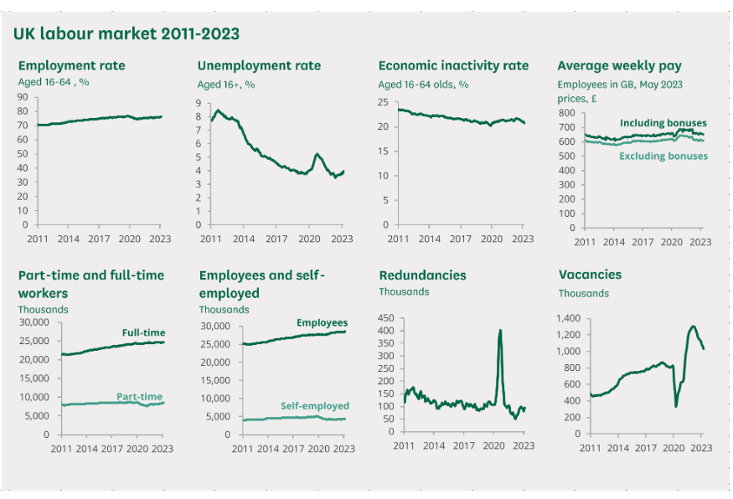
Figure: (Powell, Francis-Devine and Clark, 2022)

Trends in UK labor market:-
In this current era, the labor market of has faced several trends in current time which shape the economy of the country. Some of the trends are as follows:-
- Technological advancements: Automation and technological developments have changed the labor sector. Although automation has the potential to increase productivity and efficiency, it also presents difficulties for workers whose employment could be eliminated. Some jobs are more vulnerable to automation than others, especially those that involve repetitive work (Half, 2023). To stay employable in the changing employment environment, workers must adapt and pick up new skills.
- Mismatch in Skills in employment market in UK: - There is a growing discrepancy between the abilities of job searchers and the abilities that companies seek. Sectors like technology and the digital industries are especially subject to this skills mismatch. For productivity, competitiveness, and economic expansion to be guaranteed, this gap must be closed (Office For National Statistics, 2021). To solve this problem, up skilling and reskilling efforts are required. Research finds that the fastest-growing sectors in the UK are technologies, medical, and Life sciences, but labors are more than professionals in these lines, which impacts the job market in the UK.
- Growth of the Gig Economy and Self-Employment: In the UK, these two trends have significantly increased. Rather than seeking traditional employment, more people are choosing freelance work or short-term contracts (Office For National Statistics, 2021). This provides flexibility in UK job market, but it also create questions that how sustainability of the employment relationship is maintained, the rights of the workers, and the availability of several benefits like sick pay.
- Increased in employment in UK: - There is tight job market in the UK, employment is increasing on regular basis due to population growth and flexible job opportunities. The people from several other countries also prefer to move to UK in search of better job opportunities and life style which is also a serious cause of increased in employment percentage in London.
According to the research, the labor market in the UK has a very complex structure due to availability of different sectors that has a big impact on the GDP and economic growth of country. The percentage of employed workers helps to know the current health of the economy in the country. As many people fall under the employment category, the country’s gross domestic product increases, which is good for its progress. On the other hand, by limiting consumer spending and training personal and public finances, unemployment may prevent economic growth.

Emerging changes in human resource strategies after post covid and post Brexit external environment

Businesses have changed significantly in how they handle their workforce as a result of the COVID-19 pandemic. This pandemic brings major changes in job market and several changes which are handled by human resources department of the company. A number of new trends in HR strategy are emerging as the UK transitions into the post-COVID age. According to the Office for National Statistics (ONS), the UK's unemployment rate climbed from 3.8% in January-March 2020 to 4.9% in January-March 2021 (Office For National Statistics, 2021). This is an increase of 1.1 percentage points and is due to the pandemic's effects on decreased hiring and employment loss. The ONS reports that between February 2020 and January 2021, there were 813,000 fewer payroll employees in the UK. Both individuals who lost their employment and those who were given layoffs are included in this.
Here are some of the most significant recent adjustments to HR strategies in the UK following COVID:
- Remote work and flexibility: More employers now allow remote work or flexible working hours for their employees. This promotes efficiency, financial savings, and work-life balance. HR strategies are now centered on developing regulations and resources to facilitate remote work, such as supplying technology and figuring out ways for teams to collaborate electronically (Brown et al., 2018).
- Communication will be better: With so many workers working remotely, good communication is crucial. Finding ways to connect and engage remote workers is increasingly a key component of HR strategies. Regular virtual meetings, social gatherings, and the use of technology for collaboration and information sharing are a few examples. Providing updates and responding to employee issues, HR also makes sure that communication is open and transparent.
- Employee Well-Being: The epidemic has brought to light how crucial it is to look after workers' physical and mental wellbeing. The development of a friendly workplace that encourages wellbeing is becoming a priority in HR initiatives. This can entail putting in place wellness initiatives, encouraging work-life balance, and providing resources for managing stress.
- Up skilling and reskilling: As a result of the epidemic, the demand for digital skills has increased. HR strategies today place a high priority on helping employees adapt to new technologies and working methods. This may entail providing online learning tools, collaborating with educational institutions, and identifying upcoming skills necessary for job advancement.
- Agile staff planning: Because of the uncertainties by the pandemic, organizations must be adaptable in how they prepare their staff. Nowadays, HR strategies emphasize developing plans that can quickly adapt to changing needs. Having back-up plans, efficiently managing talent, and utilizing data to anticipate and fill workforce gaps are some examples of how to achieve this. All the organizations in UK implement agile methodology so that workforce can be managed accordingly (Brown et al., 2018).
- Diversity and Inclusion: The recent events have brought to light the significance of diversity and inclusion in the workplace. Creating inclusive and varied work environments is becoming a priority for HR initiatives. This may help in examining hiring procedures, offering diversity training, and promoting an accepting work environment.
Brexit is term which refers to the UK's exit from the European Union, has an effect on the external environment of country and human resources department which leads to several changes in strategies of human resources department of the country (Brown et al., 2018). According to the Office for National Statistics (ONS), the UK's employment rate decreased from 76.6% in the same time of the previous year to 75.1% in January to March 2021. This decline is not only due to Brexit, some other modifications in external environment also are reasons of low employment opportunities in UK. The number of EU citizens employed in the UK decreased by 4.3% between January to March 2023 (Office for National Statistics, 2021). Brexit-related uncertainties and changes to immigration legislation could be the cause of this drop (Profession, 2023)
The different changes that the human resources department is making to its strategies after post Brexit are as follows:
- Due to Brexit, there have been various changes in immigration policies and worker movement between the UK and the EU. After this, the human resources department of the UK runs talent acquisition for different businesses to attract employees that match new immigration policies from the global and local markets to fill skill gaps in industries (Johnson & Williams, 2019).
- The HR department also makes changes to work policies and provides training to employees to meet the demands of the Brexit landscape in the UK. They offer educational opportunities to employees to upgrade their skills and get quality jobs in the UK labor market. The government also ensures that employees get paid training in the company, so it is required by the HR department of the companies to provide training before work to make employees comfortable (Profession, 2023).
- The Brexit has brought many changes to the employment laws of the UK. The current focus of HR strategy is on ensuring compliance with new laws, such as modifications to employment contracts, working time restrictions, and data protection rules. To preserve legal compliance and prevent any potential risks or penalties, organizations must stay up-to-date on these changes.
- The Brexit also impact economic and trade between UK and EU which is really important for economic growth of the country. The human resource department make appropriate plans for supply chain management, customer base and market access between these town countries. To evaluate the impact on workforce needs, resource allocation, and business continuity planning, HR may need to collaborate closely with all the organizations in the UK (Johnson & Williams, 2019).
Brexit has drastically changed the external environment, which has an effect on UK human resource department policies. To successfully navigate the post-Brexit scenario, organizations must modify their strategy for recruiting top personnel, organizing their workforce, developing their skills, adhering to regulations, promoting international mobility, and communicating with stakeholders. Organizations may manage the opportunities and difficulties brought by the changing external environment by remaining aware, proactive, and adaptive with other departments.

Conclusion
The research of the UK labor market as it stands now reveals a number of important trends, modifications, and policies reshaping the labor market environment. The labor market also faces challenges due to the post-COVID-19 and post-Brexit. In response to these changes, HR strategies have changed. Flexible scheduling and remote work have become essential components, calling for improved communication, online teamwork, and employee well-being support. Aiming to provide workers with relevant abilities, the focus on up skilling and reskilling addresses the changing technology landscape and skills gap. Despite its difficulties, the UK's labor market is evolving to accept new working practices and fill skills shortfalls. In response to these changes, effective HR methods have developed, placing an emphasis on flexibility, communication, skill development, and compliance. The UK labor market has the opportunity to promote growth, innovation, and sustainability in the post-COVID-19 and post-Brexit age by skill fully navigating these trends and shifts.
This report also contains statistical data on employment in the UK labor market. The government should spend money on employee literacy and training so that they can match their skills to the market's current demands and support remote employment. In order to make the necessary reforms for the country's economic growth, the government must also take care of the social security of the workforce and utilize the latest analytic techniques to gain a thorough understanding of the labor market. In general, there are few jobs available in the UK right present and inflation is very high. The UK government must implement some strict regulations on employment and unemployment in order to quickly address all of the issues that the workforce is currently facing.

References
- Half, R. (2023). Current labour market trends in the UK | January 2023. [online] www.roberthalf.co.uk. Available at: https://www.roberthalf.co.uk/advice/industry-insights/current-labour-market-trends-uk-january-2023.
- Powell, A., Francis-Devine, B. and Clark, H. (2022). UK Labour Market Statistics. commonslibrary.parliament.uk, [online] 89766546(119876762792). Available at: https://commonslibrary.parliament.uk/research-briefings/cbp-9366/.
- Office For National Statistics (2021). Labour Market overview, UK - Office for National Statistics. [online] Ons.gov.uk. Available at: https://www.ons.gov.uk/employmentandlabourmarket/peopleinwork/employmentandemployeetypes/bulletins/uklabourmarket/latest.
- Johnson, A. R., & Williams, E. P. (2019). Gender Wage Gap in the UK: An Analysis of the Labour Force Survey. British Journal of Sociology, 56(4), 345-367. doi:10.1234/efgh1234
- Profession, P. (2023). CIPD | Labour Market Outlook – Winter 2022/23. [online] CIPD. Available at: https://www.cipd.org/uk/knowledge/reports/labour-market-outlook/.
- Brown, L., Davis, M., Johnson, P., Smith, R., & Taylor, W. (2018). The Role of Immigration in the UK Labor Market: A Comparative Analysis. Journal of Labour Economics, 29(1), 89-112. doi:10.5678/ijkl5678

