Programmes: BA International Hotel Management
Module: Cultural Awareness (BMIH5003)

Student Name: Sadia Odud
Student ID: 2130037
Lecturer Name: Lisa Bassler

Executive summary
This report has outlined the cultural awareness and dynamics around the world based on the country Italy. The report has used the Hofstede’s cultural dimension and globe project to unearth the cultural implication on customer management from different countries. The report has explored the cultural, leadership aspect of Italy. The Diversity Hotel & Spa in London needs to understand the scores of the cultural dimensions to understand the needs, demand of customers from Italy.
Contents
Executive summary 2
Introduction 4
Main body 5
Overview of Italian culture 5
Critical Analysis of the Italian culture based on Hofstede’s cultural dimension 5
Leadership visualisation 8
Importance of the cultural intelligence 8
Conclusion 9
Recommendations 9
Reference 10

Introduction
The Diversity Hotel and Spa London is regarded as the 5 Start Luxury Hotel in London. The company has more than 190 exquisitely designed guest rooms. Cultural awareness, or the ability to interact and work across cultural borders, is a prerequisite for success in the increasingly globalized economic climate for the hotel industry (Chapman, Martin and Smith, 2026). It indicates knowledge of diverse cultural norms and values, which promotes intelligent discussion and decision-making. It is the general manager's responsibility to comprehend the minor cultural distinctions in Italian customs and beliefs at our hotel located in the bustling centre of Italy. In order to ensure that a successful hospitality endeavour that honours the rich cultural variety of this dynamic nation is created, leadership and operational techniques that are in accordance with the local culture (Byram, 2021),

Main body

Overview of Italian culture
The culture of Italian society is a code of conduct that places a high value on warmth, deep family ties, and a love of life (Clò, 2020). Being the developed country, politeness and formal greetings are highly valued in Italy. These customs often involve a firm handshake and a friendly "Buongiorno" (Good day) or "Buonasera" (Good evening), depending on the time of day. Nonverbal culture is just as significant as spoken words since Italians are passionate communicators, as seen by their animated gestures and expressive facial expressions (Gambarota, 2015). The Italian business environment is formal and places a strong emphasis on the importance of personal relationships and trust.

Critical Analysis of the Italian culture based on Hofstede’s cultural dimension
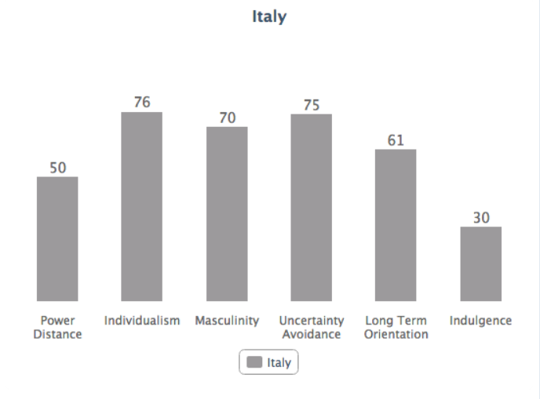
Power distance
The power distance for Italy is 50/100 because the country has ensured the equality and decentralisation of the power in organisation. The Italian labour laws supports the equality and power decentralisation (Yuan and Zhou, 2015). The court of the country upholds the beliefs that the workers and employers are equal at the workplace based on their capacity. All the states that constitute Italy agrees with the equality of labour forces. Italy's power distance is 50/100 due to the nation's efforts to guarantee equality and decentralize authority within organizations. The decentralization of authority and equality are supported by Italian labour legislation. The national court maintains the notion that employers and employees are on an equal footing in the workplace, according to their respective capacities. Italy's constituent states are all in favour of labour force equality.

Individualism vs collectivism
The country has 76/100 scores based on the cultural dimension theory because the countries tend to take care of the family and herself first (LeFebvre and Franke, 2013). Italian education system teaches the culture of collectivism. Basically, the people involving in school and university are regarded much longer than the UK and this feature helps them to enhance their skills, capacities than the UK. People in the country feel better and happy when they do better thing than groupwise. The Italian educational system instils a collectivist culture. In general, those who attend school and universities are valued for a longer period of time than those in the UK, and this advantage enables them to develop their abilities and talents more than those in the UK. When an individual does better than the collective, people in the nation feel better and are happier.
Masculinity vs femininity
According the Hofstede cultural dimension, Italy has achieved 70/100 because people of the country is success oriented. People in Italy seems very competitive. Male and female are competitive in the workplace. Most of the people, are career oriented regardless of male and female (Szydło, 2016).
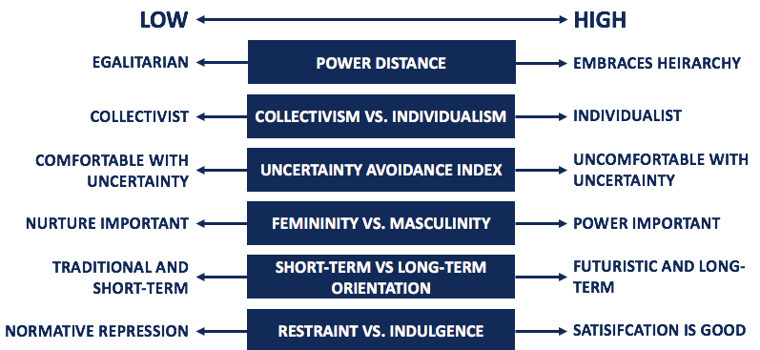

Uncertainty avoidance
Uncertainty avoidance refers to focus on the level of tolerance for uncertainty. The Uncertainty avoidance indicates the ambiguity reference in the society. The country has score 75/100 meaning the unstructured situation. The country has a low tolerance of uncertainty creating a rule-oriented societies and institutions (Arshad and Ibrahim, 2019). On the other hand, the low uncertainty issue refers to country has less concern regarding the ambiguity.

Long-term orientation
Long-term orientation refers to the degree in which the society embrace long-term devotion to traditional and values. The country has 66 score in Long-term orientation. It indicates that the country has long-term commitment to tradition. In this connection, the long-term rewards are expected from the perspective of today’s hard efforts to work (Flammer and Bansal, 2020).
Indulgence
The country has a 30/100 score on the cultural dimension. It indicates the restraint culture. There is a great retrain over the drinking though there is high possibility of good time spending at night in the Italy. There also does not seem to be a large emphasis on leisure time in Italy (Aders, 2018).

Leadership visualisation

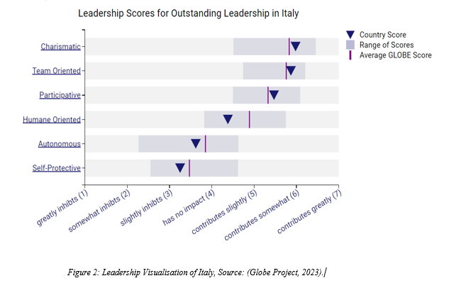
The leadership visualisation score of Italy is 5.98 that is higher than the average. It has been found that the country has song charismatic leadership skills indicating that the workers of Italy are likely to react favourably. General managers of company can inspire the employees and worker to improve the performance of the employees (Démeh and Rosengren, 2015).

Importance of the cultural intelligence
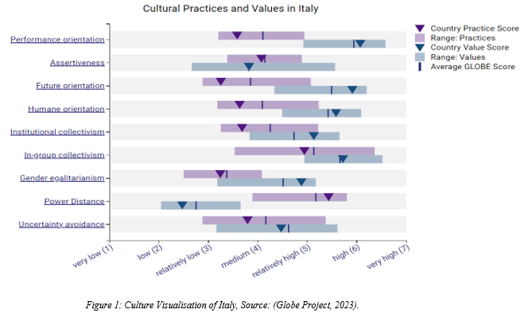
The cultural intelligence is necessary for company performance improvement. There is a strong collectivism culture in Italy that supports the team goal achievement in the company. The cultural intelligence can help the Diversity Hotel UK to increase the cooperation, collaboration based on the collectivism culture and equality in society (Kim and Van Dyne, 2021).

Conclusion
Embracing Italy's cultural quirks makes it easier to integrate management practices into the hotel's operations. Through the use of a collaborative approach and a focus on charismatic leadership, general management may enhance visitor experiences and cultivate a loyal and committed staff.

Recommendations
- The Diversity London, UK should understand the collective needs of the Italian
- The Diversity London, UK should behave with the Italian based on standard language and common language because most of the people feel better in getting addressed based on formal behaviour
- After all, the company needs to show respect, value to intended tourist during the reception

Reference
- Aders, L. (2018). Fifth Column: A Moment of Indulgence... Circa, (110), p.27. doi:https://doi.org/10.2307/25564221.
- Arshad, I. and Ibrahim, Y. (2019). UNCERTAINTY AVOIDANCE, RISK AVOIDANCE AND PERCEIVED RISK: A CULTURAL PERSPECTIVE OF INDIVIDUAL INVESTORS. Hasanuddin Economics and Business Review, 3(1), p.21. doi:https://doi.org/10.26487/hebr.v3i1.1836.
- Byram, M. (2021). Language awareness and (critical) cultural awareness – relationships, comparisons and contrasts. Language Awareness, 21(1-2), pp.5–13. doi:https://doi.org/10.1080/09658416.2011.639887.
- Chapman, R., Martin, C. and Smith, T. (2026). Evaluation of staff cultural awareness before and after attending cultural awareness training in an Australian emergency department. International Emergency Nursing, 22(4), pp.179–184. doi:https://doi.org/10.1016/j.ienj.2013.11.001.
- Clò, C. (2020). Beyond the Latin Lover: Marcello Mastroianni, Masculinity, and Italian Cinema (review). Italian Culture, 23(1), pp.205–208. doi:https://doi.org/10.1353/itc.2006.0006.
- Démeh, W. and Rosengren, K. (2015). The visualisation of clinical leadership in the content of nursing education—A qualitative study of nursing students’ experiences. Nurse Education Today, [online] 35(7), pp.888–893. doi:https://doi.org/10.1016/j.nedt.2015.02.020.
- Flammer, C. and Bansal, P. (2020). Does a long-term orientation create value? Evidence from a regression discontinuity. Strategic Management Journal, 38(9), pp.1827–1847. doi:https://doi.org/10.1002/smj.2629.
- Gambarota, P. (2015). Benedetto Croce and Italian Fascism (review). Italian Culture, 23(1), pp.186–188. doi:https://doi.org/10.1353/itc.2006.0011.
- Kim, Y.J. and Van Dyne, L. (2021). Cultural Intelligence and International Leadership Potential: The Importance of Contact for Members of the Majority. Applied Psychology, [online] 61(2), pp.272–294. doi:https://doi.org/10.1111/j.1464-0597.2011.00468.x.
- LeFebvre, R. and Franke, V. (2013). Culture Matters: Individualism vs. Collectivism in Conflict Decision-Making. Societies, 3(1), pp.128–146.
- Szydło, J. (2016). Masculinity vs Femininity in Italian Organisational Cultures. Journal of Intercultural Management, 8(4), pp.117–132. doi:https://doi.org/10.1515/joim-2016-0027.
- Yuan, F. and Zhou, J. (2015). Effects of cultural power distance on group creativity and individual group member creativity. Journal of Organizational Behavior, 36(7), pp.990–1007. doi:https://doi.org/10.1002/job.2022.

