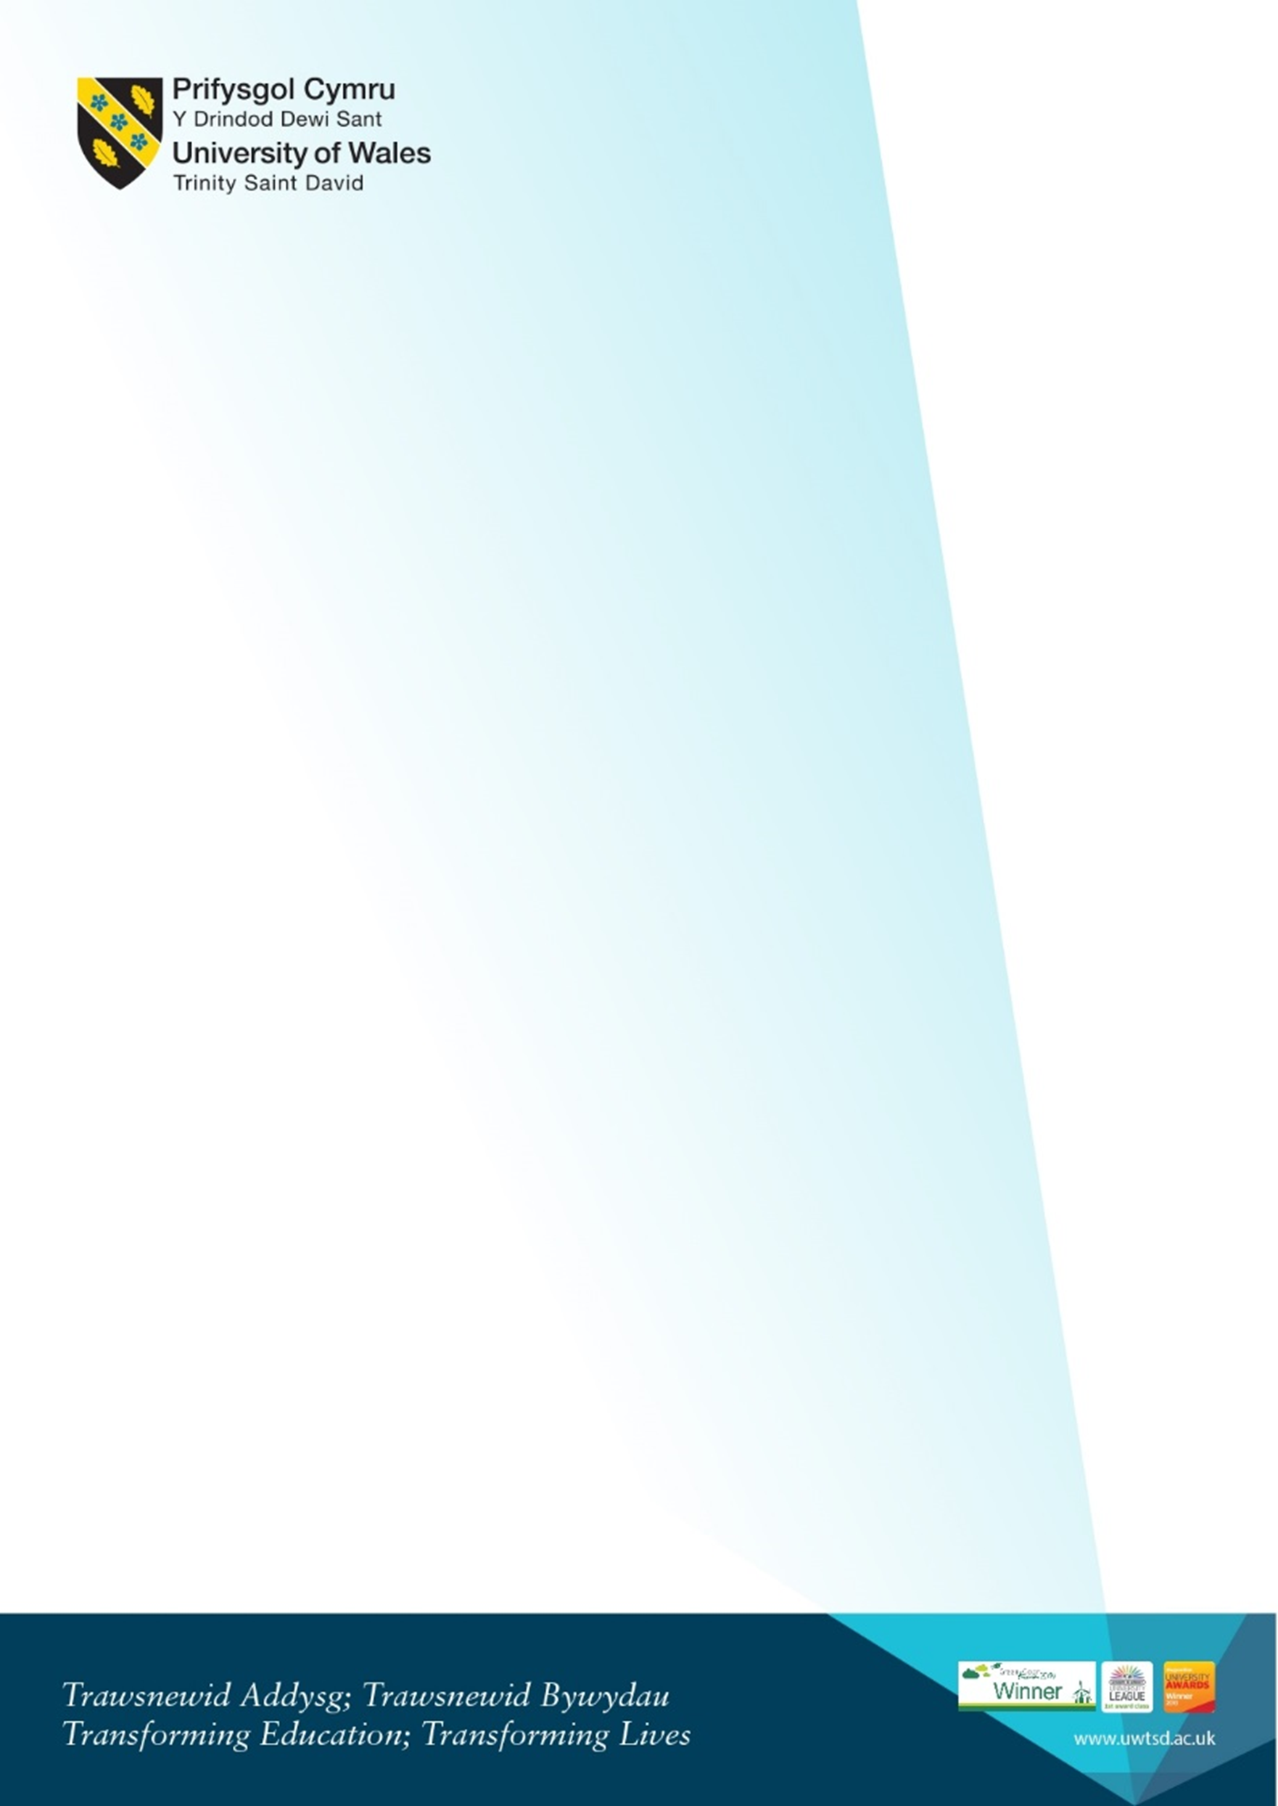
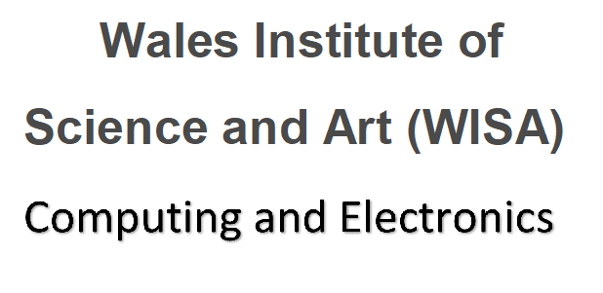

Welcome for new Digital Degree Apprenticeship (DDA)
Computing Apprentice students
Monday 22nd January 2024 10am

10am-10.30  Room IQ109 for DDA students (Software Engineering, Data and Info Systems, Computer Networks and Cybersecurity)  (first floor, IQ building) | Welcome from the programme team  Kapilan Radhakrishnan - Academic Director (Applied Computing)  Gaynor Thomas - Programme Manager DDA Apprentices  Bridget Moseley - Head of the Apprenticeship Unit  plus Liaison Officers | Who we are, our roles. Who to contact.  Introduction to the Liaison officer team  (Dan, Emma M, Emma D)  Emails for Gaynor (DDA) is:  gaynor.thomas@uwtsd.ac.uk
10.30am – 11.30 ish | Gaynor and Liaison Officers (also Lee Cobley)  Programme overview | - Introduction to the course structure and overview of the modules.  - Moodle and where to find information on Moodle. DDA General Moodle Pages (Gaynor)  - Accessing Email and Timetable (Hwb)  - Finer points of the timetable  - Free software available – Microsoft Azure for all students  - Logging on and remote access, what is the SOAC domain?  - ID Cards – do you have one, where to get them  - Information on Student Services and procedures to follow.
11.30am-12pm | Gaynor and Liaison Officers | - Opportunity to ask any remaining questions  - Students with prior credit for recognition - specific questions (individual or small group chats with Gaynor)
12pm – 1pm | Lunch break
1pm – 3pm (ish)  IQ109  (first floor, IQ building) | Liaison Officers | - Tour of the building  - Library Tour - TBA  - Apprentice-specific information regarding employers etc

MAP:
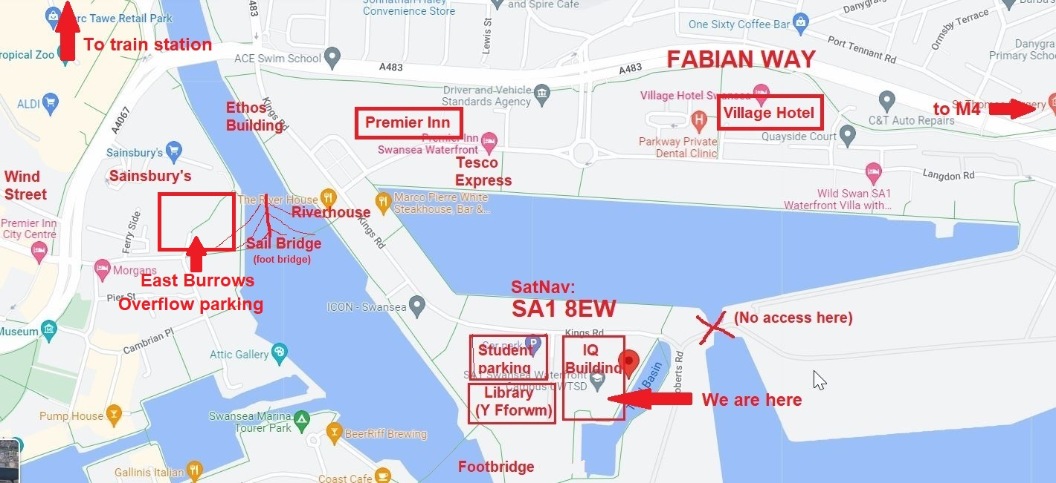
Link to Google Maps: https://www.google.com/maps/place/Swansea+SA1+8EW/@51.6186566,-3.9335031,15.5z/data=!4m5!3m4!1s0x486e8aacbcc83705:0xae10d016e8626d05!8m2!3d51.6173561!4d-3.9255004

Photo of area:


