Analysing quantitative data using IBM SPSS Statistics (version 24)
1) | INTRODUCTION

1.1) Aims
♦ To illustrate computational analysis of data.
♦ To introduce the basics of quantitative data analysis.
♦ To provide familiarisation with the IBM SPSS Statistics package so that the user can begin to assess its suitability for their own analysis.

2) | BACKGROUND

2.1) IBM SPSS Statistics for Windows
IBM SPSS Statistics for Windows is a powerful computer package providing statistical analyses and data management. The IBM SPSS Statistics suite of programs is the most widely used statistical analysis package in the world.

2.2) Data types
Before data are analysed in IBM SPSS Statistics, it is necessary to understand the type of data as this will affect the analysis used.
♦ Nominal:
nominal data consist of values which can be grouped into categories, for example gender which can be grouped into male and female; but cannot be expressed numerically
♦ Ordinal:
ordinal data consist of values which can be placed in a definite order, for example agree, not sure, disagree; but cannot be expressed numerically
♦ Scale or quantifiable:
scale data consists of values that can be expressed numerically as quantities; for example year of birth.
Scale or quantifiable data can further be subdivided into two groups:
♦ Discrete, where individual items of numeric data can have one of a finite number of values within a specified range; such as spinal column point for the variable salary scale. The value can usually be counted and it changes in discrete units, in this case whole numbers. In some instances discrete data may be rank data, for example the order a group of people finished in a race
♦ Continuous, where numeric data is not restricted to specific values and is usually measured on a continuous scale; such as journey to work distance (in km).

Journey to work distance along here
0km |  |  | 120km

With such data it is possible to tell the interval between the data values for different cases; for example the interval between a journey to work of 15 miles and another of 2 miles is 7 miles.
One potentially confusing aspect of IBM SPSS Statistics is that all data are usually coded numerically (e.g. 1 = male). Although it appears less meaningful to code such responses numerically, it is better from a data manipulation point of view since IBM SPSS Statistics allows only automatic recoding on codes, which are numeric.

2.3) The TEACH1.SAV data file
This data file consists of data about 347 people recruited to work for a UK local authority over a ten year period from the mid 1970s to mid 1980s and was obtained from personnel records. The data collection form is included as Appendix 2. The vast majority of data relates to the time of their appointment and is taken from a range of secondary data sources such as their application form and the requisition orders to various media outlets for vacancy advertisements.
The data refer predominantly to non-manual employees, although there are a few manual employees. The data have been anonymised in a variety of ways and all locational data has been amended to preserve confidentiality. Permission was obtained to use these data in suitably anonymised format for teaching purposes.
The data file can best be thought of as a large spreadsheet with each column representing a variable for which data are available and each row representing that data collected for an individual or case:

 | gender | born | marital | educate | profmemb
1 | 2 | 67 | 1 | 5 | 3
2 | 1 | 19 | . | 7 | 3
3 | 2 | 24 | 2 | 7 | 3

Thus for the table above, row 1 represents a person who has gender code 2 (female), was born in 1967, has marital status code 1 (single), was educated up to code 5 (O’level / GCSE grade C or above), and professional membership code 3 (none). The data then continues to the right for further variables. The symbol “.” A full list of variables and their codes are given in Appendix 1.

End of Exercise 1

3.1) The IBM SPSS Statistics Windows
When you load and run the IBM SPSS Statistics package it opens up a menu bar and two views. These are Data View (currently visible) and Variable View…
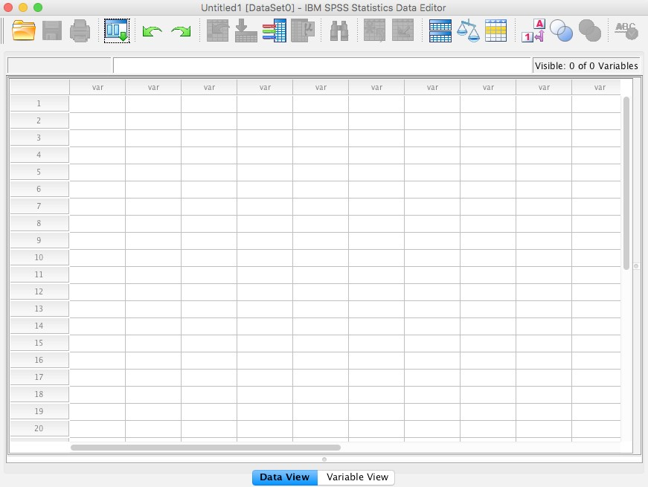
This sheet will contain your data, each column representing a variable for which data are available and each row representing the data for an individual or case. At present this sheet should be blank. As this sheet is currently selected, its name on the tab at the bottom is in bold.
At present this sheet is not visible as the variable view sheet is not active. Consequently the name is not in bold. Do not bother to click on the tab and look at this sheet yet, we will do that later.

 Now move your mouse across the menu bar and click on the various drop down menus.

This provides a selection of options (File, Edit, View, Data…) which allow you for example to open files, edit data, generate graphs, create tables and perform statistical analyses. Selecting from this menu bar will, like in other windows packages, provide further pulldown menus and dialogue boxes.
The menu bar options are used as follows:
♦ File is used to access any files whether you want to Open an existing IBM SPSS Statistics file or read data in from another application such as Excel of dBase, or start a New file. It is also the menu option you choose to Save files
♦ Edit can be used to alter data or text in the Data View or the Variable View and insert variables and cases
♦ View can be used to alter the way your screen looks. Please leave this on the default settings
♦ Data is used to define variables and make changes to the data file you are using
♦ Transform is used to make changes to selected variable(s) in the data file you are using. This can include recode(ing) existing variables and compute(ing) new variables
♦ Analyze is used to undertake a variety of analyses such as producing Reports, calculating Descriptive Statistics such as Frequencies and Crosstabs (crosstabulations) and associated summary statistics, as well as various statistical procedures such as Regression and Correlation
♦ Direct Marketing is a specialised option for use in direct marketing campaigns
♦ Graphs is used to build a variety of graphs and charts such as Bar, Line and Pie charts
♦ Utilities is for housekeeping such as displaying information on variables as well as more advanced manipulations
♦ Extensions is used to access online undertake other (more advanced) statistical analyses
♦ Windows operates in the same way as normal ♦ Help is a context sensitive help feature.

Exercise 2: To load a previously created IBM SPSS Statistics for Windows data file teach1.sav
Download the teach1.sav file to your OneDrive | U drive | Pen drive.
Open IBM SPSS Statistics, open the teach1.sav
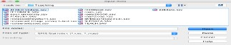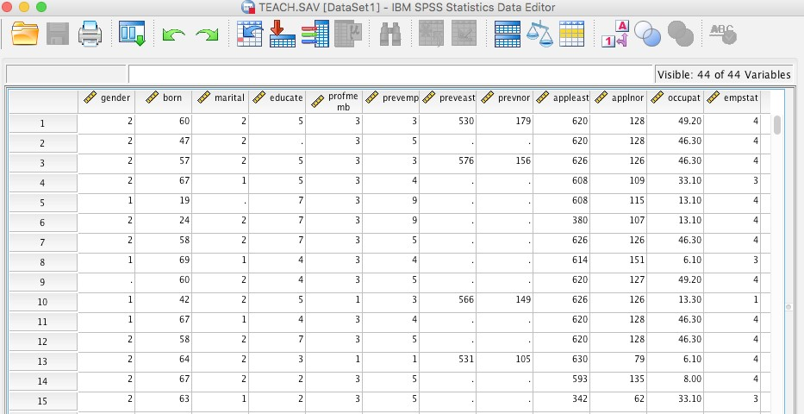
You will now see the
data
appear in the
window
Data
View
filename
and
the
above the menu bar
change to
This may take some
time so be patient!
To see the data view click on
at the bottom of the window.
End of Exercise 2

Exercise 3: To check how variables have been coded
To check what the column heading for each variable and the codes refer to: 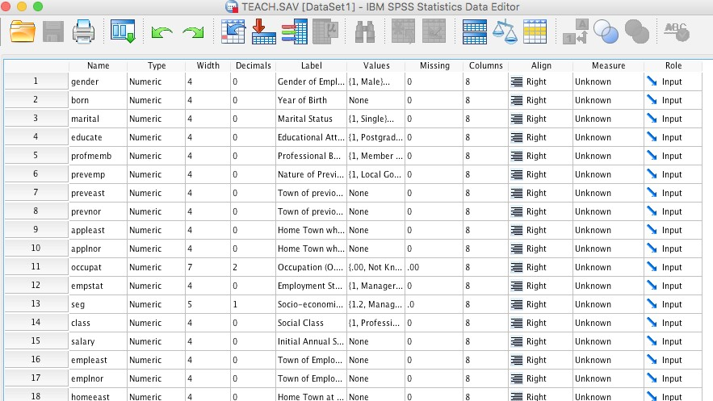 sheet at the bottom of the window. You will now see:
Click
The first column contains the variable Name, in the case of the first row “gender”. This is the column heading that appears in the .
The second column refers to the Type of data. Although gender is categorical data, it is refered to as numeric because numeric code values have been used! The key to these code values is given in the column headed Values.
The fifth column contains the variable’s Label. At present this is partially obscured by the subsequent column. To see the full value label:
Move your mouse pointer in-between the Label and the Values column headings until this appears.
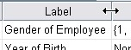
Click and drag the column width to the right until the variable’s label can be read.
Note: If you wish to edit a variable’s label just retype the label in the appropriate cell.
The sixth column contains the key to the codes used for each variable. These are known as the Values Labels.
To see the Value Labels used:
Click on the cell containing the first value for the variable gender Click on the to the right of this cell.
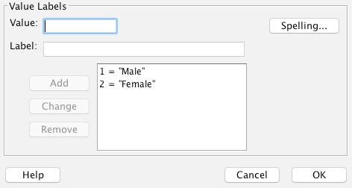
The Value Labels dialogue box appears. It shows the current value labels for this variable.
Note: You can also use this option to change each value label for the codes or enter new value labels.
Click in the
Value Labels dialogue box to return to the Variable View.
End of Exercise 3

Exercise 4: To undertake a frequency distribution
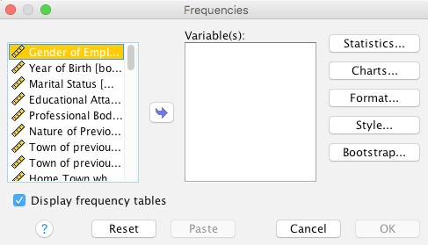
Return to
.

Click
Analyse | Descriptive
Statistics

Frequencies
|
.
The
Frequencies
dialogue
box appears.
variables
are
alphabetically
downward
- If not arranged alphabetically use the arrow on the left hand box to scroll down until Gender appears. Highlight Gender in the left hand box by clicking on it.
Click to move gender into the Variable(s) box.
Note the arrow button changes direction and the cursor moves to the Variable(s) box. This is to allow you to reverse your decision if you wish.
Click .
You will see a series of tables displayed in the IBM SPSS Statistics Viewer. Note that IBM SPSS Statistics tells you if there are missing cases. In this instance, there is one missing case.
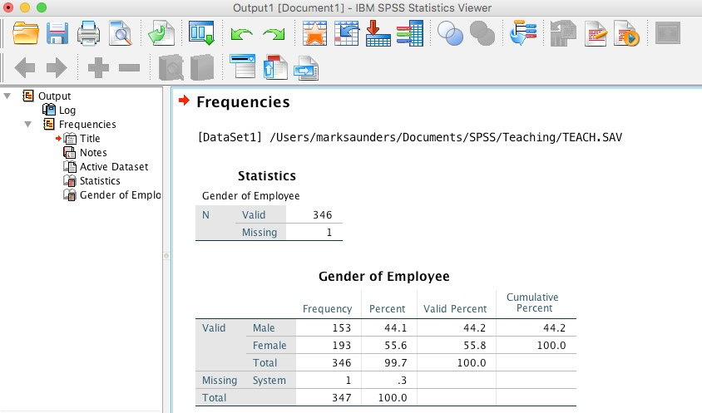

To copy any statistical output click on the output e.g. Gender of Employee tables summary), copy and paste into a word document, where you would then explain and interpret the result.
Repeat this process using Analyze | Descriptive Statistics | Frequencies for at least five other variables of your choice. You can do this by pointing and clicking on the menu commands which are visible at the top of your screen.
Whilst you are doing this explore the effect of the buttons on your output.
To remove the variables from the right Variable(s) box within the dialogue box either click or highlight the variable in the right Variable(s) box and click .
To quit this analysis (for example if you make a mistake) click .
You may (or may not!) have noticed that each of the tasks you have performed in IBM
SPSS Statistics have been automatically appended to the IBM SPSS Statistics Output Viewer. You can see this by scrolling through your output window using the up and down arrows on the right of the window.
You can edit the IBM SPSS Statistics Viewer and save it, or parts of it, to a file which can subsequently be read into a word processor. Alternatively you can print it out.
Help 4.1: To delete output in the IBM SPSS Statistics output viewer
To delete some output in the IBM SPSS Statistics Output Viewer:
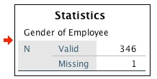
Click the area you want to delete; a line will appear around it.
 Press Delete.
To delete all the output in the IBM SPSS Statistics Output Viewer:
Ensure that the IBM SPSS Statistics Output Viewer window is maximised. In the IBM SPSS Statistics Output Viewer click Edit | Select All.
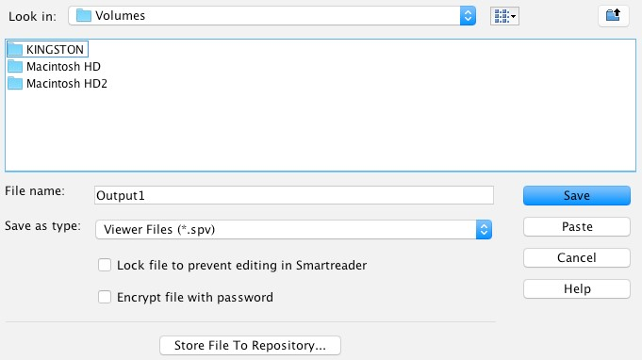
Press Delete.
Help 4.2: To save the contents of the IBM SPSS Statistics output viewer to a file
Click File | Save As…
Type in the filename you wish to save it to in the File name box, making sure the file type is *.spv.
Ensure that the file is being saved to the correct drive and directory.
Click .
End of Exercise 4

Exercise 5: To calculate the arithmetic mean (average) and the standard deviation
Click Analyze | Descriptive Statistics | Descriptives.
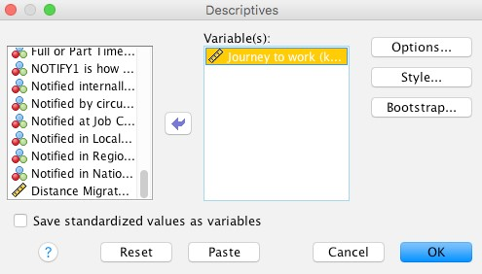
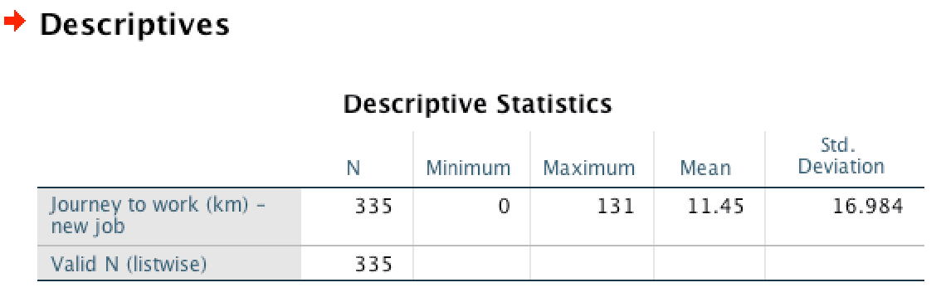
Scroll down to and select the Journey to work variable (it’s at the end of the variable list), then put it in the Variable(s) box.
Click .
Note how the results are added to the end of your output in the IBM SPSS Statistics Viewer. Note: you may need to maximise the window by clicking [] to see all the statistics.
We can therefore see that the mean journey to work is 11.45 km.
Calculating a mean makes sense as we are working out the average for scale or quantitative data. However we have to be careful.
End of Exercise 5

Exercise 6: To calculate the mode and other measures of central tendency
To calculate the mode for the variable gender:
Click Analyze | Descriptive Statistics | Frequencies.
Click to empty the Variable(s) box.
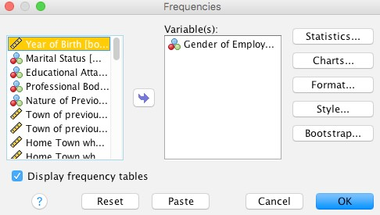
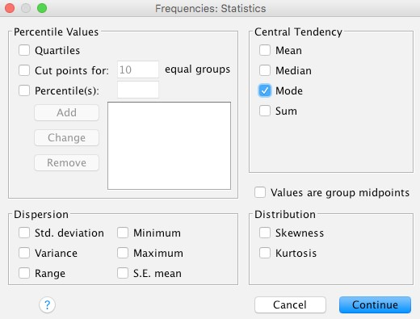
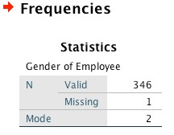
Select
Gender
,
then click
put
it
in
the
to
Variable(s)
box.
Click
on the
right
Select
Mode
in the
Central
Tendency
dialogue box by
clicking on it.
Click
to return to
the
Frequencies
dialogue
box.
This time, we do not want
an output table so click
the box to the left of
To remove the tick.
Click
.
The following will be added to
the IBM SPSS Statistics Output
We
now
know
that
the
most common gender is 2 female.
–
Repeat this process by calculating the most appropriate average for the following variables:
educate salary class others of your choice
Your choices for the most appropriate average are:
♦ Mean: normally known as the average of the data values
♦ Median: the midpoint once all the data values have been ranked
♦ Mode: the data value that occurs most often.
End of Exercise 6

Exercise 7: To produce a bar chart
Click Analyze | Descriptive Statistics | Frequencies.
Deselect all variables by clicking the button. Scroll down and select the variable (social class) Class.
Click.
Use the radio button to select Bar Charts | Continue.
At the Frequencies dialogue box click OK.
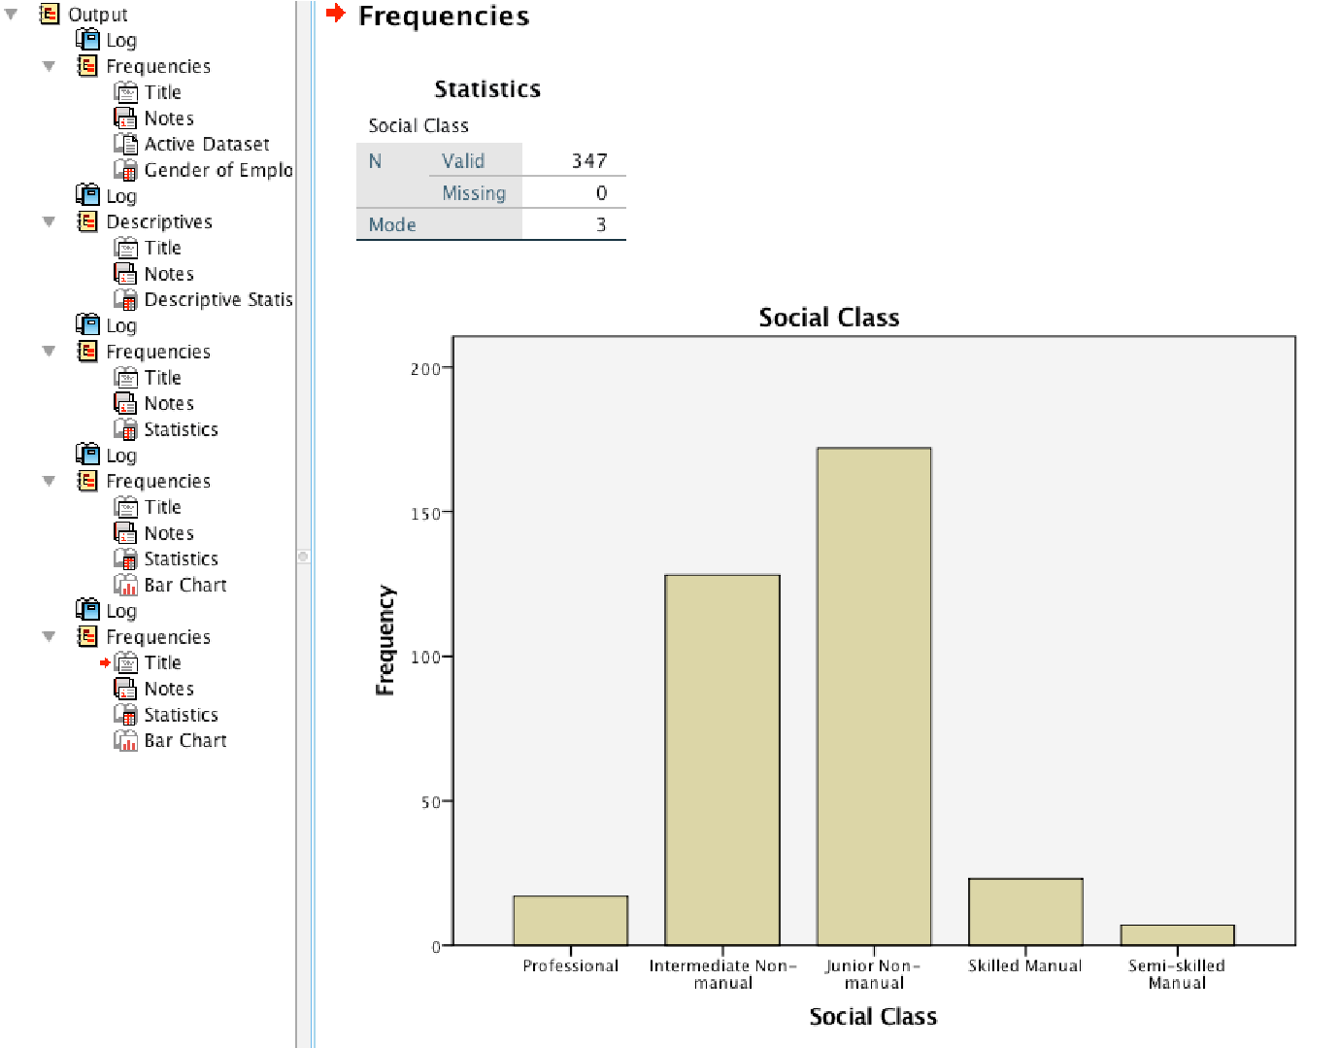
The IBM SPSS Statistics Output Viewer will contain your bar chart.
Notice that missing data are automatically excluded from the chart.
Notice also that you are presented with a different menu bar which allows you to edit the current chart and other options.
To the left of your bar chart are a series of icons. These provide an index to your output that is in the IBM SPSS Statistics Output Viewer.
Click the icon on the left towards the bottom to see what happens.
Now practice your charting skills by creating another bar chart for the variable (educational attainment) Educate but with the vertical axis displaying percentages rather than frequencies.
End of Exercise 7
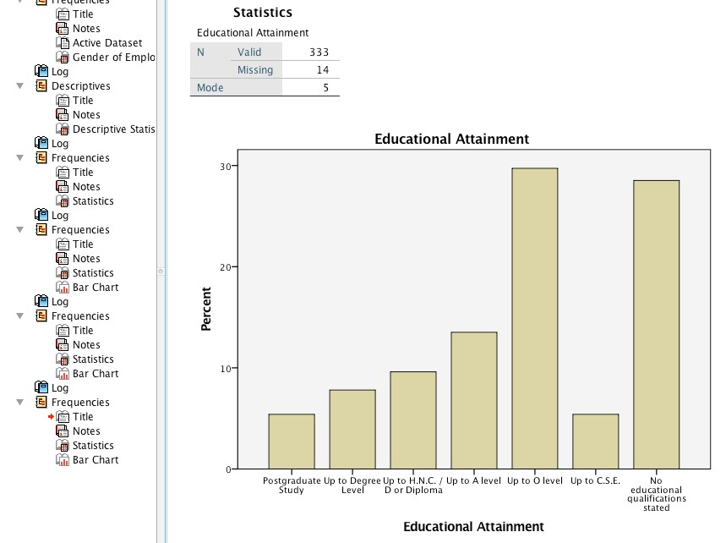
You will need to:
♦ Deselect the variable Class and select the variable Educate.
♦ Select Percentages
| Continue.
This will give you a chart like the one on the right.

Exercise 8: To create a table (Crosstab) of one variable against another
 | male | female
postgrad plus
up to degree
up to HNC/D
up to A’level
up to O’level (GCSE C+)
up to CSE (GCSE D-)
No quals.
One of the most useful features of IBM SPSS
Statistics is its ability to create crosstabulations of one variable against another. In this exercise, you will create a table of the variable Educate (Educational attainment) by the variable Gender.
You will want your table to look like this.
To do this:
Minimise the IBM SPSS Statistics Output Viewer.
Click Analyze | Descriptive Statistics| Crosstabs.
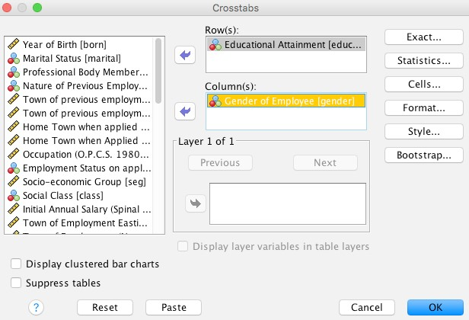
This gives the Crosstabs dialogue box.
Select the Row(s) variable
Educational Attainment and the Column(s) variable Gender using the same principles as when selecting frequencies.
Once you have selected row and column variables, you will be able to click OK.
Your table will appear in the IBM SPSS Statistics Output Viewer.
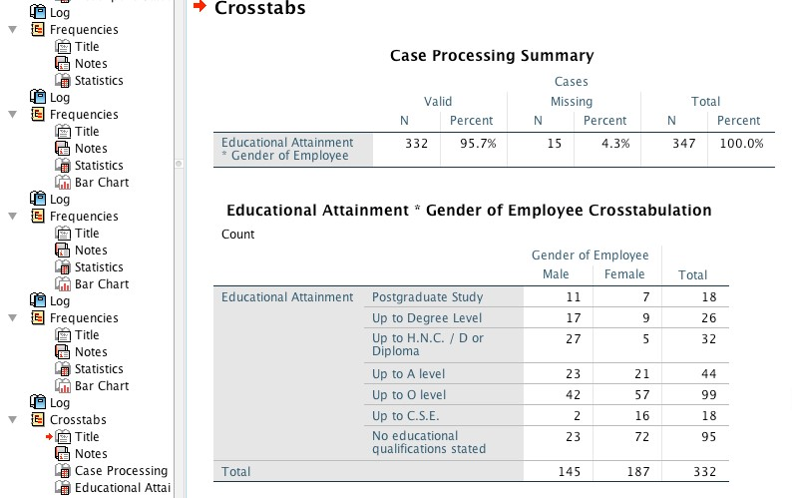
End of Exercise 8

Exercise 9: To calculate a Chi Square statistic for a table
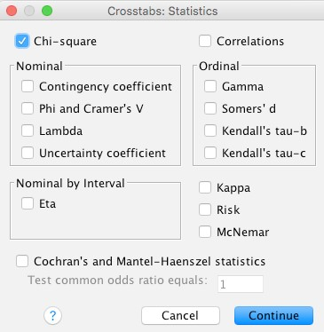
Minimise the IBM SPSS Statistics Output Viewer.
Analyze
|
Descriptive Statistics
Cross Tabs
Statistics

|
Select

the
Row(s)

variable
Educational
Attainment

and
the
Column(s)

variable
Gender

using the same
when
principles
as
selecting frequencies.
,
Crosstab:
Statistics

dialogue box
appears.
Chi
Square

Click
Continue | OK
. The
results will be displayed
the
IBM
Statistics
The key elements of your output are in the row titled Pearson Chi-Square and the associated footnote.
The chi square statistic (the value for Pearson Chi Square), is, in this case, 52.529 with 6 degrees of freedom (df).
The result is significant if this value is equal to or less than the designated alpha level (normally .05).
This is highly significant .000. The footnote states that no cells have an expected count of less than 5 and that the minimum expected frequency for each cell in the table is 7.86. This means the assumptions of the Chi Square test are satisfied.
So you testing to see do the two groups behave differently - In this example where p < 0.05, this result is thought of as being “highly significant” meaning we think the variables are independent of each other.
In other words, because p value .000 <.05 we think that Gender is associated with Educational Attainment (Men and Women have different preferences for Educational levels).
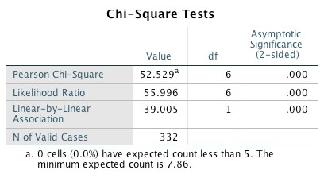
End of Exercise 9

Exercise 10: To add row and column per cents to a table using crosstabs
Minimise the IBM SPSS Statistics Output Viewer.
Select two variables you wish to use to create a table as outlined in Exercise 9.
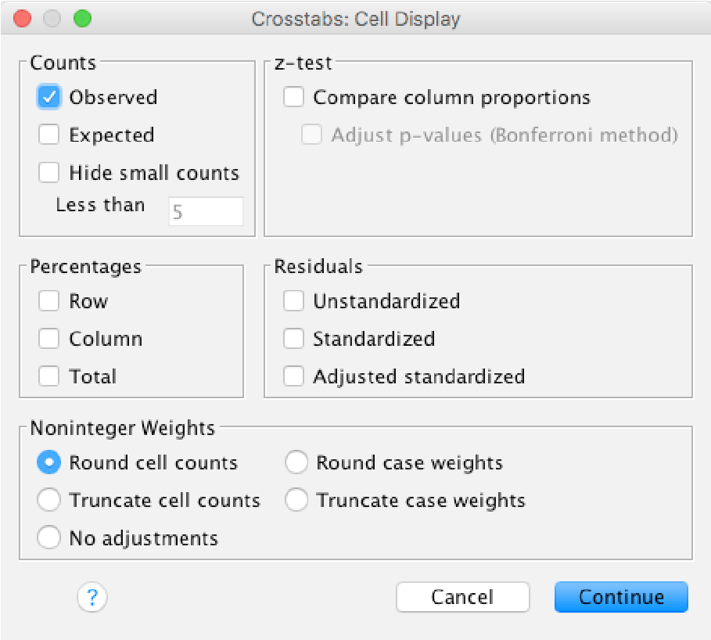
Click near the top right of the crosstabs dialogue box.
Click on Row and/or Column and/or Total in the Cell Display dialogue box (see below) to obtain the desired percentages.
Click Continue | OK.
Use IBM SPSS Statistics to create further new tables from pairs of variables of your choice.

End of Exercise 10

Exercise 11: To Test for a Significant Relationship Between Two Variables (Correlation)
Make sure you have loaded IBM SPSS Statistics and that the data file has already been opened.
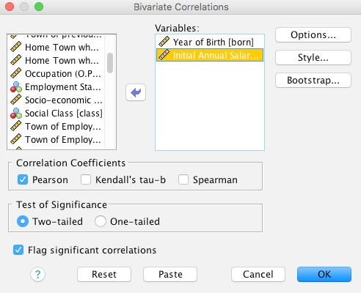
Click Analyze | Correlate | Bivariate. Click on the first variable you wish to obtain a correlation coefficient with another variable.
Clickto transfer the variable into the Variables box.
Repeat this procedure for the other variable(s) you wish to correlate with the first variable.
Choose the most appropriate Correlation Coefficient for your data and make sure there is a  in the box.
Choose the most appropriate Test of Significance and click on the radio button.
Note: Use a Two-tailed test when the direction of the relationship, positive or negative, cannot be specified in advance. Use a One-tailed test when it can be specified in advance.
Make sure there is a in the box Flag significant correlations. This will ensure that the significance level is displayed.
Click OK.
The results of the correlation will appear in the Output Window.
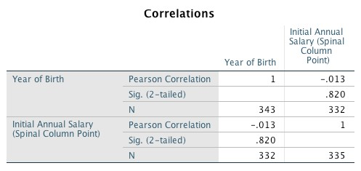
In this output window, the variables Initial Annual Salary (Salary) and Year of Birth (Born) from the teach1.sav data set have been correlated.
IBM SPSS Statistics has produced a correlation matrix. Obviously there is a perfect correlation (1.0000) between the variable initial annual Salary and itself.
As the variable is correlated with itself it is impossible to calculate the significance (p=. ).

There is no correlation (-.013) between the variable Salary and the variable Born and this lack of correlation is significant at the 0.820 (p=0.820) level.

Exercise 12: To load an Excel spreadsheet data file
Do not undertake this exercise until you need to load your own data from an Excel Spreadsheet.
Make sure that your Excel spreadsheet file is set out with one column per variable and one row for each individual (survey form).
Note: the first row should be the variable names. This is illustrated for the Excel equivalent of an extract from the teach.sav data file below:
 | A | B | C | D | E
1 | gender | born | marital | educate | profmemb
2 | 2 | 67 | 1 | 5 | 3
3 | 1 | 19 |  | 7 | 3
4 | 2 | 24 | 2 | 7 | 3
Make sure you have loaded IBM SPSS Statistics (see Exercise 1).
Insert your USB portable mass storage device.
In the Menu Bar, click File | Open | Data. The Open Data dialogue box appears. Notice that IBM SPSS Statistics looks for data files in the most recently used sub directory. As you are going to load an Excel file from a USB portable mass storage device you need to insert this first.
Clickin the Look in: box.
Click on and select Volumes to find the appropriate removable disk, for example: KINGSTON.
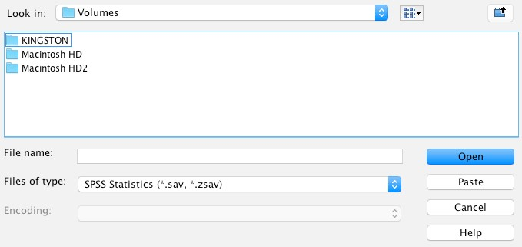
Clickin the Files of type: box and use the scroll arrows on the right of the dialogue box to find Excel.
Click Excel (*.xls). You will see your Excel files displayed in the Open Data dialogue box.
Select the filename you want by clicking on it and then click on the Open button. The Opening File Options dialog box appears.
Make sure there is a to the left of Read variable names… and click OK. You will see the file appear in the Data View and the filename above the menu bar change. This will take some time so be patient!
Because you are loading the file from Excel you will still need to add variable labels and value labels within IBM SPSS Statistics and save your data as an IBM SPSS Statistics data file (*.sav).
End of Exercise

5) | FURTHER READING
The most useful book on IBM SPSS Statistics in my opinion is:
- Field, A. (2023). Discovering Statistics Using IBM SPSS Statistics (4th Edn.). London: Sage.
This is both readable and easy to use! It also contains advice regarding when to use different statistical tests.
Another good book on IBM SPSS Statistics for beginners, which also clearly explains the statistics is:  Pallant, J. (2013). IBM SPSS Statistics Survival Manual (5th edn). Maidenhead: OUP.
These books offer a clear, non-technical approach to using IBM SPSS Statistics. They assume little familiarity with the data analysis software and cover both inputting data and how to generate and interpret a wide range of tables, diagrams and statistics. A reasonably straight forward book on collecting your data and preparing it for quantitative analysis is:
- Saunders, M.N.K., Lewis, P. and Thornhill, A. (2016). Research Methods for Business Students (7th edn.), Harlow: Pearson, Chapters 11 and 12.
If you need a statistics book that assumes virtually no statistical knowledge focussing upon which test or graph, when to use it and why. It is written for people who are fearful and anxious about statistics and do not think they can understand numbers then you may find the following helpful:
- Berman Brown, R. and Saunders, M. (2008). Dealing with statistics: What you need to know. Maidenhead: McGraw Hill Open University Press.

6) | APPENDIX 1: LIST OF VARIABLES AND THEIR CODES FOR DATA  SET TEACH.SAV
Variable names are in capitals with the variable label on the same line. Codes and value labels appear on subsequent lines.

GENDER
Gender of Employee
- Male
- Female

BORN
Year of Birth
19-- year

MARITAL
Marital Status
- Single
- Married
- Widowed
- Divorced

EDUCATE
Educational Attainment
- Postgraduate Study
- Up to Degree Level
- Up to HNC/D or Diploma
- Up to A level
- Up to O level 6) Up to C.S.E.
7) No educational qualifications stated

PROFMEMB
Professional Body Membership
- Member of Professional Body
- Not a member of Professional Body

PREVEMP
Nature of Previous Employment
- Local Government
- Outside Local Government
- Student
- Unemployed
- Self Employed
- Youth Training Scheme
- Retired
PREVEAST
Town of previous employment Eastings
PREVNOR
Town of previous employment Northings
APPLEAST
Home Town when applied Eastings
APPLNOR
Home Town when Applied Northings

OCCUPAT
Occupation (OPCS 1980 Classification)
1.00 Solicitor
2.10 Auditor
2.20 Accountant
2.50 Valuer
3.10 Personnel Officer
3.20 Work Study Officer
4.20 Computer Programmer
5.20 Advertising Executive
6.10 E.H. Officer
6.20 Building Inspector
8.00 Admin Executive
9.50 Legal Executive
9.80 Curator (Museum)
13.10 Warden (O.A.P.)
13.20 Play Group Leader 13.30 Welfare Occupations n.e.c.
18.20 Vet
22.20 Projectionist
25.00 Municipal Engineer
31.10 Architect/Town Planner
31.20 Quantity Surveyor
31.30 Building Surveyor
33.10 Architect/Town Planner Technician
33.20 Building/Engineering Technician
33.40 Works Manager
35.10 Maintenance Supervisor
35.20 Clerk of Works
36.20 Transport Manager
36.30 Stores Controller
37.20 Office Manager
39.50 Entertainments/Sports Manager 44.10 Caravan Site Manager
44.40 Managers n.e.c.
45.20 Supervisor Stores Clerks
45.30 Supervisor Drawing Assistants
45.40 Supervisor Clerks
45.50 Supervisor Cashiers
46.10 Clerk Stores
46.20 Tracer Assistant
46.30 Clerk Non-retail
47.00 Cashier Retail
48.20 Supervisor Machine Operators
49.10 Receptionist
49.20 Typist
50.00 Punch Card Operator
51.10 Telephone Receptionist
51.20 Switch Board Operator
56.00 Meals on Wheels Operator
60.40 Estate Ranger
60.60 Supervisor Security
62.10 Park Keeper
62.30 Art Gallery Attendant
63.30 Supervisor Bar
63.40 Supervisor Catering
65.20 Bar person
66.10 Counter Hand
71.10 Supervisor Caretakers
71.40 Supervisor Car Parks
72.10 Caretaker
72.20 Cleaner
75.20 Car Park Attendant 75.60 Service Worker n.e.c.
76.30 Foreman Gardeners
78.10 Horticulture Workers
78.20 Gardener
83.00 Dog Warden
100.30 Print Machine Operator
105.10 Carpenter
109.30 Black Smith
111.00 Management Trainee
114.50 Foreman Fitters
118.10 Fitter
125.00 Plumber
133.40 Painter and Decorator
139.10 Foreman Bricklayers
139.11 Foreman Sewage Workers
139.12 Foreman Construction Workers
139.80 Highways Inspector
140.10 Bricklayer
140.50 Building Worker
142.10 Sewage Plant Attendant
152.20 Refuge Vehicle Driver
152.30 Road Sweeper Driver
156.10 Foreman Storekeeper
156.40 Foreman Refuse Collection 157.10 Store Keeper
157.40 Refuse Collector
159.80 Foreman Labourers 160.80 Labourer n.e.c.

EMPSTAT
Employment Status on application
- Manager
- Foreman / Supervisor 3) Apprentice / Trainee 4) Employee n.e.c.

SEG
Socio-economic Group
1.2 Managers in Government and Industry
4.0 Professional Employees
5.1 Ancillary Workers
5.2 Foremen/Supervisors (non manual)
6.0 Junior Non manual
7.0 Personal Services
8.0 Foremen/Supervisors (manual)
9.0 Skilled Manual
10.0 Semi-skilled Manual
11.0 Unskilled Manual
15.0 Agricultural Workers

CLASS
Social Class
- Professional
- Intermediate Non-manual
- Junior Non-manual
- Skilled Manual
- Semi-skilled Manual
- Unskilled Manual
SALARY
Initial Annual Salary (Spinal Column Point)
EMPLEAST
Town of Employment Eastings
EMPLNOR
Town of Employment (Northings)

HOMEEAST
Home Town at start of Employment
(Eastings)

HOMENOR
Home Town at start of Employment
(Northings)

NOTIFY
- Notification Outlet 1
- Internal
- Word of Mouth
- Letter of Enquiry
- Circular to adjacent Local Authorities
- Job Centre
- P.E.R. (Professional Executive
Register)
- Employment Agency (Private Sector)
- Careers Office (local)
DAILY LOCAL NEWSPAPERS
- Evening Post

WEEKLY LOCAL NEWSPAPERS
- Two County Courier
- Local Town Chronicle
- County Messenger
- County Express
- Local Town News
- East County Gazette

FREE WEEKLY LOCAL NEWSPAPERS
- Local Town News in Focus
- News in Focus
- Local Town Times
- Local Town Times and Gazette

NATIONAL DAILY NEWSPAPERS 21) Daily Mail
- Daily Telegraph
- The Times
- The Guardian
NATIONAL SUNDAY NEWSPAPERS
- Sunday Times

JOURNALS AND MAGAZINES (*PUBLIC SERVICE)
- Commercial Motor
- Horticulture and Amenities Weekly
- Army Appointments Service
Magazine
- Church Times
- Parks and Recreation
- Golf Illustrated
- Groundsman
- Health and Social Services Journal
- Lady Magazine
- Public Finance and Accounting*
- Institute of Management Science
Journal
- UK Press Gazette
- Building Trades Journal
- Gardeners Chronicle
- Solicitors Journal
- Nursing Times
- Nursing Mirror
- Policy Holder Insurance Journal
- Opportunities*
- Estates Gazette
- Clerk of Works Weekly
- Computing
- Association of Recreation Managers Appointments
- Local Government Chronicle*
- Municipal Journal*
- Public Service and Local Government*
- Municipal Engineer*
- Baths Service Circular
- Caterer and Hotel Supervisor
- Accountancy Age
- Management (Work Study) Services
- Quantity Surveyors Weekly
- Surveyor
- Architects Journal
- The Planner
- Building
- Planning
- Law Society Gazette 64) Meat Trades Journal
- Protection
- Institute of Personnel Managers
Digest
- New Civil Engineer
- Veterinary Record 69) Current Vacancies
- The Stage
- Regional Arts Magazine
- Health and Safety at Work
NOTIFY2
Notification Outlet as for NOTIFY1
NOTIFY3
Notification Outlet as for NOTIFY1
NOTIFY4
Notification Outlet as for NOTIFY1
NOTIFY5
Notification Outlet as for NOTIFY1
NOTIFY6
Notification Outlet as for NOTIFY1
NOTIFY7
Notification Outlet as for NOTIFY1
NOTIFY8
Notification Outlet as for NOTIFY1
NOTIFY9
Notification Outlet as for NOTIFY1
NOTIFY10
Notification Outlet as for NOTIFY1

YEAREMP
Year of Employment
19-- Year of Employment

ASSISTAC
Assistance by Accommodation Provision
- Permanent Accommodation Provided
- Temporary Accommodation Provided
- No assistance given

ASSISTMO
Assistance with Moving Expenses
- Financial Assistance Given
- No Assistance Given

TERMYEAR
Year of Termination of Employment
19-- Year of termination

TERMWHY
- Reason for Termination
- New Job
- Spouse’s New Job
- Going to College
- Having a Baby
- Early Retirement
- Retirement
- Redundancy
- Dismissed
- Death
- Illness
- Marriage
- Family Commitments
- First Job Commitments
- Leaving the Country
- Travel Costs
- Fixed Term Contract
- Other

FULLPART
Full or Part Time Employment
- Part time
- Part time (second job)
- Full time

HEARDN1
NOTIFY1 is how first heard of vacancy
- Yes
- No

The following additional variables have been created using IBM SPSS Statistics INTERNAL
Notified internally
- used
- not used

CIRCULAR
Notified by circulating other Local
Authorities
- used
- not used

JOBCENTR
Notified at Job Centre
- used
- not used

LOCAL
Notified in Local Press
- used
- not used

REGIONAL
Notified in Regional Media
- used
- not used

NATIONAL
Notified in National Media
- used
- not used

DISTMIG
Distance Migrated (km)
-- straightline distance migrated

JTOWORK
Journey to work (km) -new job
-- straightline distance of journey

