

Effective Team Working and Communication
BMSW4002
Assignment 1 Written Assignment

Dinyo Radev
Student ID 2129750

Table of Contents
1 Introduction 3
2 Main body 3
2.1 Models of communication 3
2.1.1 Shannon and Weaver 3
2.1.2 Berlo’s model 4
2.1.3 Schramm’s model 6
2.2 Essential communication skills 7
2.3 Poor communication and ways of improvements 9
3 Conclusion 11
4 References 12

1 Introduction
This report explores the concept of communication. Important theoretical models of communication are discussed together with the key skills necessary for effective communication. The report combines theoretical insights, as well as case study information and own observations in order to critically discuss some key issues in communication and the best practices in the field. Research findings are expected to deliver an improved knowledge regarding the principles of effective communication which could guide the future practice in this important field of performance.

2 Main body

2.1 Models of communication
This section of the report thoroughly discusses the main model of communication, which serve as guidance or understanding the principles of effective communication.

2.1.1 Shannon and Weaver
The analysis begins with the communication model by Shannon and Weaver (1949). It is one of the first major attempts to explain the nature and stages of communication as a process. As shown below, communication is possible only when combining several key elements. It is a requirement to have a sender, who is the source of information, as well as receiver to whom the information is sent (Shannon and Weaver, 1949). Communication process also requires a channel through which the information is delivered by the sender to the receiver. The effectiveness of the communication channel largely determines the success of communication as a whole (Shannon and Weaver, 1949). In this respect, any noise, which may disrupt the effectiveness of the communication channel, should be eliminated. Noise may be created by interference of others, language barriers, interruption in the communication process and other inefficiencies.
The communication model also emphasises on the importance of feedback – evidence that the communication is not a one-way process. Instead, the receiver of the information often sends feedback to the sender; thereby, contributing to the development of a two-way communication process (Shannon and Weaver, 1949). In addition to all, the communication process also incorporates two additional stages – encoder and decoder. These stages facilitate the transmission of the communication messages, so that the latter are clearly understood by the receiver (Shannon and Weaver, 1949).
Figure 1 –Shannon and Weaver’s communication model
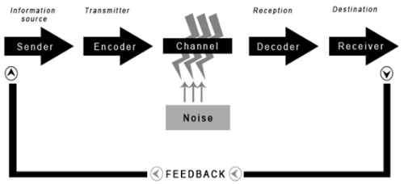
Source: Adapted from Shannon and Weaver (1949)

2.1.2 Berlo’s model
The model by Berlo is also included in the theoretical discussion. As shown below, the model incorporates some key features of the previously discussed model by Shannon and Weaver (1949), as communication requires a sender of the message and a receiver (Stead, 2017). Similarly, there is also a communication stage in the model. Communication message constitutes a distinctive stage of the communication process which a new and a specific feature of Berlo’s model (Communication Theory, 2022). The alignment between the two models leads to a consensus view regarding the importance of having sender, receiver and a communication channels.
The model by Berlo provides additional insights regarding each of the four stages. The source (sender) and receiver have specific communication skills, attitudes, knowledge, social and cultural background which eventually influences communication effectiveness (Communication Theory, 2022). Therefore, there key aspects of the participants in the communication process should be taken into consideration in order to foster communication effectiveness. Considering the role of communication message, the latter must integrate reasonable information content, combine effective structure and elements, as well as have appropriate code and treatment in order to be of contributing role for communication process (Communication theory, 2022). Berlo’s model also recognises five distinct elements, which coincide with human senses, as affecting the actual channel of communication (Communication Theory, 2022). These insights are important because communication process is suggested to be not only verbal (hearing), but also affected by body language expressions (seeing) and other senses – touching, smelling and tasting (Communication Theory, 2022).
Figure 2 – Berlo’s communication model
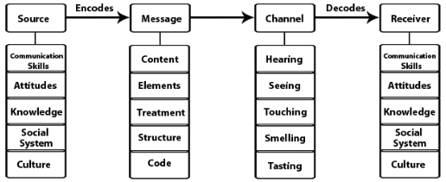
Source: Communication Theory (2022)
The Berlo’s model can be used as a foundation for understanding some communication specifics from the studied case studies. The information from the case study “One day with the Chief” provides a good example of non-verbal communication in practice. More specifically, Mark applies body language expressions in a subconscious way. His relaxed psychological state is expressed in a non-verbal manner by crossing his legs and loosening his tie. This example shows that communication messages may be expressed by alternative channels.
The case of Maria and Pedro can also be explained by the Berlo’s model. Pedro applies hearing in order to get the communication message sent by Maria. Lack of concentration; however, leads to an inability to apply the hearing channel of communication. As a result, Pedro fails to purchase a chicken for Maria, as he expected to see Maria in the kitchen. Given the proposed communication channels, Maria may use written messages in the future, as Pedro could be more concentrated and able to repetitively see the message, if there are any doubts about the meaning.

2.1.3 Schramm’s model
The model by Schramm (1949) is also included in the analysis due to its contribution to understanding the specifics of communication process. Similarly, to the previously-discussed models, Schramm (1949) suggests that communication includes a sender and a receiver. Communication messages are sent through the medium, which represents the respective communication channel. At some point in the medium, there is a zone where the communication takes place (Schramm, 1949). This zone is determined by the scope of sender’s and receiver’s field of experience; hence, it is important for both parties to have a common zone in order to develop a zone for communication (Schramm, 1949). Lack of a common zone may be a major obstacle for communication. A good example stems from the studied case “The professor and the village people” where the professor applies advanced vocabulary by using the words “edifice” and “conflagration”. These words are known for the village people; hence, the latter cannot understand the meaning expressed by the professor. As a result, there is no common zone due to the discrepancies taking place when comparing the vocabulary of the professor and village people. Respectively, communication process is impossible, as shown in the case.

Figure 3 – Schramm’s model overview
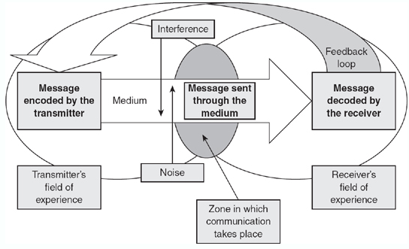
Source: Blythe (2009)
To carry on, the theoretical specifics of the Schramm’s model also confirms earlier theoretical propositions. For instance, noise is also identified as a negative development which may lower the level of communication effectiveness. Moreover, the role of feedback is recognised and it is labelled as “feedback loop” by Schramm (1949). Considering this, communication is suggested to be a two-way process – a characteristic identified by Shannon and Weaver (1949) but overlooked by the model by Berlo.

2.2 Essential communication skills
Holistic skills are necessary for effective communication. To begin with, Malik and Girdhar (2018) emphasise on several personally-related characteristics which influence the communication process. One should combine clear, complete and concrete words when performing verbal communication (Malik and Girdhar, 2018). Clarity of expression and completeness are necessary in order to avoid misunderstanding and ambiguity which are often associated with unclear and incomplete messages and meanings. The use of concrete words and facts is also of value in the process of communication, as one is able to deliver concise and effective messages to the receiver (Malik and Girdhar, 2018). Considering these factors, the application of extensive and appropriate vocabulary is quite important for effective verbal communication.
The demonstration of empathy is another personal characteristic with an impact on communication. According to Malik and Girdhar (2018), empathy ensures that one is able to consider and understand the feelings, wishes and positions of the other people. Empathy facilitates the process of communication, as one is better able to understand and interpret the received communication messages (Malik and Girdhar, 2018). Moreover, empathy strongly stimulates the development of trust between the involved parties which in turn allows for a more complete communication due to the establishment of an open and friendly communication environment (Malik and Girdhar, 2018).
Another key skill, which facilitates the process of communication, refers to active listening (Careerblog, 2022). This is considered as a skill because one can learn it over time. It requires paying close attention to the communication messages of the other party. Active listening also means being engaged in the process, rather than simply hearing what other people say (Careerblog, 2022). Therefore, active listening strongly contributes to receiving all information in the process of communication which in turn facilitates its effectiveness.
Cross-cultural competences are also necessary in the field of communication. Hall (1976) explains that communication is not only verbal, but also non-verbal. Low context nations prefer verbal communication which emphasises the role of having extensive vocabulary by disseminating clear, complete and concrete words and meanings (Hall, 1976). In contrast, high-context nations play the attention to non-verbal messages, such as body language expressions and tone of voice (Hall, 1976). The following chart shows the positions of key nations according to the low- and high-context communication spectrum (Nomura, 2018).

Figure 4 – Spectrum of communication context
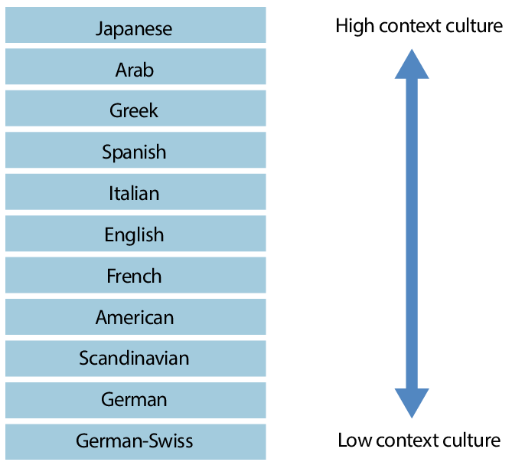
Source: Nomura (2018)
Considering this, one must be aware regarding the impact of body language expressions in the communication process, especially when interacting with representatives from the Asian, Arab and Mediterranean countries (Nomura, 2018).

2.3 Poor communication and ways of improvements
This section of the report provides a series of examples of poor communication in the personal workspace together with some ideas for improvements.
One of the most communication issues refers to the effectiveness of the communication channels. For example, the pandemic required a shift to a remote working mode where online-based communication channels were applied for some period of time. The method was required in order to protect personal health of the workforce members. Nevertheless, the complete avoidance of face-to-face contacts worsened the level of communication effectiveness. Communication messages were mainly verbal or written and it was impossible to extensively use body language as a means of getting information. As a result, it was difficult to understand some detailed nuances and insights of the expressed meaning which posed difficulties for me given my Bulgarian origin and expressed preferences for high-context culture and non-verbal communication. The solution of the problem is to improve the communication channels by restoring the ability to meet in person and participate in team discussions. While this recommendation appears to be supported by all three models of communication, it can be applied only in a normal non-pandemic environment.
Another communication problem refers to the lack of attention and active listening by colleagues. Lack of concentration and empathy, as well as overlooking some information can inhibit the effectiveness of communication, as the receiver does not consider all information sent by the sender (see Shannon and Weaver, 1949). The solutions include the development of active listening skills by all organisational members, which could enhance the ability to receive communication information, as well as the full elimination of noise. The latter is suggested by Shannon and Weaver (1949) and Schramm (1949) as a major obstacle of communication. Therefore, the employer must create effective communication channels which eliminate noise and misunderstanding by participants in the process.
In practice, communication problems may also emerge from the use of improper vocabulary. In my profession, there are specific terms and expressions which derive meaning and clear understanding. Often, outsiders of the firm are unaware about this specific vocabulary. As a result, the use of normal words, instead of the specific terms, may lead to ambiguity and misunderstanding. In other cases, it is impossible to understand each other, as the zone where communication takes place is non-existent, as suggested by the model by Schramm (1949). Considering this, it is important to make clients aware about the specific terms or, alternatively, to ask them for additional verbal explanations in order to understand their meanings. Thus, being flexible and more detailed could support mutual understanding.

3 Conclusion
To sum up, research findings demonstrated the specifics of the communication process and the importance of complying with some principles in the field. The discussed theoretical models showed the main principles of communication, as well as the similarities and differences of the theories of communication. As a whole, it can be concluded that communication requires holistic skills, such as active listening, extensive vocabulary, clear, complete and concrete expressions, empathy, cross-cultural communication and others. Therefore, advancement in the field of communication is associated with consistent efforts and incremental improvements. In this relation, the discussed communication problems in the workplace and potential solutions could be seen as a foundation for future improvement.

4 References
Blythe, J. (2009) The Schramm model of communication. In Key concepts in marketing (pp. 178-180), SAGE Publications Ltd.
Careerblog (2022) Top 11 Communication Skills, [online] Available: https://novoresume.com/career-blog/communication-skills [Accessed: 21 December 2022]
Communication Theory (2022) Berlo’s SMCR model of communication, [online] Available: https://www.communicationtheory.org/berlos-smcr-model-of-communication/ [Accessed: 30 April 2022]
Hall, E. (1976) Beyond culture. New York: Anchor Press
Malik, A. and Girdhar, A. (2018) Essence of Effective Communication. In Road map for success in career planning and advancement, [online] Available: https://www.researchgate.net/publication/326534323_Essence_of_Effective_Communication [Accessed: 21 December 2022]
Nomura, S. (2018) Interpersonal Communication: An Analysis from a Point of In-house Communications, Business Communication Research and Practice, Vol. 1, pp. 85-89.
Schramm, W. (1949) Mass Communications. Urbana, IL: University of Illinois Press
Shannon, C. and Weaver, W. (1949) The mathematical theory of communication. Urbana: University of Illinois Press
Stead, B. (2017) Berlo’s Communication Process Model as Applied to the Behavioural Theories of Maslow, Herzberg and McGregor, Academy of Management Journal, Vol. 15(3), DOI: https://doi.org/10.5465/254868.

