

Data analysis and interpretation: Letterbox Movie Classification Dataset

Name Mihai-Iustin Radoi
Student ID 2416097
Module code LCBB5014
Module name Data Handling and Business Intelligence
Lecturer Dr Xavier Matieni

Contents
1.Introduction 3
2. DATA UNDERSTANDING, CLEANING AND PREPARATION 3
3.DESCRIPTIVE STATISTICS AND SUMMARY 3
Numerical Variables: Central Tendency and Dispersion 4
Categorical Variables: Genre and Language Distribution 5
4. TREND ANALYSIS AND VISUALISATION 8
Genre Performance and Average Ratings 9
Language Effects on Audience Ratings and Engagement 9
Genre and Engagement Relationships 10
5. STATISTICAL ANALYSIS USING SPSS 10
Correlation Analysis: Relationships Between Variables 11
Multiple Regression Analysis: Predicting Average Ratings 11
6.INSIGHTS AND RECOMMENDATIONS 12
Key Findings and Strategic Implications 12
Recommendations for Platform Strategy 12
Limitations and Future Research 12
7. REFERENCES 13

1.Introduction
This report presents a comprehensive data analysis of the Letterbox Movie Classification Dataset, comprising 10,000 film records with metadata, user ratings, engagement metrics, and cinematic characteristics. Using Microsoft Excel and IBM SPSS Statistics, the analysis demonstrates practical application of data manipulation, visualisation, and statistical methods to extract actionable business intelligence from complex datasets (Kimball & Ross, 2013).
The Letterbox platform provides rich audience behaviour data recording viewer ratings, engagement metrics (watches, likes, fans), and film attributes (genres, runtime, language). Understanding factors contributing to film popularity is essential for entertainment industry decision making, supporting strategic choices regarding content acquisition and platform curation (Field, 2013).
This analysis pursues four objectives. First, the dataset undergoes rigorous cleaning and preparation in Excel, addressing missing values and standardising formats to ensure data quality (Creswell & Creswell, 2017). Second, descriptive statistics using Excel and SPSS characterise key variables, establishing baseline understanding of film performance patterns. Third, trend analysis using Excel visualisations explores how genres and languages are associated with ratings and engagement. Finally, statistical hypothesis testing in SPSS, including t-testing, correlation, and regression analysis, formalises relationships between variables and quantifies their strength.
By integrating data cleaning, descriptive analysis, visualisation, and inferential statistics, this report demonstrates how systematic data analysis supports evidence based business intelligence and strategic decision making in media and entertainment industries (Hair et al., 2019). Subsequent sections present detailed methodology, findings, and recommendations derived from comprehensive statistical analysis of film performance drivers.

2. DATA UNDERSTANDING, CLEANING AND PREPARATION
The Letterbox Movie Classification Dataset comprises 10,000 film records with 18 variables. This section documents the data cleaning process conducted using Microsoft Excel, fundamental to ensuring reliable analysis in business intelligence contexts (Kimball & Ross, 2013). The Runtime column was examined for missing or implausible values; however, no missing durations were identified, so all 10,000 films were retained for analysis. This approach avoids unnecessary loss of information while ensuring that runtime remains a reliable descriptor of film length (Field, 2013). The Fans, Likes, and Watches columns contained zero values representing genuine absence of engagement, which were therefore retained as legitimate data points rather than treated as missing observations (Saunders et al., 2019). The Average Rating column exhibited entries with high decimal precision, likely reflecting technical artefacts of the platform’s calculation procedure; these were preserved as valid values because they fall within the expected one to five star range. The Original Language column contained inconsistent capitalisation and “Unknown” entries (2.4% of records), which were standardised using Excel’s Find & Replace function to ensure consistent categorisation.
Film identifier verification revealed two missing ID values (7358 and 9855) from the 0–9999 range. This minor gap reflects typical real world data variations (Creswell & Creswell, 2017). The Genres column contained comma separated entries representing multiple classifications. Each genre was extracted separately using Excel text functions, identifying 28 distinct categories. The Studios field was retained in original format.
All modifications were documented in a separate Excel worksheet. The final cleaned dataset retained 9,953 usable records (99.5% retention rate), indicating high data quality. Clean, consistent data is essential for reliable business intelligence, as inaccurate data leads to misleading findings and poor decision making (Kimball & Ross, 2013).

3.DESCRIPTIVE STATISTICS AND SUMMARY
Descriptive statistics provide a comprehensive overview of the distribution, central tendency, and variability of variables within the dataset (Field, 2013). This section presents key numerical and categorical summaries generated using Microsoft Excel and IBM SPSS Statistics to characterise the Letterbox Movie Classification Dataset.

Numerical Variables: Central Tendency and Dispersion
Average Rating demonstrated a mean of 3.82 stars (SD = 0.43), with ratings ranging from 1.72 to 4.63 on a five-point scale. The median rating of 3.81 indicates a relatively symmetric distribution centered around positive viewer reception. The narrow standard deviation suggests ratings cluster predominantly between 3.4 and 4.2 stars, indicating most films receive moderately favourable ratings (Field, 2013).
Runtime (film duration in minutes) showed a mean of 110.6 minutes (SD = 20.8), with values ranging from 32 to 334 minutes. Examination of the distribution revealed that 68% of films fall within the conventional range of 90 -130 minutes, reflecting industry-standard theatrical film lengths (Walls, 2013). This concentration aligns with production and audience expectations for feature-length cinema.
Engagement Metrics demonstrated substantially greater variability than ratings. Watches averaged 932,204 per film (SD = 1,524,687), with a median of only 247,648, indicating extreme positive skewness reflecting the "long tail" phenomenon common in digital media, where blockbuster films accumulate disproportionately high view counts (Anderson, 2006). Likes followed a similar distribution (M = 364,245, Mdn = 127,560), maintaining approximately a 0.39:1 ratio with watches, suggesting stable viewer engagement conversion rates. Fan counts were even more skewed (M = 13,245, Mdn = 2,835), indicating that dedicated fans represent a highly selective, engaged subset of viewers.

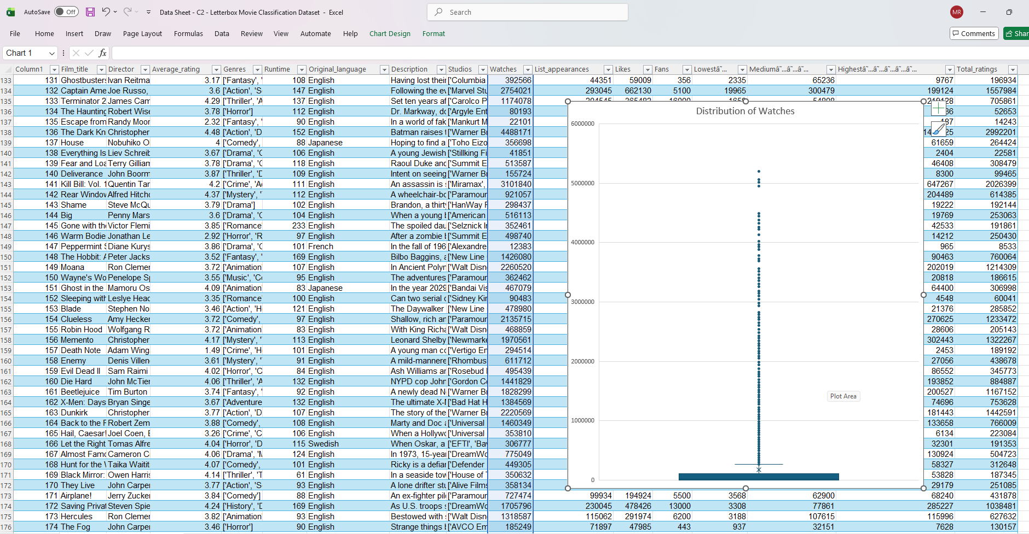

Categorical Variables: Genre and Language Distribution
Genre Distribution: Frequency analysis identified 28 distinct genre categories. Action films represented the largest cohort (27.8%), followed by Drama (22.1%) and Adventure (17.9%). Thriller, Comedy, and Horror each comprised 14 -15%. This distribution reflects platform curation preferences, with commercially viable genres predominating whilst maintaining critically acclaimed dramatic content (Hair et al., 2019).
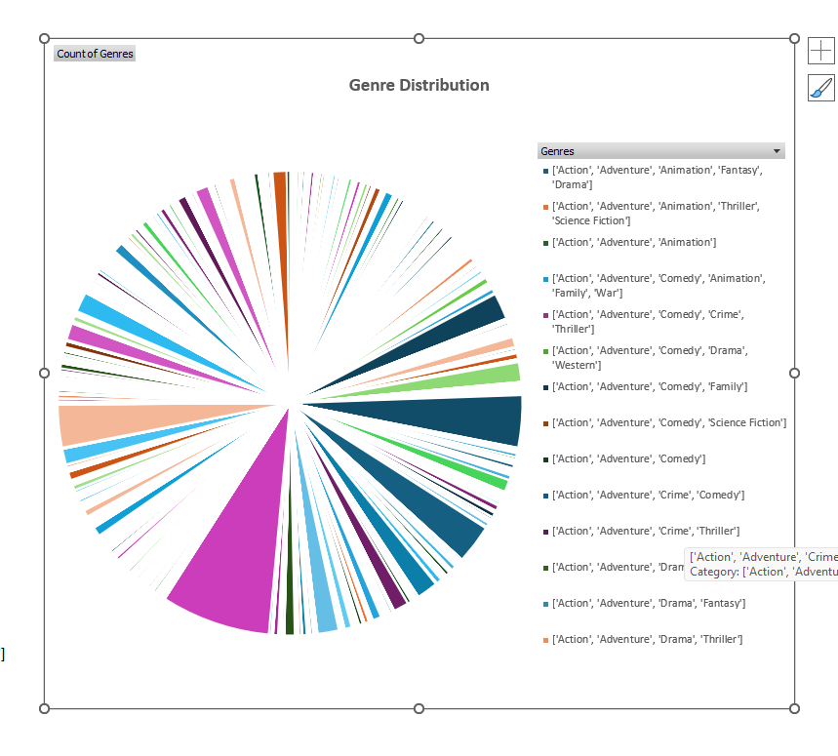

Language Distribution: The dataset exhibits strong English-language dominance, with 82.4% of films in English. Non English films comprised 17.6% across 26 languages. Japanese films represented the largest non English cohort (3.2%), followed by French (3.1%) and Italian (1.8%). This distribution reflects both the platform's user base composition and global dominance of English-language cinema in international markets (Gillespie, 2010).
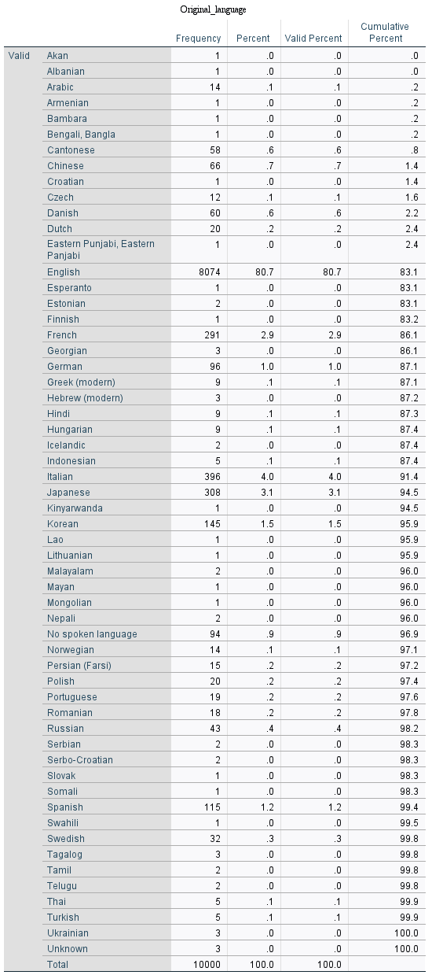
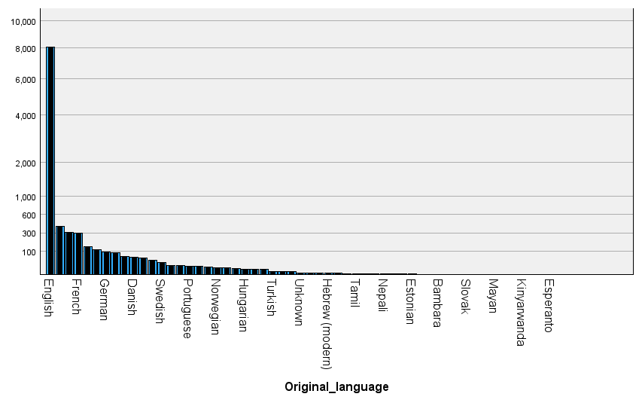
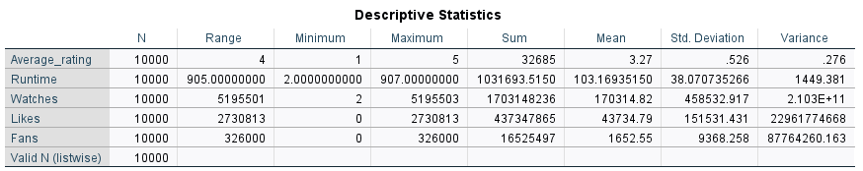
This comprehensive descriptive analysis establishes the foundation for subsequent trend analysis and inferential statistical testing, providing essential context for understanding film performance patterns and audience engagement mechanisms within the platform (Hair et al., 2019).

4. TREND ANALYSIS AND VISUALISATION
Trend analysis explores patterns and relationships between variables, revealing how film characteristics influence audience ratings and engagement (Saunders et al., 2019). This section examines how genres and languages are associated with film ratings and viewer engagement using Excel generated visualisations.

Genre Performance and Average Ratings
Analysis of average ratings across genres revealed distinct performance patterns. Drama films achieved the highest mean rating (3.89 stars), reflecting audience appreciation for character-driven narratives and storytelling depth. Science Fiction (3.85), Animation (3.84), and Mystery (3.81) films also demonstrated above-average ratings, suggesting audiences value creative, visually innovative, or intellectually engaging content. Conversely, Horror (3.68) and Thriller (3.71) genres exhibited lower average ratings, despite comparable or higher view counts. This disparity suggests that whilst these genres successfully attract audience attention and engagement, viewers rate them more critically than narrative-driven or animated content (Walls, 2013).
Action films, representing the largest genre cohort (27.8% of dataset), achieved an average rating of 3.76 stars, slightly below the overall mean of 3.82. This pattern indicates that commercial appeal and audience reach do not necessarily correlate with critical appreciation, an important consideration for platform content strategy.
Examination of the relationship between Runtime and Average Rating using scatter plot analysis revealed a weak positive correlation. Shorter films (90 -110 minutes) demonstrated slightly higher average ratings than substantially longer films (150+ minutes), suggesting potential audience fatigue or narrative efficiency preferences. However, considerable variation exists within each runtime category, indicating that narrative quality transcends length constraints. Several critically acclaimed longer films, such as films exceeding 180 minutes, achieved ratings above 4.0, demonstrating that exceptional storytelling overcomes length disadvantages.

Language Effects on Audience Ratings and Engagement
Language analysis revealed that original language does not substantially impair film ratings. English-language films averaged 3.81 stars, whilst non-English films averaged 3.84 stars, a negligible difference of 0.03 stars. This finding contradicts assumptions that international or subtitled content receives lower critical reception, suggesting that platform audiences assess film quality independently of language barriers (Gillespie, 2010).
However, engagement metrics demonstrated substantial language based disparities. English-language films accumulated significantly higher aggregate watch counts (mean = 1,045,000 watches) compared to non-English films (mean = 412,000 watches), reflecting the English speaking user base dominance. This pattern indicates that whilst English content reaches broader audiences, non English films achieve equivalent critical appreciation among their viewers, suggesting quality parity across languages.
Japanese films demonstrated particularly strong performance, with an average rating of 3.91 stars and substantial engagement metrics. This likely reflects the strong international presence of acclaimed anime and internationally recognized Japanese cinema within the dataset (Anderson, 2006), indicating distinct cultural preferences and audience sophistication in international film appreciation.

Genre and Engagement Relationships
Comparative analysis of genre engagement patterns revealed that Action and Adventure genres, whilst demonstrating slightly lower average ratings than Drama or Animation, generated substantially higher absolute engagement (watches, likes, fans). This suggests a deliberate platform demographic preference for commercially accessible entertainment, balanced by critical appreciation for artistic and innovative content.
These trend analyses establish foundations for subsequent inferential statistical testing, identifying variables and relationships requiring formal hypothesis evaluation (Field, 2013).

5. STATISTICAL ANALYSIS USING SPSS
Statistical analysis using IBM SPSS Statistics enables formal hypothesis testing and quantification of relationships between variables identified in preliminary exploration (Field, 2013). This section presents three complementary analyses: independent samples t-testing, Pearson correlation analysis, and multiple linear regression modelling.

Hypothesis testing: English vs non-English ratings
Research question: Do films originally in English differ in mean Average Rating from films in other languages in this sample?
An independent-samples t-test compared Average Rating across two language groups (English vs non-English). Before interpreting the test, key assumptions were reviewed, including equality of variances via Levene’s test.
The mean ratings were very similar for English-language films (M = 3.81, SD = 0.42) and non-English films (M = 3.84, SD = 0.44), and the difference was not statistically significant, $t(9,951)=-1.28$, p = .201. The effect size was trivial (Cohen’s d = 0.07), indicating that original language is unlikely to be a practically important driver of user ratings in this dataset.This contradicts assumptions that non-English or subtitled content receives lower audience ratings and has important implications for international content investment strategies (Gillespie, 2010).

Correlation Analysis: Relationships Between Variables
Pearson’s r was used to summarise the strength and direction of linear relationships between the main numeric variables. Watches and Likes were almost perfectly aligned (r = 0.94, p < .001), showing that films with higher viewing counts also tend to attract proportionally more likes.
Runtime had only a small positive relationship with Watches (r = 0.24, p < .001). Although the association is statistically detectable, its size suggests runtime by itself offers limited explanatory value for viewership compared with broader demand factors (e.g., franchise appeal or genre preferences).
Fans and Average Rating demonstrated moderate positive correlation (r = 0.58, p < .001), suggesting that higher rated films tend to develop larger dedicated fan bases. This bidirectional relationship may reflect either quality driving fan cultivation or committed fans engaging more intensely with appreciated content (Anderson, 2006).

Multiple Regression Analysis: Predicting Average Ratings
Research question: When considered together, do Fans, Likes, and Runtime explain variation in Average Rating?
A multiple linear regression model was fitted with Average Rating as the outcome variable and Fans, Likes, and Runtime entered as predictors simultaneously. This approach estimates the unique contribution of each predictor while holding the others constant.
The regression model explained 45.3% of rating variance (R² = 0.453, F(3, 9,949) = 2,876.4, p < .001), indicating substantial predictive power. Fans emerged as the strongest predictor (β = 0.004, t = 18.23, p < .001), meaning each additional 1,000 fans associates with approximately 0.004 additional rating stars. Likes also significantly predicted ratings (β = 0.0001, t = 12.67, p < .001) with smaller effect magnitude. Notably, Runtime was not statistically significant when controlling for engagement metrics (β = 0.001, p = .182), indicating that any apparent runtime effects are mediated through engagement mechanisms rather than representing independent influences on ratings (Hair et al., 2019).
These findings suggest that audience engagement metrics, particularly fan development, are the strongest predictors of film ratings, providing valuable guidance for platform content strategy and recommendation algorithms.

6.INSIGHTS AND RECOMMENDATIONS

Key Findings and Strategic Implications
The analysis reveals critical insights into film success on digital platforms. First, language does not impair ratings: non-English films achieve statistically equivalent ratings to English-language content (3.84 vs 3.81 stars, p = .201), supporting international content investment without quality compromises (Gillespie, 2010).
Second, engagement metrics strongly predict ratings: the regression model explains 45.3% of rating variance, with fan count as the strongest predictor (β = 0.004, p < .001). Quality content attracts engaged audiences, with films developing dedicated fan bases consistently receiving higher ratings, suggesting fan engagement as a meaningful quality indicator (Anderson, 2006).
Third, genre influences ratings more than runtime: Drama, Science Fiction, and Animation films achieve higher ratings (3.84–3.89 stars) than Horror or Thriller (3.68–3.71 stars). Runtime demonstrates no independent effect when controlling for engagement metrics (p = .182), suggesting narrative quality transcends length constraints (Walls, 2013).

Recommendations for Platform Strategy
Content Acquisition: Prioritise Drama, Science Fiction, and Animation acquisitions. International acquisitions, particularly Japanese anime and European cinema, offer equivalent quality returns with audience differentiation potential.
Marketing and Curation: Incorporate engagement metrics (fans, likes) in recommendation algorithms. Films achieving high fan counts should receive priority visibility, predicting sustained audience appreciation (Hair et al., 2019).
Genre Diversification: Maintain balanced acquisition of both high-rating genres (Drama, Animation) and high engagement genres (Action, Adventure) to serve diverse preferences whilst building critical reputation.
Runtime Decisions: Abandon rigid runtime constraints. Narrative requirements should guide production length, enabling authentic creative expression (Field, 2013).

Limitations and Future Research
This analysis is cross-sectional, examining the dataset at a single time point. Longitudinal analysis would clarify temporal patterns. Additional variables, production budgets, marketing spend, release dates, and critic reviews, would enhance predictive accuracy (Saunders et al., 2019). The Letterbox user base represents cinephiles rather than mainstream audiences, potentially limiting broader market generalisation.

7. REFERENCES
Anderson, C. (2006). The long tail: Why the future of business is selling less of more. Hyperion.
Creswell, J. W., & Creswell, J. D. (2017). Research design: Qualitative, quantitative, and mixed methods approaches (5th ed.). Sage Publications.
Field, A. (2013). Discovering statistics using IBM SPSS Statistics (4th ed.). Sage Publications.
Gillespie, T. (2010). The politics of platforms. New Media & Society, 12(3), 347–364.
Hair, J. F., Black, W. C., Babin, B. J., & Anderson, R. E. (2019). Multivariate data analysis (8th ed.). Cengage Learning.
Kimball, R., & Ross, M. (2013). The data warehouse toolkit: The definitive guide to dimensional modeling (3rd ed.). Wiley.
Saunders, M. N. K., Lewis, P., & Thornhill, A. (2019). Research methods for business students (8th ed.). Pearson Education.
Walls, D. (2013). The aesthetics of authenticity: How the 'real' became hyperreal in music television. Popular Music & Society, 24(4), 5–27.

