Component 2 Written Assignment
Poster and Pitch
EasyConnect LD: Accessible Digital and Community Health Navigation for Adults with Learning Disabilities
Programme | BSc Health and Social Care
Module | Changemakers: Creativity and Value Creation
Module Code | BMHP5014
Assessment | Component 2: Written Assignment (Poster and Pitch)
Student Name | Laurent felix Ilboudo
Student ID | 2425696
Lecturer Name | Tomy Adattu

Contents
POSTER: EASYCONNECT LD 3
Written Pitch 5
Introduction and rationale 5
Innovation and value creation 5
Target audience and co-production 6
Implementation and stakeholders 6
Policy, legislation and professional services 7
Leadership and professional practice 7
Dissemination and public involvement 8
Evaluation and conclusion 8
Timeline, Evaluation and Sustainability 8
Reference list 10

POSTER: EASYCONNECT LD
Accessible Digital and Community Health Navigation for Adults with Learning Disabilities
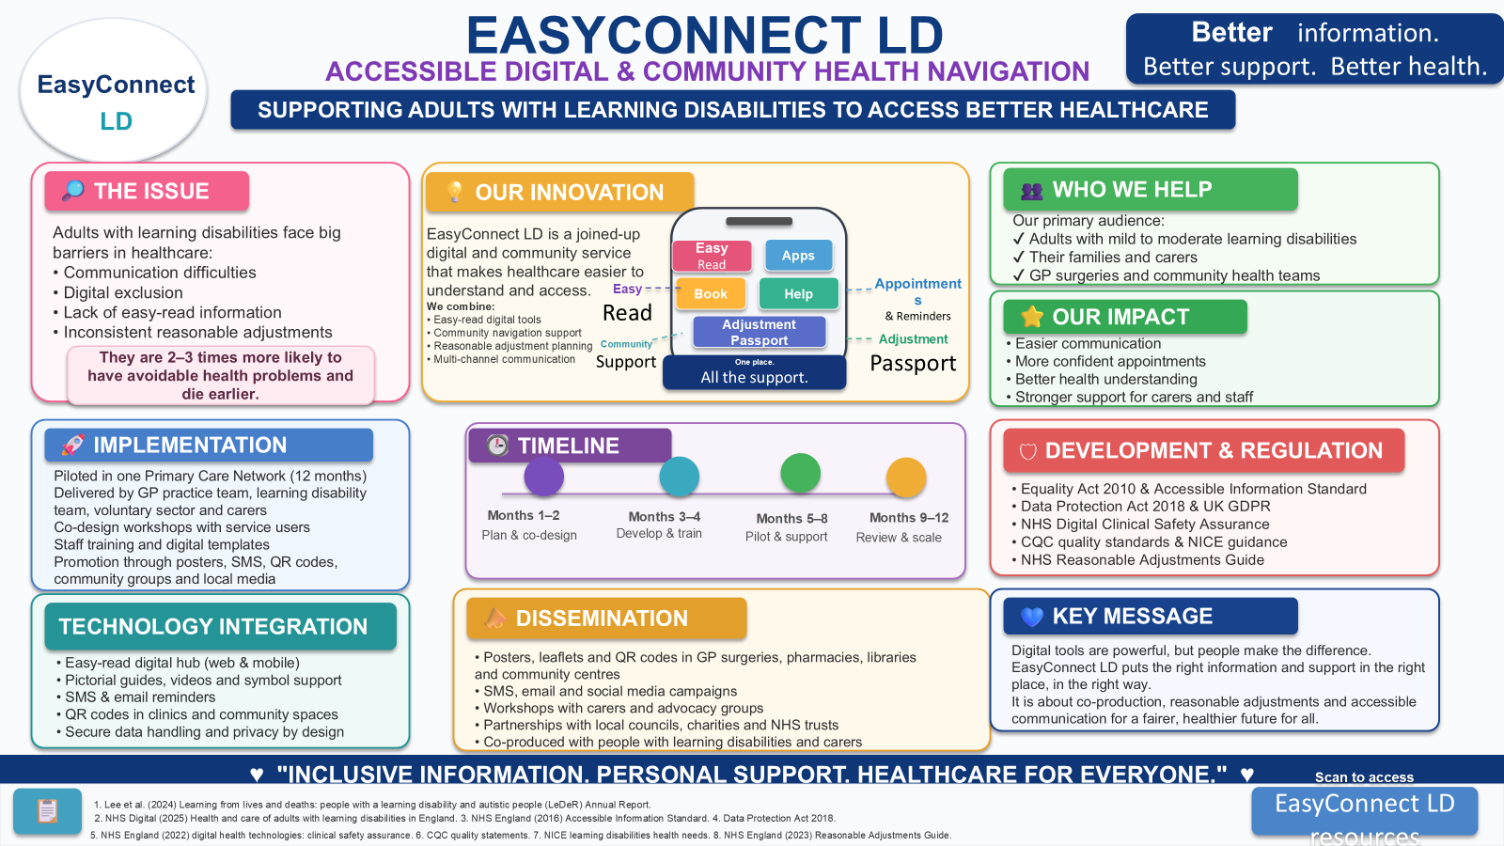
Visual/source note: poster layout is self-created; evidence and policy sources are cited in the poster text and listed in the references.

Written Pitch
Purpose: This pitch aims to outline and rationalise the EasyConnect LD poster project and demonstrate its benefits on health and wellbeing, the current policy and public engagement.

Introduction and rationale
Easy Connect LD is suggested as an innovation to increase health and social care access for adults with learning disabilities in the UK. It is a concept that directly addresses a persistent issue: individuals are asked to complete an online form, make a phone booking or seek information through a lengthy written document, but without adequate support. This may result in missed appointments, misinterpretation of treatment recommendations and missed care until a problem has escalated. The innovation is thus around the first contact with care as access is where many inequalities start. The project is creative in its use of existing resources, in that it brings together resources in a new combination: easy-read communication, digital tools, reasonable adjustment recording, and community navigation. It is also enterprising as it generates social value not profit and through partnership working can improve the outcomes for a group whose needs are often underserved. The evidence base is underpinning a need for action. NHS England's Accessible Information Standard (England, 2025) sets out the obligations for health and adult social care providers to identify, record, flag and put in place arrangements to ensure that the communication support needs of individuals are met. National progress towards disabled people having any adjustments consistently recorded where they are needed, so they do not have to explain their needs at each appointment is also reflected in the Reasonable Adjustment Digital Flag (NHS England, 2026). Standards, however, only achieve change when the processes of frontline teams are simple and service users know how to seek support. EasyConnect LD takes up this challenge by making reasonable adjustments visible, accessible and co-produced.

Innovation and value creation
The main product is an EasyConnect access pack. It contains a dedicated section of the website for accessibility, easy-to-print appointment resources, one page communication passport, and a referral process to access a trained community access champion. For instance, a pictorial checklist will be provided to a service user before his or her GP appointment so that they may select from a list of symptoms, specify communication support and record two questions. The passport may be shared with the practice, allowing staff to be aware of the need for longer appointments, quiet waiting space, involvement of carers, plain language and/or follow-up information in easy read format. This not only makes it more predictable and person-centred but also is an avenue for creating value from creativity.
The value created is utilitarian, emotional and organizational. The service can make service users more confident, independent and understand. This helps relieve the burden on the carer to have to explain a person's needs repeatedly. It saves time for professionals since key changes can be made in advance. It can help organizations ensure legal compliance and enhance quality. The common good is addressed as inclusive access will not only positively impact on one group, but the health system as a whole – missed appointments can lead to fewer; early advice can lead to better; staff will be more skilled in communicating with people with disabilities. The audience and joint production are aimed at.

Target audience and co-production
The audience is adults with learning disabilities, registered with GP practices, who are also in receipt of social care, community nursing, pharmaceutical or mental health and/or advocacy service. This pilot would focus on individuals who are less likely to attend appointments (such as those on the autism spectrum or with limited English proficiency), require annual health assessments, depend on a carer for some portion of their communication, or lack digital confidence. Co-production is central. The name will be chosen by adults with learning disabilities, the language tested, the symbols rated and instructions tested for understandability. This is because when professionals design solutions for people rather than with people, it can also fail to be a success in the area of innovation.

Implementation and stakeholders
Rather than using a health centre, the project will be delivered via a Primary Care Network as it is a regular access point to health services. The lead team would comprise of a practice manager, learning disability nurse, social prescribing link worker, digital inclusion officer and two representatives from the voluntary sector and service users. The training will be brief and practical. Reception staff will be trained on how to ask about the communication needs sensitively; clinicians will be trained on using the passport during the consultation; and access champions will be trained to support the use of the tools in the community venue. A phased pilot is feasible because it is small, assessed and grows (Demianenko et al., 2019).
There are limitations. Some may be disengaged with digital, some may not have digital devices, and some may require intensive digital support which a brief navigation service can't cover. EasyConnect LD, therefore, retains non-digital routes such as face-to-face community sessions, telephone support with either a carer or an advocate, and printed packs. Staff workload is another risk. This will be addressed in a non-detractive manner, using templates, short training and integration into the annual health check and reasonable adjustment plans that are already in place, without establishing a new pathway.

Policy, legislation and professional services
There are key policy and legal obligations which support the initiative. The Equality Act 2010 obligates to make reasonable adjustments where disabled children would be placed at a substantial disadvantage if they weren't made. The Accessible Information Standard is directly relevant as it is about communication needs in NHS and adult social care. The passport may also include information on health and disability which is important when it comes to data protection. The project will therefore implement the following as required by UK GDPR, the Data Protection Act 2018 and ICO guidance on special category data: use of consent; minimum necessary data; secure systems and clear privacy information. Digital content will be developed to align with the principles of web access (WCAG 2.2) such that it is accessible as part of the development process and not as an afterthought (W3C, 2024). Leadership and professional practice

Leadership and professional practice
To take the project from the idea stage to the day-to-day, leadership is required. There is a strong focus on behaviours in the NHS Healthcare Leadership Model to include leadership with care, connecting services and sharing the vision (NHS Leadership Academy, 2013). These behaviours are similar to EasyConnect LD and involve compassionate listening, partnerships between organisations and staff's willingness to alter their routines. The Care Quality Commission (CQC) also refers to this in their guidance on capable, compassionate and inclusive leadership for quality and wellbeing of staff (Care Quality Commission, 2024). Leaders should be flexible in setting aside time for training, and take on board comments from the people who use the service and view accessibility as a safety and quality matter rather than a luxury.

Dissemination and public involvement
The dissemination will be targeted and accessible. A public facing campaign will be developed using the message: "Tell us what helps you access care". Easy to read posters will be seen in GP surgeries, libraries, pharmacies, community centres and supported living services. Short films will give examples of what a service user might do to prepare for the appointment and request a reasonable adjustment from a service. Workshops will be organised by advocacy organisations and carers' groups, to ensure that the campaign is reaching people who may not use NHS websites. Program Coordinator meetings, staff newsletters, lunch-and-learn sessions and local quality-improvement meetings will provide the platform for reaching health and social care professionals.

Evaluation and conclusion
Evaluation will be through number and lived experiences. This will involve passports completed, reasonable adjustments recorded, annual health checks attended, missed health check rates, staff training complete and service-users opinions of training before and after support. Qualitative feedback will be captured through survey and short interview with service user, carer and staff which will be easy to read. Success won't just be measured by technology use, it will be measured by people feeling listened to and more able to access care. EasyConnect LD is an evidence-based and creative innovation overall. It provides a balance of accessible technology and human support to tackle communication obstacles, digital exclusion and variable reasonable adjustments. When implemented it might contribute to a more person-centred, lawful and inclusive health and social care services (Schultz, 2021).

Timeline, Evaluation and Sustainability
The pilot will be implemented via timeline and success measures, which will be a simple plan-do-study-act approach. The team will identify existing access issues and come to an agreement on co-production principles in months 1-2. They will create resources to explain the design in months 3-4, as well as privacy wording and staff prompts. Staff, along with community champions, will be trained in months 5-6. Service will be implemented in months 7-10 and problems, feedback and safeguarding concerns will be monitored on a weekly basis. The team will make comparisons between baseline and pilot data in months 11-12, update the resources and develop a business case for scaling up. These will be judged by the number of passports completed (at least 100), the number of trained staff reporting greater confidence (80 per cent), greater service user confidence scores and clear examples of reasonable adjustments in use during appointments.
Pilot phase | Main action
Months 1-2 | Map current access barriers; run co-production workshops with adults with learning disabilities, carers and staff.
Months 3-4 | Design easy-read resources, privacy wording, QR guides, appointment checklist and communication passport.
Months 5-6 | Train access champions, reception staff, social prescribers and clinicians; test templates with a small group.
Months 7-10 | Go live with 100 service users; monitor missed appointments, requests for adjustments and service-user feedback.
Months 11-12 | Evaluate outcomes, revise resources and prepare a rollout toolkit for other GP practices and community teams.
Evaluation measure | Indicator of success
Completed passports | At least 100 passports completed during the pilot.
Staff confidence | 80% of trained staff report improved confidence in accessible communication.
Service-user confidence | Improved pre/post confidence scores using an easy-read survey.
Access outcomes | Reduction in missed appointments and clearer recording of reasonable adjustments.
Quality learning | Case examples showing better understanding, follow-up and involvement in decisions.
Budget and sustainability: The pilot is designed to be low cost as all staff roles are used and it leverages partnerships with the voluntary sector and existing NHS digital channels. Costs are most related to co-production payments, accessible design, printing, staff backfill for training and evaluation time. This also helps to make the innovation more sustainable than a completely new app as the pathway can be followed even if the individual selects paper resources or face-to-face support. Leadership ownership, regular updating of content, induction training and a named accessibility lead each practice will be critical for the long-term sustainability.

Reference list
Care Quality Commission (2024). Capable, compassionate, and inclusive leaders - Care Quality Commission. [online] www.cqc.org.uk. Available at: https://www.cqc.org.uk/guidance-regulation-nhs-key-question-well-led-leaders.
Demianenko, V.M., Babliak, O.D., Babliak, D.Ye., Stohov, O.S., Melnyk, E.A., Revenko, K.A. and Pidgayna, L.V. (2019). Plastics of the left ventricle aneurysm with minimally invasive multivessel coronary artery bypass grafting. Cardiac Surgery and Interventional Cardiology, (3), pp.58–62. doi:https://doi.org/10.31928/2305-3127-2019.3.5862.
England, N. (2025). NHS England» Accessible Information Standard – requirements (DAPB1605). [online] England.nhs.uk. Available at: https://www.england.nhs.uk/long-read/accessible-information-standard-requirements-dapb1605/.
GOV.UK (2010). Equality Act 2010. [online] Legislation.gov.uk. Available at: https://www.legislation.gov.uk/ukpga/2010/15/section/20.
NHS England (2023). Inclusive digital healthcare: a framework for NHS action on digital inclusion. [online] NHS England. Available at: https://www.england.nhs.uk/long-read/inclusive-digital-healthcare-a-framework-for-nhs-action-on-digital-inclusion/.
NHS Leadership Academy (2013). Healthcare Leadership Model The nine dimensions of leadership behaviour. [online] Available at: https://www.leadershipacademy.nhs.uk/wp-content/uploads/dlm_uploads/2014/10/NHSLeadership-LeadershipModel-colour.pdf.
Schultz, O. (2021). Bayer nutzt easyconnect. agrarzeitung, 76(35), pp.7–7. doi:https://doi.org/10.51202/1869-9707-2021-35-007.
W3C (2024). Web content accessibility guidelines (WCAG) 2.2. [online] www.w3.org. Available at: https://www.w3.org/TR/WCAG22/.
World Health Organization (2022). Global report on health equity for persons with disabilities. [online] www.who.int. Available at: https://www.who.int/teams/noncommunicable-diseases/sensory-functions-disability-and-rehabilitation/global-report-on-health-equity-for-persons-with-disabilities.
www.england.nhs.uk. (2024). NHS England» The Reasonable Adjustment Digital Flag action checklist: what you need to do to achieve compliance. [online] Available at: https://www.england.nhs.uk/long-read/the-reasonable-adjustment-digital-flag-action-checklist-what-you-need-to-do-to-achieve-compliance/.

