Instrumentation and Control Systems


Tegan Ingram

University of Wales Trinity Saint David
Ordinance, Munitions and Explosives Engineering

Supervisor: Steve Mosey
November 2025

Table of Contents
List of Figures 3
Acronym List 3
Abstract 4
1. Introduction 4
1.1 Control Systems Background 4
1.1.1 What is a Control System 4
1.1.2 History of Control Systems 4
1.2 Types of Control Systems 5
1.2.1 Open vs Closed Loop 5
1.2.2 Controller Examples 5
1.3 CIWS Background 7
1.3.1 What is a CIWS 7
1.3.2 Benefits of a CIWS 7
1.2.3 Disadvantages of a CIWS 7
2. Simulation Setup 7
2.1 Simulation Description 7
2.1.1 Simulation Requirements 8
2.1.2 Methodology 8
3. Results 9
3.1 PID Controller Reading 9
3.2 Pole-Zero Plots 11
3.3 Nyquist Diagram 13
4. Discussion 14
4.1 Lag and Stability 14
4.2 Pole-Zero Diagrams 14
4.2.1 Time Domain Response 14
4.2.2 Pole Locations 14
4.3 Nyquist Diagrams 14
4.3.1 Gain Margin 15
4.3.2 Phase Margin 15
4.3.3 Gain and Phase Margins of CWIS System 15
5. Conclusion 15
References 15
Appendix- MATLAB Script 17

List of Figures
Figure 1 – Watt’s Flyball Governor [4] 5
Figure 2- Discrete Controller Explanation Diagram [5] 6
Figure 3 – Block Diagram, CWIS Control System 8
Figure 4 – PID Controller Parameters 9
Figure 5 – Tuned PID Controller Reading 10
Figure 6-Pole Zero Plot of Zero 11
Figure 7- Pole Zero Plot of Controller 11
Figure 8 – Pole Zero Plot of Forward TF 12
Figure 9 – Pole Zero Plot of Systems TF 12
Figure 10 – Nyquist Diagram 13
Figure 11 – Nyquist Diagram 13

Equation 1 – TF of Proportional Controller [7] 6
Equation 2 – TF for PI Controller [8] 6
Equation 3 – TF of PD Controller [9] 6
Equation 4 – Transfer function for PID Controller [10] 7
Equation 5 – Transfer Function 8
Equation 6 – Time Domain Response [9] 14

Acronym List
CWIS - Close-In Weapon System
PI - Proportional-Integral
PD - Proportional-Derivative
PID - Proportional-Integral-Derivative
TF – Transfer Function

Abstract
This report relates instrumentation and control systems to the angular positioning system attached to an automated Close-In Weapon System (CIWS). Computer programs, MATLAB and Simulink, have been utilised to design a closed loop system that can control a CIWS. The design of this system will bring the process under control in less than two seconds and have an overshoot no greater than five percent. The results of the mathematical modelling of this system are contained within this report, with tools such as Pole-Zero Plots and Nyquist diagrams being utilised to assess stability.

Introduction

Control Systems Background

What is a Control System
The objective of a control system is to achieve the desired outcome of a system or device by regulating and controlling the behaviours of subsystems within them. Control systems are developed and used to aid with the following: power amplification, remote controlling of systems, convenience of the input form, as well as compensating for disturbances [1].

1.1.2 History of Control Systems
Control systems have been used and enhanced throughout a large portion of history. The need for feedback control originated from humans’ desire to harness and control natures materials and forces for their own benefit, an example of an early control system is the mechanisms that keep windmills pointing toward the wind [2].
A major breakthrough in control systems engineering was when James Watt invented the flyball governor in 1788 for the use within steam engines, see Figure 1. The governor’s function is to minimise speed variation - where this variation in speed is due to load variation. It works by two flyballs rotating with the spindle of the governor, this spindle is coupled with the engine shaft. The flyballs rise and fall with the centrifugal action when there is a variation in spindle speed. There is a sleeve attached to the lower end of the spindle which is moved based off the centrifugal force on the flyballs. As the engine load decreases the spindle spins faster, the balls fly at a greater distance to one another thus causing the sleeve to slide up the spindle, this in turn closes the throttle valve to the extent that is needed to control and vice versa [3].
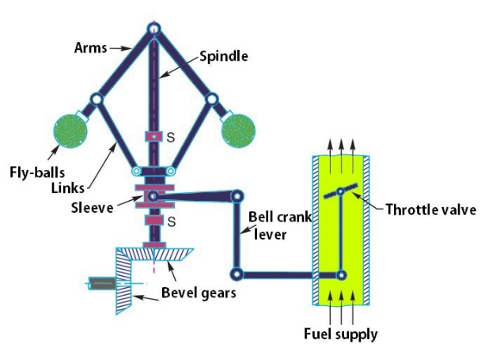
Figure 1 – Watt’s Flyball Governor [4]

Types of Control Systems
Multiple kinds of control systems exist. The choice of which one to use is made based off the complexity of what is being controlled. More simplistic systems tend to incorporate open loop systems while complex systems use closed loop systems. Multiple types of controllers for these systems are available. These controllers are to be selected for their ability to complete the task.

Open vs Closed Loop

1.2.1.1. Open Loop Control System
Open loop control systems operate without an output being fed back to the input of the system; this means that the action of the control is independent to the output. The benefit of an open loop control system is its simplicity. They are less costly due to having less components and responsibilities, making them easier to manufacture. They are often a lot smaller in size and rely on less parts being set up.

1.2.1.2 Closed Loop Control System
A closed loop control system operates by comparing a set desired output with the actual output. The actual output is fed back to the system and the input of the system is changed in ordered to meet the output desired. Closed loop systems are more complicated to design and make due to the complexity of them and their increased responsibilities.

Controller Examples

1.2.2.1 Discrete Controller
A discrete controller is a simple system that is used for processes that only involve discrete inputs and discrete outputs. Discrete control systems are employed in open-loop control systems. It works via the issue of on/off commands to reach the desired outcome for open loop control systems [5]. Due to the simplicity of such a system, it is a cheap and easy to maintain solution for systems that do not require a complex solution. Figure 2 is a block diagram explaining a discrete controller system.

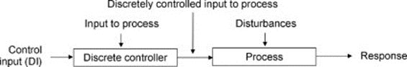
Figure 2- Discrete Controller Explanation Diagram [5]

1.2.2.2 Three State Controller
Another controller type is a three-state controller. The name originates from the fact that the output only has three states. This method is one of the most efficient ways for extending acceleration bandwidth as well as being effective for improving system dampening, it works based off the idea of pole assignment and thus can control a systems displacement, velocity, and acceleration simultaneously [6]. This kind of system is more complicated than a discrete controller however is still simple enough to make it relatively inexpensive.

1.2.2.3 Proportional Controller
In a proportional control system error signals are generated based off the difference between the set point and the process value. The proportion of the error signal is used to control the output of the system in order to reach the set point. The displacement of the final control variable is directly proportional to that of the error signal. This can be expressed as
Equation 1 – TF of Proportional Controller [7]
$$U=k_{p}E+u_{0}$$
where u is the output signal, k_{p} is the constant of proportionality (gain), E is the error/deviation and is the output value in the absence of an error [7]. This type of system is easily implemented; however, it has a long settling time, and the process value never reaches the set point.

1.2.2.4 Proportional-Integral (PI) Controller
Unlike the proportional controller a PI controller incorporates the integral average of the error in order to remove the steady state error in a system. The TF of this type of system can be described as
Equation 2 – TF for PI Controller [8]
$$G_{pI}\left(s\right)=K_{p}(\frac{1}{T_{i}S})$$
where K_{p} is the proportional gain and T_{i} is the integral [8]. This method of controlling a system has no steady state error however has a narrow range of stability.

1.2.2.5 Proportional-Derivative (PD) Controller
This method of controlling a system controls overshoot by using the rate of change of error. This method is utilised when improving the stability of a control system while having no effect on the steady state error. The transfer function for this system can be described as Equation 3.
Equation 3 – TF of PD Controller [9]
$$K\left(s\right)=\frac{k_{p}+k_{d}s}{T_{f}s+1}$$

1.2.2.6 Proportional-Integral-Derivative (PID) Controller
This type of controller is a combination of a proportional-integral and proportional-derivative controller. It incorporates the absolute error value, the integral of the error as well as the derivative of the error in order to control the process value. It is the most commonly used controller in industrial processes. A PID controller has a proportional term K_{P}, an integration term K_{I}/s, and a derivative term K_{D}s. The below transfer function can be used to describe a PID Controller.
Equation 4 – Transfer function for PID Controller [10]

$$G_{c}\left(s\right)=K_{P}+\frac{K_{I}}{s}+K_{D}s$$

CIWS Background

What is a CIWS
A close-in weapon system is a rapid fire, computer-controlled gun system that can defeat close-in threats on land and at sea. It is used as a last line of defence. At sea it is used by the navy for defeating anti-ship missiles and other threats that have made it past the outer defences, on land it is used to detect and counter rocket, artillery and mortar systems [11].

Benefits of a CIWS
There are many advantages linked to the use of a CIWS. Its rapid response means that it can engage with threats instantaneously, thus providing immediate protection against danger. Because the system is autonomous, it means that it can be relied on to provide methodical defence while minimising the need of human interaction with the system. The automated response of the system is designed to exceed that of a human’s reaction time, it features rapid-fire guns, missile launchers and advanced fire-control systems [12].

1.2.3 Disadvantages of a CIWS
Although highly beneficial, there are disadvantages that come with the system. Due to the autonomous nature of the CIWS, it must be able to differentiate between threats that are real as opposed to articles such as debris or friendly fire. If misidentified it would result in wasted ammunition as well as creating a risk for a friendly fire incident. Due to risks such as these, the system is highly complex meaning that it requires skilled workers to develop and maintain, as well as being costly to manufacture and procure.

Simulation Setup

2.1 Simulation Description
The task is to simulate a closed loop control system that can control the angular positioning system attached to an automatic CIWS turret. The design of a closed loop control system allows the actuating error signal to feed to the controller to reduce error, thus bringing the output to the value that is desired [13]. The below transfer function (Equation 1) can be used to model the process. This transfer function is for the angular positioning system of the CWIS turret.
Equation 5 – Transfer Function
$$G\left(s\right)=\frac{1}{7s^{2}+10s+10}$$

2.1.1 Simulation Requirements
The requirements for the control system are to bring the process under control in no more than two seconds, and this is to be done with an overshoot of less than 5%.

2.1.2 Methodology
The simulation set up is as seen in Figure 2. A block diagram was created in Simulink. This block diagram incorporated a PID Controller due to the complexity of the system and the precise nature of the equipment. The controller is applied prior to the plant and a subtractor is placed prior to the controller. The plant feeds back into the input signal.

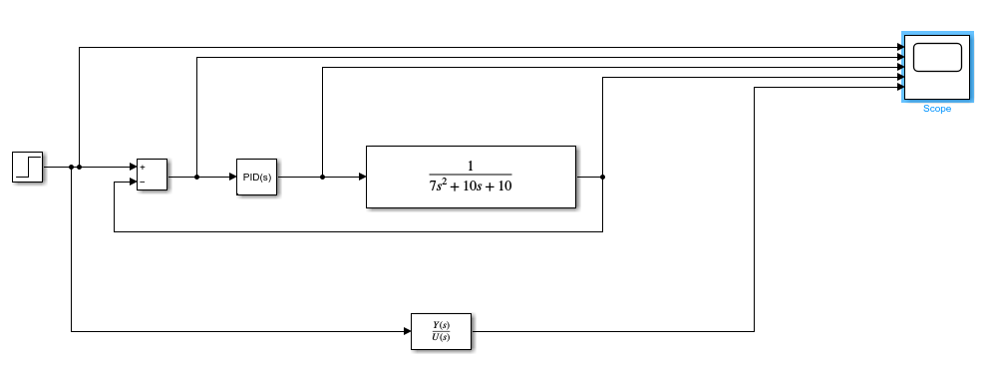
Figure 3 – Block Diagram, CWIS Control System
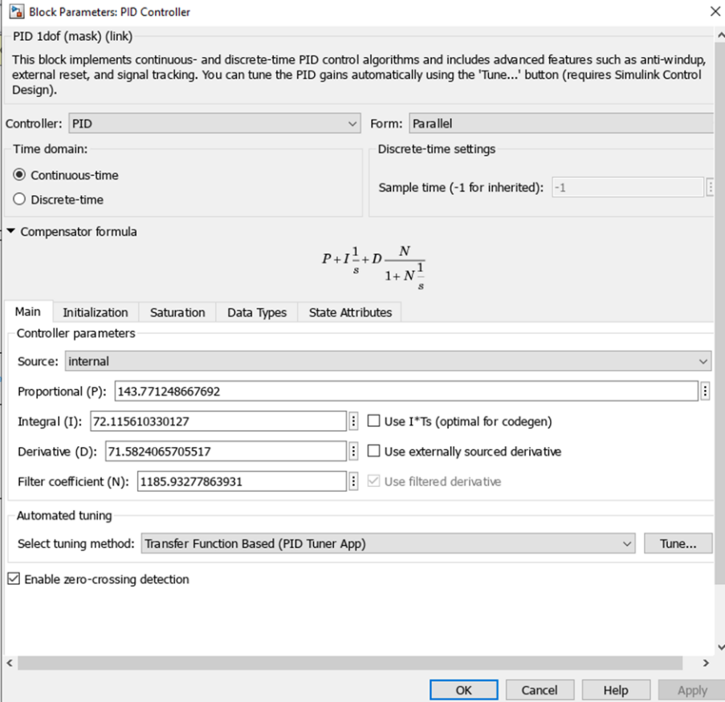
Figure 4 – PID Controller Parameters

Results

3.1 PID Controller Reading
Figure 5 describes the output of the system. From this it can be seen that the output of the systems is within the limits of the set requirements, therefore it can be said that the system has a fast reaction time with minimal overshoot, thus the system reaches a steady state in enough time to be effective, precise and accurate.
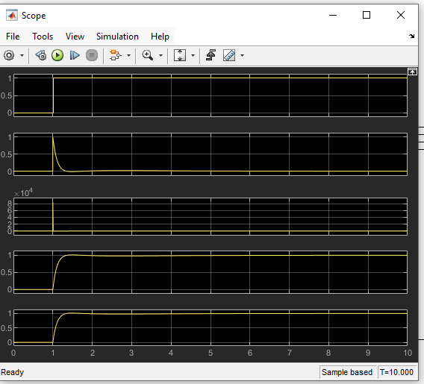
Figure 5 – Tuned PID Controller Reading

3.2 Pole-Zero Plots
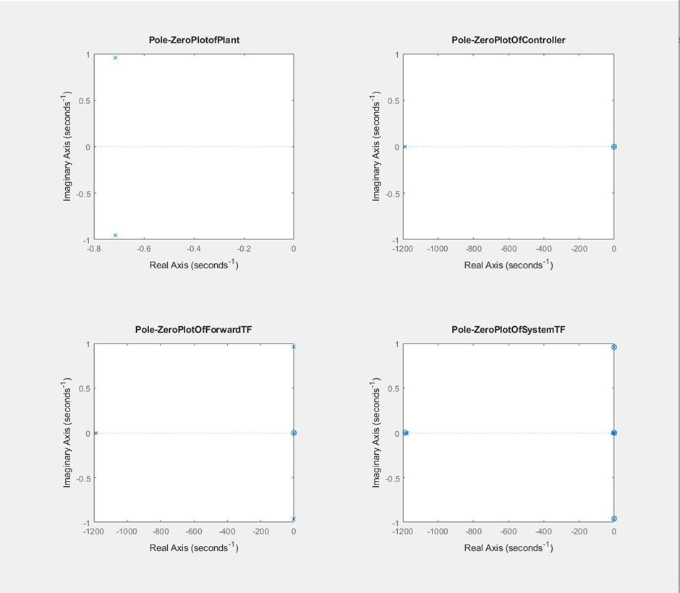
Figure 6-Pole Zero Plot of Zero
Figure 7- Pole Zero Plot of Controller

Figure 8 – Pole Zero Plot of Forward TF

Figure 9 – Pole Zero Plot of Systems TF

3.3 Nyquist Diagram
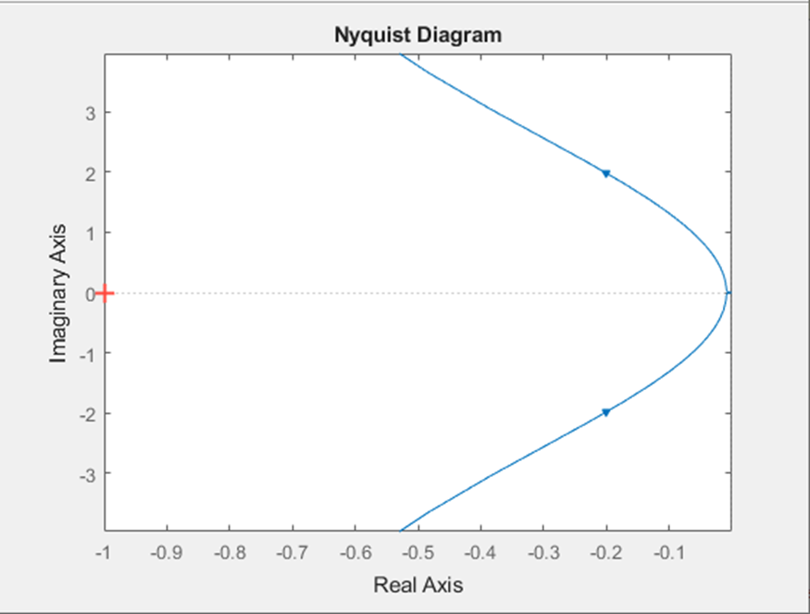
Figure 10 – Nyquist Diagram
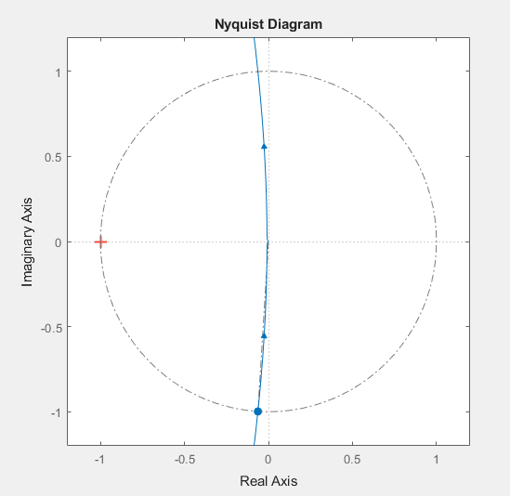
Figure 11 – Nyquist Diagram

Discussion

4.1 Lag and Stability
The addition of a small delay within a system introduces lag, this lag changes the phase relationship between the plant and the controller thus may cause the system to have increased instability. Stability of a system can be predicted using multiple methods these include pole zero plots, Nyquist plots, and bode plots. When used, these methods show and provide the gain and phase margin of a system which in turn determines the stability of the system. The reaction rate of the controller can be substituted for increased stability of the system.

Pole-Zero Diagrams
Pole-zero diagrams provide a way of visualising system response when the TF is known. As previously mentioned, they are a method often used when predicting stability of a system. A pole is said to be a point within the complex frequency plane in which the transfer function of the system tends to infinity. These poles can be located by calculating the roots of the denominator polynomial of the TF.

4.2.1 Time Domain Response
The time domain response of a system can be calculated from its locations using
Equation 6 – Time Domain Response [9]
$$y_{h}\left(t\right)=\sum_{i=1}^{n}{C_{i}e^{P_{i}t}}$$
Where y_{h}(t) = the time domain response, n = the number of poles, and C_{i} = the initial condition associated with the pole P_{i.}

4.2.2 Pole Locations
The location of the poles can be examined to find the stability of the system. If the location of the pole is on the left side of a Pole-Zero plot (P_{i} = - σ) it can be defined as an exponentially decaying component. The rate of this decay is further defined based on the location of the pole, the distance from the origin is proportional to increase in delay. When a pole is at the origin (P_{i} =0) the component has constant amplitude and can be described as it’s initial conditions. If the pole is on the right side of a Pole-Zero plot this component is exponentially increasing, thus this system is unstable.

4.2.2.1 Pole Locations of CWIS System
Figure 6 to Figure 9 show the pole location of the CWIS turret system. All of the plots are located in the negative real axis, meaning that the component is decaying, further proving the stability of the system.

Nyquist Diagrams
A Nyquist plot is a graph that can be utilised when assessing the stability of a system. This type of graph describes the frequency and phase response in a singular plot. The Nyquist diagram permits inspection of the sensitivity function, this function can be defined as the inverse of the distance between the Nyquist trajectory and the critical point [14]. Nyquist plots show both gain and phase margin.

4.3.1 Gain Margin
The gain margin of a system can be explained as the amount of additional gain that a system can handle before it becomes unstable. Gain margin can be calculated by assessing the distance between the point where the curve on the Nyquist plot crosses the real axis and the unit circle at the 180° point.

4.3.2 Phase Margin
Phase margin shows how much phase shift can occur in the system until that system becomes unstable. This can be derived from a Nyquist diagram by calculating the angle between the point in which the curve passes the unit circle and then the negative real axis at 180° point.

4.3.3 Gain and Phase Margins of CWIS System
Figure 10 and Figure 11 show the Nyquist plots for the system being assessed in the report. The phase angle shown in these figures confirms stability of the system.

Conclusion
To conclude, the outcome of the modelling produced a result that sat within the requirements specified. The conducted study describes how mathematical modelling can be used to design and tune control systems. It provides appreciation for the fact that this type of modelling can be undertaken for complex systems including a PID controller. This solution may not be feasible for real world application, however if similar tools and methods are implemented more thoroughly it could be used.

References

[1] | N. S. Nise, Control Systems Engineering, Hoboken : Wiley , 2019.
[2] | G. C. Goodwin, S. F. Graebe and M. E. Salgado, Control System Design, New Delhi: Phi Learning, 2009.
[3] | S. Kumar, R. Kumar and H. Kumar, “Analysis & Investigation on Watt Governor to Improve the Speed Range of the Governor,” International Journal of Research and Scientific Innovation (IJRSI), vol. 3, no. 6, pp. 109-112, 2016.
[4] | Sundar, “Centrifugal Governor | Types of Governors,” ExtruDesign, 28 September 2019. [Online]. Available: https://extrudesign.com/centrifugal-governor-types-of-governors/. [Accessed 01 Decemeber 2025].
[5] | M. T. Morgan and T. A. Haley, “Design of Food Process Control Systems,” pp. 485-552, 2007.
[6] | X. Yang, H. Hongxing and H. Junwei, “Three State Controller Design of Shaking Table in Active Structural Control System,” pp. 88-93, 2007.
[7] | G. S. Okochi and Y. Yao, “A Review of Recent Developments and Technological Advancements of Variable-Air-Volume (VAV) Air Conditioning Systems,” Renewable and Sustainable Energy Reviews , vol. 59, pp. 784-817, 2016.
[8] | P. K. Ray, S. R. Mohanty and N. Kishor, “Proportional-Integral Controller Based Small-Signal Analysis of Hybrid Distributed Generation Systems,” Energy Conversion and Management, vol. 54, pp. 1943-1954, 2011.
[9] | K. Iqbal, “PI, PD, and PID Controllers,” Engineering LibreTexts, 30 June 2020. [Online]. Available: https://eng.libretexts.org/Bookshelves/Industrial_and_Systems_Engineering/Introduction_to_Control_Systems_(Iqbal)/03%3A_Feedback_Control_System_Models/3.3%3A_PI_PD_and_PID_Controllers.
[10] | M. C. M. Teixeira, E. Assunção and M. R. Covacic, “Proportional Controllers: Direct Method for Stability Analysis and MATLAB Implementation,” IEEE Transactions on Education, vol. 50, no. 1, pp. 74-78, 2007.
[11] | Raytheon , “Phalanx System,” Raytheon, [Online]. Available: www.rtx.com. https://www.rtx.com/raytheon/what-we-do/sea/phalanx-close-in-weapon-system. [Accessed 01 December 2025].
[12] | T. Kunstmann, “Close-in Weapons Systems: The last line of defense,” Naval Sea Systems Command, 24 September 2025. [Online]. Available: https://www.navsea.navy.mil/Media/News/Article-View/Article/4313344/close-in-weapons-systems-the-last-line-of-defense/. [Accessed 10 December 2025].
[13] | K. Ogata, Modern Control Engineering, Delhi: Pearson , 2010.
[14] | A. G. Yepes, F. D. Freijedo, O. Lopez and J. Doval-Gandoy, “Analysis and Design of Resonant Current Controllers for Voltage-Source Converters by Means of Nyquist Diagrams and Sensitivity Function,” EEE Transactions on Industrial Electronics, vol. 58, no. 11, pp. 5321-5250, 2011.

Appendix- MATLAB Script


