

RESULT

HND/HNC ASSIGNMENT SPECIFICATION

Student name: |  | Student P number:
Programme: | HND/BSc Automotive Engineering  HND/BSc Motorsport Engineering  HND/BSc Motorcycle Engineering
Module: | Engineering Design | Module Level (4 or 5): | Level 4
Module code: | M1X8653 | Contribution to Overall  Module Assessment (%): | 60%
Lecturer: | Richard Morgan | Internal Verifier: | Andrew Thorn
Assignment Title: | The Application of an Engineering Design Methodology and the Production of 2D Technical Drawings. (Exhaust Manifold) | Assignment No (x of x): | 2 of 2
Hand Out Date: | 12/03/13 | Submission deadline: | 03/05/13
Referencing: | In the main body of your submission you must give credit to authors on whose research your work is based. Append to your submission a reference list that indicates the books, articles, etc. that you have read or quoted in order to complete this assignment (e.g. for books: surname of author and initials, year of publication, title of book, edition, publisher: place of publication).
Disclosure: | I declare that this assignment is all my own work and that I have acknowledged all materials used from the published or unpublished works of other people. All references have been duly cited.
Student’s Signature: | Assignments will not be accepted without a signature here | Date:
Turnitin: Lecturer to tick to indicate if an electronic version of the assignment must be submitted to Turnitin. Note: the Turnitin version is the primary submission and acts as a receipt for the student. Both electronic and paper versions MUST be submitted by the same deadline. No marks will be released until both submissions are received. Late submission of the electronic version will result in a late penalty grade. Penalties for late submission: Up to one week late, maximum mark of 40%. Over one week late, Refer. | YES | X
 | NO

Learning Outcomes tested  (from module syllabus) | Assessment Criteria To achieve each outcome a student must demonstrate the ability to:
Prepare a design specification | - determine major design parameters  - obtain design information from appropriate sources  - prepare a design specification  - ensure that the design specification meets requirements
Prepare a design report | - prepare an analysis of possible design solutions  - produce conceptual designs  - evaluate alternative concepts  - select the optimum design solution  - carry out a compliance check  - prepare a final report
Use computer technology in the design process | - use computer-aided design software to prepare a design drawing  - demonstrate an understanding of the principles of computer aided design

- Please submit the assignment parts in a suitable report folder– not in polypockets.
- This form (ALL PAGES) MUST be at the front of the paper submission. Assignments will not be accepted without this form as it is a requirement that you sign the disclosure regarding referencing convention.
- DO NOT put this form into Turnitin or it will match many similarities with other students’ submissions.

TASK DESCRIPTION

(Lecturer – please insert task(s) / questions / what the student must do, here)

The aim of this assignment is to provide students with an opportunity to experience the process of carrying out a design project. Successful completion of this coursework requires the synthesis of parameters which will affect the design solution.

You are required to design an exhaust manifold to transmit the products of combustion from a cylinder head’s exhaust ports to a down-pipe flange. The geometry, relative position and relative orientation of the exhaust ports and down-pipe flange have been modelled into an assembly using Siemens NX software. Please note that the centrally located, circular hole (through which the exhaust gasses would pass) has deliberately been omitted from the down-pipe flange. It should be assumed that a hole will later be created in the down-pipe flange, the diameter of which will be dictated by your finalised exhaust manifold design. Assumptions such as the production quantity or the specific application may be made but should be outlined in the introduction of your report.

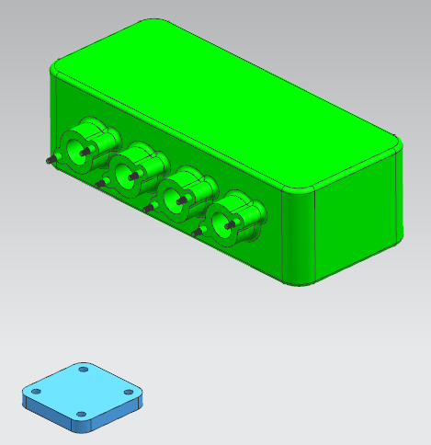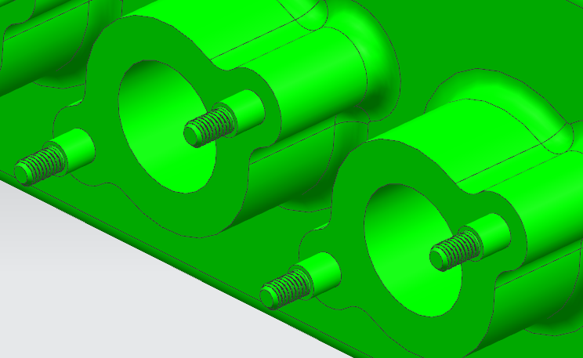

Note: The model/assembly model files are available on Moodle (Assignment_2_Exhaust_Assembly).

Demonstrating the application of an appropriate design methodology, you should arrive at a final design solution. The final design should be detailed in a fully dimensioned technical drawing. Appropriate limit and geometric tolerances should be applied to the final design.

The main stages of an appropriate design methodology are outlined below:

- Problem identification/ understanding the need.

- A Detailed Design Specification which defines targets for the design prior to any creative
/ problem solving design activity.

- The development of concept designs (any digital ‘tool’ may be used to communicate the
concept designs).

d) A design isolation exercise which objectively evaluates the concept ideas with the aim of establishing an optimum or preferable solution. This may or may not include ‘controlled
convergence’

e) Documentation of the final design, including a full description, a solid model and a
technical drawing (BS 8888). The technical drawing must be created using the Siemens
NX software.
GUIDANCE FOR Students IN THE COMPLETION OF TASKS

You will be marked on your ability to:

- Produce a report detailing each stage of the design methodology, as applied to the task. A hard copy of the report should be submitted to the library and an electronic copy should be uploaded to Turnitin.

- Create a third angle projection technical drawing of the final design.

- Only the NX Siemens CAE software may be used for the creation of the technical drawing.
- The drawing/s should be printed and submitted with your report.
- An electronic copy of the NX model file should be saved onto a CD and submitted with the hard copy of your report.
- Ensure that the CD is physically attached to your report and is properly labelled with your name, course, date, module (Engineering Design) and the assignment number (Assignment 2).

- Apply appropriate limit tolerances and geometric dimensions and tolerances to the final design. Calculations used to establish tolerance/dimension limits should be shown in the report.

GRADING criteria and Student FEEDBACK

This section details the assessment criteria. The extent to which these are demonstrated by you determines your grade. The weightings available for each criterion are shown. Lecturers will use the space provided to comment on the achievement of the task(s), including those areas in which you have performed well and areas that would benefit from development/improvement.

Common Assessment Criteria Applied | Percentage weighting | Grade  awarded
1. Research-informed Literature
Extent of research and/or own reading, selection of credible sources, application of appropriate referencing conventions.
 | 10
2. Knowledge and Understanding of Subject
Extent of knowledge and understanding of concepts and underlying principles associated with the discipline.
 | 30
3. Analysis
Analysis, evaluation and synthesis; logic, argument and judgement; analytical reflection; organisation of ideas and evidence
 | 20
4. Practical Application and Deployment
Deployment of methods, materials, tools and techniques; application of concepts; formulation of innovative and creative solutions to solve problems.
 | 30
5. Skills for Professional Practice
Attributes in professional practice: individual and collaborative working; deployment of appropriate media; presentation and organisation.
 | 10

*Assignment Result (Assessment grades are subject to ratification at the Exam Board. These comments and grades are to give feedback on module work and are for guidance only until they are confirmed. ) | Late Submission Penalties (tick if appropriate)
 | Up to one-week late
 | Over one week late

COMMON ASSESSMENT AND GRADING CRITERIA

 | OUTRIGHT FAIL | UNSATISFACTORY | SATISFACTORY | GOOD | VERY GOOD | EXCELLENT | EXCEPTIONAL
Assessment Criteria | REFER (equivalent to 0-29% | REFER (equivalent to 30-39%* | PASS (equivalent to 40-49%) | PASS (equivalent to 50-59%) | MERIT (equivalent to 60-69% | DISTINCTION (equivalent to 70-79% | DISTINCTION (equivalent to 80-100%
1. Research-informed Literature  Extent of research and/or own reading, selection of credible sources, application of appropriate referencing conventions | Little or no evidence of reading.  Views and findings unsupported and non-authoritative.  Referencing conventions largely ignored. | Poor evidence of reading and/or of reliance on inappropriate sources, and/or indiscriminate use of sources.  Referencing conventions used inconsistently. | References to a limited range of mostly relevant sources. Some omissions and minor errors.  Referencing conventions evident though not always applied consistently. | Inclusion of a range of research-informed literature, including sources retrieved independently. Referencing conventions mostly consistently applied. | Inclusion of a wide range of research-informed literature, including sources retrieved independently.  Selection of relevant and credible sources. Very good use of referencing conventions, consistently applied. | A comprehensive range of research informed literature embedded in the work. Excellent selection of relevant and credible sources. High-level referencing skills, consistently applied. | Outstanding knowledge of research-informed literature embedded in the work. Outstanding selection of relevant and credible sources. High-level referencing skills consistently and professionally applied.
2. Knowledge and Understanding of Subject  Extent of knowledge and understanding of concepts and underlying principles associated with the discipline. | Major gaps in knowledge and understanding of material at this level. Substantial inaccuracies. | Gaps in knowledge, with only superficial understanding. Some significant inaccuracies. | Evidence of basic knowledge and understanding of the relevant concepts and underlying principles. | Knowledge is accurate with a good understanding of the field of study. | Knowledge is extensive. Exhibits understanding of the breadth and depth of established views. | Excellent knowledge and understanding of the main concepts and key theories. Clear awareness of challenges to established views and the limitations of the knowledge base. | Highly detailed knowledge and understanding of the main theories/concepts, and a critical awareness of the ambiguities and limitations of knowledge.
3. Analysis  Analysis, evaluation and synthesis; logic, argument and judgement; analytical reflection; organisation of ideas and evidence | Unsubstantiated generalisations, made without use of any credible evidence. Lack of logic, leading to unsupportable/ missing conclusions. Lack of any attempt to analyse, synthesise or evaluate. | Some evidence of analytical intellectual skills, but for the most part descriptive. Ideas/findings sometimes illogical and contradictory. Generalised statements made with scant evidence. Conclusions lack relevance. | Evidence of some logical, analytical thinking and some attempts to synthesise, albeit with some weaknesses.  Some evidence to support findings/ views, but evidence not consistently interpreted.  Some relevant conclusions and recommendations, where relevant | Evidence of some logical, analytical thinking and synthesis. Can analyse new and/or abstract data and situations without guidance.  An emerging awareness of different stances and ability to use evidence to support the argument.  Valid conclusions and recommendations, where relevant | Sound, logical, analytical thinking; synthesis and evaluation. Ability to devise and sustain persuasive arguments, and to review the reliability, validity & significance of evidence. Ability to communicate ideas and evidence accurately and convincingly.  Sound, convincing conclusions / recommendations. | Thoroughly logical work, supported by evaluated evidence. High quality analysis, developed independently or through effective collaboration.  Ability to investigate contradictory information and identify reasons for contradictions.  Strong, persuasive, conclusions, justifiable recommendations. | Exceptional work; judiciously selected and evaluated evidence. Very high quality analysis, developed independently or through effective collaboration.  Ability to investigate contradictory information and identify reasons for contradictions.  Highly persuasive conclusions
4. Practical Application and Deployment  Effective deployment of appropriate methods, materials, tools and techniques; extent of skill demonstrated in the application of concepts to a variety of processes and/or contexts; formulation of innovative and creative solutions to solve problems. | Limited or no use of methods, materials, tools and/or techniques.  Little or no appreciation of the context of the application. | Rudimentary application of methods, materials, tools and/or techniques but without consideration and competence. Flawed appreciation of the context of the application. | An adequate awareness and mostly appropriate application of well established methods, materials, tools and/or techniques.  Basic appreciation of the context of the application. | A good and appropriate application of standard methods, materials, tools and/or techniques.  Good appreciation of the context of the application, with some use of examples, where relevant. | A very good application of a range of methods, materials, tools and/or techniques.  Very good consideration of the context of the application, with perceptive use of examples, where relevant.  Evidence of some innovation and creativity. | An advanced application of a range of methods, materials, tools and/or techniques.  The context of the application is well considered, with extensive use of relevant examples.  Application and deployment extend beyond established conventions. Innovation and creativity evident throughout. | Outstanding levels of application and deployment skills. Assimilation and development of cutting edge processes and techniques.
5. Skills for Professional Practice  Demonstrates attributes expected in professional practice including: individual initiative and collaborative working; deployment of appropriate media to communicate (including written and oral); clarity and effectiveness in presentation and organisation. | Communication media is inappropriate or misapplied.  Little or no evidence of autonomy in the completion of tasks.  Work is poorly structured and/or largely incoherent. | Media is poorly designed and/or not suitable for the audience.  Poor independent or collaborative initiative.  Work lacks structure, organisation, and/or coherence | Can communicate in a suitable format but with some room for improvement.  Can work as part of a team, but with limited involvement in group activities.  Work lacks coherence in places and could be better structured. | Can communicate effectively in a suitable format, but may have minor errors.  Can work effectively as part of a team, with clear contribution to group activities.  Mostly coherent work and is in a suitable structure. | Can communicate well, confidently and consistently in a suitable format.  Can work very well as part of a team, with very good contribution to group activities.  Work is coherent and fluent and is well structured and organised. | Can communicate professionally and, confidently in a suitable format.  Can work professionally within a team, showing leadership skills as appropriate, managing conflict and meeting obligations.  Work is coherent, very fluent and is presented professionally. | Can communicate with an exceptionally high level of professionalism.  Can work exceptionally well and professionally within a team, showing advanced leadership skills.  Work is exceptionally coherent, very fluent and is presented professionally.

Student Self Evaluation Form
Student name: |  | Student P number:
Programme: |  | Year of programme
Assignment Title:

This section repeats in brief the common assessment criteria detailed on previous pages. The extent to which these are demonstrated by you determines your grade. Using these criteria, tick the box that best indicates the level of achievement you feel you have achieved with regard to each of them.

Common Assessment Criteria Applied | Level of Achievement
Common Assessment Criteria Applied | REFER |  |  | PASS |  |  | MERIT | DISTINCTION
 | OUTRIGHT FAIL | UNSATISFACTORY | SATISFACTORY |  | GOOD | VERY GOOD |  |  | EXCELLENT | EXCEPTIONAL
1. Research-informed Literature | 0-29% | 30-39% | 40-49% |  | 50-59% | 60-69% |  |  | 70-79% | 80-100%
2. Knowledge and Understanding of Subject | 0-29% | 30-39% | 40-49% |  | 50-59% | 60-69% |  |  | 70-79% | 80-100%
3. Analysis | 0-29% | 30-39% | 40-49% |  | 50-59% | 60-69% |  |  | 70-79% | 80-100%
4. Practical Application and Deployment | 0-29% | 30-39% | 40-49% |  | 50-59% | 60-69% |  |  | 70-79% | 80-100%
5. Skills for Professional Practice | 0-29% | 30-39% | 40-49% |  | 50-59% | 60-69% |  |  | 70-79% | 80-100%

PLEASE COMMENT ON AREAS IN WHICH YOU FEEL THAT YOU HAVE PERFORMED WELL | PLEASE COMMENT ON AREAS you feel that you need TO DEVELOP

Student’s Name |  | Date
Student’s Signature

