Reflection on Study Skills

Robert Brazier ID: 2018693
OME Study Skills

Table of Contents

Contents | Page
- Presentation | 3
- Personal overview | 3
- Presentation slides | 4
- Creation | 6
- Improvements for future | 6
- Skills Evaluation | 7
- Higher learning skills | 7
- Transferable employment skills | 7
- Self-evaluation | 7
- Goals | 8
- Action plan for goals | 8
- Application | 9
- Looking after your data | 9
- Time management and self-evaluation | 10
- Conclusion | 11
References | 11
- Appendices | 13

1. Presentation
1.1 Provide a brief overview of yourself as per your class presentation exercise.

As per requirements for the study skills module, students were required to create and give a presentation on themselves to demonstrate skills and as an introduction to peers. The following test is a slightly reduced version of the self-overview given by the author;
Robert Neil Tiberius Brazier

Two middle names, a bit greedy, I know

A short presentation on me

Questions can be answered at the end

I grew up in the south east London area, more specifically, Barnehurst. At 23, I moved out and into a flat in Dartford, with my friend Jay for a year, to gain some experience of self-sufficiency. Moved back to my parents for a year and have since been living in a flat in Crayford with my brother.

I Studies at BETHS grammar school and after GCSEs, went on to study light vehicle maintenance and repair at North West Kent College for 3 years.
I then worked at Beadles Volkswagen commercial as an apprentice technician for 4 years. I then became a bus driver for Arriva London for two years before getting my job at Illusion pyrotechnics now.

I'm pretty shy until I get comfortable with people or a situation, so in other words, I'm an introvert. A friend has described me as creative and innovative. And I'm definitely a cat person.

My hobbies include Gaming on pc, making cosplay and props to attend Comic-Con at the Excel centre in London, this was me as a psycho from the Borderlands series of games. I have recently taken up 3D printing. I have my Classic mini that I maintain and have been a part of the London to Brighton mini run every year since 2013. I started teaching myself fire-breathing mid coronavirus lockdown, which I have wanted to do since I was young and am teaching my friend alongside my progression.

I like driving, riding my Yamaha XSR 700 motorbike, Rock and metal core music such as Beartooth, Enter Shikari and Bring me the Horizon. I enjoy going climbing, Karting and Kayaking, but don't do them very often. I like to bake sometimes and I'm known to be a bit of a biscuit fiend.

I dislike Rap music, my picture being taken and I don't do Spicy food the medium at Nando's is my limit

I believe my strengths include physical and practical work, making things and fixing things.

I think that my main weaknesses are that I'm not very analytical, Algebra, I can be a bit of a hoarder, I can sometimes be easily overwhelmed, and spiders!

From this course, I hope to gain a strong foothold on to which I can to improve my knowledge of the field and find the area that suits me best in which to specialise.

Where I'd like to see myself in the next 5-10 years; Own house with garage and garden so that I have space for my hobbies, creating new products for the company, aiding the expansion and progression of the company as well as its’ contracts.

1.2 Include 4 screengrabs from your initial powerpoint presentation that introduced yourself.

The following four images are slides taken from the author’s presentation, showing the examples of the design and layout used as well as the information displayed to the audience. They also give examples of the techniques used to engage the audience.

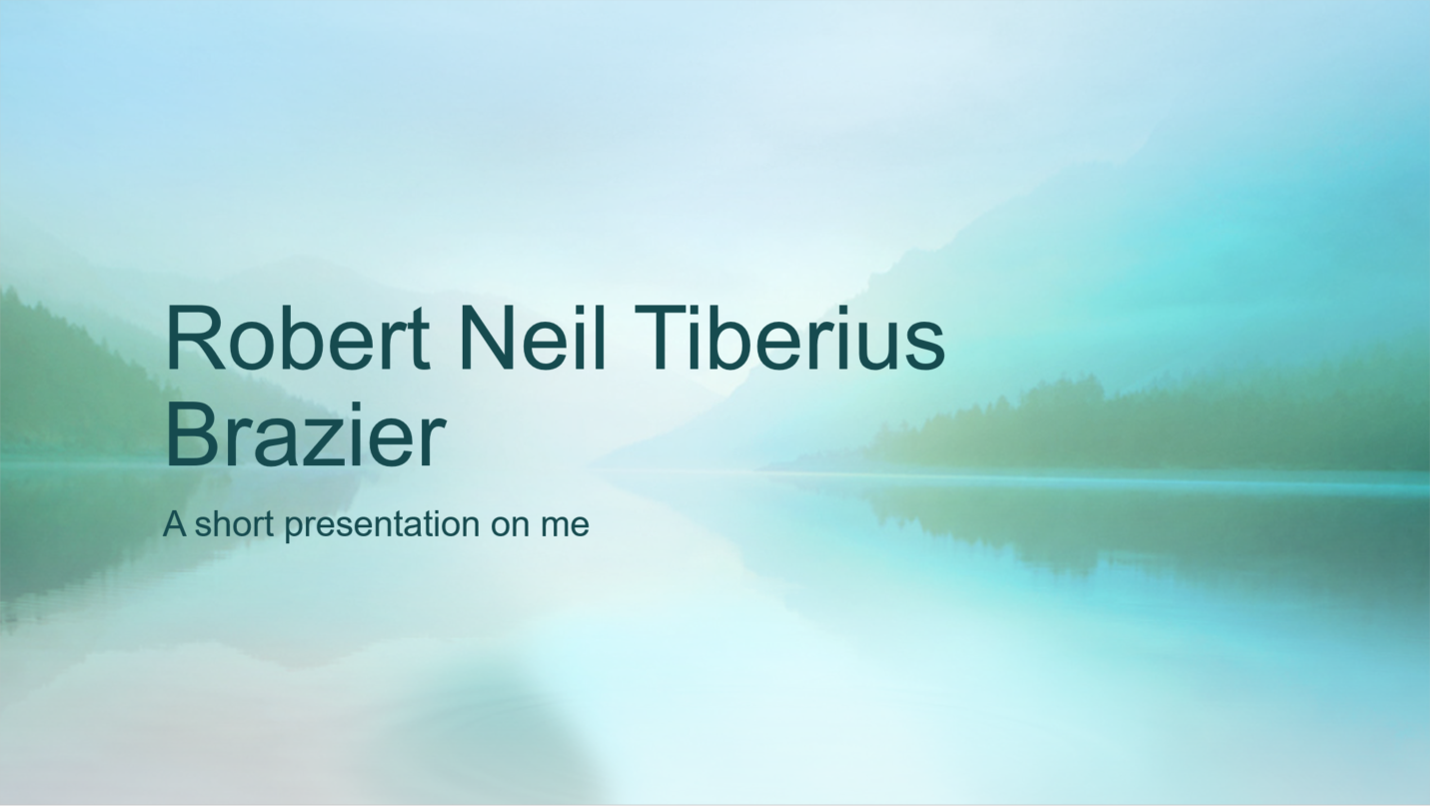

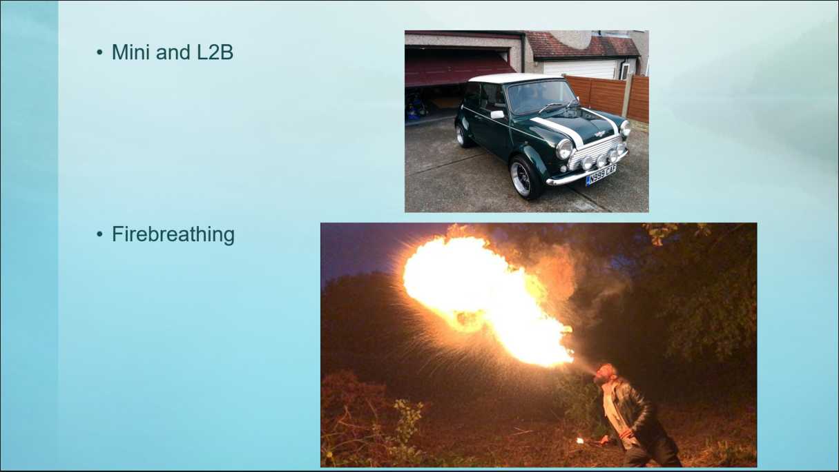

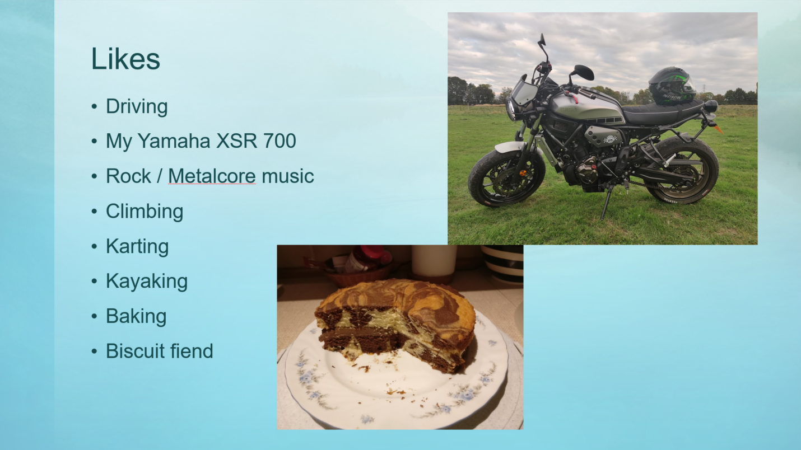
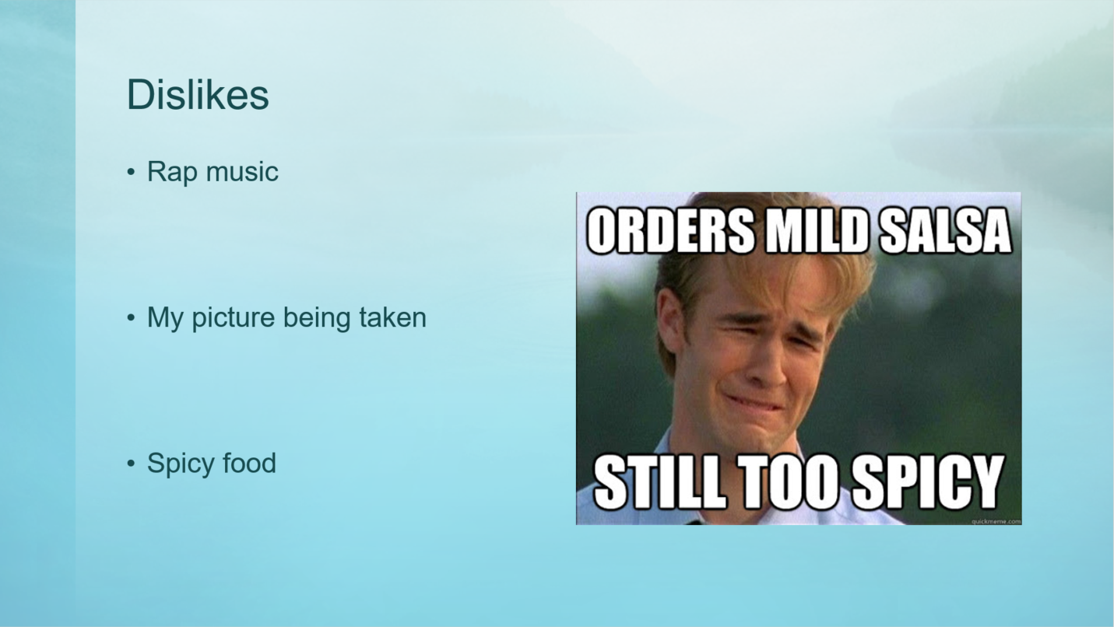
1.3 List the key points that you learnt when trying to produce and deliver a successful powerpoint presentation

Through being part of the audience of an example presentation, drawing on a small amount of previous experience and viewing a couple of TED talks on giving presentations [1] [2], the author was able to gain some helpful information and tips. First and foremost; is that when presenting with a slideshow, it is best to keep the amount of information per slide, especially text, to a low level. This is to prevent and overload of information, making it more accessible to the audience and easier to digest. To this point, it is also ideal to have a background to slides that is visually appealing, but not too busy as to distract from the information being provided in the slide. Various methods can be used to keep a personal presentation more engaging, such as injecting some humour into the mix, pictures and if appropriate, even some audience participation by posing questions.

1.4 Describe what aspects you feel you could improve on to enhance your future presentations.

On reflection, the author of this presentation felt that a bit more information could have been provided, to give a better understanding of personal views and feelings. Whilst the delivery of the presentation was believed to have gone well, given the situation of an online meeting, more confidence and rehearsal would have been beneficial for an in person delivery as too much time was spent looking at notes rather than the audience. Based on feedback given after the presentation (appendix A), some tweaking of the visuals would have been beneficial, primarily consistency by ensuring that every slide had a title, including when it was a continuation of a previous slide. Taking these points on board and putting them into practice should improve the delivery and quality of future presentations.
2. Skills Evaluation
2.1. Skills required for successful learning in a Higher Education environment

From carrying out research, some important key skills for successful higher education learning have been identified from [3] as; communication, problem solving, research and critical thinking. [4] Added to this by also including most notably; time-management and creating connections with fellow students.

2.2. Transferrable skills employers look for in prospective job candidates.

During research, it was found that different employers in differing fields desire a variety of transferable skills in prospective job candidates, from examining the findings [5] [6], three generic core skills were focused upon as follows; problem solving skills, communication skills and working in a team / groups. [7] Includes two of these three core skills; communication and teamwork as skills that employers are concerned applicants are missing. [5] Also states technological skills and flexibility as important skills.

2.3. Self Evaluation exercises

As research carried out for this piece of writing and for purposes of self-reflection, a total of 7 personality based tests were carried out from multiple websites as follows;
https://openpsychometrics.org/tests/IPIP-BFFM/
https://openpsychometrics.org/tests/OEJTS/
https://www.123test.com/jung-personality-test/
https://www.123test.com/career-test/
https://www.theguardian.com/lifeandstyle/2014/nov/11/-sp-questionnaire-what-job-would-make-you-happiest
https://www.quietrev.com/the-introvert-test/
https://www.16personalities.com/free-personality-test
Extracts from the personal results of these tests can be found in the appendices (B through H). It is the belief of the author that the results of personality tests such as the ones conducted, are not necessarily very reliable or accurate as there is a lot of variability in interpretation of questions and self-views. They can be varied notably by the test taker’s state of mind at the time. Results for tests such as appendix (B) where comparison is made to others, will also be skewed by the type of person that is likely to be taking part in the test and will not be an accurate representation of the general population. While this is likely true in numerous cases, in light of the evidence, there is some correlation with the results received by the test taker that is also in line with previous perception of himself. Most notable of the traits to fit with previous belief are being a feeler; thinking more with the heart than the head when making decisions, and having a tendency to being more of an introvert as opposed to being extroverted. Controversially, different results were received for ‘N’ (intuition) and ‘S’ (sensing) for tests (C) (D) and (H), whilst personal thoughts on this are undecided, the provided results support the theory stated earlier that these tests are not necessarily accurate.
2.4 Main academic / personal long and short term goals

- Bring knowledge and new ideas to the workplace
- Improve and broaden personal skillset
- Bulk up and increase fitness
- Improve diet
- Gain self-confidence
- Achieve homeowner status
2.5 Action plans for academic and personal/professional goals

 | Improve diet | Bulk up | Homeowner | Knowledge and ideas to workplace
S - Specific | Try 6 new dishes | Reach 10st weight – mainly muscle mass | Save money for house deposit and buying costs | Complete OME bachelors degree course
M - Measurable | 6 new dishes tried | Weighing and measuring | Save minimum of £200 per month | Pass each module of the course
A - Achievable | Yes | Yes | Yes | Yes
R - Relevant | Yes new meals can be healthier | Best to do while young | Earlier start the better | Course in progress
T –  Time-bound | 1 Year – 1 dish every 2 months | 2 years | 10 years | 5 Years

3. Application
  - Looking after your data

- Describe the backup strategy you created that obeys the “in 3 different places” rule discussed in class. Explain how it provides a robust level of data protection for any work you are likely to produce during your time in University, as well as any other important data you would not wish to lose

When it comes to looking after data, the method of following the ‘in 3 places rule’ that has been adopted by the author is to ensure that important documents and files are stored on their personal desktop computer, personal laptop computer and uploaded to Google Drive. The most important files that get created, such as university notes and coursework, are copied to the other two locations, as appropriate, at the earliest opportunity and other files are copied on a regular fortnightly basis. Both computers as well as the Google Drive account are password protected and Google Drive is set up with two factor authentication for access, providing sufficient data protection for most cases.

- Physical damage via dropping etc
- Flood / water damage
- Corruption via virus
- House fire
- Vehicle accident
- Theft
- Loss / misplacement
- Hacking / account lockout

Above is a list of potential disaster scenarios that may result in total loss of data if the ‘in 3 places rule’ is not followed, while the list is not exhaustive, it covers the majority of situations that have a reasonable chance of occurring. The measures taken by the author to keep files backed up and retrievable would be sufficient in all of these scenarios individually. In the event of physical damage, theft, in transit during a vehicle accident, loss or workstation hacking, data would be retrievable from the unaffected computer or via downloading from the Google Drive cloud service. In the event that both the desktop and laptop were to be involved in the event of a flood, house fire or theft by house burglary, data would be retrievable from Google Drive. In the event of the author’s Google Drive account being hacked or account lock out occurring, at least one of the computers will be a secure place for files until the account can be restored or replaced. Whilst the author has reputable anti-virus software installed on both personal computers, in the event of a virus attack occurring, this would be comparable to the aforementioned hacking scenario.

  - Time management and self-organisation

The steps taken by the author to provide a schedule to organise day to day activities and manage work load can be seen in the image of their personal electronic calendar / dairy. This has been done with the aim of keeping up with and being reminded of work to be carried out, this could be improved in future with the addition of set objectives for the allocated time slots, to improve motivation and focus.

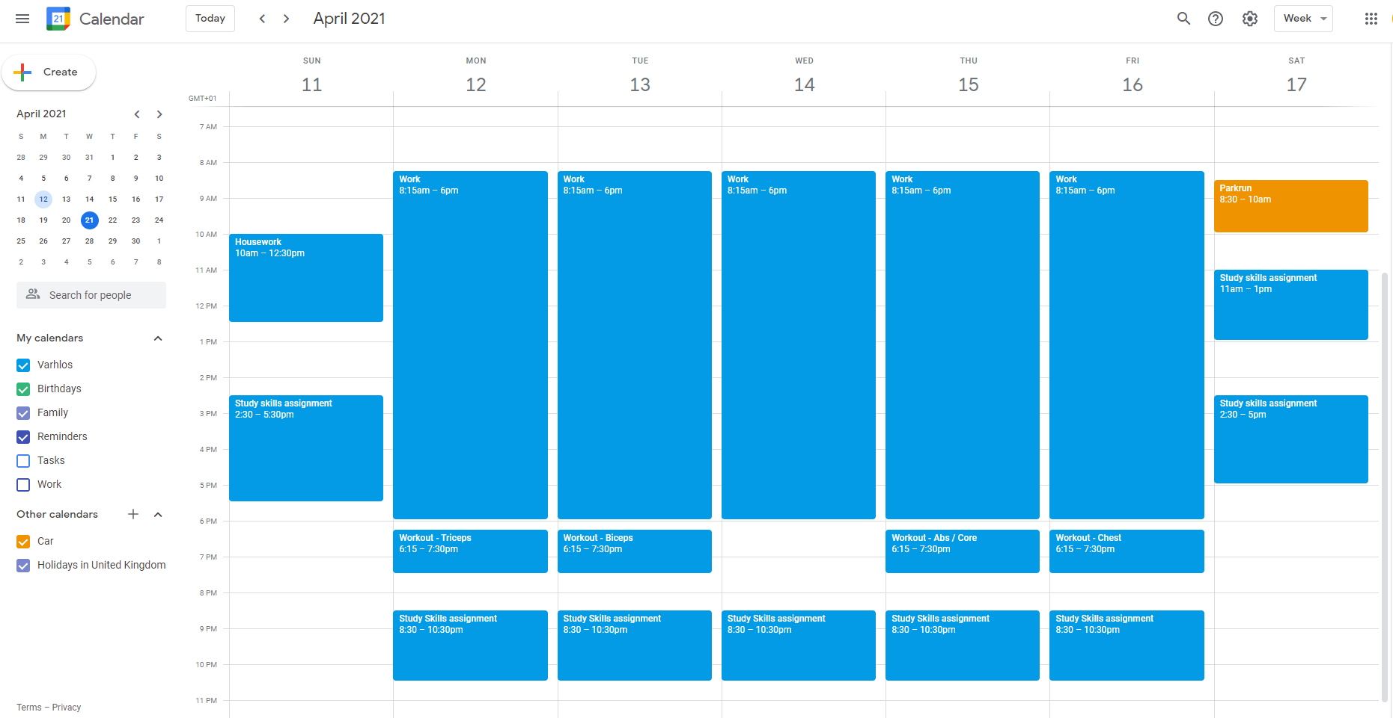

Seen below are two images showing the organisational structure of files adopted by the author for both computer and cloud storage with clearly denoted folders for each subject and the beginning of sub-folders to keep files easy to find. The current level of this is quite low but is free for expansion easy expansion as files are created and added.

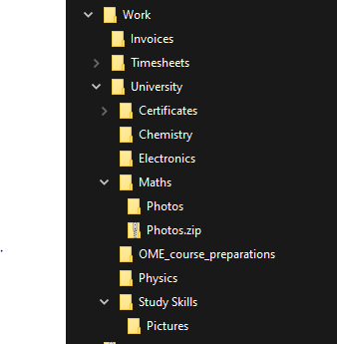
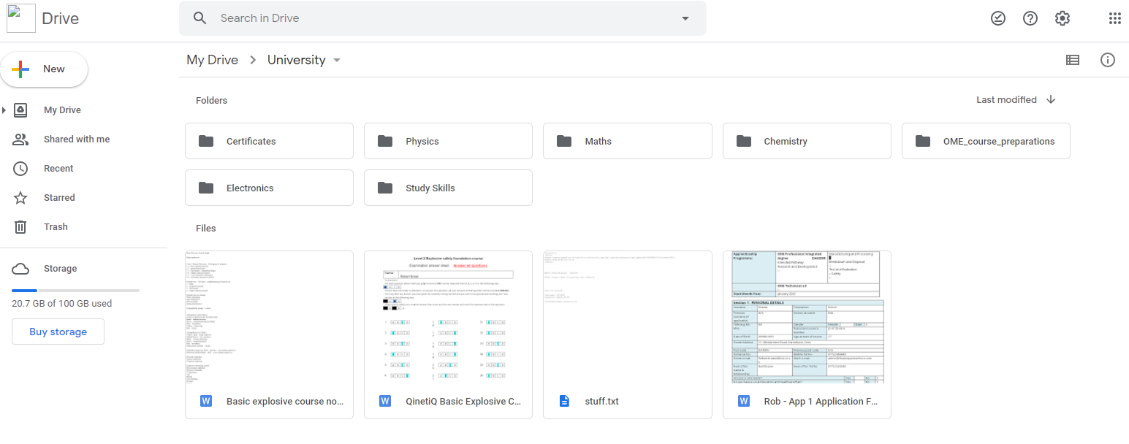
4. Conclusion & Evaluation:

In conclusion regarding the presentation, was received better than was expected, meaning that the techniques researched and used appeared to have given the necessary quality for a good presentation.
Upon carrying out and examining the results of the personality tests, it was learnt that the tests are not wholly reliable and can be variable based on state of mind of the test taker, but can still give a relatively useful indication of personality and traits.
It is believed that the levels of data backup that have already been taken are suitable and resilient enough for most realistic situations.
On reflection, it had been indicated that personal time management could benefit from some additional work whilst personal organisation is currently at an acceptable level but would benefit from future review and potential adaptation to aid in performance.

References

[1] | N. Duarte, “The secret structure of a great talk,” in TED, Online, 2011.
[2] | C. Anderson, “What makes a great talk great,” in TEDBlog, Online, 2013.
[3] | S. Brown, “opensource.com,” Red Hat, 17 06 2019. [Online]. Available: https://opensource.com/article/19/6/5-transferable-higher-education-skills. [Accessed 18 04 2021].
[4] | A. R. Roper, “How Student Develop Online Learning Skills,” Educause Quarterly, no. 1, pp. 62-64, 2007.
[5] | F. Nuryake, Budiyono, A. Muhammad and Wiranto, “The Employability Skills Needed To Face the Demands of Work in the Future: Systematic Literature Reviews,” Open Engineering, vol. 10, no. 1, 2 July 2020.
[6] | W. T. S. J. Smith David, “Personal Transferable Skills and The Job Demands on Graduates,” Journal of European Industrial Training, vol. 13, no. 8, p. 26, 1989.
[7] | “What Are Employers Looking For?,” [Online]. Available: https://www.ucas.com/careers/getting-job/what-are-employers-looking. [Accessed 19 04 2021].

5. Appendices
(A)
- Good incorporation of visuals/images/photos to help convey the story and to keep the audience engaged
- Good choice of a clear, professional looking template.
- Appropriate layout, use of fonts and text size
- Maybe have titles on all of the pages (it’s there on some)
- Clear, easy to understand.
- A professional delivery, seemed confident and well prepared.
- No Umms or Arrs! Impressive!!
- Good timekeeping at: 4.37
- Good to see all areas requested in the brief were covered
(B) https://openpsychometrics.org/tests/IPIP-BFFM/
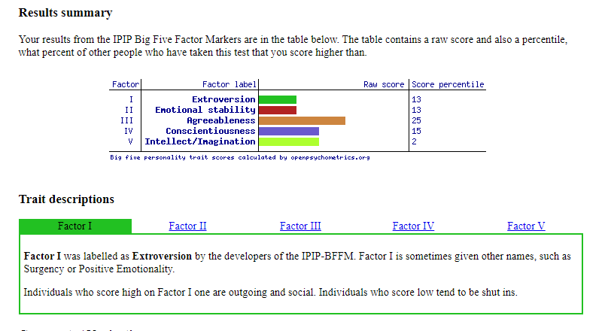
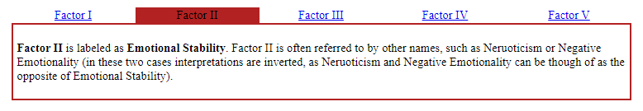
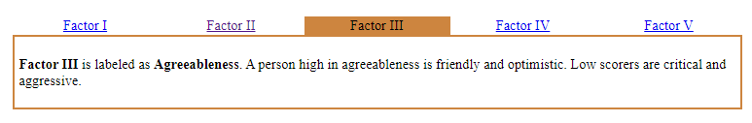
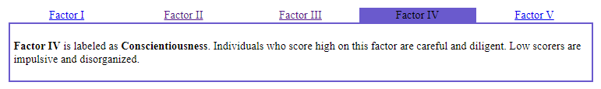
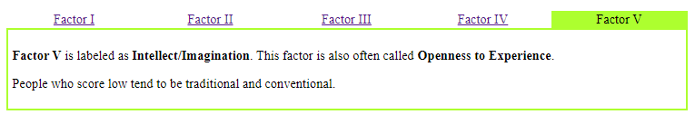

(C) https://openpsychometrics.org/tests/OEJTS/
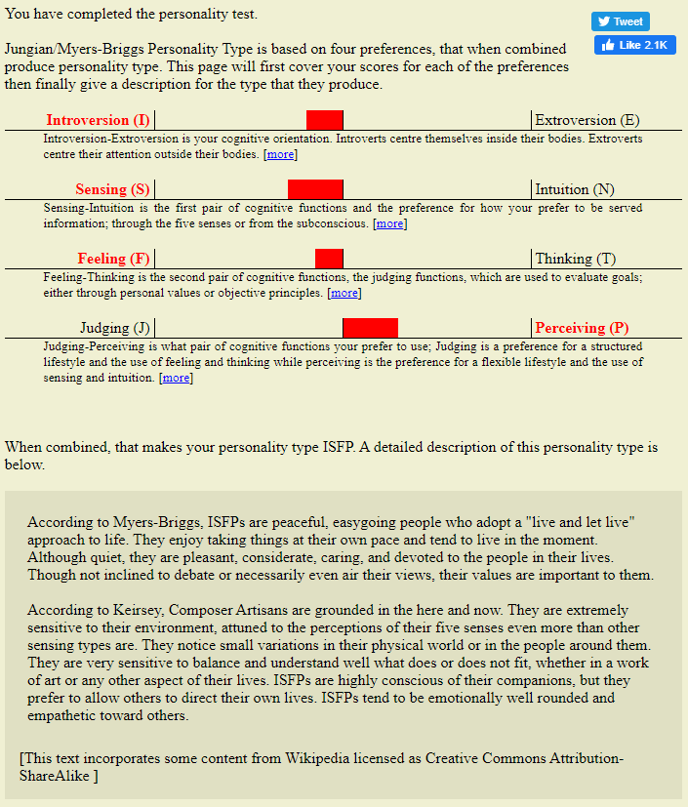

(D) https://www.123test.com/jung-personality-test/
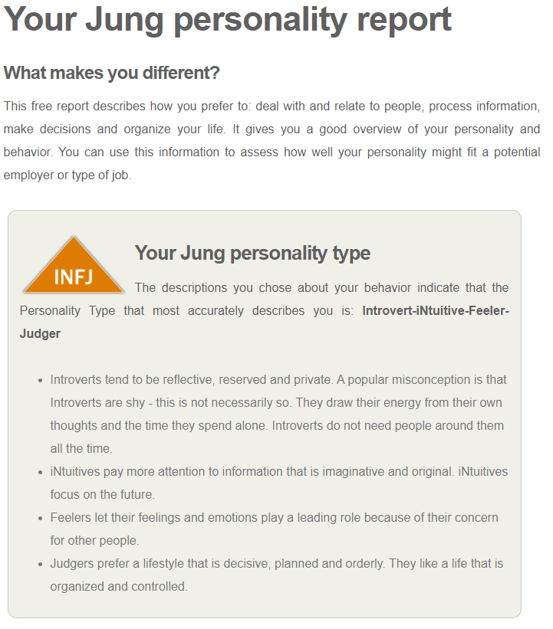

(E) https://www.123test.com/career-test/
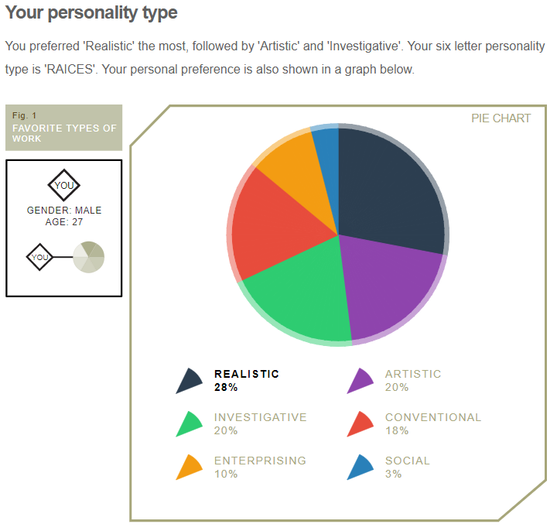
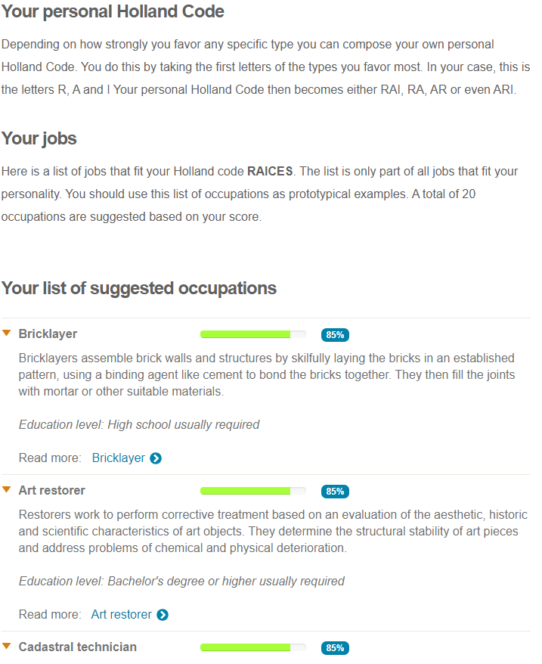
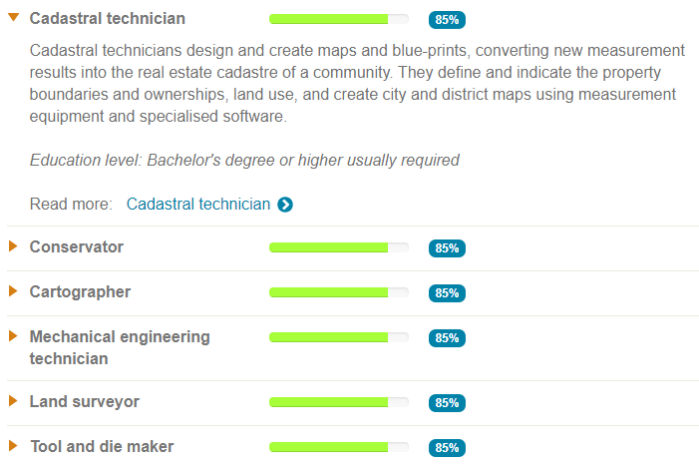
(F) https://www.theguardian.com/lifeandstyle/2014/nov/11/-sp-questionnaire-what-job-would-make-you-happiest
Your scores:
- Hands-on: 15
Your ideal work is mainly about engaging with the physical world, for example building, cooking, craft, DIY, working with animals, plants and machines, sports and hands-on therapy. Example jobs include: sports coach, physiotherapist, engineer, LGV driver, builder, mechanic, veterinary nurse.
- Information and research, processes and systems: 7
Your ideal work is mainly about researching or managing information. This will include analysis, cataloguing and database management, but may include investigating topics in depth, IT, science, maths, quality control, systems and regulations. Example jobs include: accountant, scientific researcher, investigative journalist, legal assistant, book-keeper, health and safety officer, purchasing professional.
- Influencing, negotiating, communicating: 6
Your ideal work is mainly about persuading other people to do something, buy something or believe in your cause. This includes driving others, influencing, persuading, lobbying, motivating, selling. Example jobs include: sales person, recruiter, fundraiser, event manager, estate agent, public speaker.
- Creative use of ideas, materials or situations: 11
Your ideal work is mainly about working imaginatively with ideas or designs. This includes jobs in the arts, performing, creative writing, and also visual design, lateral thinking, business creativity, adapting or coming up with new ideas, working in situations where no rulebook exists. Example jobs include: graphic designer, training consultant, wedding planner, public relations.
- Supporting people: 6
Your ideal work is mainly about working with people, with their wellbeing and development as the main focus of your work. Example jobs include: teacher, life coach, therapist, nurse, learning and development, career coach.
- Making new things happen: 6
Your ideal work is mainly about achieving things with and through other people. This may involve organisational change, planning, managing projects, leadership, creating a new business, shaping teams, getting results. Example jobs include: project manager, team leader, operations manager, sales manager, business developer.

How to use these scores
Look at your top three scores. Your ideal career path may be a combination of themes: if, say, your top scores are Creative use of ideas, Supporting people and Hands-on, you’ll want to ensure that you work in a team, creative approaches are encouraged, and you achieve tangible results – for example working for an outdoor training centre or in sports coaching.

(G) https://www.quietrev.com/the-introvert-test/

AMBIVERT
Based on your responses, you’re an ambivert. That means you fall smack in the middle of the introvert-extrovert spectrum. In many ways, ambiverts have the best of both worlds, able to tap into the strengths of both introverts and extroverts as needed. See below for information on introverts and extroverts; you’ll likely see part of yourself in both.
We have all kinds of stories and resources that will appeal to both your introverted and extroverted sides. Sign up for our newsletter to receive updates!

(H) https://www.16personalities.com/free-personality-test


