Underwater Target Detection Optimization Algorithm Based on YOLOv7
Yaocai Chen
University of Wales Trinity Saint David
2200435@student.uwtsd.ac.uk

Abstract— The scarcity of underwater image data sets, the small scale and easy aggregation of detected objects, and the low visibility of underwater scenes bring many challenges to underwater object detection in complex environments. In this thesis, the accuracy of object detection was improved by improving the YOLOv7 object detection network. The results are as follows.
Aiming at the small scale of detected objects in underwater object detection.Two-layer feature fusion network and a multi-layer feature crossover fusion network using attention module were proposed in this thesis. At present, the comm only used feature pyramid only combines the features of two adjacent layers through simple fusion, but does not establish the relationship between the layers well. However, the two feature fusion methods proposed in this paper can effectively utilize channel information and degraded pixel information of different feature layers through the attention mechanism and feature attention module to obtain information-rich features. In addition, it is verified by experiments that feature fusion can improve the problem of small scale of detected objects.
By analyzing the detailed structure and principle of YOLO series deep learning algorithms, the superiority of neural network design and the rationality of loss function design are clarified, and a new YOLOV7 deep learning algorithm is proposed to complete underwater target detection work.
Aiming at the object overlapped in underwater object detection. A positioning quality object detection network with positioning loss is proposed in candidate box generation and regression positioning network in this thesis. At present,in the process of non-maximum suppression in object detection network, the box with the highest classification score in the overlapping box is retained in the result,which makes the detector pay more attention to the accuracy of the category and ignore the positioning quality. In this thesis, the proposed network suppressed the poor quality detection frames in the candidate frame generation and regression positioning network through centrality loss function and IoU loss function, so as to obtain better quality candidate frames and positioning frames.In addition, the experiment proves that increasing the locating loss can improve the over-lapping phenomenon of detected objects.
Keywords— Underwater Object Detection, YOLOv7, Location Loss, Attention Mechanism

Introduction
Object detection is a major problem in computer vision, whose task is to perform automatic recognition and localization on objects to be detected. Driven by deep convolution networks, researchers have proposed many deep learning-based object detection methods, which greatly improve the performance. Detection of underwater objects and resources is an important task. Underwater is rich in biological and power resources, and there are many unknown dangers while waiting for human exploration. In order to explore underwater targets more safely and comprehensively, underwater target detection and underwater robotics are on the agenda. Underwater robots are designed to replace humans to go deep into the seabed and perform dangerous tasks such as underwater scientific research and military mission investigations, marine resource assessment and seabed geological testing. Underwater target detection is a key fundamental technology to help underwater robots better perform these underwater tasks. However, underwater environments are very different from land environments, making target identification more difficult. Although the benchmark dataset has achieved good performance, there are some problems with the image quality such as colour distortion, blurring and contrast distortion due to the absorption and scattering properties of light in water and other reasons when there is not enough light source in the water, resulting in lower accuracy of target detection in underwater images. The study of underwater target detection algorithms is very necessary in the reality where the recognition accuracy of underwater target detection algorithms is still low.
Underwater target detection can be divided into target signal acquisition, feature extraction and target detection according to the process order. The acquisition of the signal is the guarantee for the efficient completion of the subsequent detection work. As the acquired signal is often associated with a series of interference such as noise, the processing of the signal or image is very important. Early underwater target detection mainly used unsupervised feature extraction and target detection, or manual detection methods. This detection process cannot guarantee the accuracy and reliability of detection, and the detection process lacks supervision, and the detection results are unreliable. Due to the lack of guidance on target classification, it is often impossible to achieve effective target classification results. With the continuous development of machine learning technology, it turns out that more and more related technologies have been applied to the field of target detection, and supervised underwater target detection technology has also been greatly developed. Underwater target detection as an important part of underwater vision technology is also more and more influenced by new technologies and new ideas. Therefore, this project discusses and designs more suitable underwater target detection algorithms to complete the work of underwater target detection.
Unlike deep learning, which relies on a large number of samples and operations, single hidden layer random weight neural networks have the advantages of simple structure and fast training speed. Compared with traditional neural networks, there are no complex gradient calculations and there are not many parameters that need to be adjusted. In order to obtain better underwater image classification results, it is necessary to improve the hidden layer of the network and obtain excellent and stable network performance by optimizing the network structure. In the future, marine resources will become an important driving force for the development of science and technology, and the research and exploration of marine science will also become an important support for the sustainable development of society. Therefore, the study of underwater images is of great significance, which can better help humans understand the ocean. According to the above content, this paper studies the underwater image classification method based on deep learning. While using the good general feature extraction ability of convolutional neural network, adding a suitable attention mechanism and loss function, better classification accuracy is obtained.

State of Image Target Detection Research
Before the rise of models for deep learning, image-based target detection algorithms mainly use manually extracted features with target brightness, colour, shape and gradient, but also include features obtained by operator computation, such as LRF, Haar, HOG and SIFT features. Support vector machine, Ada Boost, etc. are usually used for feature classification of different targets. In traditional machine vision pedestrian detection scenarios, it is more effective to extract HOG features of images and classify and recognise them by SVM. However, the overall performance of traditional detection methods has some limitations because traditional machine learning for manual extraction of features can not mine the deep feature information of the image.Around 2012, due to the wide application of deep learning, the target detection algorithms have also made great progress. Target detection algorithms based on deep learning technology are divided into two main categories: two-stage target detection and one-stage target detection.
The process of two-stage target detection algorithms is mainly to first generate the region candidate box and then extract the candidate box features and finally generate the position box and predict the corresponding category. A representative network is the R-CNN network, which adopts a selective search algorithm to generate target candidate regions unlike the traditional sliding window search method, and this algorithm improves the accuracy of target detection significantly. However, due to the redundancy of generating candidate frames, there is the disadvantage of slower detection speed.In 2014, He Kaiming et al. proposed the SPPNet algorithm, which proposes a Spatial Pyramid Pooling Layer (SPP), which makes the network able to generate a fixed-scale feature representation before the fully-connected layer and avoids the repetitive computation of convolutional feature maps, which makes the network performance have a bigger improvement. computation, resulting in a large improvement in network performance.In 2015, R. Girshick et al. improved the R-CNN algorithm by proposing the Fast R-CNN algorithm, which proposes an ROI pooling layer that greatly improves the speed of detection. Shortly after, Ren et al. proposed the Faster R-CNN algorithm, which is the first deep learning detection algorithm that achieves end-to-end ground training and comes closest to implementation performance. It uses a region selection network instead of generating candidate frames, which is more accurate and faster than the Fast R-CNN algorithm.
The one-stage target detection algorithm generates the class probability and location information of the object directly through the regression of bounding boxes, which has faster speed but lower accuracy compared to the two-stage algorithm.In 2015, R. Joseph et al. proposed the YOLOv1 algorithm, which transforms the target-on-push-to-test problem into the detection of location and prediction of class for bounding boxes by dividing the lattice. Subsequently, Liu et al. proposed the SSD algorithm, which introduced multi-reference and multi-resolution detection techniques to improve the detection accuracy of small targets. Subsequently, R. Joseph proposed the YOLOv2 algorithm by applying DarkNet-19 on the YOLOv1 network structure, and the subsequent YOLOv3, YOLOv5, and YOLOv7 target detection algorithms proposed by the researchers in 2022 have led to the continuous improvement of the performance of target detection.

Related Work

Underwater Dataset
The 2022 National Underwater Robotics Competition (URPC2020) dataset consists of 5543 images. Dividing this datasetwas split into training and testing sets with an 8:2 ratio, resulting in 4434 training set images and 1109 test set images. There are four main types of organisms in these images, which are echinus, holothurian, scallop and starfish.
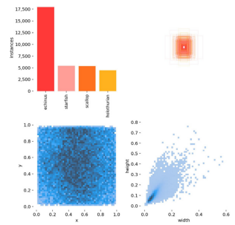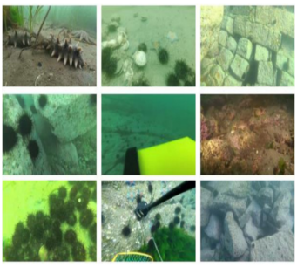
- (b)
- samples information of URPC2020;(a)labels;(b)example images

Target Detection Evaluation Index
The task of target detection is to give a picture, and it is necessary to detect the positioning information and classification information of the target in this picture, so the final output is the category, positioning frame information and degree of accuracy, as shown in the figure.
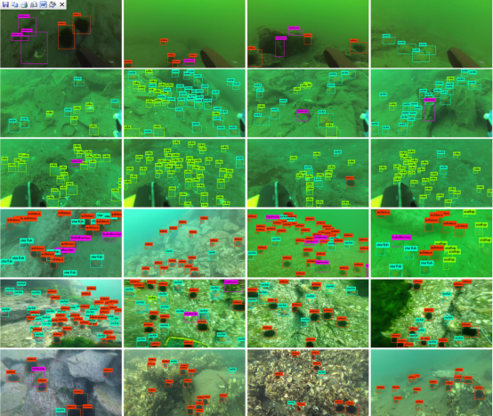
- Target detection output results in urpc2020 dataset
The output of target detection includes unstructured category information and precise positioning frame information, and the number of finally detected targets is also uncertain, with certain variability, which makes the evaluation of target detection difficult. At the same time, a wide variety of target detection evaluation indicators are generated for different people's perception of the target detection results, which is not conducive to comparing the quality of different network models. Therefore, when measuring the quality of the results of the object to be detected, a unified method must be used. In the field of scientific research and competitions, the average accuracy rate AP (Average Precision) is commonly used to measure the detection quality of various networks. mAP contains many basic concepts. TP (True Positive) refers to the correct prediction of existing objects to be detected, and TN (True Negatives) refers to the incorrect detection of non-existent objects to be detected.FP (False Positive) means that the non-existing object to be inspected is detected incorrectly, and FN (False Negative) means that the existing object to be inspected cannot be correctly predicted. IoU (Intersection over Union) can be used to measure the unstructured data of the target detection output, and distinguish what is the correct detection result and what is the wrong detection result. The overlapping size of the candidate frame position Bp predicted by the network and the real position information Bgt can be measured by IoU, the description is shown in the figure, and its expression is shown in the figure.
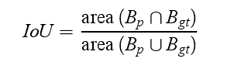
By using the IoU of Bp, and Bgt and a set threshold, it is possible to determine whether the object to be detected is correctly detected. The results of target detection can be evaluated using both precision Р and recall R. Precision is concerned with the proportion of detected targets that are true targets. Recall is concerned with how many of all true targets are detected.
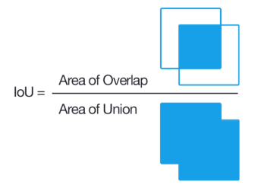
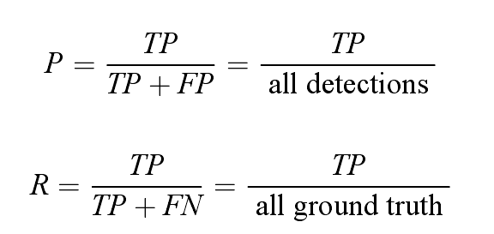
Different accuracy and recall can be obtained by using different valve values, which allows the precision recall curve to be plotted.

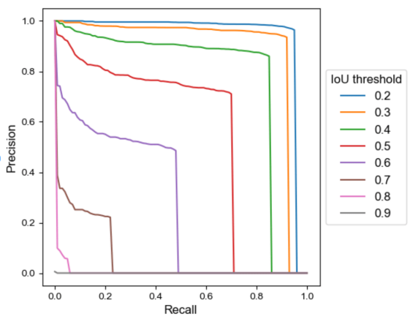
- precision recall curve
The precision recall curve in the figure shows that the adjustment of the threshold value will have a direct effect on the accuracy and recall. For the classification and localization information detected by the network, if the threshold is high, because many objects that need to be detected are not detected, the recall is lower. Correspondingly, the lower the threshold, the network will detect a lot of wrong localization information and the precision will be lower. A good target detection network should detect all objects that need to be detected and not detect objects that do not need to be detected. If the accuracy is proportional to the recall ratio, then this target detection network is the best network. In the figure, the value of AP is in the region below the precision recall curve. mAP (mean Average Precision) stands for averaging the AP of all the categories that need to be detected.
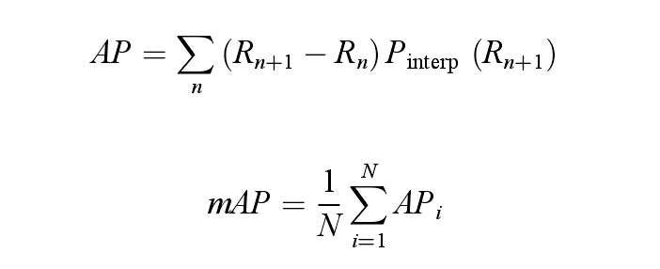

Underwater Image Enhancement Network
The analysis of the principle and characteristics of underwater optical image imaging is conducive to the smooth progress of underwater image processing, including underwater image restoration, underwater target recognition, underwater target tracking, etc. In this section we mainly discuss its impact on underwater object detection tasks. Compared with the air medium, water, as a special light transmission medium, has special performance on light attenuation, absorption, scattering, etc., which leads to the particularity of underwater optical image imaging.
In a pure medium, the attenuation of light is mainly related to the density of the medium. Compared with the air medium, the density of the water medium is more than 800 times. Therefore, the attenuation of light by the water medium is more obvious. In the actual underwater environment, the water quality is difficult to reach the conditions of a pure medium. There are often a large number of suspended solids and dissolved solids in the water. In addition, the influence of the water body's own flow on light propagation further aggravates the attenuation effect.
The strong attenuation effect of the water medium greatly limits the propagation distance of light underwater. Therefore, in the actual application environment, underwater imaging based on optical cameras often has the problem of low brightness, and this phenomenon will become more obvious as the water depth increases.
Underwater imagery plays a key role in ocean exploration, and the search for many organisms and resources requires the use of underwater imagery for target detection. The quality of underwater images is often severely degraded because of the absorption and scattering of light in the water medium and the effects of impurities in the water. The use of convolutional neural networks in areas such as image deblurring, image denoising, shimmer image enhancement and image defogging in low-order vision tasks has been very effective. Researchers in the field of underwater image enhancement have also worked on deep learning based image enhancement with good results. CNN-based approach and GAN-based approach are the two main categories of deep learning-based underwater image enhancement and restoration methods. These two categories represent different ways of implementing and developing underwater image enhancement, and there are a wide variety of networks produced under the two approaches, for which I choose Water-Net based on CNN and FUnIE-GAN based on the Gan approach to introduce them, describing their network structures, loss functions, and evaluation metrics for underwater image enhancement.
·Water-Net
Although deep learning based image enhancement networks have made significant progress, there is a wide variety of image enhancement networks.Li et al. proposed Water-Net based on a pure CNN approach as a baseline for promoting the development of deep learning based image enhancement. Therefore, I present the underwater image input processing and network structure of Water-Net.
Because of the diversity of underwater environments and lighting conditions, there is no algorithm that is compatible with all types of underwater image enhancement. One approach is to use an input and fusion strategy that performs several preprocessing operations on the underwater images, where fusion-based conventional algorithms have yielded better results.Water-Net also uses such an approach. Based on the degraded characteristics of underwater images, three different inputs are generated using three algorithms, White Balance (WB), Histogram Equalization (HE) and Gamma Correction (GC), respectively.The WB algorithm corrects the underwater images for colour difference. The WB algorithm proposed by Ancuti et al. is directly adopted and its effectiveness is proved.The HE algorithm is used to improve the contrast of the underwater image, and the L component of the Lab colour space is transformed back to the RGB colour space by using the adapthisteq function of MATLAB.The GC algorithm is used to improve the brightness of the dark area of the underwater image, and the Gamma Correction algorithm is used to improve the brightness of the dark area of the underwater image, and the value of Gamma Correction is set to 0.7 and the value of Gamma Correction is set to 0.7. value is set to 0.7 in the experiment and its effectiveness is proved.
The performance of underwater image enhancement methods using fusion has also inspired the exploration of fused networks.Water-Net uses a fusion gated network structure for underwater images using three images obtained by traditional algorithms as images to learn three confidence maps and finally combines the outputs into an enhancement result. The three confidence maps learned in the network identified the most important features in the final result. The network structure and parameter settings of Water-Net are illustrated in figure. Water-Net is a pure CNN network structure that can be combined out of widely used backbone networks such as the U-Net architecture lS2 to improve the quality of underwater images. The three images processed by the above algorithms and the original image were used as inputs to Water-Net. Three feature transformation transformation units were used to refine the three inputs, which served to mitigate the artifacts and chromatic aberrations added by the WB, HE and GC algorithms. Finally, the three image inputs and the three network confidence maps generated by the network are combined to finally obtain the underwater image enhancement results with the formula.
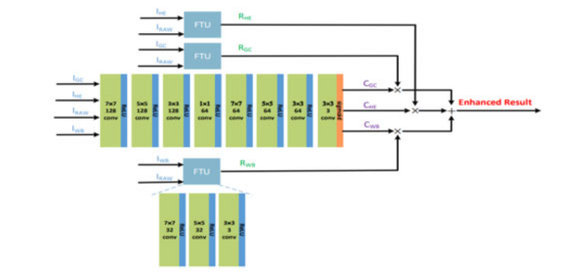
- Water-Net infrastructure
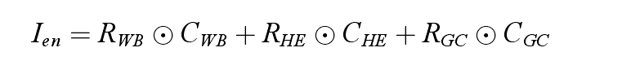
In equation is the underwater image enhancement result;o denotes the element-by-element multiplication of the matrix: Rwg, Rn and RGC are the results of the original image calculated by the WB, HE and GC algorithms, respectively;CWB, CHE and CGC are the confidence maps learned by the Water-Net network.
A perceptual loss function is used instead of a pixel loss function, which can produce a better experience visually. The perceptual loss function is shown in the following equation.
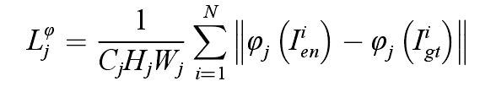
N in the formula denotes the number of samples in each training, the dimension of the convolution layer generated by the backbone network VGG19 is represented by CjHjWj,and the width, height and number of features generated by the backbone network are denoted by Wj, Ij, and Cj. Water-Net is compared with several classical underwater image enhancement methods and its superiority is demonstrated.
·FUnIE-GAN
In many deep learning image enhancement networks require paired underwater datasets, however collecting a large number of paired underwater datasets is difficult. Most of the existing networks use paired datasets imitated and synthesised using mathematical models of underwater image imaging, and the enhancement effect is not very obvious in real underwater natural environments where paired images are lacking.The FUnIE-GAN network is able to use both paired and unpaired underwater images for enhancement, and achieves better image quality. Therefore, the network structure and loss function of FUnIE-GAN are described below.
Underwater image enhancement is essentially learning a mapping from a given source domain and (underwater distorted image) to an output desired domain Y (underwater enhanced image).FUnIE-GAN uses a conditional GAN-based model, where the generators in the model wish to generate an image through an iterative min-max game, which is carried out by an adversarial discriminator in the model to discriminate between the generators and ultimately, after many operations learning a mapping from X to Y. An image generation network is designed inspired by the U-Net principle. It is a network consisting of a network of encoders and decoders corresponding to each other, and the feature layer information of the generators is shown in Fig. In more detail, the output of each encoder is connected to the corresponding corresponding image decoder for decoding. This idea of jump connections in generator networks has proved to be very effective when used in image-to-image conversion and image quality enhancement problems. Previous generative models had long running time, FUnIE-GAN uses a simpler generative model with fewer parameters in order to achieve fast inference. For the discriminator in FUnIE-GAN, a Markovian PatchGAN [S4] architecture is used. The feature level information of the discriminator is illustrated in Fig. This architecture performs discrimination based only on patch-level image information, considering pixels to be uncorrelated outside the patch size. This architecture is effective for capturing underwater image grain and style information. In addition, this patch-level based discrimination uses fewer parameters than the global discrimination at the image level and is therefore more computationally efficient.
FUnIE-GAN consists of two different loss functions for paired and unpaired datasets of underwater images. For the paired loss function consists of the GAN loss of the discriminator, the global similarity loss and the image content loss. Conditional GNA is a network model for learning the mapping G:{X,Z}→Y, where X represents the source domain, Y represents the target domain, and Z represents the random noise data.The GAN loss is shown in Eq. where the generator G in order to make the loss value smaller, and the discriminator is to make the loss value larger, and both of them play a game to form the desired result.
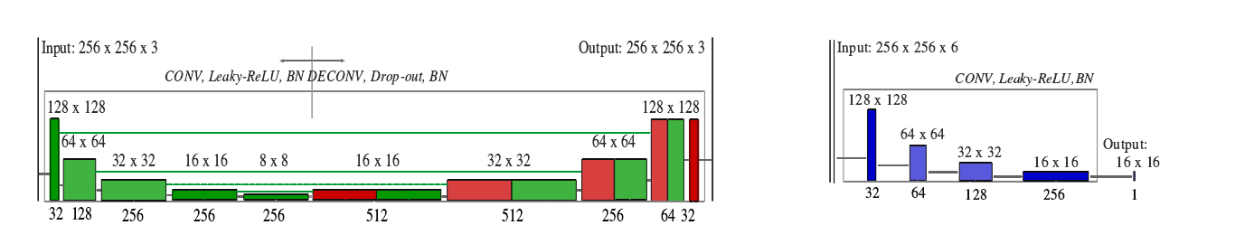
- (b)
- FUnIE-GAN infrastructure (a)generator network structure;
(b)Discriminator Network Architecture
Previous researchers [demonstrated that using Ll or L2 loss in the objective function allows the generator to learn the global similarity of the images, using the global similarity loss of Eq.
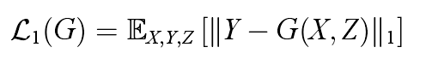
Meanwhile, FUnIE-GAN is using a content loss term as in Eq. In order for the generator to produce an underwater enhanced image similar to the content features of the real image.
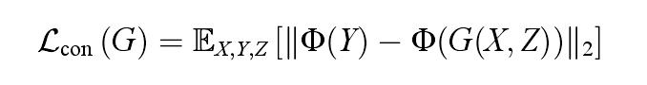
For unpaired dataset training, the network cannot be constrained using global similarity and content loss because of the lack of paired reference images. Instead, the quality of the generated images is guaranteed by maintaining cyclic consistency.G : {X,Z} →Y generates the target image Y again through the original image, Gn: {Y,Z} →X then generates the original image X through the target image Y, and ultimately the generated image as in Eq. is guaranteed to be consistent with the original image through a loss function.
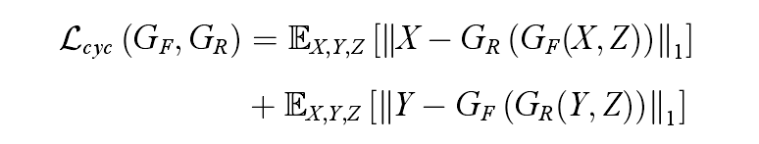
It is experimentally demonstrated that a network and loss function such as FUnIE-GAN can improve the visual perception and image quality of underwater images, whether trained with paired or unpaired underwater datasets.

·Evaluation metrics for underwater image enhancement
Comparison of the generative effectiveness of underwater image enhancement models can be done using evaluation with and without reference images.
For the evaluation of reference images, Peak Signal to Noise Ratio (PSNR), Mean Squared Error (MSE) with Structural Similarity Indicator (SSIM) are generally used. Although images in real underwater environments may be different from the reference images in training, the evaluation of the generation effect of underwater image enhancement models using reference images can demonstrate the enhancement quality in real underwater to some extent. For the evaluation with reference image, the lower value of MSE and the higher value of PSNR indicate that the generation effect of the model is closer in image content to the reference image used in training. And for evaluation is the higher value of SSIM, indicates that the model generated effect in the texture structure of the image is more similar to the reference image.
For evaluation without reference underwater images, Underwater Color Image Quality Evaluation (UCIQE) IS7 and Underwater Image Quality Measure (UIQM) are usually used. Higher values indicate that the results have a better synthesis between saturation, chroma both. Although the UCIQE and UIQM's argue that they add human visual perception to the factors affecting quality assessment, the metrics are not always the same as subjective human assessments. Such results illustrate that in some cases the metrics designed for the quality of non-referenced underwater imagery images are inconsistent with is subjective human visual perception. It may be that humans have not yet evolved to see objects to the extent that aquatic organisms do. When humans view an underwater image, they are likely to focus on objects that look colourful or distinctive, such as divers and beautiful coral in an underwater image. Subjective human observations are likely to be made for visual pleasure rather than corrective methods to mitigate scattering and refraction in underwater images.

Image-based target detection algorithms

General Flow of Target Detection Algorithm
The approximate flow of the training and detection phases of a typical target detection algorithm is.
1, the autopilot training set image adaptive scaling to a fixed size, and then according to the set batch-size (batch-size) into the network model;.
2, after the algorithm forward propagation to get the position and type information of the prediction frame of the object to be detected, the forward propagation of the algorithm consists of three parts: feature extraction network (Backbone), feature fusion network (Neck), and the detection head (Prediction), in which the feature extraction network extracts the feature information, the feature fusion network fuses the shallow positional information with the deep semantic information, and the detection head is based on the rich feature information. Detection head gives the category and location of the object to be detected based on the rich feature information; the
3、Class loss functions such as CE Loss, Focal Loss, DR Loss, and AP Loss are used to calculate the gap between predicted and real classes, and bounding box regression loss functions such as MSE, Smooth Ll Loss, and Balanced L1 Loss are used to calculate the gap between predicted and labeled boxes;
4, through the gradient descent of the loss function, iteratively update the weight parameters of the convolution, fully connected and other layers in the model, and continuously reduce the category loss and the bounding box loss.
5、Obtain the weight parameters of the model when the loss function takes the minimum value under the specified number of iterations (epoch).
6, the test set of images adaptive zoom to a fixed size, passed into the trained model, the category of the object to be detected and the prediction frame. The general target detection algorithm training and detection process is shown in Figure .
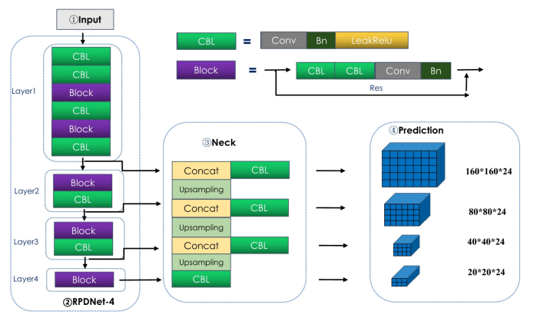
- Deep learning target detection model training process

Typical Target Detection Algorithms
·Two-stage target detection algorithm
Two-stage target detection algorithms are developed earlier, mainly RCNN, SPPNet, Fast-RCNN and Faster-RCNN, etc. Next, we take Faster R-CNN as a representative to explain its implementation process.
using the data loading function, open the appropriate number of threads, read the dataset images and annotation files;
a batch of images scaled to a uniform size and annotation file coordinates are also scaled accordingly, and then carry out the data normalisation operation;
Pass the zoomed and data normalised image (take 640×640×3 size image as an example) into the ResNet50+FPN feature extraction network, and obtain the feature matrices of 160×160×256, 80×80×256, 40×40×256, 20×20×256, and 10×10×256 sizes, respectively;
Pass the five size size feature matrices obtained in step 3 into the RPNHead network, and use a 3 × 3 and two 1 × 1 size size convolution kernels to carry out convolution operations, respectively, to obtain classification matrices and bounding box regression matrices on the five feature layers, respectively; and
Use the Anchor frame generator function to generate the corresponding five feature maps on the corresponding size of the Anchor frame, and mapped back to the original image size;
Use the RPNHead network to generate the bounding box regression matrix to fine-tune the Anchor box, so that it can fit the target object more closely.
Based on the classification matrix generated by the RPNHead network, respectively, in the five feature maps to obtain the probability of ranking the top 2000 anchor boxes, sieve out the Anchor box below the specified threshold, and after the non-maximum inhibition process, and finally filter out all the feature maps in the probability of ranking the top 2000 anchor box as a proposal box (Proposals), through the loss function of RPN part of the loss function, iterative iteration to get the final proposal box.
It will be obtained in step 7 of the 2000 proposal box ROIPooling operation (maximum pooling downsampling to 7 × 7 size), and then the down-sampled matrix spread and connected to the two fully connected layers, and then linked to a fully connected layer to get the classification matrix and bounding box regression matrix, and finally the use of the overall loss function of the Faster RCNN iterative iterative classification and bounding box matrix generation prediction box; Faster RCNN overall loss function matrix to generate the prediction box.
Eliminate the prediction frame whose classification score is less than the specified threshold, and carry out non-great value suppression processing to obtain the final prediction frame.
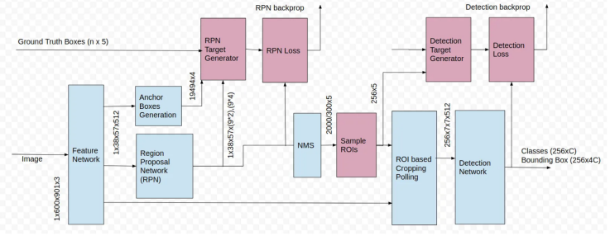
- Faster R-CNN network structure diagram

·One-stage target detection algorithm

In deep learning target detection algorithms, SSD is a more typical one-stage algorithm, compared with the Faster R-CNN algorithm due to the elimination of the candidate box extraction stage, greatly improving the detection speed of the model. Its main implementation process is as follows.
In the first stage, the image is input into the feature extraction network to obtain the feature map, the difference is that the SSD is input into the VGG16 network to generate the corresponding feature maps in the 4th, 7th, 8th, 9th, 10th, and 11th convolution layers, and then spliced through the up-sampling to obtain the multi-scale feature map.
In the second stage, the multiscale feature maps are predicted in different prediction grids, including the positional regression parameters of the bounding box and classification parameters.
In the third stage, the targets are sorted according to their confidence scores and filtered using a non-great value suppression algorithm.The structure of the SSD deep learning target detection algorithm is shown in Figure .
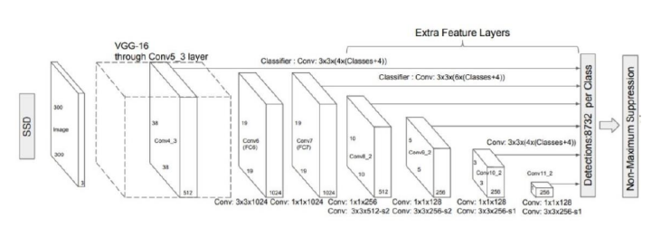
- SSD deep learning target detection algorithm structure
In addition to the SSD algorithm, typical one-stage target detection algorithms also include the YOLO series of target detection algorithms, followed by the YOLOv5 target detection algorithm as an example to illustrate its main process.
In the first stage, the image is uniformly scaled to 608×608 size, and then after Mosaic enhancement, it is inputted into Backbone feature extraction network (Darknet network) for feature extraction.
In the second stage, the feature map is fed into the Neck network for multi-scale feature extraction using the feature pyramid structure.
In the third stage, on the 76 × 76 × 255, 38 × 38 × 255, and 19 × 19 × 255 feature maps generated by the Neck network, the target is predicted, including the positional regression parameters of the bounding box and the category prediction probabilities.The structure of the YOLOv5 deep learning target detection algorithm is shown in Figure.
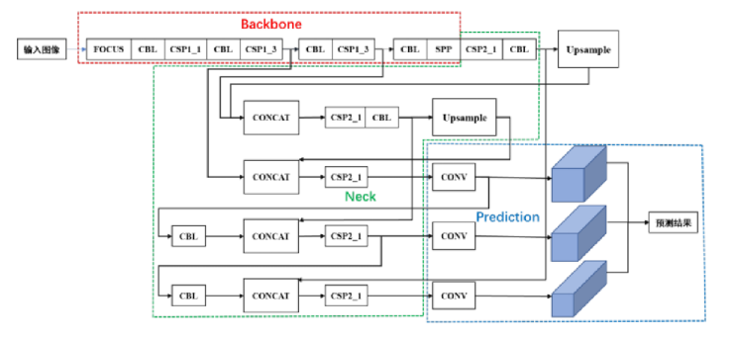
- YOLOv5 deep learning target detection algorithm structure diagram
The newly released YOLOv7 deep learning target detection algorithm by the YOLOv4 team outperforms all current target detection algorithms in terms of detection accuracy and detection speed in the range of 5~160FPS on the COCO public dataset.
The YOLOv7 model network structure is shown in Figure 4-5. Firstly, the Mosaic-enhanced image is input into the Backbone feature extraction network (50 layers in total, mainly composed of CBS, ELAN and MP1 modules) for feature extraction, and three feature matrices of 80 × 80 × 128, 40 × 40 × 512, and 20 × 20 × 1024 are obtained; then, in order to retain the shallow contour location information and the deep semantic information, the three feature matrices are passed through the Neck network (different from the path aggregation network PANet), and the three feature matrices are passed through the Neck network (different from the path aggregation network PANet). Then, in order to retain both the shallow contour location information and the deep semantic information, the three feature matrices are fused by Neck network (unlike the path aggregation network PANet, YOLOv7 adds feature extraction modules such as SPPCSPC, CBS, and ELAN-W while up-sampling); finally, the 80×80×255, 40×40×255, and 20×20×255 size of three feature matrices generated by the detection header (Prediction) are fused by the PANet network (YOLOv7). 255, 40×40×255, and 20×20×255 sized three prediction feature maps; finally, nine (each prediction feature map can predict three) targets of different sizes are predicted on the three prediction feature maps generated by the detection head (Prediction).
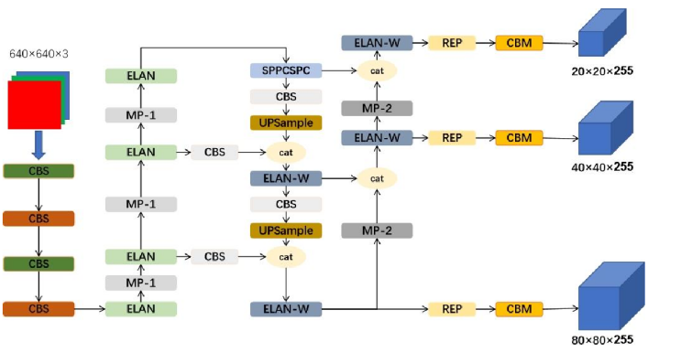
- YOLOv7 deep learning target detection algorithm structure diagram
Among them, the CBS module consists of a convolution layer, a Batch Normalization (BN) layer and a Silu activation function layer, in the structure diagram, different colours of the CBS module represent different sizes of convolution kernels (red represents a convolution kernel with a size of 1x1 step of 1, yellow represents a convolution kernel with a size of 3x3 step of 1, blue represents a convolution kernel with a size of 3×3 step of 2); ELAN module splits the input feature matrix into two branches, one of which flows through 1 CBS module and then channel fuses with the other that flows through 5 CBS modules, and finally passes through a CBS module; MP-1 module splits the input feature matrix into two branches, one of which flows through the maximum pooling, CBS module and then channel fuses with the other that flows through 2 CBS modules; SPPC module splits the input feature matrix into two branches, one of which flows through maximum pooling, CBS module and then The SPPCSPC module splits the input feature matrix into two, one of which flows through three CBS modules and performs pooling operations with kernel sizes of 5x5, 9x9, and 13x13, respectively, and then performs channel fusion with the other that flows through one CBS module after two CBS modules; the UPSample module performs bilinear interpolation upsampling; the ELAN-W module is similar to the ELAN module, and the UPSample module is similar to the ELAN module, and the UPSample module is similar to the ELAN module. module is similar to the ELAN module, the difference is the number of channels converging into the channel fusion module after a single CBS module on the second branch; the MP-2 module is similar to the MP-1 module, the difference is the change of the number of channels; the CBM module consists of a convolution layer, a batch normalization layer and a Sigmoid activation function layer. The specific flow of each module is shown as follows.
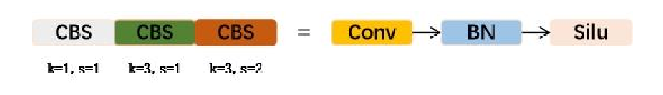
( a) CBS module flowchart
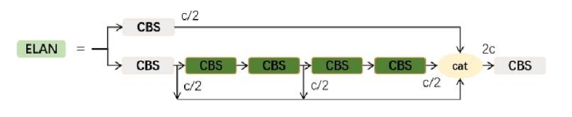
- ELAN module flowchart
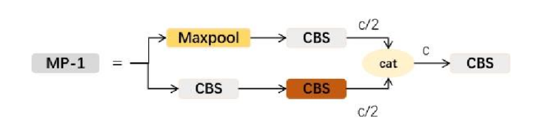
(c) MP-1 module flowchart
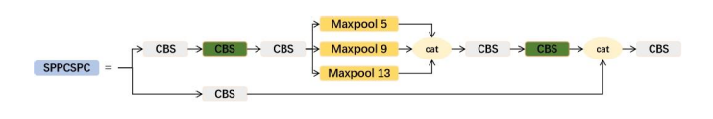
(d) SPPCSCP module flowchart
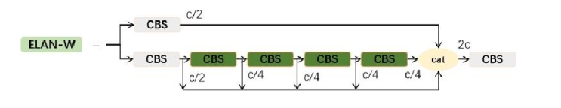
(e) ELAN-W module flowchart
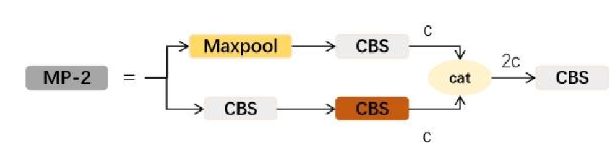
(f) MP-2 module flowchart

Mosaic data augmentation is proposed in the YOLOv4 deep learning target detection model, the main idea is to randomly select four images in the training set and randomly crop them, and then splice them onto a fixed-size map. Its advantages include: the advantage of Regional Dropout, which enables the network to focus on the non-discriminative part; the ability of the training model to accurately detect the target from the local field of view based on the target part of the region; the random splicing of different images, which will lead to a variety of situations, and improve the classification accuracy of the model, etc. The main process is divided into the following four steps. The main process is divided into the following four steps.
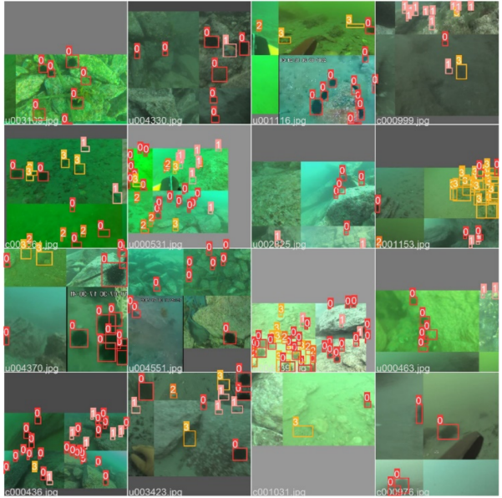
- urpc2020 dataset images enhanced with Mosaic data
In feature extraction networks, the way information is propagated and fused is very important. Generally speaking, in the bottom-up propagation process of feature extraction network information, the deeper the network experienced, the richer the semantic information extracted to the target as a whole, but the more serious the loss of localization and positioning information at the bottom layer. In order to both retain the rich semantic information of deep objects and take into account the shallow localization information, in 2017 Tsung-Yi Lin proposed Feature Pyramid Networks FPN (Feature Pyramid Networks). The basic idea is to add a top-down information flow channel on top of the bottom-up feature pyramid and connect the two lines horizontally; the top-down process is achieved by up-sampling, while the horizontal connection is a channel splicing of the up-sampling results with the feature matrices of each branch of the feature pyramid. The network structure is shown in Fig.
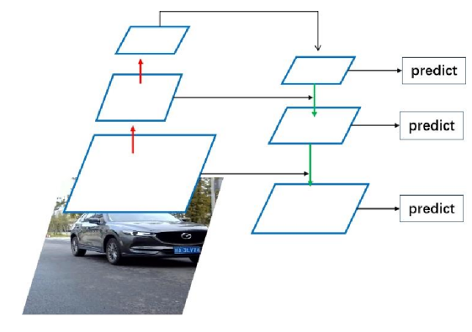
- FPN network structure
In 2018, PANet (Path Aggregation Network), jointly proposed by the University of Hong Kong, Tsinghua University, and Tencent Labs, added a bottom-up feature fusion layer and two "short-cut" layers connecting the bottom and top layers to FPN. ". The feature fusion layer in the YOLOv7 network adds feature extraction modules such as SPPCSPC, CBS and ELAN-W on top of the PANet network, so that the top layer feature matrix has rich speech information while retaining the location information in the bottom layer, which further improves the classification accuracy and the bounding box position regression accuracy. The feature fusion structure used in YOLOv7 is shown in Fig.
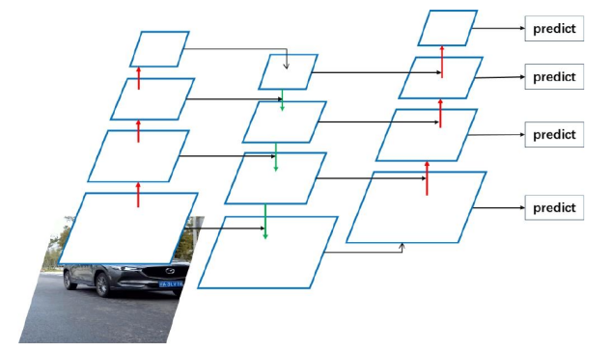

- PANet network architecture
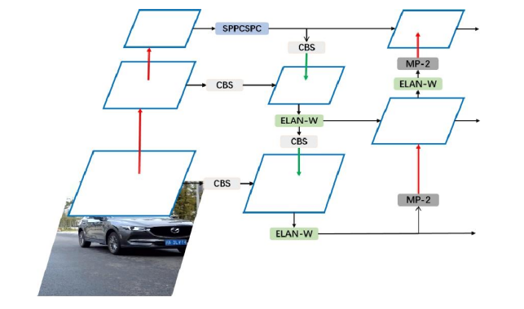
- Feature fusion structure in YOLOv7

Attention Mechanisms and Characteristic Attention Module
For the connection between two neighbouring layers in the FPN network module is just a simple addition, it can be found that such a simple operation cannot combine resolution and semantic information well. The attention mechanism can find out the key information in a picture or feature, so the attention mechanism can be used in feature fusion. Meanwhile, in the classical de-fogging network FFA, a feature attention module is constructed by incorporating the influence of different weight information contained in various channel features and the existence of non-homogeneity in different image pixels. The same problem exists for underwater image target detection networks, where the attention mechanism can be linked to the feature attention model and FPN. Next, we will elaborate on the attention mechanism and feature attention module (FA) in detail.
People tend to focus their attention on what they are interested in and not on what is irrelevant. In this way, people are able to find useful news from the huge amount of information. Since there is still a certain lack of computational power, when models such as convolutional neural networks remember all the information, they become more complex and cannot be used in real-world scenarios. The brain remembers the key words and content when it is engaged in reading a line. There are natural language researchers who have applied human attention methods to machine learning, resulting in attention mechanisms. The principle of attention in deep learning is to classify the weights of numerous information into high and low values, and extract the useful information to improve training and detection.
Most of the current attention mechanisms are based on the coding and decoding framework, and a diagram of the coding and decoding structure is given in Figure.The Encoder-Decoder model is to learn the mapping relation from the original X to the output Y. The Encoder-Decoder model is to learn the mapping relation from the original X to the output Y. The function of Encoder in the model is to transform the original X into an intermediate state of semantic information, and the function of Decoder is to transform the intermediate semantic information and the original data record information into the final expected output Y. Encoder-Decoder is a universally applied network model, which has been used in both natural language processing and visual processing. For example, for picture information interpretation, X is the picture to be described and Y is the final statement. However, Encoder-Decoder frameworks all indiscriminately transform the original X into intermediate semantic information without incorporating the idea of attention mechanism. In order to be able to incorporate the attention mechanism into the model, the intermediate semantics was made to carry out the extension of the intermediate semantic information into more than one, corresponding to different weights of the semantics, the schematic diagram is shown in Fig.
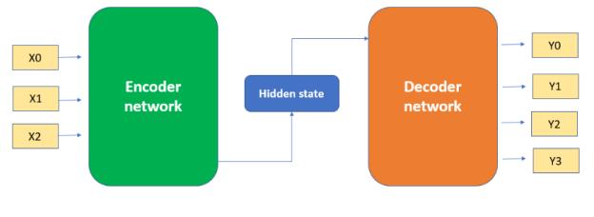
- Attention-Based Encoder-Decoder Framework
For most of the current attention mechanisms, we divide it into two steps: Step 1 is to use Query and Key and specific algorithms to obtain their weights, and Step 2 is to use the weights obtained in the former method to calculate the sum of the weights of Value to obtain the final output. The idea of Query, Key and Value comes from recommender system, the general practice is that given the input Query, the correlation between Query and Key is calculated by certain algorithms, and finally the appropriate Value is found according to the calculated correlation, for example, in the case of purchasing a product, the Query can represent the user's purchasing information (age and purchasing power, etc.), and the Key represents the information (price and material, etc.) of the product, and the Key represents the product's information (price and material, etc.). Key represents the product information (price, material, etc.) and Value represents the product that the end user wants to buy. The first step described above can be composed of two more steps, one is to use the Query and Key to perform the relevance analysis, and the other is to normalize the initial results of the previous step. The structure shown in the figure describes the processing steps of the attention mechanism. Meanwhile, in the first step, Query and Key can use different algorithms and computational functions to calculate the correlation, and the two commonly used methods are the dot product of vectors and the vector Cosine similarity. The algorithms used in the first step are different, and the magnitude of the final value is unknown. In the second step, a method similar to SoftMax is used to normalize the initial result, which not only normalizes the result, but also assigns the weights in a more detailed way, as shown in the SoftMax formula. The output of the second stage, α, is the weight value of Value, and the final result can be calculated by the formula. With the above three steps the attention value of Query can be derived, and most of the current applications of the attention mechanism follow the above abstraction operation steps.
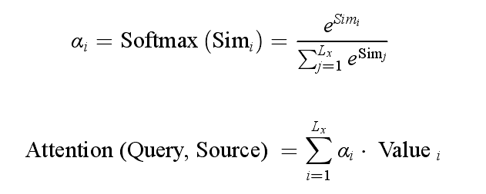

Self-attention mechanism is a development of the attention mechanism, which requires Query and Key to compute the correlation, the self-attention mechanism pays more attention to the internal phase greyness of the data symbols, and the automatic attention mechanism is to analyse the interactions between the words, which improves the problem of long-distance dependency in natural language. The main steps of the auto-attention mechanism are:The first step converts the input words into corresponding vectors. The second step gets Q, K and three feature vectors based on the particular vector. The third step yields a score for each vector. The fourth step normalises the score by an algorithm. The fifth step sums all the V's after multiplying the result of normalisation process and V to get the final result. When applied in a real network, Q, K and V are efficiently calculated using matrices, the results of Q and K are multiplied again, multiplied with appropriate constants, normalised using an algorithm and finally multiplied by V to get the final result, the process is shown in the figure. Finally, after experimentation using heat maps it was confirmed that the attention mechanism is able to correlate information from its own context well.
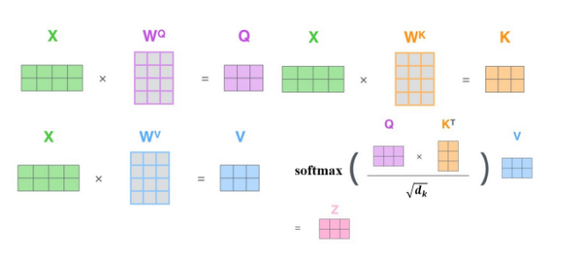
- Schematic diagram of the flow of the attention mechanism
Attention Mechanism in neural networks is a resource allocation scheme that allocates computational resources to more important tasks while solving the problem of information overload in the case of limited computational capacity. In neural network learning, generally speaking, the more parameters the model has, the more expressive the model is, and the more information the model stores, but this will bring the problem of information overload. Then by introducing the attention mechanism, focusing on the information that is more critical to the current task among the many inputs, reducing the attention to other information, or even filtering out irrelevant information, the information overload problem can be solved and the efficiency and accuracy of task processing can be improved.
This is similar to the human visual attention mechanism, which scans the global image to obtain the target region that needs to be focused on, and then devotes more attention resources to this region to obtain more detailed information related to the target, while ignoring other irrelevant information. Through this mechanism, limited attention resources can be used to quickly filter out high-value information from a large amount of information.
The core of the attention mechanism is to make the network pay attention to more important information .
The attention mechanism enables convolution neural networks to adaptively attend to more important information, and thus the attention mechanism is an important way to achieve adaptive attention in networks.
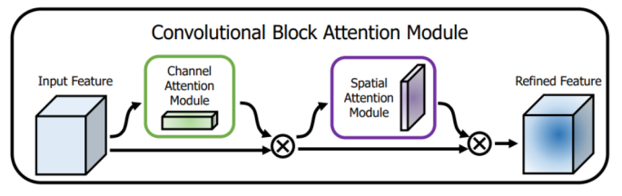
- The overview of CBAM
The core of CBAM: A combination of Channel Attention Module and Spatial Attention Module is applied to process the incoming feature layer with Channel Attention Module and Spatial Attention Module respectively.
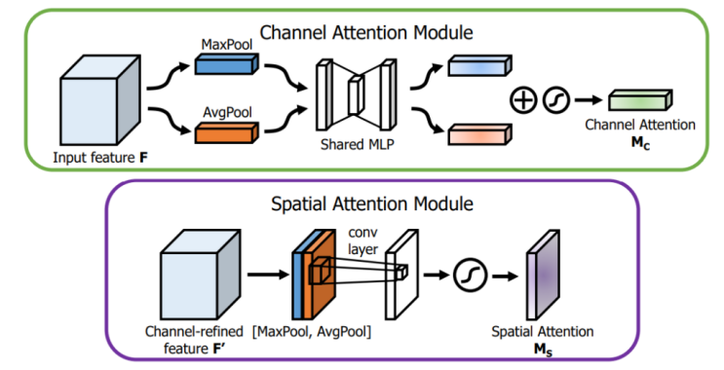
- Diagram of each attention sub-module
Total flow (generalization):
Input feature map F, F ∈ R^{C×H×W} . Generate a one-dimensional channel attention map M_{c}, M_{c} ∈ R^{C×1×1}using the channel attention module, and a two-dimensional spatial attention map Ms.
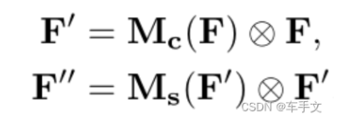
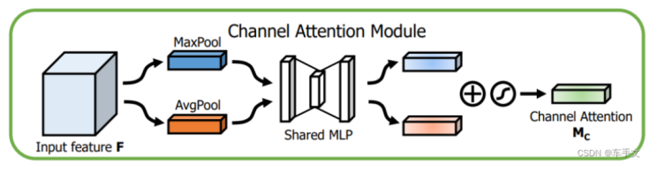
- Channel Attention Model
The above figure shows the channel attention module, which performs global average pooling (AvgPool) and global maximum pooling (MaxPool) on the incoming feature layer (both pooling are targeted at the height and width of the input feature layer), and then process the results of average pooling and maximum pooling by using the shared MLP, and then sum up and use Sigmoid activation function to obtain the channel attention graph, i.e., to obtain the weight of each channel (between 0 and 1) of the input feature layer. The results obtained from the shared fully connected layer are then summed and the Sigmoid activation function is used to obtain the channel attention map, i.e., the weights (between 0 and 1) of each channel of the input feature layer. Finally, the weights are weighted to the input feature layer channel by channel by multiplication.
Since each channel of the Feature Map extracts some level of feature information, it is more important what level of feature information in the image the Channel Attention Module focuses its attention on. In order to compute the channel attention efficiently, Channel Attention Module adopts the method of compressing the spatial dimensions of the input feature maps, as compared to using a single pooling method Channel Attention Module uses AvgPool (Average Pooling) and MaxPool (Maximum Pooling) methods and proves that the dual pooling method has stronger representational power. The computational procedure is shown below, where σdenotes the sigmoid function W0∈R^{C×C/r}, W1∈R^{C×C/r}. The weights of the MLP are shared by W₀and W₁. W₀ is preceded by the ReLU activation function.

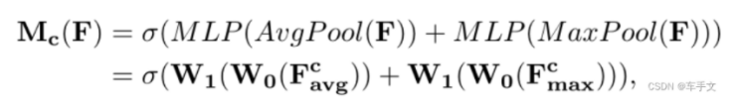
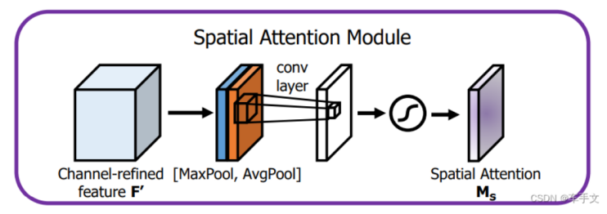
- Spatial Attention Module
Generating spatial attention maps using spatial relationships between features.Unlike the channel attention module, the spatial attention module is concerned with which part of the input image is more important and is complementary to the channel attention module. In order to compute spatial attention, average and maximum pooling are first applied along the channel direction of each feature point (both poolings are specific to the channels of the input feature layer) and stacked to generate a valid feature descriptor (using the two poolings to aggregate the channel information of a Feature Map, two 2D Maps are generated, which are the average and maximum pooling characteristics of the channel, respectively), and then a standard convolution layer (with a convolution number of 1) is used to generate the average and maximum pooling characteristics of the channel. characteristics), and then use a standard convolution layer (the number of channels is 1 convolution) for connection and convolution (adjusted the number of channels), and then use the Sigmoid activation function, and then get the two-dimensional spatial attention map that is to obtain the weight value of each feature point of the input feature map (between 0 and 1), and finally, the weight will be weighted by multiplication channel by channel to the input feature layer can be, the specific computation process is shown as follows. Equation where σ denotes the Sigmoid function, and f ^{7×7} denotes the convolution kernel of 7×7 size.
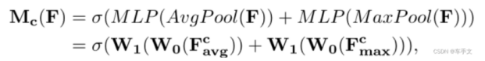

The role of wise-IoU loss function in target detection
Wise-IoU loss function is a commonly used loss function for target detection, which is used to measure the similarity between the prediction results of the detection frames and the real labelled frames, so as to guide the optimization of the model.
In target detection, the commonly used loss functions are Cross Entropy Loss Function, Smooth L1 Loss Function, Focal Loss, etc., but all these loss functions only consider the positional error of the detection frames without considering the differences in the size and shape of the detection frames. And Wise-IoU loss function can solve this problem effectively.
The Wise-IoU loss function is designed on the basis of IoU (Intersection over Union), which uses the idea of IoU to take into account the differences in the size and shape of the detection frames, while avoiding the instability of IoU calculation. Specifically, the Wise-IoU loss function uses a weighting method called "Wise" to weight the IoUs to obtain more accurate loss values. This weighting method allows the model to pay more attention to differences in the size and shape of the detection frames, thus improving detection accuracy.
Overall, the role of the Wise-IoU loss function in target detection is that it can help the model to more accurately estimate the similarity between the detection frames and the real labelled frames, thus guiding the optimisation of the model and improving the detection accuracy.

experiment

Establishment of experimental platform
The experimental platform is a laptop, and the data training server platform is provided by AutoDL Computing Cloud. The specific platform specifications are: image: PyTorch 1.7.0;Python 3.8(ubuntu18.04); Cuda 11.0. GPU: RTX 3090(24GB) * 1. CPU: 5 vCPU Intel(R) Xeon(R) Silver 4210R CPU @ 2.40GHz.
The quality and quantity of dataset samples have a significant impact on the ultimately trained network. The underwater image dataset produced through the dataset has a relatively small sample space. Therefore, this article adopts transfer learning to improve the robustness of the model, reduce training difficulty, and improve detection accuracy. Firstly, the YOLO algorithm is pre-trained using a pre-trained dataset to obtain the pre trained model of the network. Then, based on the pre-trained model, the underwater target dataset is used for training to generate the final underwater target detection model. The pre-trained and final models generated are shown in the figure. The overall training steps are divided into: building and preparing the YOLO network framework, pre-training the network model, and training the underwater target detection model.

(a)Pre-trained model (b)Underwater detection model
- YOLOv7 Algorithm Model Results
As shown in the figure, a cfg model parameter file was established based on the proposed YOLOv7 loss function and model network structure. Batchsize represents the number of images loaded in a single model training session, while subdivisions represent the number of times the loaded images are fed into the network for training. Considering the capacity limitations of the graphics memory, it is usually set comprehensively to prevent memory overflow and improve training speed. Channels, which are integer multiples of 8, represent the color channels of the input image. Due to the color image, it is set to 3. The training frequency epoch is set to 300, and the model undergoes 300 iterations to fit the weights of network parameters through the loss function to obtain the final training model. The learning rate represents the learning rate, which affects the frequency of internal parameter updates in the network. It is generally set between 0.01 and 0.001 to prevent slow training speed and weak parameter fitting effect. The model is implemented using NVIDIA CUDA programming for pre training and formal training, with a simple structure that is easy to transplant and install.
Use the model trained by FUnIE-GAN to generate an underwater image enhancement map on URPC2020, such as the original image on the left and the enhanced image on the right. Because the resolution of the URPC2020 data set is relatively high, the width and height of the image are reduced by half before image enhancement. It can be seen from the picture that the color of the original picture is blue-green and the sensory quality is not good. The color of the enhanced picture is easier for people to see and is obviously better in terms of brightness and saturation.
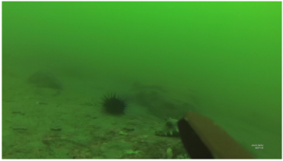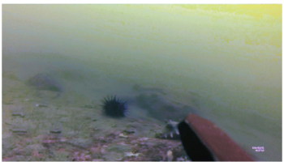
- Original image and enhanced image using FUnIE-GAN
method | echinus | holothurian | scallop | starfish | mAP
Original | 0.865 | 0.834 | 0.834 | 0.812 | 0.843
Enhanced | 0.88 | 0.835 | 0.843 | 0.801 | 0.854

- Target detection results of original and enhanced images under URPC2020 based on Yolov7
After adding the CBAM attention mechanism and wise-iou to yolov7, the detection effect has been significantly improved. Compared with yolov5-m, the map value has increased by 3.9%, as shown in the table below.The parameters of yolov5-m and the improved yolov7 are not much different, but the detection effect is indeed significantly improved.
Method | precision | recall | map
yolov5-m | 0.856 | 0.79 | 0.823
YOLOV7 | 0.84 | 0.807 | 0.843
Yolov7-CBAM-Wise-iou | 0.834 | 0.815 | 0.862
- Target detection results of Yolov5-m and improved Yolov7
The result curves of improved Yolov7 are shown in the following figure,The superiority of the improved algorithm is verified.
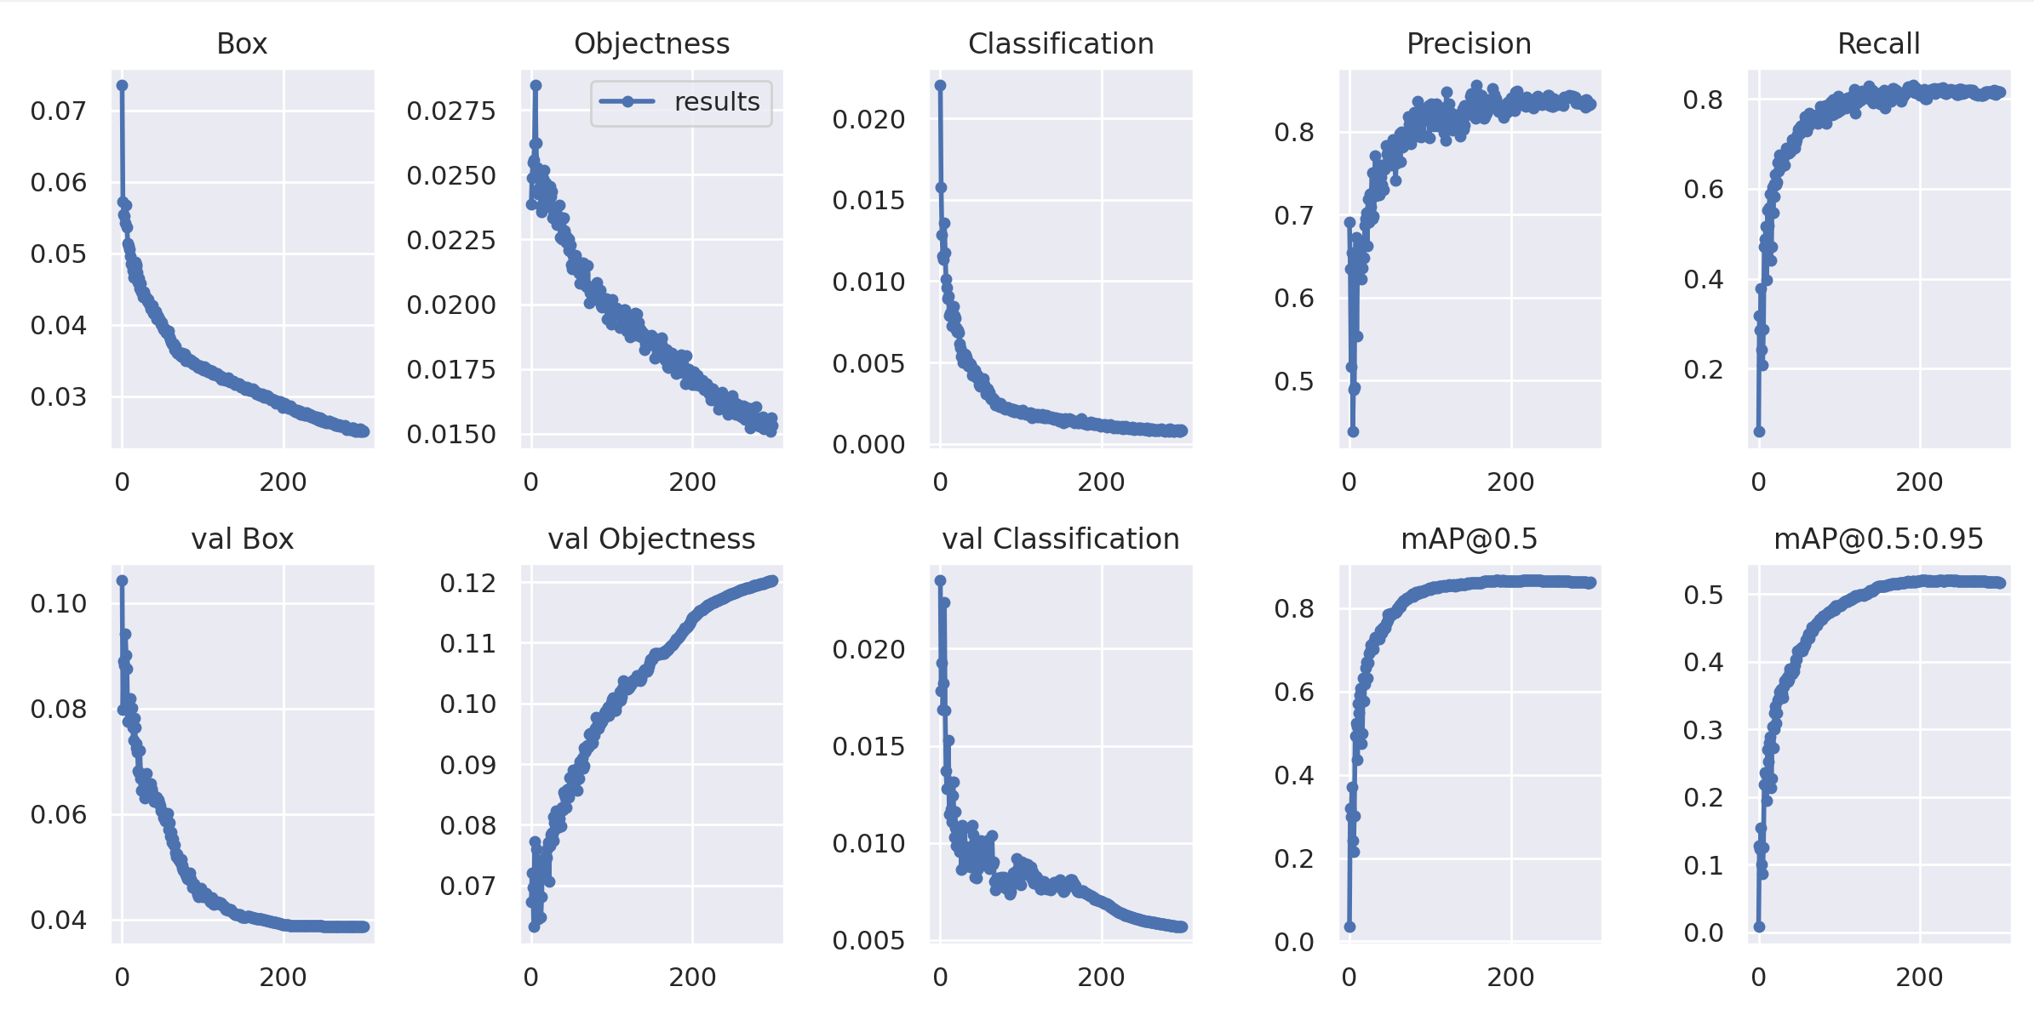
- The result curves of improved Yolov7
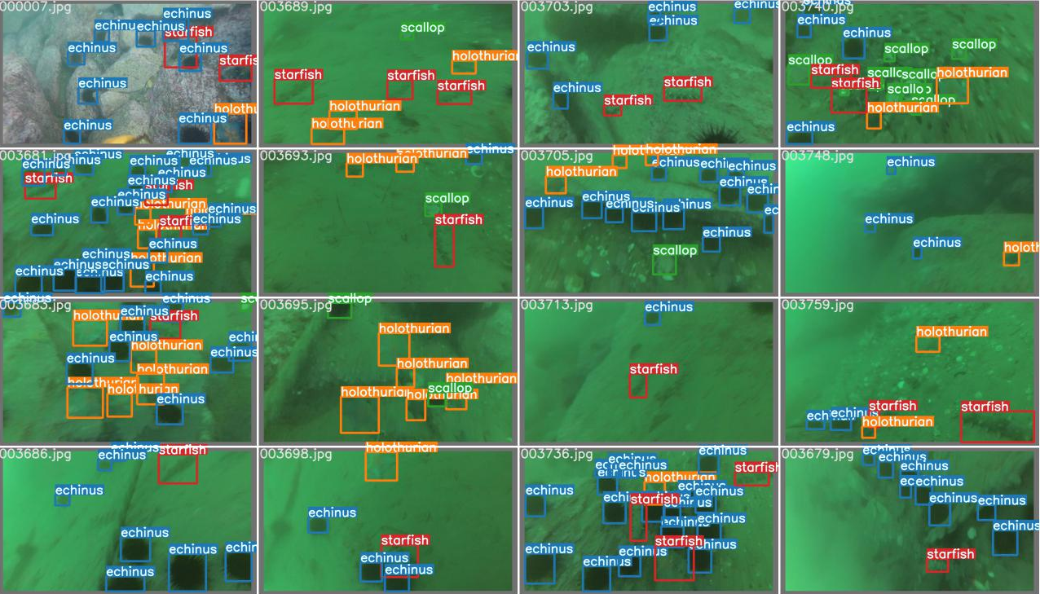
- The detection result of improved Yolov7
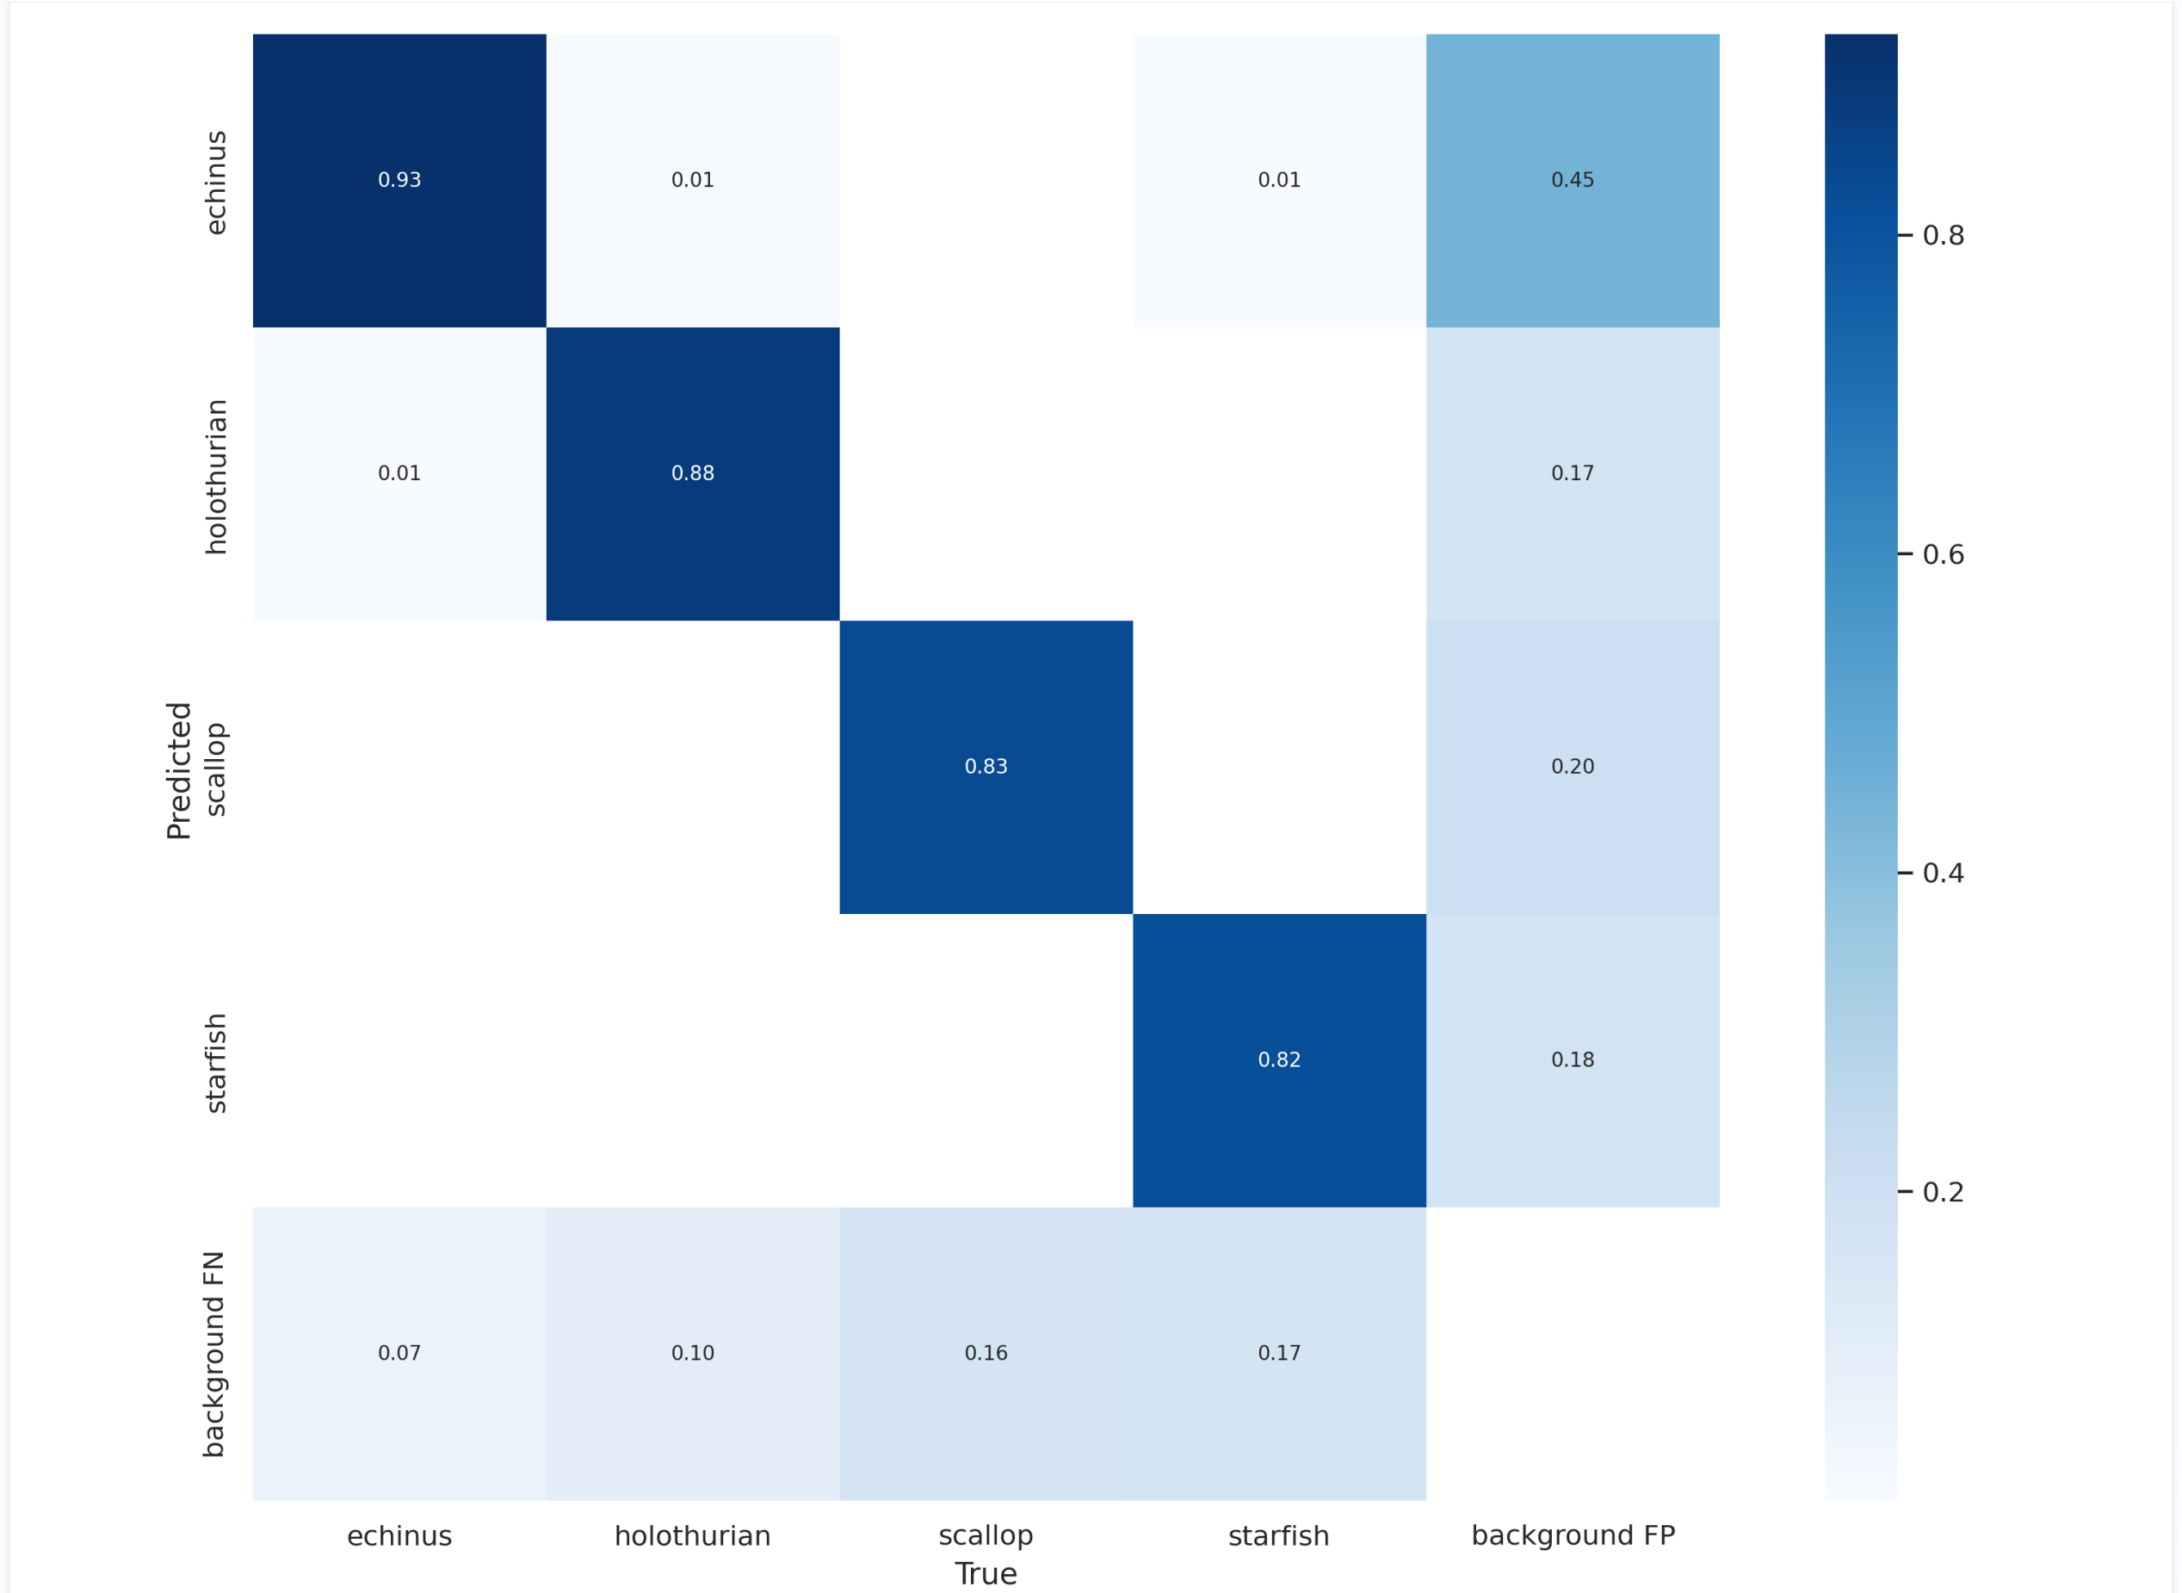
- The confusion_matrix result of improved Yolov7

Conclusion
The underwater environment has a large number of biological and mineral resources, and resource collection in the underwater environment is more dangerous, and underwater robots can explore the underwater environment instead of humans. Underwater target detection is one of the problems that need to be solved in underwater robot operation. There are many problems in the underwater environment, such as the scale of the detected objects in the water varies greatly, the organisms in the water are easy to gather resulting in the overlap of the detected objects in the picture, the image quality degradation caused by the refraction and scattering of the light in the underwater environment, and the difficulty of collecting the underwater marker pictures. Aiming at these problems by optimising the target detection network, certain results have been obtained.
Aiming at the problem of small scale of the detected object in underwater target detection, this paper proposes an upper and lower two-layer feature fusion network and a multi-layer feature cross-fusion network using an attention module. The way of simply fusing the features of two adjacent layers of the feature pyramid does not establish the relationship between the layers well. The two feature fusion approaches proposed in this paper use the attention mechanism and the feature attention module can effectively utilise the fusion relationships, channel information and pixel information of different feature layers to obtain information-rich features. CBAM attention mechanism can improve the problem of small scale of the detected object.
Aiming at the problem of overlapping detected objects in underwater target detection, this paper proposes a localisation-quality target detection network with localisation loss added to the candidate frame generation and regression localisation network. In the non-maximum suppression process in the target detection network, the frame with the largest classification score among the overlapping frames is preferentially retained, which causes the detector to pay more attention to the category accuracy and neglect the localisation quality. The network proposed by Wooden uses centrality loss function and IoU loss function in candidate frame generation and regression localisation network to suppress bad quality detection frames and obtain more quality candidate and localisation frames. Finally, it is validated on URPC2020 dataset , the results show that:The average detection accuracy of the localisation quality network on URPC2020 dataset is improved by 1.9% compared to the base yolov7 network.
This paper proposes an end-to-end network for target detection tasks in underwater optical images based on deep learning algorithms, and achieved good detection results through experiments. However, there are still deficiencies and further research is needed. For example, although the method in this paper has improved the detection accuracy, it is far from reaching the ideal height. The outlook for future work is as follows:
(1) Preprocess underwater images before detection to improve image quality. The poor image quality caused by the underwater imaging environment is an important factor affecting the accuracy of target detection. Therefore, improving image clarity, correcting chromatic aberration, and improving image resolution through certain processing methods will help to better complete target detection. Task. Image restoration technology is a method to restore image quality based on the principle of image degradation in the imaging process, which can mainly solve the problems of image blur, distortion and noise; super-resolution reconstruction technology can improve image resolution through interpolation, neural network and other methods.
(2) More underwater data sets need to be obtained. This article uses several conventional data augmentation methods during training. Using more data augmentation methods will help improve the training effect of the network. This article uses a combined data set containing more than 5,000 images, but this still cannot fully train the network for deep learning, so it is necessary to introduce more underwater image data. At the same time, the method in this paper performs well on the data set used in this paper, but the application effect for different targets and different environments is unknown. Therefore, introducing more underwater data sets can test the effect of the method in this paper in different scenarios, which is conducive to the development of the method. further improvement.

References
- Zhao,Z.Q;Zheng,P;Xu,S.T.; Wu, X. Object detection with deep learning. In Proceedings of the Computer Vision and Pattern Recognition(CVPR), Salt Lake City,UT,USA,18-23 June 2018.
- Sarkar, P; De,S;Gurung, S.A Survey on Underwater Object Detection. In Intelligence Enabled Researcht; Springer: Singapore,2022; pp.91-104.
- Jian, M; Liu, X.; Luo,H.; Lu,X.; Yu,H; Dong, J.Underwater image processing and analysis: A review.Sigonal Process. Lmage Commun. 2021,91,116088.
- Simonyan,K.; Zisserman, A. Very deep convolutional networks for large-scale image recognition.arXio 2014, arXiv:1409.1556.
- Zhao,Z.Q;Zheng,P; Xu,S.T; Wu,X.Object detection with deep learning. In Proceedings of the Computer Vision and Patter Recognition (CVPR),Salt Lake City,UT, USA, 18-23 June 2018.
- Tong, Z.; Chen, Y; Xu, Z.;Yu,R.Wise-loU: Bounding Box Regression Loss with Dynamic Focusing Mechanism. arXio 2023, arXiv:2301.10051.
- Sermanet,P; igen,D.; Zhang,X;Mathieu,M.; Fergus, R.;LeCun, Y.Overfeat: Integrated recognition, localization and detection using convolutional networks. arXio 2013, arXiv:1312.6229.
- Liu, Z; Zhuang,Y.; Jia,P; Wu,C;Xu,H; Liu, Z.A Novel Underwater Image Enhancement and Improved Underwater Biological Detection Pipeline.J. Mar. Sci. Eng. 2022,10,1204.
- Wang , C.Y; Bochkovskiy, A.; Liao,H.Y.M. YOLOv7: Trainable bag-of-freebies sets new state-of-the-art for real-time object detectors. arXiv 2022, arXiv:2207.02696.
- Li,Y; Bai,X; Xia,C.An Improved YOLOV5 Based on Triplet Attention and Prediction Had Optimization for Marine Organism Detection on Underwater Mobile Platforms. J. Mar. Sci.Eng. 2022,10,1230.
- Gholami A, Kwon K, Wu B, et al. Squeezenext: Hardware-aware neural network design[C]. Proceedings of the IEEE Conference on Computer Vision and Pattern Recognition Workshops, 2018: 1638-1647.
- Girshick R.Fast r-cnn[C]. Proceedings of the IEEE international conference on computer vision, 2015:1440-1448.
- Wang Y, Zhang J, Cao Y, et al. A deep cnn method for underwater image enhancement[C]. 2017 IEEE International Conference on Image Processing (ICIP),2017: 1382-1386.
- Liu, Z.; Zhuang, Y.; Jia, P.; Wu, C.; Xu, H.; Liu, Z. A Novel Underwater Image Enhancement and Improved Underwater Biological Detection Pipeline. J. Mar. Sci. Eng. 2022, 10, 1204.
- Wang, C.Y.; Bochkovskiy, A.; Liao, H.Y.M. YOLOv7: Trainable bag-of-freebies sets new state-of-the-art for real-time object detectors. arXiv 2022, arXiv:2207.02696.
- Zhu, X.; Lyu, S.; Wang, X.; Zhao, Q. TPH-YOLOv5: Improved YOLOv5 based on transformer prediction head for object detection on drone-captured scenarios. In Proceedings of the IEEE/CVF International Conference on Computer Vision, Montreal, BC, Canada, 11–17 October 2021; pp. 2778–2788.
- Tong, Z.; Chen, Y.; Xu, Z.; Yu, R. Wise-IoU: Bounding Box Regression Loss with Dynamic Focusing Mechanism. arXiv 2023, arXiv:2301.10051.
- Woo, S.; Park, J.; Lee, J.Y.; Kweon, I.S. Cbam: Convolutional block attention module. In Proceedings of the European Conference on Computer Vision (ECCV), Munich, Germany, 8–14 September 2018; pp. 3–19.
- Xie K,Pan W,Xu S. An underwater image enhancement algorithm for environment recognition and robot navigation[J]. Robotics, 2018,7(1): 14.
- Sung M, Yu S C, Girdhar Y. Vision based real-time fish detection using convolutional neural network[C]//OCEANS 2017-Aberdeen.IEEE, 2017: 1-6.
- Tian z,Shen C, Chen H, et al. Fcos: Fully convolutional one-stage object detection[C]V/Proceedings of the IEEE international conference on computer vision.2019: 9627-9636.
- Zhang S,Chi C, Yao Y, et al.Bridging the gap between anchor-based and anchor-free detection via adaptive training sample selection[C]//Proceedings of the IEEE/CVF Conference on Computer Vision and Pattern Recognition.2020: 9759-9768.
- Zhao Q,Sheng T, Wang Y, et al. M2det: A single-shot object detector based on multi-level feature pyramid network[C]//Proceedings of the AAAI Conference on Artificial Intelligence.2019,33:9259-9266.
- Pedersen M, Bruslund Haurum J, Gade R, et al. Detection of marine animals in a new underwater dataset with varying visibility[C]. Proceedings of the IEEE/CVF Conference on Computer Vision and Pattern Recognition Workshops,2019.2019: 18-26.
- [67] Fan B,Chen w,Cong Y, et al. Dual Refinement Underwater Object Detection Network[M].Proceedings of the 16th European Conference on Computer Vision，Cham:Springer International Publishing, 2020,275-291.
- Liu H, Song P, Ding R.Towards domain generalization in underwater object detection[C]. 2020 IEEE International Conference on Image Processing (ICIP), 2020.IEEE,2020:1971-1975.

故
注14
天将降大
任
注15
于
是
注16
人也
，
必
注17
先
苦
注18
其
心志
注19
，
劳
注20
其筋骨

