13/05/2019
Student ID : 1702871

Data Handling
Ruby Khatun


Tables of contents
  - Introduction……………………………………………………………………………..2

  - Report Remit……………………………………………………………………………..2
2.0 Main findings……………………………………………………………………………..2
2.1 Pivot Table……………………………………………………………………………..2
2.2 IF Statement……………………………………………………………………………..3-4
2.3 Look Up……………………………………………………………………………..4-5
2.4 Strengths and weaknesses of Excel……………………………………4-5
3.0 Part 2……………………………………………………………………………..
3.1 Prediction, association and clustering definition ………….5
3.2 Prediction Sarn Helen Data Set……………………………………5-6
3.3 Association Sarn Helen Data Set………………………………..6
3.4 Clustering Sarn Helen Data Set………………………………..6-8
4.0 Conclusion…………………………………………………………………8
5.0 Recommendations ……………………………………………………8
6/0 Biblography……………………………………………………………..9

- Introduction
1.2 Report Remit
This report will be looking into two various data mining software’s which will be Microsoft excel and also Weka. In 2017 by Sarn Helen Office noticed a reduction in profit this is why the company has engaged with a data analytics company to support them to analyse the data that they have and deliver recommendations on how they can stay involved with analytics in the upcoming future to have better decision-making process. This report will be split into two parts. The writer will provide a spreadsheet made by Microsoft excel showing the handling of data. Throughout this report there will be screenshots to provide the differences of two of the data mining programs.
  - What is Data Mining
Data mining is the procedure of organising through big data sets to recognise patterns and create relations to resolve complications through data analysis. Data mining tools let enterprises to foresee upcoming movements (Rouse, n.d.).

  - What is Microsoft Excel
Microsoft Excel is a spreadsheet program. It is used to make grids of text, numbers and formulas stipulating controls. That's very important for numerous businesses, which use it to record costs and income, plan budgets, chart data and briefly show existing economic consequences.
- Main Findings
2.1 Pivot Table

This table shows that there are a lot of profit and losses in all five areas. These five areas are Dyfed, Mid Glamorgan (MG), South Glamorgan (SM) and West Glamorgan (WM). It shows that ‘bookcases’ are losing a lot of money through three areas which are MG, SM and WM the grand total these 3 regions have lost is £-14309.9. SM is losing profit on ‘Computer Peripherals’ they have lost £-312.85. Dyfed has lost a total of £-148.68 on Copiers and Fax and also MG has lost £-6511.61. it shows that all four areas have lost profit in ‘Scissors, Rulers and Trimmers and also ‘Tables’. The grand totals are all positive in all four regions. Figure 2.1.1 shows a lot of minuses that need to be fixed so Sarn Helen data need to turn the out comes to positive.

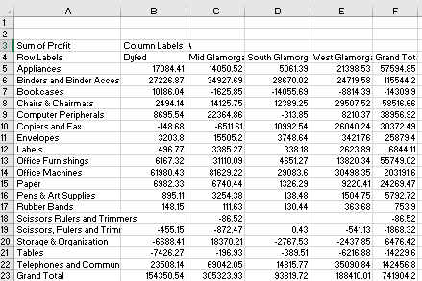

Figure 2.1.1

Figure 2.1.2
2.2 IF Statement
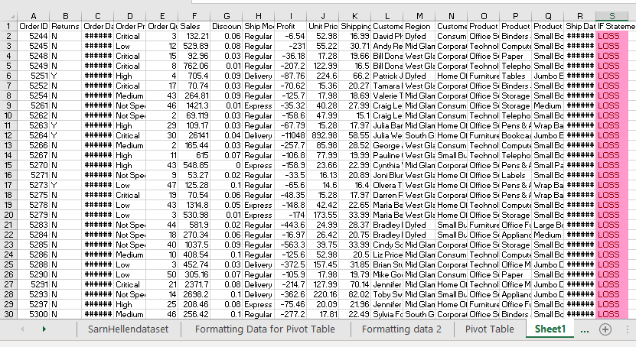
Figure 2.2.3 shows that there is 1638 losses and it shows that is 1921 profit. If the company do not fix the problems the company is facing the losses will soon catch up which therefore make the company struggle to get back on track.
2.3 Look Up
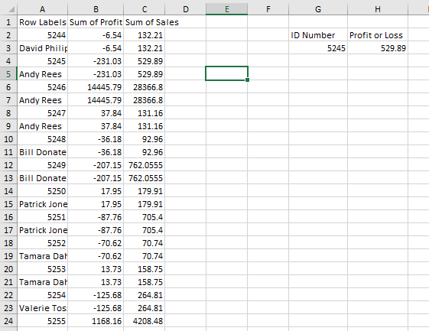
Figure 2.3.4 shows that there was 102 losses and 102 profits for customers. This shows that throughout this spreadsheet it shows that the data was even, however they should work on more profits within the future.
2.4 Strengths and weaknesses of Excel
The advantage of Excel is its main purpose: The capability to establish large quantities of data into arranged, logical spreadsheets and charts. With the data organised, it's easier to examine and digest, when used to make graphs and other graphic data representations (Foster,2018).
The weakness of Excel is it is very time consuming as you have to enter data manually into excel. As it takes a long time depending how much data you need to process it can be very inefficient, therefore this can lead to boredom and also potentially costly inattentiveness (Foster,2018).
3.0 Part 2
3.1 Prediction, association and clustering definition
Predictive analytics intentions to recognise the possibility of upcoming events based on past data. By using mathematical algorithms and machine learning technology, predictive analytics has the possibility to deliver an evaluation of what will happen. it provides a view of what’s happening and what should be done to do well. This can be used within a business so companies can see customers purchasing patterns so they can use it for future references (insideBIGDATA., n.d).

Association is a rule-based machine learning technique for learning thought-provoking relations among variables in big databases. It is planned to recognise solid rules exposed in databases using some events of interestingness. This regulation method also produces new guidelines as it examines more data. The final goal, supposing a big enough dataset, is to benefit a machine impersonate the human brain’s feature extraction and abstract association abilities from new unspecified data (DeepAI, n.d.). Companies use association guidelines to make programs inempt of machine learning.
Clustering is a Machine Learning method that includes the assemblage of data points. A set of data points, we can use a clustering process to classify each data point into an exact set. Data points that are in the similar set should have comparable properties, but data points in another group should have extremely different properties. Clustering is a technique of unconfirmed knowledge and is a mutual method for numerical data analysis used in numerous areas (Seif, 2018). Organisations collect valuable evidence. Data mining software examines the associations between and forms within data.
.
3.2 Prediction - Sarn Helen data set
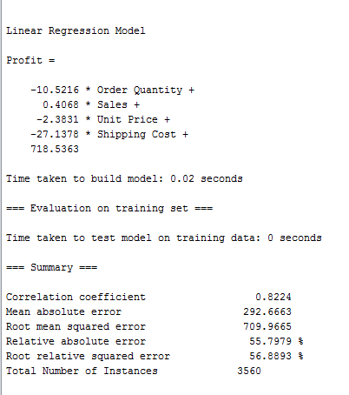
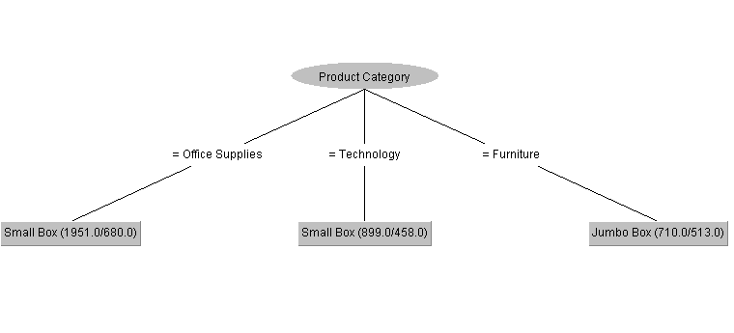
Figure 3.2.1 shows the errors that occurred within this picture. It shows that both office and technology supplies were in a small box and furniture was in a jumbo box.
3.3 Association - Sarn Helen data set

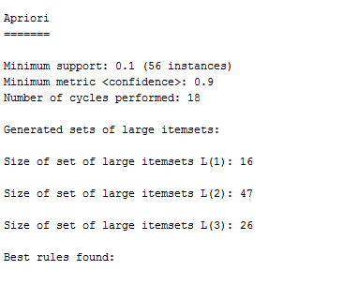
Figure 3.2.2 shows that there were 56 instances and 18 cycles were performed. This therefore made large groups of Item sets. Group 1 had 16, group 2 had 47 and finally group 3 had 26. The figures show that group 2 had the most item sets.
3.4 Clustering - Sarn Helen data set
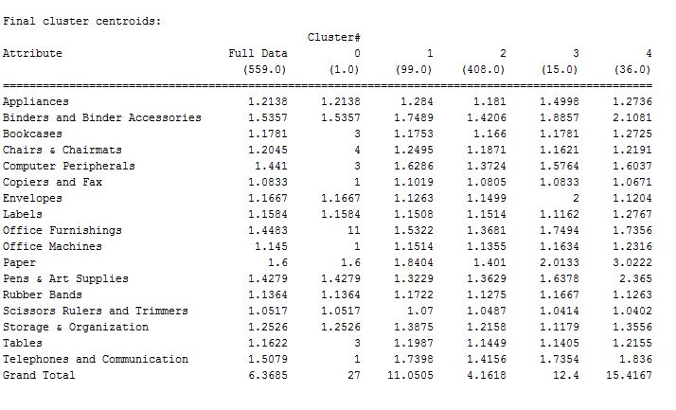
Figure 3.4.3 shows that this diagram above created five groups which we are able to see their purchasing records. As you can see group 0 has purchased the most appliances within all five groups. This is helpful for Sarn helen as they are able to see what groups are buying what which will therefore push them to sell more products that may not be selling well.
- Conclusion
To conclude this report, it has shown how Microsoft excel is a helpful tool within many companies but there are also downsides to this application as you can make mistakes for example using the wrong formulas. Weka is now being used more in many companies because Weka is a group of machine learning procedures for data mining tasks.
- Recommendations
I recommend that companies should use Weka more often as excel is a long process. Weka helps many businesses as it is a faster tool and it learns different algorithms for many data tasks. The algorithms can also be applied straight to a dataset.

6.0 Bibliography
DeepAI. (n.d.). Build with AI | DeepAI. [online] Available at: https://deepai.org/machine-learning-glossary-and-terms/association-learning [Accessed 13 May 2019].
Rouse, M. (n.d.). What is data mining? - Definition from WhatIs.com. [online] SearchSQLServer. Available at: https://searchsqlserver.techtarget.com/definition/data-mining [Accessed 12 May 2019].
Seif, G. (2018). The 5 Clustering Algorithms Data Scientists Need to Know. [online] Towards Data Science. Available at: https://towardsdatascience.com/the-5-clustering-algorithms-data-scientists-need-to-know-a36d136ef68 [Accessed 13 May 2019].
insideBIGDATA. (n.d.). Data Mining and Predictive Analytics: Things We should Care About - insideBIGDATA. [online] Available at: https://insidebigdata.com/2018/11/24/data-mining-predictive-analytics-things-care/ [Accessed 13 May 2019].
Foster, D. (2018). Disadvantages of Using Microsoft Excel. [online] Techwalla. Available at: https://www.techwalla.com/articles/disadvantages-of-using-microsoft-excel [Accessed 13 May 2019].

