Links between poverty and educational attainment

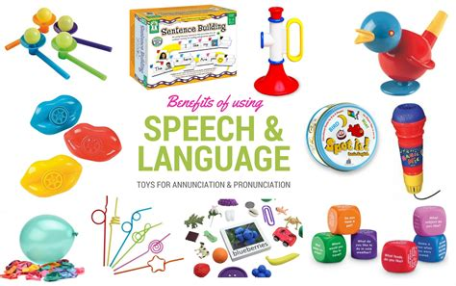

Poverty has a major impact on education achievement in Wales. The indicator for this is the percentage of children who receive free school meals who are living in poverty. On average it is about 17% of children in Wales (JRF, 2013).



Bibliography
Bowen, S. (1998) Speech language therapy. Available at: http://www.speeh-language-therapy.com [Accessed: 1 October 2016].
Dunlap, L.L. (2014) Possible causes for developmental delays. Available at: http://www.education.com/pdf/possible-causes-developmental-delays/ [Accessed: 1 October 2016].
Goodman, A. & Gregg, P. (2010) The Importance of Attitudes and Behaviour for Poorer Children’s Educational Attainment. York: JRF
Hirsch, D. (2007) ‘Education, poverty and children’s perspectives’. JRF Round-up (September 2007, Ref: 2123)
Horgan, G. (2007) The Impact of Poverty on Young Children's Experiences of School. York: JRF
Issa, T. and Hatt, A. (2012) Language, culture and identity in the early years. London: Bloomsbury USA Academic.
Law, J., Todd, L., Clark, J., Mroz, M. and Carr, J. (2013) EARLY LANGUAGE DELAYS IN THE UK. Available at: http:// www.ncl.ac.uk/cflat/news/documents/Lawetal2013EarlyLanguageDelaysintheUK.pdf [Accessed:1 October 2016].
Levitas, R. (2005) The inclusive society? Social exclusion and new labour, Basingstoke: Palgrave Macmillan
Lovelylisa135 (2009) LIFE IN THE WOMB BEFORE BIRTH senses hearing and touch part . Available at: https://m.youtube.com/watch/v=lxC2X2QqYJc [Accessed: 1 October 2016].
Mansell, W. (2010) Poor children a year behind in language skills. Available at: https://www.theguardian.com/education/2010/feb/15/poor-children-behind-sutton-trust [Accessed 1 October 2016].
Perkins, S.C., Finegood, E.D. and Swain, J.E. (2013)”Poverty and language development: Roles of parenting and stress,” 10 (4).
Riley, J. (2006) Language and literacy 3-7: Creative approaches to teaching. London: Paul Chapman Educational Publishing.
Spicker, P. (2007) The Idea of Poverty, Bristol: Policy Press
The Save the Children Fund (2015) Ready to read closing the gap in early language skills so that every child in England can read well. Available at: https://www.savethechildren.org.uk/sites/default/files/images/Ready_to_Read_England.pdf#page41 [Accessed 1 October 2016].
Terms, P.I. (2016) The effect of poverty on language development. Available at: https://prezi.com/m/wcumrmffjccp/the-effect-of-poverty-on-language-development/ [Accessed: 1 October 2016].
The, R. of (2016) Speech and language delay and disorder: Your child: University of Michigan health system. Available at: http://www.med.umich.edu/yourchild/topics/speech.htm [Accessed: 1 October 2016].
Waldfogel,J & Washbrook, E ( 2010) Low income and early cognitive development in the UK. Available at: http://www.suttontrust.com/research/low-income-and-early-cognitive-development-in-the-uk/ [Accessed: 25 August, 2018].
Welsh government (2016) Available at: http://gov.wales/topics/people-and-communities/people/parenting-support-guidance/help/flyingstart/?lang=en [Accessed: 1 October 2016).
Whitehead, M.R. (2004) Language and literacy in the early years. 3rd edn. London: Sage Publications.

