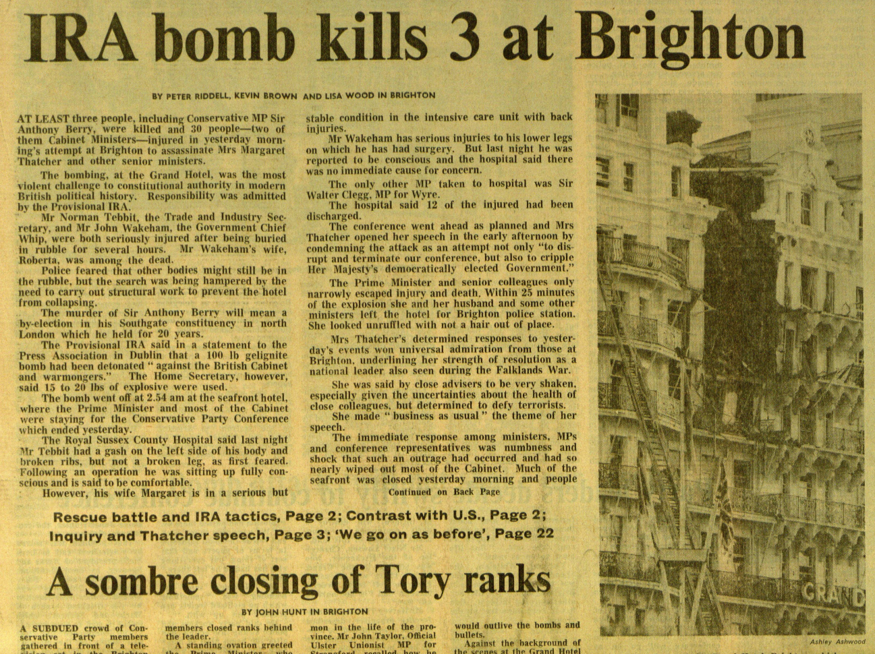
Primary Source Analysis

For the primary source analysis I have chosen the front page Financial Times article detailing the Grand hotel Brighton bombing by the Provisional Irish Republican Party (IRA) in October 1984. The incident discussed in this article was part of the IRA activities in England, and during the turbulent Northern Irish Troubles period of 1966 until 1998. During the 1970s and 1980s, the IRA were their most active, with regular bombings all over the UK, most of which targeted large towns and cities within England, with the majority aimed at civilians; very few military bases were targeted. However, the 1984 Grand Hotel Brighton bombing was aimed at politicians of the party in power, the Conservatives under Margeret Thatcher. The article was written by in house Financial Times journalists Peter Riddell, Lisa Wood and Kevin Brown. It was published the day after the explosion, on 13th October 1984. For the purpose of this essay, the final paragraph that ends mid-sentence is irrelevant, however the picture is included in this analysis.
Peter Riddell, the main writer, was a respected journalist as of 1984, and in years following the publication of the article, Riddell was also an author of factual books. Riddell’s work includes several book published on Thatcher about her tenure, as well as her legacy in the years since, and continued to write political books about Tony Blair. Although at the time of the Financial Times article, Riddell was the political editor, a role he had since 1981. Previously, he was an economics reporter with the Financial Times. Since writing the article, Riddell has achieved a CBE and was appointed as the Commissioner for Public Appointments in 2016. Despite the continuing importance of Riddell, neither Lisa Wood nor Kevin Brown are reporters of much fame.
The picture that accompanies the article was taken by celebrated Financial Times photographer Ashley Ashwood. Ashwood was famous for his pictures of leading political figures of the 1980s and 1990s both of Britain, and around the world. Due to his prominence as the staff photographer for the Financial Times, he was well travelled, although occasionally such jobs landed him in trouble; he was deported from Lagos in 1993 as a direct result of his political affiliations. At the time of the 1984 terror attack, Ashwood was the principal political photographer for the Financial Times, therefore would have been sent alongside key political reporters due to the nature of the incident. The picture used is printed in black and white, as the Financial Times were printing in monochrome on its iconic pale pink paper stock. It was not until years later that the Financial Times started printing full colour pictures, although even to this day, they still print on pink paper, therefore the colours of the photos would be tinted. The fact that it is a monochrome photographs means that it does not show the full extent of the damaged Grand Hotel building. Therefore, the section most damages and missing, and due to either side remaining intact, as well as the burnt nature, appears as an almost solid black mark, and one cannot see the remaining floor sections.
The article was published Saturday 13th October 1984, the day following the bomb detonation. The newspaper would have gone to print around 11pm on Saturday 12th, ready to be printed and delivered for Saturday morning. Therefore the information used was not finalised as it had been less than 24 hours since the blast. Although some of the language used clearly demonstrates the initial attitudes and sentiments towards the incident. It states that “the bombing … was the most violent challenge to constitutional authority in modern British political history”, which clearly states the significance of the bomb and what it means for the future and how it will be viewed in the past. It also recognises the fact that the IRA would be considered an unconstitutional organisation, akin of nothing but terrorists far removed from civil democracy.
The bomb was planted in Margaret Thatcher’s en-suite in The Grand Hotel on the Brighton sea front. It went off just before 3am on Friday 12th October, the morning of the official opening of the Conservative’s Party Conference. The IRA new that the hotel would once again be used, and even could predict which room Thatcher would stay in, based on the presumption she would be in the same room as previous, with similar security arrangements. The conference was held at the Grand Hotel two years previous; the IRA had access to details of the rooms used. During 1983, IRA members stayed at the hotel to learn its internal configurations. The hotel seemed an obvious target to the IRA, after all, that weekend saw a considerable amount of MP’s and Ministers staying under one roof, as well as plenty of civilians who were attending the conference. The fact that Thatcher was also staying on site meant that the Prime Minister could have been assassinated. If it was not for Thatcher’s lucky escape, the face of British politics today could be completely different, 1985 was only five years into Thatcher’s 12 year tenure, as well as the 18 years of Conservative government.
The Conservative’s Party Conference is a yearly event, and is usually held in October, and they often hold a Spring Forum around April. The October event is the biggest, usually attended by current MP’s, local Association members, Young Conservatives, general members as well as businesses and other exhibitors. Therefore, as well as high profile politicians, there were also a large amount of civilians, meaning that the IRA could target a large proportion of, generally speaking, Irish unionist supporters. However, the fact that the bomb was set in Thatcher’s hotel room’s bathroom, demonstrates clearly that the politicians were the target; if the IRA wanted to cause wider damage, they could have set the bomb in the main conference hall where almost all attendees would be and not in the hotel where the majority of politicians were residing.
One of the biggest issues during the immediate rescue operations was to what extent the structure of the hotel had been damaged. This caused a delay in evacuation as well, after all, one does not want initial responders to be hurt if the hotel further collapsed. Luckily, the hotel remained largely intact due to its high standard of building during the Victorian times. Only the immediate area surrounding the bomb, and only 8 floors were badly affected. The rebuilding work took two years to complete. The picture accompanying the article shows the extent of the damage, but also how localised it was, one can clearly see how many balconies have remained intact. It is unclear how soon after the blast this photo was taken, although presumably several hours as it appears to be daylight.
Despite thorough security sweeps of the venue, the bomb remained undetected. The bomb had been planted three and a half weeks earlier. It was placed by Provisional IRA member Patrick Magee, who was found to be staying at the hotel under the pseudonym Roy Walsh. Magee stayed at The Grand Hotel between the 14th and 17th September 1984 with the sole purpose of placing and priming the bomb. Magee, supposedly, had learned about the creation and delayed destination of bombs from a Libyan terrorist. Indeed, he had the technology to create a detonation timer for 24 days. The bomb used was one of the larger, more powerful ones. The IRA had a penchant for letterbox and car bombs, often targeting civilian hotspots, indeed Harrods was a frequent target. Although the Brighton hotel bomb was not the biggest, most damaging of the IRA. The most severe is in fact the 1996 Manchester Corporation Street bomb, of which the damage was so severe, more or less the entire area in front of the Corn Exchange was rebuilt, with the exception of a single post box that survived the explosion and is still in use today and also acts as a memorial.
Magee was imprisoned on several counts of murder, but was released early from prison as a result of the Good Friday Agreement in 1999. Whilst imprisoned, Magee earned a PhD and he was studying how the Troubles had been portrayed in literature. Upon his release from Northern Irish prison Long Kesh (or HM Prison Maze) in Belfast, many showed their outrage over Magee’s release. Even Blair described Magee’s release as ‘’unpalatable’’ alongside many other officials from the time. Despite the outrage at Magee’s release, others demonstrated their forgiveness, including Jo Berry (daughter of Anthony Berry MP, one of the first announced dead) and the manager of the Grand Hotel in Brighton, who even stated that Magee was more than welcome back to the hotel as a paying guest!
This particular newspaper report was written only hours after the bomb went off. It states ‘‘at least three people … were killed’’, when in fact there were five deaths as a direct result of the initial blast and injuries acquired. However, the article only gives two names of those murdered; Sir Anthony Berry and Roberta Wakeman; it does not specify who the third known death was. Since the article’s publication, the three remaining victims were named: Lady Muriel Maclean, Lady Jeanne Shattock and Eric Taylor. As the article mentions, the only constituency who had to elect a new MP was Southgate in London, a role of which Berry held for 20 years previous. The inaccuracies in the article are a result of how soon it was written after the event before all the details were available.
The Financial Times is a trusted, British newspaper that is published globally. Its origins are as a broadsheet, first published in 1888 as the London Financial Times. Although, in 1984 it was only published in Britain and Germany, it was not until 1985 that the Financial Times started publishing in America, then in later years America had their own version with different articles to that of the British. Throughout the 1980s, the Financial Times supported the Conservative Party, therefore a large proportion of their readers would be Tories and support Thatcher, therefore would have been horrified to read about such a violent attempt on her life, and dismayed at the death toll of respected Conservative members and their spouses. In 1984, the paper’s chief editor was Sir Geoffrey Owen and throughout the 1980s endorsed the Conservatives and Thatcher’s leadership and policies.
January 1984 also saw the creation of the Financial Times and London Stock Exchange top 100 market share companies, more commonly known as the FTSE100, which meant that those working in the newly modernised stock companies would have been part of the Financial Times readership, of which many would have been considered to be Yuppies within the social context of 1984. Therefore, in October 1984 the Financial Times would consist of a largely educated and well off readership.
The bombing was reported worldwide, indeed, it made the front cover of the New York Times also on October 13th, the day after the incident. The fact that reports of the attack dominated front pages on worldwide newspapers is a testament to the bombing’s prominence in (then) current affairs, but also of its importance within British, and world, history.
1984 was, politically, a very turbulent year. The Miner’s Strike dominated politics. The strike started in March of 1984, and lasted until March 1985, therefore would have been in full swing at the time of the IRA bomb in Brighton. The Miner’s Strike would have been influential to Ireland, as many of the workers were sons of Irish emigres who fled Ireland in search of better, and regular work during the 1920s. Many of the Irish descendant miners were concentrated around Rotherham in South Yorkshire. However, there were no affiliate links between the striking miners and the IRA. The ongoing Northern Irish Troubles, coupled with the Miner’s Strike would have been stressful, to say the least, for Thatcher and the British government, as well as Irish officials. Despite the many inflictions of that year, 1984 was also the year in which satirical TV series Spitting Image (Central Independent Television) first aired; a programme that continuously parodied British and Irish political figures until 1996 and offering some light relief of the rather serious nature of everyday life. Two of Ireland’s most prominent political figures during the Troubles, Reverend Ian Paisley, founder and leader of the Democratic Unionist Party and Gerry Adams of Sinn Fienn appeared regularly in sketches. After 1988, Spitting Image often parodied the BBC ban of using the voices of IRA members, including Adams, often by using a completely different voice e.g. female, over a puppet sketch.
In conclusion, the Financial Times front page article reporting on the IRA bomb at the Grand Hotel in Brighton, published on October 13th 1984 was a significant newspaper report detailing an important event in British and Irish history. The bombing was one of such importance due to the fact that it could have changed the course of British political history for good, but luckily Thatcher was unhurt in the incident. Owing to the article’s publication in the Financial Times, a respected broadsheet newspaper, demonstrates the importance of the facts; it was not a sensationalised tabloid article, although the news was also front page in that days tabloids. The urgent nature of the publication meant that some of the facts were wrong, where details were not fully known yet, or disclosed to the press, therefor accounting for the inaccuracies throughout the article.

References:
Apple Jr, R. W., I.R.A. SAYS IT SET BOMB THAT RIPPED THATCHER'S HOTEL (1984) <https://www.nytimes.com/1984/10/13/world/ira-says-it-set-bomb-that-ripped-thatcher-s-hotel.html> [accessed 20 May 2021].
Audley, Fiona, 30 year anniversary of the end of British miners' strike (2015) <https://www.irishpost.com/news/30-year-anniversary-end-british-miners-strike-42814> [accessed 20 May 2021].
BBC, 1984: Tory Cabinet in Brighton bomb blast (2008) <http://news.bbc.co.uk/onthisday/hi/dates/stories/october/12/newsid_2531000/2531583.stm> [accessed 18 May 2021].
BBC, Outrage as Brighton bomber freed (1999) <http://news.bbc.co.uk/1/hi/uk_politics/375092.stm> [accessed 20 May 2021].
BBC, Patrick Magee: The IRA Brighton bomber (1999) <http://news.bbc.co.uk/1/hi/uk/301223.stm> [accessed 20 May 2021].
Bower Bell, J, The Irish Troubles: A Generation of Violence (Dublin: Gill and Macmillan Ltd, 1994).
Edgerton, Gary, 'Quelling the "Oxygen of Publicity": British Broadcasting and "The Troubles" During the Thatcher Years', Journal of Popular Culture, 30.1, (1996), 115-131.
Hancock, Matt, Commissioner for Public Appointments appointed: Peter Riddell (2016) <https://www.gov.uk/government/news/commissioner-for-public-appointments-appointed-peter-riddell> [accessed 18 May 2021].
London Stock Exchange, FTSE 100 (2021) <https://www.londonstockexchange.com/indices/ftse-100> [accessed 20 May 2021].
Magee, Patrick, Patrick Magee: my Troubles with fiction (2015) <https://www.irishtimes.com/culture/books/patrick-magee-my-troubles-with-fiction-1.2400545> [accessed 19 May 2021].
Marsh, Peter, Photographer who put subjects at ease (2008) <https://www.ft.com/content/5c397d16-aeb2-11dd-b621-000077b07658> [accessed 19 May 2021].
McKittirick, David, McVea, David, Making Sense of the Troubles (Chicago: New Amsterdam Books, 2002).

McSmith, Andy, No Such Thing as Society: A History of Britain in the 1980s (London: Constable and Robinson Ltd, 2011).

media.info, Financial Times (2021) <https://media.info/newspapers/titles/financial-times> [accessed 18 May 2021].

Riddell, Peter, The Thatcher Era and its Legacy, 2nd edn (Oxford: Blackwell Publishers, 1993).
Somerville, Ian, Purcell, Andy, 'A history of Republican public relations in Northern Ireland from “Bloody Sunday” to the “Good Friday Agreement”', Journal of Communication Management, 15.3, (2011), 192-209.
Thatcher, Margaret, Cole, John, TV Interview for BBC (immediate reaction to Brighton Bomb) [“The conference will go on, as usual”] (1984) <https://www.margaretthatcher.org/document/105574> [accessed 20 May 2021].
Turner, Alwyn W., Rejoice! Rejoice!: Britain in the 1980s (London: Aurum Press Ltd, 2010).

Hancock, Matt, Commissioner for Public Appointments appointed: Peter Riddell (2016) <https://www.gov.uk/government/news/commissioner-for-public-appointments-appointed-peter-riddell> [accessed 18 May 2021].
Marsh, Peter, Photographer who put subjects at ease (2008) <https://www.ft.com/content/5c397d16-aeb2-11dd-b621-000077b07658> [accessed 19 May 2021].
Bower Bell, J, The Irish Troubles: A Generation of Violence (Dublin: Gill and Macmillan Ltd, 1994).
BBC, 1984: Tory Cabinet in Brighton bomb blast (2008) <http://news.bbc.co.uk/onthisday/hi/dates/stories/october/12/newsid_2531000/2531583.stm> [accessed 18 May 2021].
BBC, Patrick Magee: The IRA Brighton bomber (1999) <http://news.bbc.co.uk/1/hi/uk/301223.stm> [accessed 20 May 2021].
Magee, Patrick, Patrick Magee: my Troubles with fiction (2015) <https://www.irishtimes.com/culture/books/patrick-magee-my-troubles-with-fiction-1.2400545> [accessed 19 May 2021].
BBC, Outrage as Brighton bomber freed (1999) <http://news.bbc.co.uk/1/hi/uk_politics/375092.stm> [accessed 20 May 2021].
media.info, Financial Times (2021) <https://media.info/newspapers/titles/financial-times> [accessed 18 May 2021].
London Stock Exchange, FTSE 100 (2021) <https://www.londonstockexchange.com/indices/ftse-100> [accessed 20 May 2021].
Apple Jr, R. W., I.R.A. SAYS IT SET BOMB THAT RIPPED THATCHER'S HOTEL (1984) <https://www.nytimes.com/1984/10/13/world/ira-says-it-set-bomb-that-ripped-thatcher-s-hotel.html> [accessed 20 May 2021].
Audley, Fiona, 30 year anniversary of the end of British miners' strike (2015) <https://www.irishpost.com/news/30-year-anniversary-end-british-miners-strike-42814> [accessed 20 May 2021].

