15th April 2019 - 10th May 2019
Charlotte Allington
1703149 ¦ HPAR5003
A Placement at Creswell Crags
An Ice Age Heritage site in
Nottinghamshire

Contents
Introduction 1
The Crags 1
Placement Breakdown 3
Placement Log 3
Key Tasks in detail 3
Supervising Craft Sessions 3
Café 3
Taking down gallery 4
Shop Stock 4
Victorian week spreadsheet 4
Creating Marketing materials 4
Map investigation 4
Asset spreadsheet 4
Discussion 5
Education 5
Preservation 7
Promotion 8
Conclusion 10

Introduction

In the 1800s, an eagle-eyed quarry foreman spotted an artefact sticking out of the rubble, an artefact that would lead to a fascination that has never truly left the area.
This essay will explore the efficacy of Creswell Crags as a heritage site and how successful they are at achieving their stated aims. It will also provide an overview the activities undertaken during the placement.
The purpose of undertaking the placement module was to provide industry experience and to encourage a further understanding of the inner workings and challenges that face Creswell Crags.

The Crags

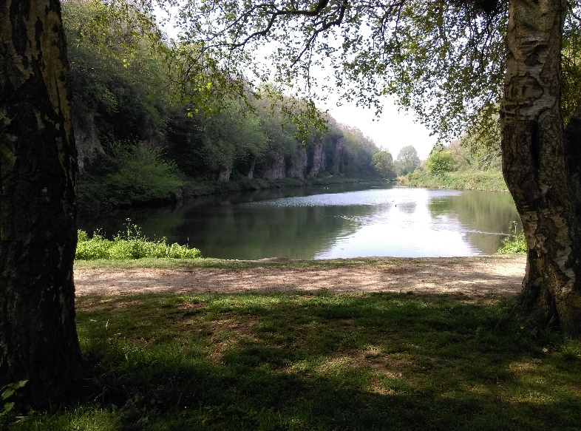
Creswell Crags are a series of 20 magnesium limestone caves lining a natural gorge. Along the middle of the gorge lies a manmade lake which straddles the boarder of Derbyshire and Nottinghamshire. The area has been used as a seasonal settlement since around 50,000 years ago in the Neolithic period, when the ice retreated far enough for it to be habitable, as evidenced by the stone tools left behind. This occupation pattern continued until the Bronze age, when the area became more used for burials and cremations. The Romans used it occasionally for camps. During the early medieval period, a small village was established in the meadow.
Figure 1: The Lake and the Crags
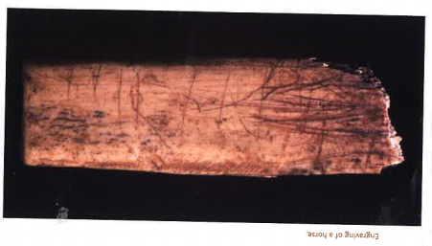
This village moved to the head of the gorge sometime in the 18th Century, although in the late 1860s, the 5th Duke of Portland who had recently purchased the land decided that the village spoiled his personal view. He moved the village, and later added the lake in order to thwart attempts to build a railway through the gorge. In the 1870s, the Duke gave the Antiquarians, including William Boyd-Dawkins, permission to excavate. The Antiquarians used highly destructive methods of excavation such as dynamite to uncover artefacts such as the famed Ochre Horse.
Figure 2: The Ochre Horse (Creswell Crags, 2018)
There was little attention given to the Crags until the 1980s, when the site was designated by English Nature as a Site of Special Scientific Interest (SSSI) due to its varied ecosystem and the first visitors centre was built. A few years later, it was also given the designation of Scheduled Ancient Monument. The Creswell Heritage Trust, the managing body of the site, was also formed around this time.
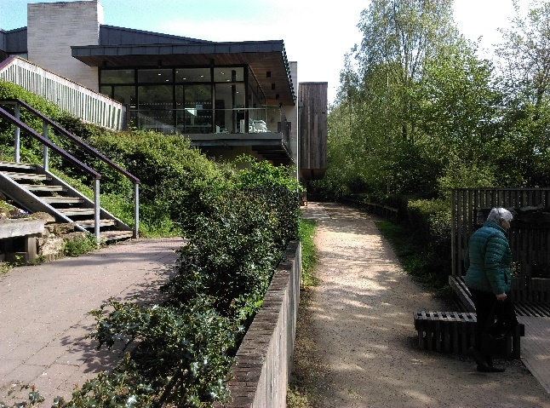
In 2003, Britain’s oldest rock art was discovered by Paul Bahn, Paul Pettitt and Sergio Ripoll. This led to a renewed interest and a road that ran through the Crags being diverted in order to protect the art.
Figure 3: The Visitors Centre Today
In 2009 the modern visitors centre was opened. An Ice Age Hyena Den was identified after bones were discovered at the back of Church Hole cave. The ever-developing nature of the Crags is displayed by the 2019 discovery of the Witch Marks in Church Hole cave. Found in January, just over 200 of these protective marks have been identified to date, making it the most numerous collections in Britain.

Time there

The placement was from 15th April 2019 to 10th May 2019. This fell over the final week of the Easter holidays, which provided the opportunity to experience all the visitor centred areas and practices of the site at one of their busiest times of the year. Time spent there during the placement period was thoroughly enjoyable, mostly due to the people there. The staff at the Crags, from the volunteers to the director himself were welcoming, friendly and enthusiastic about the site and their positions in it.

Placement Log

Below is the log kept during the placement to track the tasks undertaken during the 20-day period.
Table 1: Log of placement activities
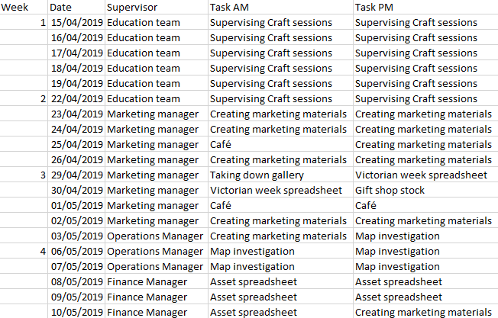

Key Tasks in detail

For clarity, the activities mentioned above are broken down below.

Supervising Craft Sessions
- Ice age animal mask making, colouring, Easter card making, pinwheel making
- Participants (excluding parents) ranged from 2 years to around 13 years old
- Average size of groups ranged from 2 to 25 participants
- Received enough donations to make a £20 profit after materials
- Run in conjunction with a site wide Easter Egg hunt
- Often had parents bringing children in after Egg hunt so they could rest

Café
- Worked either front of house or helping with clearing dishes/plates
- High intensity area
- Covered for staff sickness/absence
- Finance manager and fundraising officer also helped

Taking down gallery
- Aided outside vendor with dismantling and stock taking of local artists work
- Outside vendors regularly use the smaller gallery to display work
- Aided the vendor in checking off sold stock

Shop Stock
- Aided receptionist in processing and distributing the stock in the gift shop
- Receptionist unwell so was not able to do so alone

Victorian week spreadsheet
- Displayed progress on preparation for July’s Victorian week celebration
- Created to help Director be aware of planning stage
- Collating different documents to be easily read

Creating Marketing materials
- Utilised internet resource called Canva
- Created posters based on ‘Events’ page
- Later printed and put posters up around site

Map investigation
- Investigation aimed at finding a map within the library/archives to show Creswell Village before it was moved by 5th Duke of Portland
- At the request of University team that wished to excavate to locate the old village
- Asked by Operations manager to undertake task
- Located maps from 1700 displaying field boundaries, and of surrounding areas
- Could not find map specifically of the village

Asset spreadsheet
- Preparing and correcting asset list to be imported into asset management software (Sage)
- Spreadsheet previously filled in by staff
- Assets defined by Finance Manager as ‘Anything that isn’t nailed down’
- Required reorganising and quality assuring
- Showed the awareness of making the most of their assets as well as diligence in preserving and managing funds in a fiscally responsible way
- Maximised financial viability of improving revenue

Discussion

The aims of Creswell Crags are laid out on the Objectives and Activities page of their website. They are as follows;

‘The objectives of the charity as set out in the Memorandum of Association are that of promoting, for the benefit of the public, the conservation and preservation of the geology, archaeology, ecology and landscape in the Creswell Crags Heritage Area and the surroundings; of taking steps to secure the removal of inappropriate development from the Creswell gorge and at other sites the Trust is seeking to enhance and preserve; to advancing public education and promote research relating to the archaeological sites in the Area and to publish the useful results of that research; of providing or assisting in the promotion of facilities for the recreation and other leisure time occupations of those living, working or resorting in the area with the object of improving their conditions of life in the interests of social welfare.’

Through analysing the aims and objectives, they can be broken down into the themes of Education, Preservation and Promotion. While these points will cross one another, each will be considered and discussed separately.

Education

A key part of meeting the education goal is the site’s involvement with schools. Creswell Crags has benefitted greatly from the current KS2 curriculum (Department of Education, 2013), which requires teaching about the changes in Britain from the Stone Age to the Iron Age. In the example of what to include, an analogous site (Skara Brae) is mentioned (Department of Education, 2013).
The Crags has formed an education program around his which is very popular with the schools in the surrounding area. Their online availability page (last updated 18/4/19 at time of writing) shows that the rest of the school year is fully booked, while the September 2019 bookings are already heavily populated with schools.
The school education program is mainly aimed at KS2 children (years 3-6), although it is stated on their website that they are able to tailor programs to secondary school aged children (REF). The schools are able to book different packages (Crags, 2019) based in workshop format.
Workshop formats have been shown to be an effective way of imparting knowledge to children and educating them in a way that encourages greater recall abilities and understanding through more physical engagement (Young, et al., 2017) (Arin, 2014) (Rousseau, et al., 2005). It is also true of education methods that involve physical activity. Evidence suggests that physical activity can help with the learning experience (Ahmad, et al., 2015) (Cleveland & Fisher, 2014) (Shaari & Ahmad, 2016). All but one of the programs feature a physical outdoor activity known as ‘Survival Skills’. They also utilise ‘hands on’ multi-sensory learning activities, allowing the student to examine replica bones or mimic Ice Age art. This serves a dual purpose of ideally encouraging knowledge retention and making the activity engaging enough to promote a return visit.
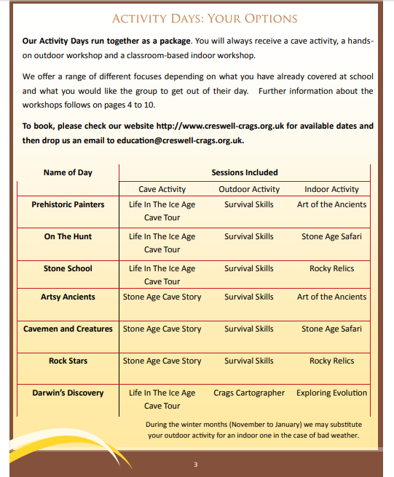

Page 3 of the Creswell Crags Primary & Secondary Trips brochure (Crags, 2019)

These activity programs consistently receive positive reviews from education professionals, for example;

‘We took our boarders to Creswell Crags. It was unanimously agreed that it was one of the best outings we have ever had and we will be going back. The activities included a visit to the caves, how to create and start a fire, making a shelter out of basic materials, and various art and craft. It was the enthusiasm and knowledge with which each activity was presented that engaged the children and made it such an enjoyable day.’
(Teacher, 2019)

This speaks to the quality of the education program, as the view of the teachers directly contributes to the likelihood of a return visit by the school. This in turn contributed to their education objective through encouraging schools to return.
Public and adult education is largely conducted through tours. The four tours currently available to the public cover the current knowledge of the Crags archaeology. These have been expanded this year to include the Witch Marks and the Hyena’s Den. The updated tours reflect the speed with which the staff at Creswell Crags typically responds to developments. The tours are reasonably priced for the industry (£9 per adult 1 tour, tours lasting 1.5 hours and up (Crags, 2019)), and there are a number of discounts available to concessions and groups. All of them include exhibition entry. This encourages more footfall into the exhibition, leading to a greater understanding of the history and archaeology found at the Crags.
There are 2 exhibition rooms in the Crags. One is used for the permanent exhibition, while the other is used for travelling exhibitions (particularly of local art). The permanent exhibition showcases a large number of artefacts that have been found. It also includes an interactive display that utilised kinetic sand and projection effects to simulate the changing landscape. There are also touch screens to show information and a large display screen that plays a video about the Crags.
This is not the only method used for the education of older people. They also have programs in place for further education and special interest groups. These groups are booked in with two package options that include guided talks, tours and artefact handling in a way that is far more intense than that of those aimed at younger attendees. There is also a process whereby staff can be booked to be guest speakers. The price may vary according to distance to the Crags. Guest speakers are important for groups that host their own lecture series (McRee, et al., 2014) (Zorek, et al., 2011). This service is a revenue boost, and it is also a way of helping local communities to expand their knowledge. The differing rates for location also encourages community interaction and education about the areas’ past. This in particular helps them to meet their goal of ‘providing or assisting in the promotion of facilities for the recreation and other leisure time occupations of those living, working or resorting in the area with the object of improving their conditions of life in the interest of social welfare.’ (Crags, 2018) This aim is matched with the local authorities core strategy for Historic Environment, which states ‘The historic environment is an asset of enormous cultural, social, economic and environmental value. It contributes significantly to our quality of life and to the quality of our places.’ (Council, 2011). The cohesion between the Crags and the Council comes in part from the funding that the Crags receive from the local government (Trust", 2017), as they in turn will help the Council achieve their stated goals.
Research at the Crags continues, but not with the same volume as it once had. With the recent discoveries of Witch Marks and the Hyena Den, this may change. There is also a planned excavation to uncover the old village of Creswell Crags and other sources to try and identify the location of the old village. This new information will help to further the aim of education as it will help increase knowledge of the local area and build a greater sense of identity for the community (Hales, 2018). The endeavour is already being facilitated by the Head Ranger, whose extensive knowledge has already helped the research process through identifying likely areas and dates to look for in the Crags records.
Overall, the aim of Education is met very well. While there could be more advertising with regards to their secondary education program, overall there is nothing that can really be improved upon.

Preservation

In the 1800s, the antiquarians made the decision to ‘excavate’ the caves using dynamite. When preservation efforts began, the extensive damage done to the stone became apparent. There wasn’t much that could have been done to reverse the damage done, but daily cave checks are employed to monitor the caves for any issues.
One of the key challenges to preserving the caves is the proximity of the quarry. The tarmac quarry located under a mile away, regularly uses dynamite in order to facilitate its mining operations. This poses a risk to the caves due to the vibrations caused by the explosions. These vibrations are so strong that the staff working in the office report being able to clearly feel them. The structural integrity could be compromised by the repeated blasts.

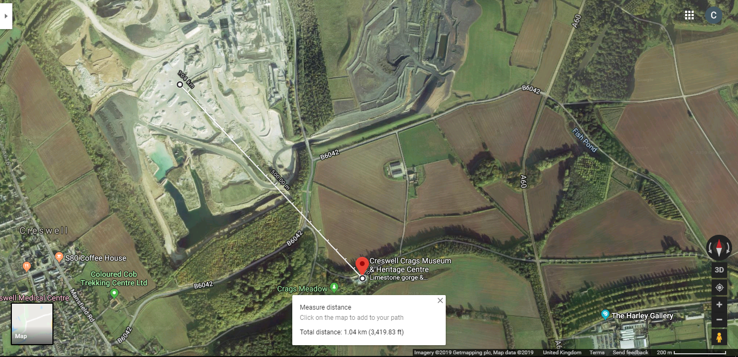
Figure 4: The above map demonstrates the distance ‘as the crow flies’ is just over 1km (Google, 2019)

Due to the quarry being privately owned the Crags cannot completely stop the activity. However, they have secured a number of methods to attempt to protect the caves.
The quarry and the Crags have formed an agreement where the quarry will inform the staff at the Crags before blasting occurs. They will then conduct inspections of the caves post blasting in order to ensure that no damage has occurred, accompanied by the Crags Rangers.
The status of protected monument awarded to the Crags means that the quarry is restricted in how close they are permitted to get to the Crags. While it can reduce the intensity of the tremors by keeping a distance between the quarry and the Crags, it cannot fully protect them.
The main precaution taken to help maintain the structural integrity of the caves is the use of metal struts. They are used inside the caves to provide support from within, bracing the roof against the tremors. The struts are analogous to those used when protecting against seismic (i.e earthquake) damage (Langenbach, 1989) (Pejsa, et al., 2014) (da Silva Brandao, et al., 2018). These struts demonstrate how seriously Creswell Crags takes its conservation efforts in the cave.
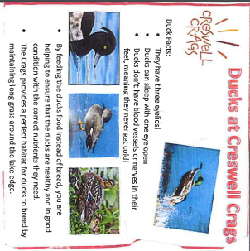
There is not much that can practically be done to further protect the cave from the quarry or its blasts. This is unfortunate, as it is arguably the greatest risk to the Crags in that in that it could lead to them collapsing and the archaeology being lost.
Figure 5: Insert from duck feed available at the Crags
Part of the preservation aim includes that of wildlife. The Crags are home to a number of different bat species, including endangered ones (Voigt & Kingston, 2016), including the Brown Long-eared bat and the Natters Bat. The Crags are a rich source of prey to the bats because of the variety of vegetation (Arrizabalaga-Escudero, et al., 2015)and ideal habitat. Facilitating this conservation of bat species is done through closing tours in Church Hole cave during certain times of the year (Crags, 2019). Church Hole cave is where bats will nest, and therefore closing the tours gives the bats a safe environment in which to breed.
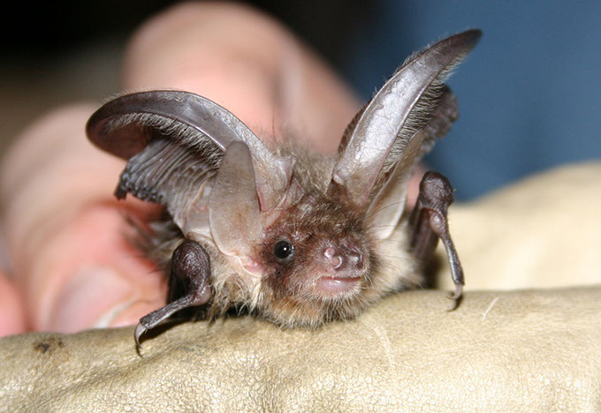
Another issue of preservation of the animal species is the yearly wild bird shoots that take place. The site itself is part of the Welbeck estate, and is leased to the Trust. Due to this, the Trust cannot stop the shoots (Mapunda, 2017). While they do not take place in the Crags, they do disturb the local wildlife. While this is not currently posing an issue, if too much hunting takes place, issues could develop that result in the ecosystem being destabilised (Caro, et al., 2015).
Figure 6: Brown Long-eared bat (Crags, 2019)
Animal conservation is highly important to the Crags aim of preservation, stated as ‘the conservation and preservation of the geology, archaeology, ecology and landscape in the Creswell Crags Heritage Area and the surroundings.’ While it does not directly relate to the archaeological evidence, it does fulfil their aims as a site and as a Trust (Crags, 2018).
The dynamic life of the site is underpinned by Bassetlaw District Council’s development and protection plan as much as the historic art is. Policy DM9 (Council, 2011) lays out the councils ‘strong biodiversity interest’, again demonstrating how the aims of the Crags and the aims of the Council come together to benefit both organisations.
An ongoing problem with the Crags is protecting against modern interference. Most often children are responsible for this. The only way to truly combat this to cover the walls to block the art, however this would be a dramatic move which would significantly decrease the efficacy of education (El-Badry, et al., 2018). Instead, the staff monitor the children during tours and will stop them from any vandalism. They also try to rely on parents or teachers accompanying the children, however this does not always work due to parents not noticing or not carrying to stop the children.
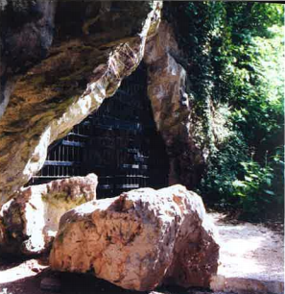
There are also large metal gates installed at the entrance to the caves regardless of whether they host tours or have significant archaeological discoveries associated with them. This is in part due to health and safety, as it was common in the past for children to play in the caves. When the Trust took over the lease of the Crags they became legally culpable for any injuries sustained, so in the interest of preserving their own funds and reputation they needed to keep unauthorised access out. The gates also act as a method of preservation to archaeological materials. The Witch Marks inside Church Hole cave are particularly vulnerable due to being in arms reach of anyone standing at ground level. This makes them vulnerable to vandalism (Elia, 1997). It was originally thought that the Marks were the result of modern vandalism when they were first noticed, until this was later corrected by experts.
Figure 7: The gates outside Robin Hood Cave (Creswell Crags, 2018)
The aim of preservation is reasonably well met considering the issues faced by the staff. Without seeing legal ways to prevent blasting by the quarry or compromising their education program there is little that can be done better to meet their aims.

Promotion

The aim of promotion is one that has experienced a great deal of success over the past few months. Upon the discovery of the Witch Marks, these were effectively marketed, leading to international renown.
The promotional campaign that surrounded the discovery of the Witch Marks was very well done, largely due to the efforts of the Marketing Manager. She launched a campaign of media coverage that led to international renown for the protective marks, utilising press releases, blog posts and other social media interaction in order to promote the discovery (Baker, 2019).
This is a model that should be utilised in future to promote the Crags due to its efficacy and its proven record (Kreger, 2014).
The Crags have also been very successful in promoting themselves to schools. This is a key part of many heritage sites, and especially those that have a clear link to a current curriculum. This is another part of their promotion that they have a clear link to a current curriculum (Department of Education, 2013, p. 3). This is another part of their promotion strategy that they do well, thanks to the education team. They have leaflets available in the facility and they keep contact details of the schools that visit in order to distribute further marketing. They currently do not make a concerted effort to draw in new schools, however that could be simply due to not having enough time to accommodate many more schools, as demonstrated by their already heavily populated ‘Booking Availability’ page (Crags, 2019).
They also focus heavily on primary school students, and do not promote themselves to secondary schools as much. Promoting themselves to secondary schools might not result in school trip bookings due to the differing curriculums, however it could result in greater volunteer numbers.
Promotion to draw in volunteers is not done anywhere outside of the website and a single banner in the stairwell of the visitors centre. Given that the trust relies heavily on volunteers to support their thinly stretched staff. This is particularly true of the Ranger team. Due to the tough nature of their work it is more difficult to find volunteers. They have a program in conjunction with a local special needs care home for the enrichment of their residents (Flores, 2014), though this cannot provide the numbers needed to keep up with what the team requires. More promotion might draw more volunteers from programs such as Duke of Edinburgh award, which requires volunteering (Award, 2019). They could also use a sense of community history in order to convince more local people to volunteer (Alexander & Hamilton, 2016) (Boezeman & Ellemers, 2007).
Drawing in volunteers has issues accompanying it. There is no direct public transport to the site, and utilising pushbikes leads the rider along a main road. These two factors effect their ability to draw volunteers, however the lack of promotion is probably the greatest detrimental factor in the issue.
Creswell Crags could do a great deal more to advertise themselves not only to the local area, but also to the nation as a whole. Adverts taken out in magazines or put on the internet would be useful to them, but raising their social media presence would be the beneficial to the aim of promoting the Crags nationwide (Feinman & Garraty, 2010) (Taheri, et al., 2016) (Pantano, 2011). This would be especially true when it comes to special events, such as the upcoming ‘Victorian week’ (Costa, 2010).
The 10th anniversary celebration of the Crags will be taking place from May onwards, but has not been widely advertised. They have special events planned, including a ‘Big Birthday Event’, a holiday club for the local children and a Victorian festival. However, there has been little done. Most of them are going to be taking place from the summer half term to September, and yet there has been very little advertising done off site. Even on site advertising consisted of little more than a few posters. This is directly in opposition to the aim of advertising and means that they will lose out on both revenue and reputation. This would be detrimental to the Crags as a whole, and in particular, to revenue, which the Crags cannot afford to lose.
Combatting this would be remarkably easy. Social media event pages or leaflets would be cheap and quick to create when utilising Canva (Canva, 2019), as they have in the past.

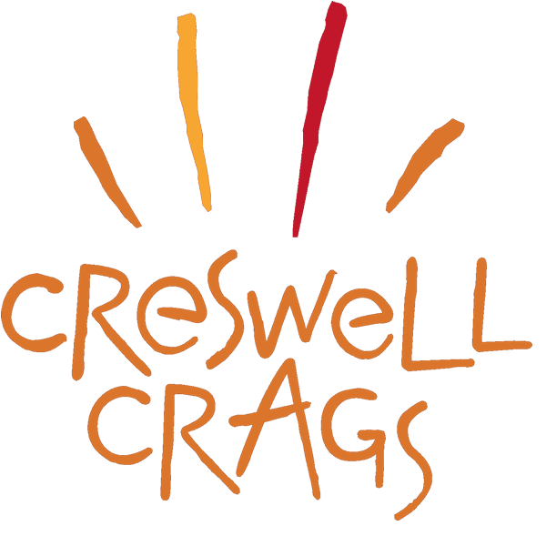
Figure 8: The Crags Logo

The current newsletter is put out sporadically at best. It is also not advertised anywhere on the website. This newsletter could be an invaluable asset in promotion of events and archaeology of the Crags (Bannan, 2007). The team currently use a subscription service that costs around £10 a month (MailChimp, 2001), and do not make the most of this resource. With an average of 1 newsletter sent out every 3 months, that means a single newsletter can cost £30, which is a dire waste of money for a charitable foundation. With a properly advertised and regularly used mail service, the team at the Crags could further their goal of promotion, as news letters are a provenly effective business tactic (Newswire, 1999) (Hines, 2005). It would also help to track the interest in different areas of development, as it has for other campaigns (Association, 2002).
Promotion is the least well met of the state objectives. With the departure of their Marketing Officer, Creswell Crags will need to be vigilant in order to retain the recent success that they have experienced thanks to her handling of the Witch Marks discovery. They could also advertise to the wider country as opposed to simply advertising to the immediate area. Using the Witch Marks marketing campaign as a model for further marketing would he advisable, as they have already experienced success with this method.

Conclusion

Overall, Creswell Crags meets their stated aims and objectives reasonably well given the financial and practical constraints that accompany a heritage site such as theirs. There is room for improvement in all areas, particularly in the area of promotion, where the staff are actively working towards achieving and improving on these.

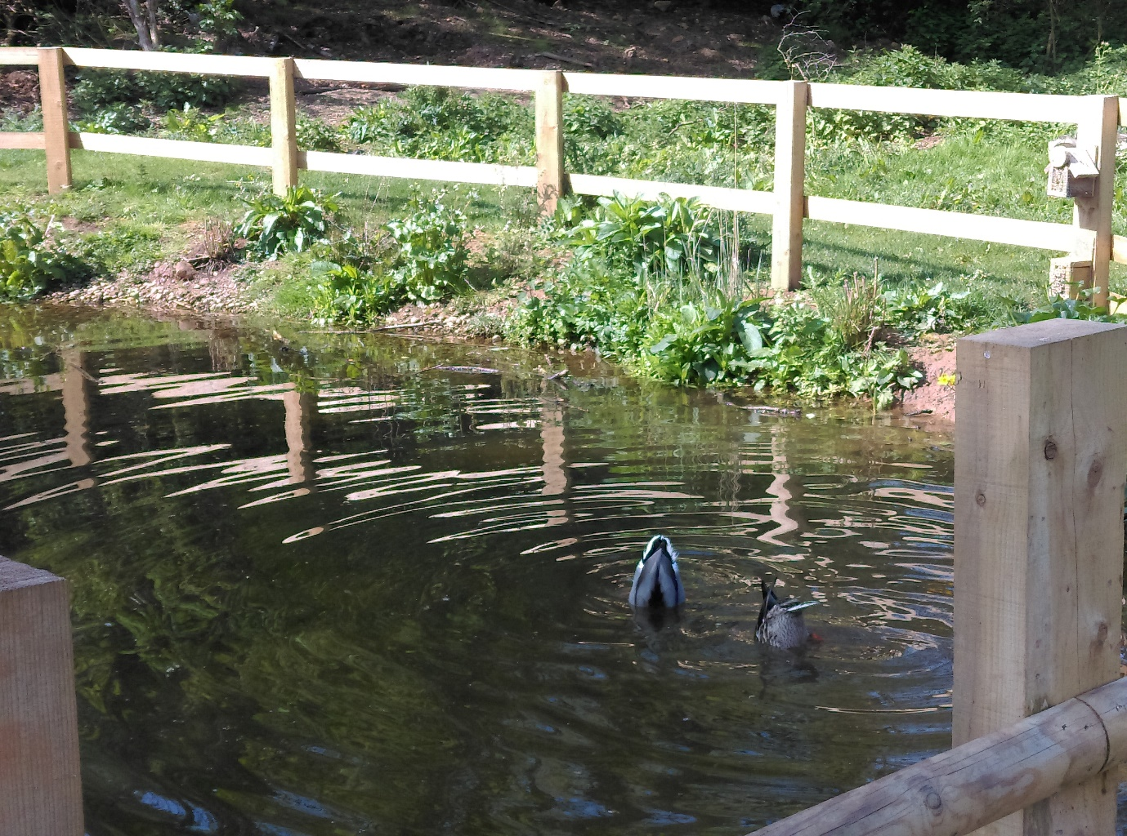
Figure 9: Ducks at the Crags

References
Ahmad, S. S., Shaari, M. F., Hashim, R. & Kariminia, S., 2015. Conducive Attributes of Physical Learning Environment at Preschool Level for Slow Learners. Procedia - Social and Behavioral Sciences, Volume 201, pp. 110-120.
Alexander, M. & Hamilton, K., 2016. Recapturing place identification through community heritage marketing. European Journal of Marketing, 50(7/8), pp. 1118-1136.
Arin, S., 2014. Built Environment Education For Children Through Architectural Workshops. Procedia - Social and Behavioural Sciences, Volume 143, pp. 35-39.
Arrizabalaga-Escudero, A. et al., 2015. Trophic requirements beyond foraging habitats: The importance of prey source habitats in bat conservation. Biological Conservation, Volume 191, pp. 512-519.
Association, P. N., 2002. Monthly Newsletter Tracks Life Science Advertising Trends. PR Newswire, p. 1.
Award, D. o. E., 2019. Volunteering. [Online]
Available at: https://www.dofe.org/doing-your-dofe/activities-sections/volunteering
[Accessed 26 5 2019].
Baker, P., 2019. News: Witches' Marks Help Crags Go Global. Worksop: Creswell Crags.
Bannan, K., 2007. E-newsletter advertising. B to B, 92(15), p. 19.
Boezeman, E. J. & Ellemers, N., 2007. Volunteering for Charity: Pride, respect and the commitment of volunteers. Journal of Applied Psychology, 92(3), pp. 771-785.
Canva, 2019. Design Anything. [Online]
Available at: https://www.canva.com/
[Accessed 7 05 2019].
Caro, J. et al., 2015. Effects of hunting management on Mediterranean farmland birds. Bird Conservation International, 25(2), pp. 166-181.
Cleveland, B. & Fisher, K., 2014. The evaluation of physical learning environments: a critical review of hte literature. Learning Environments Research, 17(1), pp. 1-28.
Costa, M. L., 2010. Heritage Marketing: Back to the future. Marketing Week, pp. 20-21.
Council, B., 2011. Adopted Core Strategy, Worksop: Bassetlaw District Council.
Crags, C., 2018. Objectives and Activities. [Online]
Available at: https://www.creswell-crags.org.uk/digging-deeper/objectives-and-activities/
[Accessed 20 5 2019].
Crags, C., 2019. Booking Availability. [Online]
Available at: https://www.creswell-crags.org.uk/education/availability/
[Accessed 20 5 2019].
Crags, C., 2019. Creswell Crags Bats. [Online]
Available at: https://www.creswell-crags.org.uk/explore/nature-crags-bats/
[Accessed 13 6 2019].
Crags, C., 2019. Education. [Online]
Available at: https://www.creswell-crags.org.uk/wp-content/uploads/2019/05/Creswell-Crags-KS-1-2-Brochure-2019-2020.pdf
[Accessed 4 6 2019].
Crags, C., 2019. Tickets and Prices. [Online]
Available at: https://www.creswell-crags.org.uk/visit/tickets-and-prices/
[Accessed 3 5 2019].
Creswell Crags, 2018. Guide Book. 1 ed. Worksop: Creswell Crags.
da Silva Brandao, F. et al., 2018. Seismic Behavior Assessment of Brazilian Heritage Construction. Frattura ed Integrita Strutturale, 12(45), pp. 14-32.
Department of Education, 2013. National curriculum in England: history programmes of study. [Online]
Available at: https://www.gov.uk/government/publications/national-curriculum-in-england-history-programmes-of-study
[Accessed 20 5 2019].
El-Badry, A. E.-H. A., Ali, M. F. & El-Ghafour, N. G. A., 2018. Diagnostic Study of the Deterioration Aspects of Rock-Cut Panels from Gebel El-Silsila, Aswan, Egypt. Journal of Science and Arts, 18(3), pp. 701-710.
Elia, R. J., 1997. Looting, collecting, and the destruction of archaeological resources. Nonrenewable Resources, 6(2), pp. 85-98.
Feinman, G. M. & Garraty, C. P., 2010. Preindustrial Markets and Marketing: Archaeological Perspectives. Annual Review of Anthropology, Volume 39, pp. 167-191.
Flores, R., 2014. From Personal Troubles to Public Compassion: Charity Shop Volunteering as a Practice of Care. The Sociological Review, 62(2), pp. 383-399.
Google, 2019. Google Maps. [Online]
Available at: https://www.google.com/maps/place/Creswell+Crags+Museum+%26+Heritage+Centre/@53.2671212,-1.1931405,1400m/data=!3m1!1e3!4m5!3m4!1s0x0:0x94b314ed4b77eedf!8m2!3d53.2634899!4d-1.1935294
[Accessed 11 6 2019].
Hales, A., 2018. The local in history: Personal and community history and its impact on identity. International Journal of Primary, Elementary and Early Years Education, 46(6), pp. 671-684.
Hines, E. G., 2005. Top Advertising Newsletter Revamps - AdBumb Is Better Than Ever. PR Newswire, p. 1.
Kreger, W. H., 2014. Marketing Archaeology. Ethical Theory and Moral Practice, 17(5), pp. 923-939.
Langenbach, R., 1989. Bricks, Mortar, and Earthquakes: Historic Preservation vs. Earthquake Safety. APT Bulletin: The Journal of Preservation Technology, 21(3/4), pp. 30-43.
MailChimp, 2001. Flexible plans that grow with you. [Online]
Available at: https://mailchimp.com/pricing/?gclid=CjwKCAjw8qjnBRA-EiwAaNvhwJZywyhQr8sef6hVk4DEKYjONn8a5_rltSmYlSJadaTitJfpRGhLQhoCX9wQAvD_BwE&gclsrc=aw.ds&currency=GBP
[Accessed 26 5 2019].
Mapunda, B., 2017. Get off my land! Towards mutual understanding in archaeological field conflicts. Online Journal in Public Archaeology, 3(0), pp. 74-96.
McRee, A.-L., Madsen, N. & Eisenberg, M. E., 2014. Guest Speakers in School-Based Sexuality Education. American Journal of Sexuality Education, 9(2), pp. 205-218.
Newswire, P., 1999. PennMedia.com Passes 8 Million Network Subscribers. PR Newswire Association LLC, p. 1.
Pantano, E., 2011. Cultural factors affecting consumer behaviour: a new perception model. EuroMed Journal of Business, 6(1), pp. 117-136.
Pejsa, S., Dyke, S. J. & Hacker, T. J., 2014. Building Infrastructure for Preservation and Publication of Earthquake Engineering and Research Data. International Journal of Digital Curation, 9(2).
Rousseau, C. et al., 2005. Evaluation of a classroom program of creative expression workshops for refugee and immigrant children. Journal of Child Psychology and Psychiatry, 46(2), pp. 180-185.
Shaari, M. F. & Ahmad, S. S., 2016. PHysical Learning Environment: Impact on Children School Readiness in Malaysian Preschools. Procedia - Social and Behavioral Sciences, Volume 222, pp. 9-18.
Taheri, B., O'Gorman, K. & Baxter, I., 2016. Contemporary issues in museums and heritage management: introduction to the special issue. Journal of Marketing Management, 32(15/16), pp. 1387-1391.
Teacher, V., 2019. Response to query about Creswell Crags visit. Oakham: -.
Trust", ". H., 2017. Consolidated financial statements, Worksop: Charity Commission.
Voigt, C. C. & Kingston, T., 2016. Bats in the Anthropocene: Conservation of Bats in a Changing World. 1 ed. New York: Springer.
Young, V. L. et al., 2017. A mixed-method evaluation of peer-education workshops for school-aged children to teach about antibiotics, microbes and hygiene. Journal of Antimicrobial Chemotherapy, 72(7), pp. 2119-2126.
Zorek, J. A., Katz, N. L. & Popovich, N. G., 2011. Guest Speakers in a Professional Development Seminar Series. American Journal of Pharmeceutical Education, 75(2), p. 28.

Appendices

Appendix 1
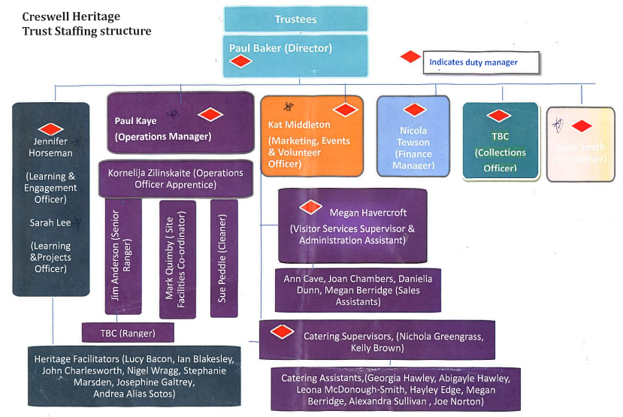
Staffing structure (photocopied from pack provided during volunteer orientation)

Appendix 2
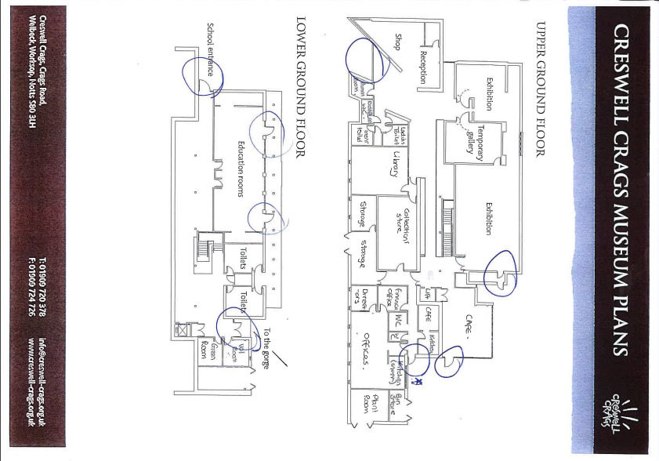
Plan of the visitors centred (photocopied from pack provided during volunteer orientation)

Appendix 3

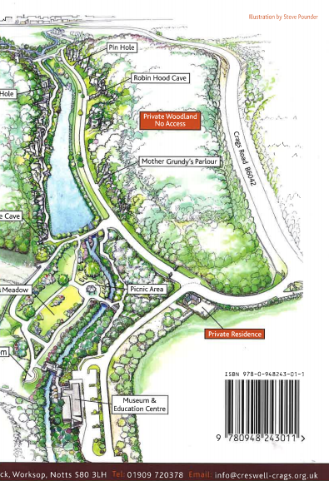
Map of the Crags (taken from the back of the Visitors guidebook - (Creswell Crags, 2018))

Appendix 4

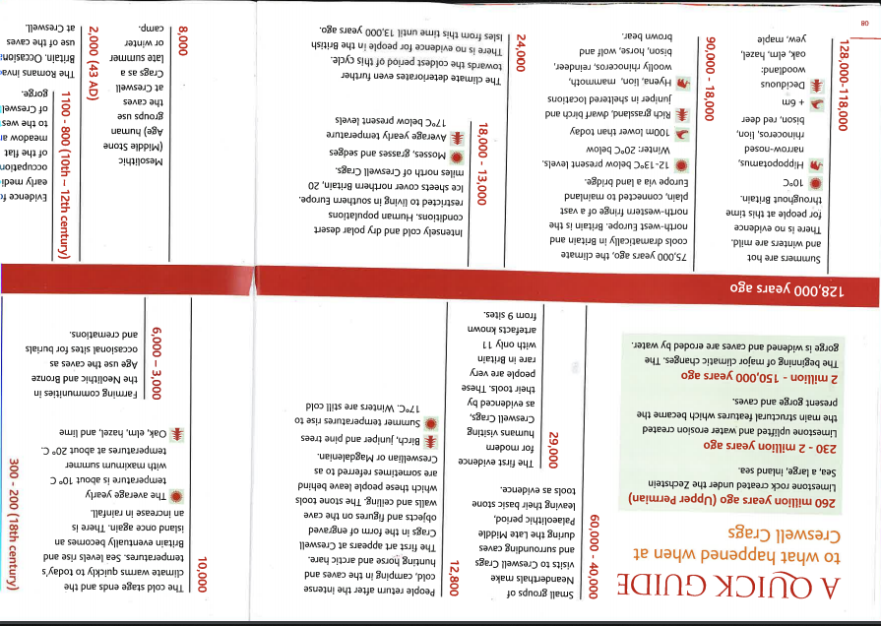
Time line of the Crags (Taken from the Creswell Crags visitors guide book - (Creswell Crags, 2018))

