Ransomware
What is it and how can it be mitigated?

L4 – Study Skills for Electronics
Code: (ACDA4021) (EES version)
BEng Embedded Electronics Degree
Bobby Webb - 2308625

Robert (Bobby) Webb
2308625@student.uwtsd.ac.uk
Contents:
1. Introduction
2. Requirements

3. Malware
3.1 What it is.
3.2 Ways on infection

4. Ransomware
4.1 What it is.
4.2 How to reduce the risk of ransomware.

5. Crypto wall
5.1 What it is.
5.2

4. How to keep your business secure
5. Conclusion
6. References

Introduction:

Within this report, you shall be reading a brief overview of what ransomware and crypto walls are as well as the types of issues it can cause for businesses and people. This report will also include ways of mitigation to help reduce the likelihood of you being a target for a ransomware attack as well as what to look for to help identify if you may have ransomware on your devices without your knowledge.

Requirements:
The use of this report is to:
- Explain what malware is.
- Explain how it can end up on users’ computers.
- Explain what ransomware does to a user’s computer and files.
- Explain what to do in case of an attack.
- Ways to improve security to reduce the likelihood of infection.
- Answer basic questions about ransomware and Crypto walls.

Malware:
What is it?

Malware or “malicious software” [1] is the main term which is used to describe all types of malicious software such as ransomware, crypto wall that has been designed by cybercriminals to harm and/or exploit any device over network services such as WIFI or data.

There are many types of malwares which are being used every day by cybercriminals to access people's data. Overall, these criminals do this to try and get victims' personal details and data which can then be put into a portfolio which then could lead to identity theft of the victim. This can then be upscaled to businesses through the simple ability of being able to find

Types of Malware: [2]
- Ransomware
- Trojan Horse
- Worms
- Spyware
- Adware

Ways of infection:
The way of getting infected from malware is astonishingly easy to do as it most often comes from downloading free documents from the internet, however, these downloads are often illegal documents which may have pirated content or similar. [3] Like most viruses, it would be as easy as to downloading files from non-trusted websites, the malware would often be hidden within the files where the user wouldn’t notice it being there or the file name is a legitimate file name to make it less suspicious.
Malware is also commonly found in things as simple as emails and email attachments which can be sent to anyone in bulk by emailing loads of people in one go.
Malware can also be found on removable media [2]such as USB’s, CD’s etc this is because it is an easy way to gain access because when people buy removable media it first requires to be plugged in, one being plugged in the device/system can instantly be affected.

Ransomware:
What is it?
Ransomware is a software that has been specifically designed and programmed to search through a victim’s files and encrypt their valuable information. This locks the victim out of using/accessing their own data. The way to get the data back would be to pay the cybercriminal amount of money they specify to get given the encryption key to get the files back. [4] This is the standard form of malware i.e. making the users assets virtually useless on their own computer until the sum specified is paid. However, even once paid it is still a 50/50 chance if you will still get your files back.
Another type of Ransomware called ‘double extorsion attack’ [1]. This type of malware effectively does the same however also adds the threat of leaking the victim’s information if payment criteria is not met within the given amount of time. The payments tend to range from a few hundred pounds all the way to a few thousand, its hard to judge but there is no set standard for the victim to go off.

The third type of malware is known as a ‘triple extortion attack’ [1] which is the two previously combined together with an extra threat of a DDoS attack(Distributed denial of service), this is where the cyber criminal would flood a victims device with random internet traffic [5] that can pass some firewalls which will prevent them from accessing the internet/any online resources. This is a added thread as it will make the device effectively useless until it ends.

CryptoWall:
What is it?
CryptoWall is a type of malware which works by encrypting files from an infected computer which will require the victim to pay a fee to receive a key (decryption key) which can unlock their files again. Very similar to ransomware however it is much harder to be found on a victim’s device until it is too late for them to act on it.

According to records [6] the USA is the lead of the top 10 affected countries of Cryptowall with 40.6% and the UK closely follows in 3rd with 6.6%.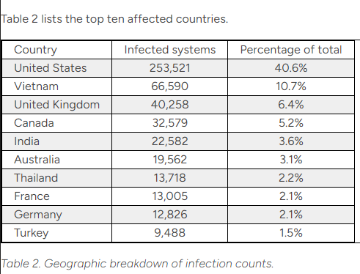

[7]
How does it work?
With CryptoWall having multiple different versions its hard to justify it across them all. Some of the functionalities are the same throughout the different types. Currently at the time of writing the latest version is ‘CrytpoWall 5.1’ [7]. However, the latest version (5.1) is completely different to its predecessors as it can also be used on completely different codebases compared to normal. This is due to it now being on its own codebase compares to its previous versions.
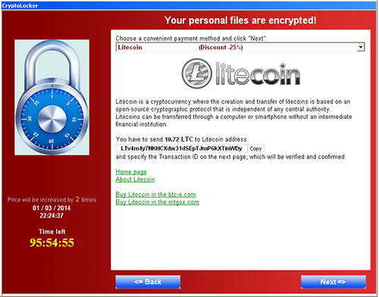

[8]

How to keep your business secure:
There are simple ways you can keep your business secure which should be followed for all equipment which can access the internet, this because anything with internet connectivity can be affected. The better the business can stay secure the harder it is for cybercriminals to try and gain access to the businesses data with this it will make your business less likely to be targeted due to being well protected and secured.

Suitable ways of mitigation for a business [9]:
- Training Awareness Course: Conduct a training course for your staff to ensure they understand and know about the possible threats the business could have to deal with as well as ways for them to mitigate the situation.
- Adding a policy which has a protocol to follow if there was to be the possibility of a ransomware attack. This would be a basic instruction list for employees to follow in the event of a possible attack i.e. contacting IT support, closing apps etc.
- Set up harsh spam filters to better reduce the likelihood of phishing emails from entering the employees’ inbox.
- Make sure all equipment is up to date as these updates often contain important security updates and bug fixes to help keep the device as secure as possible. These updates are vital as some software versions could have serious flaws which makes it easier for cyber criminals to infiltrate a business’s systems and cause havoc.
- Setting up an automated backup system: this system will allow the businesses data to be backed up at defined intervals to ensure that no data is lost in the event of a attack. Copies of data should be stored in a range of ways i.e. cloud, external hard drives which are kept away from the businesses premises as well as being secured by only allowing trusted users to back up to it.
- Simple antivirus software on all the businesses machines i.e. Mcafee, bulldog protection to name but a few.

Conclusion:
To conclude, ransomware is a huge concern in this technical era as we slowly move to everything being online, the security risk is ever increasing for scams, theft and fraud to take place. For the cybercriminals it is becoming easier than ever to get people to fall for it as most of the links look genuine and real.
As a business it is a must to keep everything as secure as possible to prevent the possibility of a malware attack as it has the ability to hugely affect businesses, due to the factor of targeting finance departments to try and rinse the business of its funds and capital. It is becoming an ever bigger threat so nowadays so keeping up to date and keeping staff in check with protocols is a must to reduce the likelihood of your business coming under a ransomware attack.

References

[1] | IBM, "What is malware?," [Online]. Available: https://www.ibm.com/topics/malware. [Accessed 13 11 23].
[2] | J. Holmes, "Malware is a threat to businesses - Heres what you need to know," 13 7 23. [Online]. Available: https://www.ibm.com/topics/malware. [Accessed 13 11 23].
[3] | McAfee, "What is malware?," MaAfee, 2023. [Online]. Available: https://www.mcafee.com/en-gb/antivirus/malware.html. [Accessed 1 11 2023].
[4] | &. M. H. J. Whitman, Management of information security., Sixth Edition ed., Boston: Cengage Learning, 2019, pp. 25-31.
[5] | Fortinet, "What is DDoS Attack?," Fortinet, [Online]. Available: https://www.fortinet.com/resources/cyberglossary/ddos-attack#:~:text=DDoS%20Attack%20Meaning,connected%20online%20services%20and%20sites.. [Accessed 14 11 23].
[6] | D. S. C. T. U. T. Intelligence, " CRYPTOWALL RANSOMWARE THREAT ANALYSIS," Dell, 27 8 2014. [Online]. Available: https://www.secureworks.com/research/cryptowall-ransomware. [Accessed 11 13 23].
[7] | "What is CryptoWall Ransomware?," proofpoint, [Online]. Available: https://www.proofpoint.com/uk/threat-reference/cryptowall-ransomware. [Accessed 10 11 2023].
[8] | D. S. C. T. U. T. Intelligence, "Cryptowall Ransomware Threat Analysis," Secureworks, 27 08 2014. [Online]. Available: https://www.secureworks.com/-/media/images/insights/resources/threat-analysis/010-cryptowall-ransomware/cryptowall_ransomware_01.png?h=198&w=500&hash=11A6A95B581072D3A9E32B6687ECD473EB734630. [Accessed 10 11 2023].
[9] | E. Heaslip, "11 Things You Can Do Right Now To Protect Your Business from a Ransomware Attack," US Chamber of Commerce, 09 01 2023. [Online]. Available: https://www.uschamber.com/co/run/technology/ransomware-attacks-business-protection. [Accessed 10 11 2023].

