Module name: Business management
Lecture name: Tushara Balendran
Student name: Radoslav Kamberov
Student ID: 2029262
Submission date: 07.01.2022

Table of Contents
Introduction: 2
Blog 1: 2
Blog 2: 3
Blog 3: 4
Blog 4: 5
Conclusion: 5
Bibliography: 7

Introduction:
This assignment focuses on choosing an well known company of U and creating blogs for them as a process of communication activities for the chosen organization. These blogs are created for targeting the audience. The aim is to focus on creating and increasing awareness of the project and creating a specific bond between the audience and the chosen company. In this project Walmart, has been chosen. Walmart being one of the largest retail companies in UK. Walmart owns a chain of stores in UK named as ASDA , it is also noted that Walmart’s acquisition of ASDA being the catalyst of owning 100of ASDA stores all over Europe. Walmart Inc is an American multinational retail company that operates its chain of operation along with its subsidiaries in Canada. There are almost 2 million employees and it owns a total asset of US$252.5 billion (walmart.co.uk, 2021).
The blog posts create the understanding of customers and audiences among the company. The key elements of marketing theory are in relation to the way in which one plans, develops and executes the communication.

Blog 1:
Walmart Connect- The more the media-meaningful connections are created:
Walmart Connect –are taking retail media to the next level. There are no other platforms that can correlate online and in store activity at Walmart. The Closed loop system creates a holistic approach of Walmart customer behavior and creates its accountability. This is an insight data that helps in creating customer centric approach towards Wlmart retail.
Have you heard of Walmart DSP?? That’s the new Technological approach of Walmart. The Walmart DSP combines the best in class technology along with the performance of the trade Desk, along with the robust scale of Walmart’s unparalleled omni channel data. This will help the advertisers for driving more effectiveness.

Jeff Clark is the VP of Product, Walmart Connect says that Connecting with the customers are ahead of the purchase decision are driving awareness and the consideration are imperative for marketers. However, the increasing journey of fragmented shoppers are always becoming harder to connect and according to the new GWI core study , the increase of daily time spent in media has increased 63% over the last decade and in the pandemic season it has reached its high.
The critique to reach shoppers outside the shopping context searches whee they hav been and aways continues to build connection with the points that is all the way to the point f purchase.
This is the reason of creating the Walmart DSP, it’s a first platform that keeps and understands the customers demand. Walmart DSP has been built with in collaboration with independent DSP, Trade Desk, it is a pioneer for a new frontier in digital advertisement, it helps to reach the advertiser and hep them to reach high number of customers. This platform provides the advertisers and the customers to experience an open, transparent along with objective platform that upholds the privacy standards. This standalone platform creates a new best in class technology along with the performance of the trade Desk with the robust scale of Walmart’s customer base. The inspiration, discovery and the purchase can take place anytime. The suppliers can broaden the reach and engage with the customers and bring back to the Walmart’s ecosystem.


The reason behind the excitement of Walmart Connect is:
Reaching Audience with a greater precision- Walart DSP filters the advertisements and it allows the advertisers to reach the specific audience and it increases the precision by leaveraging the almar’ts past purchase and predictive audience segments are there. The advertisers are alowe to reach the target audience with increased precision. The DSP collects the brand level shopping behavior data across the entire Walmart ecosystem. It includes Walmart App, 4700 physical stores.
Accessing the trade desk’s premium inventory and the private marketplace:
The advertisers are getting full access to the trade Desk’s premium invemtory and he integrated private marketplace. It includes display, video, TV, audio, it helps in targeting and measuring multiple number of inventory sources among the closed loop data of Walmart.
Apart from this, Controling frequency across all the campaign, tracking the impact of your campaign through the Walmart’s Closed Loop measurement are the deliverables

Blog 2:
Walmart’s successful story of supply chain management
If you are visiting at Local Walmart , you will e witnessing the greaest logic as well as operational triumphs. According to recent data, the Global Retail Giant is operatable at more than 11,700 stores and it is spread across 59 company undertakings. The company has around 2.3 million employees around 28 countries and manages inventory of $32 billion. Customer-friendly prices and focus on bulk sales to maximize sales rather than overpricing products.
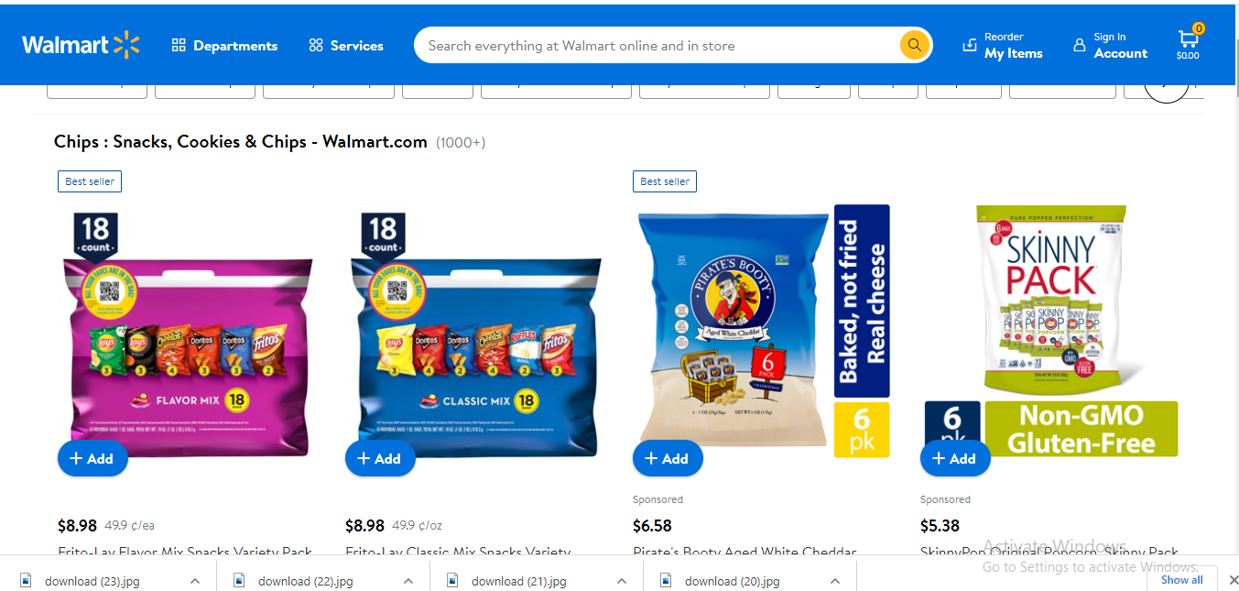
These numbers and figures indicate that it is having an effective and efficient supply chain management strategy. The organization is committed to have this model of cost driving out of the supply chain for enabling the consumers to save money.
Walmart’s segmentation, targeting and positioning is the focus of Walmart’s strategic marketing. Walmart uses its mono segment positioning type in marketing. The marketing managers of Walmart Appeals to be a single customer segment, it would place a greater value as well as price attributes of products that are compared t the other attributes.
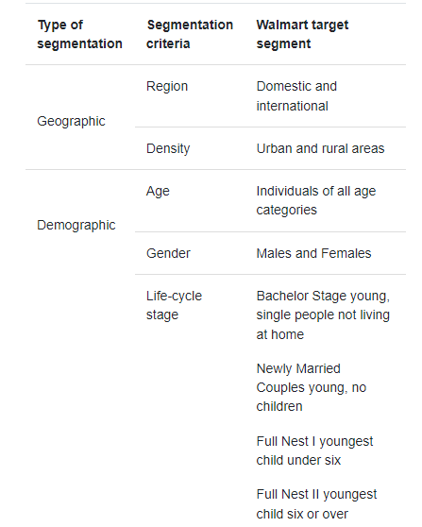
Walmar attempts to specify its target customers of all the ages through its marketing communication, the messages and most attention is given to the new generation young customers. It’s important to gain the loyalty of the new age customers for long time profitability. The promise of cheap prices, Walmart attracts the milleminals through effective integration of the social media marketing into the marketing communication strategies.

Blog 3:
Few Links in Wal-Mart Supply Chain:
With the early season, Walmart’s supply chain management has contributed a major path in its success. The supply chain of Walmart is innovative and it began with the company that is removing the few links of the supply chain. It is right from the very beginning that Walmartt has focuse ore on selectively purchased bulk merchandise and it is transported to its history directly.. Walmart deals with its suppliers directly and the manufacturers cuts the cost and it effects its supply chain more effectively.
Walmart has long practices its strategic sourcing in order to find the products in the best offered prices from the suppliers those who are in a position to ensure, that the demand is meet from both ends. The company establishes its strategic partnership with mostly their vendors; it offers them from potential long term as well as high volume purchases in exchange with the lower possible prices, warehouse, warehouses and retail store are being described as behaving like a single firm.
Walmart has streamlined its supply chain by creating a constant communication and supply chain management by constructing proper communication ad relationship networks through the global network of suppliers. This has improved material flows and along with the lower inventories. The global suppliers, warehouses, retail stores all acts as a single entity.
Walmart Also focuses o cross docking, that creates a logistic practice and it’s a centerpiece of the Walmart’s strategy for replenishing the inventory more efficiently. It means the direct transfer of products from inbound or outbound truck trailers without the need for extra storage, by unloading items from an incoming semi-trailer truck or railroad car and loading these materials directly into outbound trucks, trailers.
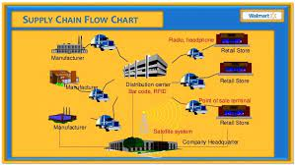
This has reduced the cost of Walmart’s costing and it also allows the company to pass the saving to the customer with any highly competitive pricing.

Blog 4:
Walmart Enlist PR campaign:
Walmart is seen to look beyond the mainstream media and it works directly with the bloggers. It feeds them exclusively, with news nuggets. As you enjoy little bites of nuggets; The suggestions fr posting and even inviting them to the corporate headquarters. Walmart os the nation’s largest private employer and it has been forthright with the bloggers.

To maintain better customer relation and reach them quickly , Walmart focuses o its social media and creating blogs. The approach to Walmart’s blogging is like rather promoting any product, giving 300$ to the social marketing and the target customers is more easy to increase sales.
It has been seen that more and more Americans search internet to get information from credible, varied and trusted source, and Wakmart is committed to participate in the online conversation.

Conclusion:
The assignment determined the segmentation, targeting process along with the determination of mix marketing strategies of Walmart. It needs to be creative as one wants to be in relation with the blog posts and the assignment focuses on developing mechanism for engaging with the audience and encouraging them for a question answer session. This communication will help in understanding the customer’s choice.

Bibliography:
Walmart Enlists PR campaign Retrieced from https://www.nytimes.com/2006/03/07/technology/walmart-enlists-bloggersin-pr-campaign.html, on Dec 21, 2021
Tan, B., Yan, J., Chen, S. and Liu, X., 2018, December. The impact of blockchain on food supply chain: The case of walmart. In International Conference on Smart Blockchain (pp. 167-177). Springer, Cham.
Arli, V., Dylke, S., Burgess, R., Campus, R. and Soldo, E., 2013. Woolworths Australia and Walmart US: Best practices in supply chain collaboration. Journal of Economics, Business, & Accountancy Ventura, 16(1).
Shin, S. and Eksioglu, B., 2015. An empirical study of RFID productivity in the US retail supply chain. International Journal of Production Economics, 163, pp.89-96.

