Food and Beverage Operation
BMIH4002 - LEVEL 4

Table of Contents
Assignment 2: Menu Engineering (Practical Task) 3
Introduction 3
PART 1: Restaurant Concept 3
PART 2: Menu Design 5
Conclusion 10
Reference 12

Assignment 2: Menu Engineering (Practical Task)

Introduction
In the hospitality sector food and beverages are the most important aspects for maintaining the reputation of the organisational quality and services. They encompass the management and execution of the wonderful dining and culinary experiences. Menu engineering plays an important approach which involves the designing of the menu, price optimization, profitability and the satisfaction of the guests (Zrnić et al., 2023). This entails the analysis of costs and popularity of the menu items. By combining operational efficiency with menu engineering, businesses can appeal to customers by balancing profitability while delivering dining experiences to the guests.

PART 1: Restaurant Concept
Concept of the Restaurant
At Trinity International, the restaurant offers high-quality food of international levels and cuisine types to the guests that combine innovation, tradition and culture with excellence. The restaurant presents a unique ambience that impresses the guests while having the dining experience and the restaurant at the same time offers numerous flavours and dining options with the commitment to excellent service. The restaurant crafts its menu by giving preferences to locally sourced foods and by maintaining well-balanced international food items by considering the sustainability issues of the current times for choosing ingredients. They celebrate global influences and cater for the tests and preferences of the people who belong to diverse choices and places. The restaurants wish to draw the attention of the local customers by offering calm and suitable dining decor and an environment with modern, fine and mesmerizing warmth and approaches.
Target audience
The target audience of the restaurant is diverse and broad. This includes business professionals, clients from the international ground, high-profile customers along local customers. The restaurant aims to cater for a wide range of customers, global tourists and international residents who have cravings for global cuisines along with high-quality food. The restaurant welcomes locals to have a culinary adventure, and customers willing to explore diverse dishes, the international community belongs to the UK through comfort food, families and social groups looking for varied menus, food enthusiasts and adventure eaters willing to try new and exotic dishes.
The Reasoning Behind Menu Choices
The diverse international menu selection of the restaurant includes several reasons and ensures a rich and dynamic dining experience for the guests. In the globalized world, the UK is a multicultural society and offering international cuisine allows the restaurant to embrace the cultural diversity of the people along with meeting their various tastes and requirements within a single dining establishment. In 2021, nearly 95% of British Residents enjoyed multinational cuisine through home-cooked or takeaway orders and a significant 71% of individuals expressed their acceptance of cultures regarding culinary experiences and willingness to embrace a diverse range of cuisines in the UK (Shaw, 2021). Through this means, the restaurant can cater to a diverse customer base and provides a platform for culinary experiences and exploration which allows the customer to experiment with different flavours, ingredients and cooking styles as well.
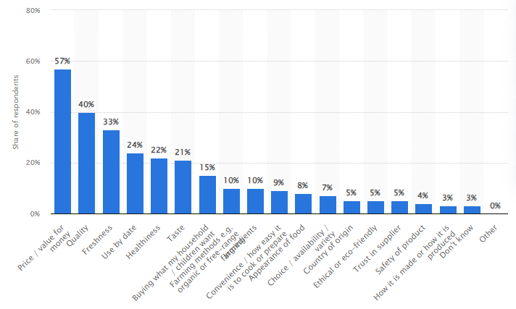
Figure: Most important factors consumers consider when choosing which foods to purchase in the United Kingdom (excluding Scotland) in 2022
(Source: Ozbun, 2023)

PART 2: Menu Design
Part 2
Conceptualization
‘Making every international business meet special with Trinity International’ is the main concept behind developing the restaurant in Dublin and London. Many restaurants and hotel chains provide dining options, accommodations and specific cuisine menus for guests but Trinity Internation aims to develop its offerings especially for international business meets and corporate parties with a wide variety of international menus. So, that guests do not need to compromise their food habits even in foreign areas.
Trinity International mainly welcomes high-profile business personnel and arranges international business meets with lots of dine-out options. The restaurant extends a warm welcome to its clients and makes every effort to customise the special occasion and provide the guests with an exceptional and exclusive dining experience, guaranteeing that every occasion will be remembered. Based on the concept of Walker (2021), it can be mentioned that if a restaurant wants to expand its business operations in the international platform and attract international customers, it is important to include different types of international menus with some unique twists. The menu features this new restaurant's thoughtfully chosen assortment of fusion foods with a contemporary touch (Norris, 2023). According to the viewpoint of Lee et al. (2021), it can be mentioned that an attractive al-a-carte can easily increase a restaurant’s popularity as well as goodwill exceptionally. It is projected that Trinity International will be able to expand its service standards in a lucrative position and will be able to grab the leading position in the global platform. For special corporate meetings and business parties, the restaurant has provided a magnificent setting along with flawless service to make memories that will last a lifetime.
From Continental dishes to traditional Greek platers, from African Peri Peri to Indian Masala items, from Thai Lobster Salad to exclusive Irish desserts, Trinity International is ready to serve its guests with a handful of alternatives to provide homely environments even in an offshore marketplace. As per the research work of Kraak et al. (2019), it can be mentioned that restaurant chains in the international platform must focus on different guests’ preferences instead of promoting rigid menu options. It is projected that Trinity International will be able to include a huge alternative in its menu charts and offer a wide variety of platters to international guests. The menu might begin with appetisers, which are made more elegant by adding fresh creams, avocado, cooked champagnes and more items accordingly.
Menu Items
To ensure an excellent experience with a wide variety of menu items, Trinity International is going to design its menu items wisely for international guests. Though the basic objective of this restaurant is to organise parties and dine-outs for international business personnel and corporate personalities, the authority focuses on different international dishes.
Appetizers
Veg | Broccoli broth, Continental sizzler, Baked vegetables, Green salads,  Red sauce pasta, Pesto farfalle, Veg lasagne, Glazed vegetables, Spring veggies Thai Curry, Thai Veg Sticky Rise, Indian Masala Soups, Royal Veg Thali, Cheesy Taco, Enchilada Lasagna and more.
Non-Veg | Asparagus Bruschetta, Beef Burger, Baked Kidney Beans with Alfredo Sauce, Baked Pesto Pasta, Chicken Lemon Butter, Truffles, Khao mok nuea, Thai Chicken Soup, Khao mu krop, Thain Steamed Lamb, Sushi, traditional Indian Fishball curry and more

Main courses
Veg | Pizza Quesadillas, Taco Spaghetti Pie, Taco Pizza, Cheesy Taco Pasta, Mughlai Makhani Paneer, Crispy Bottom Pan-Fried Vegetable Buns, Chinese Hot Pot, Cranberry Pumpkin Steamed Buns and others
Non-Veg | Roast chicken with steamed rice, Osso Buco, Filet mignon, Lobster Thermidor, Beef Risotto, Lemon Seafood, Pad Thai, Thai Fish Rice, Pork Salad, Hamm Rids, Rogan Josh and more

Side dishes:
Veg | Mexican corn on the cob, Anchovy garlic bread, Baked vegetables al forno, Peanut and cucumber salad, Rainbow slaw with tahini dressing, Chunky onion salsa, Asian soft noodle cabbage salad and more
Non-Veg | Asian greens with oyster sauce, Italian Fajitas, Fishball buffet, Korean Marinated Eggs and more

Desserts: Tres Leches Cake, Strawberry Gelato, White Peach Tart, Banana Pudding, Brownies, Cheesecake, S'mores, Cobblers and Crumbles, curd-based dessert, Cucumber and Yoghurt combo, Mochi, Egg tarts, Dragon Beard Candy and others.
Beverage options: Coffee, Tea, Italian Red Wines, Tequila, Campari, Bubble Tea, Yerba Mate, Kompot, Sangria, Daiquiri, Mint Julep, Manhattan, Rob Roy and more.

Menu Design
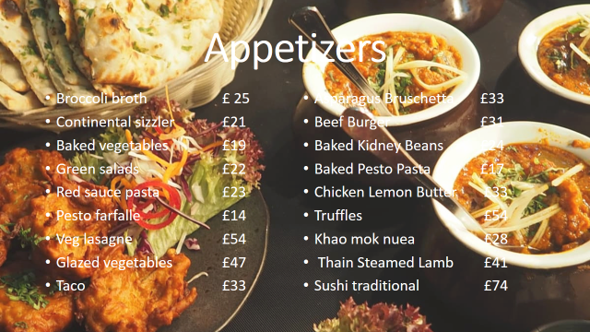
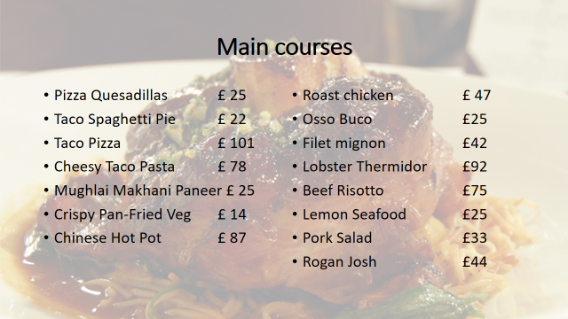
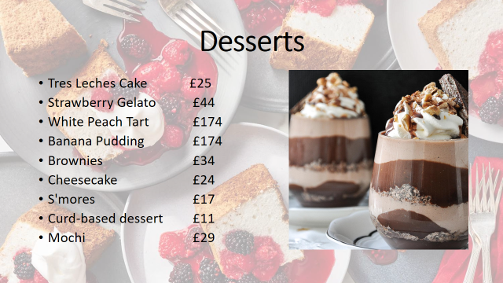
Figure 1: Food Menu
(Source - Created by the learner)

Pricing Strategy
Pricing strategy plays an important role in balancing profitability and customer satisfaction. It is essential to set the prices of each menu option considering the ingredient costs, preparation complexity, market demand, competition and customers’ expectations. Determining the prices for vegetarian, non-vegetarian and vegan items is a common approach for reflecting the cost disparities and catering to the range of dietary preferences (Afshin et al., 2017). The basic consideration of pricing depends on ingredients’ costs as meat and seafood tend to be more expensive than plant-based food options and non-vegetarian dishes are costly. Moreover, naturally sourced ingredients are more affordable. The preparations of the dishes are cost cost-influencing. Complex non-vegetarian dishes involve intricate cooking techniques and are priced higher than simple vegetarian foods.
Vegetarian items: The average ingredients cost of the vegetarian items will be around $40 and the staffing cost and equipment costs will be nearly $5110. The average pricing will be between $50 to $400 which depends upon the ordered meal.
Non-vegetarian items: The average ingredients cost of the non-vegetarian items will be approximately $ 55 and the staffing cost will be the same as both the staff prepare the vegetarian and non-vegetarian items. The equipment costs are nearly $450. The average pricing for the menu option ranges between $100 to $750 depending on the ordered meal or food item.
Vegan items: The average cost of the items will be around $45 and the staffing cost will not be added further but the equipment costs will be around $ 300. The average pricing of vegan food options will be in the range between $90 to $500 depending on the ordered meal.
Menu Description
Veg Menus: By considering vegetarian guests’ considerations, the hotel develops veg menus full of various greens. The primary components of the vegetarian dishes will be fresh veggies, such as jalapeño, broccoli, onion, basil, and many more. Herbs will also be used to improve the flavour of every food item. From the huge alternatives, guests can easily choose their preferred ones accordingly. Additionally, the company tries to provide organic food items along with fresh veggies to keep the proper food values of all prepared dishes.
Non-Veg Menus: Guests can avail a wide variety of non-veg food items in Trinity International with the elegant taste of international dishes. Meat, chicken, and a few of the veggies listed above will be the main components of the non-vegetarian dishes. The flavour will be enhanced with herbs and spices, much like on the vegetarian menu. By maintaining hygiene and collecting fresh meats, the hotel authority tries to maintain the standard of its offering among international guests.
Vegan Menus: Many people are consuming nut-based food items and some light items as their meals. Trinity International also prepares dishes for those. Tofu, almonds, veggies, and many more will be the staple constituents of vegan food. Similar to the vegetarian cuisine, taste will be enhanced using herbs and spices.
Beverages: A wide range of alcohol-based and non-alcohol-based beverages are available in Trinity International for its global guests. By providing top-class beverages with advanced quality, Trinity International tries to keep its goodwill in the global market.
Sustainability and Seasonality
Embracing sustainability and seasonality in the menu is one of the responsible choices of restaurants that help to adhere to the regulations and stay in tune with environmental trends (Davis et al., 2018). The restaurant will prioritize locally sourced ingredients and ensure the sustainable practices of the suppliers as well. Seasonal products taste fresher and support the local farmers which is associated with low carbon footprints and reduces long-distance transportation as well (Esteve-Llorens et al., 2019). By designing the menu which incorporates seasonal changes in the ingredient availability the commitment to sustainability allows one to experience flavoured and fresh offerings throughout. Minimization of waste production and recycling of kitchen scraps will be emphasized for better waste management practices in the restaurant. Along with these the restaurant will also invest in energy-efficient kitchen appliances, replace eco-friendly alternatives to plastic use, focus on water-conservation practices and educate and engage the staff for better and transparent practices.

Conclusion
Thus, it can be concluded that the restaurant will celebrate global flavours and excellent services for the guests by maintaining the offerings at international levels and embracing sustainability and seasonability. The target audience encompasses diverse customers and the concept of different international menu choices emphasizes ingredient sourcing, waste reduction, and energy efficiency as the menu is designed to complement the concept, flavours and quality by reflecting eco-conscious commitments as well.

Reference
Afshin, A., Penalvo, J.L., Del Gobbo, L., Silva, J., Michaelson, M., O'Flaherty, M., Capewell, S., Spiegelman, D., Danaei, G. and Mozaffarian, D., 2017. The prospective impact of food pricing on improving dietary consumption: a systematic review and meta-analysis. PloS one, 12(3), p.e0172277.
Davis, B et al. (2018) Food and Beverage Management. 6 edn London: Routledge.**
Esteve-Llorens, X., Darriba, C., Moreira, M.T., Feijoo, G. and González-García, S., 2019. Towards an environmentally sustainable and healthy Atlantic dietary pattern: Life cycle carbon footprint and nutritional quality. Science of the Total Environment, 646, pp.704-715.
Kraak, Vivica, Sofia Rincón-Gallardo Patiño, Deepthi Renukuntla, and Eojina Kim. "Progress evaluation for transnational restaurant chains to reformulate products and standardize portions to meet healthy dietary guidelines and reduce obesity and non-communicable disease risks, 2000–2018: a scoping and systematic review to inform policy." International Journal of Environmental Research and Public Health 16, no. 15 (2019): 2732.
Lee, P.Y., Koseoglu, M.A., Qi, L., Liu, E.C. and King, B., 2021. The sway of influencer marketing: Evidence from a restaurant group. International Journal of Hospitality Management, 98, p.103022.
Norris, C.L., Russen, M. and Taylor Jr, S., 2023. Expanding the experiential value scale to predict independent restaurant dining intent. Journal of Hospitality and Tourism Insights, 6(2), pp.613-631.

Ozbun, T. (2023) U.K.: which foods to purchase by factor 2022, Statista. Available at: https://www.statista.com/statistics/1258892/factors-when-choosing-which-foods-to-purchase-in-the-united-kingdom/ (Accessed: 8 November 2023).
Shaw, N. (2021) Multiculturalism makes British food better, Wales Online. Available at: https://www.walesonline.co.uk/news/uk-news/multiculturalism-makes-british-food-better-21066970 (Accessed: 8 November 2023).
Walker, J.R., 2021. The restaurant: from concept to operation. John Wiley & Sons.
Zrnić, M., Gajić, T., Vukolić, D., Knežević, S. and Knežević, M., 2023. Managing food and beverage in hotels: Challenges, opportunities and best practices. Turističko poslovanje, (31), pp.63-70.

