

Postgraduate/Distance Learning
Assignment coversheet & feedback form

THIS SHEET MUST BE THE FIRST PAGE OF THE ASSIGNMENT YOU ARE SUBMITTING (DO NOT SEND AS A SEPARATE FILE)

For completion by the student:
Student Name: Holly Brenna Gonzalez McNiven

Student University Email: 2022651@student.uwtsd.ac.uk
Module code: HPCA7015  Module title: Foundations in Cultural Astronomy and Astrology | Student ID number:  2022651 |  |  | Educational support needs:  Yes/No
Assignment title: Essay based on a Sky Journal

Assignment due date: 2nd December 2021
This assignment is for the 1st 2nd 3rd 4th 5th 6th module of the degree
I confirm that this is my original work and that I have adhered to the University policy on plagiarism.
Signed ………………Holly McNiven……………………………………………
Email submission: if you are submitting this form via email, please tick this box □
(as a substitute for your signature) to confirm that you agree to the above declaration.
Assignment Mark
1st Marker’s Provisional mark
2nd Marker’s/Moderator’s provisional mark
External Examiner’s mark (if relevant)
Final Mark

NB. All marks are provisional until confirmed by the Final Examination Board.

For completion by Marker 1:
Comments:

Marker’s signature: |  |  | Date:
For completion by Marker 2/Moderator:

Comments:

Marker’s Signature: |  | Date:
External Examiner’s comments (if relevant)

External Examiner’s Signature: |  | Date:

Essay based on a Sky Journal

Introduction

This essay is based on a sky journal where I observed clouds in a day sky from the period of the 1st to the 10th of November 2021, placing my observations within the context of Alexandra Harris’ quote, “To think is to walk among clouds.”. Phenomenological research, such as sky journaling, is a valuable tool to better our understanding of the world and our connection to it. Phenomenology aims to analyse one’s own conscious experience as viewed from a first-person perspective, and this was the approach I utilised for this particular research. This essay will explore the relationship between cloud and mind: by first, analysing the connection between clouds, thought and imagination; and secondly, reflecting on the emotional influence that cloud has on mood and thought patterns. I will be drawing from my own sky journal observations and findings throughout, reflecting on how my personal experience shaped my understanding of how the process of thought was inherently linked to “walking among clouds”.

Clouds: Thought and Imagination

The ever-changing nature of the weather has made it a significant means for humanity to discover the most incorporeal and dynamic parts of ourselves- our thoughts and spirits. The symbolic relationship between the human mind and clouds is so deeply ingrained as to go unnoticed; for example, it is not surprising to have one’s ‘head in the clouds’ or ‘a cloud hanging over one’s head’. Even in cartoons, thought bubbles take the shape of clouds. This connection between mind and cloud has seemingly persevered for millennia. In a branch of early Christian mythology, Adam’s “unstable mind” was said to have been made with “a pound of cloud”, alluding to the innate mutability of both cloud and thought. A similar association can also be seen in the play Clouds, by the Classical dramatist, Aristophanes of Athens (c. 446- c. 385 BCE), whereby the clouds change form at will to reflect the inner nature of whoever was looking at them. The clouds in this particular narrative are deities in themselves and are considered the source of inspiration for philosophers and poets alike. For renowned playwright William Shakespeare (c. 1564-1616), this relationship between clouds and mind became a way of conveying the creative power of poetic-artistic imagination. In Antony and Cleopatra, Shakespeare has Antony reflect on the protean imagery found in the clouds, stating that “Sometime we see a cloud that’s dragonish, A vapour sometime like a bear or lion”. Meanwhile in Hamlet, Hamlet too points out shapes of animals in the clouds, “Do you see yonder cloud that’s almost in shape of a camel?... Methinks it is like a weasel…Or like a whale.”. Scholars have interpreted the symbolism behind Shakespeare’s clouds in different ways, showing that even metaphorical clouds are imbued with subjective meaning and symbolic power in the imagination and thoughts of the perceiver. This theme of seeing animals and other earthly objects in cloud formations was something I personally got to experience during the process of keeping my sky journal, a phenomenon often referred to as pareidolia.

Pareidolia is the experience of seeing patterns and shapes, such as animals, faces and objects, when viewing certain textures, backgrounds and other stimuli. During my sky observations, I experienced this phenomenon first-hand when, on multiple occasions, I noted seeing “life reflected in the clouds”. Some reoccurring themes were animals, including a seahorse (Fig. 1), a lemur (Fig. 2), a vulture (Fig. 3) and a peacock (Fig. 4). The cloudscape often morphed and shifted more than I could keep up, but I consciously tried to stay present in the moment and morph my thoughts and imaginings in harmony with the sky. In addition to animals, I also noted the variance of apparent cloud textures, likening some to rippling sand dunes (Fig. 5), cotton (Fig. 6) and ice sheets (Fig. 7). In my accounts on these particular ‘textural’ clouds, I often stated my imaginings of what they would feel like to touch, wishing I could “feel the soft plushness” of the cotton clouds or the “course, graininess” of the sweeping sandy clouds. To witness the clouds in the daytime sky and to allow myself to be fully immersed in the experience, provided me with a profound sense of child-like wonder. I was reminded of times in my childhood when I would sit in my garden and try to make out different shapes and animals in the clouds, creating stories for myself to help pass the time. Keeping a sky journal allowed me to recognise and reflect on my own past experiences and enter an authentic dialogue with the sky. This nostalgic fondness for clouds had an influence on my thinking and perception during my sky journaling. During the process of cloud-gazing, I often found myself losing track of time and daydreaming as I did in my youth, letting my mind and my thoughts, as Alexandra Harris asserts in her quote, “walk among the clouds”. As author and founder of the Cloud Appreciation Society Gavin Pretor-Pinney recounted at the end of his 2013 TED Talk, this presence of mind and imagination inherent to cloud-watching is “good for the way you feel… your ideas…your creativity. It’s good for your soul”. In this sense, the variability of clouds is seen to be not only intrinsically linked to the fluctuating nature of thought and imagination, but the fluidity of mood and feeling too.
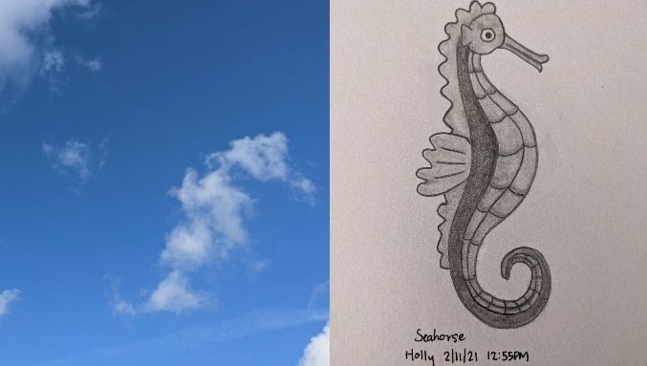
Figure 1: (Left) Cloud observation from my back garden. 2nd November 2021, 12:55 PM- Carlton, Nottingham, UK, and (Right) My drawing of what I saw in the cloud shape. Photo and Artwork: Holly McNiven

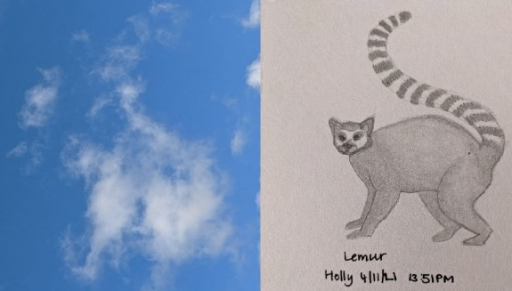
Figure 2: (Left) Cloud observation taken from the high street. 4th November 2021, 13:51 PM- West Bridgford, Nottingham, UK, and (Right) My drawing of what I saw in the cloud shape. Photo and Artwork: Holly McNiven

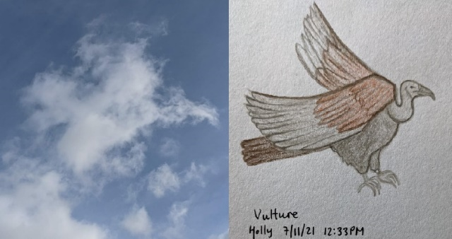
Figure 3: (Left) Cloud observation from my back garden. 7th November 2021, 12:33 PM- Carlton, Nottingham, UK, and (Right) My drawing of what I saw in the cloud shape. Photo and Artwork: Holly McNiven
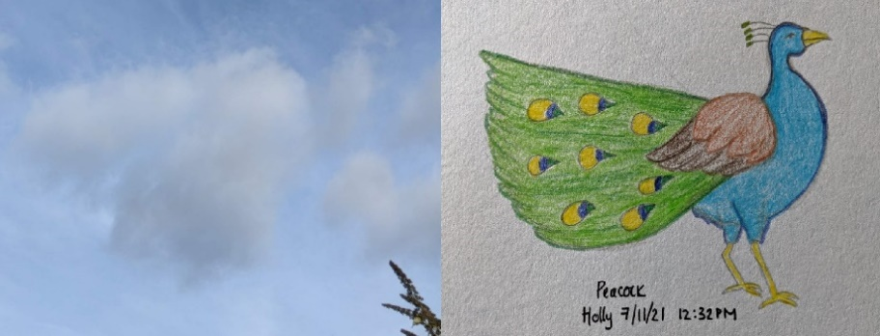
Figure 4: (Left) Cloud observation from my back garden. 7th November 2021, 12:32 PM- Carlton, Nottingham, UK, and (Right) My drawing of what I saw in the cloud shape. Photo and Artwork: Holly McNiven

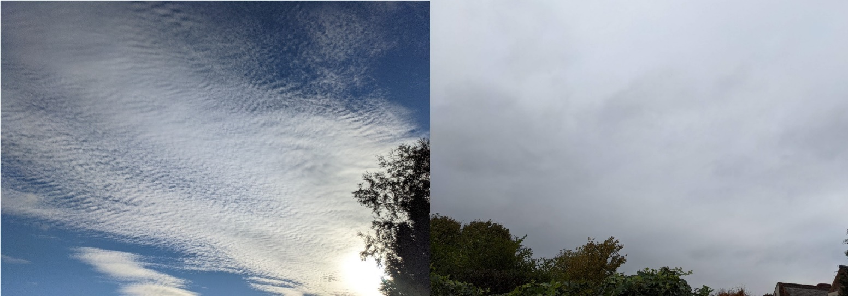
Figure 5: Cloud observation from my back garden. 5th November 2021, 14:19 PM- Carlton, Nottingham, UK. Photo: Holly McNiven

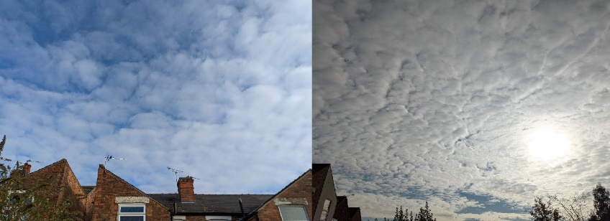
Figure 6: Cloud observation from my back garden. 5th November 2021, 12:39 PM- Carlton, Nottingham, UK. Photo: Holly McNiven

Figure 7: Cloud observation from my back garden. 5th November 2021, 12:39 PM- Carlton, Nottingham, UK. Photo: Holly McNiven

Clouds: Mood and Feelings

Just as our thoughts are influenced by the kind of weather we are in, so too are our moods and feelings. The sky is experienced, belonging to a phenomenal order of reality that transcends the physical. As British anthropologist Tim Ingold remarks, “Though no less real than the physical world, the environment is not a reality of objects or bodies in space but reality for the beings that make a living there.”. In other words, we are all interconnected with the world around us; as we are part of it, it is part of us. By engaging in the phenomenological fieldwork of sky journaling, I was able to experience for myself this interconnection with the environment and allow my mind and my senses to be open to the world around me. As I wrote at midday on the 8th of November, “The sky is mostly clear, and I have a sense that the blue above goes on indefinitely. A cold breeze passes through me, yet my elation is not dampened. I feel I could fly up there and touch the blue somehow.”. As my imagination took me flying ever upward into the blue, this positive experience with the sky directly evoked an emotional response in me and uplifted my mood. In Tim Ingold’s 2016 paper ‘Reach for the stars! Light, vision and the atmosphere’ he notes that “in opening our eyes and ears to the sky, vision and hearing effectively become one. And they merge with feeling, too, as we bare ourselves to the wind.”. This ‘feeling’ for me was not only a physical reaction to the cool wind or the warm rays of the sun, but an emotional feeling and mental clarity that is hard to describe yet refreshingly simple to experience. That being said, not all my interactions with the sky were positive ones, and in some notable cases I was left feeling frustrated and, to use my own words, “smothered” by the clouds.

This frustration at the obscuring quality of certain cloud and mist is an experience shared by Romantic poet John Keats (1795-1821), who in 1818 ascended Ben Nevis only to have his view obstructed by mist. He remarked, “that all my eye doth meet /Is mist and crag, not only on this height, /But in the world of thought and mental might!”. Keats likened the obscuration of cloud and mist as a symbol of the occluded mind itself. Similarly, the German painter Caspar David Friedrich (1774-1840) also made this symbolic connection between mind and cloud, stating that when our view of the sky is “narrowed down, constrained, and obscured by clouds… the mind is proportionately constrained and oppressed”. This idea of oppression of mind caused by an overcast sky was something I also experienced during my observations. As I noted in my sky journal on the afternoon of the 8th of November, “I feel trapped under the grey. I no longer feel I can fly up into the infinite blue. Now there is a ceiling.”. Tim Ingold has proposed that because people normally write and think indoors, the world described in writing is often imaginatively reconstructed as if one was already within an interior environment. This certainly seems to be the case in this particular entry, whereby I likened the experience of being under stratus clouds to having a physical ceiling over my head. On the following day of the 9th of November, the overcast sky persisted (Fig. 8), and I noted feeling “caged by the mass of it” and “trapped under the grey”. During these overcast periods, my mood and my thoughts turned overwhelmingly negative to reflect the dreariness of the clouds. It was as if the sky was trying to shut me out, letting me know it too was in no mood to play. However, as seen previously, in those moments when the sky was clearer and not obscured, my interaction with the sky was richer and more open. Friedrich described this feeling of upliftment from a break in the clouds as the “infinite” prevailing over the “finite”. As if the clear sky went on forever and the ever-changing clouds were as fickle and shifting as one’s own day-to-day thoughts and feelings.

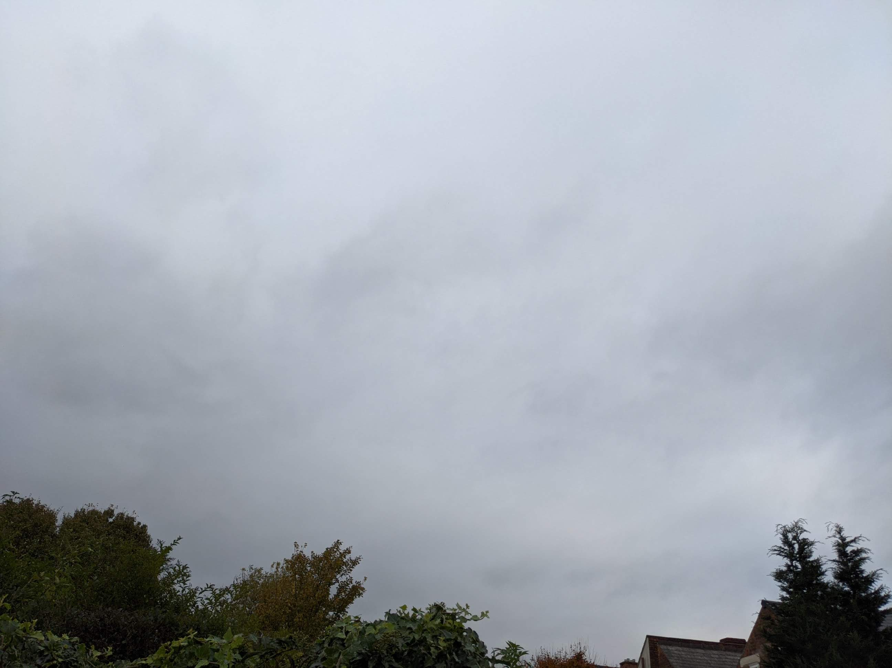
Figure 8: Cloud observation from my back garden. 9th November 2021, 12:02 PM- Carlton, Nottingham, UK. Photo: Holly McNiven

Conclusion

Having observed the clouds for my sky journal, I would like to make a slight amendment to Harris’ words and assert that “To think and to feel is to walk among clouds.”. The act of thinking and feeling are both ever-changing and often intrinsically linked to our experience with the weather and the sky we are under. From the overwhelming feeling of being “smothered” by the bleakness of an overcast sky, to the child-like joy caused by seeing pareidolic images of animals and shapes in the clouds; I have personally found that the sky and clouds have a profound impact on one’s mind. The symbolic connection between cloud and mind has been considered for millennia, from Classical writers like Aristophanes to Romantics such as Keats and Friedrich. Shakespeare for one used this symbolic relationship as a means of illustrating the limitless creative power of poetic-artistic imagination. The human mind is like a theatre; entire worlds can be created and destroyed in a single thought, just as the sky is a perpetual canvas of endless possibilities. Clouds have an uncanny ability to capture our imagination and sway our moods, having one’s ‘head in the clouds’ one minute to being on ‘cloud nine’ the next. In this sense, the variable nature of clouds can in themselves be seen as reflections of our own inner environment, where thoughts and feelings change at whim like clouds in a day sky.

References

Alfeld, Matthias, Kristina Mösl and Ina Reiche, ‘Sunset and Moonshine: Variable Blue and Yellow Pigments Used by Caspar David Friedrich in Different Creative Periods Revealed by in Situ XRF Imaging’, X-Ray Spectrometry, 50.4 (2021), 341–350

Aristophanes, Clouds. Wasps. Peace., ed. and trans. by Jeffrey Henderson. Loeb Classical Library 488 (Cambridge, MA: Harvard University Press, 1998)

Bätschmann, Oskar, ‘Carl Gustav Carus (1789-1869): Physician, Naturalist, Painter, and Theoretician of Landscape Painting’, in Nine Letters on Landscape Painting: Written in the Years 1815-1824; with a Letter from Goethe by Way of Introduction, trans. by David Britt (Los Angeles: The Getty Research Institute, 2002), pp. 1-73

Cheney, David R., ‘The Meaning of the Cloud in Hamlet’, Shakespeare Quarterly 10.3 (1959), 446-447

Colvin, Sidney, Life of John Keats: His Life and Poetry, His Friends, Critics and After-Fame (New York: C. Scribner’s Sons, 1917)

Cross, James and Thomas Hill, The Prose Solomon and Saturn and Adrian and Ritheus (Toronto: University of Toronto Press, 2017)

Davies, Charlotte Aull, Reflexive Ethnography a Guide to Researching Selves and Others, 2nd edn. (London: Routledge, 2012)

Diana, Lorenzo and others, ‘A Divergent Approach to Pareidolias- Exploring Creativity in a Novel Way’, Psychology of Aesthetics, Creativity, and the Arts, 15.2 (2021), 313-323

Goddard, Harold Clarke, The Meaning of Shakespeare (Chicago: University of Chicago Press, 1951)

Harris, Alexandra, Weatherland: Writers and Artists Under English Skies (London: Thames & Hudson, 2016)

Holden, Anthony, William Shakespeare: His Life and Work (London: Little, Brown and Company, 1999)

Ingold, Tim, ‘Earth, Sky, Wind, and Weather’, The Journal of the Royal Anthropological Institute, 13.S1 (2007), S19-S38

Ingold, Tim, ‘Reach for the Stars! Light, Vision and the Atmosphere’, in The Imagined Sky: Cultural Perspectives, ed. by Darrelyn Gunzburg (Sheffield: Equinox Publishing, 2016), pp. 215-233

Ingold, Tim, ‘The Eye of the Storm: Visual Perception and the Weather’, Visual Studies, 20.2 (2005), 97-104

Keats, John and John Barnard, John Keats, the Complete Poems (Harmondsworth, England: Penguin Books, 1988)

Lewis, Rhodri, ‘Shakespeare’s Clouds and the Image Made by Chance’, Essays in Criticism, 62.1 (2012), 1-24

Marshall, C. W., ‘Aristophanes’, in Aristophanes: Frogs, ed. by C. W. Marshall (London: Bloomsbury Publishing, 2020), pp. 9-12

McNiven, Holly, Sky Journal, 1st November-10th November 2021

Pretor-Pinney, Gavin, Cloudy with a chance of joy [video]. 2013 <https://www.ted.com/talks/gavin_pretor_pinney_cloudy_with_a_chance_of_joy/transcript> [accessed 23 November 2021]

Shakespeare, William, Stanley Wells and Gary Taylor, The Complete Oxford Shakespeare: Histories, Comedies, Tragedies, 3 vols. (Oxford: Oxford University Press, 1987)

Smith, David Woodruff, ‘Consciousness with Reflexive Content’, in Phenomenology and Philosophy of Mind, ed. by David Woodruff Smith and Amie L. Thomasson (Oxford: Oxford University Press, 2005), pp. 94-114

Stevenson, Angus, ‘cloud’ in Oxford Dictionary of English (2010) < https://www.oxfordreference.com/view/10.1093/acref/9780199571123.001.0001/m_en_gb0156550?rskey=z3oYSD&result=1> [accessed 24 November 2021]

Strauss, Leo, Socrates and Aristophanes (Chicago: University of Chicago Press, 1980)

Tilley, Christopher Y., The Materiality of Stone: Explorations in Landscape Phenomenology 1 (Oxford: Berg, 2004)

Trienens, Roger J., ‘The Symbolic Cloud in Hamlet’, Shakespeare Quarterly, 5.2 (1954), 211-213

Alexandra Harris, Weatherland: Writers and Artists Under English Skies (London: Thames & Hudson, 2016), p. 247
Christopher Y. Tilley, The Materiality of Stone: Explorations in Landscape Phenomenology 1 (Oxford: Berg, 2004), p. 2
David Woodruff Smith, ‘Consciousness with Reflexive Content’, in Phenomenology and Philosophy of Mind, ed. by David Woodruff Smith and Amie L. Thomasson (Oxford: Oxford University Press, 2005), pp. 94-114 (p. 95)
Harris, Weatherland, p. 247
Harris, Weatherland, p. 13
Angus Stevenson, ‘cloud’ in Oxford Dictionary of English (2010) < https://www.oxfordreference.com/view/10.1093/acref/9780199571123.001.0001/m_en_gb0156550?rskey=z3oYSD&result=1> [accessed 24 November 2021]
Harris, Weatherland, p. 13
Harris, Weatherland, p. 239
James Cross and Thomas Hill, The Prose Solomon and Saturn and Adrian and Ritheus (Toronto: University of Toronto Press, 2017), pp. 67-68
C. W. Marshall, ‘Aristophanes’, in Aristophanes: Frogs, ed. by C. W. Marshall (London: Bloomsbury Publishing, 2020), pp. 9-12 (p. 9)
Aristophanes, Clouds. Wasps. Peace., ed. and trans. by Jeffrey Henderson. Loeb Classical Library 488 (Cambridge, MA: Harvard University Press, 1998), pp. 56-59
Aristophanes, Clouds, pp. 50-51; Leo Strauss, Socrates and Aristophanes (Chicago: University of Chicago Press, 1980), pp. 17-18, 21
Anthony Holden, William Shakespeare: His Life and Work (London: Little, Brown and Company, 1999), pp. 8, 320
Rhodri Lewis, ‘Shakespeare’s Clouds and the Image Made by Chance’, Essays in Criticism, 62.1 (2012), 1-24 (p. 1)
William Shakespeare, Stanley Wells and Gary Taylor, The Complete Oxford Shakespeare: Histories, Comedies, Tragedies, 3 vols. (Oxford: Oxford University Press, 1987), III, p. 1366 (Act 4, Scene 15, 2-11)
Shakespeare, Wells and Taylor, Complete Oxford Shakespeare, III, p. 1144 (Act 3, Scene 2, 364-370)
Please see: Harold Clarke Goddard, The Meaning of Shakespeare (Chicago: University of Chicago Press, 1951), p. 357; Roger J. Trienens, ‘The Symbolic Cloud in Hamlet’, Shakespeare Quarterly, 5.2 (1954), 211-213 (pp. 211-212); David R. Cheney, ‘The Meaning of the Cloud in Hamlet’, Shakespeare Quarterly 10.3 (1959), 446-447 (p. 447); Lewis, ‘Shakespeare’s Clouds’, p. 8
Lorenzo Diana and others, ‘A Divergent Approach to pareidolias—Exploring Creativity in a Novel Way’, Psychology of Aesthetics, Creativity, and the Arts, 15.2 (2021), 313-323 (p. 314)
Holly McNiven, Sky Journal, 1st November-10th November 2021, (Entry from Tuesday 2nd November 2021, 12:00 PM)
McNiven, Sky Journal, (Entries from Friday 5th November 2021, 12:00 PM-14:00 PM, Sunday 7th November 2021, 14:00 PM, Monday 8th November 2021, 12:00 PM)
McNiven, Sky Journal, (Entries from Friday 5th November 2021, 14:00 PM, Sunday 7th November 2021, 14:00 PM, Monday 8th November 2021, 12:00 PM)
Charlotte Aull Davies, Reflexive Ethnography a Guide to Researching Selves and Others, 2nd edn. (London: Routledge, 2012), pp. 4,7
Harris, Weatherland, p. 247
Gavin Pretor-Pinney, Cloudy with a chance of joy [video]. 2013 <https://www.ted.com/talks/gavin_pretor_pinney_cloudy_with_a_chance_of_joy/transcript> [accessed 23 November 2021]
Harris, Weatherland, p. 14
Tim Ingold, ‘Earth, Sky, Wind, and Weather’, The Journal of the Royal Anthropological Institute, 13.S1 (2007), S19-S38 (S25)
Ingold, ‘Earth, Sky, Wind’, S25
Tilley, The Materiality of Stone, p. 2
McNiven, Sky Journal, (Entry from Monday 8th November 2021, 12:00 PM)
Tim Ingold, ‘Reach for the Stars! Light, Vision and the Atmosphere’, in The Imagined Sky: Cultural Perspectives, ed. by Darrelyn Gunzburg (Sheffield: Equinox Publishing, 2016), pp. 215-233 (p. 231)
Tim Ingold, ‘The Eye of the Storm: Visual Perception and the Weather’, Visual Studies, 20.2 (2005), 97-104 (p. 103)
Tilley, Materiality of Stone, p. 15
McNiven, Sky Journal, (Entries from Monday 1st November 2021, 12:00 PM, Monday 8th November 2021, 14:00 PM, Tuesday 9th November 2021, 12:00-16:00 PM, Wednesday 10th November 2021, 14:00 PM)
Sidney Colvin, Life of John Keats: His Life and Poetry, His Friends, Critics and After-Fame (New York: C. Scribner’s Sons, 1917), pp. 3, 519
Colvin, Life of John Keats, pp. 293-294
John Keats and John Barnard, John Keats, the Complete Poems (Harmondsworth, England: Penguin Books, 1988), p. 270
Harris, Weatherland, p. 246
Matthias Alfeld, Kristina Mösl and Ina Reiche, ‘Sunset and Moonshine: Variable Blue and Yellow Pigments Used by Caspar David Friedrich in Different Creative Periods Revealed by in Situ XRF Imaging’, X-Ray Spectrometry, 50.4 (2021), 341-350 (p. 342)
Oskar Bätschmann, ‘Carl Gustav Carus (1789-1869): Physician, Naturalist, Painter, and Theoretician of Landscape Painting’, in Nine Letters on Landscape Painting: Written in the Years 1815-1824; with a Letter from Goethe by Way of Introduction, trans. by David Britt (Los Angeles: The Getty Research Institute, 2002), pp. 1-73 (p. 36)
McNiven, Sky Journal, (Entry from Monday 8th November 2021, 14:00 PM)
Ingold, ‘Earth, Sky, Wind’, S32
McNiven, Sky Journal, (Entry from Tuesday 9th November 2021, 12:00-16:00 PM)
McNiven, Sky Journal, (Entries from Monday 1st November 2021, 12:00 PM, Monday 8th November 2021, 14:00 PM, Tuesday 9th November 2021, 12:00-16:00 PM, Wednesday 10th November 2021, 14:00 PM)
McNiven, Sky Journal, (Entries from Tuesday 2nd November 2021, 12:00-16:00 PM, Wednesday 3rd November 2021, 14:00 PM, Thursday 4th November 2021, 14:00 PM, Friday 5th November 2021, 12:00-14:00 PM, Sunday 7th November 2021, 12:00-14:00 PM, Monday 8th November 2021, 12:00 PM)
Bätschmann, ‘Carl Gustav Carus’, p. 36
Harris, Weatherland, p. 247

