From the twilight of Rome to the Dawn of Islam: The World of Late Antiquity (AD 235-632)
Workshop: Debating the end of Antiquity – Should we adopt a Catastrophist or Continuist model?

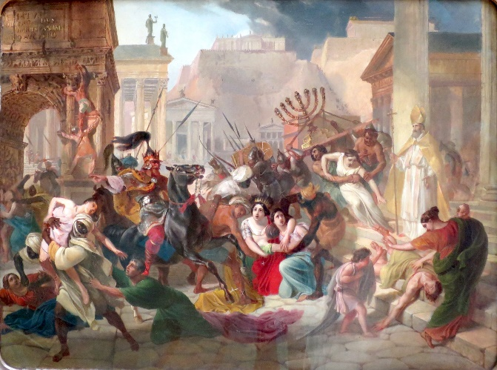
Genseric sacking Rome, by Karl Briullov (1833-1836)

In this workshop we will explore the long debated question over whether the political extinction of the western Roman Empire should be understood in terms of a distinct and catastrophic end to Antiquity (in the West) or merely part of a longer stage of continuity and transition. The former catastrophist view, often characterised as the “decline and fall of the Roman Empire”, tends to see the transition between the Late Antique and medieval words as fairly rapid, with many quite negative consequences for various peoples in Europe. The latter continuist view emphasises a longer and more drawn out process of transformation and transition, one that was less perceptible to contemporaries; that is to say a not overly traumatic rapture that rapidly led from Antiquity to the medieval world. We will debate these issues in the seminar. As such you should prepare arguments for both viewpoints, and then ultimately decide which of the two models you find most convincing. Bring your notes along for discussion.

Issues to consider:
- To what extent can we see continuity or decline in cultural and educational practices from Antiquity? Are the mentalities still broadly similar?
- What about legal codes, systems of justice and the capacity for tax collection?
- What about artistic representations and styles?
- What about civic infrastructure and amenities? Does the picture vary in different parts of Europe?
- What degree of accommodation can be discerned between traditional elites and new “Germanic” military-political elites? How might Christianity have facilitated this?
- Should we see the “Germanic” groups as an invading force or as groups integrated into the Roman world?
- Is any notable economic or demographic decline discernible?

In order to address these issues you should take a look at the following scholarship:
Marcone, A. 2008. ‘A Long Late Antiquity? Considerations on a Controversial Periodization’, Journal of Late Antiquity 1 (1): 4-19.
Ward-Perkins, B. 1997. ‘Continuitists, Catastrophists, and the Towns of Post-Roman Northern Italy’, Papers of the British School at Rome 65: 157-176.
Wickham, C. 2005. Framing the Early Middle Ages: Europe and the Mediterranean, 400-800. Oxford: Oxford University Press [read the Conclusion, pages 825-831: https://whel-primo.hosted.exlibrisgroup.com/permalink/f/14dj339/44UWTSD_ALMA51177227780002421]

