

Implementation and Evaluation on an Open-Source Security Information and Event Management (SIEM) for Small Scale Networks

by
James Turner

Supervisor: Simon Thomas

Project submitted as part of the requirements for the award of
BSc (Hons) Computing (Computer Networks and Cyber Security)

2025/6

DECLARATION

I, James Turner, declare that I am the sole author of this Project; that all references cited have been consulted; that I have conducted all work of which this is a record, and that the finished work lies within the prescribed word limits.

This work has not previously been accepted as part of any other degree submission.

Date: 1/5/26

FORM OF CONSENT

I, James Turner, hereby consent that my Project, submitted in candidature for the B.Sc.(Hons) Computing (Computer Networks and Cybersecurity) degree, if successful, may be made available for inter-library loan or photocopying (subject to the law of copyright), and that the title and abstract may be made available to outside organisations.

Date: 1/5/26

Abstract

This project aimed to evaluate the effectiveness of an open-source SIEM, Wazuh, in terms of its detection performance and alert clarity specifically for a small network environment. The main objectives set out were to evaluate the detection ability of the system against several common cyber-threats, look over the alerts generated and determine if they were suitable for the implemented attack, and finally checking the generated alerts to see if they provided the necessary information to respond to a potential attack.

The methods used for the project involved setting up a virtual environment using several virtual machines to represent a small network. This included setting up an isolated internal network to ensure that ethical considerations were met, as well as setting up the SIEM Wazuh to detect the suspicious activity and report it. Threats such as authentication attacks and network-based attacks were introduced into the environment to determine how the SIEM would respond to its presence.

The main findings obtained show that Wazuh’s base installation was mostly effective against common threats, with particular focus on authentication and file manipulation, which relied on system-based log data. The SIEM was limited in its effectiveness against network-based attacks, as it was unable to detect these threats unless an additional piece of software was integrated into the system. This highlighted a limitation of the base installation of Wazuh, as it required 3rd party resources to help provide more-rounded protection.

The project overall demonstrated that an open source SIEM can provide an effective monitoring solution for small networks, but does require additional configuration and tools in order to be fully viable for organisations. The recommendations suggested include evaluating the SIEM with the additional tools mentioned, as well as implementing the solution in a more realistic environment with real user behaviour.
Contents
Abstract 3
1.0) Introduction 6
2.0) Research and Literature Review) 9
2.1) Introduction to review 9
2.2) Cyber Security Landscape 10
2.3) Security Monitoring and Detection 12
2.4) Security Information and Event Management 14
2.5) Virtual Machines and test environments 15
2.6) Summary of literature 17
3.0) Research and development methodology 18
3.1) Methodology Introduction 18
3.2) Research Approach 19
3.3) Test Environment and Experiment Design 21
3.4) Data Collection 22
3.5) Analysis Methods 24
3.6) Methodology Summary 25
4.0) Design and Implementation 26
4.1) Environment Design 26
4.2) Network Design 26
4.3) SIEM Architecture Design 28
4.4) Virtual Machines Design 29
4.5) Design Summary 31
4.6) Implementation Introduction 31
4.7) Environment Setup 32
4.8) Network Configuration 33
4.9) SIEM Deployment 34
4.10) Attack Implementation 36
4.11) Attack Analysis 43
5.0) Evaluation 45
5.1) Results Evaluation 45
5.2) Comparison to Objectives and Aims 46
5.3) What would be done differently 47
6.0) Conclusions and Recommendations 49
6.1) Conclusion 49
6.2) Recommendations 49
7.0) Reflection 51
Bibliography 53

Introduction

Cyber-attacks in the past few years have become more frequent and complex, creating challenges for organisations of all sizes. While larger organisations can afford to invest in dedicated security teams and advanced commercial security solutions, small and medium enterprises (SMEs) often lack both the technical knowledge and budget required to effectively respond. This reduced ability to act against cyber-attacks leaves these SMEs especially vulnerable to threats such as unauthorised access, credential exploitation, and network surveillance. As a result of these attacks, system monitoring, suspicious behaviour detection, and incident response are now essential for modern organisations cyber defence. Security Information and Event Management (SIEM) systems support these processes, by collecting both network and system logs from several devices to provide insight into the network and its connected devices. While SIEMs provide valuable monitoring capabilities, most commercial SIEM systems are either too expensive, too complicated or require too many resources to be viable for smaller environments. As a result, interest in various open-source solutions as more accessible alternatives has increased, however their effectiveness and usefulness have yet to be fully determined in smaller network environments.

This project evaluates an open-source SIEM solution in a controlled virtual environment, with a particular focus on defensive cyber security monitoring. While some systems do offer preventative measures against attacks, the vast majority of SIEMs focus on detecting and analysis of suspicious activity through a combination of log sources and generating alerts in real-time. The system chosen for this project is the open-source solution Wazuh, a popular choice in the open-source community. To evaluate this solution, a virtual network environment will be created, aiming to replicate a small organisation’s network. This network will comprise of a mix of Windows and Linux machines, allowing different types of cyber-attacks to be carried out in a controlled environment, without risk to real-world infrastructure. Several different attack types will be carried out, such as brute force password attacks as well as remote access attempts on various devices on the network. These simulated attacks will provide several different information logs that will be transferred via Wazuh’s agent system to the SIEM server, and the logs will be analysed to assess how effectively the SIEM detected and alerted to attacks.

The main objective of this project is to measure the effectiveness of an open-source SIEM system, including its ability to detect common cyber-attacks in a small environment, while also analysing its maintainability and ease of use. To achieve this aim, the following objectives were developed; to configure and deploy a Wazuh server along with several agents on connected devices; to simulate a range of common cyber-attacks on the devices; to collect and analyse a range of data events such as network and system logs to assess its detection performance, and analyse it as a product, including its ease of use and data visualisation. The results should include a fully configured virtual environment, documented experimental results, finally leading to an analysis of the effectiveness of the SIEM.

The following chapter, Chapter 2, will lead to a review of relevant literature, giving sufficient background knowledge into the project for the reader. Chapter 3 covers the research methodology/methodologies used and will cover the various experiments used and their purpose. Chapter 4 will cover the design and implementation of the project. This covers the creation of the virtual network along with implementing the experiments from the previous chapter. Chapter 5 will discuss the evaluation of the data and objectives, including whether aims were met and a complete evaluation of the SIEM. Chapter 6 will cover the project conclusions and recommendations for the project for the future. Chapter 7 focuses on the reflection for the project, including the work already done and the skills developed in the process of project. Chapters 8 and 9 cover the references used and a bibliography for the full list of background research used.

2.0) Research and Literature Review)

2.1) Introduction to review

Security Information and Event Management (SIEM) systems have become a necessary tool for modern cyber security, providing organisations with the ability to collect, analyse and react to a wide range of cyber threats from a range of sources. SIEM systems combine log data from a variety of sources, including servers, network devices, user devices, etc, and apply rules to help detect and deal with suspicious activity before it becomes an active security breach. Due to its centralised approach, security teams are able to detect and respond more efficiently and can even help with meeting different regulatory requirements such as GDPR, HIPAA and PCI-DSS [1] and provide reports tailored to the specific regulatory system. SIEMs are widely used in larger organisations, however, its use in small and medium enterprises (SMEs) has been limited due to resource restrictions and lack of technical knowledge. This has led to open-source alternatives being introduced, such as Wazuh, combining threat detection, log management, and alerts, commonly found on commercial solutions at no financial cost to the company. [2]
This review explores the wider cybersecurity environment and fundamentals of attack detection and monitoring, before moving on to discuss SIEMs in further detail. There is a further analysis into open-source solutions, including previous studies and comparisons. Following this, potential ethical and legal considerations will be looked at, including both privacy concerns and regulatory compliance. This aims to provide sufficient background knowledge for readers to help understand the importance of monitoring and detection systems, how specifically SIEMs can help aid these needs, as well as addressing current gaps in research for the topic, with a particular focus on open-source solutions.

2.2) Cyber Security Landscape
The current cyber security research highlights that attacks are not only becoming more frequent, but are also easier to carry out with the availability of automated tools. As organisations continue to adopt cloud services and remote working, the number of potential vectors for attacks has dramatically increased. Research from Mrabet et al, and Najem and Kareem have shown that common attack strategies, such as brute-force attacks, phishing, malware and vulnerability attacks remain widespread for businesses and individuals. [3] [4] Many of these attacks do not rely on advanced tools or require vast knowledge about the device to take advantage of the system, but instead exploit weak passwords, misconfigurations, and a lack of active monitoring.

Small and Medium Enterprises (SMEs) are particularly vulnerable to cyber threats due to limited resources, lack of expertise and lack of investment in security measures. In a systematic mapping study done by Awan and Abu [5], it was found that many SMEs lack effective cyber defence strategies, including dedicated security teams and effective monitoring systems. These findings were also reported by Rombaldo Jr et al [6], who also described SMEs as “unaware, unfunded and uneducated” regarding cyber security risks. This lack of awareness and investment in proper cyber defence systems can result in SMEs having delayed attack detection, increasing overall impact when incidents occur. Rawindaran et al [7] further highlights that SMEs often underestimate the likelihood of being targeted for a cyber-attack, despite evidence showing that ransomware and credential attacks are increasingly affecting smaller organisations compared to larger organisations. Research done by OECD [8] supports these findings, noting that while SMEs adopt modern technologies quickly, they often neglect to invest in proper security controls alongside them.

Alongside this, the way cyber-attacks are being used has also changed in recent years. Many different attack tools have become more widely available, with many of these tools being fully automated, allowing attackers to examine more devices, and faster [3] [9]. Additionally, cybercrime has become increasingly more organised, with cyber criminals offering their skills and programs “as-a-service,” meaning that even those with limited technical knowledge are able to create and run ransomware and phishing campaigns. As a result, companies can no longer just depend on firewalls and antivirus software but must also prioritise having up-to-date detection and monitoring systems to identify potential threats before they exploited.

Cyber Threat Intelligence (CTI) research further highlights the importance of monitoring and detection systems in strengthening organisational strength. Systematic reviews done by Saeed et Al [10] as well as Haastecht et al [11] show that collecting and sharing threat information improves organisations ability to detect new risks and respond effectively. These ideas are also found within frameworks such as the National Institute of Standards and Technology (NIST) Cybersecurity framework, which has identified that detection and continuous monitoring systems are key components for effective security management [12]. This includes recognising abnormal behaviour and generating alerts to mitigate potential threats, reinforcing the role of monitoring systems in modern cyber-security.

In summary, the existing literature shows the current cyber threat environment is ever-changing and is becoming increasingly more automated. This is putting mounting pressure onto organisations, particularly SMEs, to ensure that their cyber security systems are consistently up to date. The literature also shows that while preventative measures are still important for security, breaches are often unavoidable, and so effort should be made to include effective monitoring and log analysis tools for cyber protection. This in turn provides a convincing argument for SIEM technologies, which purpose is to provide a centralised location for data logs and help identify suspicious activity inside the network.

2.3) Security Monitoring and Detection

The next research area chosen is security monitoring and detection literature. With security monitoring becoming an important part of modern cybersecurity, it is considered the “primary method of assessing current capabilities” by ENISA [13]. This suggests that purely preventative measures are no longer enough, and require systems to be able to detect activity after access has already been obtained. Ferrag et al. [14] have highlighted the need for Intrusion Detection Systems (IDS), and now act as a “second line of defence”[14] rather than an additional tool. This has been a common trend in the security industry, where IDS requirements have increased in the past few years.

IDS tools are often categorised into two main approaches, signature-based which focuses on recognising patterns of suspicious activity, and anomaly-based, which often depends on machine learning to differentiate between normal and abnormal activity. Kharaisat et al [15] details that signature-based detection is based on existing patterns, and is very powerful at detecting those patterns. However, it notes that it struggles with newer attacks, as the pattern for that attack has not yet been documented. This contrasts with anomaly-based tools, which use machine learning with a large amount of training data to identify those newer attacks from comparisons to normal behaviour. While this approach can prove useful in detecting newer attacks, there is a high false positive rate as “anomalies may just be new normal activities”[15]. Buczak and Guven [16] argue that independently these systems do not work for every environment, with Khenwar and Nawal [17] pointing out the number of alerts that could be produced, leading to “genuine threats being overlooked or ignored.”

Due to these limitations, recent work on IDS technologies have started to focus more on machine learning techniques to help improve detection. Ferrag et al.[14] has already discussed the benefits of machine learning, and Shone et al. [18] has examined the use of deep learning techniques that show promising results in improving the detection rate. While these results do look great in controlled environments, both Shone et al. [18] and Sommer and Paxson [19] both argue that these models are often not as capable in real-world situations, with Hozouri et al. [20] also critiquing the high computational requirements necessary, leading on to a difficulty in real-time deployment.

Alongside the strictly performance issues of the IDS approaches, there is also the problem of being able to collect and analyse this log data. Khenwar and Nawal [17] have already discussed the number of false positives and false negatives, and warn that these inaccuracies could lead to “alert fatigue” [17]. This display of log data is often overwhelming for security professionals, and the existing literature shows that a centralised location for these data logs is required.

2.4) Security Information and Event Management

With the need for a centralised location for the collection of data logs, a Security Information and Event Management (SIEM) system is recommended. As previously mentioned, the amount of log data generated has vastly increased and has become too much for manual sorting. Cremer et al. [21] not only notes the large amount of data in a cyber-security environment, but also the lack of relevant data for real-world use. This shows that a lot of data is taking up space when it is not even useful in detecting suspicious behaviour, and can harm visibility into actual potential threats.

SIEM systems are designed to address these issues, as they act as a collector of log data for multiple sources into a central location [22]. Gonzalez-Grandillio et al. [22] also talks about how SIEM solutions can provide a multitude of different benefits, including real-time processing, analysis of large data volumes and visualisation of data, although not every solution supports each of the benefits. Muhammad et al. [23] further explains the benefits that an SIEM can bring, especially when integrated with machine learning and IDS systems, all “built from an open-source project that everyone can use.”

While there are many advantages to using an SIEM, there have been several limitations identified from the literature. Both Tariq et al [24] and Saju et al. [25] describe how the sheer number of alerts tends to “overwhelm” analysts, and combining a large number of alerts with a high false positive rate leads to a reduced ability to react to actual threats. This can be extremely harmful to the companies security if the workers have to focus on every alert rather than the most suspicious ones, and is often down to the SIEM and its detection ability. In a study done by Uetz et al. [26], they found that out of 292 common rules, over 110 were fully evadable. This shows that base rules for SIEMs are often not effective enough for widespread detection, with just under 40% of all rules being undetectable.

In order to address some of these limitations, researchers have suggested that combining SIEM detection with additional tools such as Machine Learning, AI, and even IDS could be beneficial. Kikissagbe and Adda [27] suggest that machine learning solutions offer a “promising solution” and is cable of responding to new and evolving threats. Tendikov et al. [28] did a study regarding SIEMs and integrating machine learning algorithms, and found that they are not only capable of “processing vast and diverse data sets” but do so with human-like precision. This not only improves the security of the organisation, but frees the security professionals to further look into credible threats, rather than constant false positives.

2.5) Virtual Machines and test environments

When researching existing literature for SIEMs and other systems, they often used virtual machines (VMs) and virtual test environments to support their testing. These environments help to create a controllable research area without affecting outside systems and networks. Sierra-Arriaga and Branco [29] some of the benefits of virtualisation, including isolation, emulation of multiple devices as well as greater control over the virtual environment compared to real-world solutions. Isolation is very important part when testing potentially harmful content in these environments, as it reduces the risk that the harmful activity could escape and impact real networks and devices. This reduces the risk of any ethical considerations being broken.

Another advantage to using virtual machines is the ability to simulate a virtual environment with multiple devices inside a singular piece of hardware. Arogundade and Palla [30] discuss the ability to create a virtual environment that is able to simulate real-world infrastructure, which includes using various machines and network deployments. Akeel et al [31] also mention the usefulness of virtual test environments for security purposes, with a specific highlight on its accessibility for students and researchers alike as not just a testing ground, but as a learning environment. This is echoed by Thorpe et al [32], who also shares their benefits of virtual machines as a way to ensure experiment repeatability.

Although there are advantages to using a virtual environment, there are limitations to this approach. One issue mentioned by Sierra-Arriaga and Branco [29] is that while virtualisation can have strong isolation from networks, there will be an inherit sharing of resources, which could lead to attacks escaping the environment and affecting real infrastructure. Another limitation found by Chouliaras et al. [33] is that the testing data used for comparison lacks consistency, which makes it hard to compare results between different findings as the data used will heavily skew the findings. There are even some systems designed, one of which is designed by Jiang et al. [34] that specifically act to be incompatible with real networks, severely limiting the ability to determine the effectiveness of tools deployed in these environments.

2.6) Summary of literature

The existing literature shows that cybersecurity is an ever-evolving industry, and is continuously met with frequent and increasingly accessible attacks. It highlights common threats such as authentication attacks and malware that still affect organisations of all sizes, and shows that misconfigurations are often the leading cause for successful exploits. The literature also shows that SMEs are often in more danger to these attacks compared to larger organisations due to their limited budgets and a lack of security awareness.
As well as this, security monitoring systems such as IDS are now considered to be essential pieces of cyber defence, with both signature-based and anomaly-based approaches providing real benefits to organisations. These approaches do have their limits, and are often noted to have a high false-positive rate which had led to cyber analysts feeling overwhelmed and having a reduced response effectiveness.

One of the suggested solutions to these challenges was using SIEM systems, which provide a centralised location for these data logs to be analysed. The benefits often mentioned with SIEMs are their real-time monitoring capabilities and their ability to integrate with several other technologies including IDS. These systems still suffer from the ability to be overloaded with alerts, and as such recommendations such as Machine Learning techniques have been introduced with positive results.

3.0) Research and development methodology

3.1) Methodology Introduction

This chapter describes the research and development methods used to design and evaluate the SIEM system. The aim for this project was to investigate an open-source SIEM platform, in this case Wazuh, and assess its ability to detect and respond to harmful activity in a small network environment. For this project, the hypothesis was that the SIEM Wazuh would be able to detect most common forms of harmful activity while generating clear and understandable alerts. To support this, a controlled virtual setup was selected to provide greater control over network behaviour, due to the variability of working with real-world networks.

The methodology follows the Research Onion framework, which was used to structure the methodology. For the first layer of the framework, a positivist philosophy was selected, due to its focus on measurable outcomes, such as detection rate of the SIEM and response time. The second layer supported a deductive approach, in which the existing knowledge of SIEMs informed the testing design. Next on the Onion was strategy, in which an experimental strategy was chosen, with help from a mixed-method approach due to a combination of both quantitative and qualitative data collected. The fifth layer determined the time horizon choice, where a cross-sectional horizon was used due to the collection of data being from a single testing period.

The remainder of the chapter explains the methodologies used during the project, including the research approach for the project, the development approach, the test environment, the experimental design.

3.2) Research Approach

The research approach used in this project was a combination of both experimental testing and an iterative development methodology. This combined method was selected because both the system and testing processes could evolve when necessary throughout the project, while still providing the structure needed for evaluation of the SIEM.

Figure 1: Example of iterative design cycle

For this project, a positivist approach was most appropriate, however, elements from a pragmatic approach were also used. This is because while the main focus of the project was on measurable behaviour from the SIEM, there were also some subjective elements such as clarity of the alerts generated and usability of the system as a whole that fit a more pragmatic approach. A deductive research approach was followed, which meant that expectations of the system was based on already existing knowledge, and were created prior to testing. The expectations, such as repeated login attempt detection, were compared against the actual observed behaviour during implementation, allowing for a direct evaluation of the system compared to the expected outcomes.

During the initial stages of the project, a Waterfall model for development was considered. Waterfall is a linear model where each stage of development finishes before the next stage starts. Unfortunately, while this approach is useful for projects with clear requirements from the start, a project such as this with ongoing and continued evolution meant that it was not a suitable approach.

Because of this, an iterative approach was used instead, which enabled continuous refinement of the different development stages. As the virtual environment and the SIEM system required constant adjustments throughout the project, this approach was much more suitable, as it supported a cycle of testing into review into changing elements where needed. This cycle of continual testing meant that changes to both the system configuration and the testing process itself could be made, to ensure that evaluation was as accurate as possible.

The experimental strategy followed was selected to evaluate how the SIEM responded to different types of activity within the controlled environment. Several common cyber-attacks were used to record the ability of SIEM in a consistent environment, meaning that it was possible to compare the outcomes of these attacks and identify potential patterns in the SIEM’s performance.

Despite the advantages of this combined approach, there were some limitations. Using an experimental approach means that a controlled environment must be used, which cannot fully reflect real-world conditions. Factors such a normal user behaviour as well as varying system performance between devices cannot be easily replicated, which may reduce how well the findings apply to real-world environments. As well as this, as a cross-sectional horizon was chosen, which meant that long term behaviour of the system was not considered, which could impact the reliability of the results for real world applications.

3.3) Test Environment and Experiment Design

To support the research approach, a controlled virtual environment was created to help simulate a small-scale network. This environment made it possible to test a mix of cyber-attacks safely without affecting external systems, while also keeping test conditions consistent.

The environment consisted of multiple virtual machines, including a central server, client machines that ran both Linux and Windows operating systems, as well as a dedicated machine for launching the different attacks. These client machines were used to gather system data that was subsequently sent to the server machine for analysis. The attack machine was used to generate activity on the client machines to evaluate the detection ability of the SIEM.

An internal network was selected to allow the devices to communicate, while also ensuring that the traffic generated stays within the environment. This setup prevented external factors from affecting the machines, and stopped the machines affecting the outside environment.

The experimental design for the project was focused on implementing various common cyber-attacks under similar conditions. These attacks were designed to represent common forms of potentially harmful behaviour, allowing the SIEM to be tested against realistic scenarios. To reduce the impact of an isolated environment, machines that were not targeted during testing aimed to replicate normal user behaviour, as to evaluate the ability of the SIEM to distinguish between legitimate and harmful activity.

3.4) Data Collection

The data collection stage was focused on collecting both quantitative and qualitative data from the SIEM during the testing period. It also examined the effectiveness of the SIEM in detecting different types of activity while also allowing for the clarity and usefulness of the alerts generated to be evaluated.

Data was collected primarily from the Wazuh dashboard using the “Security Events” section, which provided real-time alerts based on the log data sent from the connected client machines. Each of the alerts contained a wide range of data, including the timestamp for the alert, the system that was affected, a small description of the activity detected, and a severity level given by the Wazuh manager. The structure for the alerts made it easier to collect and compare data across the different types of attacks.

In order to generate this data, different types of potential attacks were carried out in the environment. These attacks included authentication-based attacks, which involved repeated login attempts to both the Linux and Windows clients. This generated a large amount of failed authentication attempts, which were then sent to the SIEM for analysis. Another attack surface used was network-based attacks, which included network reconnaissance as well as Denial of Service (DoS) attacks, which aim to slow down the network. Finally, there was insider attacks such as file changes, which detected changes such as file deletion, file addition or plain file changes.

For each of the tests, there was a consistent set of data collected for later evaluation. The quantitative data collected included whether the SIEM could detect the attack, the time it took for a related alert to be generated, and the severity level given for the alert. This was collected alongside qualitative data, such as the clarity of the alert generated and whether the given description was useful in identifying the attack.

For reliability reasons, each of the attacks was repeated multiple times under the same conditions. This reduced the impact of anomalies on the results and ensured that there was a repeatable result for each attack. Where inconsistencies were found, there were additional checks using the devices own logs to confirm that the attack was successful, which helped to identify if the SIEM could not detect an attack.

3.5) Analysis Methods

For the analysis stage, the collected data was chosen to assess the effectiveness of the SIEM in detecting and responding to different attack types, while also evaluating the clarity and usefulness of the alerts that were generated.

The quantitative analysis was based on the measurable metrics of the collected data, such as the detection rate of the SIEM and it’s response time to different scenarios. The detection rate for each attack was calculated by dividing the detected events against the number of successful attacks implemented. A percentage was calculated for each attack type, which could then be compared against other attacks. For the response time, the time difference between the attack being launched and an alert being generated was used, and an overall average for each alert type was calculated. These two metrics provided a general view into the effectiveness of the system against different attack types.

The qualitative analysis focused on the non-numerical metrics collected, such as the clarity and usefulness of the generated alerts. Each of the alerts was reviewed to determine whether the provided data such as the affected system, activity type and severity alert were relevant for each of the attacks. The alerts that were easier to understand at a glance were considered to be more effective as they could allow for faster reactions in a real-world situation.

For the data analysis, a cross-sectional approach was used, allowing for multiple different tests to be compared from a singular point in the project. This approach allowed for patterns and relationships to be identified from the different types of attacks and the responses from the SIEM. This analysis was then used to compare responses to authentication and network-based attacks, such as detection rate or alert clarity. These analysed results were also compared to the expected outcomes of the system from earlier, allowing for an evaluation into whether the system responded as expected based on existing literature of SIEM systems.

3.6) Methodology Summary

In conclusion, the chosen methodology for this project combined both an iterative development with an experimental testing strategy to evaluate the SIEM system. With the use of a controlled virtual environment, testing can be done under similar conditions for each attack, allowing for a comparison between each of the scenarios.

The data collection methodology was created to capture both the SIEM’s performance metrics and its overall usability, providing a better overview into the system as whole, while the repeated tests under the same conditions improved the reliability of the results.

The data analysis stage applied a cross-sectional methodology, which allowed results from multiple different attacks to be compared against each other, letting patterns be identified. This approach was chosen to assess how the system responds to different types of attacks and see whether it matched initial expectations.

While there were certain limitations, such as the controlled environment limiting real-world behaviour, the overall methodology provided a relevant framework to help evaluate the system as a whole.

4.0) Design and Implementation

4.1) Environment Design

For this environment design, a client-server model was chosen. A central server was used to collect and analyse the log data, while various client machines were used to generate the necessary system activity. There was also an additional machine added to the environment, as a way to generate the attacks used in the network.

The client-server model was used as it reflects how SIEMs are typically integrated in real-world environments, where data from multiple sources are collected and stored in a centralised location. This model also helped with comparing activity across the different machines, as all data was able to be analysed using a singular machine.

The use of multiple client machines was also deliberate, as it allowed for an evaluation into how the SIEM could handle a variety of data. The environment used both Windows and Linux based devices, which meant a larger range of data could be analysed by the system, leading to a more complete evaluation of the SIEM in a typical organisation environment.

4.2) Network Design

The network used was designed to be able to support reliable communication between the machines, while maintaining isolation from external networks. Because of this, an internal network within the virtualisation platform VirtualBox was used to keep traffic contained within the virtual environment.

An internal network was used over other choices such as bridged and NAT networking as it reduced the chance of network interference and kept the environment isolated. Keeping the network isolated helped address ethical concerns about using a virtual environment, as it meant external systems were extremely unlikely to be affected.

In the network, each of the machines were given their own static IP addresses. Static addressing was used to maintain a consistent connection between the devices, as using a dynamic addressing solution would have brought unnecessary complexity when trying to implement the attacks. This simplified the systems configuration, as the connections remained stable throughout the testing process.

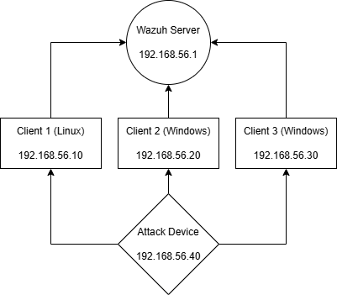
Figure 2: Initial design of the network and their associated IP addresses

In order to create a more realistic environment, there were several network services that were enabled on the client devices. These services included Secure Shell (SSH) for the Linux device and Remote Desktop Protocol (RDP) for the windows systems. These services were used because they replicate common services enabled in real-world environments, while also providing another possible attack service often exploited.

4.3) SIEM Architecture Design

The SIEM system was designed around having a centralised server that was responsible for collecting and analysing data from the connected client machines. This is a common approach for deploying SIEMs in the real-world, so was a suitable choice for evaluating a realistic environment.

The chosen SIEM was Wazuh, as it is a popular open-source solution with many publicly available guides and configurations. Compared to commercial solutions such as IBM’s Security QRadar and Micro Focus ArcSight, Wazuh provided its core functionality without expensive licensing costs, which would benefit smaller companies with reduced security budgets.

To collect the necessary log data, each of the client machines was installed with a Wazuh agent, a small piece of software that collects system logs and forwards them to the server. By using the same software across the different devices, consistent data collection was ensured, even with different operating systems.

During the architecture design stage, the analysis of the log data was also considered. Wazuh provides their own built-in ruleset, which gives a basic level of threat detection. However, the given ruleset used very simple rules, and was not effective at detecting every possible attack vector. The testing stage was configured with this limitation in mind, and involved multiple scenarios aiming to evaluate the limitations of the given ruleset.

4.4) Virtual Machines Design

Using virtual machines was a core part of the projects design process. By using virtualisation software, multiple different systems were able to be created and managed from a singular physical system, reducing the need for additional hardware.

The virtualisation platform used was VirtualBox, as it is easily accessible and very user friendly. Other virtualisation options considered included Microsoft Hyper-V and VMWare, however, due to familiarity with VirtualBox along with the fact it has much more online documentation, they were not as suitable for this project.

The virtual environment for the project contained a combination of both Linux and Windows systems. For the central server and Linux device, the popular system Ubuntu was chosen, due to it supporting Wazuh while also being easy to set up. The Windows clients in the setup were running Windows 11, allowing multiple types of system activity to be generated and then analysed.

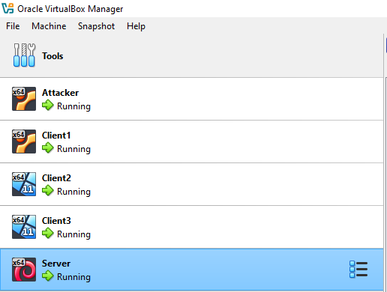
Figure 3: Screenshot showing the virtual machines created in VirtualBox

In order to generate the necessary system activity, a separate machine running Kali Linux was chosen to be included in the environment. Kali was chosen due to it coming pre-installed with the necessary tools and applications needed to simulate a variety of cyber-attacks, proving a more realistic view into how attacks are commonly launched.

Each of the machines except the server were allocated 4GB of memory as well a singular CPU core. The server had an additional 2GB of RAM and an extra CPU core as it had to consistently run Wazuh’s central components, which required additional computing power.

While this design only had a total of 5 different machines, increasing the number of machines would have led to increased complexity and resources required to host these machines. With this in mind, keeping with the 5 machines ensured a balanced setup that did not require overly advanced hardware.

4.5) Design Summary

The overall design of the system was centred around creating a controlled yet manageable environment that supports the ability to evaluate the SIEM. Some of the key decisions made included using a centralised server, having an isolated network, and using multiple operating systems. This helped balance creating a realistic environment that was also simple to implement and manage.

Also, while VirtualBox was the preferred option for this project due to being free, VMware is the better performance option. VMware has much better CPU utilisation compared to VirtualBox, as found by Djordejević et al [35], which leads to smoother overall usage and better performance for testing with a larger number of machines.

4.6) Implementation Introduction

Once the design stage was completed, the system was implemented and analysis of the SIEM began. The main objective for this stage was to have the environment setup and working so the SIEM system could be evaluated on its performance and usability.

The implementation was broken into multiple stages, which included setting up the virtual machines, configuring the internal network used by the devices, installing and deploying the SIEM, and finally test the attacks in the environment.

4.7) Environment Setup

The virtual environment was created using VirtualBox, with each virtual machine being configured and setup before the network was implemented. The Linux client machine was setup first, followed by the two Windows devices, as they had to have additional configuration that was not necessary for the other systems.

The initial setup for the machines went mostly without issues, with the only issues coming from a few necessary updates. However, during the setup of the windows devices, the system was extremely slow and laggy, and the background memory and CPU usage was far too high to continue on its current virtual hardware. This required changing the Windows devices to the same hardware as the server, with an extra 2GB of RAM and extra CPU core. This change to the system provided a noticeable difference, as on restarting the system it was far more responsive to inputs.

The Linux and Windows client devices also had to have SSH and RDP services enabled, which were simple command line instructions that only required a restart of the system in order to be fully operational.

4.8) Network Configuration

During the first pass of the network configuration stage, there were several issues with the connections, with a majority of the machines not being able to respond to ping requests. This made it difficult to confirm if the machines were able to communicate, and required many troubleshooting steps to correct the connections.

The first issue was with the Windows firewalls, as by default they block the ping requests needed to confirm connection. This was an easy fix as it only required a simple firewall rule to allow this change, and was able to ping most of the other devices after this change. Another problem came from not using the correct network adapters, as some machines were not connected to the internal network, however this did not fix all the issues present. The next issues were with the Linux devices, as the network configuration was less familiar to me compared to Windows and required extra attention to configuration files to fix the connection issues.

Once the configuration files were fixed, a consistent connection was established between the devices. Each of the devices could successfully ping the others, and were persistent even after system reboots, meaning that changes to the system were unlikely to affect the network connections.

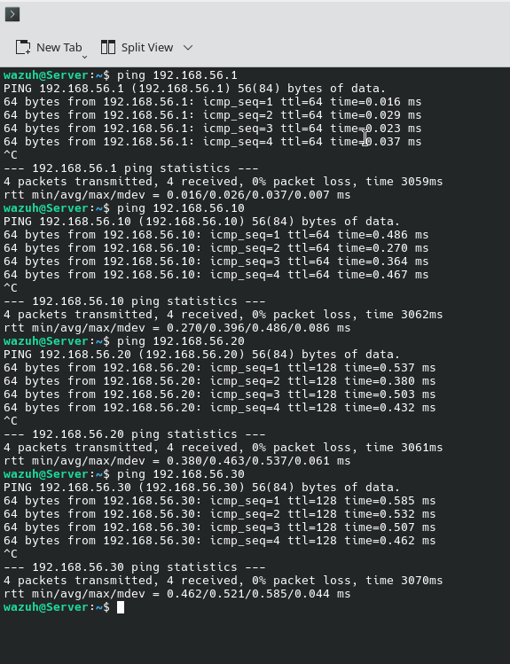
Figure 4: Screenshot showing connections between the server and the other devices

4.9) SIEM Deployment

Once the environment had been created and the network connections were configured, the setup for the SIEM system began. The installation process was simple, with Wazuh providing a single command to download and install the system. Initially the system did not correctly start, and required a shutdown and restart before all the included components were operational.

After installation was complete, I logged in to the Wazuh web interface using the provided credentials, and found the Wazuh dashboard, which was expectedly empty, as the required agent connections had not yet been added.

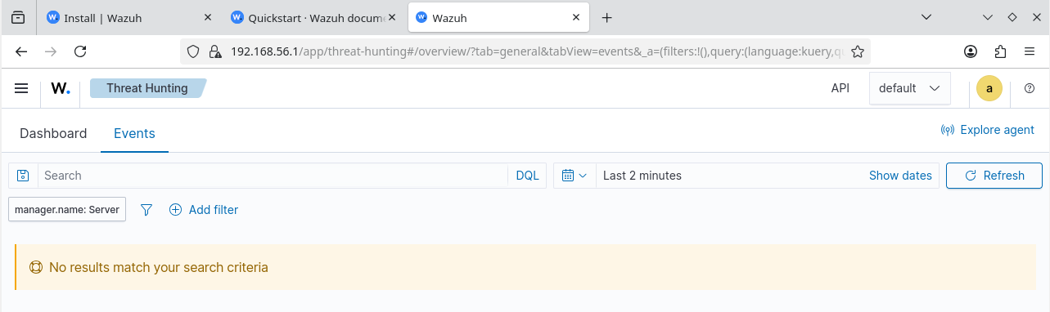
Figure 5: Example for what an empty dashboard with no alerts looks like

As the system setup was completed, the process of downloading and installing the Wazuh agent software on the client machines started. There were a few issues during this setup, with the Windows machines causing most of the issues. Both of the Windows machines required multiple attempts to start the agent system and required checking both network settings and the configuration files to fix.

Once the agents were running, the Wazuh dashboard correctly showed the individual systems connected, and for initial testing, logging out and back into each device showed an alert in the dashboard, confirming the device logs were being successfully sent to the server.

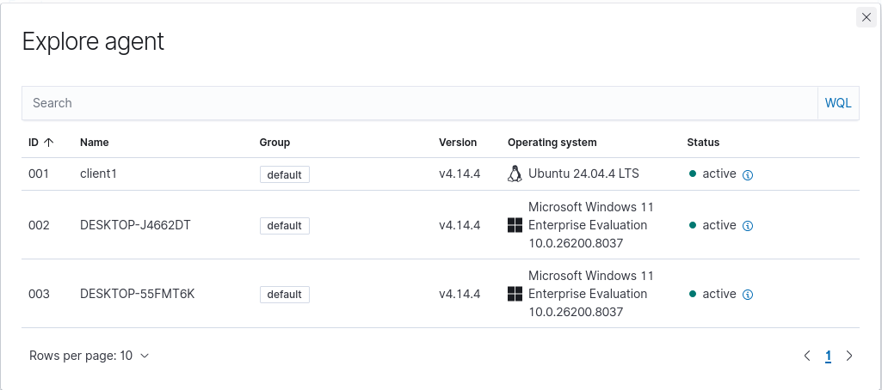
Figure 6: Screenshot showing the Wazuh agents active and connected to the Wazuh Server

4.10) Attack Implementation

With the SIEM system fully functional and able to generate alerts from the client machines log data, different types of cyber-attacks could be introduced to the environment.

The first attacks implemented were authentication-based attacks, targeting both the SSH and RDP services enabled on the devices. These attacks involved repeated login attempts, which generated a large amount of authentication failure alerts. The attack was implemented using the open-source tool Hydra, which used the rockyou.txt wordlist that contains over 14 million passwords obtained from the 2009 RockYou hack [36].

This activity was consistently identified by the SIEM. The alerts were displayed almost immediately and the rule description provided clearly stated it was authentication related. Each of the machines correctly identified that there was a possible attack and the Windows devices were locked out for 30 minutes due to the default rules set by RDP. The Linux device did not lock out, as there is no default lockout.

Each of these results were consistently obtainable the tests, and there was almost no variation in the results between each test. From this, I can assume that the SIEM could correctly identify authentication-based attacks.

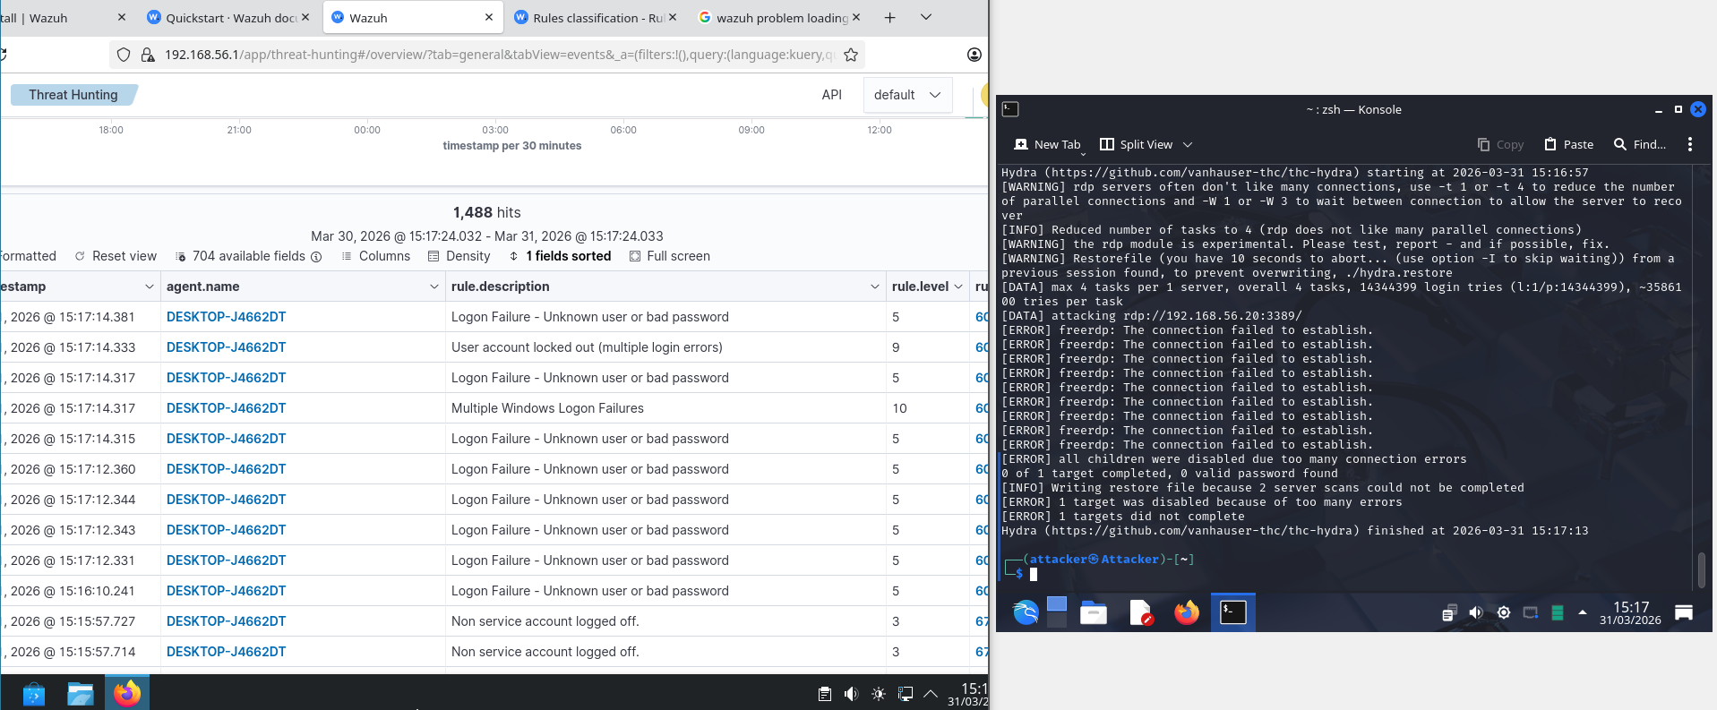
Figure 7: Authentication failures and subsequent lockout of the Windows device after too many failed login attempts

Figure 8: The attack platform Hydra shows the attack starting and then terminating due to the lockout

The next attack that was tested was a network reconnaissance attack, using the tool Nmap. This involved using several system scans to show the devices open ports and then further investigate into what the purpose of the open ports is. The attacks used were successful, and information about the targeted devices ports and their use was obtained. However, there were no generated alerts that were found in the SIEM.

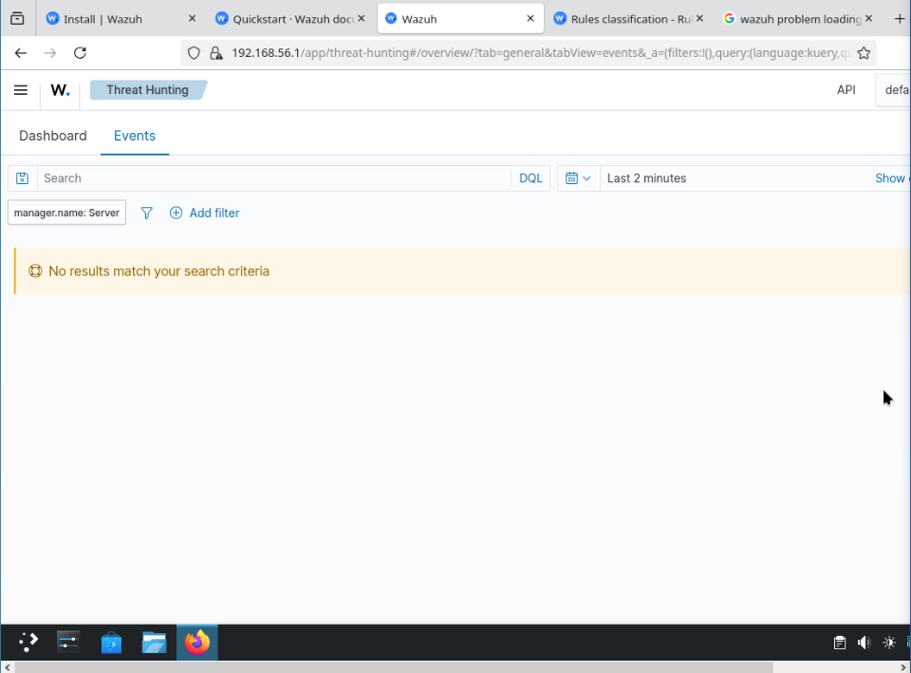
Figure 9: Wazuh dashboard showing no alerts. This screenshot was taken only 30 seconds after the attack had begun.

During attempts to troubleshoot this issue, I discovered that the base Wazuh installation and agents did not have the necessary rules and network decoders to detect reconnaissance tools. This meant that if users wanted the ability to detect these tools, they would have to install and configure a separate piece of software called a Network Intrusion Detection System (NIDS) [37]. There are several software solutions, such as Suricata or Snort that can connect to Wazuh, however this was out of the scope of the project, and would not be implemented.

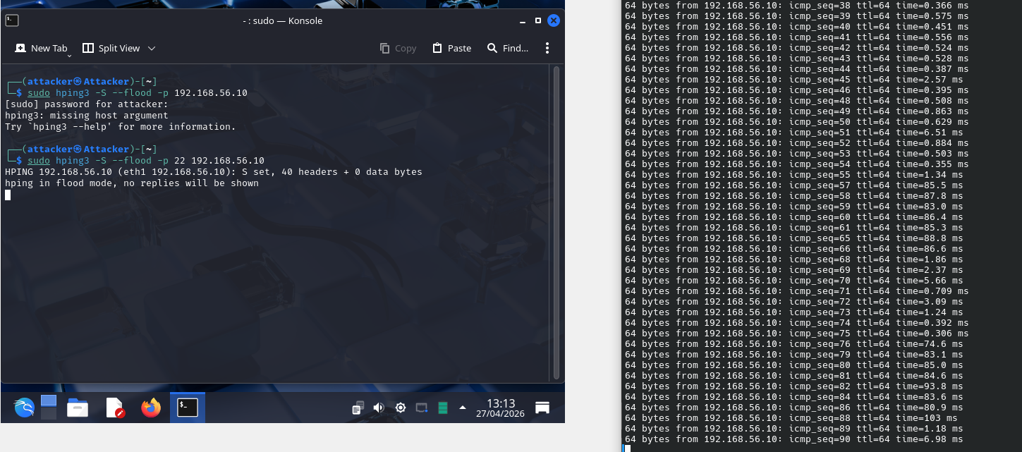
Figure 10: Screenshot showing slower network activity, but no alert was generated

As the base Wazuh installation was unable to detect network tools, I decided to move onto other types of attacks, including file modifications and adding unauthorised users to the machines. Setting up the system to recognise file changes was simple and required adding a file pathway to the ruleset. Once this was completed, the SIEM was able to detect files being added and even changed.

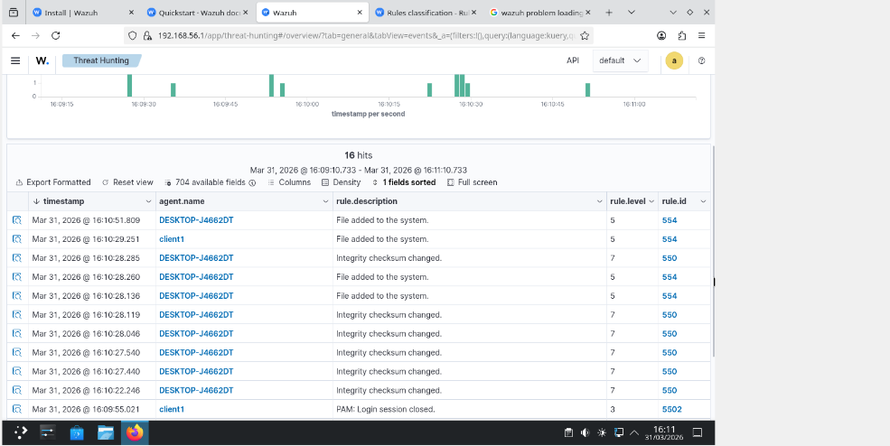
Figure 11: Wazuh Dashboard showing the creation of several files, as well as file changes being displayed

It is important to note that the Wazuh ruleset will by default only check for file changes each day. For repeated testing purposes, this check was reduced to every 60 seconds, which is why file changes and modifications appear in bulk rather than in real time.

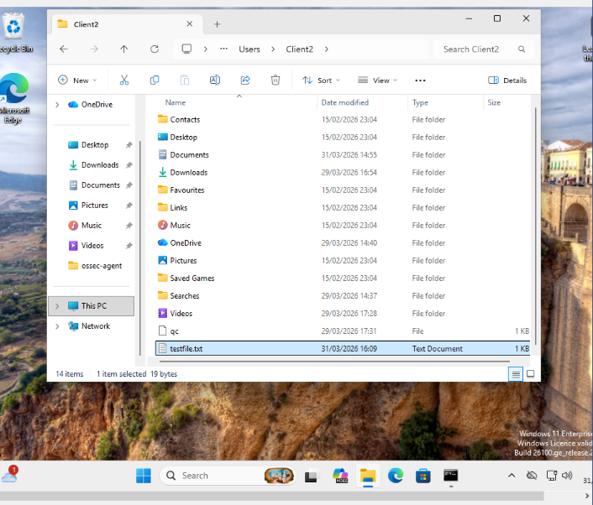
Figure 12: Screenshot showing while file was modified at 16:09, the changes were not reported until 16:10, which aligns with the ruleset change

The final test for the system involved checking for user account creation. This is important as attackers will often pre-generate a user account which will then be used for further exploitation. It is important that these accounts are verified to reduce the chance of this happening. Both systems were able to generate alerts for new accounts and were flagged for potentially harmful activity.

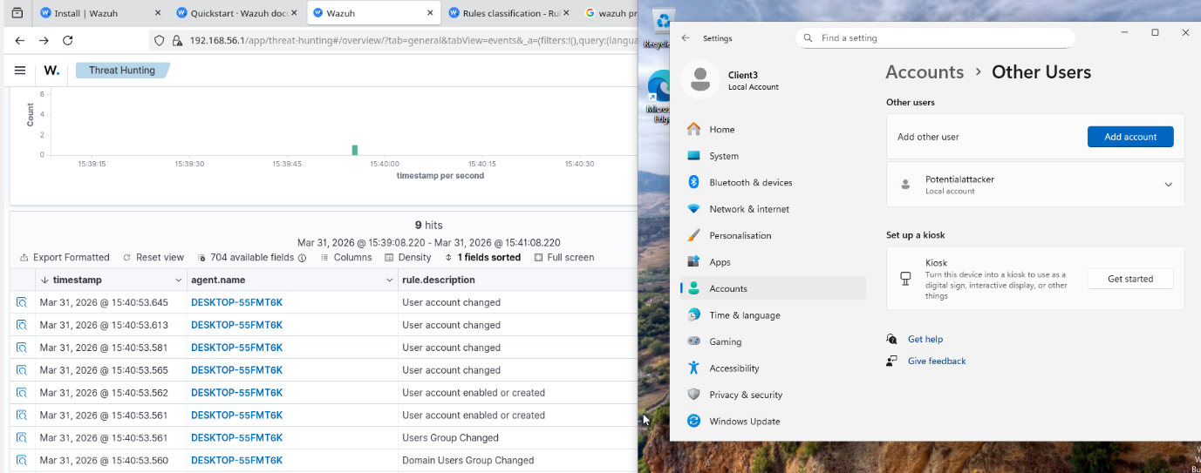
Figure 13: This shows the Wazuh dashboard showing a new user account on Windows was created, along with proof of the user account added to the system

4.11) Attack Analysis

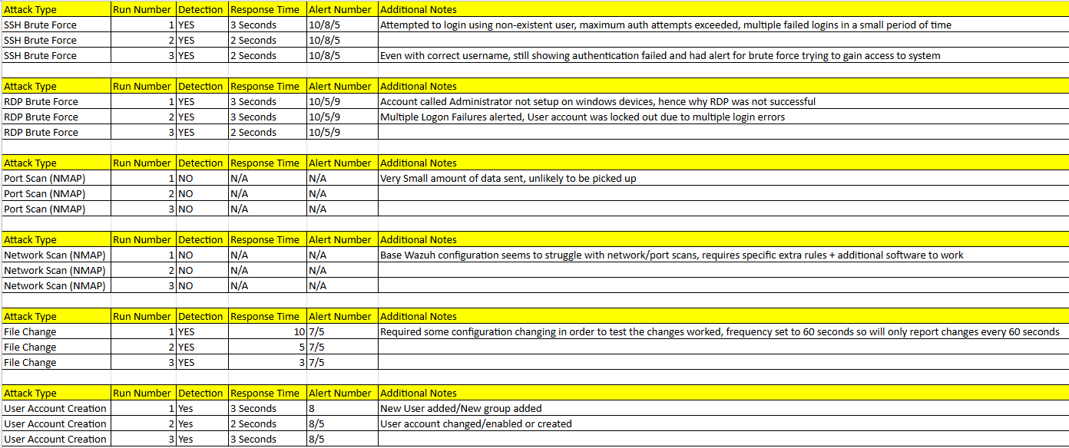
Figure 14: Overall results for the attacks implemented

Overall, the results collected were mostly expected, but there were a few areas that gave surprising results.

The most unexpected part of the testing was that the base Wazuh installation was not equipped to provide detection or alerts for network-based attacks and instead required additional tools for this purpose. This was surprising as the existing literature had described SIEM as being able to monitor network traffic, and while Wazuh is able to do so with additional software, it would be difficult for someone to notice the lack of network alerts without specifically searching for them.

Despite this limitation, the system provided strong alerts against attacks that changed the system, and the consistent results obtained show that the SIEM can accurately detect potential threats. However, this result was expected from existing knowledge on SIEMs, so the system acted as expected.

5.0) Evaluation

5.1) Results Evaluation

The results gathered from the testing phase of the project shows that Wazuh can be a capable tool, but requires a fair amount of additional knowledge to fully utilise the system. The base Wazuh system still proved valuable in alerting to potential system threats, however, requires the use of third-party tools to be effective against network threats.

The tests involving authentication-based attacks performed as expected, with both the Linux and Windows devices generating alerts. These alerts were quick and provided adequate descriptions for the potential threat without needing to fully dive into the alert data. These results were also found when implementing the file modification tests. Each of the tests were detected, and the ruleset was easy to change when necessary to reduce the time taken between each file set. This behaviour was expected, as file monitoring is commonly implemented with scheduled checks compared to real-time detection that could cause a sea of unwanted data.

These system tests follow the existing research on SIEMs, as they are commonly described as being effective at detecting system changes such as files and even authentication logs from both operating systems.

The tests involving network-based activity provided some unexpected results. Despite the network threats being successfully implemented, there were no alerts generated by the SIEM to indicate that these attacks were being used. These attack failures were initially thought to be errors with the system or an issue during installation. But as troubleshooting steps were carried out, I realised that this was intentional for the base install, and if network alerts were desired, they required an additional tool.

These tests somewhat contradict the current literature, as SIEMs are often described at being able to collect network log data and analyse it for potential threats. This is without needing additional tools to do so. For Wazuh specifically, there was no warning or alert to warn users about this limitation, and did not mention the need for an Intrusion Detection System (IDS) in order to fulfil this aim. This highlights a gap in the existing research as not all SIEM systems have the necessary tools to support common features and require additional configuration.

5.2) Comparison to Objectives and Aims

For the project, the primary aim was to evaluate an open-source SIEM system and its ability to detect common cyber-threats in a small environment. The results gathered show that these aims and objectives were met.

In terms of performance, the system did not quite meet expectations. While the SIEM proved valuable in detecting common system and authentication-based threats, its inability to provide any information into potential network threats meant it did not meet the hypothesis proposed. One could argue that with additional tools and configurations, this limitation could be avoided. However, this adds additional complexity to the system that users may not be aware about, and could lead to a system being compromised.

The objectives also mentioned the usability of the system, which I believe were met. The dashboard provided a clear overview of the generated alerts, and were quickly understandable with no additional configuration. There was a small issue of identifying priority alerts, as the most important alerts could be lost in the sea of lower priority alerts. This could be easily solved by filtering by severity level, so was mostly ignored.

5.3) What would be done differently

If this project was to be repeated, there are several key improvements that I would like to make. The most important improvement would be greater research into the specific SIEM system used. There were some limitations that were not understood until the implementation stage, and knowledge of these constraints could have allowed for changes into the design of the system, such as including a network-detection tool with the system.

Another improvement that would be made would include a wider variety of different attacks. While the attacks implemented are commonly found in the real-world, there are several other threats which currently exist that were not considered, and would improve the analysis on detection of other types of threats.

The final improvement would be an investigation into the Wazuh dashboard, such as the different search parameters and creating custom rules for the data. While usability was mainly determined from the generated alerts, including some time into evaluating the experience of searching for specific attack types or creating custom rules for alerting to potential activity would allow for a better overall evaluation of the system.

6.0) Conclusions and Recommendations

6.1) Conclusion

This project was created to investigate an open-source SIEM solution, and determine whether it can compete with larger commercial solutions in terms of performance and usability. This involved reviewing the existing literature for SIEM systems and security as a whole, and led to the use of a popular tool called Wazuh. To facilitate the testing of the tool, a virtual environment was designed to mimic a real-life environment, including using a server to host the SIEM and a few virtual machines to test different attacks. This led to creating the environment and testing several cyber-threats, some of which were easily detected and others which were not discovered at all. The evaluation of the results showed that Wazuh could easily detect system-level changes, but its base configuration was not suitable for network-based threats. This could be fixed with additional software, but highlights the difference between commercial solutions which often are useable right out of the box compared to open-source tools that require extra configuration to meet the same functionality.

6.2) Recommendations

During the project, there were several areas discovered that needed extra work. One of these areas would be the inclusion of an Intrusion Detection System when testing and evaluating the SIEM. By using a tool such as Suricata, there would be a more complete evaluation of the SIEM, as they are complementary and reflect common practices to have both of these tools used together.

Another area that could have been investigated more would be the different types of attacks implemented. Most of the attacks implemented focused on gaining access to the machines and reconnaissance of the network, however there are many types of malware that were not tested that are common threats. Some of these include Viruses, Ransomware, Spyware, Keyloggers and many more. By using some of these malwares in the environment, a greater evaluation of the SIEM could be made.

The final area that could have been improved would be extending and improving the virtual environment. For testing purposes, the environment was tightly controlled, but this does not reflect real-world conditions, and could have reduced the ability for false positives to occur. This would also include the ability to measure the systems performance over a period of time with normal user activity, to provide a more realistic evaluation of the SIEM.

7.0) Reflection

This project has helped me learn a lot, not just in a technical capacity, but as a student and a person. During the initial proposal stage for this project, I was very scared and doubtful about how I would react to taking on a big project, as it is something I have never done to this scale before. Trying to find a project idea that I was not only interested in, but had enough depth in order to write a 10,000-word report was a struggle, and took several weeks to even decide on a general topic.

After I had chosen the topic, nerves started to settle as I began to research into the necessary parts of the project, such as SIEMs and virtual machines. This research however was very brief, and I wish that I had spent a lot more time diving in depth into how SIEMs work, the different components that make up a system, its limitations and its strength, etc. Paying more attention to this stage would have been very helpful in the overall development of the project. Unfortunately, due to the intimidating nature of such as project and the stress that it caused, I spent several crucial months of the project not doing much, and simply relegated to something “I would do tomorrow”. This thinking hindered the projects development, even if I eventually moved past that attitude and started to seriously work on it.

While the were several setbacks met during the project, I am glad that I was able to learn as much about SIEMs and cyber-security as a whole during the project. Learning about how the SIEMs function was actually interesting, and learning that SIEMs really depend on the custom configuration for the network they are deployed in made me think that implementing one myself would be a fun challenge. Troubleshooting during the implementation of the project was a surprisingly fun experience, with trying to find solutions to network connection issues and eventually learning about the limitations of the base installation of Wazuh being key memories of this project. It involved a lot of trial and error, which helped develop my research skills as well as testing skills, as just because it worked once did not mean it would work again.

The project also helped develop some of the softer skills as well as the more technical skills. Time management was a skill that I did not particularly respect at the beginning of the project, but later on during the final few weeks of the project I gained a valuable lesson in the importance of time keeping. With there being several setbacks in the implementation and troubleshooting issues, starting taking the project more serious earlier would have left me a lot more time overall, and would have reduced a lot of the stress felt during the project. I also developed a lot of independent learning skills, as I had to fully understand the system that I was using compared to just following simple instructions and not thinking for myself.

Overall, the project was stressful and scary and nerve-racking, yet undeniably informative not just in technical skills but more general skills that I would be able to take to further my career. Its something I won’t ever forget, and provided some of the most challenging yet rewarding experiences I’ve ever faced.

Bibliography

[1] | Huntress, “What is SIEM?,” [Online]. Available: https://www.huntress.com/cybersecurity-education/what-is-siem. [Accessed 10 February 2026].
[2] | Wazuh, “Wazuh,” [Online]. Available: https://wazuh.com. [Accessed 10 February 2026].
[3] | H. E. G. N. K. H. E. G. Zakaria El Mrabet, “Cyber-Security in Smart Grid: Survey and Challenges,” Computers and Electrical Engineering, vol. 67, pp. 469-482, 2018.
[4] | S. M. K. Duaa Fadhel Najem, “A Review on Cyber Security and Cyber Attacks,” Journal of Al-Qadisiyah for Computer Science and Mathematics , vol. 17, no. 2, pp. 153-161, 2025.
[5] | A. A. Mujtaba Awan, “Cybersecurity Threats and Defensive Strategies for Small and Medium Firms: A Systematic Mapping Study,” Administrative Sciences, vol. 15, no. 12, 2025.
[6] | I. B. S. J. Carlos Rombaldo Junior, “Unaware, Unfunded and Uneducated: A Systematic Review of SME Cybersecurity,” Journal of CyberSecurity, pp. 1-31, 2025.
[7] | A. J. E. P. C. H. Nisha Rawindaran, “Perspective of small and medium enterprise (SME's) and their relationship with government in overcoming cybersecurity challenges and barriers in Wales,” International Journal of Information Management Data Insights, vol. 3, no. 2, 2023.
[8] | OECD, The Digital Transformation of SMEs, OECD Studies on SMEs and Entrepreneurship, Paris: OECD Publishing, 2021.
[9] | Y. Y. M. A. A. D. Wasyihun Sema Admass, “Cyber security: State of the art, challenges and future directions,” Cyber Security and Applications, 2024.
[10] | S. A. S. M. S. A.-G. H. A.-M. A. M. A. Saqib Saeed, “A Systematic Literature Review on Cyber Threat Intelligence for Organizational Cybersecurity Resilience,” Sensors, 2023.
[11] | G. G. G. T. R. K. C. P. D. D. A. R. L. B. S. F. J. F. R. E. A. M. B. M. S. Max van Haastrecht, “A Shared Cyber Threat Intelligence Solution for SMEs,” Electronics, 2021.
[12] | N. I. o. S. a. T. (NIST), “The NIST Cybersecurity Framework (CSF) 2.0,” 2024.
[13] | ENISA, “State of cybersecurity in the EU,” [Online]. Available: https://www.enisa.europa.eu/topics/state-of-cybersecurity-in-the-eu. [Accessed 30 April 2026].
[14] | L. M. A. A. M. D. H. J. Mohamed Amine Ferrag, “RDTIDS: Rules and Decision Tree-Based Intrusion,” Future Internet, vol. 12, no. 3, 2020.
[15] | I. G. P. V. J. K. Ansam Khraisat, “Survey of intrusion detection systems: techniques, datasets and challenges,” Springer Nature, vol. 2, 2019.
[16] | E. G. Anna L. Buczak, “A Survey of Data Mining and Machine Learning Methods for Cyber Security Intrusion Detection,” IEEE Communications Surveys & Tutorials, vol. 18, no. 2, pp. 1153-1176, 2016.
[17] | M. N. Medha Khenwar, “Challenges and Limitations of IDS: A Comprehensive Assessment and Future Perspectives,” SKIT Research Journal, vol. 14, no. 1, pp. 35-39, 2024.
[18] | T. N. N. V. D. P. Q. S. Nathan Shone, “A Deep Learning Approach to Network Intrusion,” EEE TRANSACTIONS ON EMERGING TOPICS IN COMPUTATIONAL INTELLIGENCE, vol. 2, no. 1, pp. 41-50, 2018.
[19] | R. Sommer and V. Paxson, “Outside the Closed World: On Using Machine Learning for Network Intrusion Detection,” IEEE Symposium on Security and Privacy, pp. 305-316, 2010.
[20] | A. M. M. E. Ali Hozouri, “A comprehensive survey on intrusion detection systems with advances in machine learning, deep learning and emerging cybersecurity challenges,” Springer Nature, vol. 5, no. 1, 2025.
[21] | B. S. M. F. A. N. K. M. M. F. M. S. M. Frank Cremer, “Cyber risk and cybersecurity: a systematic review of data availability,” National Library of Medicine, vol. 47, no. 3, pp. 698-736, 2022.
[22] | S. G.-Z. R. D. Gustavo González-Granadillo, “Security Information and Event Management (SIEM): Analysis, Trends, and Usage in Critical Infrastructures,” National Library of Medicine, vol. 21, 2021.
[23] | P. S. A. A. W. Adabi Raihan Muhammad, “Integrated Security Information and Event Management (SIEM) with Intrusion Detection System (IDS) for Live Analysis based on Machine Learning,” Procedia Computer Science, vol. 217, pp. 1406-1415, 2023.
[24] | M. B. C. S. N. a. C. P. Shahroz Tariq, “Alert Fatigue in Security Operations Centres: Research Challenges and Opportunities,” ACM Comput, vol. 57, no. 9, 2025.
[25] | A. P. A. A. J. G. F. A. F. E. Md Hasan Saju, “SynRAG: A Large Language Model Framework for Executable Query Generation in Heterogeneous SIEM System,” Cryptography and Security.
[26] | M. H. L. H. S. S. M. H. Rafael Uetz, “You Cannot Escape Me: Detecting Evasions of SIEM Rules in Enterprise Networks,” Cryptography and Security, 2023.
[27] | M. A. Brunel Rolack Kikissagbe, “Machine Learning-Based Intrusion Detection Methods in IoT Systems: A Comprehensive Review,” Electronics, vol. 13, 2024.
[28] | L. R. B. S. I. S. M. H. A. A. M. M. A. Noyan Tendikov, “Security Information Event Management data acquisition and analysis methods with machine learning principles,” Results in Engineering, vol. 22, 2024.
[29] | R. B. Federico Sierra-Arriaga, “Security Issues and Challenges for Virtualization Technologies,” ACM Computing Surveys, vol. 53, pp. 1-37, 2020.
[30] | D. K. P. Oluwasanmi Richard Arogundade, “Virtualization Revolution: Transforming Cloud,” nternational Advanced Research Journal in Science, Engineering and Technology, vol. 10, no. 6, 2023.
[31] | M. H. S. Z. M. H. H. O. N. &. A. M. Akeel, “Virtual Testbed for Cyber-Physical System Security Research and Education: Design, Evaluation, and Impact,” Electronics, vol. 15, 2026.
[32] | J. T. a. L. P. S. a. S. H. a. G. C. a. T. Tarman, “Verification of Cyber Emulation Experiments Through VirtualMachine and Host Metrics,” CSET, vol. 15, pp. 71-80, 2022.
[33] | N. K. G. K. I. M. L. P. G. &. F. M. A. Chouliaras, “Cyber Ranges and TestBeds for Education, Training, and Research,” Applied Sciences, vol. 11, 2021.
[34] | T. C. R. K. L. K. Hetong Jiang, “Pandora: A Cyber Range Environment for the Safe Testing and Deployment of Autonomous Cyber Attack Tools,” Cryptography and Security, 2020.
[35] | B. Djordjević, V. Timčenko, N. Kraljević, I. Jovičić and N. Davidović, “Comparison of VMware Workstation, VirtualBox and MS Hyper-V hypervisor performance with MS Windows OS based guests,” in IEEE, East Sarajevo, 2023.
[36] | Zacheller, “rockyou,” 23 November 2022. [Online]. Available: https://github.com/zacheller/rockyou. [Accessed 25 April 2026].
[37] | I. Odike, “Responding to network attacks with Suricata and Wazuh XDR,” 2022.
[38] | NIST, “Guide to Intrusion Detection and Prevention Systems,” NIST Research Library, Maryland, 2007.

