Title:
Essay on
A Comparison of the Marketing Methods of Two Multinational Hotel Brands, Six Senses and Moxy
Student Name: Zomir Hussain Khan
Student ID: 2209207
Marketing Essentials BMIH4005
Lecturers name: Gayathri Mudiyanselage
Word count: 1500

Introduction
The tourism industry is one of the most impactful industries all over the world. If we look closely at the world economy, we will see it creates various scenarios where tourism plays important contribution that will increase the revenue for a company and boost economy of the country. This essay will focus on the marketing aspects of two companies like Six Senses and Moxy (Wu and Lu, 2012). The main prospect of this essay how these two companies are implementing marketing methods for the two international hotel brands which is essential to grow them more. The overall thought process of marketing for Six Senses and Moxy will be described here in details which is highly necessary to make marketing methods more useful in any campaign scenario.

A Comparison of Marketing Methods of Two International Hotel Brands
There are multiple international hotel brands. One of the most prominent ones is Marriot International. In United Kingdom there are also many brands that are currently helping the economy to fuel it for better. In this report, the marketing of two renowned tourism giant will be discussed (Torres and Kline, 2006). First, we need to see about Six Sense. Six Sense is an award-winning hotel group. One of the most notable hotel chains that can be found in operation at this time in the United Kingdom is the six senses. The most important thing that had to be considered in this situation was how they are conducting business across international borders in order to gain an understanding of the fact that it is extremely important to strategize the marketing policy for their campaign in order to improve the overall results of their campaign. The primary goal of this exercise is to get an understanding of how the success or failure of a campaign may have a significant impact on the total production of a firm.
Another example of a hotel chain that is doing very well is the MOXY. In the last several years, MOXY has been performing really well in terms of the marketing opportunities that it has been pursuing (Shaw et al, 2011). The effective branding of this hotel group not only improved its brand image but also improved the entire perspective of the result of the organisation by embracing cutting-edge technology. This technology is very vital for the modifications that are required to push this hotel group to the next level.
Throughout the course of history, there are a number of different paths that one might choose to follow (Rudež and Mihalič, 2007). The marketing mix is something that all businesses have in common and should strive to improve in order to maximise their sales and profits. The four P's make up the typical components of the marketing mix used in the market. When considering the quality of the products that Six Sense brought to the market, we are able to state that they were among the best available. By making use of the pertinent information, the primary objective here is to determine which goods the customers are going to adore and be able to put to good use. The majority of the work being done on this location is in the United Kingdom (Pikkemaat and Peters, 2006). The cost of their services, such as staying in various locations, varies from one location to the next. However, during the off season, they do give promotional offers such as coupons, discounts, and other similar things, which in reality do serve to increase the marketing mix of the organisation. There isn't much of a difference between the MOXY and other brands. The 4P's of MOXY are now in the process of offering high-quality services in the market in an effort to attract the most premium clients in the industry (Orfila-Sintes and Mattsson, 2009). MOXY is attempting to tailor its offerings to meet the requirements of the service business, which requires an increasing number of clients who are likely to spend a significant amount of money. There is going to be some variation in the cost of their service from one location to the next. MOXY's primary objective is to expand its operations to other locations outside of London in order to acquire the greatest number of customers possible in the relevant market.
The abbreviation "STP" stands for "segmentation, target, and placement." It is possible, with the assistance of the STP, to get a better understanding of the position that a firm is functioning in within the present market context (O’neill and Davis, 2011). The present market position held by Six Sense, which enables the company to provide clients with excellent services that are also within their price range. On the other hand, MOXY's existing service offerings are geared more towards the luxury market sector than they are towards the mainstream market. In spite of the fact that they are direct competitors with one another, according to the data that has been gathered (Nieves and Segarra-Ciprés, 2015). On the other hand, the goods and services they are putting on the market to compete with one another are not the same. At the present, their target market is the United Kingdom, and consumers in this market may be effectively separated from one another because to the segmentation that exists (Martĺnez-Ros and Orfila-Sintes, 2009). Their services are offered in a way that is distinct from one another, and despite the fact that they may reap different advantages owing to their segmentation in various market positions, they do so in a way that is distinct from one another.
One of the most important things that one can do to better the present market environment is to adjust their marketing plan. The primary objective of this investigation is to get an understanding of the processes that these two titans of the hotel industry are using with the goal of generating more income than they have in the past (Kayaman and Arasli, 2007). The primary objective of this study is to get an understanding of marketing strategy in order to determine how an individual may contribute to the already-present situation in ways that are beneficial to the overall marketing benefit of the corporate environment (Kang et al, 2012). If we look at the most recent campaign that Six Senses has run, we can see that they are shifting their focus more towards striving towards sustainable development. Their primary selling point is that they provide distinctive development, which not only benefits the traveller but also contributes to the preservation of natural resources. On the other hand, the MOXY places an emphasis on city living (Benitez et al, 2007). This way of life also places an emphasis on the efforts that contemporary tourists, and notably corporate tourists, make in order to attract a greater number of customers to the hotel chains that they frequent. The
We are performing the PESTEL analysis and the SWOT analysis of MOXY and Six Senses, and we are witnessing a rise in the number of focuses on sustainability, which in fact do help to improve the factors associated to sustainable living. The sustainability is also over the above as there are also chances that are related towards the impacting expansion, which in reality do assist for the general prosperity of the firm (Jones et al, 2014). In today's contemporary culture, there is a greater emphasis placed on symbiotic relationships, which, in turn, will contribute to increased overall development and improved earning potential in the foreseeable future. The social effect of this form of impactful growth not only helps the overall prospects of the firm, but the social impact factor also increases as a result of this kind of growth. They want people to know that their infrastructure is powerful enough to have an effect on all aspects of society, and that this is the most important message they want to express (Chan, 2008). The geopolitical system is also assisting these two hotel chains owing to the fact that there is the chance of operating in new regions by collecting money from the United Kingdom as well as the European Union. This might open up new business opportunities for the hotel chains. The most important aspect that had to be considered in this scenario was the optimal balance that should be struck between making a profit and providing a social value proposition (Akbaba, 2006). This balance should be such that it will communicate new messages to the market in the interest of attracting more customers than the typical hotel chain. These are the primary areas in which we have the opportunity to get the greatest possible quantity of value propositions, which will enable the organisation to go to the next level (Benitez et al, 2007). These updated marketing messages will assist with additional development as well as overall consumer acquisition.

Conclusion
The tourism sector is widely recognised as one of the most significant contributors to the global economy. If we examine the global economy in more detail, we will notice that it generates a number of different situations in which tourism plays an essential contributing role, which will result in an increase in income for a firm and a boost to the economy of the nation. The emphasis of this paper was on the marketing strategies used by two different firms, namely Six Senses and Moxy. The primary objective of this paper is to examine how these two corporations are putting into practise marketing strategies for their respective worldwide hotel brands, which is critical for the brands' continued expansion. This section had provided a detailed explanation of the entire marketing strategy that was used for Six Senses and Moxy.

References
Akbaba, A., 2006. Measuring service quality in the hotel industry: A study in a business hotel in Turkey. International journal of hospitality management, 25(2), pp.170-192.
Benitez, J.M., Martín, J.C. and Román, C., 2007. Using fuzzy number for measuring quality of service in the hotel industry. Tourism management, 28(2), pp.544-555.
Chan, E.S., 2008. Barriers to EMS in the hotel industry. International Journal of Hospitality Management, 27(2), pp.187-196.
Jones, P., Hillier, D. and Comfort, D., 2014. Sustainability in the global hotel industry. International Journal of Contemporary Hospitality Management.
Kang, K.H., Stein, L., Heo, C.Y. and Lee, S., 2012. Consumers’ willingness to pay for green initiatives of the hotel industry. International journal of hospitality management, 31(2), pp.564-572.
Kayaman, R. and Arasli, H., 2007. Customer based brand equity: evidence from the hotel industry. Managing Service Quality: An International Journal.
Martĺnez-Ros, E. and Orfila-Sintes, F., 2009. Innovation activity in the hotel industry. Technovation, 29(9), pp.632-641.
Nieves, J. and Segarra-Ciprés, M., 2015. Management innovation in the hotel industry. Tourism Management, 46, pp.51-58.
O’neill, J.W. and Davis, K., 2011. Work stress and well-being in the hotel industry. International journal of hospitality management, 30(2), pp.385-390.
Orfila-Sintes, F. and Mattsson, J., 2009. Innovation behavior in the hotel industry. Omega, 37(2), pp.380-394.
Pikkemaat, B. and Peters, M., 2006. Towards the measurement of innovation—A pilot study in the small and medium sized hotel industry. Journal of Quality Assurance in Hospitality & Tourism, 6(3-4), pp.89-112.
Rudež, H.N. and Mihalič, T., 2007. Intellectual capital in the hotel industry: A case study from Slovenia. International Journal of Hospitality Management, 26(1), pp.188-199.
Shaw, G., Bailey, A. and Williams, A., 2011. Aspects of service-dominant logic and its implications for tourism management: Examples from the hotel industry. Tourism management, 32(2), pp.207-214.
Torres, E.N. and Kline, S., 2006. From satisfaction to delight: a model for the hotel industry. International Journal of contemporary hospitality management.
Wu, S.I. and Lu, C.L., 2012. The relationship between CRM, RM, and business performance: A study of the hotel industry in Taiwan. International Journal of Hospitality Management, 31(1), pp.276-285.

Appendices
- SIX Senses Similar Web Analysis
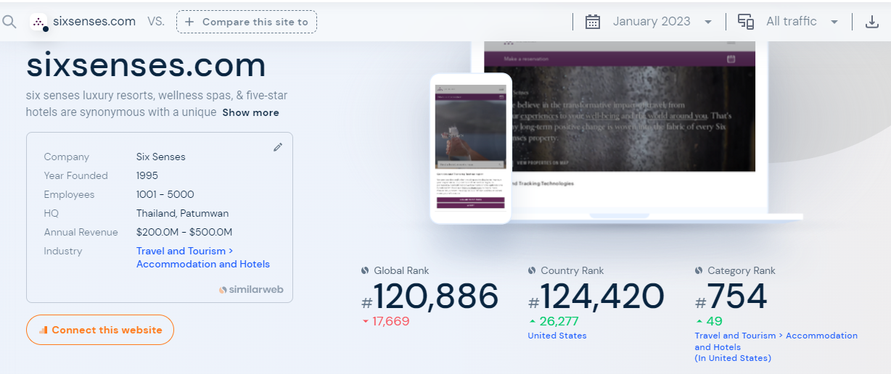
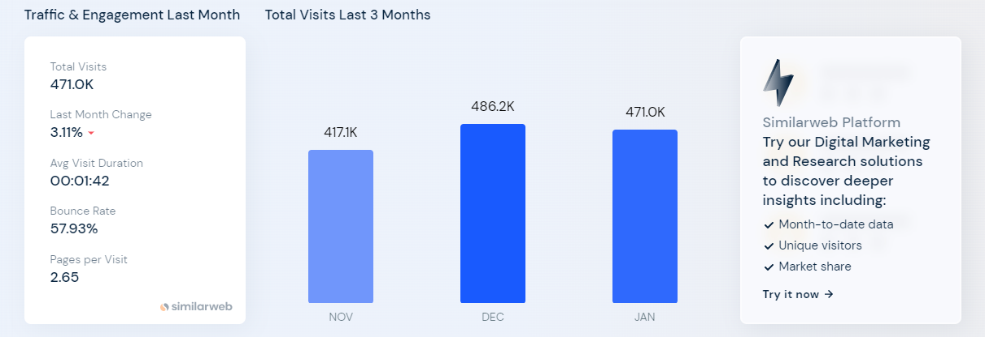

- MOXY Hotels


