Quality Engineering

Assignment 1: The Impact of Product Recalls on Businesses and Projects.

MSc Engineering Project Management

Name: Stephen Thomas

Student Number: P150906

Student Email: SThomas.150906@student.uwtsd.ac.uk
Contents
Introduction 3
Product Recall Process 4
Figure 1: Recall Rates by Manufacturer (Finlay, 2016) 4
Toyota's Accelerator Pedal Recall 5
Figure 2: Evidence on Toyota Recalls (Ciravegna, 2014) 5
DVLA Identification Framework 6
Figure 3: DVLA Vehicle Recall Search (Dft.gov.uk, 2019) 6
Manufacturer’s Guide to Recalls in the UK Automotive Sector 7
The General Recall Process 7
1) Gathering of Information 7
2) RAPEX 7
3) Pre-Launch Dialogue with DVSA 7
4) The Recall Launch 7
VIN Number 7
(Wynn et al., 2011. Data and Process Requirements for Product Recall Coordination) Case Study 8
Figure 4: Data Requirements for Product Traceability. (Wynn et al., 2011) 8
Figure 5: Suitable Recall Process (Wynn et al., 2011) 9
House of Commons Library, Product Safety and Recall (Cornway, 2018) 10
General Product Safety Regulations 2005 10
Sanctions for Failure to Recall a Product 10
Product Recall Process Conclusion 11
Costs Associated with Product Recalls and Controls 12
Direct Recall Costs 12
1) Notification Costs 12
2) Inventory losses 12
3) Cost of Refund/Compensation 13
4) Logistic Costs 13
5) Fines and lawsuit 13
Indirect Recall Costs 14
1) Subsequent loss of Sales 14
2) Negative Impact on Brand Image 14
3) Negative Impact on Morale 14
4) Cost to Rehabilitate Reputation 14
Managing Costs 15
Activity Based Costing 15
Figure 6: Activity Based Management Tool. (Mowen et al., 2006) 15
Functional Based Costing 16
Figure 7: Functional Based Costing Model (Slideshare.net, 2017) 16
Restoring Customer Confidence 17
(Harrison-Walker L, 2019). “The Critical Role of Customer Forgiveness in Successful Service Recovery” Case Study 17
Figure 8: Conceptual Model of the Effect of Service Recovery Strategies as Mediated by Forgiveness on Service Recovery Outcomes (Harrison-Walker L, 2019). 18
Conclusion 19
References 20
Bibliography 23

Introduction
Research will be carried out to identify a suitable process which can be followed in an event of a product recall. This research will focus of the automotive industry product recall performance and recognise key legislation and guideline which must be followed by UK law. Costs associated with a product recall and how these costs can be managed will be investigated to establish the total costs associated with a product recall process. Suitable cost management systems will be researched such as ABC and Functional Based Costing to establish how costs can be managed and controlled. Case studies will be used throughout this assignment to establish literature associated with the recall process and to identify how customer confidence can be restored from a product recall process.

Product Recall Process
A fundamental element of a company’s product safety management system is a product recall system. All organisations involved with the sale and supply of a product must take the necessary action to safeguard public health if they become aware of a potential safety incident or are notified. Product recalls are initiated to ensure compliance with legal requirements, protect company assets including the reputation of the company and minimise the risk of injury (Consortium, 2003).
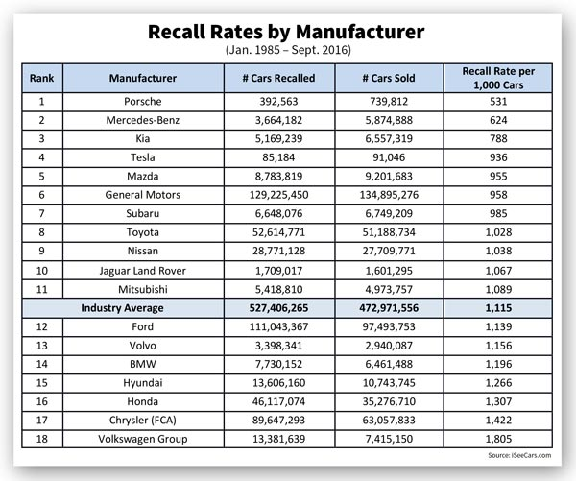
The automation industry has been subject to a wide range of product recalls over the years involving a range of components and different companies. This statistical data identified by (Gareffa, 2017), recognised that the safety and reliability aspect of automation is decreasing. More than 53.2million passenger vehicles were recalled in 2016 compared to the 51.1 million in 2015.

Figure 1: Recall Rates by Manufacturer (Finlay, 2016)
The statistics identified by (Finlay, 2016), recognised recall performance between 1985-2016, Volkswagen Group had the poorest performance of product recalls averaging 1,805 recall rate per 1,000 cars and Porsche performing the best with 531 vehicles recall rate per 1,000 cars.

Toyota's Accelerator Pedal Recall
On the 21/01/2010, Toyota issued a recall for a faulty accelerator that was sticking and causing unintentional acceleration to occur, this resulted in a range of incidents including 50 deaths. This fault was referred to by Toyota as the Sticking Accelerator Pedal (Ciravegna, 2014).

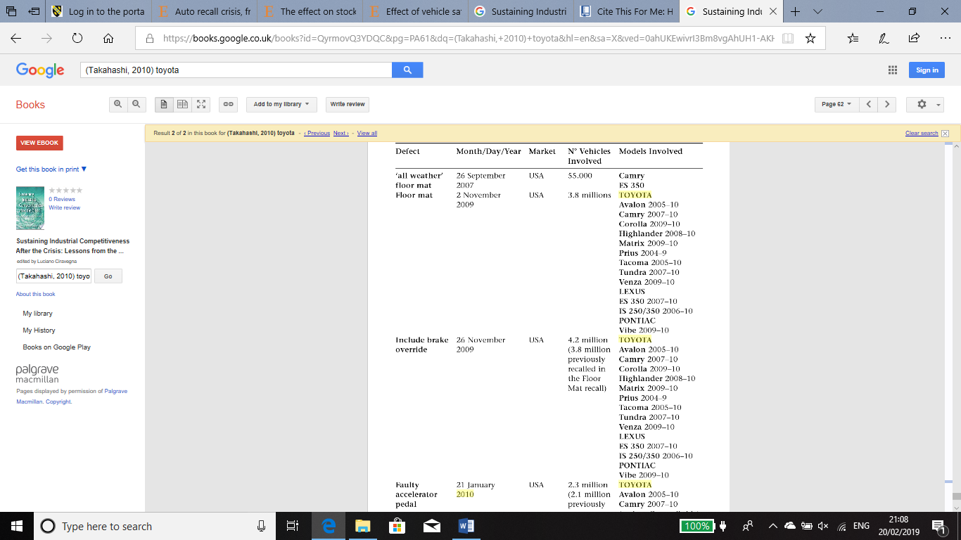
Figure 2: Evidence on Toyota Recalls (Ciravegna, 2014)
Toyota’s faulty accelerator pedal alone affected 2.3 million vehicles in the USA market and the outcome resulted in a 66.15-million-dollar fine set by the authorities and this was followed by compensation claims, claims for damage and a 1.2-billion-dollar penalty (Maurer et al., 2016).

DVLA Identification Framework
The Driver and Vehicle Licensing Agency (DVLA) holds over 48 Million driver records and over 40 million vehicle records (GOV.UK, 2019). The agency is responsible for:
- “Recording driver disqualifications, authorisations and medical conditions.
- Registering and issuing tachograph cards
- Helping the police and intelligence authorities deal with crime
- Issuing of photo card driving licences
- Supplying vehicle registration certificates to vehicle keepers
- Taking enforcement action against vehicle tax evaders
- Selling DVLA personalised registrations
- Providing anonymised data to those who have the right to use the service”
In some sectors chain of communication there will be an involvement by the regulator. For vehicles recalls the DVLA can address and send letters directly to registered vehicle owners (Harmon, 2018).

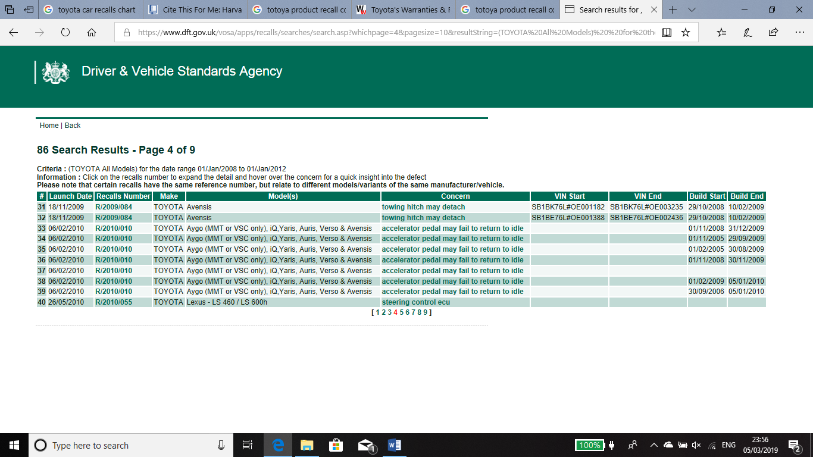
Figure 3: DVLA Vehicle Recall Search (Dft.gov.uk, 2019)
DVLA holds all UK recall data identifying recall dates, vehicle make and brand, recall number set by the manufacturer, the reason for the vehicle recall, dates and VIN start and end dates (Dft.gov.uk, 2019).

Manufacturer’s Guide to Recalls in the UK Automotive Sector
The purpose of this guide is to assist manufactures and suppliers in the automotive industry sector, in the implementation and construction of a product recall. The guide will identify a vigorous system of managing safety recalls. The effectiveness of this system demands co-operation with DVSA (Driver and Vehicle Licensing Agency), trade associations and manufacturers (Assets.publishing.service.gov.uk, 2019).

The General Recall Process
- Gathering of Information
The gathering of information is critical at this stage of the procedure to ensure the recall process is successful. This stage of the process requires information to be gathered and then registered to initiate a recall campaign with DVSA (Assets.publishing.service.gov.uk, 2019). The information required is as follows:
Make and Model, Vehicle Keeper Details, Build Dates, VIN Numbers, Issue/Concern, Possible Consequence, The Repair, Number of Vehicles, Parts information, Type Approval Number (Assets.publishing.service.gov.uk, 2019).
- RAPEX
Under the Directive 2001/95/EC the European Union initiative is known as RAPEX. RAPEX is the sharing of information about serious issues that affect products sold in member states (Assets.publishing.service.gov.uk, 2019).
- Pre-Launch Dialogue with DVSA
It is the industry standard to launch a safety recall within six weeks of the official notification, and DVSA monitor this recall. Any delays must be reported to DVSA by the manufacturer immediately (Assets.publishing.service.gov.uk, 2019).
- The Recall Launch
DVSA consider the first launch to be the date that the first letter is dispatched by the manufacturer. However, in the interest of customer safety, DVSA will consult with the manufacturer to place information on the website regarding the product recall. (Assets.publishing.service.gov.uk, 2019).

VIN Number
A study conducted by (Wynn et al., 2011. Data and Process Requirements for Product Recall Coordination), identified that assembly plants use components from more than 4000 suppliers and that a Vehicle Identification Number is applied to the product, so it can be tracked. The VIN number is assigned at the beginning of the production line and monitoring unit systems are used to keep track of the vehicles production process along the assembly lime.

(Wynn et al., 2011. Data and Process Requirements for Product Recall Coordination) Case Study
A study conducted by (Wynn et al., 2011), constructed a product recall framework that can be used in the automotive industry. The framework was fabricated based on notations by (van der Aalst and ter Hofstede, 2005) and validated against guidelines set by the EU, US and Australia (Product Safety Australia, 2019). This process describes main activities that are carried out in the event of a product recall. It identifies key steps which must be taken to ensure the product recall is monitored and the defect is amended.

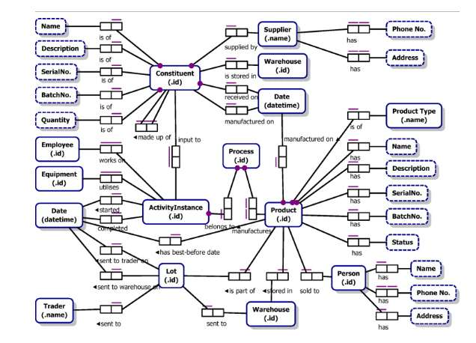
Figure 4: Data Requirements for Product Traceability. (Wynn et al., 2011)
(Wynn et al. 2011. Data and Process Requirements for Product Recall Coordination) study had acknowledged and constructed a process that will enable a company to track the product from its supply chain, to the customer. The study goes on to identify the need for adequate data sets to be kept for each product and how these data sets are maintained to produce an efficient recall process. The framework acknowledged in figure 4 allows for product traceability to be carried out find the root cause of the product recall.

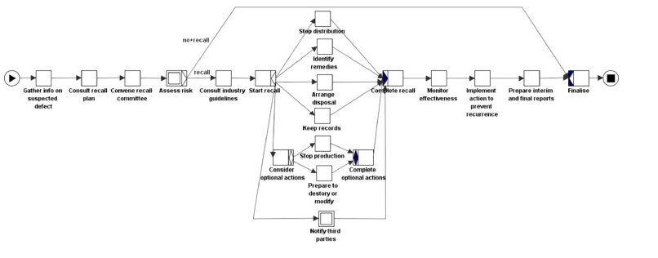
Figure 5: Suitable Recall Process (Wynn et al., 2011)

House of Commons Library, Product Safety and Recall (Cornway, 2018)
Under the Product Safety and Recall Information published by the House of Commons (Cornway 2018), crucial product recall guidelines and data can be seen for all UK sectors. The key aspects of this published information which affects the product recall process is as follows:

General Product Safety Regulations 2005
The GPSR’s 2005 is implemented into the UK general product safety directive (2001/95/EC). The product safety responsibilities are imposed on each link in the supply chain from manufacturer through to the distributor (Cornway, 2018). Some product sectors have their own enforcement agencies that manage the product recall process, these sectors include the following:
- The Drivers and Vehicles Standards Agency (which replaced the Vehicle and Operator Services Agency (VOSA)
- The Medicines and Healthcare Products Regulator Agency (MHRA)
Otherwise, responsibility for enforcing legislative safety provisions lies with the local authorities Trading Standards services. Under the GPSD (2001/95/EC) manufacturers must carry out checks on their products to ensure they are safe. These duties are then enforced by Market Surveillance Authorities (MSAs) (Cornway, 2018).

Sanctions for Failure to Recall a Product
A distributor or producer who is found to have placed unsafe products on the market can face a fine of up to £20,000, up to 12 months imprisonment or both. Failure to take appropriate action to avoid the risks associated with an unsafe product can result in a fine of up to £5,000, 3 months’ imprisonment or both. Failing to comply with a recall notice issued by Trading Standards could also face a fine of up to £20,000, 12 months’ imprisonment or both. (Cornway, 2018).

Product Recall Process Conclusion
(Wynn et al., 2011. Data and Process Requirements for Product Recall Coordination) Case Study, constructed a product recall framework which can be seen in figure 5, this framework has been validated against the EU, USA and Australia. It is a generic framework and can be used in the automotive industry to carry out a product recall while following the UK’s ‘Manufacturer’s Guide to Recalls in the UK Automotive Sector’. The ‘Product safety and Recall’ UK guidelines presented by the house of commons identifies key legislation which must be followed in a product recall and the consequences for not following the UK standard regulations. These standards must be executed into the framework conducted by (Wynn et al., 2011) to ensure the product recall is carried out efficiently and effectively.
As stated by (Assets.publishing.service.gov.uk, 2019), the DVSA (Driver and Vehicle Licensing Agency) must be notified of the product recall issue by the manufacturer and the recall process will begin by following the framework under the UK guidelines as seen in ‘Manufacturer’s Guide to Recalls in the UK Automotive Sector’. DVLA (Driver and Vehicle Licensing Agency) will send letters directly to registered vehicle owners (Harmon, 2018), and keep records of the Product recall data such as model, recall dates, vehicle make and brand, recall number set by the manufacturer, the reason for the vehicle recall, dates and VIN start and end dates (Dft.gov.uk, 2019).

Costs Associated with Product Recalls and Controls
On September the 29th 2009, Toyota recalled 3.8 million US vehicles regarding a faulty accelerator pedal. Over the next six-month period, Toyota announced measures to solve this problem and recalled millions more vehicles. On January 16th, 2010, Toyota informed NHTSA (National Highway Traffic Safety Administration) of the accelerator pedal fault and Toyota recalled a further 2.3 million vehicles (Greto, Schotter and Teagarden, 2010).
Toyota’s Faulty accelerator pedal alone affected 2.3 million vehicles in the USA market and outcome resulted in a 66.15-million-dollar fine set by the authorities and this was followed by compensation claims, claims for damage and a 1.2-billion-dollar penalty (Maurer et al., 2016).
Product recalls are subject to direct and indirect costs and impact the bottom line of a manufacturing company. These costs are as follows: (GOLINSKA, 2016) (Stanwick and Stanwick, 2017),

Direct Recall Costs
- Notification Costs
One of the most major elements of a product recall process, is the notification process which is classified according to the importance of the problem. A comprehensive recall campaign may require notifications that involve government agencies media, and formal communication to all users. Notification efforts must be designed to communicate three aims practically, a recall is being conducted, what the hazard is and how to deal with the defective product. The bigger the product recall, the more cost that is generated (Gookins, 2012).
- Inventory losses
Inventory costs consist of all the costs involved in purchasing the inventory and preparing it for sale. In the case of raw materials or goods acquired for resale by the merchandising firm, costs include the purchasing price, freight, and receiving and storage costs. (Albrecht, Stice and Stice, 2008). The cost of work-in-progress is the sum of the costs of the raw materials, the production labour, and some share of the manufacturing overheads required to keep the process running. A Product recall would affect the inventory costs and supply chain from the customer back to the manufacturer. (Albrecht, Stice and Stice, 2008).

- Cost of Refund/Compensation
Salvage and scrap disposal as well as handling of goods, are part of the superior process referred to as reverse logistics and are significant components of the supply chain. Buyers may return items to the seller due to incorrect items received, product defects and product recalls (Taylor, 2009). In many industries where customers return products for replacement, repair recycling or remanufacturing, reverse logistic costs are higher relative to forward logistics costs. The costs of moving a product back through the system from the consumer to manufacturer may be as much as nine times the cost of moving the same product from the producer to the consumer often the return goods cannot be stored, transported and held as easily, resulting in higher costs per item/unit processed. (Taylor, 2009)
- Logistic Costs
Logistics is involved in disposal and removal of waste material from the production, distribution or packaging processes. If waste material cannot be used to produce other products, they must be disposed of in an efficient manner. Whatever the by product, the logistics process must professionally and effectively handle transport, and store it. (Taylor, 2009). Transportation costs is expenditure to move goods in various states of the production process. This could include the movement of raw materials to manufacturing facilities and the movement of components to be included in the final product. Transportation costs are measured by carrier’s revenue collected for providing freight services (Taylor, 2009).
- Fines and lawsuit
Consumers may file private lawsuits requesting both fines and damages based on the violation, including actual loss, loss of profit and moral damages. It is important to note that, it a competent court or authority establishes that the product is dangerous or toxic, the producer, importer and distributor of the product would be jointly and several liable for the damages caused to consumers. Toyota’s Faulty accelerator pedal resulted in a 66.15-million-dollar fine set by the authorities and this was followed by compensation claims, claims for damage and a 1.2-billion-dollar penalty (Maurer et al., 2016).

Indirect Recall Costs
- Subsequent loss of Sales
In addition to the direct costs associated with a product recall, a retailer may also find that a product recall may affect its sales of other products. Retailers typically stock similar products with competing brands to cope with same variability (Flynn and Zhao, 2015). In addition, the lost sales represent an opportunity cost not derived from financial statements and must be estimated. A product recall has a negative impact on sales, since there are fewer customers persuaded to purchase a vehicle from a manufacture that is producing a poor quality products. The decline in sales is measured by assessing the company’s market share or number of cars sold. (Engemann, Lafuente and Merigo, 2012)
- Negative Impact on Brand Image
Brand awareness is one of the most important dimensions in brand quality. Brand awareness is the extent of which a brand is correctly recognised by the potential customers and can be correctly associated with a product. It shows the extent of association which consumers have for a brand. According to (Trot and Sople, 2016) “Brand awareness is the ability of the potential buyers to recognise or recall a brand as a member of certain product category.” This can have a negative impact on the company’s image regarding product quality image by the consumer.
- Negative Impact on Morale
An example of internal failure cost related to ethics would be reduced productivity due to low employee moral following ethical laps. Day to day ethical problems in such areas include sexual harassment, conflict of interest, unauthorised payments unsuitable gifts which all have a potential adverse effect on employee morale and productivity (Maguad and Krone, 2014). Product recalls would again effect employee morale in terms of company uncertainty prior to the recall investigation.
- Cost to Rehabilitate Reputation
Product recalls put a company’s reputation at risk. Potential customers, individuals and current owners will have worries about, capability, product quality and motivations of the firm’s management (Burke, Martin and Cooper, 2016). A product recall may signal the admittance of mistakes with potential litigation costs, but delaying the recall signals misperception and doubt, more negative consumer/customer perceptions, and chance that the problem my become even larger if not dealt with quickly (Burke, Martin and Cooper, 2016).

Managing Costs
The implementation of traceability systems has now become a necessary part of product safety strategy. A product recall calamity dramatically affects the revenue of risks which may lead to serious outcomes. Large recall encourages great recall costs such as cost of notification and repairing or destroying recall products. Traceability systems are used to minimise the likelihood and size of recalls. (GOLINSKA, 2016) Direct and Indirect costs can be managed using two different systems. These systems are as follows: (Kim, 2017)

Activity Based Costing
ABC has been developed as a method of overcoming the problems if traditional cost accounting, mainly lack of involvement to reduction of total costs and cost distortion due to misallocation of overhead costs. ABC is an accounting methodology that identifies activities in a production system or an organisation. ABC assigns the costs of each activity by cost object (Kim, 2017).

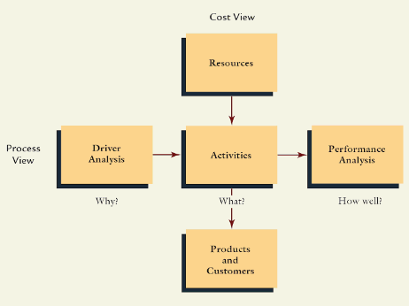
Figure 6: Activity Based Management Tool. (Mowen et al., 2006)
This product-based management system constructed by (Mowen et al., 2006) offers significant benefits, including greater product costs accuracy, improved decision making enhanced strategic planning and an increased ability to manage activities.

Functional Based Costing
A functional based cost systems assumes that production costs are an undeviating function of the volume or units of products manufactured. These, units of product or other factors highly connected with units produced, such as machine hours and direct labor hours are the only drivers assumed to be of significance. These units or volume-based drivers are used to assign production costs to products (Hansen, Mowen and Guan, 2009).

Figure 7: Functional Based Costing Model (Slideshare.net, 2017)
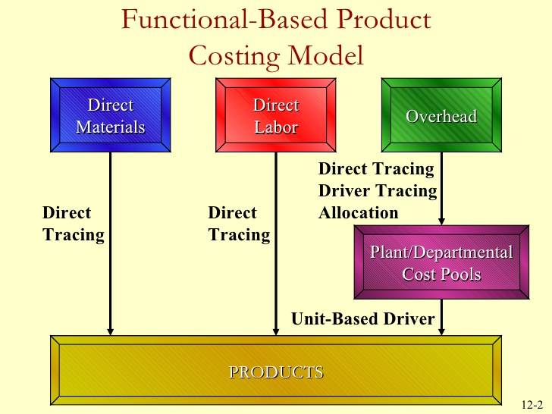

A functional based operational control system holds the organization unit manager accountable for monitoring the allocated costs and assigns costs to organizational units. Performance is then measured by comparing actual outcomes with standard or budgeted outcomes (Hansen, Mowen and Guan, 2009).

Restoring Customer Confidence
The potential costs to recall a product can be substantial for most manufacturing organisations. Apart from the physical costs of collection and transportation, there are issues of a legal and moral nature to be addressed, plus damage to the brand, corporate reputation and customer confidence. (Berwick, 2017)
Demand side disasters are usually caused by changes in customers perceptions about safety or quality of the product, firms often respond by trying to restore customer confidence. That can take the form of a recall of the product, redesign of the product to improve quality safety, increased advertising or a combination of these actions (Owen, 1995).
(Albrecht, Stice and Stice, 2008) identified elements that are key to service recovery and restoring consumer confidence, these factors are as follows:
- “Acknowledge the problem or failure
- Explain the reasons for the failure wherever possible
- Emphasize, with sincere expression of feeling for customers inconvenience
- Apologise where appropriate
- Solve the problem as quickly as possible, speed is crucial
- Compensate the customer appropriately
- Provide extra value – in the form of coupons or extra services, to demonstrate regret and appreciation for the business
- Follow up with a phone call, letter or other commination.”

(Harrison-Walker L, 2019). “The Critical Role of Customer Forgiveness in Successful Service Recovery” Case Study
A study conducted by (Harrison-Walker L, 2019) recognised the need for customer satisfaction after a product recall by identifying that customer’s satisfaction regarding a company’s response will increase brand loyalty by 33%, when the problem is minor and 44% when a problem is major. Furthermore, 47% of customers will recommend the brand to others when satisfied.
Although poor recovery leads to significant loss in revenue, effective recovery can increase revenue. Research conducted (Bruce Temkin, 2016) identified that when recovery is poor 63% of customers cut back spending. However, when recovery is good, 30% of customers increase spending. Furthermore, it has been reported by (Customer Rage Study 2015) that 76% of customers want an apology, but only 32% receive once. About 40-50% of customers want some form of compensation, but only 10-20% receive it. These statistics prove that better recovery strategies are required to improve customer satisfaction and therefore improve company performance.

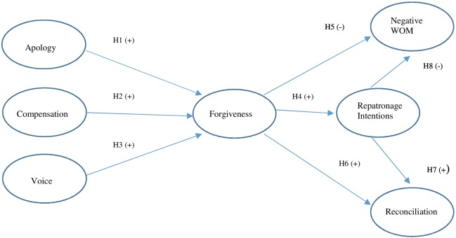
Figure 8: Conceptual Model of the Effect of Service Recovery Strategies as Mediated by Forgiveness on Service Recovery Outcomes (Harrison-Walker L, 2019).
(Harrison-Walker L, 2019) developed a model which can be used to restore customer confidence after a product recall has been conducted. The model focused on forgiveness as the main factor by identifying customers positive response. The study recognised that if forgiveness takes place, customers are motivated towards positive relationship outcomes. The mediating role of forgiveness between conflict and relationship quality and has been reported in a business context “forgiveness is an intrinsic consumer characteristic that may implicitly facilitate the evolution of service outcomes”. (Y. Tsarenko, D. Tojib, 2011).
The forgiveness model was tested in different industries to recognise its effectiveness in terms of restoring customer confidence and found that it has a positive effect. The study acknowledged that by having a good recovery management system that can put in place apology, compensation and voice procedures, it would affect the forgiveness mechanism and therefore, impact the Word Of Mouth, reconciliation and patronage intensions.

Conclusion
Research into the identification of a suitable process that can be used in an event of a product recall, the costs associated with a product recall and how to restore customer confidence has be carried out. Statistics by (Finlay 2016, Recall Rates by Manufacturer) identified the automotive product recall performance. Research was then carried out to establish the process which can be used in the automotive industry to recall a product. (GOV.UK, 2019) identified the need for DVLA to be informed of a product recall and the UK automotive (Manufacturer’s Guide to Recalls in the UK Automotive Sector, Assets.publishing.service.gov.uk, 2019), set out the process which must be followed in an event of a UK automotive product recall. The (House of Commons Library, Product Safety and Recall, Cornway 2018) acknowledged the UK guidelines which must be followed in an even of a UK automotive Recall, the guidelines identified key elements such as ‘General product Safety Regulations 2005’ and ‘Sanctions for Failure to Recall and Product’. A study conducted by (Wynn et al., 2011. Data and Process Requirements for Product Recall Coordination) constructed a generic framework which has been validated against guideline by the UK, EU and Australia which is suitable for an automotive recall.
(GOLINSKA, 2016) (Stanwick and Stanwick, 2017), recognised the costs associated with a product recall and categorised these costs as Direct and Indirect. These Direct and Indirect costs had then be broken down into key costs such as Notification Costs, Inventory losses, Cost of Refund/Compensation, Logistic Costs, Fines and lawsuit, Subsequent loss of Sales, Negative Impact on Brand Image, Negative Impact on Morale, Cost to Rehabilitate Reputation. A suitable process to manage the product return costs was then identified by (Kim, 2017) as ABC and Fictional Based Costing.
(Albrecht, Stice and Stice, 2008) identified elements that are key to service recovery and restoring consumer confidence, these factors included “acknowledge the problem or failure, explain the reasons for the failure wherever possible, emphasize, with sincere expression of feeling for customers inconvenience, apologise where appropriate, solve the problem as quickly as possible, speed is crucial, compensate the customer appropriately, provide extra value – in the form of coupons or extra services, to demonstrate, regret and appreciation for the business, follow up with a phone call, letter or other commination”. A study conducted by (Harrison-Walker L, 2019) developed a model which can be used to restore customer confidence after a product recall has been conducted. The model focused on forgiveness as the main factor and identified how forgiven can impact a positive customer response.

References
- Albrecht, W., Stice, E. and Stice, J. (2008). Financial accounting. 7th ed. Mason, OH: Thomson, pp.280-290.
- Assets.publishing.service.gov.uk. (2019). [online] Available at: https://assets.publishing.service.gov.uk/government/uploads/system/uploads/attachment_data/file/302389/manufacturers-guide-to-recalls-in-the-uk-automotive-sector.pdf [Accessed 2 Mar. 2019].
- Bruce Temkin, C. (2019). Report: What Happens After a Good or Bad Experience, 2016 - Experience Matters. [online] Experience Matters. Available at: https://experiencematters.blog/2016/03/30/report-what-happens-after-a-good-or-bad-experience-2016/ [Accessed 9 Mar. 2019].
- Burke, R., Martin, G. and Cooper, C. (2016). Corporate reputation. 1st ed. London: Routledge, pp.25-30.
- Ciravegna, L. (2014). Sustaining industrial competitiveness after the crisis. 2nd ed. Basingstoke, Hampshire, England: Palgrave Macmillan, pp.60-65.
- Consortium, B. (2003). Product recall guidelines. London: TSO, pp.7-10.
- CORPORATION. T. (2010). Toyota Global Site | Annual Report 2010. [online] Toyota Motor Corporation Global Website. Available at: https://www.toyota-global.com/investors/ir_library/annual/pdf/2010/ [Accessed 3 Mar. 2019].
- Cornway, L. (2018). Product Safety and Recall. House of Commons Library, [online] 1(1), pp.1-25. Available at: http://researchbriefings.files.parliament.uk/documents/CBP-8211/CBP-8211.pdf [Accessed 6 Mar. 2019].
- Dft.gov.uk. (2019). [online] Available at: https://www.dft.gov.uk/vosa/apps/recalls/default.asp [Accessed 5 Mar. 2019].
- Finlay, S. (2016). Best and Worst of Automaker Recall Rates. [online] WardsAuto. Available at: https://www.wardsauto.com/industry/best-and-worst-automaker-recall-rates [Accessed 5 Mar. 2019].
- Flynn, B. and Zhao, X. (2015). Global supply chain quality management. 2nd ed. NewYork: CRC Press, pp.240-250.
- Gareffa, P. (2017). Why Are So Many Cars Being Recalled. [online] 1(2), pp.1-10. Available at: https://www.edmunds.com/car-safety/why-are-so-many-cars-being-recalled.html [Accessed 5 Mar. 2019].
- GOLINSKA, P. (2016). Logistics operations, supply chain management and sustainability. 1st ed. [Place of publication not identified]: SPRINGER INTERNATIONAL PU, pp.100-120.
- Gookins, E. (2012). Achieving a Safe and Reliable Product. 1st ed. Quality Press, pp.35-50.
- GOV.UK. (2019). About us. [online] Available at: https://www.gov.uk/government/organisations/driver-and-vehicle-licensing-agency/about [Accessed 6 Mar. 2019].
- Greto, M., Schotter, A. and Teagarden, M. (2010). Toyota: The accelerator Crisis. 1st ed. [ebook] USA: Thunderbird: Scholl of Global Management, pp.1-23. Available at: https://www.researchgate.net/publication/304038275_Toyota_The_accelerator_crisis [Accessed 6 Mar. 2019].
- Harmon, J. (2018). Product Recall. 1st ed. London: Law Business Research LTD, pp.120-140.
- Harrison-Walker, L. (2019). The critical role of customer forgiveness in successful service recovery. Journal of Business Research, [online] 95, pp.376-391. Available at: https://www-sciencedirect com.ezproxy.uwtsd.ac.uk/science/article/pii/S0148296318303680
- Kim, Y. (2017). Activity based costing for construction companies. 1st ed. West Sussex. UK: John Wiley & Sons, pp.16-20.
- Maguad, B. and Krone, R. (2014). Managing for Quality in Higher Education. 1st ed. London: London Business School, pp.97-102.
- Maurer, M., Gerdes, J., Lenz, B. and Winner, H. (2016). Autonomous Driving. 1st ed. pp.590-560.
- Mowen, M., Hansen, D., Mitchell, G. and Tibbits, G. (2006). Management accounting. 2nd ed. South Melbourne, Vic.: Thomson Learning Australia, pp.30-42.
- Owen, B. (1995). The economics of a disaster. 3rd ed. Westport, Conn.: Quorum Books, pp.11-15.
- Product Safety Australia. (2019). Submit a recall. [online] Available at: https://www.productsafety.gov.au/contact-us/for-retailers-suppliers/submit-a-recall?source=recalls [Accessed 2 Mar. 2019].
- Slideshare.net. (2017). 12-1 Activity-Based Costing. [online] Available at: https://www.slideshare.net/simon23/121-activitybased-costing [Accessed 7 Mar. 2019].
- Stanwick, P. and Stanwick, S. (2017). Understanding business ethics. 1st ed. pp.180-185.
- Taylor, G. (2009). Introduction to logistics engineering. 4th ed. Boca Raton: CRC Press, pp.25-50.
- The Customer Rage Study. (2015). [ebook] Available at: https://epicconnections.com/wp-content/uploads/2016/04/DialogDirect_CustRage_Guide_v5_0.pdf [Accessed 9 Mar. 2019].
- Toyota-tsusho.com. (2019). Value Chain. [online] Available at: https://www.toyota-tsusho.com/english/common-files/modal/guide04.html [Accessed 3 Mar. 2019].
- Trot, S. and Sople, V. (2016). BRAND EQUITY: AN INDIAN PERSPECTIVE. 2nd ed. New Delhi: PHI Learning Private Lmimited, pp.29-30.
- van der Aalst, W. and ter Hofstede, A. (2005). YAWL: yet another workflow language. Information Systems, 30(4), pp.245-275.
- Wynn, M., Ouyang, C., ter Hofstede, A. and Fidge, C. (2011). Data and process requirements for product recall coordination. Computers in Industry, 62(7), pp.776-786.
- Y. Tsarenko, D. Tojib, (2011). A transactional model of forgiveness in the service failure context.Journal of Services Marketing, pp. 381-392

Bibliography
- Berman, B. (1999). Planning for the inevitable product recall. Business Horizons, 42(2), pp.69-78.
- Berwick, G. (2017). The Executives Guide to Insurance and Risk Management. 2nd ed. Australia: Quality Results PTY Limited, p.272.
- Ciravegna, L. (2014). Sustaining industrial competitiveness after the crisis. 2nd ed. Basingstoke, Hampshire, England: Palgrave Macmillan, pp.60-65.
- Drang, D. (2014). Toyota Accelerator Issue Solution Diagram. [image] Available at: https://leancrew.com/all-this/2010/02/the-toyota-pedal-problem/ [Accessed 20 Feb. 2019].
- Engemann, K., Lafuente, A. and Merigo, J. (2012). Modeling and Simulation in Engineering, Economics, and Managemen. 1st ed. NY, USA: Springer-Verlag Berlin, pp.89-100.
- Faulty Toyota Pedal Diagram. (2011). [image] Available at: https://blog.toyota.co.uk/recall-fix-toyota-confirms-plan [Accessed 26 Feb. 2019].
- Figure 2: Evidence on Toyota Recalls. Ciravegna, L. (2014). Evidence of Toyota Recalls. [image] Available at: https://books.google.co.uk/books?id=QyrmovQ3YDQC&pg=PA61&dq=(Takahashi,+2010)+toyota&hl=en&sa=X&ved=0ahUKEwivrI3Bm8vgAhUH1-AKHX9ADVYQ6AEILjAB#v=onepage&q=(Takahashi%2C%202010)%20toyota&f=false [Accessed 20 Feb. 2019].
- Hansen, D., Mowen, M. and Guan, L. (2009). Cost management. 6th ed. Mason, Ohio: South-Western Cengage Learning, pp.31-43.
- Wynn, M., Ouyang, C., ter Hofstede, A. and Fidge, C. (2011). Data and process requirements for product recall coordination. Computers in Industry, 62(7), pp.776-786.

