

Assessment 1 – Reading Task Template
PART 1: Upload your photo of your A3 in-class notes here:
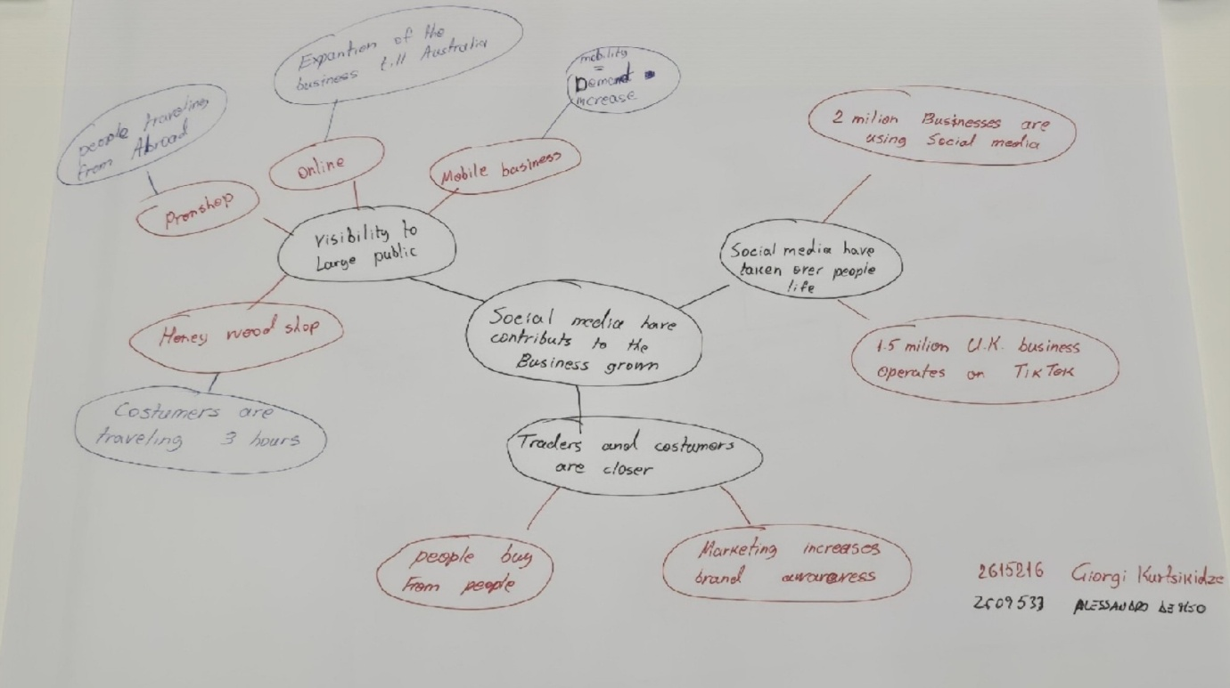

PART 2:
- Answer every question below in 1-3 full sentences.
- Use your own words. Do not use generative AI to answer these questions.
- Include a specific detail from the text when asked.
REMINDER
- The main idea is the overall message of the whole text.
- A key point helps to explain the main idea.
- A specific detail or example from the text shows that the key point is true.

- What is the main idea of the whole text?
The main idea is the impact social media has on businesses. Social media makes it easier to gain visibility and go viral. Social media has widened businesses' growth and shortened distances, smoothing the trading process between customers and traders.

- What is one key point that supports the main idea, and which specific example from the text shows this?
A key point that supports the main idea is proposed in the first Abstract: “social media platform such as Tik Tok and Instagram have made it easier than ever to get noticed by the world”.
Social media enhances visibility, helps businesses reach the public, and get noticed. Social media has become part of everyday people’s lives.

- What is a different key point that supports the main idea, and which specific example from the text shows this?
A different example that supports the main idea is when it says “it’s really amazing”- 1.5 million UK businesses operate on TikTok social media, according to figures shared by the social media platform. And “this has taken over my life”- according to the government, businesses worldwide are using Instagram to reach customers”.

- Which part of the text do you think is most important, and why?
I believe an important quote can be found at the beginning: “If you post it they will come”. This title consolidates a formula: it links the importance of being visible to being known in order to expand the business's range of operation, shortening the distance between customer and trader. This highlights the importance of identifying the right communication channel if we are talking about businesses.

Reflection:
- What did you find difficult in this task (including in-class components), and why was it difficult?
I found it more challenging to create the mind map in class. I’m usually need my solo space when I read and produce.
Then, once I read it the first time quickly title and general topic, I thought about skimming skills in order to make connections, and the map slowly started to make sense.

- What helped you with this difficulty, and how did it help you?
For sure, skimming the whole text has helped me focus on the main idea. I could reorganise a general structure that explained, in all directions, how the interaction between businesses and social media is correlated. I realised that perfection will come with practice.

