Mohammed Azar
1818591
This is a report analyzing communication for Navami Sudarsan

Effective Team Working and Communication BMSK4002 (health and social care group 3
Communication in the Workplace

Contents
Introduction 3
Verbal and Non-verbal Communication 4
What is Verbal Communication? 4
Verbal communication is when people communicate with words. The use of a language using an organised system of words as opposed to just sounds to communicate. For example, when we speak to colleagues at work, speak to friends on the phone or speak to our family over dinner it is a form of verbal communication. 4
Why is Verbal Communication Important? 4
Verbal communication is important for us to be able communicate our needs, share information or feelings. It is also a way for us to understand one another better and more clearly. Verbal communication can be used to vitalize thought and creativity and deepen relationships or start new ones. At times words can be more effective than actions and can be used to right wrongs (o.e.l, 2019). 4
What is Non-Verbal Communication? 4
Non-verbal and verbal communication go hand in hand as it can have a slight impact on the exchange of information between people and their perceptions but in big ways. What someone says verbally can sometimes be completely different to what they mean. For example, when people use sarcasm. The tone, pitch and volume of our voice is non-verbal communication. A person’s facial expressions, body posture, gesture and eye contact are all types of body language. Touching (e.g. hug, putting hand on shoulder to comfort, handshake, pat on the back etc) someone is another form of non-verbal communication. The clothes we wear are also forms of non-verbal communication and can lead to people making judgments about us that may or may not be true (eol, 2019). 4
Why is Non-Verbal Communication Important? 4
Non-verbal communication is important because it supports verbal communication and helps people to communicate emotions and how they are feeling. It can be used to comfort (hug), praise (pat on the back), to greet (handshake) or say goodbye (wave) (o.e.l, 2019). 4
Models of communication 4
Linear model 5
The Shannon-Weaver model 5
Berlo’s SMCR Model 5
Circular Model 6
Schramm’s Model 6
Communication Styles 7
Analytical Communication 8
Personal Communication 8
Intuitive Communication 8
Functional Communication 8
Communication Style Used at My Workplace (Barnardo’s) 8
Improvement strategies 9
Conclusion 9
References 10

Introduction

This report aims to analyse different models of communication; verbal communication; non-verbal communication and the styles that my workplace uses to communicate. It will also look at how I can improve my communication and the communication at my workplace.
To communicate is to share or exchange information, ideas or thoughts between two or more people (Mound 2017). There are lots of different ways to communicate such as writing a letter, sending a text, speaking, emailing, using facial expressions or body language etc. Communication is a vital skill and having good communication skills are very beneficial for working as part of a team at work or when doing group assignments as part of a course at university.

Non-verbal and Verbal Communication

Verbal communication is when people communicate with words. The use of a language using an organised system of words as opposed to just sounds to communicate. For example, when we speak to colleagues at work, speak to friends on the phone or speak to our family over dinner it is a form of verbal communication.

Verbal communication is important for us to be able communicate our needs, share information or feelings. It is also a way for us to understand one another better and more clearly. Verbal communication can be used to vitalize thought and creativity and deepen relationships or start new ones. At times words can be more effective than actions and can be used to right wrongs (Lucas, 2019).

Non-verbal and verbal communication go hand in hand as it can have a slight impact on the exchange of information between people and their perceptions but in big ways. What someone says verbally can sometimes be completely different to what they mean. For example, when people use sarcasm. The tone, pitch and volume of our voice is non-verbal communication. A person’s facial expressions, body posture, gesture and eye contact are all types of body language. Touching (e.g. hug, putting hand on shoulder to comfort, handshake, pat on the back etc) someone is another form of non-verbal communication. The clothes we wear are also forms of non-verbal communication and can lead to people making judgments about us that may or may not be true (Lucas, 2019).

Non-verbal communication is important because it supports verbal communication and helps people to communicate emotions and how they are feeling. It can be used to comfort (hug), praise (pat on the back), to greet (handshake) or say goodbye (wave) (Lucas, 2019).

Models of communication

In my lectures, I have learnt about a few different models of communication that help to explain the process of communication. This report will focus on the Shannon-Weaver model and Berlo’s model as well as Schramm’s Circular Model.

Linear model

Linear models are models where communication is one way and there is no reply from the receiver.

The Shannon-Weaver model

Claude Shannon and Warren Weaver developed the Shannon-Weaver model to explain the transfer of a message (Mound, 2017). It focuses on eight components:
- Sender – The person or persons wanting to send information or data.
- Encoder – Encodes the message in a way that can be understood by the receiver.
- Message – The data or information being sent to the receiver.
- Channel/Transmitter – The method or tool that transfers the information from the sender to receiver.
- Noise – Noise present at channel and can affect the communication.
- Decoder - Decodes message for the receiver to understand it.
- Receiver – Recipient of the message.
- Feedback – Confirmation to the sender that the message has been received and understood (Mound, 2017).
(Businesstopia, 2018)
The sender encodes a message (verbal, written, oral etc) and uses a channel to send it which can be affected by noise. The message is then decoded by the receiver and gives feedback to the sender that the message has been received and understood (AEDT1160U, 2013).

Berlo’s SMCR Model

IDavid Berlo developed a model that expands on the Shannon-Weaver model. Berlo’s model focuses on five components (Jenkinson, P. 2013):
- Sender – Sender of information or data.
- Message – The data or information being sent to the receiver.
- Channel – The method or tool used to transfer the information to the receiver.
- Receiver – The recipient of the information.
- Coding – Encoding and decoding message.
However, unlike the Shannon-Weaver model Berlo’s model also adds some extra variables to four of the components in the model.
(Businesstopia, 2018)

Berlo’s method considers how good or bad the sender’s and receiver’s communication skills are; their attitudes towards one another; the clarity of the message; the sender’s and receiver’s beliefs and values; and their cultural.
It also considers the content of the message; how the message is transferred; the structure and form of the message as well as the effectiveness of the channel based on the five senses (Jenkinson, P. 2013).

Circular Model

A Circular model of communication is a transactional model where the communication is a two way. It can also be known as a transactional model. An example of a circular model is the Schramm’s model.

Schramm’s Model

In 1954 Wilbur Schramm developed a model of communication that explained communication as a two-way process. Schramm wanted his model to be able to better explain the complexity of human communication and believed one-way communication is incomplete (Santiago 2018). Schramm’s model has nine components:
- Sender – The person or persons wanting to send information or data.
- Encoder – Encodes the message in a way that can be understood by the receiver.
- Decoder - Decodes the message in a way that the receiver can understand it.
- Interpreter – Analyses and tries to Understand message
- Receiver – The recipient of the message.
- Message – The data or information being sent to the receiver.
- Feedback – Confirmation from the receiver to the sender that the message has been received and understood.
- Channel/Transmitter – The method or tool used to transfer the message from the sender to the receiver.
- Noise/Semantic Noise - Noise that is present at the channel and can affect or disrupt the communication/when the receiver misinterprets what the sender intended to send (Santiago. 2018).

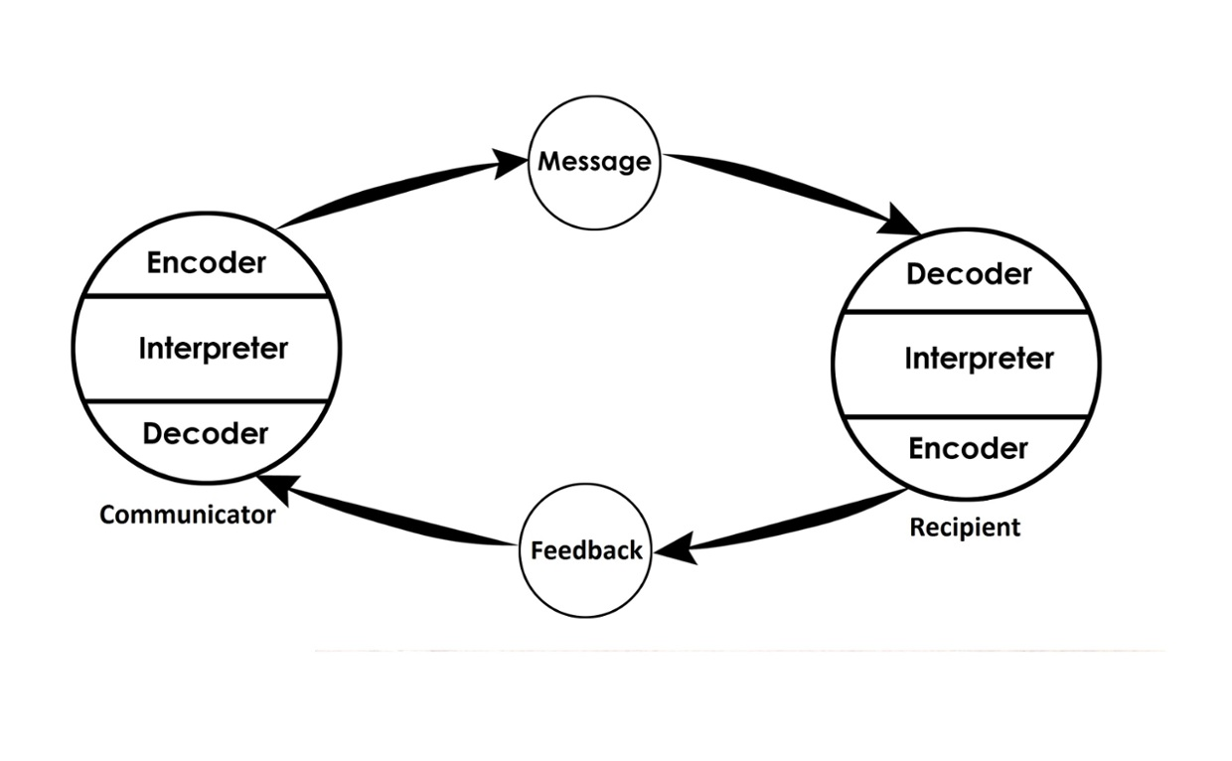 (Joerges, 2014)

The concept of Schramm’s model is that people are all different and come from different walks of life, cultural backgrounds and have different religions and beliefs. They also have different life experiences and knowledge so emphasis must be given to all these factors when encoding and decoding. He also believed that communication was incomplete unless it was two-way therefore in Schramm’s model the sender and receiver must take turns to send information, both are senders and receivers, both must encode and decode information and Interpret before sending and receiving the information (Santiago 2018).

Communication Styles

There are four styles of communication that people use when interacting or exchanging information from each other. These are Analytical communicators, Personal Communicators, Intuitive communicators and Functional communicators (Next level life, 2017).

- Analytical Communication - Analytical communicators like facts and like to back up what they say with facts

- Personal Communication - Personal communicators like to use emotional language and use it to build a kind of bond or strong relationship with people when communicating (Next level life, 2017).

- Intuitive Communication - Intuitive communicators are direct and like to get straight to the point rather than focus on details and prefer to receive information in the same way (Next level life, 2017).

- Functional Communication – Unlike intuitive communicators, functional communicators like to pay attention to detail (Next level life, 2017).

Communication Style Used at My Workplace (Barnardo’s)

I work for a non-profit organisation called Barnardo’s. At Barnardo’s we work to help disadvantaged children and children with complex needs, disabilities, learning difficulties or any other problem they might have. My role is to help parents of children who have disabilities or learning difficulties with strategies they can use or put in place to help them and their child overcome a behavioural difficulty. I must also write a report about what services I feel the child would benefit from and forward my recommendation to the social services. I use the personal communication style as It is always important for me to be professional but also show empathy, listen actively, praise and build strong relationships with the parents and young people that I work with.
When working with children with disabilities it is very important for the parents and all the professionals that work with them such as social workers, doctors, teachers, carers etc to work together in order to keep them safe, help the child achieve their targets and for their development. Communication between all parties is vital and when all parties are communicating and sharing information such as learning objectives and outcomes; medications and diet; boundaries set etc it creates stability, continuity and safety for the child.
We have a very diverse team and all of us have different styles of communication. Some are functional communicators, some intuitive and some Analytical but almost all our staff use the personal communication style. We are trained to listen actively, to emphasise, to praise to problem solve and to be aware and respect people’s thoughts and feelings. This is especially important when working with children and their parents.
I would say that most of the people at the top of Barnardo’s such as directors and assistant directors tend to use intuitive style of communication. They like paying attention to detail when we report back to them and can go into a great deal of detail in meetings. Meetings are done in an orderly fashion according to the agendas set.
Communication at Barnardo’s is very good, and a lot of emphasis is given to it by having regular trainings, eLearning courses and refresher courses available for staff to access. However, if I was to improve it further, I would suggest that the senior managers and directors adopt the personal communication style a bit more and as there is a bit of a disconnect between them and the staff working at ground level.

Improvement strategies

Keys approach

The KEYS approach is a strategy which uses the acronym ‘KEYS’ as a quick reminder of things to be aware of when communicating. It can help improve communication in the workplace.
K now yourself - Knowing yourself reminds you to know yourself and your audience.
Evaluate context - Evaluate the context of the environment.
Your Communication or interaction with others - Be aware that you cannot take back what you have said.
Step Back and reflect - Reflect on the communication interaction when it has finished and think about how it went.

Seven C’s of Communication

These seven C’s can be used to improve the way you communicate at the workplace. The seven C’s are:
- Clear – Be clear when making objectives and avoid complicated words and phrases.
- Concise – Stick to the point.
- Concrete – Be factual and avoid being vague.
- Correct – Don’t mistakes such as typos and make sure your facts are right
- Coherent – Be logical and make sense.
- Complete – Make sure you’re your message is complete and has everything in it.
- Courteous – Be respectful and be polite always.

Active listening skills

Active listening is the ability to listen with all of you senses and not just your hearing. It requires full concentration to listen and understand what is being communicated as well as looking non-verbal cues and summarising what is being said or nodding to show that you are listening. The acronym SOLER can be used to help improve active listening skills.
Sit side on to the person speaking (about a ninety-degree angle) and at a comfortable distance.
Open posture.
Lean forwards towards the person speaking to show them you are paying attention.
Eye contact should be made.
Relax when using these techniques.

Importance of culture

It is important to aware of the differences in people’s cultures. What is acceptable in one culture may not be in another. We must be aware, considerate and respectful of others always. I have learnt about High context and low context cultures in my lectures.

High context
Latin American, East Asian, Southern Mediterranean and Arab countries have similar values and cultural understanding. They value relationships and do not always say everything they want to communicate but instead use nonverbal cues or silence to communicate what is not said (Tero trainers, 2016).

Low Context
Countries in America, Canada and Western Europe also have similar values and cultures. They prefer to be specific, clear and descriptive when they communicate. They find it hard to trust relationships in Business communication (Tero trainers, 2016).

Conclusion

We have looked at some models of communication such as the Shannon-Weaver model, how Berlo expanded on it with his model and Schramm’s transactional model. We have also touched on verbal and non-verbal communication and styles of communication and spoke about the importance of communication when working with children.

References

Lucas, A (2019) The Importance of Verbal & Non-Verbal Communication [online] Available at: https://oureverydaylife.com/the-importance-of-verbal-non-verbal-communication-5162572.html (Accessed 20 August 2019).
Mound, A. (2017) Certificate in higher education: skills for the workplace student yearbook. London: Sage Publications Ltd.
Morgan, P. (2017) The business student’s guide to study and employability, London: Sage Publications.

Santiago, B. (2018) Schramm's Model of Communication [video] Available at: https://www.youtube.com/watch?v=2lC_GDVYm64 (Accessed 18 August 2019).

AEDT1160U (2013) VidClip 2.2 Shannon and Weaver Model [video] Available at: https://www.youtube.com/watch?v=etcIX0aC-4E&t=52s (Accessed 18 August 2019).

Jenkinson, P. (2013) Communication Models: Basic SMCR Model [video] Available at: https://www.youtube.com/watch?v=yUGW2d6nXe0 (Accessed 18 August 2019).

Businesstopia (2018) Shannon and weaver model of communication [online] Available at: https://www.businesstopia.net/communication/shannon-and-weaver-model-communication (accessed 18 August 2019).

Jeorge, H. (2014) Wilbur Schramm's Model of Communication [online] Available at: https://www.thinglink.com/scene/619885942081060866 (Accessed 18 August 2018).

Next Level Life (2017) 4 Styles of Communication | Communication Styles In The Workplace [video] Available at: https://www.youtube.com/watch?v=Al3L6cnCmMU (Accessed 18 August 2019).

Tero Trainers, (2016) What is the difference between a high context and low context culture [video] Available at: https://www.youtube.com/watch?v=qKViQSnW-UA (Accessed 21 August 2019).

In Class Exercises


