
Problem Solving and Decision Making within Green Haven Florists
Module code: LCLM4004
Name: Mariana Madem
Student ID: 2438257
Tutor name: Faizu Edu

Table of Content
Introduction 3
Business problem analysis 3
Two alternative solutions 4
Evaluation of both solutions using PMI 4
Selection of the best solution with justification 5
Basic risk analysis of the selected solution 5
Action plan for implementation of the solution 6
Measuring effectiveness of the implemented solution 7
Conclusion 7
References 9
Appendices 10

Introduction
This particular report is written in order to explain the main problem faced by Green Heaven Florists and in order to show how two possible solutions can be analysed and used in order to support a clear business decision. It is going to guide the business owner towards a practical step that can help to recover from the shops falling sales. Green Heaven Florists is a small flower shop in Norwich that once worked appropriately because of its personal service and eco-friendly style but along with time it has lost many walk-in customers, strong competitors have entered in the market, and costs have gone up. These changes have made the business struggle. This particular report is directly connected to the decision making and problem solving because the owner now needs to understand the cause of the problem, then compare the options and choose the most suitable action to stabilize the business.

Business problem analysis
Nature of the problem | The main problem at Green Heaven Florists is the sharp fall in instore sales and difficulty of the shop in keeping up with digital changes. It is also facing higher flower prices and stronger competition that is making it difficult for the owner to maintain profit (Fernandes Barbosa, 2021).
Scope of the problem | The problem is affecting almost every part of the shop and it touches customer numbers, marketing, pricing, and service delivery.
Impact on business operation | Because of the decline in walk-in customers the shop cannot depend only on online orders and income has dropped. Rising prices for imported flowers put pressure on Profit margin. The outdated website slows down the online growth and weak digital marketing means few customers even notice the shop (Larkin, 2024).
Evidence from the case | The case shows a 30% fall in the store sales, a slow and old website, higher supply cost, and to new competitors where one using strong media and other is offering lower price and white delivery

Two alternative solutions
Solution 1: website redesign and digital marketing
This particular solution includes creating a new and easy to use website with clear product pages having mobile friendly design and smooth ordering system. It also includes regular social media posts, basic search engine updates, and simple online ads so customers can find the shop more easily (Husna et al. 2024). The current website of the shop is outdated and confuses many customers and at the same time people in the area have shifted to online purchasing. As two competitors already use strong digital methods improving online presence of green heaven is directly connected to the falling of their sales. A modern website can attract more online orders and help the shop to reach customers who do not visit the high street anymore. Better visibility on Instagram or Facebook can draw the attention of younger customers and increase brand awareness that can ultimately help in reducing dependence on walk-in customers (Chen and Huang, 2020). The cost of redesigning a website can be difficult for a small shop dealing with low revenue. Liyam and Priya can also struggle to manage digital marketing because they have limited experience.
Solution 2: subscription service and flexible delivery option
This particular solution offers customers some monthly or weekly flower subscriptions for homes and offices and it also adds more delivery choices like planned delivery slots and same day delivery as well as wide delivery areas if possible. Customer feedback shows interest in more flexible delivery and many people now like routine services at the same time. Subscription can create stable income that is useful when sales are falling down. It can bring predictable monthly revenue and help the shop to plan stock better (Kenanoğlu, 2023). It can also attract busy customers who prefer convenience. The limitation of this solution is delivery changes need extra planning and staff time. Subscription can be difficult to manage if stock price rise suddenly

Evaluation of both solutions using PMI
The PMI tool was used in order to compare both solutions because it helps the owner to see the positives, neutral, and negative points in a simple way. For the website redesign and digital marketing option the positive points when mainly connected to higher online visibility, stronger competitiveness against online retailers, and easier customer access (Kalina et al., 2025). It also had the opportunity to bring in new customers who prefer digital shopping. The negative points were the cost of creating a new website and the time needed to learn digital marketing skills. A few neutral points such as the need for small content updates were also noted. Fortis subscription and flexible delivery option depositives include study monthly income, the ability to target busy customers, and better customer loyalty. This option can help to reduce the impact of falling walk-in customers. The analysis is also showing risks such as delivery delay, pressure on stock, and fuel cost if the price of the flower rises again (Kalina et al., 2025). Few neutral points are connected to the need of basic delivery planning tools. When both solutions were compared the PMI scores show that the website re-design and digital marketing strategy had a slightly stronger advantage.

Selection of the best solution with justification
The chosen solution from the option for Green Heaven Florists is the website redesign combined with digital marketing strategy. This solution is considered the most appropriate because it directly points towards the main reason for declining sales being limited online presence and weak digital engagement (Fitzpatrick, 2024).
From this particular case study it has been observed that the current website is outdated and difficult to use for the shop and the owner has not kept up with online marketing trends. Computers are already attracting their customers with the help of strong social media and efficient online platforms that is making it necessary for the shop to modernise. This solution also connected with customer needs as feedback indicated that many clients prefer the convenience of browsing and ordering online (Khalil, 2022). Industry trends show a clear shift towards digital shopping, active online engagement, and mobile friendly platforms. By improving the website and using social media effectively it can reach both existing and new customers that will ultimately enhance its visibility and recover lost revenue.

Basic risk analysis of the selected solution
Three main risks are identified for the website redesign and digital marketing strategy. The first risk is high initial cost that can occur because professional website development and marketing tools can be expensive and this can be controlled by comparing different service providers and starting with a simple and functional website before adding advanced features. The second risk is lack of digital skills as Liam and Priya have limited experience with online marketing. This can be reduced by taking short training courses or hiring a part time digital assistant to manage the online presence (Salenius, 2021). The third risk is slow customer response that can happen if the website and marketing changes take time to attract attention. This can be reduced by promoting the shop through social media, special offers, and local advertisement during the initial phase.

Action plan for implementation of the solution
Tasks | Responsible person | Time frame | Resource required | Communication plan | Monitoring steps
Redesign website layout and update product pages | External web designer | Four weeks | Designs software, content, and images | Weekly email updates to Liam and Priya | Check website progress early week
Set up mobile friendly version and payment system | External web designer | 2 weeks | Payment gateway and testing tools | Bi-weekly calls with owners | Test all functions before launch
Develop social media content calendar | Priya | 1 week | Social media tools and photos | Daily check ins on WhatsApp | Review engagement metrics weekly
Run initial online marketing campaign | Liam | 2 weeks | Advertisement budget and social media platform access | Weekly meeting with Priya | Track clicks, orders, and enquiry
Train owners in basic website updates | External trainer | 1 week | Training sessions and manual | Report progress via email | Test owners ability to update the content
Launch website and campaign | Liam and Priya | Launch day | Website hosting and advertisement budget | Announce via social media and news letters | Monitor orders and website traffic daily for first month
Review and adjust strategy | Liam and Priya | Monthly | Reports and analytics tools | Monthly meeting | Address campaign and website as needed based on performance.

Measuring effectiveness of the implemented solution
Green Heaven can analyse the success of the website re-design and digital marketing strategy by using clear keep performance indicators that include the number of website visitors, engagement on social media platforms, and online orders. Customer feedback scores from surveys or reviews can also show satisfaction level (Han and Anderson, 2022). Monitoring tools like Google Analytics can also help in tracking website traffic, conversion rate, and user behaviour. Social media perspective will help to measure the lights and shares along with comments and follower growth. Online order reports can also indicate whether sales are increasing or not (Calvo et al., 2023). Review time must be set regularly such as weekly check for Website traffic and social media as well as monthly review for the sales and customer feedback.

Conclusion
From this report it has been observed that Green Heaven Florists is losing in store sales because of an outdated website, from competition, rising cost, and limited digital marketing. Customers want easier online access and flexible options. The selected solution of website design and digital marketing is suitable because it is directly pointing to all these issues and it can improve visibility, increase online orders, and attract new customers who help the shop to recover the revenue. This particular case study shows the importance of problem solving and decision making in business. By carefully analysing the problem, choosing a practical solution, and evaluating the option the owner can take clear and effective actions. Making informed decisions ensures the shop will adapt to the changing customer behaviour and industry trend that will ultimately support long term sustainability growth.

References
Calvo, E., Cui, R., and Wagner, L. (2023). Disclosing product availability in online retail. Manufacturing and Service Operations Management, 25(2), 427-447.
Chen, L. C., and Huang, L. C. (2020). The motivation, strategies, and barriers for adopting social media marketing in the flower retailing business. Horticulturae, 6(4), 80.
Fernandes Barbosa, M. (2021). Digital Transformation in the Brazilian Flower Industry: Cultural and Technological Issues, Economic Benefits and Firms' Actual Adoption (Doctoral dissertation, Politecnico di Torino).
Fitzpatrick, P. (2024). The Art of Small Business Social Media: A Blueprint for Marketing Success. Bloomsbury Publishing USA.
Han, S., and Anderson, C. K. (2022). The dynamic customer engagement behaviors in the customer satisfaction survey. Decision Support Systems, 154, 113708.
Husna, N., Hartoyo, H., and Hasanah, N. (2024). Redesigning Digital Marketing Strategy for Increasing Sales of Small Business: A Case Study in Pinescarf. Bonus Business Review, 15(3), 239-249.
Kalina, V., Lhota, J., and Kalender, Z. T. (2025). Effective project portfolio management for SMEs: A conceptual framework using business intelligence tools. Procedia Computer Science, 253, 745-756.
Kenanoğlu, Z. (2023). Problems of retailers in the cut flower sector and a proposal for the sustainability of the sector: the case of Turkey. Horticulturae, 9(8), 932.
Khalil, I. (2022). Website redesign: The role of the user experience design process in the improvement of local e-commerce website design (Doctoral dissertation, Doctoral dissertation, Rhine-Waal University of Applied Sciences).
Larkin, L. (2024). Flower Farming for Profit: The Complete Guide to Growing a Successful Cut Flower Business. Chelsea Green Publishing.
Salenius, C. (2021). Online Presence for a New Entrepreneur: Case Landscape Design and Gardening Firm.

Appendices
PMI Evaluation Table
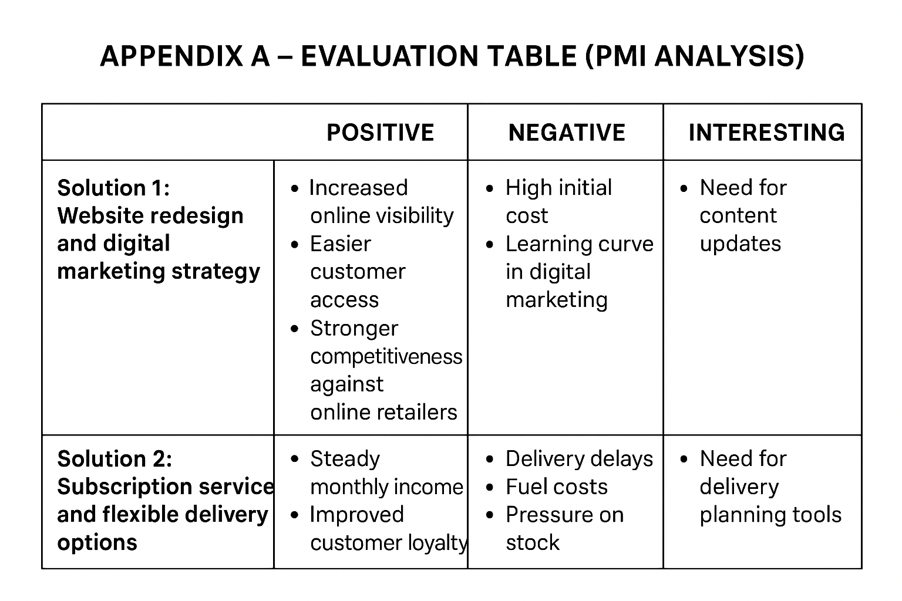
Risk Table


