Activity 4
James Beard
1901671

Which link did you use to download the tool?
https://www.tenable.com/products/nessus
After doing some research the author found that multiple websites and documents sources Tenable as the owner of this software, so the author selected it.
What is the purpose of this tool?
Nessus is a vulnerability scanner used for penetration testing engagements and vulnerability assessments [1]. The tool scans devices and raises an alert if it finds vulnerabilities in the network that could be potentially exploited by hackers or criminals [2]. It achieves this by running over thousand checks on a device, testing to see if any potential attacks could be used to exploit weaknesses in the devices or otherwise cause harm [2].
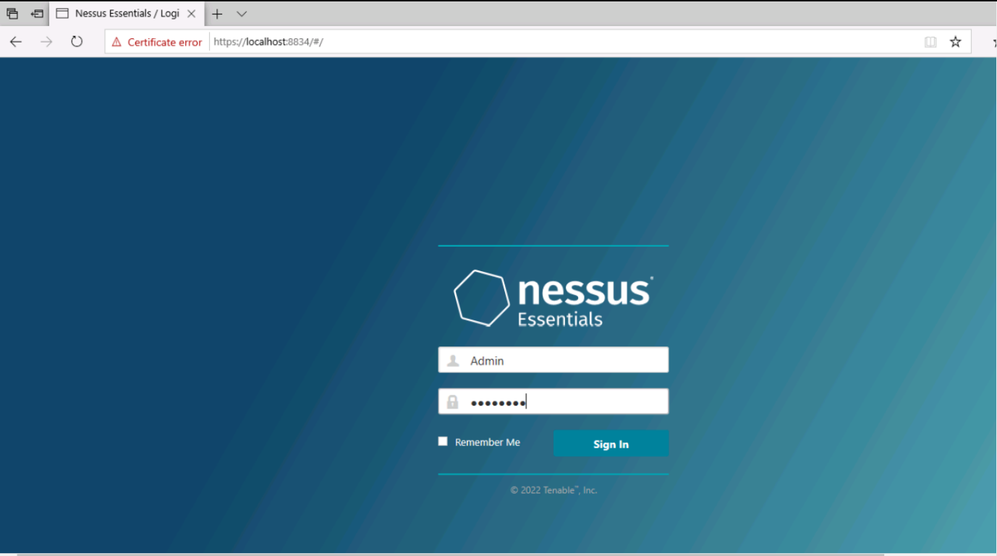
Why would we turn off ping the remote host option?

Why would we set them to unlimited?

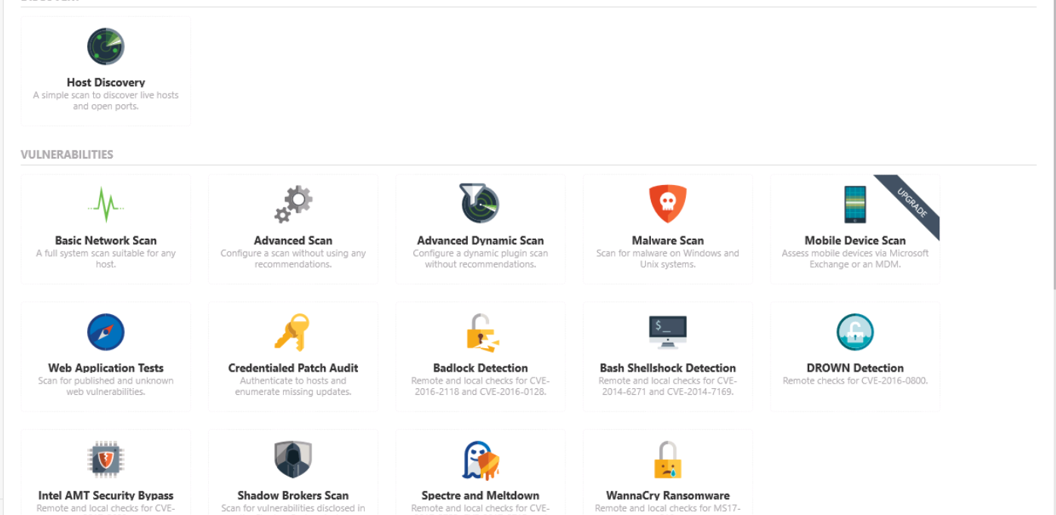
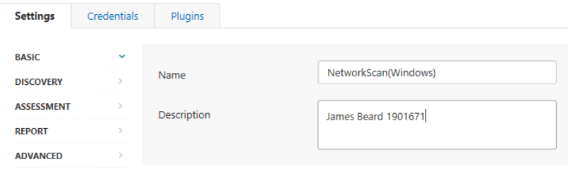
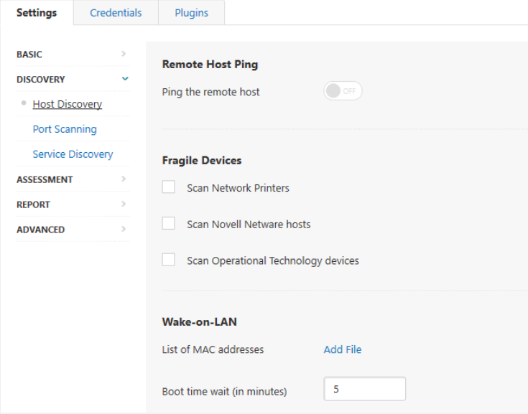
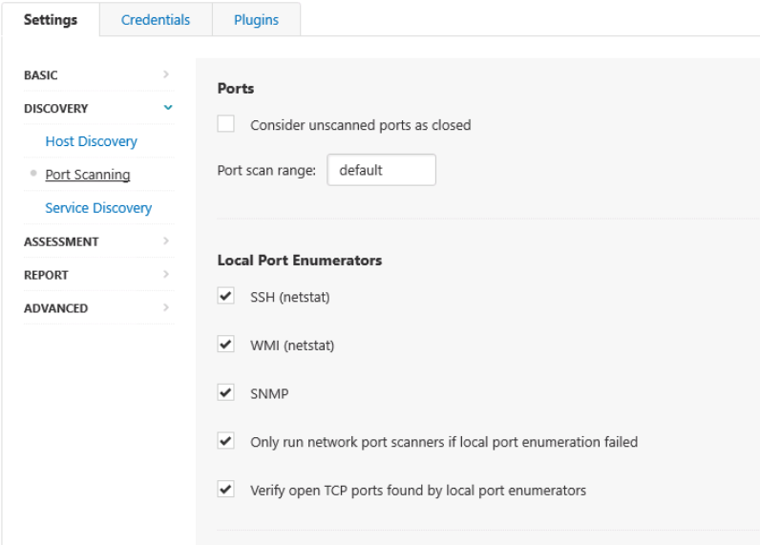
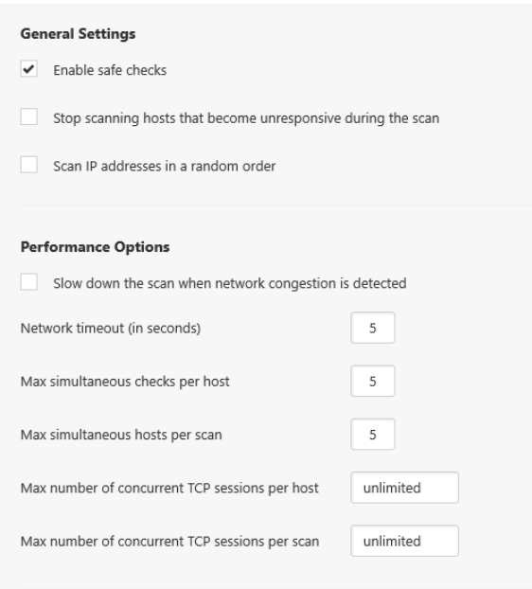
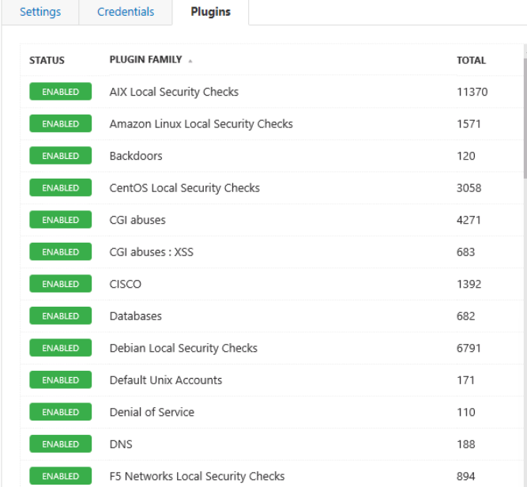
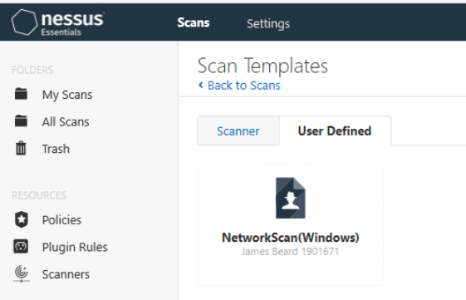
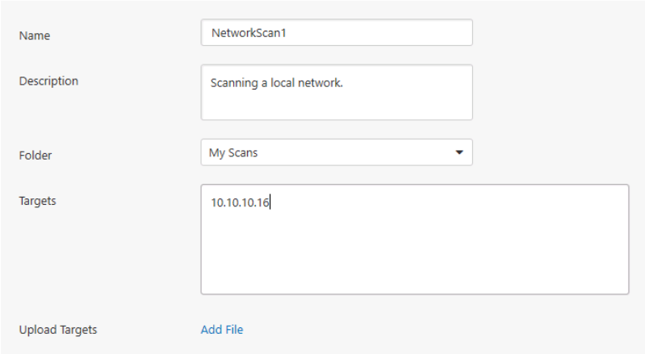
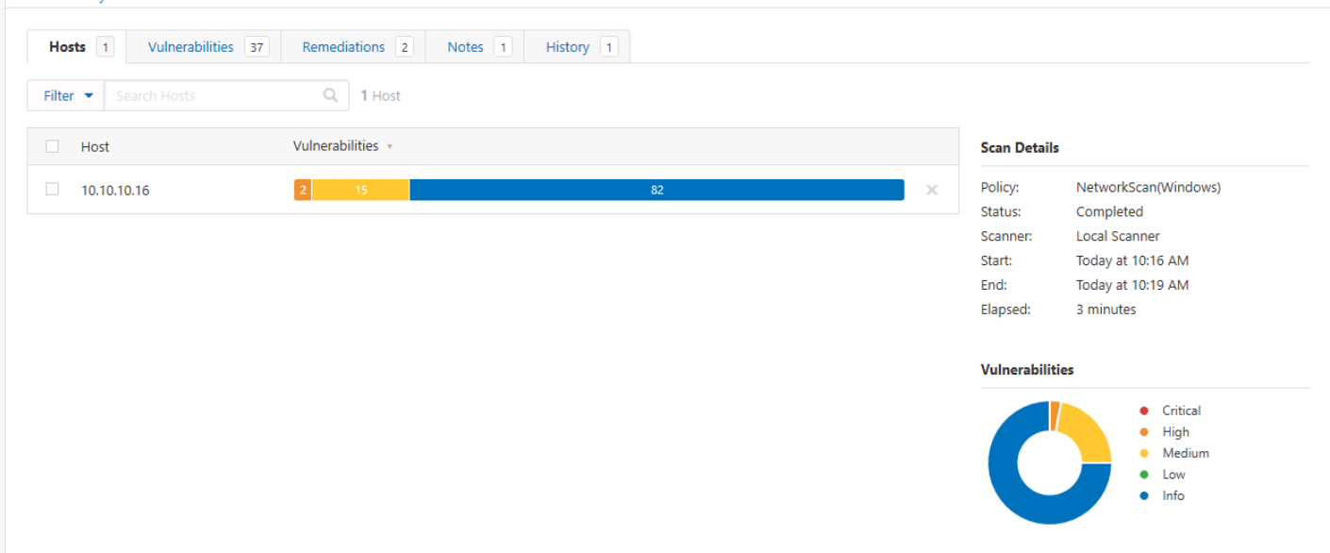
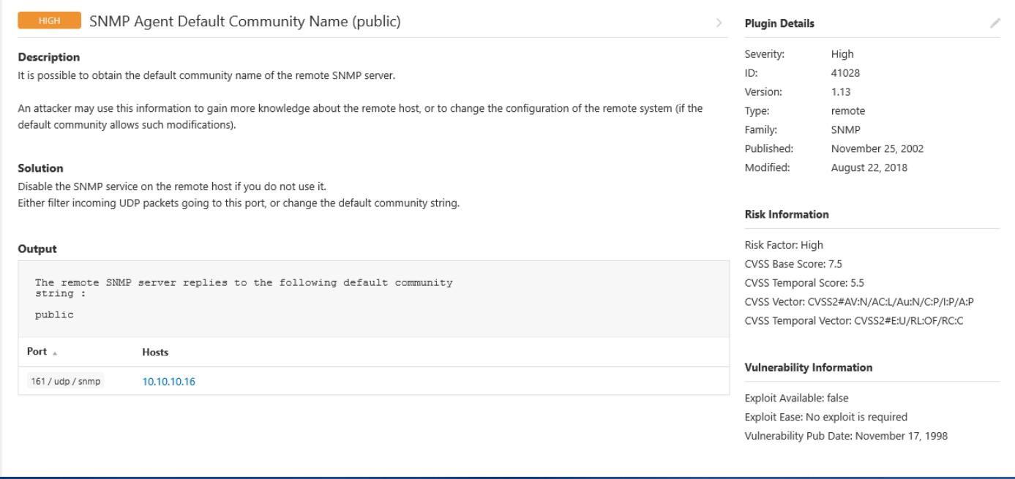
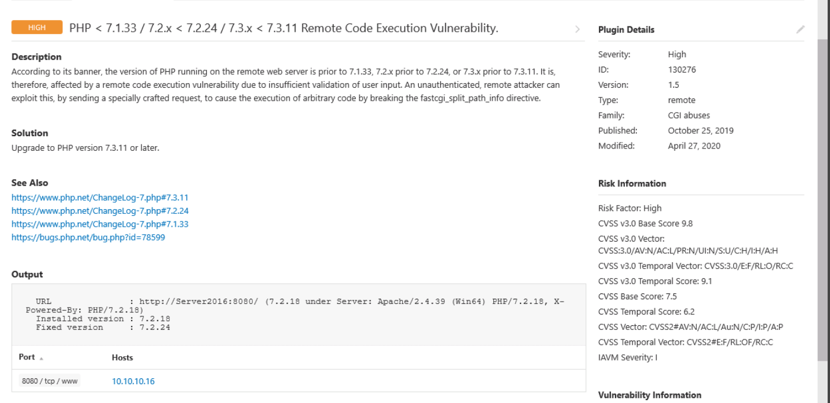

Use the report and classify action plan/ mitigation steps to overcome the vulnerabilities.
a. To do that, categorize all the listed vulnerabilities based on its severity.


NetworkScan1
Report generated by Nessus™
Mon, 07 Mar 2022 10:19:30 Eastern Standard Time
TABLE OF CONTENTS

Hosts Executive Summary
• 10.10.10.16...........................................................................................................................................................4
Hosts Executive Summary

10.10.10.16
0 | 2 |  | 15 |  | 0 |  | 50
CRITICAL |  | HIGH |  | MEDIUM |  | LOW |  | INFO
Vulnerabilities |  |  |  |  |  |  |  | Total: 67
SEVERITY CVSS |  | PLUGIN NAME
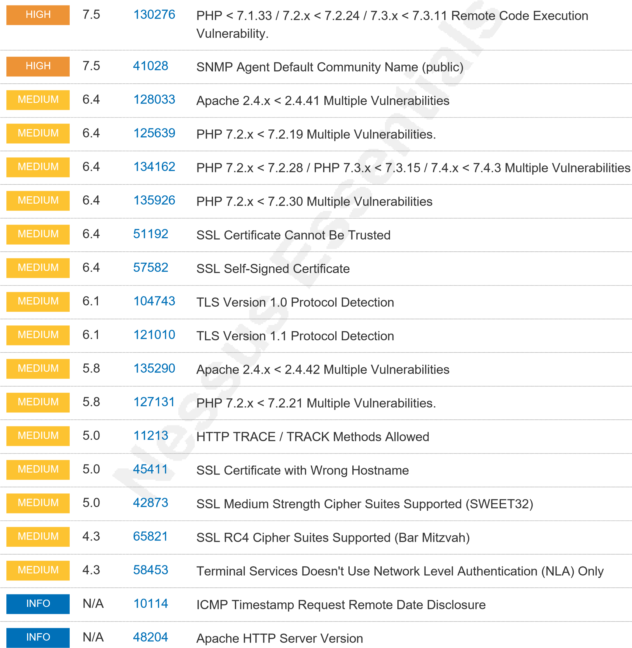
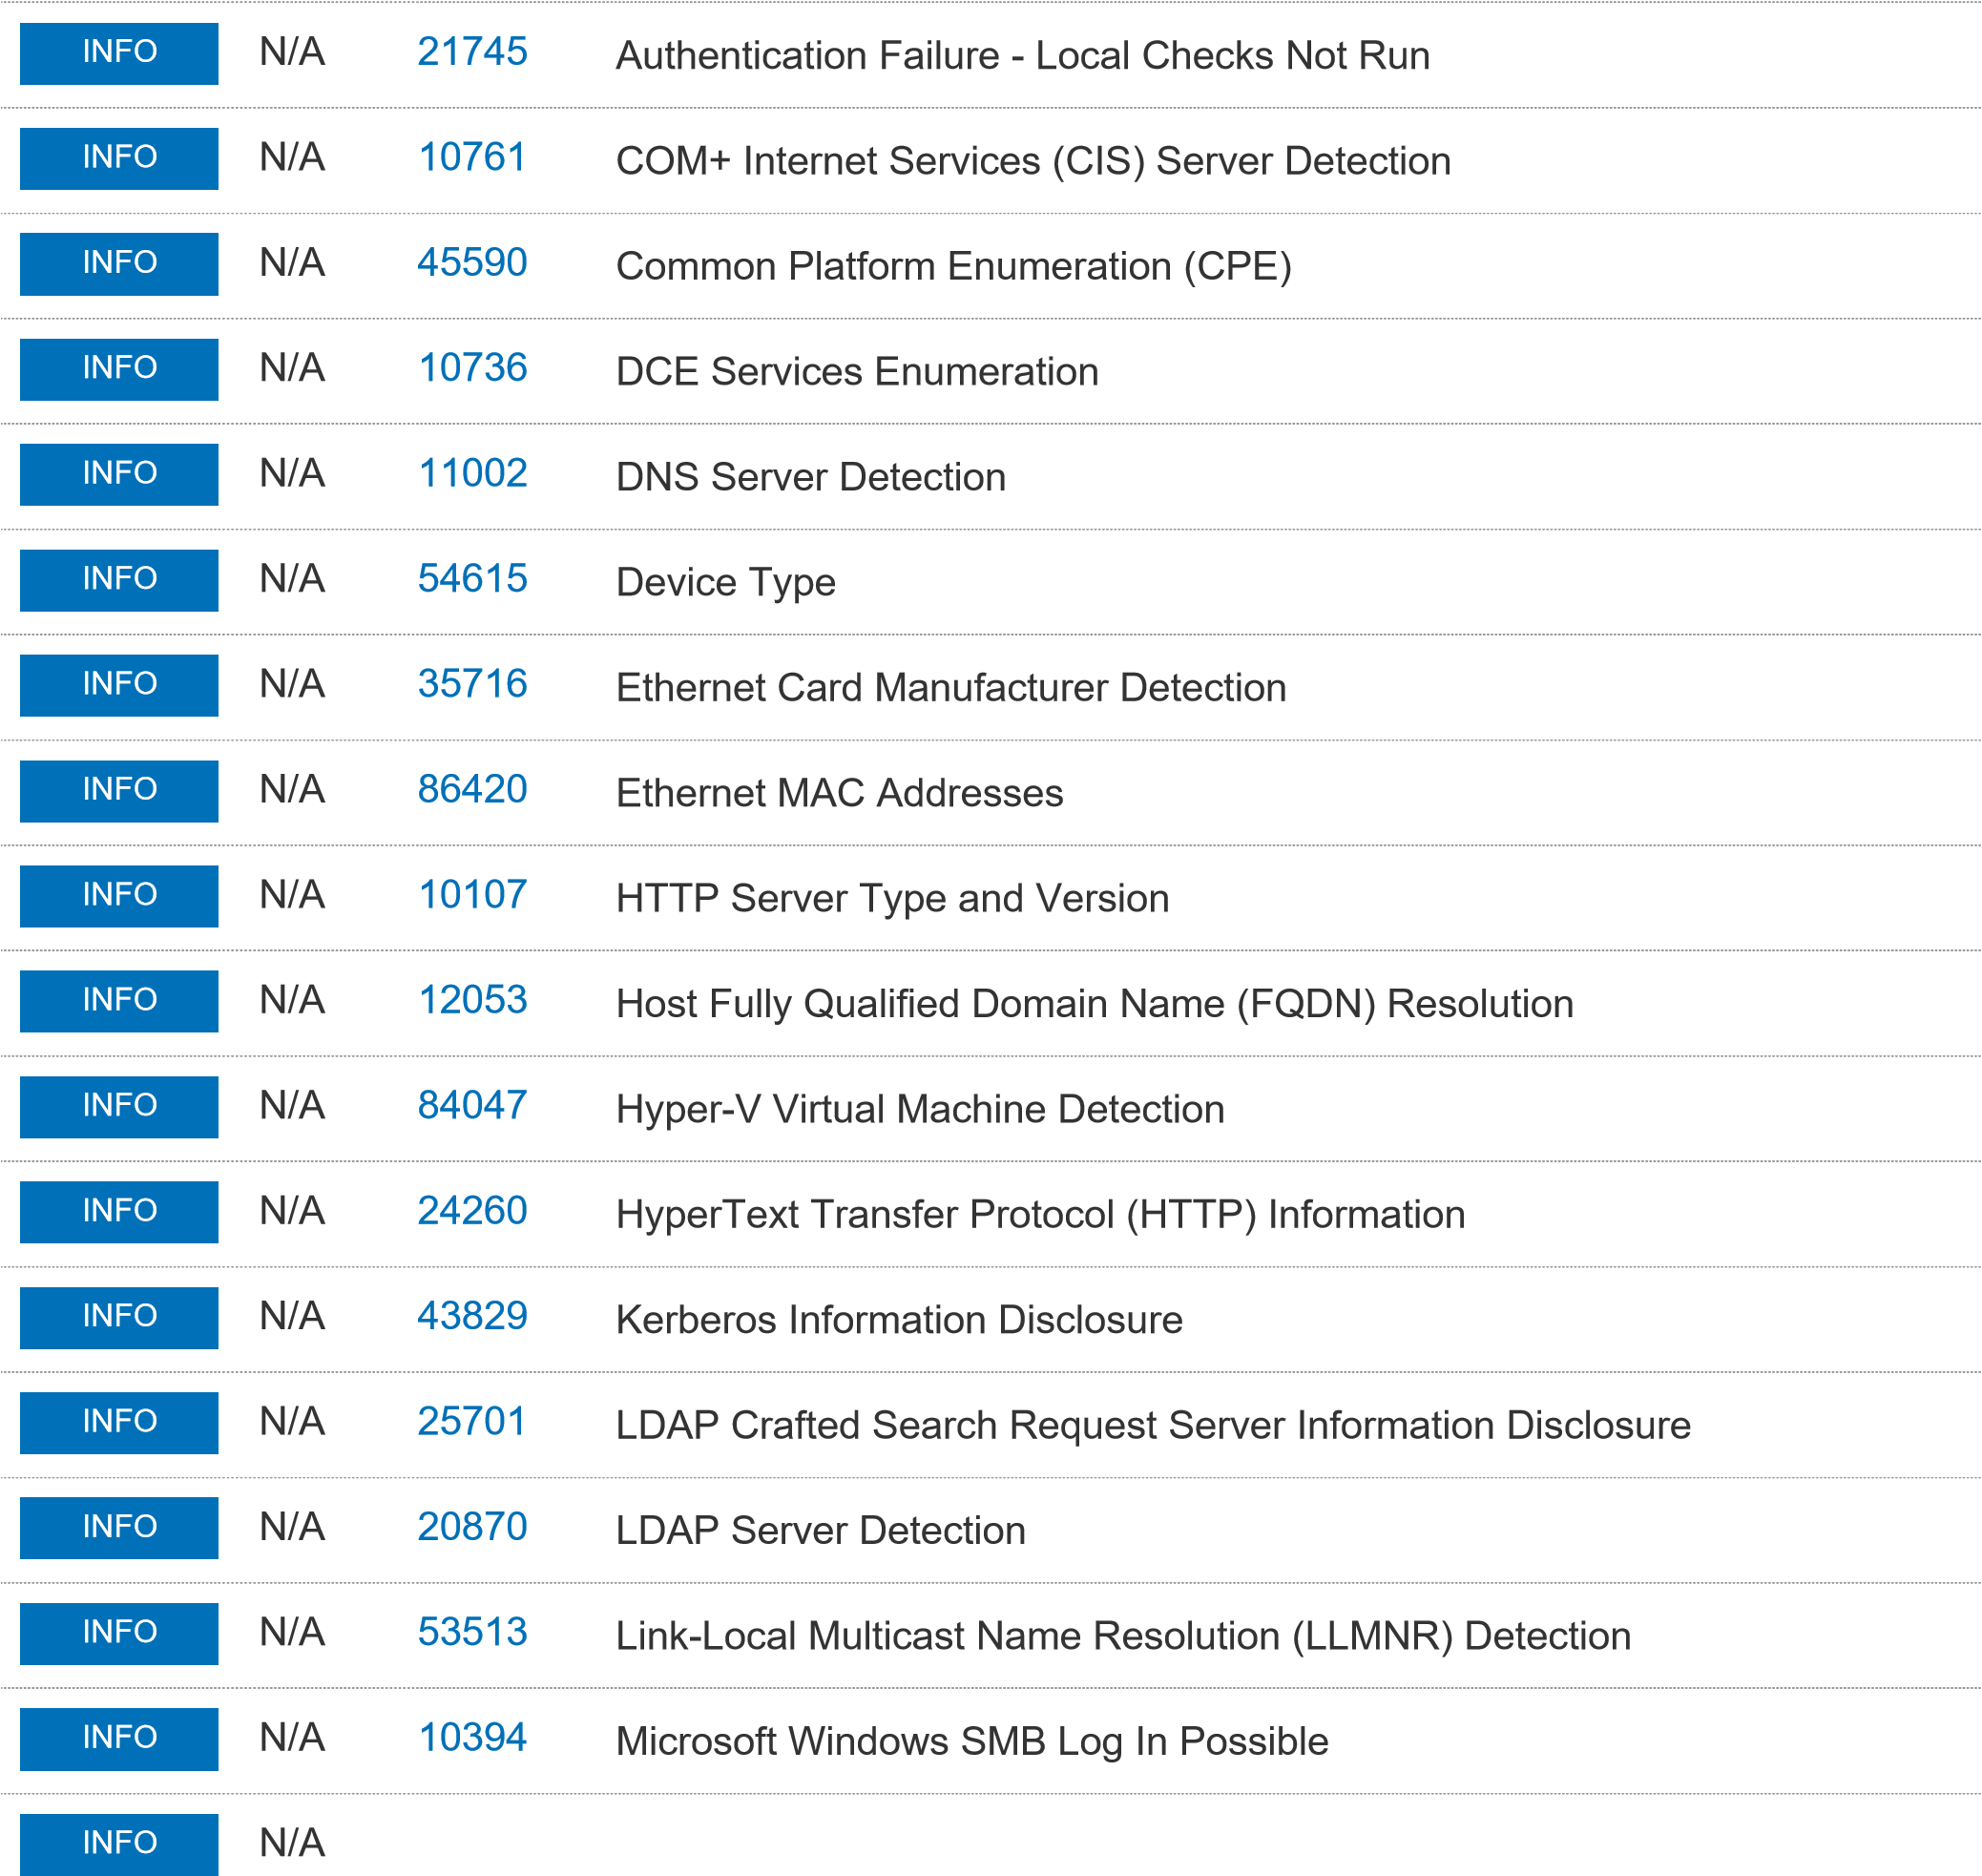10785 Microsoft Windows SMB NativeLanManager Remote System Information Disclosure
INFO
N/A
1
1101
Microsoft Windows SMB Service Detection
INFO
N/A
1
10087
Microsoft Windows SMB Versions Supported (remote check)
INFO
N/A
6
10671
Microsoft Windows SMB2 and SMB3 Dialects Supported (remote check)
INFO
N/A
6
1950
Nessus Scan Information
INFO
N/A
2478
6
Nessus Windows Scan Not Performed with Admin Privileges

Registry
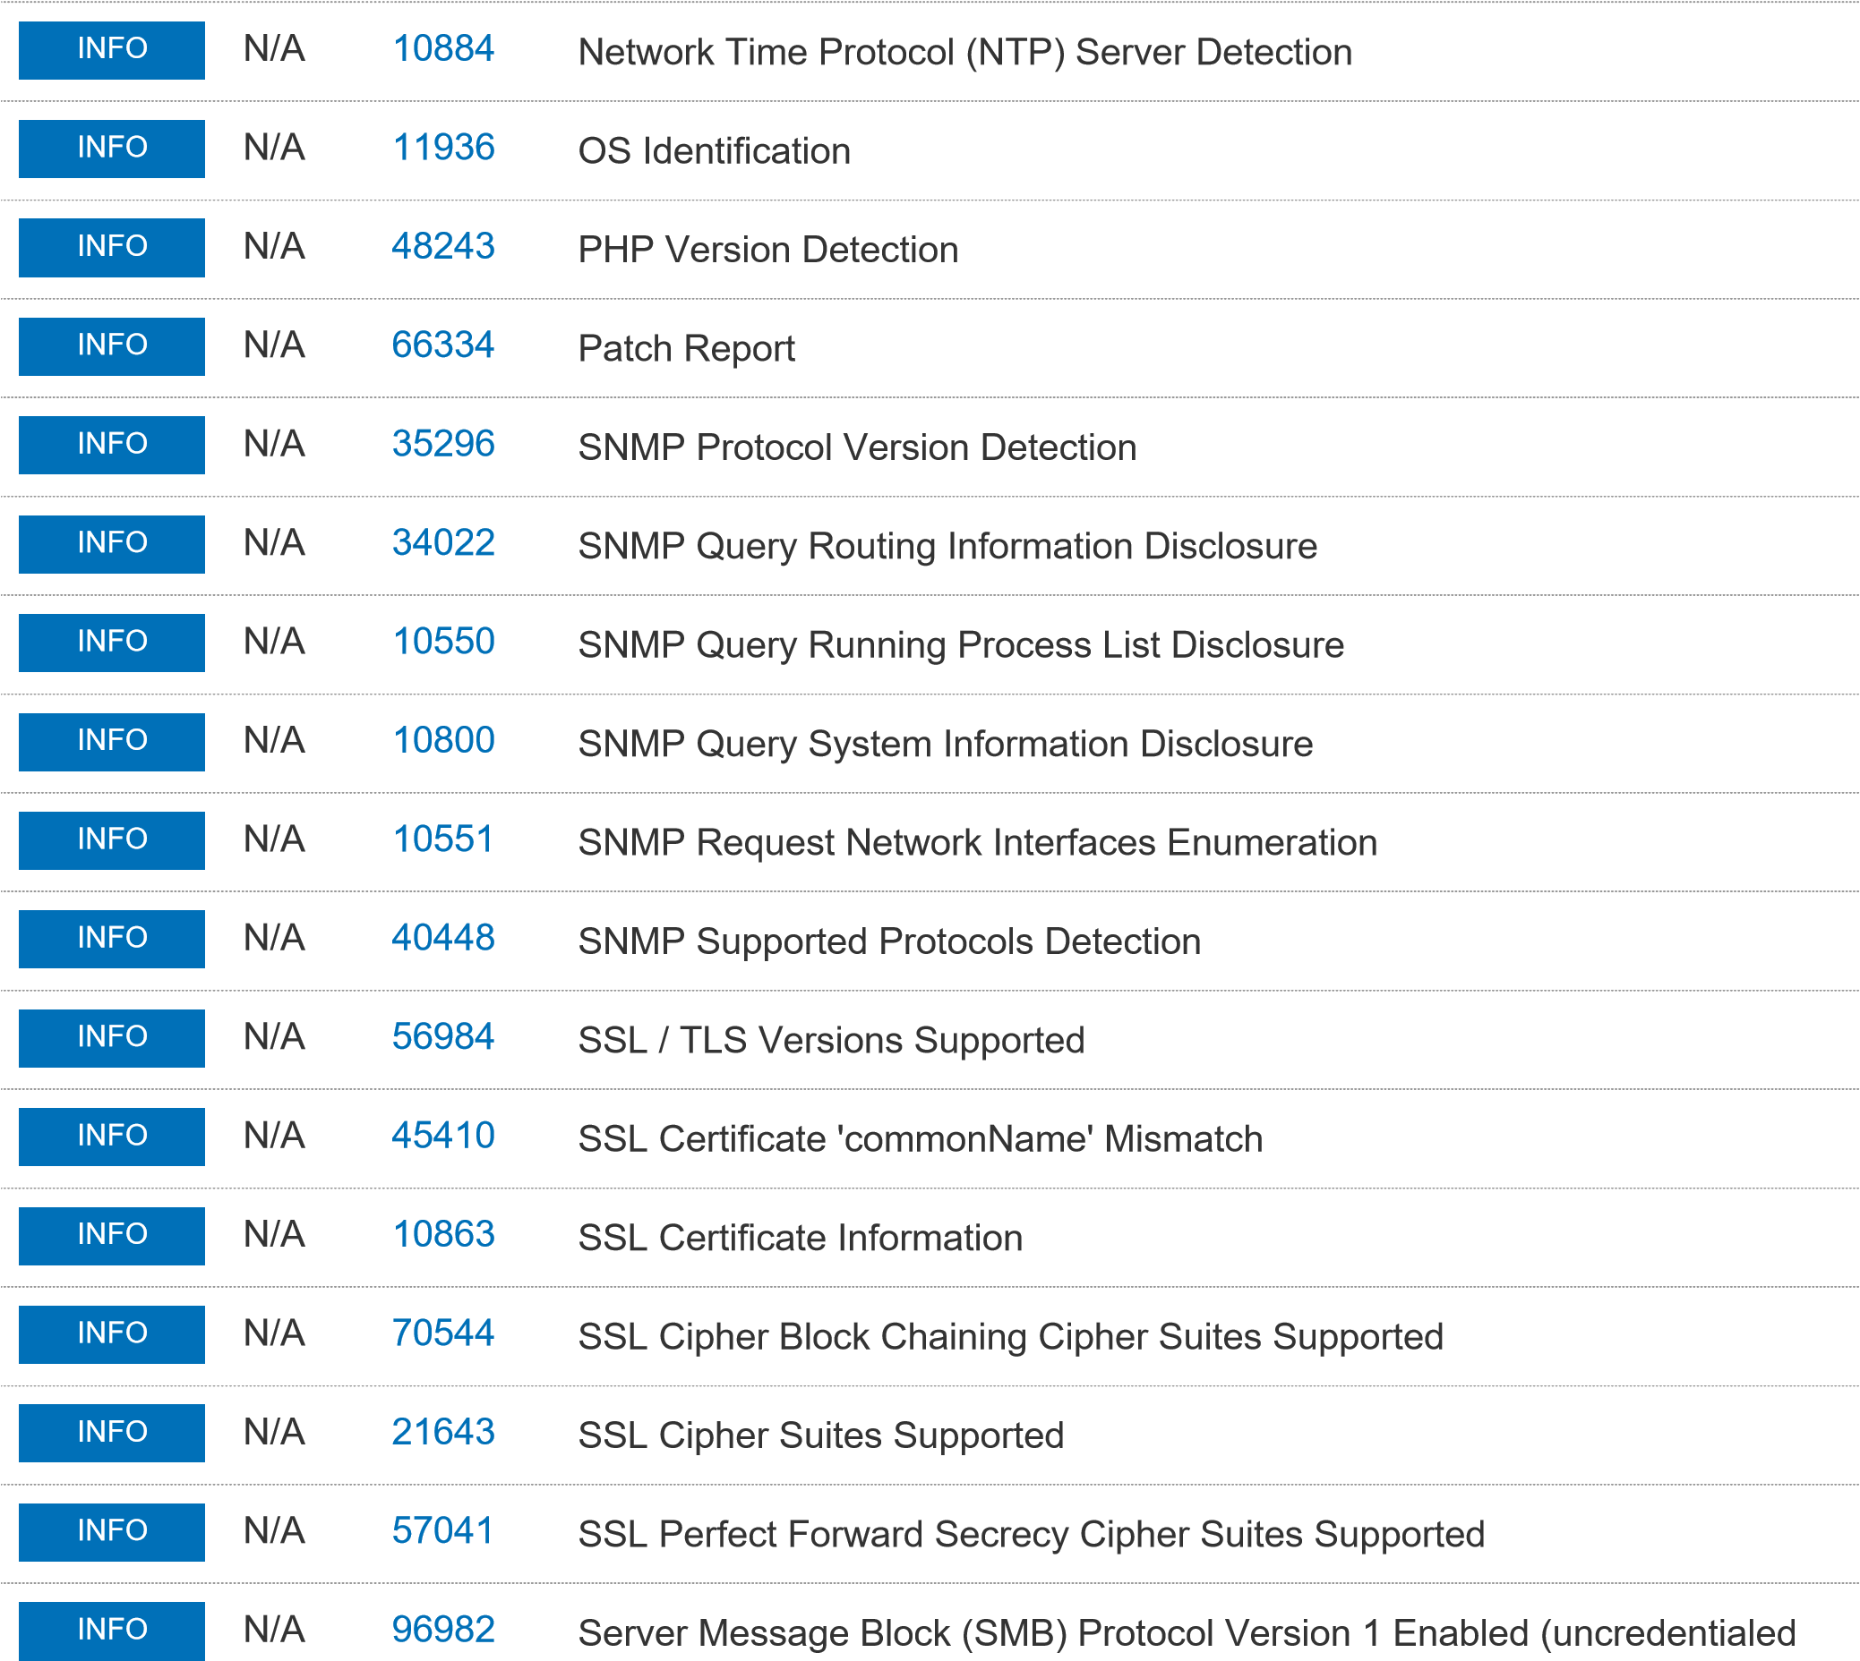
check)
INFO
N/A
2296
4
Service Detection
INFO
N/A
0
2522
TCP/IP Timestamps Supported
INFO
N/A
4
6481
Terminal Services Use SSL/TLS
INFO
N/A
1028
7
Traceroute Information
INFO
N/A
13586
0
WMI Not Available
INFO
N/A
1015
0
Windows NetBIOS / SMB Remote Host Information Disclosure
INFO
N/A
1094
0
Windows Terminal Services Enabled

N/A 26917 Microsoft Windows SMB Registry : Nessus Cannot Access the Windows
INFO

SNMP Agent Default Community Name (Public) - Mitigation strategies
The user should disable the SNMP service on the host if the user is not using it [3]. The second mitigation strategy is to filter the incoming UDP packets going into the port [3], [4]. The third strategy is to change the default community string from “public” for the read-only access and “private” for the read-write access , this strategy still leaves it vulnerable to packet sniffing[3], [4].

Kali

Which link did you use to download the tool?
https://www.tenable.com/products/nessus
This was chosen for the same reasons listed before.
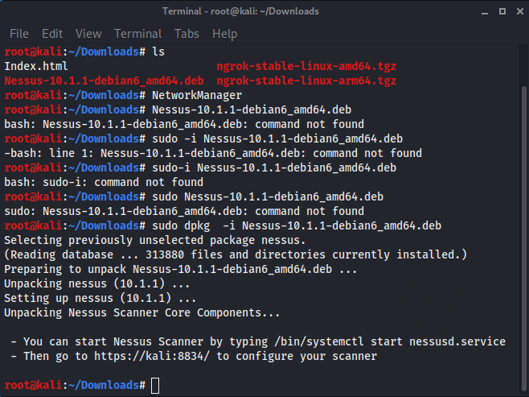

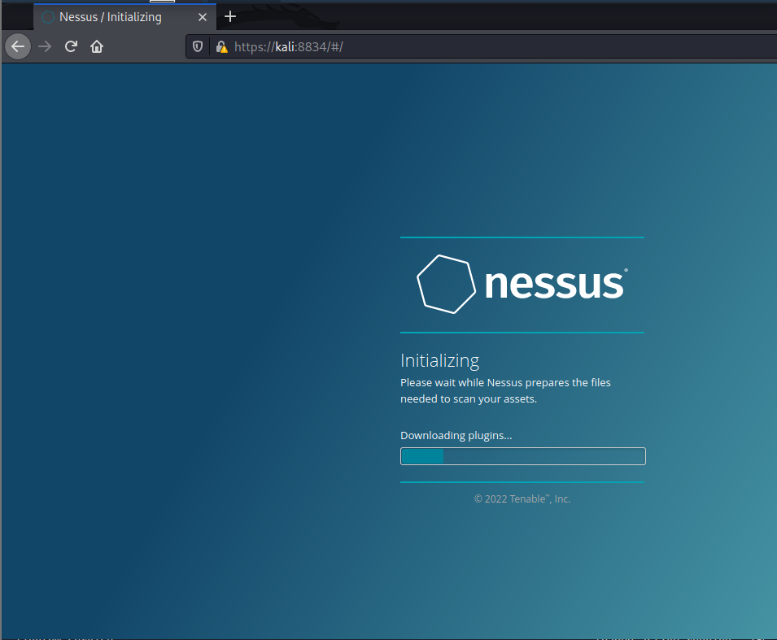
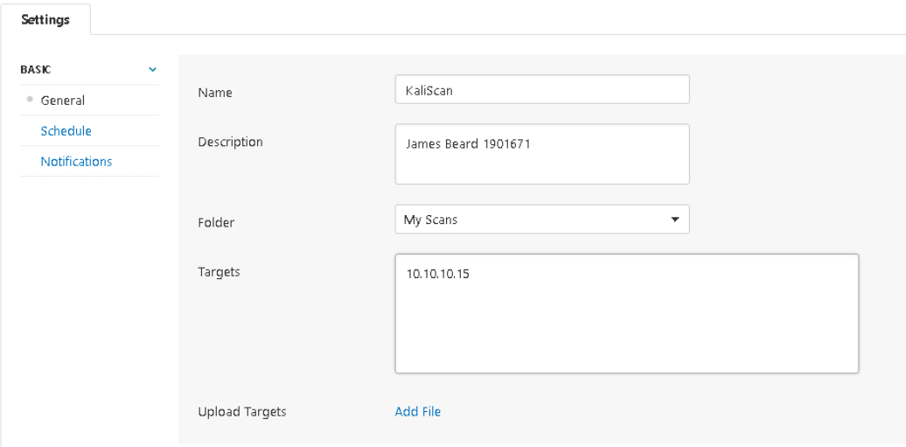

Mitigation Strategy
Possible mitigation strategy is to upgrade to PHP version 7.3.11 or later [5]. Updating the software will patch vulnerabilities that were present in the older version that hacker were taking advantage of.

Activity 3

Which command did you issue to download Nikto?
Sudo apt-get install nikto -y.
Why?
The Sudo apt-get install command is a Linux command that installs the newest version of the desired software from an online software repository that the users sources.list configuration file points the users to [6].
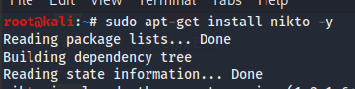

What is the purpose of this tool?
Nikto is an open source vulnerability tool that scans web servers for programs or files that could be potentially dangerous [7]. The tool also checks servers outdated versions of software that could be potentially vulnerable or have security configuration problems [7]. Performs server type specific checks as well as genetics checks. The tool scan for and capture any cookies received [7]. The tool provides SSL support and Proxy support [8].However, the tool is not designed to be stealthy, the scanning test is obvious in log files and to an IDS/IPS [7]. The tool is designed to test web servers in the quickest time possible [7]. Other aspects include Easily update CSV-format checks database, , Available HTTP version automatic switching and reports outputted in plan text of HTML format [8].

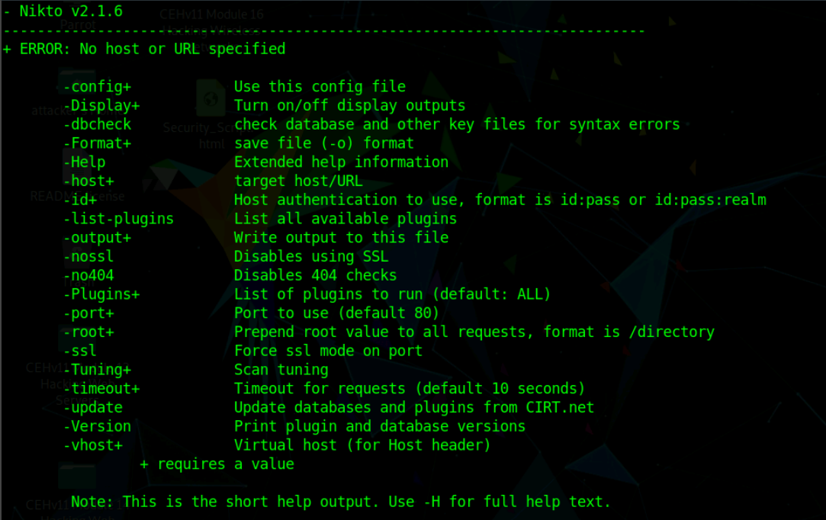

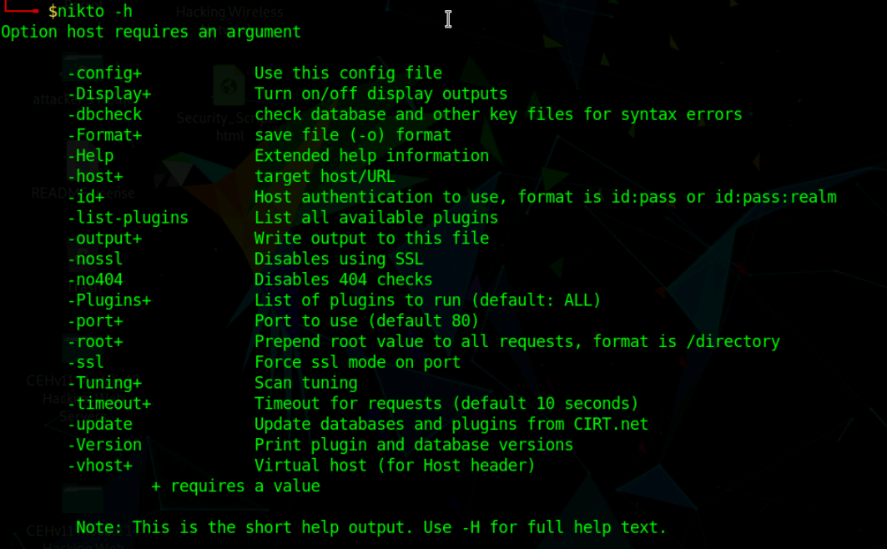

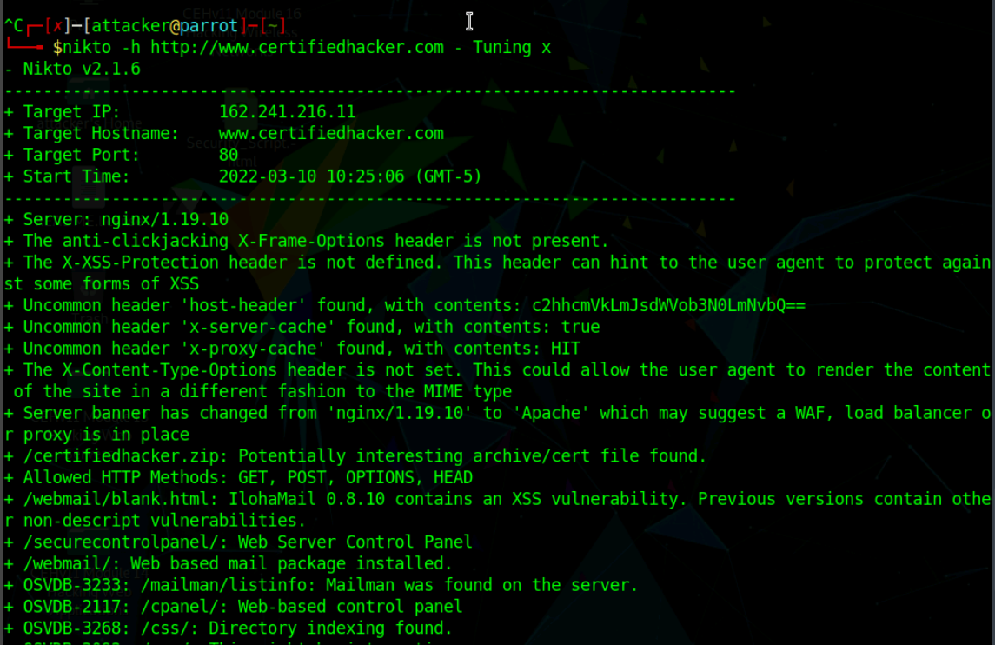
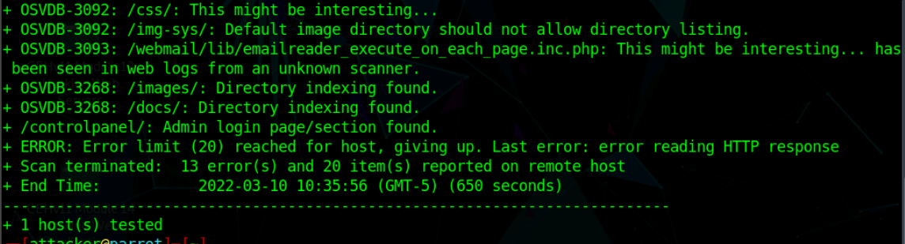

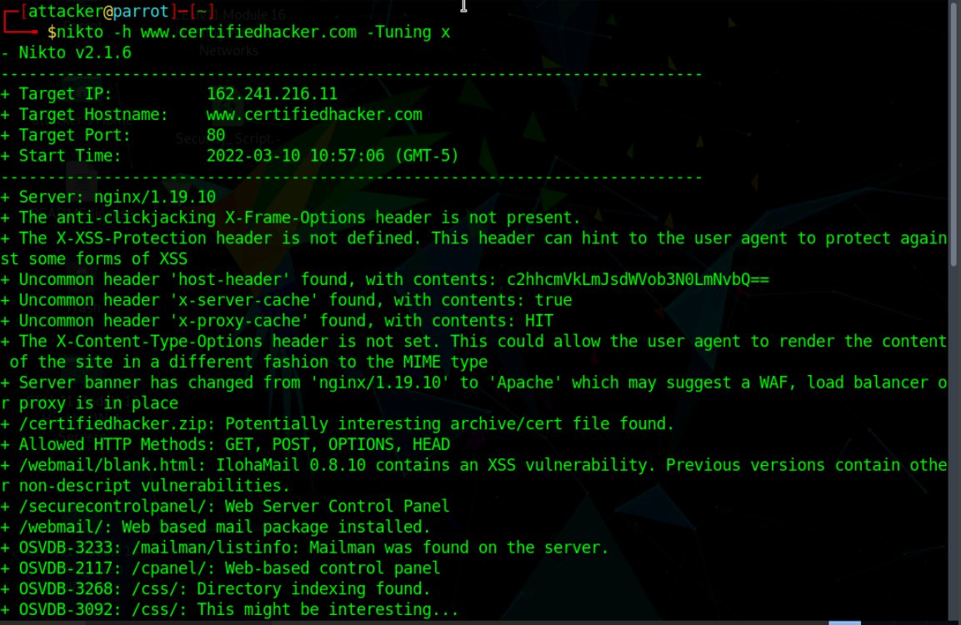
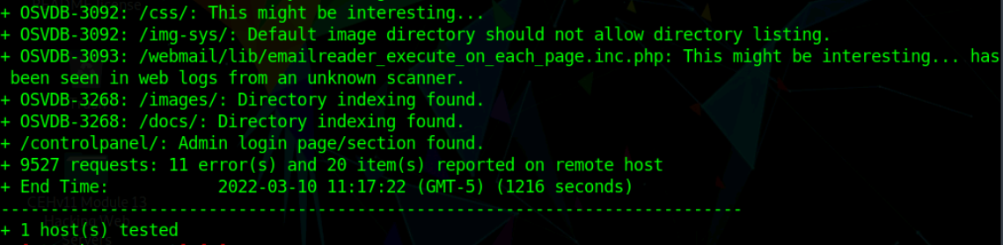

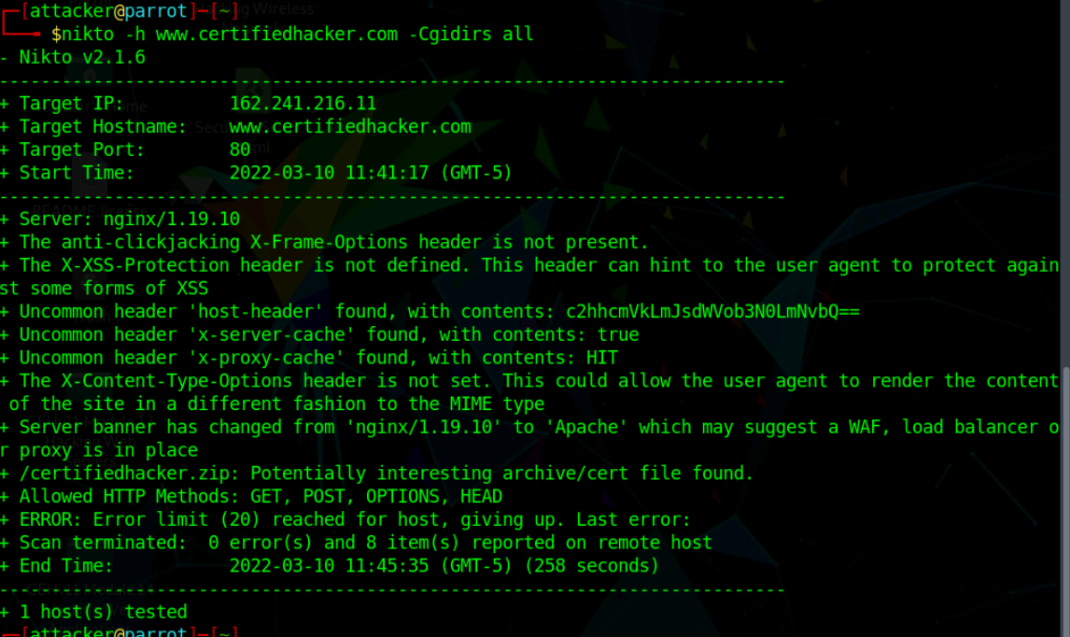
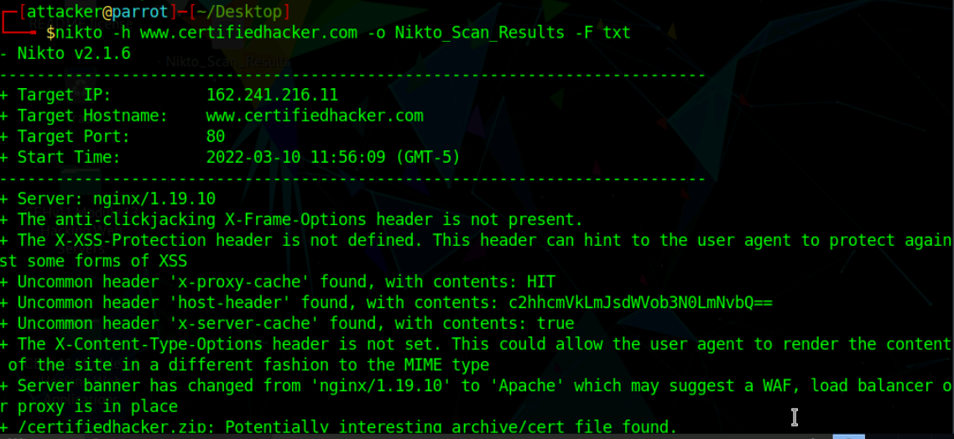
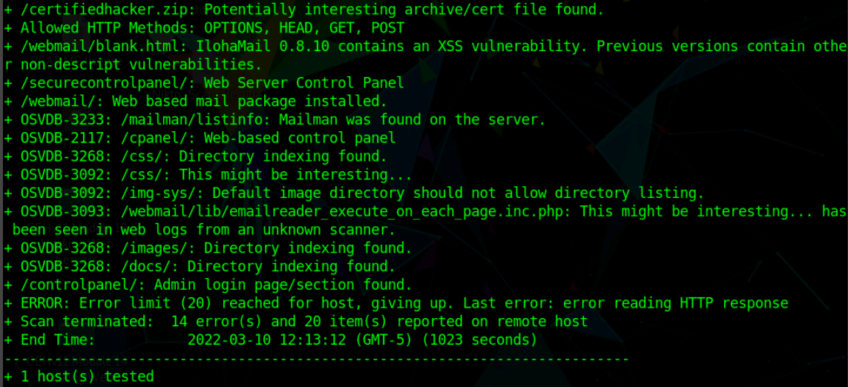

Mitigation Strategy – IlohaMail 0.8.10 XSS vulnerability.
The user should update the version of the software/ application to 0.8.11 as the patch should rectify this vulnerability[9].

Write a report to provide your thoughts and observation on your target’s security posture and exposure?
Certifiedhacker.com web server has several vulnerabilities discovered by Nikto that could be exploited by a criminal or hacker and seems that the target has numerous examples of outdated software that could exploited to gain a backdoor into the system. The scan also outlines the possible ways that the sever can be interacted with such as POST,GET and HEAD. The server uses and or interacts with a variation of Mailman that could be manipulated to exploit the web server. In conclusion there a number of ways that this web server could be exploited with many weaknesses and vulnerabilities that need to be addressed.

References

[1] ‘A brief introduction to the Nessus vulnerability scanner’, Infosec Resources. https://resources.infosecinstitute.com/topic/a-brief-introduction-to-the-nessus-vulnerability-scanner/ (accessed Mar. 17, 2022).
[2] ‘Nessus’. https://www.cs.cmu.edu/~dwendlan/personal/nessus.html (accessed Mar. 17, 2022).
[3] ‘SNMP Agent Default Community Name (public)’. https://www.tenable.com/plugins/nessus/41028 (accessed Mar. 17, 2022).
[4] Guofei Jiang, ‘Multiple Vulnerabilities in SNMP’. Institute for Security Technology Studies (ISTS), Dartmouth College, 2009.
[5] ‘PHP < 7.1.33 / 7.2.x < 7.2.24 / 7.3.x < 7.3.11 Remote Code Execution Vulnerability.’ https://www.tenable.com/plugins/nessus/130276 (accessed Mar. 17, 2022).
[6] A. EI, ‘“sudo apt-get install” Command Explained For Beginners!’, Embedded Inventor, Jan. 06, 2021. https://embeddedinventor.com/sudo-apt-get-install-command-explained-for-beginners/ (accessed Mar. 17, 2022).
[7] M. Bintahin, ‘What is Nikto Tool in Kali and how to use it?’, Cyber-Today.com, Jul. 06, 2021. https://cyber-today.com/what-is-nikto-tool-in-kali-and-how-to-use-it/ (accessed Mar. 17, 2022).
[8] ‘nikto | Kali Linux Tools’, Kali Linux. https://www.kali.org/tools/nikto/ (accessed Mar. 17, 2022).
[9] ‘IlohaMail user Parameter XSS’. https://www.tenable.com/plugins/nessus/14637 (accessed Mar. 17, 2022).

