Student Name: Gabriela Skrzyniarz
Student Number: 2100458
Programme of Study: BA Graphic Design
Module: ADAD5004 Research in Practice
Tutor’s name: Donna Williams

Word count: 2261

Humour, Controversy & Conventions and Nonsense
Level 6 Independent Project Proposal

The purpose of this essay is to explore possible themes to formulate an essay question for my Level 6 Independent Project. By focusing on 3 key words; Humour, Controversy & Conventions and Nonsense, I plan to reference both the work of connecting visual artists such as Marcel Duchamp as well as philosophers such as Plato and Sigmund Freud to gain a better understanding of the significance of my key words both in and outside of the context of graphic design.

Humour
Humour is an integral part of our everyday, nigh inescapable in the age fast paced communication. As put by Gregory (1923) ‘A world without humour would be a world without men and a world without laughter would be a world without children.’ As a species, we crave connection. From our earliest moments, we are programmed to seek attention and acceptance from those around us, from our parents to the communities we surround ourselves with later on in life. As illustrated in Maslow’s hierarchy of needs, when our basic needs are met, we seek out ‘Love and Belonging’ from those around us. Without that sense of connection we cannot thrive, we simply survive. Humour is one of the best ways to achieve the connection we so desperately crave. There is no better way to alleviate the tension of a new environment, ‘break the ice’ so to say, than engaging in humour. It can often dictate the outcome of an interaction, disregarding all other variables. Humour helps us connect with likeminded people, and identify those who we would rather not interact with. When it comes to what amuses us, we are all authorities, experts in the field. (Critchley, 2011) We need not look further than the success of various comedians to observe the power humour holds over us. Many have built entire careers around consistently proving themselves exceptionally amusing.
In trying to understand what it is that we find amusing and why, one should turn to the three basic theories of humour: superiority theory, relief theory and incongruity theory. Superiority theory suggests that we find the misfortune and shortcomings of others to be amusing, tracing back to the philosopher Plato. However it can be disputed with the simple fact that we are able, and in fact often do, laugh at our own mistakes and flaws. Later insights into the theory of humour resulted in the relief and incongruity theories. The Relief Theory is an hydraulic explanation in which laughter does in the nervous system what a pressure-relief valve does in a steam boiler (Morreall, 2012). Often associated with Sigmund Freud, the theory suggests that what we experience as humour is the relief of being able to indulge in things that can sometimes be seen as ‘taboo’. An example would be how we delight in controversies, even though they are not conductive to a harmonious society. Alternatively, the prevalence of shock and dark humour in media could also be explained by this theory. Freud argues that humour is a bout of personal rebellion against the preconceived notions of propriety. The incongruity theory on the other hand suggests that we find inconsistencies in logic amusing. As Diack (2012) wrote, ‘humour is a critical conceptual tool in part because it demands a disarming step away from the ordinary so as to take account of the ordinary in its absurdity, in its strictures, in its illogical suspension of disbelief’. It is perhaps best illustrated in the widespread use of nonsensical images, often far removed from their original context, in media and online culture. Social media platforms are full of repetitive images called ‘memes’, which have become an integral part of modern communication, especially when trying to appeal to younger demographics. There are many other theories that seek to explain why we laugh at certain things, and all of them hold a modicum of truth in them, however there is no one single way to interpret humour and no theory could ever truly encompass its inherent complexity, there will always be something more to add or explore.
In short, we communicate with humour, and thus it is an integral part of design, being prevalent in many parts of the industry. For example, advertisers often deploy humour in an attempt to appeal to potential audiences and foster a sense of community surrounding a product or an idea. A successful application of humour almost demands attention from the viewer, being far more memorable than standard attempts at trying to garner an audience. People are far more likely to spread an advertisement if it contains elements of humour, insuring that it will reach a much wider audience. For example, Pepsi’s 2013 Halloween advertisement, got a lot of attention for light heartedly mocking its biggest rival in the market of soft drinks.
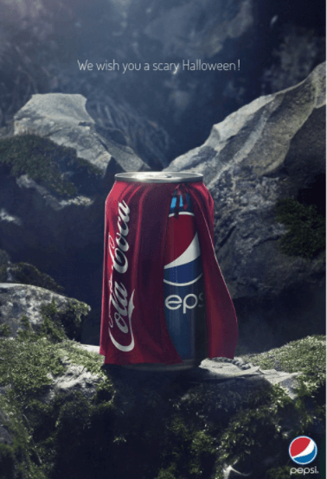

Figure 1: Pepsi advertising campaign, Halloween, 2013
Regardless of personal preferences, the campaign was successful in what it aimed to do, diverting attention to Pepsi. While Coca Cola did not officially retaliate to the campaign, many fans of the beverage produced alternate version of the advertisement, mostly changing the caption to be more in favour of Coca Cola instead. It could be argued that the campaign and any parodies that were created as a result, perfectly performed its function, and brought attention to both companies.
Controversy & Convention
Controversy and convention are two words that perfectly describe the cyclical nature of society. We quickly become bored with could be considered the commonplace, needing intrigue to keep us entertained. What was once radical and faced with controversy will inevitably lose its novelty and either fade into obscurity or be accepted as the new norm. Much like humour, following conventions and indulging in controversy foster a sense of community. For example, trends can create a sense of “tribalism” or a herd, which gives people a sense of unity or harmony with each other (Gomaa, 2021). We are inclined to follow what is conventional because in that way we fit in and are accepted as a part of a group. It is easy to adapt to a common truth and not have to think for yourself. However there will always be outliers - those who seek controversy for the thrill and chance at recognition. After all, everyone loves a scandal, something new and interesting to talk about. A challenge to the established rules everyone is living by is equally thrilling as it is nerve-inducing. Controversy, can be a phenomenal tool to gain the attention of an audience, if used sparingly. The spectacle of a controversy can be linked back to Freud’s relief theory about humour. We follow conventions because that is what is societally deemed appropriate yet happily indulge in observing the scandalous when given the opportunity. Shock value makes events memorable, and in many cases the distinction between fame and infamy is very minor. In the world of art and design any publicity is good. People will always be keen to criticise abstract art, yet fail to realize that in trying to rationalize their distaste and convince others to take the same approach, they inadvertently spread intrigue around the piece. Controversy and conventions can both be tools of media manipulation. By dictating what is to be considered ‘normal’ purposeful controversies have more of an impact.
Famously, the Guerrilla Girls have used controversy to their advantage to call attention to discrimination against women in the world of art. A group of anonymous artists, hiding their identities behind gorilla masks and the names of famous deceased women, they adapted the visual language of advertisements in a way that challenged the conventional with controversy. Perhaps one of their most famous works, depicting a naked woman with the iconic gorilla mask with typography demanding to know whether a woman needs to be naked to get into the Met Museum. Though the piece was a commission by the Public Art Fund, it was ultimately rejected due to ‘a lack of clarity’ (The Met Museum). In an effort for the piece to still reach an audience, it was instead displayed on New York busses, a more unconventional means to reach an audience but nonetheless a very successful one. The efforts of the Guerrilla Girls to fight racial and sexual discrimination are perhaps best described by Mark Brown in his 2016 article: ‘They use rigorous research and humour to expose alarming truths, including the art world’s slow pace of change.’ Their
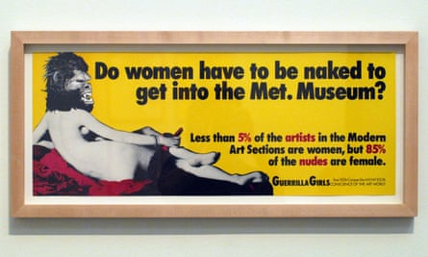

Figure 2: Do Women Have To Be Naked To Get Into the Met. Museum?, The Guerrilla Girls, 1989
In the world of art, anything can be controversial, even if it was not created with the intention to be. There exists a preconceived notion of what art is supposed to look like and upon that ideal being challenged, people have various opinions. The work of Marcel Duchamp, for example, may be controversial to some due to his rejection of the traditional concepts of art. As highlighted in a Manhattan Arts International article, Duchamp ‘rejected the art produced by Henri Matisse and other fellow artists claiming it was “retinal” art, created with the purpose of pleasing the eye.’ He was far more concerned with the concept of the piece than he was with its aesthetics. His concept of the ’ready-made’ was deemed anti-art, controversial in its simplicity, akin more to vandalism than to the works of famous artists before him. A perfect example of this being his piece L.H.O.O.Q. A postcard replica of Leonardo DaVinci’s Mona Lisa with a doodled moustache and a caption that, when read out loud in French, sounded like a crude pun: “Elle a chaud au cul”, translating to “She is hot in the arse”. The most famous scandal connected to Duchamp’s body of work, however, is decidedly the ready-made piece ‘The Fountain’ an upturned urinal with the initials R. Mutt hastily written on the bottom of the piece. In the words of Grovier (2017) the piece showed Duchamp’s ‘inclination towards cerebral playfulness’. In presenting the piece to the Society of Independent Artists Duchamp did so with the knowledge it would leave his fellow members ‘scrambling for their next move.’ (Grovier, 2017)

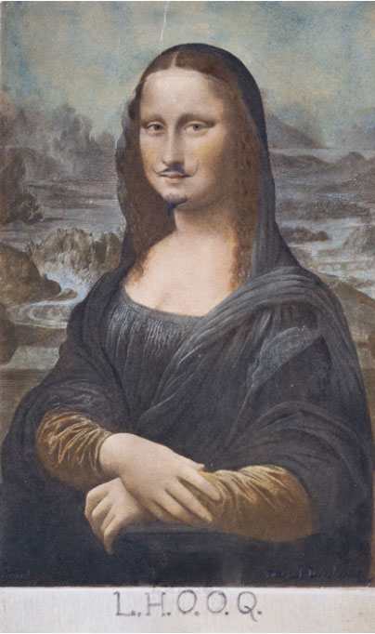

Figure 3: L.H.O.O.Q Marcel Duchamp, 1919
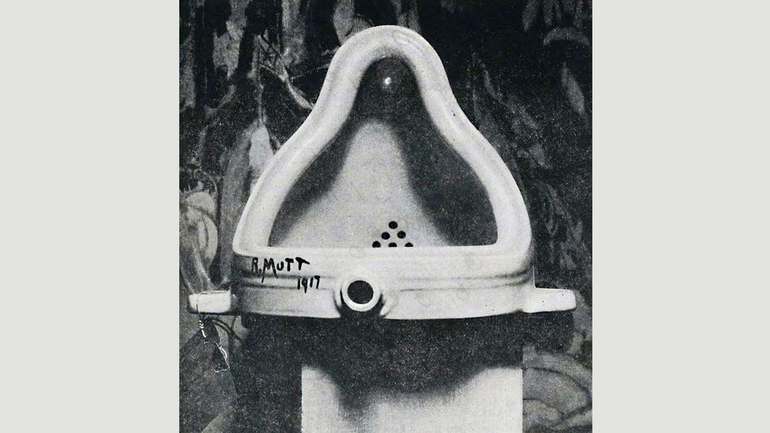
Figure 4: Fountain, Marcel Duchamp, April 1917
Nonsense
I wanted to explore the theme of nonsense because I feel it can seamlessly connect to both humour and controversy and conventions in the way it challenges both while also providing the foundation for a unique final project. The Merriam-Webster dictionary defines nonsense as ‘words or language having no meaning or conveying no intelligible ideas’ (Merriam-Webster. (n.d.). Nonsense. Massey (2018) argues that while nonsense may be the “archenemy of reason,” it is also tied to the intrinsic nature of reason; the two, simply put, cannot exist without each other. If reason exists, so does nonsense, if simply because nonsense is the lack of reason. Even though it has no inherent meaning of its own, we are still drawn to nonsense, amused by the perplexity hidden in plain sight amidst supposed simplicity. Perplexity of our own creation. Art is what we and the artist interpret it to be. The same way Duchamp’s upturned urinal is a work of art because he elevated it to such a level in its creation, pure nonsense can be elevated to a status designating it more than meaningless abstraction. Lewis Carroll’s ‘Alice in Wonderland’ is full of fantastical nonsense that does not need any explanation. It goes beyond the standard fantasy nonsense we’re all accustomed to, going out of it's way to pull the reader out of reality and into the strange world of Wonderland. The exchange between the mad hatter and Alice perfectly exemplifies the theme of nonsense prevalent throughout the book
“Mad Hatter: “Why is a raven like a writing-desk?”
“Have you guessed the riddle yet?” the Hatter said, turning to Alice again.
“No, I give it up,” Alice replied: “What’s the answer?”
“I haven’t the slightest idea,” said the Hatter” (Carroll, 1893)

Visual nonsense is equally as thought-provoking as its literary counterpart. Works of artists such as Nina Bachman or Johanna Walderdorff are delightfully straightforward yet captivating in their absurdity. When looking at their pieces, the viewer would be too preoccupied trying to ascertain what is happening to trouble themselves with trying to interpret the meaning behind them. In an extremely fast paced world, it is my opinion that absurdity and nonsense is needed to force people to slow down. Additionally, it is extremely memorable, standing out amidst the neatly arranged complexities of our society. Nonsense is not trying to be anything else than what it truly is. A colourful disruption in the everyday.
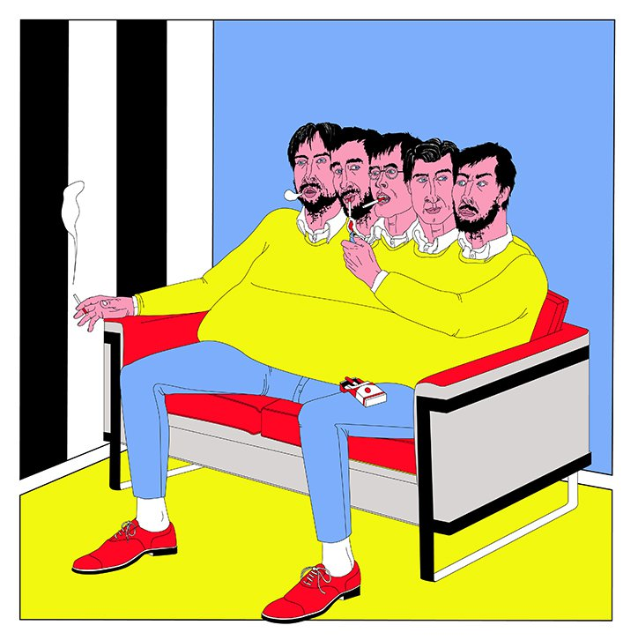

Figure 5: Johana Walderdoff illustration
Exploring the themes of my three key words led me to several potential questions and themes I could further develop on in my Year 3 of my degree. A connection can be drawn between all three words as they relate to how we perceive and can be influenced by media. As a starting point for the essay question to be answered in the independent project and the practice-based project I plan to work from ‘How does the portrayal of humour and nonsense, specifically through the prism of graphic design, challenge the conventions of modern media’. The broad themes allow for exploration of alternative questions within the scope of the main one. For example: ‘Exploration of controversial humour’, ‘The normalisation of controversy in our society and its effect our perception of conventions’,‘Exploring the grey area between nonsense and humour and where we draw the line between the two’, as well as ‘Exploring the controversy of including abstraction and nonsense in the defining of art’.
Bibliography
Artincontext (2022) “Fountain” by Marcel Duchamp – Duchamp’s Controversial Urinal Art Available at: https://artincontext.org/fountain-by-marcel-duchamp/ (Accessed 26/04/2023)
Carroll, L (1893) Alice's Adventures in Wonderland, New York, Boston, T. Y. Crowell & co
Critchley, S. (2011). On Humour. United Kingdom: Taylor & Francis.
Diack, H. (2012). The Gravity of Levity: Humour as Conceptual Critique. RACAR: Revue d’art Canadienne / Canadian Art Review, 37(1), 75–86. Available at: http://www.jstor.org/stable/42630859 (Accessed 26/04/2023)
Gomaa, B. (2021) “The psychology behind trends,” NU SCI MAGAZINE Northeastern University's Student-Run Science Magazine., 8 December. Available at: https://nuscimagazine.com/the-psychology-behind-trends (Accessed: 26/04/2023).
Gregory, J. C. (1923). Some Theories of Laughter. Mind, 32(127), 328–344. Available at: http://www.jstor.org/stable/2249238 (Accessed 26/04/2023)

Grovier, K (2017) The Urinal that changed how we think’ BBC Culture, available at: https://www.bbc.com/culture/article/20170410-the-urinal-that-changed-how-we-think (Accessed 26/04/2023)
Lintott, S. Superiority in Humor Theory, The Journal of Aesthetics and Art Criticism, Volume 74, Issue 4, October 2016, Pages 347–358, Available at: https://doi.org/10.1111/jaac.12321 (Accessed 26/04/2023)
Massey, I. (2018) Necessary Nonsense - Aesthetics, History, Neurology, Psychology, Ohio State University Press

Manhattan Arts International, Marcel Duchamp Stirred Controversy and Influence Available at:https://manhattanarts.com/marcel-duchamp-stirred-controversy-and-influence/ (Accessed 26/04/2023)
McGraw , P. (2011) The importance of humor research, Psychology Today. Sussex Publishers. Available at: https://www.psychologytoday.com/intl/blog/the-humor-code/201109/the-importance-humor-research (Accessed: 26/04/2023).
Merriam-Webster. (n.d.). Nonsense. In Merriam-Webster.com dictionary. Available at: https://www.merriam-webster.com/dictionary/nonsense (Accessed: 26/04/2023).
Morreall, J, "Philosophy of Humor", The Stanford Encyclopedia of Philosophy (Summer 2023 Edition)[First published Tue Nov 20, 2012] , Edward N. Zalta & Uri Nodelman (eds.), Available at: https://plato.stanford.edu/archives/sum2023/entries/humor (Accessed 26/04/2023)
List of Figures:
Figure 1: Pepsi, Halloween, Buzz in a Box, Brussels, Belgium (2013) Available at: https://www.adsoftheworld.com/campaigns/halloween-1206b9d1-09cd-4a59-887d-ed71e5fed4ca (Accessed 26/04/2023)
Figure 2: The Guerrilla Girls Do Women Have To Be Naked To Get Into the Met. Museum?, (1989) Available at: https://www.theguardian.com/artanddesign/2016/jul/19/guerilla-girls-feminist-art-activists-first-uk-show-whitechapel (Accessed 26/04/2023)
Figure 3: Marcel Duchamp, L.H.O.O.Q (1919) Available at: https://manhattanarts.com/marcel-duchamp-stirred-controversy-and-influence/ (Accessed 26/04/2023)
Figure 4: Marcel Duchamp, Fountain, April (1917) Available at: https://www.bbc.com/culture/article/20170410-the-urinal-that-changed-how-we-think (Accessed 26/04/2023)
Figure 5: Johana Walderdoff Available at: https://www.google.com/search?q=johanna+walderdorff+nonsense+art&sxsrf=APwXEdcGrXvrF0X4_sFLprrG3DjYCK5t4A:1682542467190&source=lnms&tbm=isch&sa=X&ved=2ahUKEwjt0s2Qt8j-AhUTVaQEHWJPCPM4ChD8BSgBegQIARAD&biw=1422&bih=677&dpr=1.35 (Accessed 26/04/2023)

