

Module: Management Accounting for Managers
Module code: LCBB5010
Assignment Title: Component 1: Coursework: Individual Report

Student Name: Nicoleta Carp
Student ID: 2125547

Date of Submission: 28.03.2026
Word Count: 2,150

Table of Contents
1. Introduction 2
2. Cost Analysis and Business Model 3
Revenue model of Tesla 3
Key cost structures of Tesla 4
3. Budgeting and Financial Planning 4
Role of budgeting in the company’s operations 4
Reviewing operating expenses in the current year-on-year changes 5
4. Performance Measurement and Decision-Making 6
Strategic decisions made by Tesla based on financial and non-financial data 8
5. Sustainability and Ethical Considerations 8
Ways applied by Tesla for integrating sustainability into its financial decision-making 8
Ethical considerations in cost management and pricing strategies 9
6. Conclusion and Recommendations 9
References 11

1. Introduction
Tesla Incorporated (Inc.) is a well-known American multinational automobile and clean energy company, founded in the United States in 2003 (Zhu, 2022). Key products of Tesla are focused on solar products and electric vehicles, including the high-volume Model Y, Model X, and Model S, through which it has become eligible to expand its market size and retain global customers (Ezugwu et al., 2025).
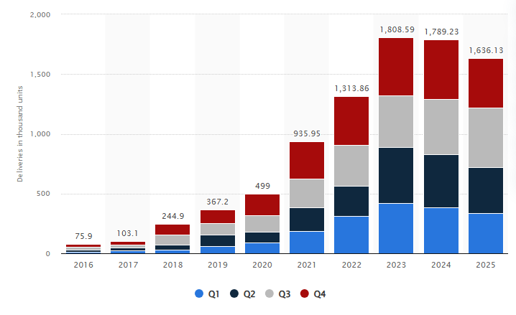
Figure 1: Number of Tesla vehicles delivered worldwide over the years
(Source: Statista Research Department, 2026)
As shown in Figure 1, Tesla sold approximately 1,636,130 vehicles worldwide, which increased its market capitalisation to around US$798.1 billion in the last year (2025) (Statista Research Department, 2026). Rapid accelerations of the electric vehicle trends enable it to improve its market size and capitalisation, for which it is ranked among the world’s best-selling automobile brands.
As a modern business, Tesla group prioritise management accounting to lead strategic decisions, cost control, investments and pricing through following data-driven insights and marketing forecasting, which is crucial for optimising resource allocations and enhancing operational efficiency. Sonjaya et al. (2025) reviewed that management accounting allows for making decisions depending on the internal financial reports, cost structure and departmental performances, which ensures meeting goals and accountability. This report outlines the present business model, financial planning, performance nature of Tesla and its sustainable decision-making. It allows for understanding how these factors impact strategic management accounting decisions of Tesla, and such recommendations are drawn at the end of this report.

2. Cost Analysis and Business Model

Revenue model of Tesla
The revenue model of Tesla majorly relies on large-volume sales of its electric vehicles (EVs) via a direct-to-consumer (D2C) model and traditional dealership. As per Carlier (2025), the Tesla group became eligible to improve its revenue from US$72.5 billion (2024) to US$94.8 billion (2025) through optimising the delivery of EVs (1,636.13 K) and supercharging stations. By expanding the EV charging facilities, Tesla inspires customers to shift to sustainable automobile solutions, which positively impacts its revenue conditions.
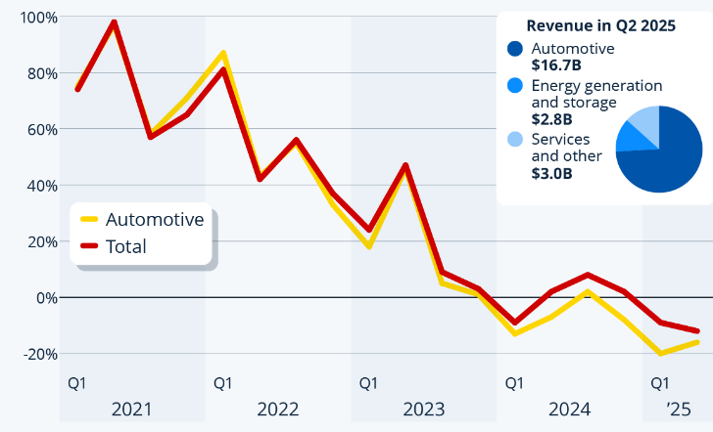
Figure 2: Year-over-year growth of Tesla in the first quarter of each year
(Source: Richter, 2025)
In contrast, Richter (2025) argued that Tesla's quarterly earnings seemed to have decreased by 12% over the period, and the operating profits of $923 million had fallen by 25%, as the intense competitive pressures of other automakers negatively impacted its sales performances (Figure 2). Compared with the review of Carlier (2025), which analysed whether the high-volume sales and charging station networks of Tesla are viable for revenue growth, the high competitiveness of the automobiles seems less approachable for growing the profitability range.
However, Leong (2024) revealed that Tesla group set a comprehensive vertical integration framework across its transportation and energy ecosystem through launching Tesla's Megapack and Powerwall, which store energy for solar panels, wind and other renewable energy sources, which is feasible for generating 7% of its revenue. Due to the peak electricity demands across the transportation services and households, this business initiates solar panel installation services that seem economically viable for revenue generation.

Key cost structures of Tesla
Fixed costs of Tesla Inc. primarily relied on R&D (Research and Development), technological development, Gigafactories and salaries of the workers, which are fixed over the years. Tesla (2026) showcased that the operating expenses for R&D of Tesla were around $3,264 million out of total expenses ($7,778 million) in 2025. As the research and development on the gigafactories and EV battery technologies are crucial for growing production lines of the EV, it is considered the most valuable fixed cost and the Tesla group leads high investment regarding this operation.
On the other hand, variable costs of Tesla lie in sourcing raw materials, direct labour and automobile manufacturing, which have direct impacts on the substantial gross profit margins. Lu and Zhu (2024) argued that raw materials are the most significant expenses for battery production and electric vehicle manufacturing for Tesla, as the sourcing of Lithium hydroxide and lithium carbonate accounts for more than 50% of its variable costs. Compared with the fixed cost nature of Tesla, high variability in lithium sourcing and manufacturing seems quite critical for Tesla to stabilise its profitability rate and product costs, whereas the fixed costs are suitable for managing expenditure and gross profits.

3. Budgeting and Financial Planning

Role of budgeting in the company’s operations
Budgeting is important for financial planning, creating roadmaps for investing in resourcing, managing business performances, achieving strategic objectives and solving corresponding tasks (Lumanauw and Lolowang, 2024). Along with budgeting protocols, the financial management of Tesla set up a framework for investment planning through monitoring actual results against planned targets and facilitating accountability, which is an integral part of strategy formulation. In contrast, AYOADE (2025) revealed that improper projections of the financial investments, irrelevant information and high fluctuations of market trends become critical for Tesla management to manage the budgetary targets for managing EV networking and technological infrastructure setup. Low accuracy and poor detections of the updated information are responsible for causing wrong budget formations, for which proper budgeting is significant to control operating expenses over a period.

Reviewing operating expenses in the current year-on-year changes
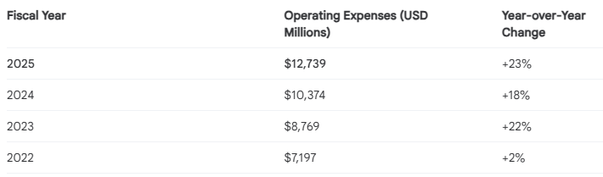
Figure 3: Operating expenses and year-on-year change in Tesla
(Source: Google Finance, 2026a)
Based on the Google Finance review (Figure 3), the operating expenses of Tesla were around USD$12,739 million in 2025, which is estimated to be higher than previous years (USD$10,374 million in 2024) (Google Finance, 2026a). Year-on-year changes are found 23% and increased over the period, due to strong demand for Tesla's EV, R&D expansions and high earning power. As per Yahoo Finance (2025), the Tesla group expected the possibilities for growing the capital expenditure by around $11 billion in 2026, as this electric automaker invests in developing new automobile factories and AI (Artificial Intelligence) infrastructures. For this reason, the operating expenses seem higher in recent fiscal years, which seems positive and ideal for expanding its automobile service networks.
Decisions made by Tesla management (Internal) to influence the changes in operational expenses
In collaboration with Elon Musk (Tesla founder), the Tesla group makes decisions for streamlining management through global layoffs across the R & D department. In April 2024, the Tesla group announced a global layoff of over 10% (equivalent to around 14,000 employees) to address duplication of roles issues, manage expenses and build an innovative structure (Liu and Zou, 2025). As the forecasting of operational expenses seems to have accelerated over recent periods, it becomes critical for the Tesla management group to gain profitability and manage financing, for which they showcase interest in cutting investments in direct labour and employees.

4. Performance Measurement and Decision-Making
The KPI nature of Tesla
Operating margin
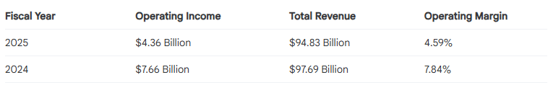
Figure 4: Operating margin of Tesla
(Source: Google Finance, 2026b)
As per Google Finance (2026b), the operating margin rate of Tesla was approximately 4.59% in 2025, which was lower than the previous year (7.84% in 2024, Figure 4). The reason behind the rapid decline of the operating margin is poor operating income level ($4.36 billion in 2025), as Tesla struggles to boost EV demands across the international market due to intense competition from local automobile brands.
Cash flow
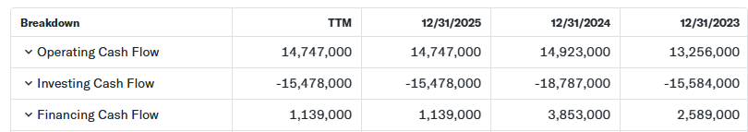
Figure 5: Cash flow nature of Tesla
(Source: Yahoo Finance, 2026b)
Based on Figure 5, the financing cash flow of Tesla is around $1,139,000 in 2025, which is lower than in 2024 ($3,853,000) (Yahoo Finance, 2026b). The low cash flow of Tesla is examined due to high capital expenditures, rising competition, and inventory buildups, which reduce profitability in automobile operations.
Liquidity Ratio
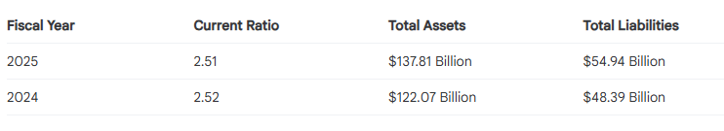
Figure 6: Liquidity Ratio of Tesla
(Source: Google Finance, 2026c)
In the fiscal year of 2024-2025, the liquidity ratio of Tesla is approximately 2.51, which indicates stable liquidity in the automobile market (Google Finance (2026c), Figure 6). Due to the growth of total assets ($137.81 billion) and liabilities ($54.98 billion), Tesla became eligible for maintaining strong liquidity positions and creating healthy financial benchmarks over its short-term assets.
Average Selling Prices
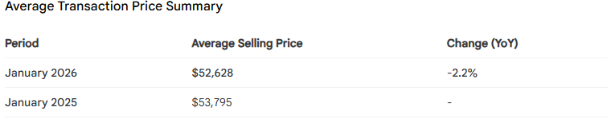
Figure 7: Average Selling Price forecasting of Tesla
(Source: Google Finance, 2026d)
Based on the average transaction price summary (Figure 7), the average selling price of Tesla is around $52,628 (2026), which seems 2.2% lower than the previous year ($53,795 in 2025) (Google Finance, 2026d). As Tesla experiences the intense competition level for selling EVs and a high level of customer bargaining, Tesla groups become concerned about lowering selling prices for customers.
Supercharge network expansions
As per Tesla's annual report, the Tesla group expanded approximately 6,975 supercharger stations across the US and international markets, and the year-on-year rate is around 17% (Tesla, 2025). Through expanding the growth of supercharging stations, this international business became eligible for connecting around 65,495 individual connectors, which seems approachable for expanding the EV sales over periods (Tesla, 2025).

Strategic decisions made by Tesla based on financial and non-financial data
Cost-cutting and product pricing: Through experiencing declines in operating profits and cash flow range, the Tesla group made decisions to downgrade hardware usage in manufacturing EV models, which allows for cutting costs of manufacturing and sourcing equipment. Sweney (2025) reviewed that the Tesla group launched a cheaper version of the Model 3 car in the European market to revive sales due to backlash against Elon Musk's job with Donald Trump. As the political backlash weakened the demand for Tesla EVs, Tesla prioritised cheaper hardware versions for Model 3, which is currently selling at a range of £33,166 across the European zones (Sweney, 2025). Although the strategic decisions of launching lower-priced models are found ideal for regaining selling ranges, it is limited to maintaining premium and superior quality product ranges.
Expansion of the ‘Tesla Semi’ services: In regard to recovering the operating income range, the Tesla group take initiatives to introduce 'Tesla Semi', the electrified trucks, which are used for transforming long-haul freight via battery efficiency and aerodynamics. Mohammed and Villegas (2023) found that the Tesla Semi needs one megawatt-hour of electricity for charging fully to reach an average distance (50,000 kilometres per year), which is beneficial for individuals to manage electric truck fleets by using one-third of the electricity consumption. However, Pradhan et al. (2023) argued that the battery voltages increase due to sudden fluctuations of the surrounding temperature and changes in DC fast charging connector types in Tesla Semi, which seems to be the major challenge. Although the thermal limitations become critical for ensuring long-term journey and longevity of this vehicle, this initiative creates scope for expanding Tesla operations across logistics and freight services.

5. Sustainability and Ethical Considerations

Ways applied by Tesla for integrating sustainability into its financial decision-making
Tesla group integrates sustainability practices with its financial decision-making through promoting closed-loop recycling and investments in clean energy technologies. As the EV production requires a large number of lithium-ion battery packs and critical cathode materials, including Cobalt and Nickel, the Tesla group prioritise closed-loop recycling practices to synthesise these raw materials and reduce waste formation level (Islam and Iyer-Raniga, 2022). Although this practice is limited to the availability of refurbished vehicle equipment and batteries, the sourcing of recycled components creates scope for Tesla to reduce investments in raw materials.
Moreover, Bhardwaj et al. (2025) argued that the R&D group of Tesla prioritises the application of Tesla disc turbine technology for rising power generation by around 30% for continuing car manufacturing operations, which is advantageous for lower maintenance requirements and reducing manufacturing costs. Though this clean energy technology has the possibility of systematic glitches like conventional turbines, it is feasible for Tesla to reduce emissions and control the costs of daily operations.

Ethical considerations in cost management and pricing strategies
In the case of cost management, Johansson and Owen (2025) reviewed that the Tesla group integrated an AI-driven predictive maintenance system across its manufacturing plants, which are upgraded to get robust data collections on product manufacturing level, market databases and navigating complexities in the internal operations ethically. It allows the financial management group to track and maintain cost levels through focusing on data-driven results, which is quite feasible for maintaining ethics and relevancy for planning investments.
On the other hand, AlZohbi and Alradhi (2026) argued that most customers experience issues of high purchase prices and high maintenance costs for operating Tesla EVs, which are the major ethical issues regarding Tesla operations. Compared with cost management cases, while the data-driven oriented financial decision-making seems approachable for controlling investment levels, the price gouging issues of Tesla seem to be the major threats to maintaining a proper relationship with the customers.

6. Conclusion and Recommendations
Based on the brief discussions on management accounting, it can be interpreted that the data-driven financial monitoring, interventions of clean energy technologies and cost-cutting initiatives are significant for Tesla to secure proper investments and improve operational profit margin in future. However, the intense competitive pressures, ethical issues and high variable cost ranges are found as major drawbacks for Tesla to manage profitability and revenue growth in future. For this reason, the Tesla group should be concerned with implementing the investment plans and strategic initiatives based on management accounting principles.
Recommendations
Adopting activity-based costing: From the case example of Toyota, Oybekovna (2025) revealed that this automobile sector adopts activity-based costing through focusing on how specific activities and resources drive indirect costs, which allows them to control expenses. Similarly, the Tesla group should be concerned with increasing activity-based costing to control investments through accurately allocating costs to specific R&D and automobile production rather than a broader view. It will be beneficial for controlling the operational expenses level and variable cost range in future.
Value-based pricing for cash-flow optimisations: For example, BMW adopted the value-based pricing to become a key player in the EV market to strengthen its profitability and customers' retention rate (Pettersson et al. 2025). Through using databases on customer usage level and capabilities of premium self-driving features in automobiles, Tesla should be responsible for managing value-based pricing rather than price gouging to maximise margins.

References
AlZohbi, G. and Alradhi, N. (2026) ‘AI in the Adoption of Electric Vehicles: Advantages, Challenges and Future Outlook: A Review’, Science, 17, p. 100260.
AYOADE, O. (2025) ‘Bridging Risk Management and Financial Forecasting for Project Management: An Analysis of Current Practices, Challenges, and Emerging Technologies’, IRE Journals ISSN: 2456-8880. 8(7), pp. 34-49.
Bhardwaj, M., Nain, S. and Dhull, U. (2025) ‘An Exhaustive Review of Research and Development of Tesla Turbine Technology’, Arabian Journal for Science and Engineering, 50(17), pp. 13549-13580.
Carlier, M (2025) Tesla - statistics & facts. Tesla Operating Expenses 2012-2025 | TSLA. Available at: https://www.statista.com/topics/2086/tesla/?srsltid=AfmBOoorXS5v54yoYpCu_XLSPRqj1Z3PxUdnuBdhktKA6NyKxUiZbBuW#statisticChapter (Accessed on: 24th March 2026)
Ezugwu, E.O., Bhattacharya, I., Ayomide, A.I., Antony Dhason, M.V., Soyoye, B.D. and Banik, T. (2025) ‘Powertrain in battery electric vehicles (BEVs): Comprehensive review of current technologies and future trends among automakers’, World Electric Vehicle Journal, 16(10), p. 573.
Google Finance (2026a) Operating expenses of Tesla in 2026. Available at: https://www.google.com/finance/beta/quote/TSLA:NASDAQ?hl=en#research (Accessed on: 24th March 2026)
Google finance (2026b) Analysis of Tesla's Operating Margin. Available at: https://www.google.com/finance/beta?hl=en#research (Accessed on: 24th March 2026)
Google finance (2026c) Tesla Liquidity Ratios (2024–2025). Available at: https://www.google.com/finance/beta?hl=en#research (Accessed on: 24th March 2026)
Google Finance (2026d) Tesla Average Selling Price (ASP) Trends (2025–2026). Available at: https://www.google.com/finance/beta?hl=en#research (Accessed on: 24th March 2026)
Islam, M.T. and Iyer-Raniga, U. (2022) ‘Lithium-ion battery recycling in the circular economy: a review’, Recycling, 7(3), p. 33.
Johansson, G. and Owen, O. (2025) ‘Exploring the Impact of AI on Sustainable Practices in Electric Vehicle Manufacturing’, Available at SSRN 5232268.
Leong, J.Y. (2024) ‘Review on Circularity in the Electric Vehicle (EV) Industry’, World Electric Vehicle Journal, 15(9), p. 426.
Liu, J. and Zou, Z. (2025) ‘A Case Analysis on Tesla's 2024 Global Layoff’, Highlights in Business, Economics and Management. 50 (1), pp. 154-163.
Lu, Y. and Zhu, T. (2024) ‘Status and prospects of lithium iron phosphate manufacturing in the lithium battery industry’, MRS communications, 14(5), pp. 888-899.
Lumanauw, B. and Lolowang, I.R.A., (2024) ‘Exploring Strategic Financial Management Techniques in Entrepreneurship: A Detailed Literature Review on Practices That Drive Business Sustainability and Growth’, Atestasi: Jurnal Ilmiah Akuntansi, 7(2), pp. 1111-1132.
Mohammed, J. and Villegas, J. (2023) ‘Total impact of electric vehicle fleet adoption in the logistics industry’, Frontiers in Sustainability, 4, p. 1158993.
Oybekovna, K.L. (2025) ‘Analysis of The Current State of Strategic Cost Management’, Central Asian Journal of Innovations on Tourism Management and Finance, 6(3), pp. 622-628.
Pettersson, M.O., Björkdahl, J. and Holgersson, M., (2025) ‘Profiting from AI: Evidence from Ericsson’s Pursuit to Capture Value’, California Management Review, 67(4), pp. 5-20.
Pradhan, R., Keshmiri, N. and Emadi, A. (2023) ‘On-board chargers for high-voltage electric vehicle powertrains: Future trends and challenges’, IEEE Open Journal of Power Electronics, 4, pp. 189-207.
Richter, F. (2025) Tesla's Growth Engine Is Stuck in Reverse-Statista. Available at: https://www.statista.com/chart/34869/tesla-revenue-growth/?srsltid=AfmBOorFtN2igPMb71ZvpQmmgcuFedKPRKqDFvxBOM7CLiWaxtp37ouq (Accessed on: 24th March 2026)
Sonjaya, Y., Prasetianingrum, S. and Pasolo, M.R. (2025) ‘Innovations in Managerial Accounting: A Review of Recent Developments’, Advances in Management & Financial Reporting, 3(3), pp. 1205-1218.
Statista Research Department (2026) Number of Tesla vehicles delivered worldwide from 1st quarter 2016 to 4th quarter 2025. Available at: https://www.statista.com/statistics/502208/tesla-quarterly-vehicle-deliveries/#:~:text=Transportation%20&%20Logistics%E2%80%BA,the%20refreshed%20Model%20S%20Plaid. (Accessed on: 24th March 2026)
Sweney, M. (2025) 'Tesla launches cheaper version of Model 3 in Europe amid Musk sales backlash,' The Guardian, 5 December. Available at: https://www.theguardian.com/technology/2025/dec/05/tesla-cuts-model-3-price-europe-sales-elon-musk-backlash#:~:text=Tesla%20launches%20cheaper%20version%20of%20Model%203%20in%20Europe%20amid%20Musk%20sales%20backlash,-This%20article%20is&text=Tesla%20has%20launched%20the%20lower,weakening%20demand%20for%20electric%20vehicles. (Accessed on: 24th March 2026)
Tesla (2025) Annual Report of Tesla Inc. 2024. Available at: https://ir.tesla.com/_flysystem/s3/sec/000162828025002993/tsla-20250129-gen.pdf (Accessed on: 24th March 2026)
Tesla (2026) Tesla, Inc.-United States Securities and Exchange Commission. Available at: https://ir.tesla.com/_flysystem/s3/sec/000162828025045968/tsla-20250930-gen.pdf (Accessed on: 24th March 2026)
Yahoo Finance (2025a) Tesla expects capital expenditure to exceed $11 billion in 2026, 2027. Available at: https://ca.finance.yahoo.com/news/tesla-expects-capital-expenditure-exceed-111852777.html?guccounter=1&guce_referrer=aHR0cHM6Ly93d3cuZ29vZ2xlLmNvbS8&guce_referrer_sig=AQAAAHRlRm_kMAbxSup2RVBwRheD7xBn5Z2jb1EsnSuhGDJ0HLhASQBTIFLEj9DOHJ4znPi1CEBqrYHcjdHvDAjzQeZGmYoIYSaUkxhP9JmJLj84kdCcIQBiVZU8nlbmudX0-T_aYF2cswvSHRn9za6A4nd-rbPP67vfVakZgLJZA8Ay (Accessed on: 24th March 2026)
Yahoo Finance (2026b) Tesla, Inc. (TSLA)- Cash Flow. Available at: https://finance.yahoo.com/quote/TSLA/cash-flow/ (Accessed on: 24th March 2026)
Zhu, Z. (2022) ‘Analysis of the valuation of Tesla Inc’, In SHS Web of Conferences (Vol. 151, p. 01045). EDP Sciences.

