Introduction to Web and Database Concepts
Contents
Normalization 3
ERD 4
Data Dictionary 4
Customer 4
Hire 5
Tool 5
Tool Condition 5
Reserve 5
Table Data 5
Customer 5
Hire 5
Tool 6
Tool Condition 6
Reserve 6
Creating the Tables in SQL 6
Customer 6
Hire 6
Tools 7
Tool Condition 7
Reserve 8
Adding to the tables in SQL 9
Customer 9
Hire 9
Tools 9
Tool Condition 9
Reserve 9
Showing the Tables in SQL 10
Customer 10
Hire 10
Tool 10
Tool condition 10
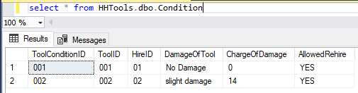 10
Reserve 10
Access Forms 11
Access Report 12
Main Menu 13

Normalization
0NF
Customer id, Customer Name, Customer Address, Payment Details, Tool ID, Type of Tool, Price of tool, Tool Condition ID, Damage of tool, Charge of Damage, Hire ID, Return date, hire date, return early, Actual return date, Reserve ID, Reserve tool)
1NF
Customer (Customer ID, Customer Name, Customer Address, Payment Details,)
Hire (Hire ID, Customer ID, return early, Return date, hire date, actual return date, Tool ID, Type of Tool, Price of tool, Tool Condition ID, Damage of tool, Charge of Damage, Allowed rehire, Reserve ID, Reserve tool)
2NF
Customer (Customer ID, Customer Name, Customer Address, Payment Details)
Tool (Tool ID, Type of Tool, Price of tool)
Link (Tool ID, Customer ID, Hire ID, return date, hire date, actual return date Tool Condition ID, Damage of tool, Charge of Damage, Allowed rehire, Reserve ID, Reserve tool)
3NF
Customer (Customer ID, Customer Forename, customer Surname, Customer Address, Postcode, Payment Method, Phone number)
Tool (Tool ID, Type of Tool, Price of tool per day)
Hire (Hire ID, Tool ID, cost of tool, Collection date, initial cost, return date, actual return date, days late, late fee)
Tool Condition (Tool Condition ID, Tool ID, Hire ID, Damage of tool, Charge of Damage, Allowed rehire)
Reservation (Customer ID, Tool ID, Reserve ID, Reserve tool, Reserve date)

ERD
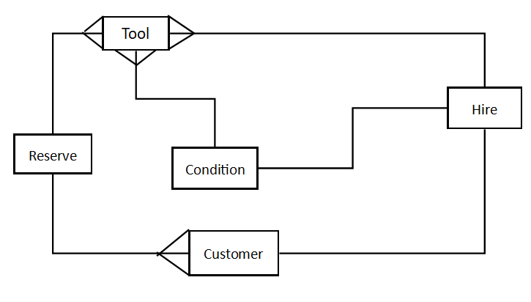
In this ERD above you will see that Tool is has many multiple outings the reason I think this is because Reserve, Condition and Hire all need the Tool ID so they can get multiple outcomes. The reason why Reserve is linked that way to tools is because it needs to check if the tool is available for that time of hire. Hire needs to see if the tools are there but a person can hire multiple tools and condition is like that as multiple tools can have the same condition but one tool can’t have multiple conditions. Multiple customers can Reserve but they can only hire once. The single link from Condition and Hire is there so the condition can see who did the damage via the Hire ID.

Data Dictionary
When making the data dictionary I thought about how each field will be represented in the table I found that I used varchar a lot as most needed a written answer but I used date and decimal for the date of hire and the price of the tool/ Hire. When making these I found it hard on how to make them and if I used the correct variables for each field.

Customer

Hire

Tool

Tool Condition

Reserve

Table Data
When filling the tables I did dome in SQL and Access but before I did that I wanted to make some base data for it as shown below (these are done in Access as I filed) these were kind of hard

Customer

Hire

Tool
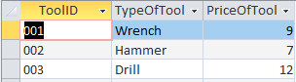

Tool Condition
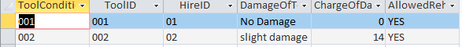

Reserve
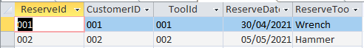

Creating the Tables in SQL

Customer
use HHTools;

Create Table Customer(
Customerid varchar (3),
ForeName varchar (20),
Surname varchar (20),
Address1 varchar (20),
Address2 varchar (20),
Postcode varchar (10),
PaymentMethod varchar (10),
PhoneNumber varchar (15),

Primary key (Customerid)
);

Hire
use HHTools;

Create Table Hire(
HireID varchar (2),
ToolID varchar (3),
CostOfTool decimal (10),
CollectionDate date,
DurationOfHire decimal (6),
IntialCost decimal (10),
ReturnDate date,
ActualReturnDate date,
DaysLate decimal (6),
LateFee decimal (10),

Primary Key (HireID),

Foreign Key (ToolID) References Tools(ToolID)
);

Tools
use HHTools;

Create Table Tools(
ToolID varchar (3),
TypeOfTool varchar (10),
PriceOfToolPerDay decimal (10),

Primary Key (ToolID)
);

Tool Condition
use HHTools;

Create Table Condition(
ToolConditionID varchar (3),
ToolID varchar (3),
HireID varchar (2),
DamageOfTool varchar (20),
ChargeOfDamage decimal(10),
AllowedRehire varchar (3),

primary key (ToolConditionID),

Foreign Key (ToolID) References Tools(ToolID),
Foreign Key (HireID) References Hire(HireID)
);

Reserve
use HHTools;

Create Table Reserve(
ReserveId varchar (3),
CustomerID varchar (3),
ToolId varchar (3),
ReserveDate date,
ReserveTool varchar (10),

Primary key (ReserveId),

foreign Key (CustomerID) References Customer(CustomerID),
foreign Key (ToolId) References Tools(ToolId)
);

Adding to the tables in SQL

Customer
Use HHTools;

Insert Into Customer Values ('001','Leon','Harris','898','Llangyfelach Road','SA5 9AU','CARD','07462360388');

Hire
use HHTools;

Insert Into Hire Values ('01','001',8.56,'2021-04-30',5,45,'2021-05-05','2021-05-05', 0, 0);

Tools
use HHTools;

Insert Into Tools Values ('001','Wrench',08.56);
Insert Into Tools Values ('002','Hammer',07.00);
Insert Into Tools Values ('003','Drill',11.99);

Tool Condition
use HHTools;

Insert Into Condition Values ('001','003','01','No Damage',0,'YES');

Reserve
use HHTools

Insert Into Reserve Values ('001','001','003','05-05-2021','Drill')

Showing the Tables in SQL

Customer
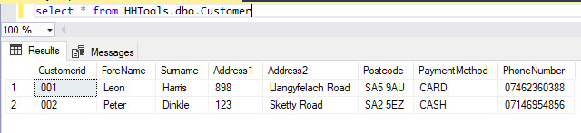

Hire
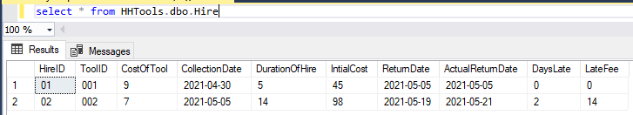

Tool
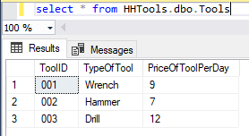

Tool condition

Reserve
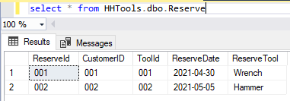

Access Forms
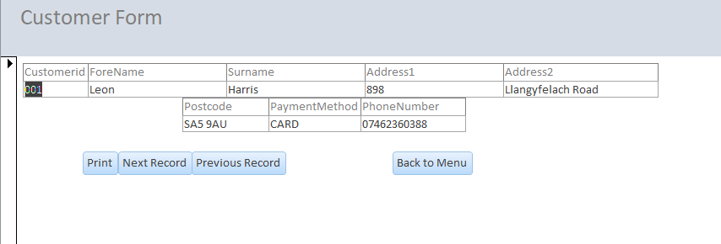
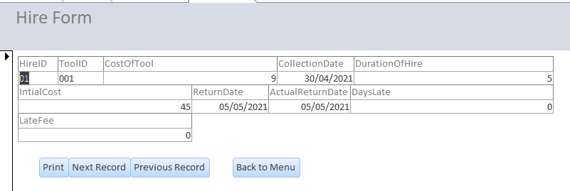
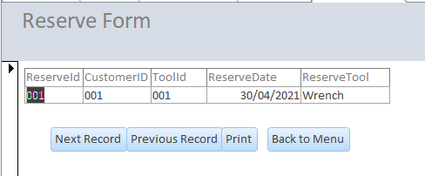
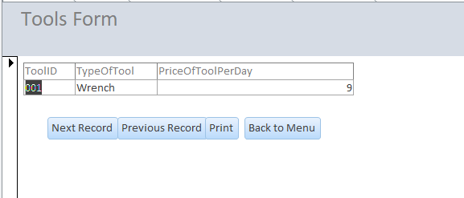
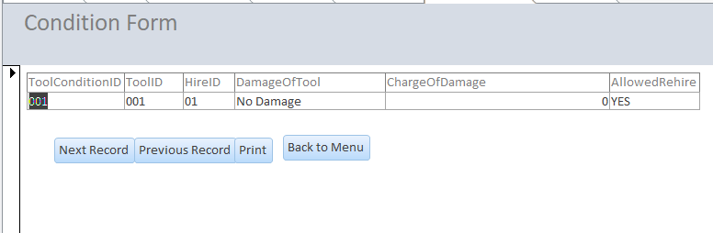

Access Report
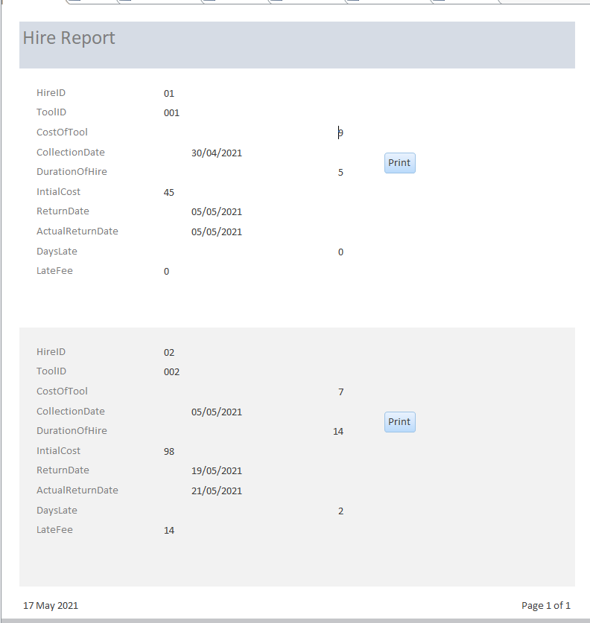

Main Menu


