Lab – Understanding Ethernet Cable Standards
Topology
Addressing Table
Device | Interface | IP Address | Subnet Mask | Default Gateway
PC-A | NIC | 192.168.10.1 | 255.255.255.0 | N/A
PC-B | NIC | 192.168.10.2 | 255.255.255.0 | N/A
Objectives
Part 1: Analyze Ethernet Cabling Standards and Pinouts
Part 2: Build an Ethernet Crossover Cable
Part 3: Test an Ethernet Crossover Cable
Background / Scenario
In this lab, you will build and terminate an Ethernet crossover cable and test it by connecting two PCs together and pinging between them. You will first analyze the Telecommunications Industry Association/Electronic Industries Association (TIA/EIA) 568-A and 568-B standards and how they apply to Ethernet cables. You will then construct an Ethernet crossover cable and test it. Finally, you will use the cable you just constructed to connect two PCs together and test it by pinging between them.
Note: With autosensing capabilities available on many devices, such as the Cisco 1941 Integrated Services Router (ISR) switch, you may see straight-through cables connecting like devices.
Required Resources
- One length of cable, either Category 5 or 5e. Cable length should be 0.6 to 0.9m (2 to 3 ft.)
- 2 RJ-45 connectors
- RJ-45 crimping tool
- Wire cutter
- Wire stripper
- Ethernet cable tester (optional)
- 2 PCs (Windows 7 or 8)
- Analyze Ethernet Cabling Standards and Pinouts
The TIA/EIA has specified unshielded twisted pair (UTP) cabling standards for use in LAN cabling environments. TIA/EIA 568-A and 568-B stipulates the commercial cabling standards for LAN installations; these are the standards most commonly used in LAN cabling for organizations and they determine which color wire is used on each pin.
With a crossover cable, the second and third pairs on the RJ-45 connector at one end of the cable are reversed at the other end, which reverses the send and receive pairs. The cable pinouts are the 568-A standard on one end and the 568-B standard on the other end. Crossover cables are normally used to connect hubs to hubs or switches to switches, but they can also be used to directly connect two hosts to create a simple network.
Reflection:
Write a research report (Max word count 600) on Cat 5e and 6 Ethernet cable standards.

[1] As written by S. Gill, passive devices such as cable and connectors can ultimately determine a networks performance. The components frequency dictates its performance. As an example cat 5e runs at 100 mhz frequency, with cat 6 offering higher performance, with a frequency starting at 350 mhz.
[2] From the website recorded in the citation, a mhz is the speed at which a signal stage can change. In networking this would be from the state of 1 to 0, or 0 to 1. Interestingly, Cat6 cable was designed to provide 1GB connectivity, at 250mhz over two pairs, but the decision was finally reached to use four pairs at 100 mhz which allowed Cat5e to reach 1GB.
From class I understand that the state of 1 can be represented by a positive volt, and the state of 0 can be represented by a negative volt. Normally + or – 5 volts.
[2] As detailed by Reyburn and Lasseigne category (Cat) cable is a classification of a varying number of twisted pairs, of insulated conductors. By increasing the number of pairs and the quality of the conductors the cable can be used to communicate within a more complex system.
Cat-5e is today’s most abundantly used cable for networking and data-transfers systems. It contains four twisted pairs for a total of eight conductors. As seen in class these were blue, orange, brown and green with their white striped pair.
With straight cable, these pairs terminate in the same pin of the connector at both ends 1 to 1, 2 to 2 and so on. With cross over cable, the pairs which are in use cross over, 1 to 3, 2 to 6, 3 to 1 and 6 to 2. This in fact joins the transmitter to the receiver and receiver to the transmitter. For data communication the other pairs are not used in 5e or cat 6.
[2] As documented by Reyburn and Lasseigne cat 6 cable is more robust than its cousin 5e. This is due to it typically having larger-gauge wire. This also provides higher bandwidth, with higher frequency, less attenuation and less delay skew. Cat 6 cable of can run at speeds of 10GB vs 5e’s 1GB.
By pushing the gauge of wire, to increase the mhz, and utilizing four pairs Cat 8 can now achieve 40GB speeds. However, signal attenuation is an issue for cable lengths. For 5e and 6 the maximum recommended length to avoid this is 100 meters as stated on Schneider Electric website [5]. Longer networking runs can be connected via networking equipment such as a switch.
Both cat5e and 6 cables are twisted to increase wire flexibility, as well as to “assist in decreasing crosstalk that can disrupt signals and reduce electromagnetic induction, which produces voltage across a conductor transferring through a magnetic field“ as stated on technopedia. [5] The twisted pairs are then covered in an outer wrap of plastic, to protect the cables from the environment as well as insulate it from external factors.

References

[1] | S. Gill, Understanding industrial Ethernet cable requirements., CFE Media, 2018, p. 31.
[2] | "Making sense of," 04 11 2019. [Online]. Available: https://www.cablewholesale.com/support/technical_articles/megahertz_madness.php.
[3] | R. H. a. L. J. B. Reyburn, Vital tips about wiring., CFE Media, 1996, pp. 38 - 42.
[4] | "Schneider Electric," 4 11 19. [Online]. Available: https://www.schneider-electric.com/en/faqs/FA269550/.
[5] | "techopedia," 4 11 2019. [Online]. Available: https://www.techopedia.com/definition/25741/twisted-pair-ethernet.
[6] | "https://en.wikipedia.org/wiki/Power_over_Ethernet," [Online]. Available: https://en.wikipedia.org/wiki/Power_over_Ethernet.

  - Analyze diagrams and tables for the TIA/EIA 568-A standard Ethernet cable.
The following table and diagrams display the color scheme and pinouts, as well as the function of the four pairs of wires used for the 568-A standard.
Note: In LAN installations using 100Base-T (100 Mb/s), only two pairs out of the four are used.
568-A 10/100/1000Base-TX Ethernet
Pin Number | Pair Number | Wire Color | 10Base-T Signal  100Base-TX Signal | 1000Base-T Signal
1 | 2 | White/Green | Transmit | BI_DA+
2 | 2 | Green | Transmit | BI_DA-
3 | 3 | White/Orange | Receive | BI_DB+
4 | 1 | Blue | Not Used | BI_DC+
5 | 1 | White/Blue | Not Used | BI_DC-
6 | 3 | Orange | Receive | BI_DB-
7 | 4 | White/Brown | Not Used | BI_DD+
8 | 4 | Brown | Not Used | BI_DD-

The following diagrams display how the wire color and pinouts align with an RJ-45 jack for the 568-A standard.
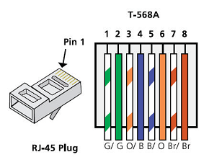
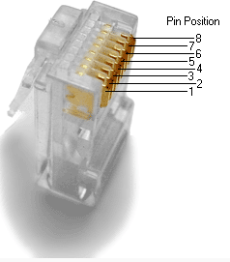
  - Analyze diagrams and tables for the TIA/EIA 568-B standard Ethernet cable.
The following table and diagram display the color scheme and pinouts for the 568-B standard.
568-B 10/100/1000-BaseTX Ethernet
Pin Number | Pair Number | Wire Color | 10Base-T Signal  100Base-TX Signal | 1000Base-T Signal
1 | 2 | White/Orange | Transmit | BI_DA+
2 | 2 | Orange | Transmit | BI_DA-
3 | 3 | White/Green | Receive | BI_DB+
4 | 1 | Blue | Not Used | BI_DC+
5 | 1 | White/Blue | Not Used | BI_DC-
6 | 3 | Green | Receive | BI_DB-
7 | 4 | White/Brown | Not Used | BI_DD+
8 | 4 | Brown | Not Used | BI_DD-
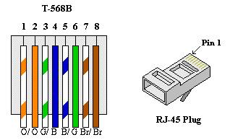

- Build an Ethernet Crossover Cable
A crossover cable has the second and third pairs on the RJ-45 connector at one end, reversed at the other end (refer to the table in Part 1, Step 2). The cable pinouts are the 568-A standard on one end and the 568-B standard on the other end. The two following diagrams illustrate this concept.
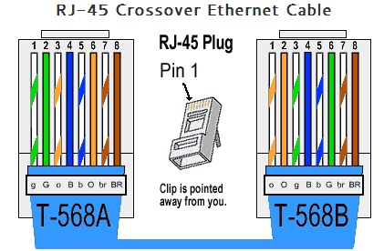
  - Build and terminate a TIA/EIA 568-A cable end.
    - Determine the cable length required. (Your instructor will let you know the cable length you should make.)
Note: If you were making a cable in a production environment, the general guideline is to add another 12 in. (30.48 cm) to the length.
    - Cut off a piece of cable to the desired length and using your wire stripper, remove 5.08 cm (2 in.) of the cable jacket from both ends.
    - Hold the four pairs of twisted cables tightly where the jacket was cut away. Reorganize the cable pairs into the order of the 568-A wiring standard. Refer to the diagrams, if necessary. Take as much care as possible to maintain the twists in the cable; this provides noise cancellation.
    - Flatten, straighten, and line up the wires using your thumb and forefinger.
    - Ensure that the cable wires are still in the correct order for the 568-A standard. Using your wire cutters, trim the four pairs in a straight line to within 1.25 to 1.9 cm (1/2 to 3/4 in.).
    - Place an RJ-45 connector on the end of your cable, with the prong on the underside pointing downward. Firmly insert the wires into the RJ-45 connector. All wires should be seen at the end of the connector in their proper positions. If the wires are not extending to the end of the connector, take the cable out, rearrange the wires as necessary, and reinsert the wires back into the RJ-45 connector.
    - If everything is correct, insert the RJ-45 connector with cable into the crimper. Crimp down hard enough to force the contacts on the RJ-45 connector through the insulation on the wires, thus completing the conducting path. See the following diagram for an example.
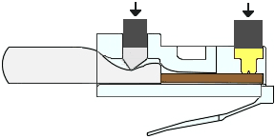
  - Build and terminate a TIA/EIA 568-B cable end.
Repeat steps 1a to 1g using the 568-B color wiring scheme for the other end.
- Test an Ethernet Crossover Cable
  - Test the cable.
Many cable testers will test for length and mapping of wires. If the cable tester has a wire map feature, it verifies which pins on one end of the cable are connected to which pins on the other end.
If your instructor has a cable tester, test the crossover cable for functionality. If it fails, check with your instructor first as to whether you should re-cable the ends and re-test.
  - Connect two PCs together via NICs using your Ethernet crossover cable.
    - Working with a lab partner, set your PC to one of the IP addresses shown in the Addressing Table (see page 1). For example, if your PC is PC-A, your IP address should be set to 192.168.10.1 with a 24-bit subnet mask. You partner’s IP address should be 192.168.10.2. The default gateway address can be left empty.
    - Using the crossover cable you made, connect the two PCs together via their NICs.
    - On the PC-A command prompt, ping the PC-B IP address.
Note: The Windows firewall may have to be temporarily disabled for pings to be successful. If the firewall is disabled, make sure you re-enable it at the conclusion of this lab.
    - Repeat the process and ping from PC-B to PC-A.
Assuming IP addressing and firewall are not issues, your pings should be successful if the cables were properly made.
Reflection
  - Which part of making cables did you find the most difficult?
Personally the most difficult part of cable making for me is to hold the cables firmly in place enough while you arranged the cables, straightened the cables, cut them to an appropriate length and then continue to do so while you push the plug on successfully to then allow you to get a tidy crimp.______________________________________________________________________________________
  - Why do you have to learn how to make a cable if you can easily buy pre-made cables?
It reinforces the understanding of how the pins work, for example that certain pins are used for sending while others are used for receiving. It is also an invaluable skill to have in the field if you need to make a cross over cable for any reason, or straight cable to fix an issue._______________________________________________________________________________________

