Control and Automation

Design of an industrial automatic control system
Module – ACMA5001
Lecturer – Rob Goodson



Table of Contents
Introduction 3
The Brewing Process 4-5
Types of Controllers 6-7
Instrumentation, Controllers, and Actuation for a Microbrewery Plant. 8-9
Safety and Environmental factors for Micro-Breweries 9-11
Benefits of the hydraulic power supply system to the microbrewery plant 11-12
Conclusion 12
References 13

Introduction
The brewing environment of today is a far cry from the primitive brewing containers used by some of the first brewers. Besides, the method of brewing in today’s market would be unrecognisable to the brewers of the 1900’s. The technological advancements have changed the whole nature of the brewing process. Automation within the brewing process has seen a significant reduction in the variability of the produced beer. (didora, 2018)
The motive behind the production of automated systems is not only the reduction of the use of energy abut to also enhance capacity, lower risk, and deliver real-time data on production. This project aims to offer suggestions of suitable control systems to help regulate the precise beer brewing parameters like mashing process, temperature, and water level in the cooker which significantly affects the yielded beer viscosity. Salanța (Salanta, 2020) argues that the correct brewing process control, ensures the production of reliable beer to satisfy the needs of customers. The purpose of this assignment is to offer recommendations on an automated Micro Brewery. The control of the brewery should be self-regulating for an entire batch.

The Brewing Process
Fig.1
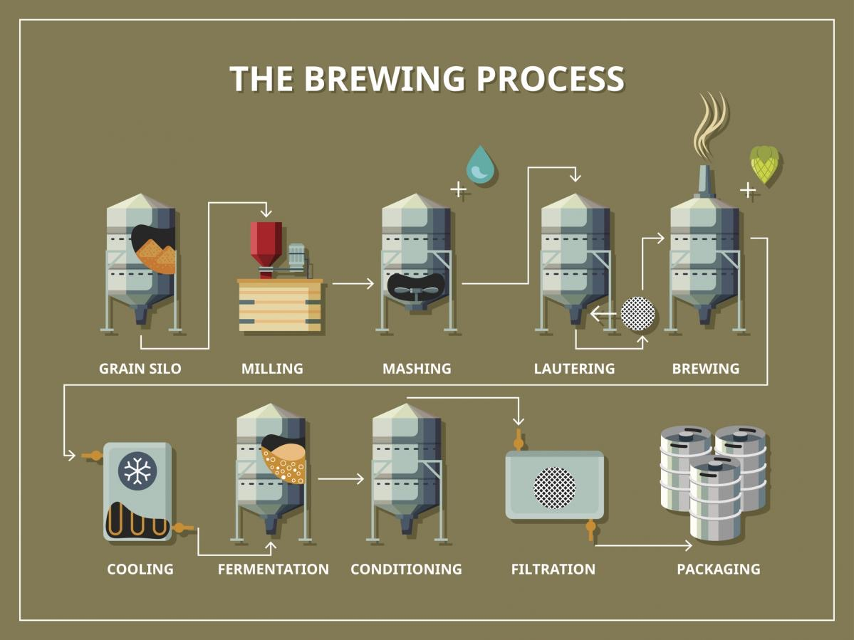
(Zoedale, 2017)

The brewing process involves three significant steps: mashing, boiling, and fermenting. However, there are seven stages in total. Milling, mashing, boiling, cooling, fermenting, filtering and packing (Fig.1). The start of the process differs with each recipe of beer.
During the milling stage, various types of malt are crushed together to break apart grain kernels and release fermentable sugars, resulting in grist, a milled product. This is then fed into a mash, turned and is mixed with warm water. Temperature during the mixing is important, it transforms sugars, some of these are non-fermentable, while other are fermentable. During this time, enzymes found on malted barley convert starch to fermentable sugars, as well as enzymes that break down proteins to make amino acids. Proteins, sugars, vitamins, and amino acids are extracted from barley to produce a wort. This wort will then be fed in to a kettle.
When the wort is moved to the kettle, it will boil for around one and a half hours, allowing it to become sterile while also reducing the water content and enhancing the colour. Hops will be added at the start of the boil and again near the finish to increase the bitterness. Following this, the wort is the circulated to coagulate the enzymes and proteins.
Next in the process is to cool the wort. 20 degrees is the optimal temperature it’s cooled to prior to transferring to the fermentation stage.
During fermentation, yeast will be added and this will allow the wort to ferment, which converts the liquid in to beer. Fermentation is a long process, this will take around 4 days, and the temperature within the tank is dependent on the style of beer. At this point its time to mature the beer, this is done by cooling it to approximately 10 degrees, prior to a lower 4 degrees for around 3 weeks.
The beer will now be ready for packing; bottle or keg is the common choice. The beer is filtered to remove any yeast, although, some will choose to keep the yeast, this gives you the crisp, clear beer that we all enjoy. CO2 can be altered within the tank prior to packing in to the preferred packaging. (Zoedale, 2017)
The process of brewing entails various science and engineering principles like heat transfer, fluid flow, material balance, stoichiometry, and kinetics of chemical reactions. Besides, topics like material compatibility, circuits, and electronics, engineering economics are integrated into the design. They are broken down as shown below. (Farrell, 1999)

Principle or Topic | Its Applicability
Fluid flow | Draining of tanks/transfer of fluids
Mass transfer | Filtering after boiling and smashing
Heat transfer | Smashing, boiling, chilling
Mass balancing and stoichiometry | Fermentation
Kinetics of chemical reactions | Fermentation
Compatibility of materials | Cans and bottle packaging
Electronic acquisition of data | Temperature regulation and evolution of CO₂ during fermentation
Environmental issues | Bottles and cans recycling

Types of Controllers
The kinds of utilised controllers in these processes of beer brewing include micro-controllers, Programmable Logic Controllers (PLC), or PID controllers.
PLCs are simple robust, reliable, and I/O interface performance. Microcontrollers have consistent performance. They have a dependable in-built programmer, simple programming language, and a dynamic user-base with various sample codes. The recommendation for this project would be the VersaMax I/O control. This PLC will provide enough I/O points to not only set up the micro-brewery, but improve or grow it in the future. (Maware, n.d.) The PLC will have the capacity to manage the whole system, it can regulate fluid flow, heat, pressure of the tanks while also having the memory to hold programs for various beers. Once the set points are programmed, the data can be sent to the user, while also saving data for trending, this will give the user a platform to improve their brews.

When higher levels of precision are necessary in control, PID control is used. It combines three control terms into a single output that controls the set point. The parameters and variables in the brewing process are important, but I will be advising on the PLC controller.

What will be required for the process
- Valves
- Control unit
- Flow meters
- Pumps
- Sensors
- Controllers
- Heating element

Choosing the correct temperature sensor in the Brewery
Pt100 temperature sensor is recommended due to its high responsiveness, it is highly sensitive and has long-term constancy in wetness. (sensors, 2021) It is also easy to install with high accuracy temperatures, hence the best. This type of sensor can be used for the CIP process also. The temperature can be controlled through the PLC control system, on all areas of the brew house. An example of the control loop is below. (Maware, n.d.) The system suggested would be controlled through signals sent from the sensor to the PLC ensuring your set up is regulated to the set temperature. The PLC would activate the heating element when the temperature falls below the set parameters, likewise, when the temperature comes within the higher tolerance barrier it will de-activate. Please ensure top temperature band is set 2 degrees below the highest temperature allowed.
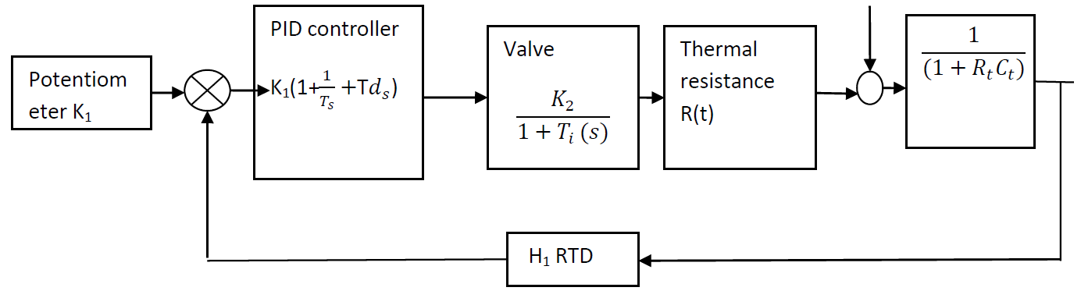

Heat exchanger
For the cooling stage, a plate heat exchanger is recommended; these are the most typically employed in the brewing process. A heat exchanger can help you save money on energy. Selection is crucial; if a high-quality piece of equipment is selected, the amount of water used in the operation can be reduced. (busines., 2021)

Heating element
The heating is critical for heating up the wort, moreover, it needs to maintain the temperature to ensure a quality product. The set points can be made in the PLC making this part of the process easily monitored. The temperature sensors highlighted above will communicate with the PLC and transmit when the I/O will be initiated.

Instrumentation, Controllers, and Actuation for a Microbrewery Plant.
The purpose of the control valve will be to provide the means for activation or implementation of a control strategy for process operation. The control valve will provide a conscious flow of variables necessary for the regulation or adjustments of the steady-state for the running conditions of the fermentation process. However, the subject will be able to be extended to include the selection and specification of on-off control valves same with the ones used for batch control or the sequentially processes such as routing or mixing of fluids. The instruction engineers are highly encouraged to take responsibility for the specification of the pressure valve (Datta et al., 2018). When a fluid is very viscous or flowing slowly through the pipe, individual fluid particles travel effectively in layers at different speeds and they slide over each other thus creating a laminar flow pattern in that pipe. At a point when the flow increases, the unbalanced forces in the fluid can be high to cause the fluid near the surface of the pipe to lose the forward motion and start flowing backward. (physics, 2021). The point is called the separation point and can cause substantial energy losses at the exit of the port of the control valve. It is the responsibility of the control valve to control this pressure and ensure a continuous flow of the fluid. Below is a P&ID of a control loop. The control valve is the last control feature in the process, it’s very important that it performs well so selection is key. (Bhatia, 2021) The PLC will be programmed to achieve all outputs.
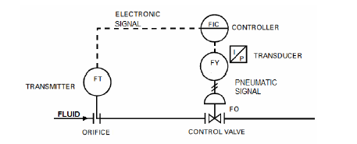
The valves recommended for various stages of the process are below. Pneumatic valves will be used for the process because the facility already has a pneumatic power supply. All of these will require actuators, and the material of the valves will need to be stainless steel. The material selection is extremely important, if you select the wrong material you could compromise the quality of the beer. Seals within the valves should also be carefully selected so they don’t deteriorate quickly with the heat and chemicals involved in the CIP process. EPDM is recommended for the seals.

CIP process – Butterfly valve
The advantage of using these types of valves is in the design. The sealing properties are excellent and can be cleaned very easily, unlike the ball valves. Typically, these are recommended for the CIP process and any fluid flow that does not entail high pressures.

Flow of wort – Ball valve
Wort is quite viscous, this would require a valve that will not restrict, or obstruct the flow. Ball valves are best for this.

Fluid transfer – Non return valves
Non return valves will be recommended on all other processes, during the transfer of fluid, we must ensure that there’s no back flushing, or fluid returning to any of the previous vessels.

Safety and Environmental factors for Micro-Breweries
The Brewery Safety Committee's mission is to advance safe brewing performs by offering education and resources to brewers to assist them to generate a safe and healthy work environment for all brewery workers. The aims will be to offer brewery-specific health and safety technical program references and guidance to assist workers in simply know industry standards, practices, and regulations. (Wojtyra, 2020)
All the factors of delivering beer and brewing to the market will be burdened with environmental issues, with energy and water consumption being the main natural resource reflections. Carbon emissions will be mainly comparative to energy consumption. Beer production and Barley farming will be the biggest water consumers. Water consumption in the brewery will be expressed as a water ratio applied to real beer produced. All these effects will be better classified in several areas; transportation and production of raw materials that will change into beer and its packaging. Second is the resource intake that can be tied straight to the brewery and the beer-making process. Lastly, the refrigeration and transportation of beer after it leave the brewery.
Brewing and malting lead to a big amount of several by-products. The majority of these by-products are usually utilised as fertilisers in the ground, get incinerated, and drained as waste. The kind of usage of the by-product spells a main environmental issue and requires to be addressed because the new technologies development can influence and redirect the misuse of the biotechnologically significant by-product (IFC, 2007). The by- products decrease to re-incorporation or minimum, into the production progression as raw materials can assist in accomplish ecological sustainability. Regarding that several of the by-product originating from brewing and malting manufactures are valuable and nutritious, but less expensive and affordable, they can cooperate into several manufactures oriented to biotechnology, pharmaceutical, and food production.
Significantly, all process pipes and equipment are maintained disinfected, and clean. Cleaning is done by a cleaning-in-place (CIP) system, where cleaning managers are circulated in the sprinkled or equipment over the surface of the tank. Acids are frequently applied as cleaning agents. The brewery disinfection and cleaning equipment can use a substantial quantity of disinfectants, cleaning agents, water, and energy. The CIP system plan can differ greatly, ranging from a simple system in which a cleaning solution batch that generates it is likely to reuse some cleaning solution and water. Wastewater, both from the brewery and other industries, is subject to pre-treatment to limit and prevent negative effects on the environment. Wastewater treatment in the brewery alienated into primary and secondary treatment, which implies changing the biological, chemical, and physical wastewater properties to reach the best impacts of subsequent processes. Physical approaches are the primary methods by which solids originate in water. Such as large particles, sludge, and label paper are removed. 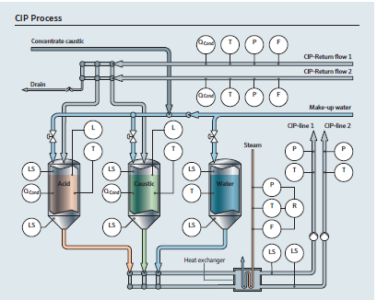
(Huser, 2021)

Benefits of the hydraulic power supply system to the microbrewery plant.
Micro-breweries of today use a hydraulic power supply system, and this decision is motivated by a desire to save money on energy and reduce carbon dioxide emissions from the actuators in to the environment. (Cordis, 2015). The goal is achieved because of the increased efficiency of the systems in water and through the avoidance of pneumatic systems that can leak. The hydraulic media which is composed of sterilized tap water mixed with glycol is incompressible in the pressure during the operation that ranges between 725 Psi and 1450 Psi. The strategy gives the system stability which allows the industry to trusts the valve in staying at the expected position, usually open or closed. The industry benefits directly from this system because the unintended mixture of products due to pressure peak cannot happen (P Datta, 2018). A hydraulic system would be best placed in the packing area. There will be significant weight when the beer has been packaged.

Conclusion
To create a fully automated control system, a PLC would be the instrumental in allowing a quality product while keeping costs down. Besides, it will allow you to store a range of programs for different beers. All valves, sensors, elements and meters should be hygienic grading because of the regulated brewing industry.

References

Works Cited
Bhatia, A., 2021. https://www.cedengineering.com/userfiles/Control%20Valves%20Basics%20-%20Sizing%20&%20Selection.pdf. [Online].
busines., c. b., 2021. craftbrewingbusiness.co.uk. [Online].
Cordis, 2015. https://cordis.europa.eu/project/id/222313/reporting. [Online].
didora, P. L., 2018. https://www.growlermag.com/the-evolution-of-of-brewing-tech-innovations-that-have-redefined-beer-in-the-modern-age/. [Online].
Farrell, S., 1999. https://www.researchgate.net/publication/3844934_Investigation_of_the_brewing_process_an_introduction_to_reverse_process_engineering_and_design_in_the_Freshman_Clinic_at_Rowan_University/figures?lo=1&utm_source=google&utm_medium=organic. [Online].
Huser, E. &., 2021. https://portal.endress.com/wa001/dla/5000581/7128/000/00/SO00008B60EN1416_Brewing.pdf. [Online].
IFC, 2007. https://www.ifc.org/wps/wcm/connect/8afeb6b7-6602-4394-8584-7643035eeb50/Final%2B-%2BBreweries.pdf?MOD=AJPERES&CVID=jqeI3sW. [Online].
Maware, C., n.d. DESIGN OF A CONTROL SYSTEM TO ENHANCE PROCESS PERFOMANCE IN THE PRODUCTION OF SORGHUM BEER. 2013.
P Datta, K. M. J. c., 2018. Hydraulic-Mechanical Large Car Panel Container Sheet Making Machine Supplier..
physics, U., 2021. https://courses.lumenlearning.com/suny-osuniversityphysics/chapter/14-7-viscosity-and-turbulence/. [Online].
Salanta, L.-c., 2020. https://www.researchgate.net/publication/345141470_Non-Alcoholic_and_Craft_Beer_Production_and_Challenges. [Online].
sensors, P., 2021. Peaksensors.co.uk. [Online].
Wojtyra, B., 2020. How and why did craft breweries ‘revolutionise’.
Zoedale, 2017. https://www.zoedale.co.uk/blog/info-graphics/the-brewing-process/. [Online].

