Fabiha Begum
Student Number: 1813640
Module Name: Effective Team Working and Communication
Lecturer: Christopher Mafuva

Table of Contents
- Introduction
- Strategies for Effective Team Working Process
- Communication Skills
- Conclusion
- References

Introduction
Team building is the process of managing individuals and turning them into a group to work effectively and add to the productivity of the business (Ibarra and Barbulescu, 2010). I will be discussing various strategies that are needed for effective team building process and I will be discussing a range of communication skills, backed up by various theories that explain the importance of communication skills a at workplace.
Strategies for Effective Team Working Process
In the team building process the major goal is to run the team effectively. The most effective team members will build their bond with trust, loyalty rather than building it with fear of position or any other conditions. The main strategies that can be used for effective team building process are as follows. From working in retail, I have noticed there are five leadership strategies that allowed my company to achieve effective team building.
- Developing diversity in the team: diversity within a team is very important. Since companies have employees that are large in number, diversity is surely to exist because people come from various backgrounds, religions, place of origin, etc. This is why the thought process of such diversified individuals is also different. This diversified thinking can help to provide new perspectives to the company by giving new ideas to issues relating in the business and help to provide a new outlook for things. Building a team with diversified individuals that consists of people from different backgrounds, culture and experiences benefits the business by providing them with different perspectives and views.
- The team should always be the priority for the company to create an effective and powerful creative culture (Huffman et al, 2010). The usual business strategy of any company is to always give priority to their customers but to create an effective team building and enhance the productivity of the organization the priority should be given to team rather than customers because the employees are the ones who are working for the company and reaching out to customers to enhance the sales of the company.
- Problem solving in groups: when the problem-solving skills are practiced in teams it helps to create and develop effective and a cooperative culture within the business. Every business has diversified individuals with skills and perspectives that help the company to solve problems and look out for solutions in various manners. Putting such diversified individuals and making them work towards the common goals and issues within the company will help to stimulate creative ways of dealing with the existing problems within the company and create long lasting relationships with co-workers.
- Encouraging employees to speak out and give their opinions freely in the company. if they speak out what they feel they will feel valued and will help to build loyalty with the business because they know their perspectives and their voice will be respected.
- There should be fun activities in the workplace otherwise the environment would be too suppressed and boring, and employees will not enjoy coming to work which will greatly demotivate them (Farnsworth and Boon, 2010). Natural events and activities should be existent in the company to engage employees to take part in fun activities and depart the employees from the stress they have from the work on daily basis. Many companies have sport activities and shared hobbies that help to create a fun environment at the workplace and employees will have fun at work which will also prevent them from switching to other companies.
Group Dynamics
Group dynamics is a system of behaviours and the psychological processes that occur within a social group at a workplace. For a successful management at a workplace, it is essential to have a strong understanding of group dynamics and the role it plays in business operations in the organisation. To understand group dynamics and effective team building process Tuckman’s theory can be applied to an organisation. Tuckman’s theory consists of five stages of team development and group dynamic process. The five stages of Tuckman’s theory are as follows:
- Forming stage: this is the initial stage in the team building process and it often comes with uncertainty because the employees are just newly introduced to the group hence, they are uncertainty about their position and their role within the group. The goals of the group have still not been established and the tasks are also not allocated to the employees.
- Storming: this stage has the highest number of conflicts and disagreements between the employees working in the same group because all the employees come from various backgrounds and culture and initially it is difficult to cooperate with all the employees and work together to achieve the goals of the company (Decuyper et al, 2010).
- Norming: at this stage employees start to cooperate and believe in each other’s thought process and work together to achieve the goals of the organisation. At this stage, the employees will develop a feeling of unity and identity.
- Performing: at this stage, the group has matured and started cooperating with each other and has a feeling of cohesiveness. Individuals now are able to work together, and the conflicts are resolved through various group discussion. In this stage, the employees do not concentrate on emotional issues and take rational decisions that are adding to the productivity of the organisation.
- Adjourning: in this stage, many groups of various organisations do not reach this stage effectively because this stage is characterised by disbandment of the group. At this stage the groups get dissolved because either they have completed the task and achieve the goal of the organisation or the individual working in the group decides to go on their own ways for their personal development.
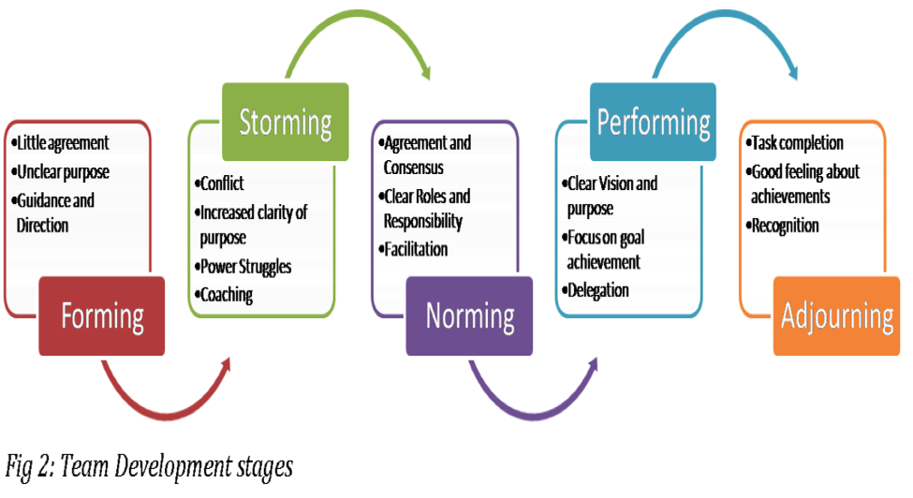

Tuckman’s theory of team development (Available at: http://www.mspguide.org)
Communication Skills
Communication is very important for an individual to be able to convey their thoughts and individuals openly. Communication can be both verbal and non-verbal depending on the situation and the person an individual is dealing with. Most important life skill is to be able to communicate effectively and set thoughts of an individual in public. Communication skills have also been an essential part of effective management at workplace that helps to provide clarity of thoughts and perspectives of an individual (Bone Bright, 2010). To gain success within an organisation it is very essential to be able to effectively communicate to set out the company’s thoughts and goals out to the employees loud and clear. To do this, the leader of the company needs to have effective communication skills otherwise they might not be able to convey their goals for the company to the employees and without understanding the goal of the company the employees will not be able to work towards it and achieve it. The manager is the main link that connects the head of the organisation to its team members and employees working in the company. To gain success within the workplace it is very essential to have effective business communication skills. For example:
- It helps to gain a competitive advantage of the company. Effective communication is very important to put the business ideas across the stakeholders and clients that can effectively understand the goals of the company so they can invest and enhance the productivity of the organisation by boosting the sales of the company (Bertrand et al, 2010).
- It enhances the productivity of the organisation by effectively communicating which is the key aspect for successful teamwork. Clear communication and putting across thoughts prevent uncertainty and promotes understanding and builds trust between the employees and the employees of the organisation.
- It helps to build customer base with effective communication to the customers and clients who are the most important lifelines of the business that enhances the productivity of the organisation.
- It enhances the business partnership because communication is very essential to build and connect to partners that are a part of the business organisation. Communication is needed to communicate to suppliers and external clients and put across ideas and the goals of the organisation by effectively communicating to them.
- Effective communication at workplace facilitates business innovations which is very important for businesses to flourish in this competitive and technology driven world. Since the use of technology has become so prevalent in every organisation it is essential to effectively use technology that can help an organisation to reach customers globally (Byrd and Luthy, 2010).
McGuire Theory of Communication
The theory covers three dimensions that are essential for social and business interaction within an organisation through effective communication methods. The three important elements are use of language while communicating, the behaviour while communicating and other nonverbal gestures that are helpful in communication.
The right use of language is very important and crucial in business since the employees usually connect to potential customers and clients that add to the productivity and profits of the organisation (Berger et al, 2010). Hence, it is very essential to use a proper and a polite way of communicating to the important people that add to the productivity of the organisation. The tone and the use of words or vocabulary should always be considered while connecting to people because that is what reflects your personality greatly.
The behaviour is another essential element of this theory where while connecting to an individual it is essential to have a proper body language that greatly affects the whole meaning of communication. Body language and face expressions play a very crucial role in communication that sends across messages to the opposite person more than verbal communication.
The final elements are the non-verbal gestures and presentations that are given to clients or the important stakeholders and investors that are investing in the company. Communication plays a very crucial role in this situation because if the idea of the project is not communicated effectively the whole process is disturbed and the investors and stakeholders will not be able to understand what the individual is trying to convey and the company might lose out on effective investors and stakeholders that can add great productivity to the organisation.

Conclusion
Team building is the process of managing individuals and turning them into a group to work effectively and add to the productivity of the organisation. Group dynamics is a system of behaviours and the psychological processes that occurs within a social group at workplace. For a successful management at the workplace it is essential to have a strong understanding of group dynamics and the role it plays in business operations in the organisation (Arvidsson, 2010). Communication is very important for an individual to be able to convey their thoughts and individuals openly. Communication can be both verbal and non-verbal depending on the situation and the person an individual is dealing with. Most important life skill is to be able to communicate effectively and set thoughts the thoughts of an individual in public

References
Arvidsson, S. (2010). Communication of corporate social responsibility: A study of the views of management teams in large companies. Journal of Business Ethics.
Berger, C.R., Roloff, M.E. and Ewoldsen, D.R. eds., 2010. The handbook of communication science. Sage.
Byrd, J.T. and Luthy, M.R. (2010) IMPROVING GROUP DYNAMICS: CREATING A TEAM CHARTER. Academy of Educational Leadership Journal.
Bertrand, M., Goldin, C. and Katz, L.F. (2010) Dynamics of the gender gap for young professionals in the financial and corporate sectors. American Economic Journal: Applied Economics.
Bonebright, D.A. (2010) 40 years of storming: a historical review of Tuckman's model of small group development. Human Resource Development International.
Decuyper, S., Dochy, F. and Van den Bossche, P. (2010) Grasping the dynamic complexity of team learning: An integrative model for effective team learning in organisations. Educational Research Review.
Farnsworth, J. and Boon, B. (2010) Analysing group dynamics within the focus group. Qualitative Research.
Huffman, M.L., Cohen, P.N. and Pearlman, J. (2010) Engendering change: Organisational dynamics and workplace gender desegregation, 1975–2005. Administrative Science Quarterly.
Ibarra, H. and Barbulescu, R. (2010) Identity as narrative: Prevalence, effectiveness, and consequences of narrative identity work in macro work role transitions. Academy of management review.
Morrison, G., Goldfarb, S. and Lanken, P.N. (2010) Team training of medical students in the 21st century: would Flexner approve?
Myers, K.K. and Sadaghiani, K. (2010) Millennials in the workplace: A communication perspective on millennials’ organizational relationships and performance. Journal of Business and Psychology.
Sahin, Y.G. (2011) A team building model for software engineering courses term projects. Computers & Education.
Tuckman, B.W. and Jensen, M.A.C., (2010) Stages of small-group development revisited. Group Facilitation: A Research & Applications Journal.
Tevel, E., Katz, H. and Brock, D.M. (2015) Nonprofit financial vulnerability: Testing competing models, recommended improvements, and implications. Voluntas: International Journal of Voluntary and Nonprofit Organisations.

