York Museums Trust Public Programme Proposal Form
Please email to exhibitions@ymt.org.uk once completed

What is the title of your  proposal? | Male, Female, Other : Gender and Sex throughout history
Date proposal submitted | 8/11
Please provide your name  and contact details | Rachael A Bone  2103272@student.uwtsd.ac.uk
Is it an idea for:  Event Exhibition  Subject / anniversary Communications campaign Research and Development Don’t know yet | Exhibition
Elevator pitch: in no more  than three sentences summarise your proposal | A new exhibition which shows the changing attitudes of gender and sex throughout time, from Ancient Egypt, the Medieval and Victorian periods, and the 21st Century. With each period showcasing their culture’s own view of gender; through the mediums of art; statues, paintings, architecture and literature.

Who are the target  audience?  Reference Audience Spectrum segments if known.  If not known, who do you think this would this appeal to? | The Target audience is very broad for this exhibition as it ties in both the wider world and things pertaining to York. It will hopefully draw in the Metroculturals, Experience Seekers, it would also draw in a few of the Comuterland culturebuffs but not all as they prefer things focused classical and this has both a focus on classical and modern. This would largely appeal to the Trips & Treats demographic with older children who are active on social media, rather then those with younger children (16+). While not a recognised group on the Audience Spectrum segments, there would be a pull for a great many young adults and those involved in the LGBTQ+ community as this is something linked intrinsically to their cultural heritage.
What is the budget? | The budget at a minimum would be around £1000, but more would be appreciated to ensure better quality.
Are there any fundraising  opportunities? | Not additional ones affected or added because of this display but putting donation boxes in the exhibition room would allow for some fundraising. There is also the option of adding a charge as this not planned as a permanent exhibition, however this would by up to the purview of yourselves.
Are there any partnership  opportunities? | Yes, as many of the artifacts are stored with different museums it would allow for the YMT to create a working relationship with Cyfarthfa Castle Museum and Art Gallery
Are there any other similar  shows / events happening regionally or nationally? | Regionally nothing of this kind has been publicised or is currently being displayed. Nationally the Science Museum in London has the closest exhibition to this one – but that is focused on current understandings and ideas around Gender and Sex with no tie in to history.
Does it draw on any of  YMT’s collections, or is inspired by them? | Yes, Items such as YORCM : BA374.1-3 would come from the York Collection, it’s a Victorian wedding dress currently not on display. There is a Canopic Vessel cover, and Ushabti, a statute of a woman which would be included for the section on Egypt, and ties in nicely with some of the items from other museums. Where possible many of the sections would take inspiration from the current display on clothing at the YMT, perhaps looking at some similar items as clothing and gender are usually linked.
Proposed location / gallery  for your idea. | The exhibition would work best within the York Castle Museum as there are exhibitions focused around similar areas of history – ‘Kirkgate: The Victorian Street’, and ones that hold a similar theme – ‘Shaping the Body’.
Who have you consulted  with at YMT or externally? | I have consulted with other exhibition designers working with similar artefacts, I have also discussed with Jodie Deacon, Curator of Prehistory at the National Museum of Wales.

How is this project unique  for YMT? | The current exhibits offered at the YMT are about Roman York, and the prehistoric times, by having one exhibit on display that isn’t focused on one place but the multiple, with tie-ins to York history and Culture when looking at the Medieval, Victorian and Modern times. It would also be one of the first exhibitions for the YMT to look into gender.
When would this project be  delivered? Does it link to any critical dates? | While not linked to any critical dates around the time of a major holiday would be preferable, as it allows for more people to visit and explore, around Christmas 2024 onwards.
Please add relevant images | 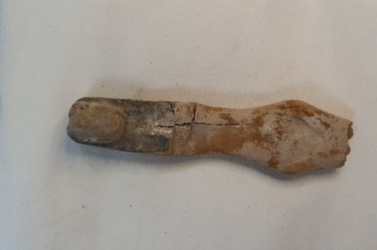  Image Credit to Pijus Norkus, 2022  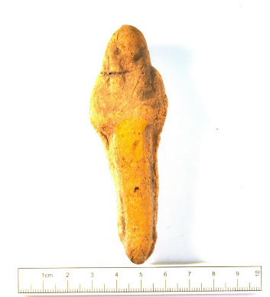  Ushabati - YORYM : 2010.751 1  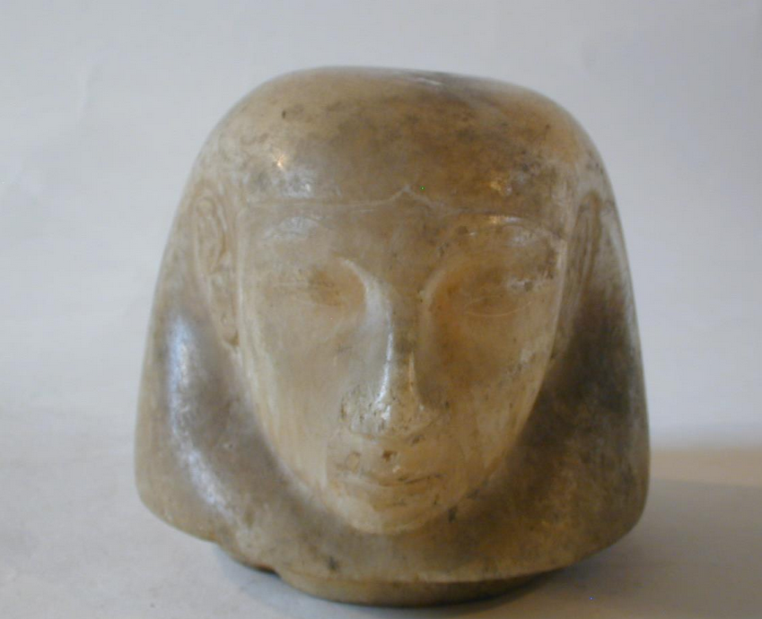  Canopic Vessel Cover - YORAG : 1436 1

When you have completed your proposal please email to: exhibitions@ymt.org.uk
Many thanks for submitting your proposal. We will be in touch once the proposal has been reviewed.

