The Global Business Environment: Part Two Fashion
Student Name: Anton Mersinkov ID: 2014039

Course Title: LCBB4005

Lecture: Gregory Cowan

University of Wales Trinity Saint David

Date: 07.05.2021

BBE Part Two Fashion
The fashion industry represents a significant part of the world economy because it employs more than 300 million individuals across the globe (Gazzola et al., 2020). The firms in the sector operate in a highly competitive market that is dominated by global brands. Although the world experienced a financial crisis in the last decade, the industry has continued to grow (Gazzola et al., 2020). Also there are numerous transformations experienced in the fashion sector, for instance, the quantity of companies operating in the industry has continued to increase. The fashion industry presents opportunities to search both the old and young generations. Therefore, firms need to satisfy consumer requirements due to diversities present in the global and domestic markets. Fashion companies are also impacted by political instability and economic uncertainty that has reduced the level of consumer spending. People are looking for customized products and it is predicted that they will be offered at lower prices in the coming years. Other factors impacting the fashion industry include natural disasters, terrorist attacks, and new epidemics (Roberts-Islam, 2021). A combination of the issues has major consequences not only to the firms but also the local communities where businesses are located.
A major epidemic that has impacted the fashion industry is COVID-19. It affected all levels of the supply chain including manufacturers, retailers, and consumers. Some companies have also closed down due to reduced demand for apparel. Big corporations are trying to minimize their production costs and maximize profits and so they exploiting their workers. There has been massive closure of stores located in the high streets (Orlova, 2021). Fast fashion firms are using online sales tactics to reach wider audience and provoke more purchases from the customers. For instance, many brands have been offering up to 70% sales discounts to attract buyers since they cannot open their physical stores. (Open Access Government, 2021). Furthermore the advanced social media tools such as Facebook and Instagram advertising and google ads are becoming more and more powefull marketing tools.
In the light of the description, this essay will conduct a thorough scan of the changes that have taken place in the fashion industry with emphasis on H&M’s business model and evaluate how the transformations will earn the organisation a competitive advantage. Furthermore, relevant recommendations will be provided to the management to ensure that the company attains a top position in the market, especially during the COVID-19 pandemic.

H&M
H&M (Hennes & Mauritz) is one of the largest brands in the fashion sector. The company mostly deals with fast fashion products (Momin, 2021). Fast fashion is a term that is used to refer to commodities that are replicated from expensive brands by producing them from cheaper fabrics and low-paid labor. The trends are also sold to consumers at reduced costs to ensure that producers earn high profits. H&M is an inspiration to many since it was initiated as a small in Sweden and has now grown to a leading multinational company that operates in 74 countries and with 5000 outlets (Momin, 2021). H&M sells a variety of products for all generations from children to the elder population and for all genders. The company has changed its business strategy and now focuses on key areas such as customer satisfaction.
One of the current changes made by the business to promote its market positioning is the diversification of products. When the company was first opened, it would sell women's apparel. The retailer is now selling clothes for everyone and in different varieties including shoes, cosmetics, accessories, candles, and decor pieces (Momin, 2021). The company also introduced other brands under H&M that operating with unique identities that are popular to consumers. The strategy was made to target specific customer groups. The company has also opened branches in different countries and its global presence has made it develop a strong competitive advantage compared to other firms in the industry. H&M has also adjusted its prices to ensure that supplies earn justifiable profits.

Evaluating H&M using PESTLE Analysis
PESTLE analysis is a framework that is used to describe the forces in the market that impact businesses. The approach is an acronym for political, economical, social, technological, legal, and environmental factors that affect businesses. The framework involves the variable in a company’s macro-environment that affects a company’s competitiveness.
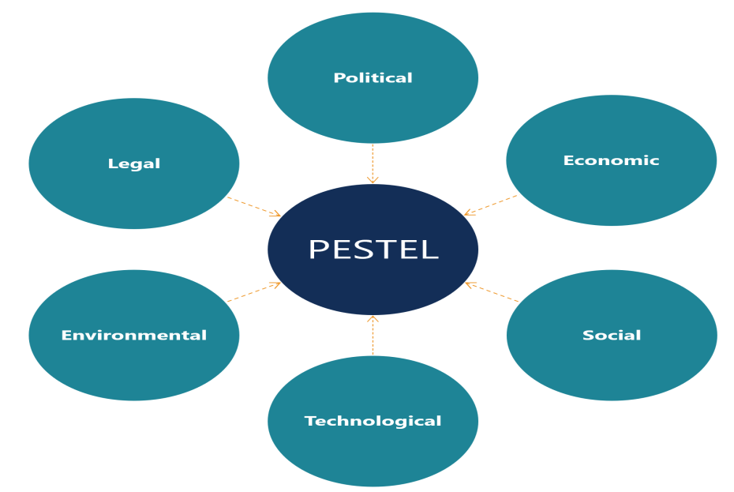
Fig 1: External factors affecting the fashion industry

Political
Political factors describe the extent to which policymakers influence the commercial environment through trade regulation, labor laws, environmental regulations, and taxation (Rastogi et al., 2016). Government regulation can have either a positive or negative influence on businesses. The major political factors that have impacted H&M in the past two years result from COVID-19 protocols. In the past decade, the fashion industry had experienced economic consistency and high performance especially in developing nations like Asian countries. However, with the current Coronavirus pandemic, the government has imposed restrictions to fight the spread of disease thereby impacting consumer buying patterns. Besides, policymakers have advised people to work from home to promote physical distancing. The restrictions have led to the closure of business and H&M was deeply impacted. The company recently announced that it would close 70% of its stores across the globe.

Economic Factors
Monetary factors affect business profitability and the effectiveness of the industry. The most common economic threat is Dross Domestic Product (GDP) that is measured through assessment of purchasing power parity (PPP) to foster equitable comparisons among different nations (Rastogi et al., 2016). Besides, GDP can be used to establish per capita income that influences the buying power of consumers. Even though people have lost jobs during the pandemic, many fashion companies have augmented the prices for their products. H&M has responded to the pandemic by adopting a price leadership strategy where the cost of its commodities is lower compared to that of other firms in the industry (Momin, 2021). Currently, the company is selling is high-quality goods at a relatively low price.

Social
Social factors determine consumer patterns, tastes, buying patterns, and volumes of products demanded (Rastogi et al., 2016). For instance, due to COVID-19 restrictions, people have changed their buying patterns and are currently purchasing products through the internet. H&M has managed to maintain a strong online presence on different platforms to attract consumers (Momin, 2021). People are also demanding sustainable products. Therefore, has adopted sustainable purchase practices to purchasing from genuine supplies that care about garment quality.

Technological
The rapid technological changes that are driven by innovation have resulted in the transformation of fashion supply chains. Therefore, the adoption of new technology is imperative because it earns companies and competitive advantage. For instance, the proliferation of e-commerce and internet use has resulted in increased consumption of fashion products because people view products through various platforms. H&M has responded to challenge through improved branding and adoption of e-commerce in its operations (Momin, 2021). The strategy has led to improved brand awareness, the attractiveness of the company’s products, and increased profitability.

Legal
Legal factors include laws and regulations that are imposed on businesses including taxation and employment laws. For instance, H&M must maintain workers' rights because many fast-fashion products are made in developing nations whereby manufacturers depend on cheap labour. Therefore, consumers are boycotting such products. Additionally, there is ongoing activism against fats fashion products because they produce there not durable. Therefore, during this COVID-19 era, H&M should concentrate on sustainable products to minimize negative impacts on its supply chain.

Environmental Factors
Fast fashion products like the ones sold by H&M have detrimental effects on the environment. However, the company has recently changed its strategy and adopted a comprehensive approach ad the key pillar of the success of its business. The rationale for environmental sustainability was founded upon the realization that the production and supply of fast fashion products have a detrimental impact on the ecosystem (Oral, 2019). Currently, the company has initiated a program for recycling products aiming to reduce the disposal of garments in the environment. The move has improved the company’s competitive advantage because celebrities have joined H&M in advocating and creating awareness about sustainability.

Product Life Cycle
The product life cycle is a strategy that addresses the overall phases of goods from conception until their disposal. The strategy is applied because it tries to reduce energy losses, workforce, and materials. The product life cycle for fast fashion companies is very short and includes designing, producing, delivering, and selling to the final consumers. H&M introduces goods that have been manufactured by its suppliers and are easily accepted in the market because the company deals with fast moving products. However, sales eventually stabilize due to high competition and the introduction of new products by competitors. Later, the products enter a decline phase due to the entry of substitute goods in the market. Therefore, sales and profits reduce and the company realizes a recession.
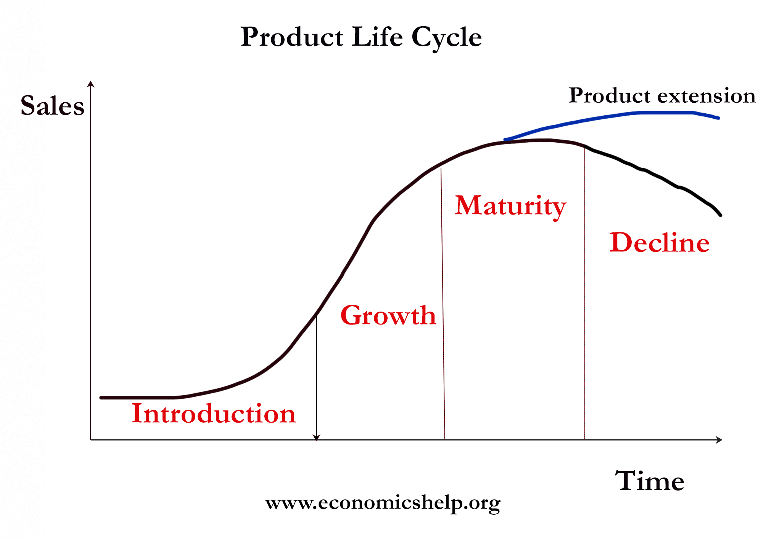
Fig 2: Product Life Cycle
The clothing industry has two features, which are fast fashion and fad and H&M belongs to both. In this case, products take 21 days from the time designed to maturity. Therefore, clothing mostly stays in the stores for about two weeks, and then new products are introduced. H&M uses different strategies including segmentation, targeting, and brand positioning to respond to market forces. Besides, the company strives to maintain a high position in the market due to the presence of other companies including ZARA that sell similar products. Its positioning strategy has proved effective because it enables the firm to create a positive image that will enable it to occupy a competitive position. H&M is also concerned with ensuring the different customer segments perceive its products differently compared to those of other players in the industry.

Product Sustainability
The 21st century has experienced transformations in the fashion industry. There is an increase in consumer spending and the reducing costs of production. For instance, the number of apparel bought each year is has doubled and fast fashion has become a hot segment in the sector. Therefore, companies have resulted in the use of unsustainable production methods that lead to negative impacts on natural resources. For instance, the manufacture of clothes requires a lot of water while the chemicals used to produce dyes emit high amounts of greenhouse gases (Remy, Speelman, and Swartz, 2016). Therefore, H&M has adopted a transparency approach to ensure that people are aware of how and where their products are made as a way of helping consumers to be more sustainable (H&M, n.d.). Therefore, clients can make informed decisions about the products that they purchase since they are confident that the goods were made concerning environmental protection. Additionally, the company publishes its suppliers on the website and also educates people on the need to recycle clothing (H&M, n.d.). Such strategies have been imperative in attracting consumers and earning a competitive advantage since people are increasingly getting concerned about care for the environment.

Porters Value Chain
The strategy is concerned with the conversion of inputs to outputs that can be purchased by consumers. Porters looked into inbound logistics that include the processes of receiving, storing, and input distribution. Operations involve a set of activities that from manufacturing to finished goods. Outbound logistics are the activities regarding the delivery of products to final consumers. Marketing and sales are the persuasions of clients to purchase from the company instead of competitors while service is the activities for maintenance of the value of the product or services once purchased by clients. Other important aspects of Porter's value chain include procurement, human resource management, infrastructure, and technological development. 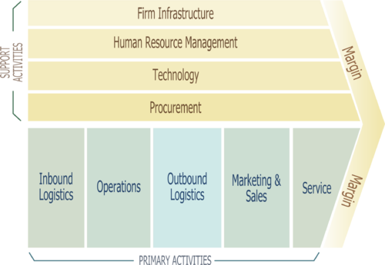
Fig 3: Porters Value Chain

H&M has an efficient infrastructure that can enable it to optimise its value chain, especially during the current COVID-19 outbreak. The company practices effective human resource management by recruiting, selecting, and hiring the best employees. Additionally, H&M is technologically advanced. For instance, it has technology-supported customer service, data analytics, and conducts product design research. The procurement of company products is carefully done especially in the operation, outbound, and inbound value chain. Therefore, H&M has achieved cost efficiency, differentiation, and gained a competitive advantage in the market.

References
Fashion Revolution, 2020. The impact of COVID-19 on the people who make our clothes - Fashion Revolution. [online] Fashion Revolution. <https://www.fashionrevolution.org/the-impact-of-covid-19-on-the-people-who-make-our-clothes
Gazzola, P., Pavione, E., Pezzetti, R. and Grechi, D., 2020. Trends in the fashion industry. The perception of sustainability and circular economy: A gender/generation quantitative approach. Sustainability, 12(7), p.2809.
H&M, n.d. Product sustainability. [online] H&M. <https://www2.hm.com/en_gb/customer-service/product-and-quality/product-sustainability.html> [
Momin, A., 2021. H&M SWOT Analysis: 7 Threats Hennes & Mauritz is facing. [online] PESTLE Analysis. https://pestleanalysis.com/hm-swot-analysis/
Open Access Government, 2021. Impacts of COVID-19 on the fashion industry. [online] Open Access Government. <https://www.openaccessgovernment.org/covid-19-fashion-industry/89851/>
Oral, E., 2019. Sustainability challenges of fast fashion: Environmental and social impacts of cotton growing and the ready-made garment industry in Turkey. Yuridika, 34(3), pp.443-466.
Orlova, D., 2021. How will COVID-19 change the fashion industry?. [online] Newseu.cgtn.com. Available at: <https://newseu.cgtn.com/news/2020-05-05/How-will-COVID-19-change-the-fashion-industry--QdWaZBwGCQ/index.html>
Rastogi, N.I.T.A.N.K. and Trivedi, M.K., 2016. PESTLE technique–a tool to identify external risks in construction projects. International Research Journal of Engineering and Technology (IRJET), 3(1), pp.384-388.
Remy, N., Speelman, E. and Swartz, S., 2016. Style that’s sustainable: A new fast-fashion formula. McKinsey & Company, [online] <https://www.mckinsey.com/~/media/McKinsey/Business%20Functions/Sustainability/Our%20Insights/Style%20thats%20sustainable%20A%20new%20fast%20fashion%20formula/Style-thats-sustainable-A-new-fast-fashion-formula-vF.pdf>
Roberts-Islam, B., 2021. Social sustainability, Overstock and ‘greenwashing’: How COVID-19 is changing the fashion industry. [online] Forbes. <https://www.forbes.com/sites/brookerobertsislam/2020/04/21/social-sustainability-overstock-and-greenwashing-how-covid-19-is-changing-the-fashion-industry/?sh=4d4c538f582d>

