Sports Infrastructure, Design and Operation
(BSM5010)

Cole Darley

Contents:

Task A 3 - 6
Task B 7 - 8
Task C 9 - 15
Task D 16 - 17
Task E 18 – 21

References 22

Task A
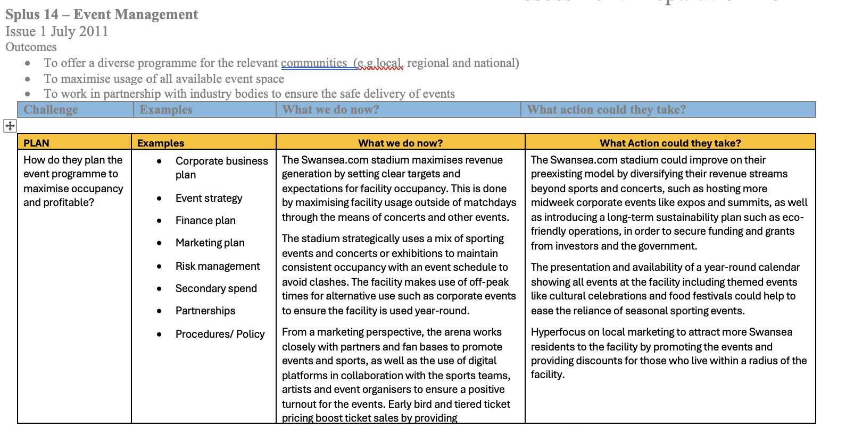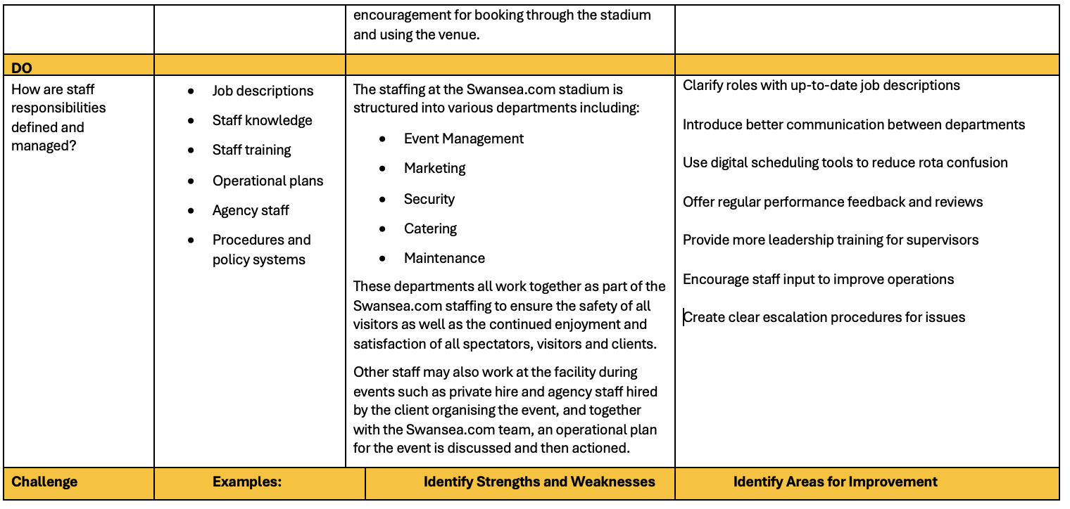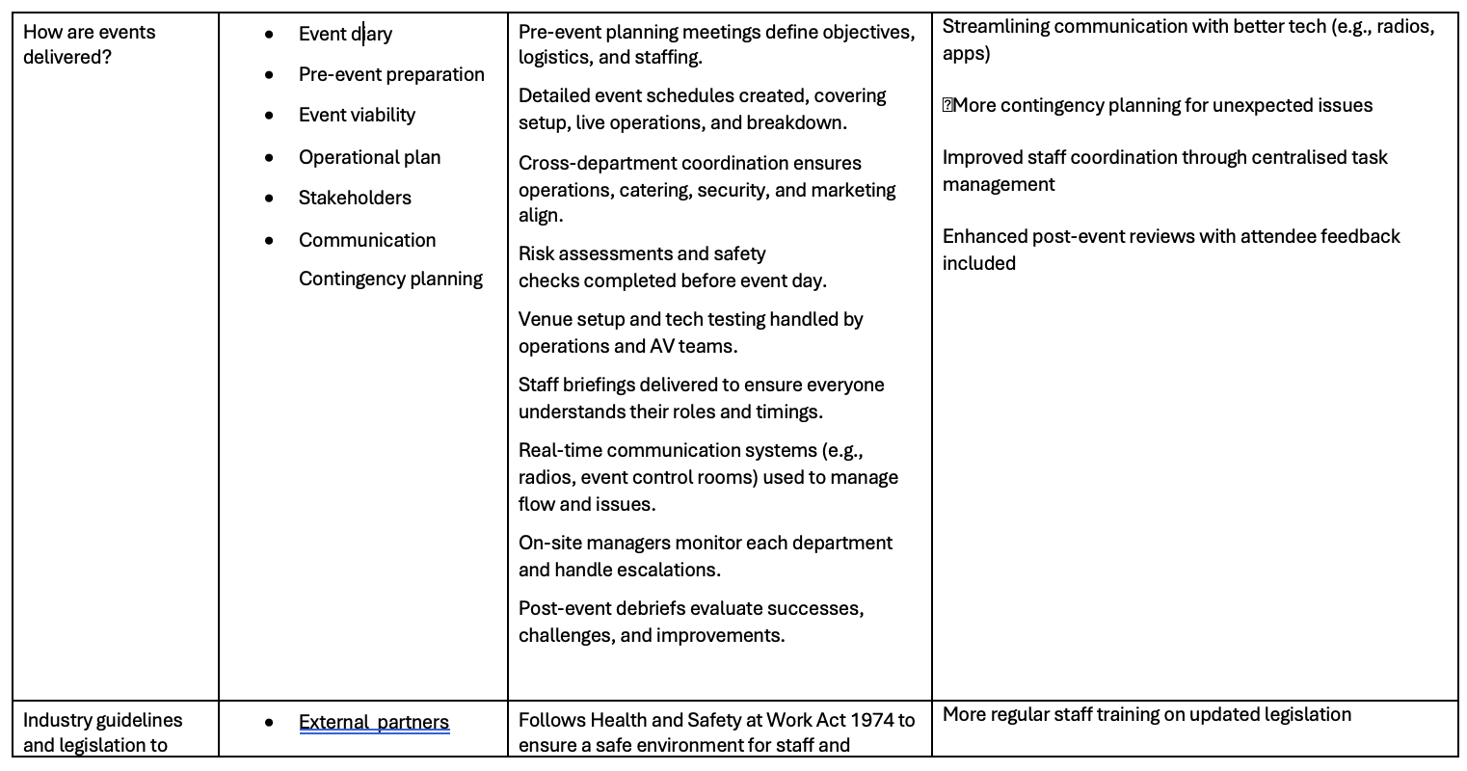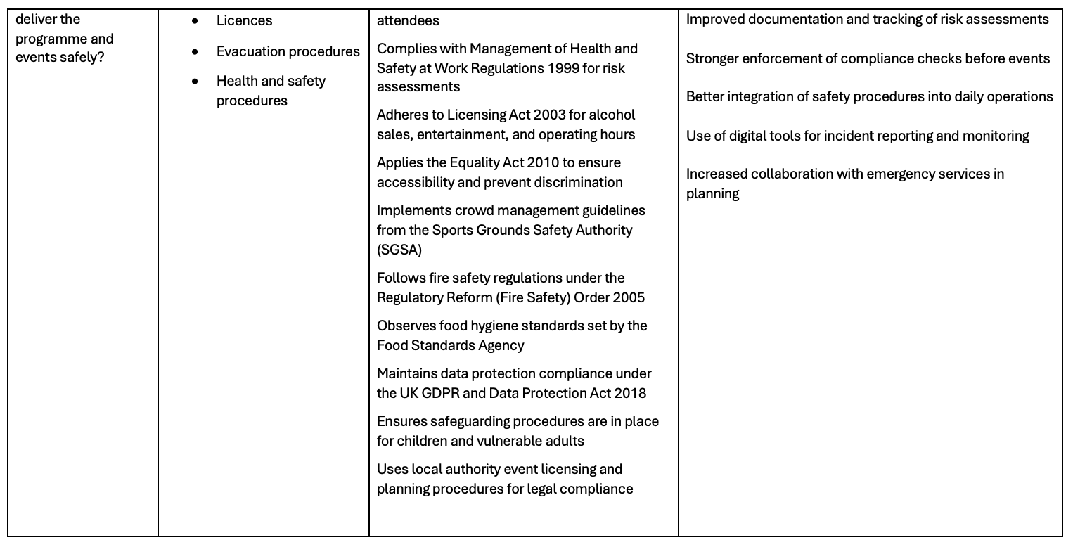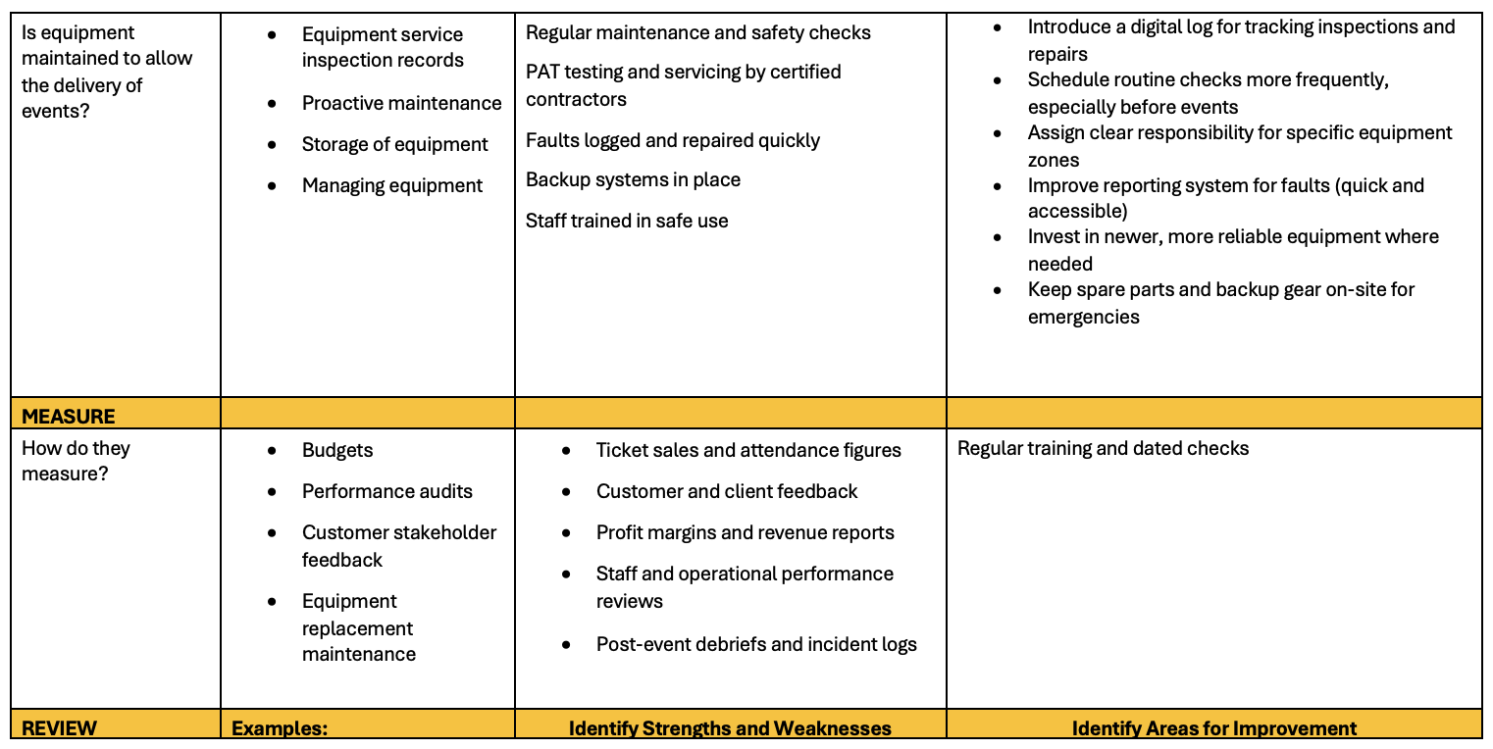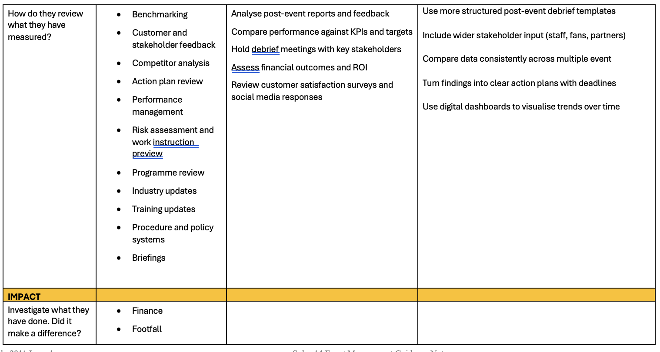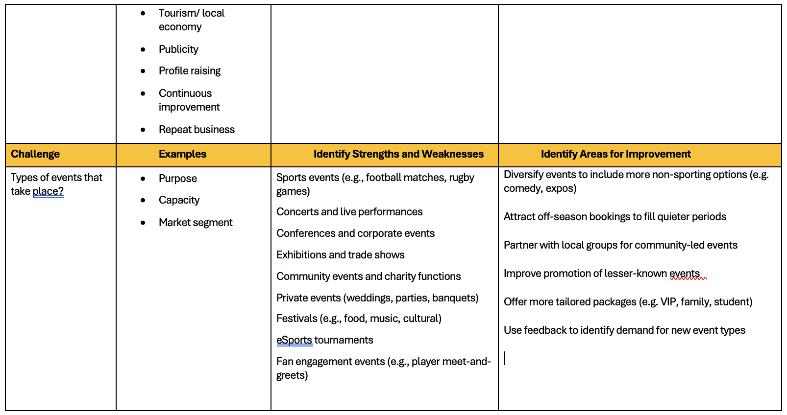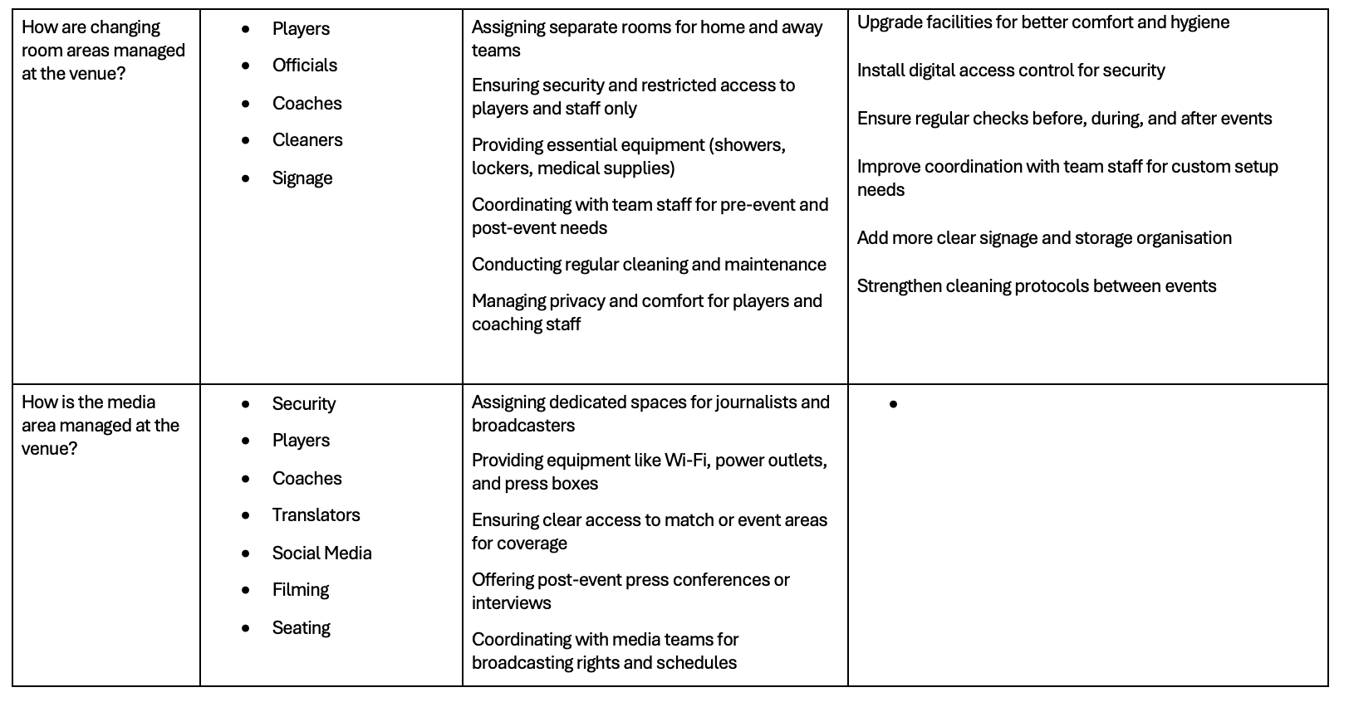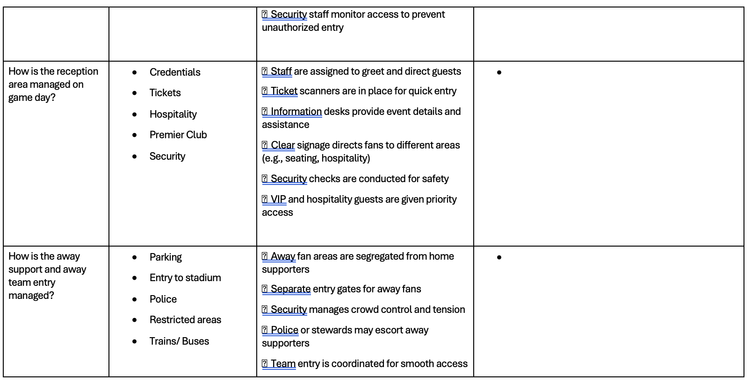
Task B 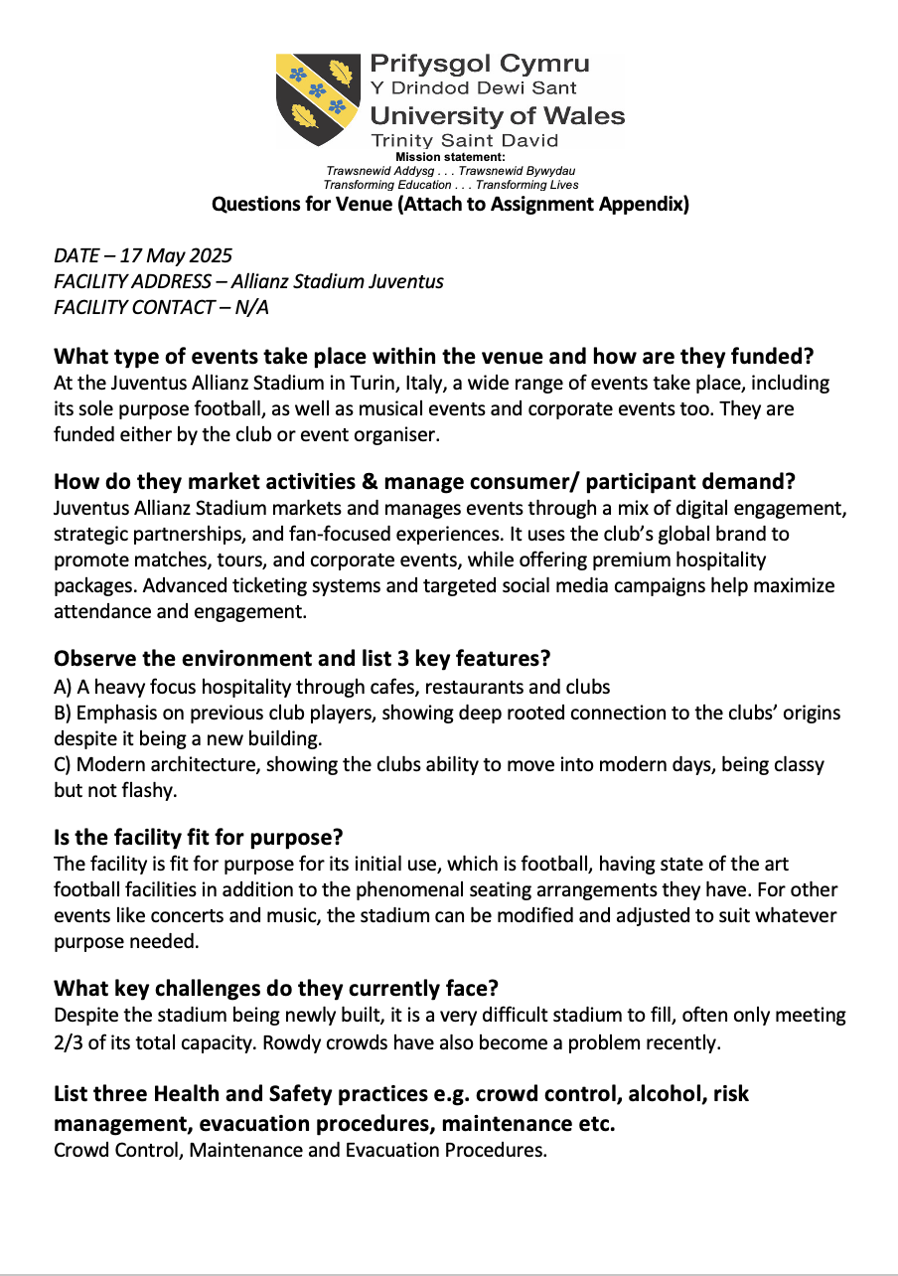

Task C

Before we start, it is to be noted that the sample size of this survey is only 50 responses, which is rather small and potentially biased and misleading. Due to this reason, each question and response will be approached with caution and open-mindedness.

Graph 1.1

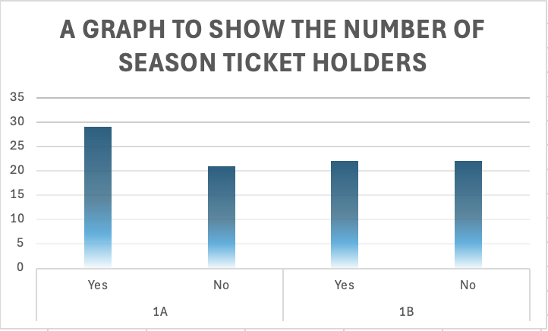

This bar graph represents the number of participants in the survey who were season ticket holders. Of 50 participants, all answered this question, with 29 being a season ticket holder, and 21 not being a holder. This is interesting as it does suggest that fan engagement is high for Swansea City AFC, with over half of the fans taking this survey being seasonal ticket holders, however, there is questioned to be made about why fans who supported the club enough to complete a survey did not hold a season ticket.

The second set of data in this this bar graph represents the number of participants in the survey who either knew about the ability to exchange tickets for fixtures they could not attend or not. The idea behind this concept, is that the spectator can return their seat for sale again if they can no longer attend the match. By the responses to this question, it is clear that a significant number of participants from the survey were unaware of the opportunity to exchange a ticket in this way and raises concerns over Swansea City and Swansea.com’s promotion and guidelines on ticket purchases and refunds.

Graph 1.2

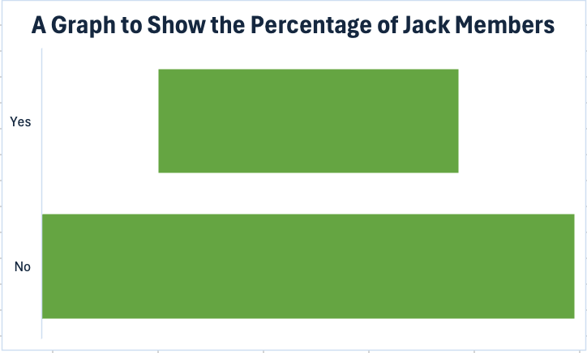

This graph shows the number of Jack Members who took the survey, and with the numbers coming out at 18 who were and 32 who were not, it is clear there is not enough incentive to become a member. From my research, becoming a member costs roughly £30, and provides members with the opportunity to take part in events, acquire merch for discounts, among other opportunities.

Graph 1.3

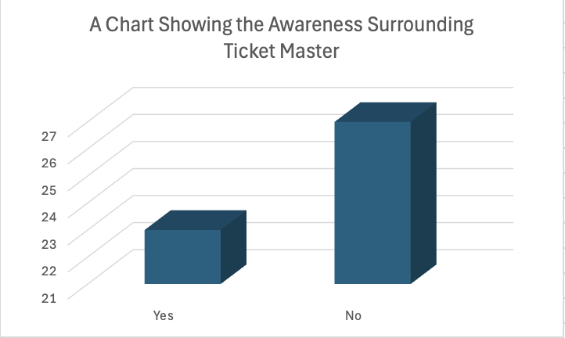

This graph shows the awareness of fans taking the survey about the introduction of ticket master at the start of the 2014/15 season. There were more fans who were unaware of the introduction of Ticketmaster than were, and this is potentially a failure on Swansea.com’s behalf.

Graph 1. 4

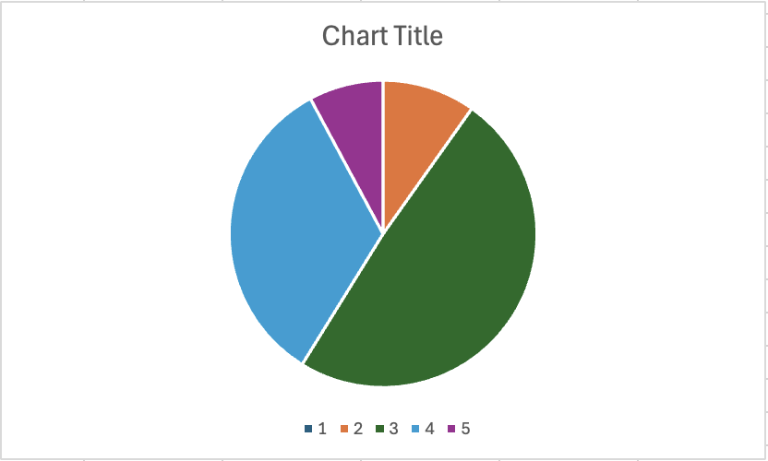

This graph shows that the majority of fans, being 24/50 or 48%, ranked their experience with tickets this season as a 3/5. This suggests that the experience was not terrible, but it could be improved on. No fans voted for a 1 and only 5 voted for a 2/5, which suggests that the general experience was positive. 17 voted for 4/5 and then an insignificant 4 voted for 5/5, so there were clearly still some minor improvements to be maxe. Likely, on of the major issues was the lack of knowledge about the online ticketing serice being offered.

Graph 1.5


This graph illustrates how fans of the Swans acquire their tickets, whether it be in person, by website or over the phone. While only a small percentage purchase tickets over the phone, website and in person both had 22 votes each, which is because there was one double vote for both website and in person. This shows that some fans do not limit themselves to just one opportunity of getting tickets.

Graph 1.6

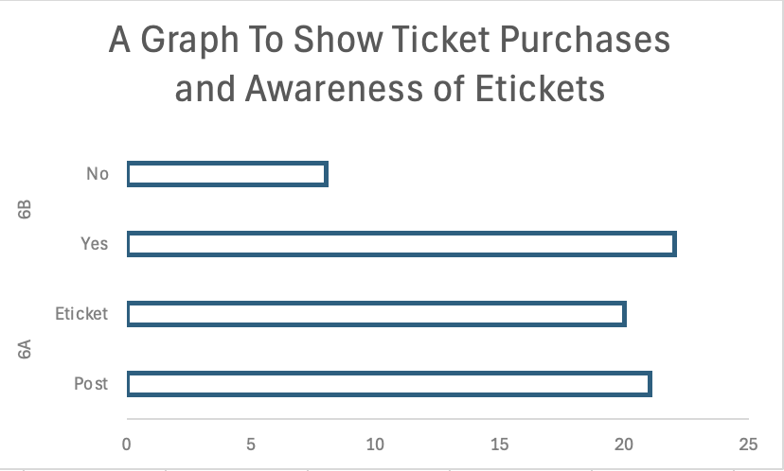

6a of this graph displays the number of survey participants who accessed tickets through an E-ticket service like ticket master vs received them by post. From the data we can see that 21 participants received their tickets by post, and 20 received them digitally. This shows that both methods are still popular. 6b, was aiming to highlight the lack of knowledge about tickets if participants had answered no to 6a, however, many participants answered both questions after answering yes to the first. This suggests that the information may be incorrect as 22 had answered yes, but many of those figures had evidently already known as they had voted E-ticket in the previous part.

Graph 1.7

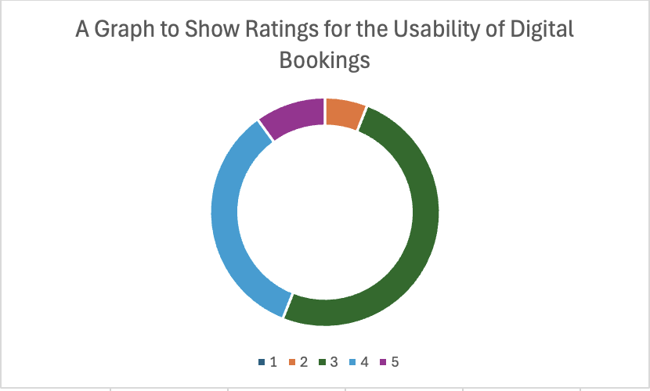

This graph displays the opinions about online booking and the usability of the website in which bookings can be made. As with the last ranking question, the majority of votes are placed on 3/5 with this option pulling exactly 50% of the votes. The other 50% are split between 2, 4 and 5, with the majority of which being on the upper percentile of the opinion. This is positive, showing that those who have used online booking have had a good experience.

Graph 1.8

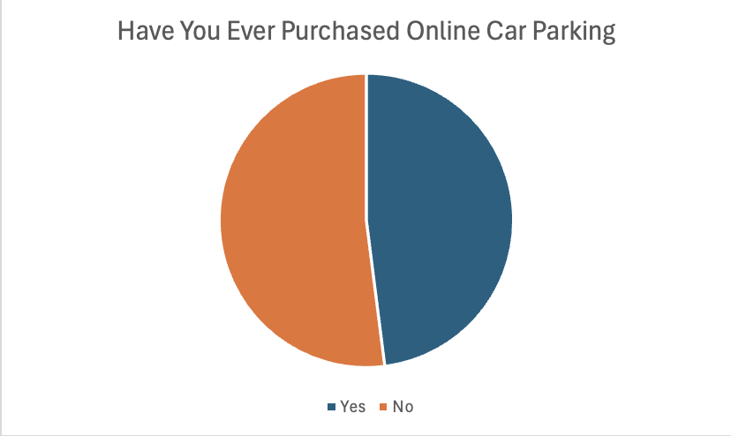

This question garnered an almost perfect 50/50 split, however it was rather 26:24 instead and this is due to a few reasons. Within the text field below this question, many answers about either not having a driving license, not needing to drive as the journey was walkable, or ride sharing to the venue, thus not needing to pay for parking.

Graph 1.9

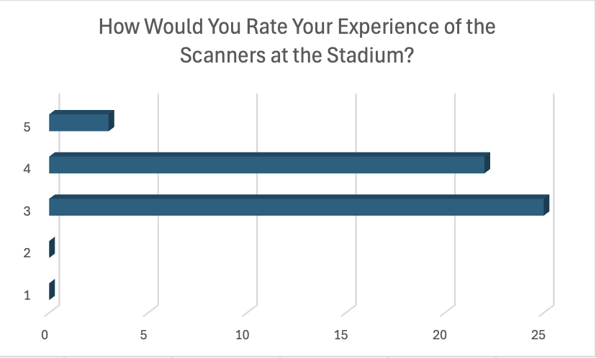

This question is asking about turnstile and gateway entry to the stadium and how user friendly they are and the experiences that visitors and fans have had while attending events at the stadium with the machines. It is clear from the graph that the majority of people have had positive experiences with it, with no surveys suggesting they were inherently bad. As with most of the survey results with questions rating 1-5, the majority of votes went central to 3, which is a common happening on these types of questions.

Graph 2.0



This graph clearly shows that there is demand for prebooking food, drink and other beverages at a discounted price before the event online.

Graph 2.1

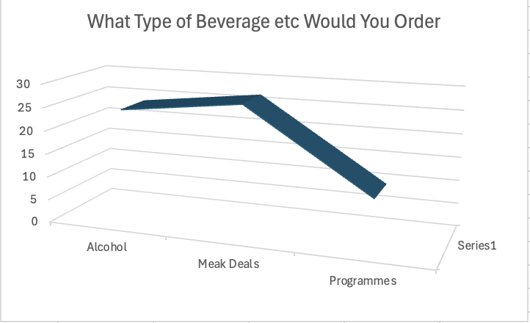

This final graph from the survey shows that people would most like to pre purchase alcohol and meal deals from the stadium on match day, if it meant they were entitled to a discount.
Task D

The ‘Be Active Wales” fund is a funding opportunity for not-for-profit sports clubs and organisations across Wales (Sport Wales, n.d.). It is supported and funded by the National Lottery and can offer up to £50,000 in grants to help clubs open, run and operate effectively, sustainably and without worry. The fund can cover clubs for anything from equipment, coaching courses, venue hire and improvement to facilities. The applications for such a course are run in application windows, due to the high application rates. This is a high incentive and reason for sports development in Wales and allows for community sports to grow and develop naturally with the support of the National Lottery.

Sport Wales is in charge of the development of sports in Wales, and as of January 2024, they had pledged to spend £3 million on improving community sports facilities and leisure centres. By this point, over £1.8 million had already been awarded to local authorities and leisure trusts to improve centres, making them more energy efficient, which allow activities to remain cost affordable for communities to enjoy. However, a further £1.3 million was awarded to some 13 projects such as athletics and basketball opportunities and clubs. Of the £3 million proposed spending, £123,000 was awarded to Blaenau Gwent to improve the air handling unit, Bridgend was receiving £100,000 for Ogmore Valley Centre, among many other centres and improvements. Other locations to invest in include Cardiff, Conwy, Gwynedd, Neath Port-Talbot, Pembrokeshire, Powys and Swansea under Freedom Leisure, Vale of Glamorgan, and many more.

In September of 2024, over £500,000 was invested to sustain sports facilities in Carmarthenshire. The largest developments of this investment were the introduction of a new 3G pitch and the Llandovery Rugby Football Club. The community led initiative, is to be accessible by local sports clubs and schools. Other improvements included LED floodlights, spectator viewing areas, and new pathing surrounding the pitch. Other key investments include the installation of a new PA and Solar Panels for the New sports club Carmarthen Town Football Club as well as improvements to multiple other pitches and sites. Felinfoel RFC is also receiving new floodlights, and Tumble RFC is receiving funding for a professional team of experts who will oversee the development of a new facility to work alongside the existing facilities in place, while keeping the community at the centre of the focus.

South Wales sees sport development in a range of ways and for a range of reasons. From mass investment in sporting facilities in various counties, by various organisations and government schemes, to the development of facilities and clubs alike, there are many reasons for the development of sports in South Wales and the following are some of the leading factors. Sports is developed and driven by many factors including the desire to promote physical activity and overall health and wellbeing. This is seen in NHS Wales’ guidance on physical activity expectancy as well as Swansea Sport and Health Teams schemes and projects. Antoehr reason for the develpkment is community engagement and development, in addition to healthier communities. If there are healthier communities, it means that there is potentially less strain on the NHS, leaving room to lighten the budget for the NHS and in turn sports to continue the cycle. As for community engagement, by promoting sports and facilities, it allows to potentially prevent children and young people from getting involved with crime, by keeping them in sports clubs, giving them guidance, mentors, figures to look up to, among other benefits.

Task E 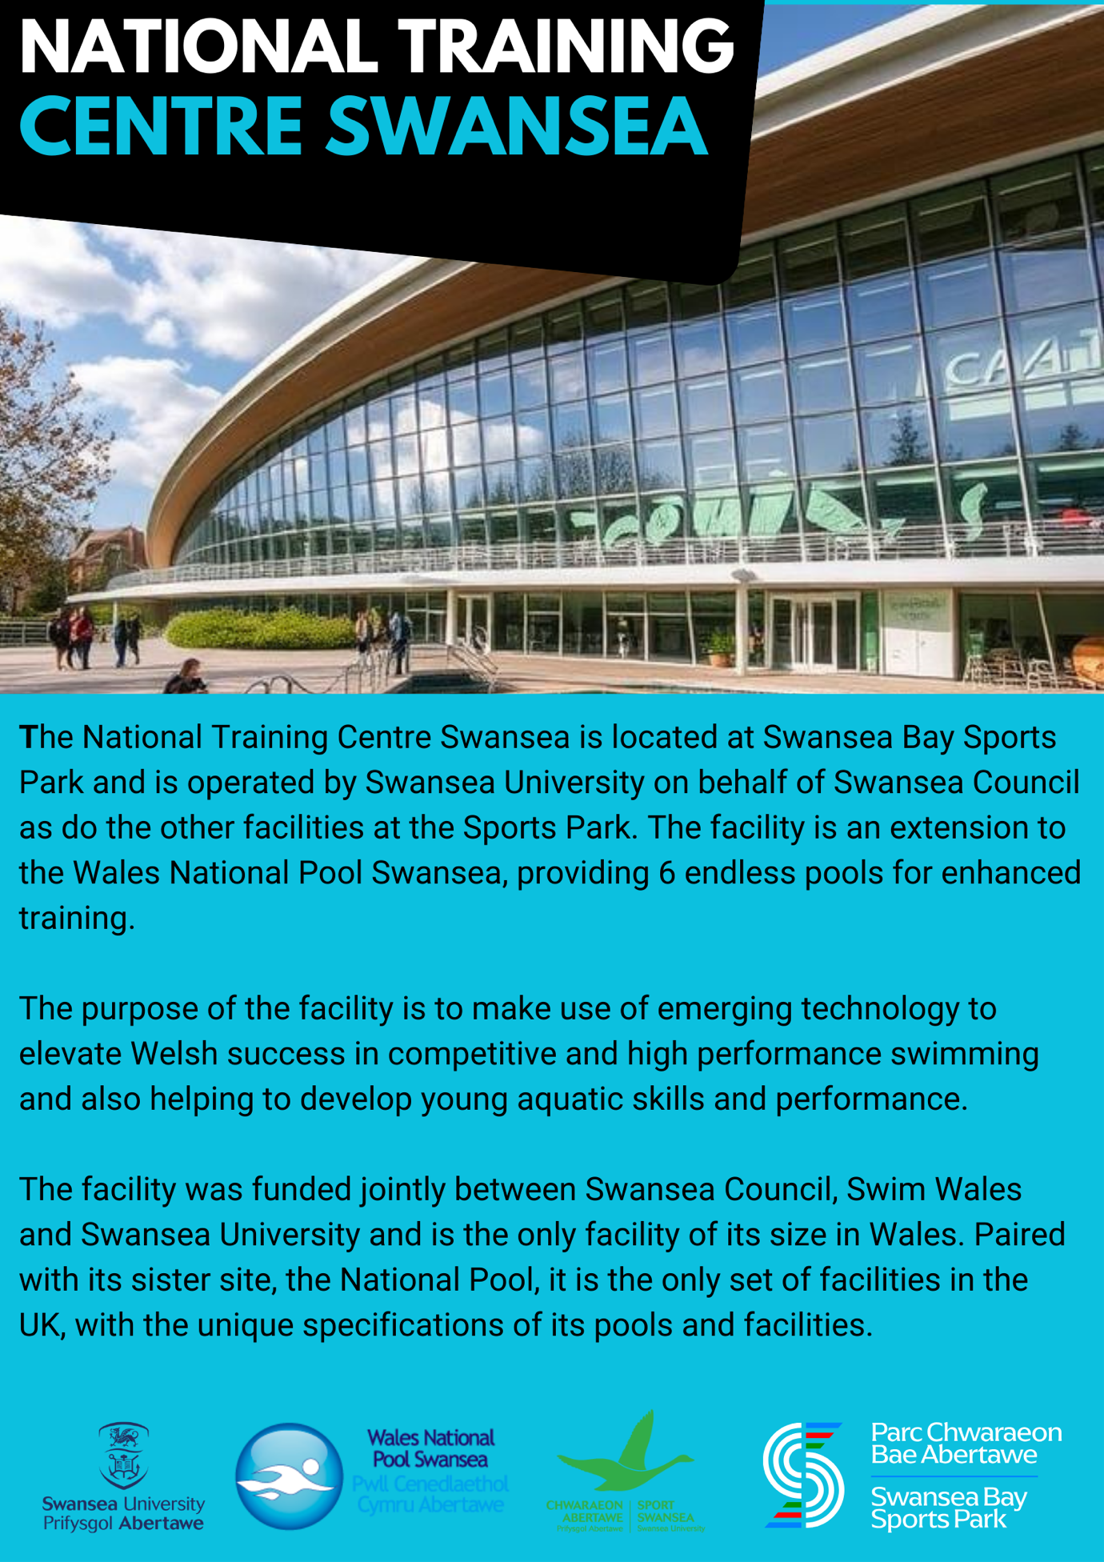
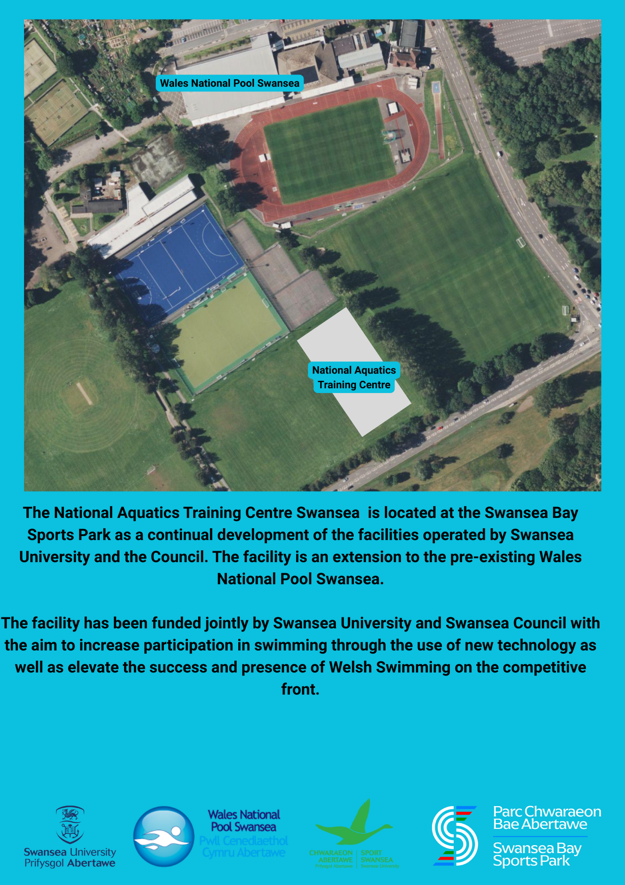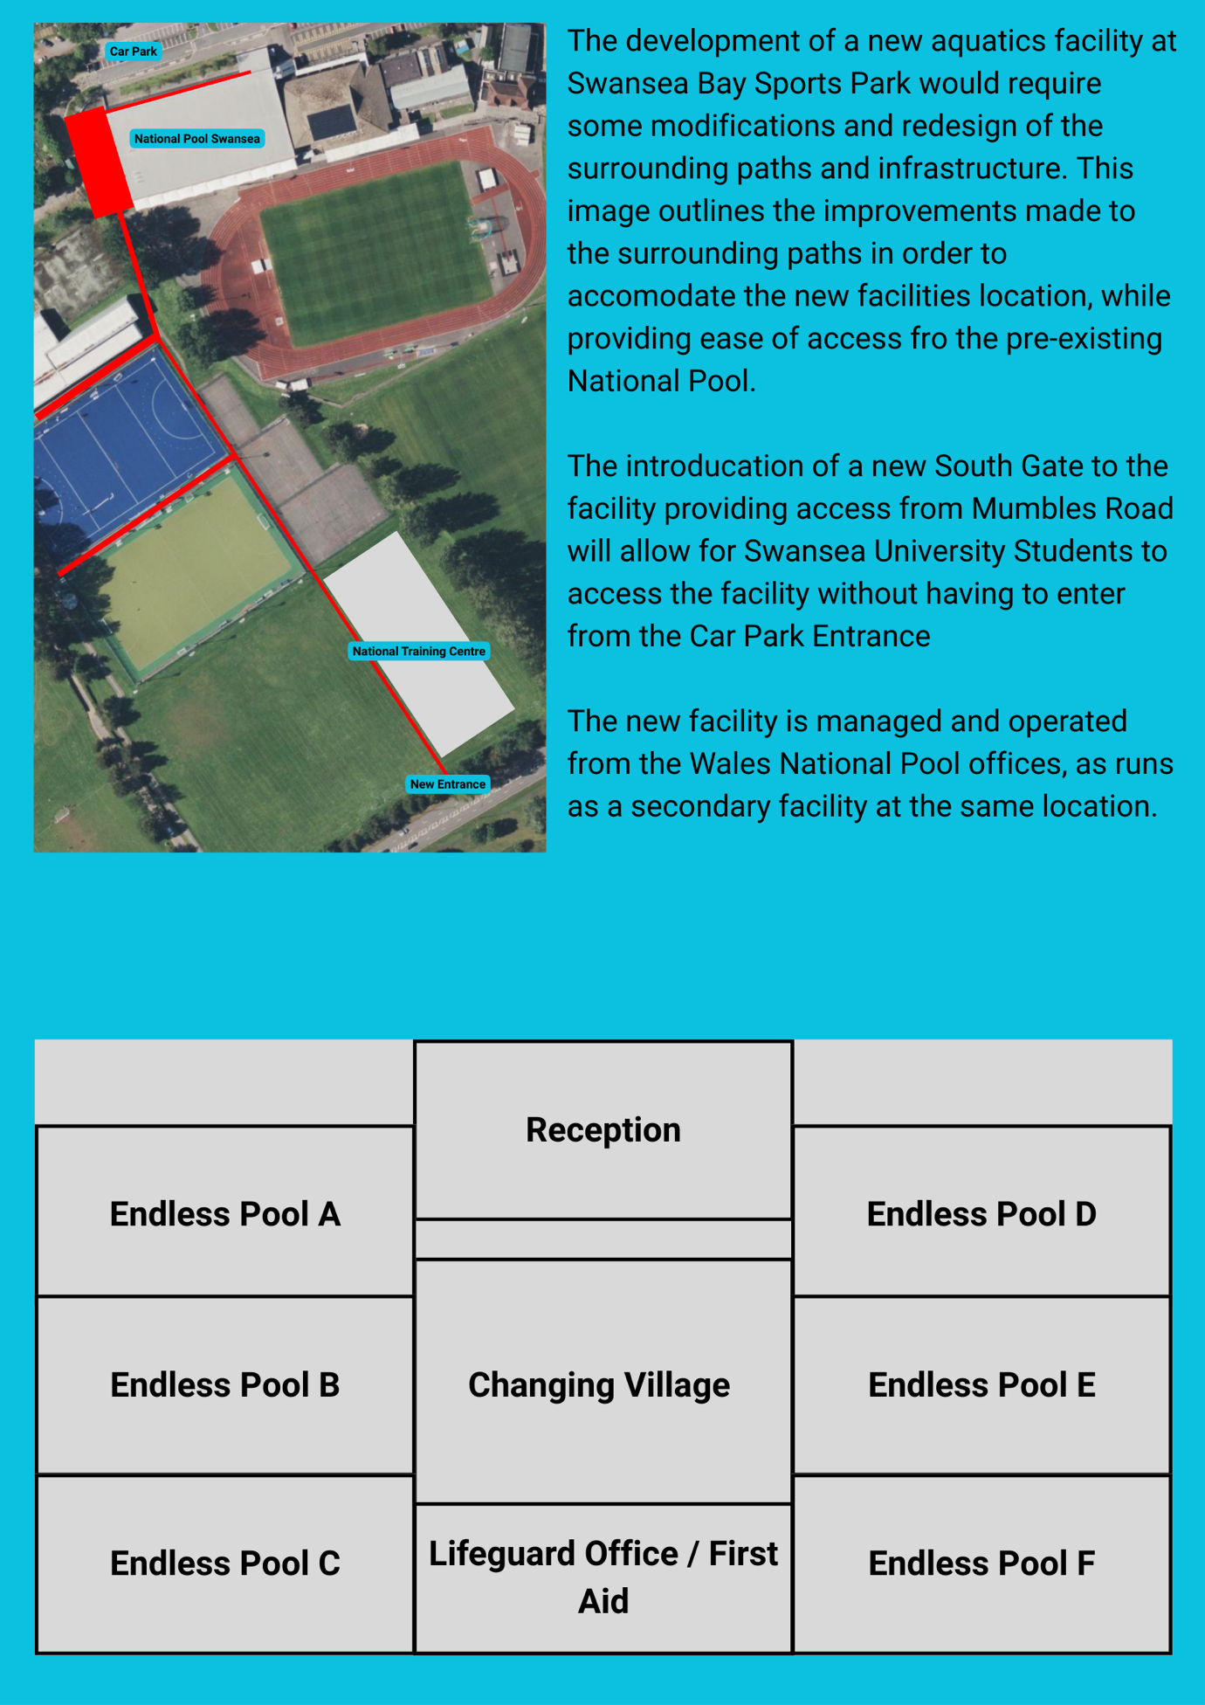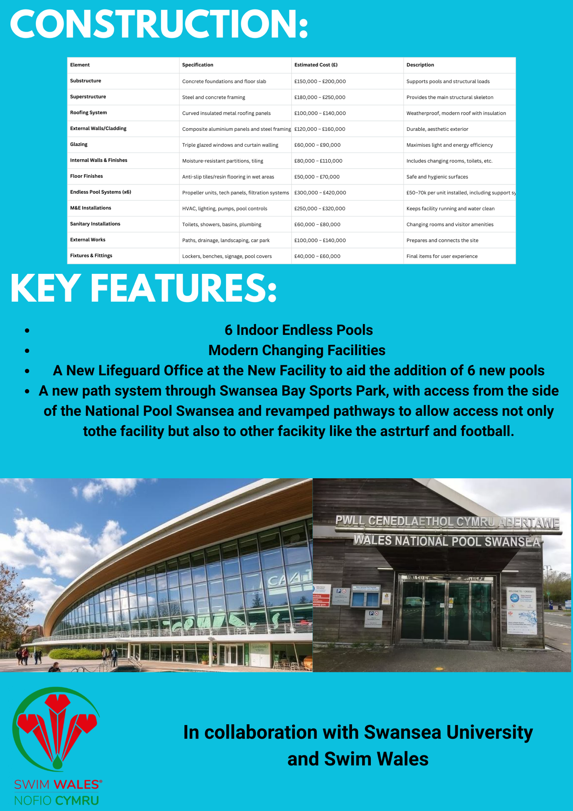

References

Sport Wales (2024) How £3m will be spent on improving community sports facilities and leisure centres. [Accessed: 17.5.2025] Available at: https://www.sport.wales/media-centre/latest-news/3m-spent-on-improving-sports-facilities-and-leisure-centres/

Sport Wales (n.d.) Be Active Wales Fund. [Accessed: 17.5.2025] Available at: https://www.sport.wales/grants-and-funding/beactivewalesfund/#:~:text=The%20Be%20Active%20Wales%20Fund%20offers%20grants,Wales%20to%20improve%20access%20to%20physical%20activity

Carmarthenshire News Online (2024) Investment of over £500,000 to Sustain and Enhance Sports Facilities in Carmarthenshire. [Accessed: 17.5.2025] Available at: https://www.carmarthenshirenewsonline.com/carmarthenshire-county-council/investment-of-over-500000-to-sustain-and-enhance-sports-facilities-in-carmarthenshire/

