Coexistent Perspectives Essay

By Katie Richards

Submission date: 28-April 2023

Title:

The Role of the Sublime in Contemporary Art in the Anthropocene Age

Name: Katie Richards

Student Number: 1902311

Programme: MA Contemporary Dialogues – Part-time

Module: Coexistent Perspectives

Module Code: ADCD7001

Supervisor: ROB JONES

Submission Date: 28TH April 2023

Word Count:
(Excluding title page, table of contents, list of illustrations, in-text chapter titles, in-text image references & bibliography)

Table of Contents

Introduction. Page 4

Theoretical Discourse of Sublimity. Page 6

James Turrell Page 13

Mariele Neudecker Page 20

Conclusion Page 27

Bibliography Page 29

List of Figures Page 31

The Role of the Sublime in Contemporary Art in the Anthropocene Age

Introduction

“Without a recalibration of the senses, at the level of our global species-being …. we cannot conceive of another mode… [of co-existence] …between ourselves and the earth.

That is why we send pictures from deserts and write words on water …make earthworks that stand on the landscape of the mind. That is why we listen to the whispers of an eccentric planet….

The world is all, that is the case.”
(Raqs Media Collective in Davies & Turpin, 2015; 22)

The Sublime is a multi-sensory experiential phenomenon that is difficult to understand or define because it is elusive, multifaceted, and often overused with exaggerated or trivialised meaning. The earliest notion of a sublime experience was defined as one that is beautifully beyond representation, unimaginable, overpowering the senses with such intensity that, paradoxically, it evokes admiration and awe yet is poignantly disorienting and distressing, eliciting feelings of fear, fragility and finitude, insignificance in a void and a sensation of loss of control. In the words of Gaston Bachelard,

“resonances of [objects or images] are dispersed on the different planes of our life in the world, while the repercussions invite us to give greater depth to our own existence.” (Bachelard,1964,xxii).

The word ‘Sublime’ has been used within the philosophy of arts and aesthetics since the 17th century, to describe transcendence, terrifying awesomeness and the unimaginable: ‘Awe and Terror’ but from a safe distance. The concept has been debated ever since, gone out of favour and come back again. But how relevant the concept is in today’s anthropocentric world and more specifically whether it is possible to achieve sublimity in art will be investigated and explored in detail. By researching how philosophical inquiry of the sublime has evolved, been developed and shaped by the technological and scientific advancements of the Anthropocene epoch, from the discourses of Edmund Burke and Immanuel Kant to Timothy Morton’s idea of Hyperobjects, it is intended to critically evaluate how art can challenge the human biases pervading modernity by evoking feelings of sublimity.

Intrinsic to this research will be the consideration of this new epoch called the Anthropocene and how humanity’s anthropocentric reality of accelerating domination of the earth without responsibility has resulted in mankind being on a ‘collision’ course with the natural world. By making visible the interdependencies between humanity and nature, the ideology of contemporary art creating a new discourse in the aesthetics of the sublime, articulated through images, paintings, or sculpture, will be studied. Further enquiries include how art can “impart a stronger sense of the unpresentable” (Lyotard, 1997,81 in Shurkus, 2013,18), and “make seen what makes one see, not what is visible” (Lyotard in Morley, 2010, p.37), transporting the viewer beyond aesthetics to the limits of the imagination, attuning to and reflecting upon the new realities of the Anthropocene. This will be supported by considering the works of visual artists James Turrell and Mariele Neudecker.

Theoretical discourse of Sublimity in Contemporary Art

The word sublime originates from Latin prepositions ‘sub’ and ‘limis’ (sublimis), translated as ‘up-to’ and ‘oblique’ or boundary, meaning the metaphorical elevation to celestial heights. ‘The sublime’ was put forward as a rhetorical concept by Roman scholar ‘Longinus’ to describe human genius (the noble minded) in figurative speech, a powerful ‘force of language' that creates feelings of ‘grandeur, wonder and astonishment’ exerting threatening ‘invincible power’ over the hearer, uplifting their soul with domination, “tear(ing) everything up like a whirlwind.” (Shaw, 2006,13). Genius equated to the beautiful. Thus, the sublime and the beautiful were intrinsically linked. His writings, titled Du Sublime, translated by Nicholas Boileau in 1674, sparked a fascination of the powerful experiential affects and emotions of the sublime in the creative arts ever since. Artists began to explore the origins of sublimity, unencumbered by traditional cultures and conventions. And philosopher Edmund Burke published in 1757 a comprehensive enquiry of a coherent and systematic discourse on the sublime as an aesthetic experience, titled A Philosophical Enquiry into the Origin of our Ideas of the Sublime and Beautiful, which became the cornerstone for all philosophical enquiries since.

Burke theorised that the sublime wasn’t experienced when encountering the beauty in the vastness, magnitude, or power of nature. It was terror and a sense of obscurity or incomprehension emanating from objects that had the most powerful and profound effect on the mind, inducing a feeling of potential pain that ‘seems to endanger…survival’ (Morley, 2010,15) and characterised the experience as being sublime. This mix of fear and delight which overwhelms the mind, psychologically effecting the viewer, is ‘the ruling principle of the sublime’ (Morley, 2010,15) - yet it also strengthens the self. He theorised that there was contradictory perverse pleasure or “delight in sublime terror so long as actual danger is kept at bay.” (Shaw, 2006, 54) Furthermore, “art that alludes to a magnificence beyond all capacity of measurement, assessment, or reproduction …[is] an artistic effect productive of the strongest emotion the mind is capable of feeling.” (Burke, 2008,36 in Shurkus,2013)

German Philosopher, Immanuel Kant, further explored and developed the idea that the sublime was actually conceived in the mind and experienced within ourselves, not present within some natural object or event. In his Critique of Judgement (1790), Kant argued that the sublime could be experienced in formless or unbounded objects, in contrast to judgements of the beautiful which concerned bounded forms. Kant surmised that the sublime originates from experiencing the limits of perceptions and understanding: the mind is unable to imagine, represent or resist nature which evokes emotions of terror. However, after experiencing these feelings of terror, Kant reasoned that the mind is capable of recognising and rationalising its own limitations or failure to comprehend the unrepresentable, boundless or infinity by accepting that the principle of infinity makes sense and is unrepresentable, resulting in ‘transcendence of reasoning.’ This he defined as the Mathematical sublime. Objects or phenomena that are of such extreme magnitude to evoke astonishment are not in themselves sublime but they provoke thinking about infinity which is the sublime experience. The complexity of nature was beyond human comprehension or control, and it is this awareness of indeterminacy that transforms the initial negative experience into a positive one.

Kant’s discourse offered another concept of sublime - the dynamic sublime which is experienced when encountering ‘irresistible forces’ (Nye, 2022,7) that threatens to destroy us but from a safe distance. In this instance, reasoning overpowers the imagination, allowing the mind to transcend finitude in space and time. Such transcendence implies human superiority over the immensity of nature, and independence from it but suggested a freedom to act morally.

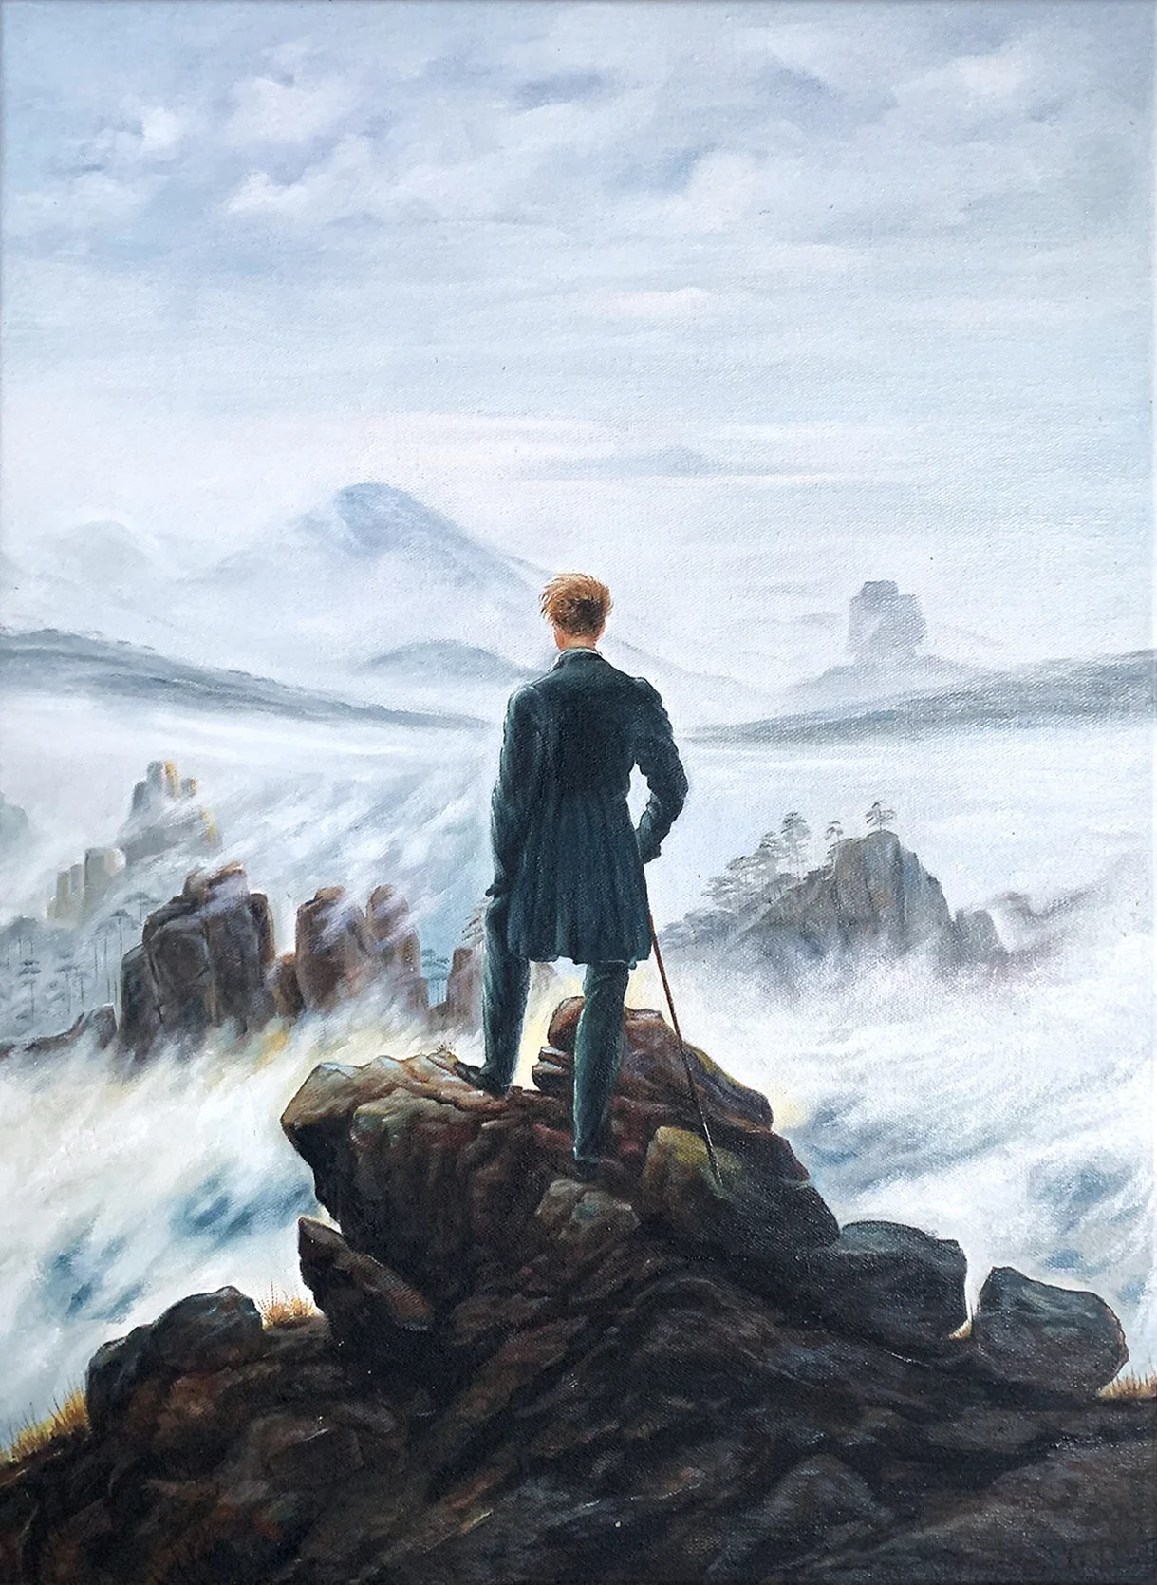
Kant’s idea of sublimity being transcendent through our ‘supersensuous powers of reasoning’ influenced European Romantic artists whose sensibilities became intrinsically linked to nature. By releasing their creativity from the ‘rules’ of art with an intensity driven by the idea of representing the unrepresentable and stimulated by overwhelming sensations of awe, fear, and emptiness at the sheer vastness of nature, artists attempted to create intense experiences beyond the imagination and conscious control of the viewer, introducing qualities of obscurity to evoke a fear of the unknown. Their paintings became an allegory for the essence of the soul and a symbolism of freedom and infinitude. Artists Casper David Friedrich and J M W Turner whose works embodied their emotional experiences of nature and landscapes, effectively portrayed humanity’s fragility and smallness in the face of nature’s unpredictable power - the natural sublime.
Fig.1: Wanderer above the Sea of Fog, 1818. Casper David Friedrich
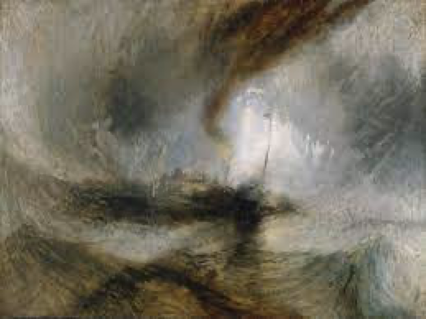
Fig.2: Snow Storm – Steam Boat off Harbour’s Mouth, 1842. Joseph William Mallard Turner

Another Romantic artist, John Martin, inspired by technological advances of that era, chose imagery of ruinous industrialised landscapes and civilisations to suggest a sublime aesthetic of impending disaster, a premonition of the future perhaps? But introducing buildings and technological objects into the artworks assigned greater significance to human endeavour, shifting the notion of natural sublime to a technological sublime reinforcing humanity’s dominating power over nature.

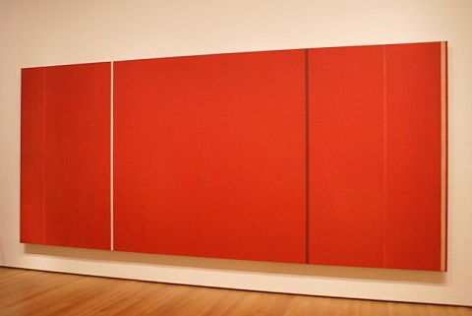
The sublime aesthetic was less influential during the 19th century but became prominent again during the early 20th century, shifting and evolving once more. With an avant-garde approach, expressionist painter Barnett Newman, believed that “the impulse of modern art resides in the desire to destroy beauty.” (Shaw, 2013 in Tate Research Publication). The arguments in his essay ‘The Sublime is Now’ were consistent with the principles of Kantian sublime and underpinned his art practice of abstraction and colour field painting, yet he moved away from the figurative or natural representations to artworks that had no clear distinction between “form and formlessness,” that exuded a “sensation of time,” of ‘now,’ an infinitely simple occurrence and a “presentation of that which can be said but not shown.” (Shaw, 2013 in Tate Research Publication)
Fig.3: Vir heroicus sublimis (1950-1), Barnett Newman

Newman’s art reflected the Romantic principle of representing the unrepresentable pictorially, but it is the paint/painting that is the occurrence which he considered to be sublime. The viewer was encouraged to place themselves beside the canvas in order to ‘make themselves present,’ to contemplate hidden meanings within the art, whether divine or human creation - the idea that “Man is Present” (Shaw, 2013 in Tate Research Publication).

Newman’s influence can be seen in other artists of that time: Mark Rothko and Jackson Pollack, similarly rejecting traditional approaches to representation, produced enormous canvases that were radically boundless, formless and not based on any reality, created to provide the viewer with a direct sublime experience of a ‘here-and-now’ through an encounter with the physicality of the painting. Yves Klein took this sublime notion further: his fascination with space is seen in his famous “Leap into the Void, 1960”. He wanted the viewer to experience that empty space with him and share in the anticipated horror of impending disaster/death, the subversive sublime. (AS-Magazine, 2020)
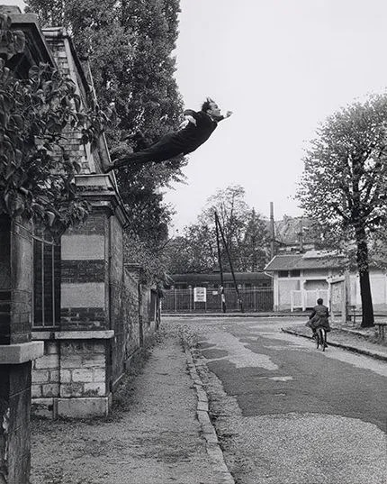
Fig.4: Leap into the Void, 1960. Yves Klein

Artists pursued sublimity in scientific discoveries, large-scale technological and urban constructs, disasters, the digitised world, and the dramatic and complex ecological impact of humanity’s energies in what is now referred to as the ‘Anthropocene.’ This term was put forward in 2002 by Paul J Crutzen who suggested that this epoch started with the invention of the steam engine in 1789 and its proliferated development/use ever since has been directly responsible for the global warming crisis that exists today. Another major defining factor was the ‘Great Acceleration’, a consequence of the nuclear bombs detonated in Japan during WWII (1945), post-war population explosions and hedonistic exponential growth in consumerism, all fueled by technological and digital development. There are irrefutable ecological recordings of these events that mark the dramatic impact of humans on the world which will last for eternity: ice caps imprinted with carbon dioxide, soils with nuclear radiation, the land and oceans devastated/destroyed through over-consumption and pollution.

However, ‘the Anthropocene is still in the making’ as ‘the violence [continues to be] inflicted upon the non-human world,’ (Davis & Turpin, 2015,4,7), pushing the Earth System towards a mass-extinction event. The ‘Anthropocene’ requires a shift from human-centric beliefs to a ‘creative engagement with the environment’ (Nye, 2022, 14), with art and sensory experiences becoming the central ‘vehicles of aesthesis’ (Davis & Turpin, 2015, 3) to re-imagine and deal with the complexities of the era, the interconnectedness, shared separations, and intra-actions with the non-human world.

James Turrell (b.1943 -) American Light artist
Fig.5: Key-lime (1994). James Turrell.
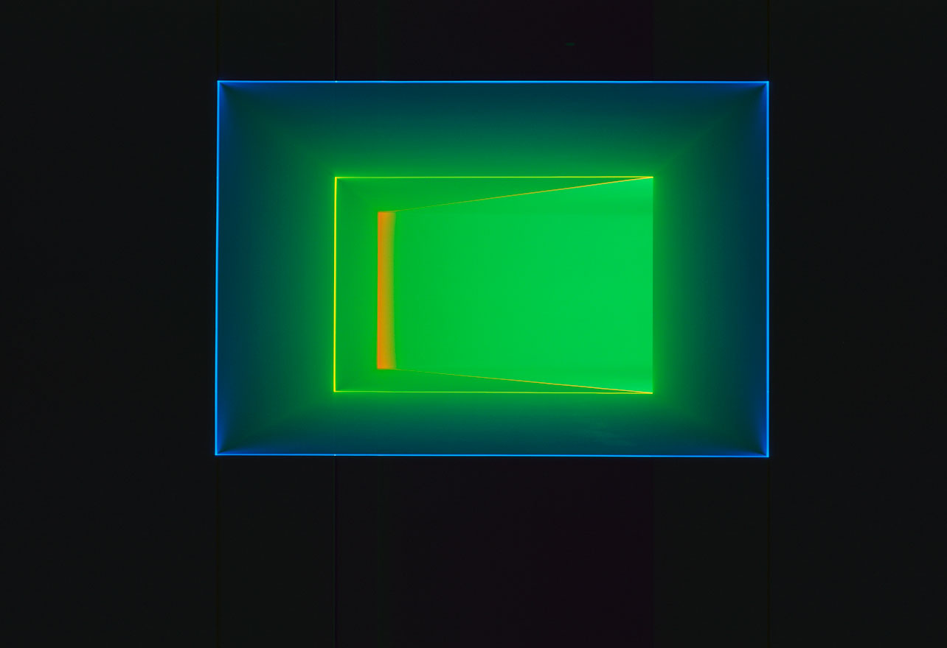
James Turrell’s art practice is a proponent of the tangible sublime. Since the 1960’s, Turrell has created minimalist art installations of space and light that are subjectively experiential and contemplatively subliminal. His inspiration comes from a fascination with the concept of ‘light’ being a presence that occupies ‘space’, a real thing which is essential to all humans and non-humans for life and vision, an element that is ‘powerfully enlightening’ (Morley, 2010, 96). His early influences came from Monet’s ‘Water Lilies’ - the luminosity captured his imagination - and Thomas Wilfred’s ‘Light in a Box.’ He believed, like Newman and Rothko, that Kant’s negative or non-presentation of placing the viewer at the limits of understanding, the edge of an abyss or in a void could be achieved by reducing “optical pleasure … to near nothingness … [which] promote[d] an infinite contemplation of infinity.” (Morley, 2010, 34) His passion for flying also instilled in him a different perspective of the world - seen from a distance, the essence of the natural world was reduced to geometric shapes and colours and its vastness of scale highlighted humanity’s smallness.

Turrell believes that experience is far superior at evoking the sublime than any photograph. His genius (a characteristic of Longinus’s sublime) is that he erases backgrounds to reveal the ‘presence of space’, making visible the abstractly invisible phenomena of light and space, exploring its physicality and power. He creates an atmosphere that reinforces our inter-connectivity with the world and the universe through the sensory form of ‘pure light’, challenging the viewer’s limits of visual perceptions. This effect overwhelms and disorients the viewer within the space, being blinded in the moment, evoking a deeper contemplation of the experience so that they feel intimately ‘lost’ within the light - as vision falters, a powerful transcendence occurs intensifying the experience of sight, perception and time. His artworks are designed to be viewed again and again as a commitment to “looking” as Turrell calls it, and its magical/mysterious/spiritual quality prevails unaltered. In his own words, Turrell imbues an intensity “to see ourselves seeing,” with a sense of quietude “to create an experience of wordless thought.” (Turrell, 2023)
Fig. 6: Gard Blue, 1993. James Turrell, Projection Series
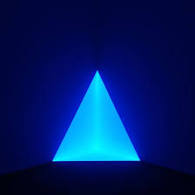

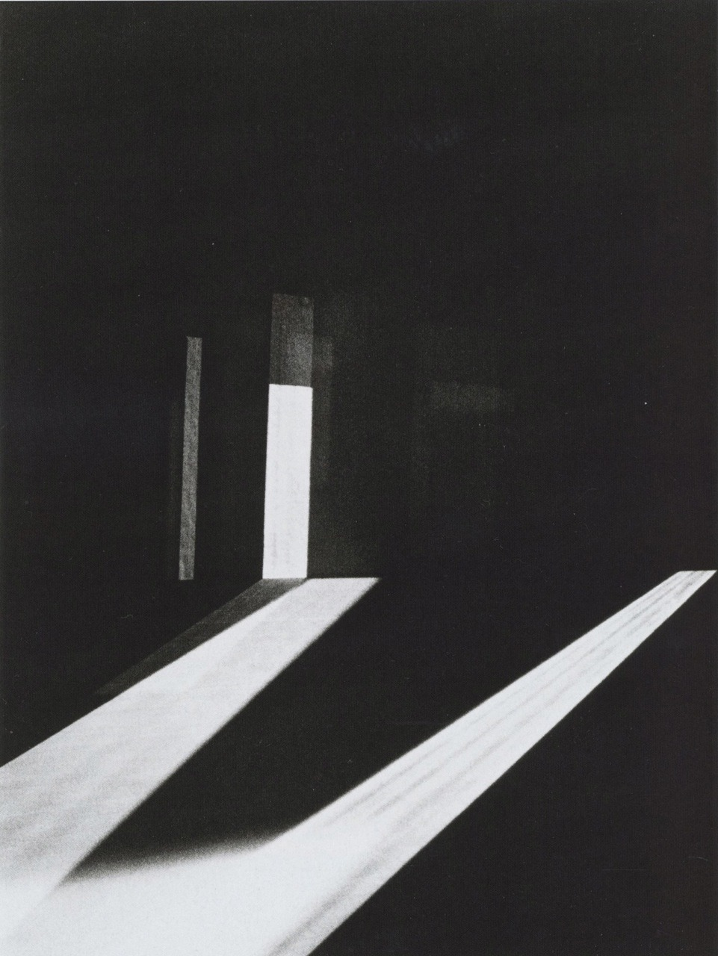
Turrell’s early works consisted of coloured light projected within a dark space, giving the illusion of some physical 3-D shape, as if made of perspex or glass. These projections made light and space appear tangible and tactile yet interaction with the ‘light’ confuses and disorients, challenging the mind to comprehend the incomprehensible. This is akin to Kant’s sublime of irresistible forces creating “a powerful sensory experience … which … leads to reflections about the meaning of such encounters.” (Nye, 2022,163) However, this sublime experience could also correspond to the intangible environmental sublime, as advocated by David Nye: rejecting the theory of human domination over nature, the environmental sublime is about immersion in the complexity of life and of symbiotic relationships between all things, relying on personal experiences and scientific knowledge. The technology of artificial light cocoons the viewer in a mysterious void which intensifies the natural light, creating a discernible tension between the two which invokes transcendence - the sublime experience.
Fig. 7: Mendota Stoppages, 1969. James Turrell

In a later series titled Stoppages (1969-1974), Turrell introduced apertures into site-specific dark spaces through which natural light could flood in. The darkness took away depth perception - everything in the space became indistinguishable giving the illusion of no floor, ceiling or walls - apart from the natural light piercing the dark, changing in intensity and direction as the sun traverses the space. He further experimented with this idea by manipulating the ‘sky’ by using artificial coloured light to transform the space.

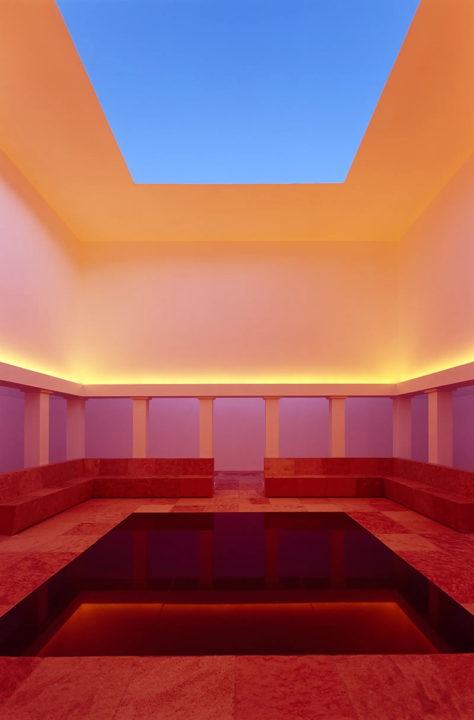
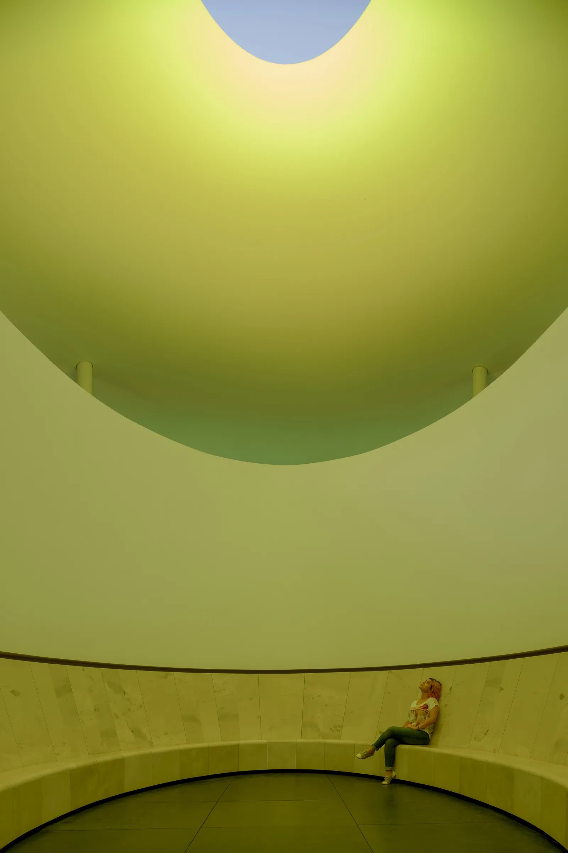
This concept has since been integral to all his subsequent “Skyspace” works of constructed observatories with the sky and universe framed through a squared, circular or oval aperture carved out of the ceiling. The same segment of sky is viewed at any time of day or night from within the chamber, although most intensely experienced at dawn and dusk. Each large-scale installation is unique and sympathetically sited in spectacular or remote locations around the world, offering internal spaces for small numbers of viewers to “see themselves seeing,” placing them “in direct contact with ‘light’.” (Morley, 2010,99). Turrell’s works allow for shared experiences of sensations that enables the viewer to conceptualise the limits of understanding - the sublime - in the artwork.
Fig. 9: Encounter, 2015. James Turrell, Projection Series
Fig. 8: Unseen Blue, 2002. James Turrell, Projection Series

Fig.10: Aten Reign 2015. James Turrell, Projection Series
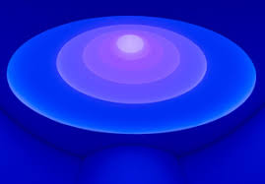
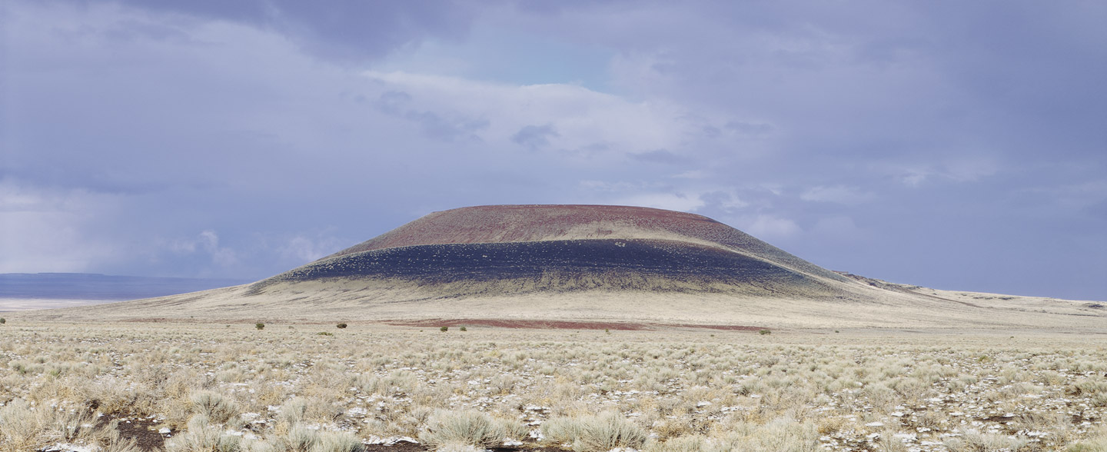
Turrell’s most visionary “skyspace” is his ‘Roden Crater’ which has been under construction since 1977, incorporating elements of all of his other works in a labyrinth of subterranean tunnels and chambers. His lifelong project is to create a naked-eye celestial observatory, in Arizona’s Painted Desert, an area known for its dark skies and spectacular sunrises and sunsets, to enable viewers to experience different segments of the sky and celestial events evoking a transcendence as one contemplates the spirituality of the universe.
Fig.11: Roden Crate, 1977 - . James Turrell, Projection Series

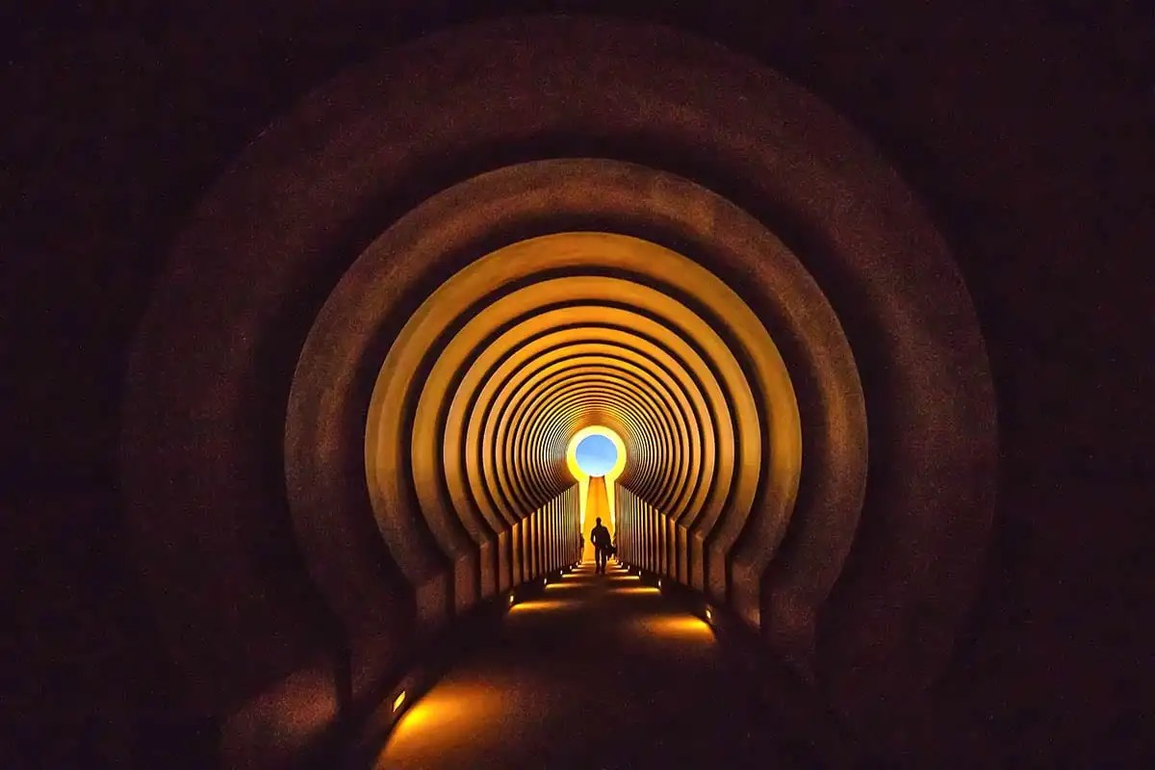
Unobtrusively constructed in an ancient extinct volcanic cinder-cone crater, Turrell wants the viewer to ‘feel geologic time’ and hopes that it will last for millennia, to reflect the ingenuity of humanity and its quest to understand the universe and its place within it. This will be his greatest achievement once completed as it establishes a direct and unforgettable link through the sky with the infinite universe beyond. “Rather than being ephemeral, it will be timeless.” (Morley, 2010,100) Roden Crater is a space that is transformational, each chamber positioned to capture different aspects of the universe above, to encourage the viewer to pause, to watch and to sense the constant movement of the sun or the moon or the stars. (Figs.12 & 13). In the words of Turrell, “In this stage set of geologic time, I wanted to make spaces that engage celestial events in light so that the spaces perform a ‘music of the spheres’ in light.” (Turrell, 2023)
Fig.12: The East Portal of the Roden Crater Project, also known as The Roden Crater Keyhole, 1979 - present, James Turrell
Fig.13: Staircase to Heaven…. Roden Crater, Painted Desert, Arizona. James Turrell
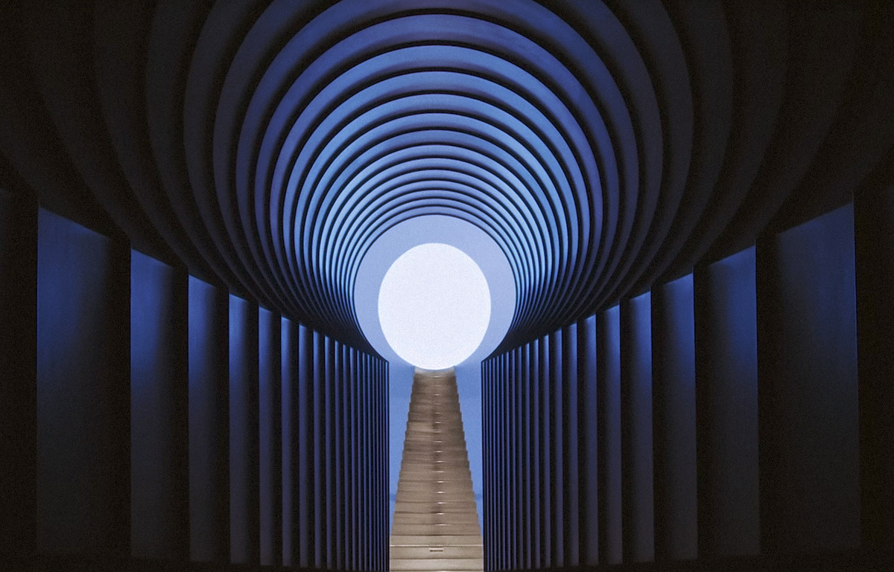

Turrell’s artworks embody the notion of the sublime by creating opportunities for individual and shared transcendence. His powerful and visionary use of the medium of ‘light’ stimulates an uneasy knowledge that the technological advancements of humankind have created a void in consciousness in which the sublime can be experienced. The spaces in Roden Crater are filled with light - starlight that can be “billions of light years old” or merely "twenty light years” mixed together with “a physical presence which speaks of its time.” (Morley, 2010, 101). To immerse the soul within these spaces is to discover what Gaston Bachelard describes as “the Immensity … within ourselves” (Barchelard in Morley, 2010,101)

Mariele Neudecker (b.1965). German Multi-media artist
Fig.14: “The Touch of Earthly Years, 2018. Mixed media including water, acrylic medium, salt, fibreglass. Mariele Neudecker
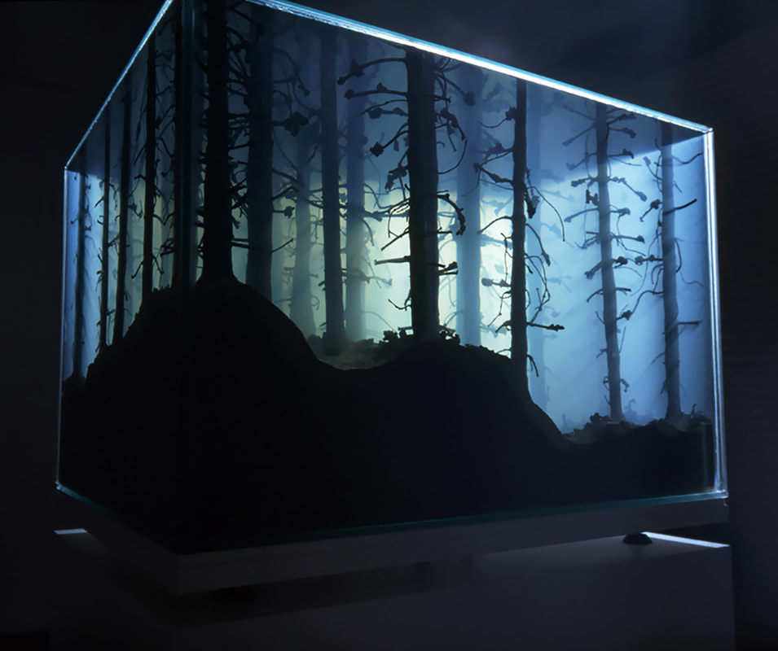
Mariele Neudecker is a multi-media artist who is fascinated with space, time, phenomenology, and science. She explores the notion of Burke’s Romantic sublime in landscape in today’s contemporary era by focusing on the inter-relationships between humans and landscapes of both the natural world and of the technological spheres, in search of the limits of human perception and experience. Through her practice of sculpture, video, photography and sound, Neudecker uses technology to investigate how our experiences and perceptions of Nature are enhanced by that technology but how it can also limit what we “see”. Her inquiries challenge how we look, see, and understand images.

In her early works, Neudecker created intricate 3-D perceptions of reality from 2-D images - fibreglass resin landscapes of forests, mountains and icecaps that were contained or framed within glass tanks (vitrines) of chemical and water solutions, subtly lighted creating unique misty atmospheres, capturing isolated fragments of Nature in time. It was her belief that “Everything we look at is mediated, screened, cropped and framed in different ways by our eyes, our senses, our technology and the environment: we can never ever truly see the thing itself in its entirety”. (Trigg, 2022). Her tanks are representations of this mediated romantic sublime concept of landscape, but her sculptures emphasise them as human constructs.

The influence of her scientific enquiries can be seen in the sculpture in [Fig.15] which explores the complexity of sight and limits of perception: intricate resin mountains are inverted and suspended in two glass spheres of saline solution. The effect is to replicate how the human eye sees images: inverted images are processed and flipped to the correct orientation by the brain.
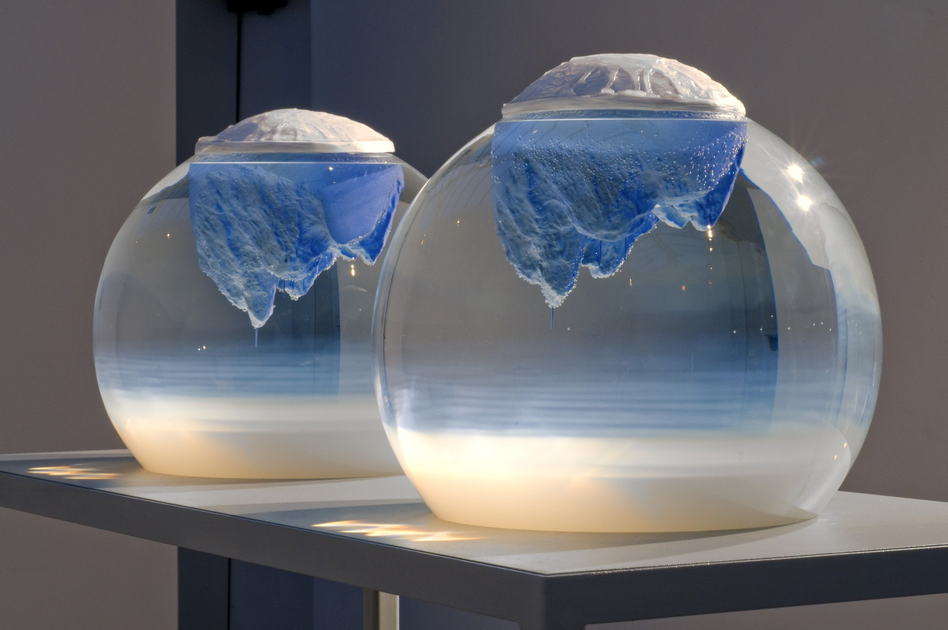
Fig.15: “400 Thousand Generations”, 2009. Mariele Neudecker.
Installation: ‘GSK Contemporary: eARTh: art in a changing world’, Royal Academy of Arts, London.

In order to truly experience the sublime aesthetic evoked by Nature, Neudecker’s later works were created from personal experiences of Nature and landscape - she immersed herself in Greenland’s Arctic environment, the Indian Ocean’s deep seas and the world of quantum physics and subatomic particles (through an artist residency) at CERN. Whilst her previous artworks were a contemporary sublime representation akin to the Romantics, her latest creative responses to these expeditions were tanks that now are considered to evoke the intangible Environmental Sublime (Fig.14]. Global Warming, a hyperobject - defined by Timothy Morton as “things that are massively distributed in time and space relative to humans…. occupy[ing] high-dimensional phase space …. invisible to humans for stretches of time” (Morton, 2013,1) - requires a response that recognises humanity in a symbiotic relationship with Nature: that Nature is infinitely and defiantly complex: and that “humans … are not running the show, at their most powerful technical mastery on a planetary scale.” (Moron, 2013, 164). The encounter with Nature still inspires awe but is tempered by scientific knowledge and understanding. It is this understanding that evokes the sublime experience, arousing the fear of extinction for the whole world, human and non-human: a realisation that “the wounds of the natural world are also social wounds, and that planetary ecological crisis is the material and historical consequence of the anthropocentric and dualistic worldview.” (Opperman & Iovino in Nye, 2022, 117)

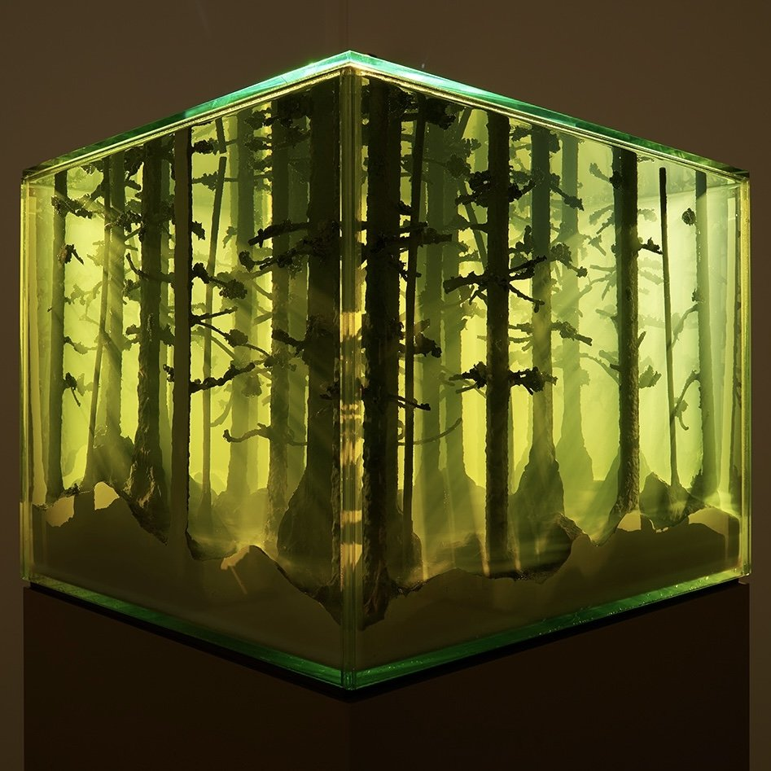
Neudecker’s expeditions confirmed the reality that there is no such thing as the wilderness “because everything is saturated by culture in some way.” (Trigg, 2022). She understood that the quest for the sublime in the Anthropocene requires the limits of human perception to be challenged beyond simply landscape. Her latest tanks of “submerged worlds appear as deathly portents of poisoned … futures.” (Fig; 16) (Trigg, 2022). This exhibit makes the intangible hyperobject tangible and sublime: her use of acid yellow is jarring which gives the sculpture a “ghostly spectrality that comes in and out of phase with the normalised human spacetime.” (Morton, 2013, 169). Similar to the aesthetics of Romanticism, this piece cleverly evokes irony, “the aesthetic exploitation of gaps…. [that is] the echo of a mysterious presence …[of] something already there.” (Morton, 2013,173)
Fig.16: “And Then The World Changed Colour: Breathing Yellow”, 2019, Mariele Neudecker
Mixed media incl. glass, water, salt, plastic. Commissioned by Dulwich Picture Gallery. Courtesy: Galeria Pedro Cera, Lisbon. Photo: Benjamin Jones

Researching each environment over extended periods of time clarified to Neubecker that global warming was having a catastrophic impact on our planet, pushing fragile environments to the brink of collapse. Her Arctic expedition revealed the impact on indigenous peoples shortening their hunting season, pushing their centuries-old traditional culture to the brink of extinction too. In response to these findings, she created There is Always Something More Important, 2012, freestanding fibreglass icebergs exhibited with photographic and video footage of the Arctic and images of the sun rising and setting at opposite positions around the world, titled Echo Chamber. Neubecker’s quest is to share the sublimity of her experience and portray the ecological anxiety that overwhelms our very being, and in her words, “to let others look through my eyes, not to tell them what to see. What people make of it is up to them.” (Trigg, 2022)
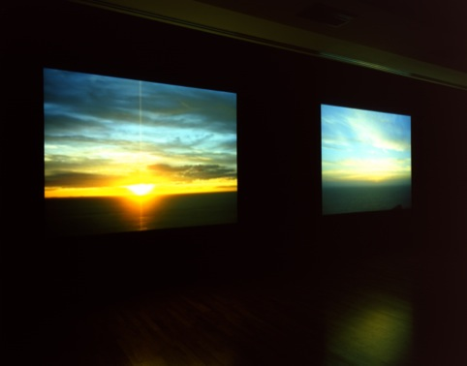
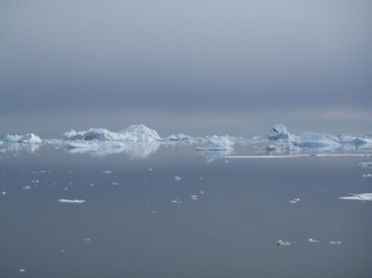
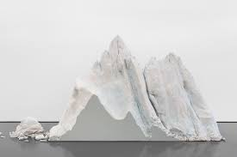
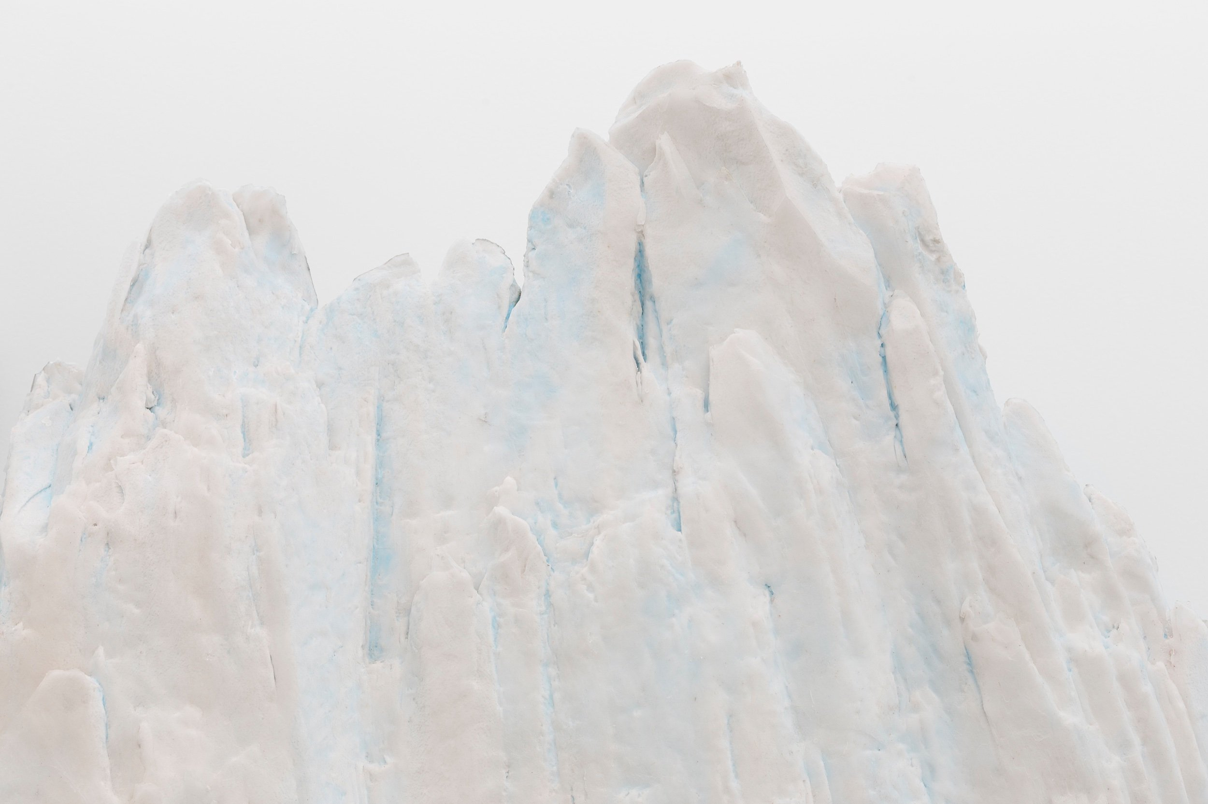
Fig. 17: “There is Always Something More Important”, 2012. Mariele Neudecker

Another example of Neubecker’s intuitive connection to Nature is seen in her 2001 The Sunken Village installation, a large-scale view of a drowned village in Germany comprising 2 houses and a church. The idea of submersion was initially inspired by villages lost to reservoir constructions but in more recent times, it parodies the devastation of flooding caused by global warming, evoking the new contemporary sublime experience.
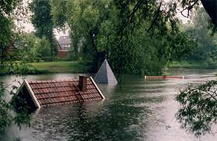
Fig.18: The Sunken Village, 2001. Mariele Nuedecker

The Hyperobject of Global Warming is changing humanity’s perception of Nature and of the ideology and aesthetics of the Romantics “landscape:” Neudecker’s artworks now focus attention on planetary survival including humanity whilst still searching for the limits of perception. Her interest in scientific discovery has taken her to CERN as artist in residence. Here, through her observation of the Cloud Experiment where scientists recreate world atmospheric conditions in a drum and then experiment with different scenarios to understand consequences of global warming, Neudecker’s artworks visualises the mysterious and invisible subatomic world of those experiments where ‘things’ behave bizarrely and ‘strangeness’ rules and provides a mediated experience of the digital sublime. Experiments at CERN are according to Neudecker, “unperceivable and it has all happened in the past or will happen in the future. There is no real experience in the present, which is really intriguing because everything is analysed in hindsight or predicted for the future, so the experiments are all re-enactments, representations of other things.” (Spicer, 2018).

Conclusion
In today’s reality, no environment is untouched by man. But humanity is now being overwhelmed by Nature’s response to its hedonism. Timothy Morton suggests that we are entering “the Age of Asymmetry” where knowledge becomes ineffective in controlling the non-human forms and the experience of the Romantic sublime of watching from a safe distance is no longer available. In the words of Morton, “we are no longer poised on the edge of the abyss, contemplating the vastness while leaning on a stick … [Friedrich’s Wanderer] …. [evoking transcendence]. We have discovered that we are already falling inside the abyss.” (Morton,2013,160) Nature is no longer the background to human-centric life: humanity is no longer able to distance itself from Nature: Nature will confront and haunt until we co-exist.

The concept of the sublime is as relevant today as it was in the times of Burke and Kant. Even though there are now many different dimensions of sublime experiences, they all impact the senses. These experiences at the limits of understanding still evoke awe, excitement, danger, or fear and provoke awareness, reflection, and action. This is where Art can influence. Art that searches for a presentation of that intimate sublime experience is art that captures the essence and depth of the inner space of all things, vividly revealing the gap between ‘phenomenon and thing’ that is beyond comprehension or ‘unreal’ thus requiring acceptance of co-existence. Artists are not fearful of using the fractured world as their inspiration: they tackle the realities of the Anthropocene and challenge their audience to re-sensitise and engage.

The artists James Turrell and Mariele Nuedecker both continually challenge themselves to represent the unrepresentable, make visible the invisible. Turrell’s artworks are large-scale constructs that achieve transcendence by over-powering the senses with light imbued with consciousness, offering a direct, powerful encounter with the sublime where subjective perceptions and emotions give the works authenticity. Turrell’s works evoke the historical sublime, by giving presence to invisible space that enables the viewer to “see themselves seeing” evoking a sense of infinity that is unfathomable.

Mariele Neudecker similarly seeks to represent sublimity in space and time with emphasis on the interconnectedness between humans and Nature. She believes that there is no ‘wilderness' anymore so her artworks offer an aesthetic experience of the intangible environmental sublime. Her ‘tanks’ embody the complex intricacies of life, provoking thoughts about impermanence and survival of all species. Neudecker’s multi-media practices investigate and give visual representation to scientific data and the invisible elements of life evoking “a different concept of time…. Deep time [that] began before humanity existed…. To see ourselves as part of a … legacy stretching over millions of years past and millions to come.” (Nye, 2022,160)

The aesthetic concept of the sublime is likely to evolve further as new technologies afford different perspectives of the world. Art is a creation of the imagination, designed to reveal the essence or presence of an invisible space or dimension, another reality or truth not previously seen. Therefore, the role of the artist in visualising the astonishing advancements of science is crucial in provoking a sense of responsibility to Nature - by searching for that sublime experience. In the words of Bachelard, “contemporary painters no longer consider the image as a simple substitute for a perceptible reality.” (Bachelard, 1964, xxxiii) and as Simon Morley suggests, “the sublime is an experience looking for a context … is an experience that can serve many interests; it is now for us to decide what it holds for the future.” (Morley, 2010, 21)

Bibliography

Bachelard, Gaston (1964). The Poetics of Space. Orion Press Inc, New York.
ISBN 0-8070-6473-4

Bello, M. (2019). Quantica. In Search of the Invisible.
https://www.researchgate.net/publication/341702277_Quantica_In_Search_of_the_Invisible

Blyth, F. (2020). James Turrell: celestial encounters in light and space
https://hero-magazine.com/article/176325/james-turrell

Davies & Turpin (2015). Art in the Anthropocene. Open Humanities Press. ISBN:978-1-78542-005-4

Lyotard, J-F. (1984). The Sublime and the Avant-Garde. Artforum
https://www.artforum.com/print/198404/the-sublime-and-the-avant-garde-32533

Lyotard, J-F. (1997) in Mărie Shurkus (2013). The Sublime Event with Kant, Deleuze and Lyotard.

Lyotard, J-F. In Morley (2010). The Sublime. Documents of Contemporary Art. Whitechapel Gallery Ventures Ltd. ISBN: 978-0-85488-178-9

Morley, S. (2010). The Sublime. Documents of Contemporary Art. Whitechapel Gallery Ventures Ltd. ISBN: 978-0-85488-178-9

Shaw, P. (2006). The Sublime. The New Critical Idiom. Routledge, Oxon.
ISBN13 9-780-415-26848-6 (pbk)

Shaw, P. (2013). ‘Sublime Destruction: Barnett Newman’s Adam and Eve’, in Nigel Llewellyn and Christine Riding (Eds), The Art of Sublime, Tate Research Publication.
https://www.tate.org.uk/art/research-publications/the-sublime/philip-shaw-sublime-destruction-barnett-newmans-adam-and-eve-r1140520

Shurkus, M. (2013). The Sublime Event with Kant, Deleuze and Lyotard.

Spicer, E. (2018). Mariele Neudecker: ‘I get labelled as a climate change artist at times, but I don’t look at it that way’.
https://www.studiointernational.com/mariele-neudecker-interview-climate-change-cern

Trigg, D. (2022) Mariele Neudecker: The Contemporary Sublime.
https://seismamag.com/visual-fine-art/mariele-neudecker

Turrell, J. (2023)
https://jamesturrell.com/about/introduction/

Turrell, J. (2023)
https://rodencrater.com/celestial-events/

List of Figures

Fig. 1: Wanderer above the Sea of Fog, 1818. Casper David Friedrich
Fig. 2: Snow Storm: Steam Boat off Harbour’s Mouth,1842. Joseph William Mallard Turner

Fig. 3: Vir heroicus sublimis (1950-1), Barnett Newman

Fig. 4: Leap into the Void, 1960. Yves Klein

Fig. 5: Key-lime (1994). James Turrell.

Fig. 6: Gard Blue, 1993. James Turrell, Projection Series

Fig. 7: Mendota Stoppages, 1969. James Turrell
Fig. 8: Unseen Blue, 2002. James Turrell, Projection Series

Fig. 9: Encounter, 2015. James Turrell, Projection Series

Fig.10: Aten Reign 2015. James Turrell, Projection Series

Fig.11: Roden Crate, 1977 - . James Turrell, Projection Series

Fig.12: The East Portal of the Roden Crater Project,
also known as The Roden Crater Keyhole, 1979 - present, James Turrell

Fig.13: Staircase to Heaven…. Roden Crater, Painted Desert, Arizona. James Turrell

Fig.14: “The Touch of Earthly Years, 2018.
Mixed media including water, acrylic medium, salt, fibreglass. Mariele Neudecker

Fig.15: “400 thousand Generations”, 2009. Mariele Neudecker.
Installation: ‘GSK Contemporary: eARTh: art in a changing world’, Royal Academy of Arts, London.

Fig.16: “And Then the World Changed Colour: Breathing Yellow”, 2019, Mariele Neudecker

Fig.17: “There is Always Something More Important”, 2012. Mariele Neudecker
Fig.18: The Sunken Village, 2001. Mariele Nuedecker

